# | Pts Possible | Pts missed | Extra Credit
1 | 18
2 | 12
3 | 6
4 | 14
5 | 7
6 | 12
7 | 12
8 | 10
9 | 9
Total | 100
Score
NAME _______________________
BRING THE EXAM ON PAPER to our last class or UPLOAD TO THE CLE SITE BEFORE 08:45 ON THURSDAY DECEMBER 4. Late exams cannot be accepted; submit EARLY to be safe if you won't be in class. Do NOT plan to print it at Mission Hall on 12/4.

Collaboration with others is NOT permitted. Answers must be in your own words.

Please show your work.

1. With thanks to Bardia Nourbakhsh.
Distinguishing neuromyelitis optica from multiple sclerosis
Neuromyelitis optica (NMO) is an inflammatory disease affecting optic nerve and spinal cord. For decades, it was thought to be a subtype of multiple sclerosis (MS) a much more common inflammatory disease of the central nervous system. Recent developments in the field, including the discovery of an immune marker (NMO-IgG) in the blood of many NMO patients, refuted this theory. There is evidence that MS medications are ineffective (or even harmful) for NMO patients, so it is important to distinguish these two entities despite their overlapping presentations.
Wingerchuk et. al.¹ studied the diagnostic accuracy of NMO diagnosis models combining clinical criteria and NMO-IgG antibody status in 129 patients ascertained through Mayo Clinic MS centers, all of whom had a diagnosis NMO or MS. Per the methods section of the paper, "The reference standard for the study was a diagnosis of NMO or MS based on the final clinical diagnosis rendered by the study neurologist based on his or her integration of all available clinical, imaging, and laboratory data and the period of follow-up after disease onset."
The investigators summarized their models in the table on the next page. (Parentheses denote percent for proportions or 95% CI for point estimates of sensitivity and specificity.)

For now ignore possible biases and random error in this study and assume that the numbers in Table 2 are correct.
- What are the LR(+) and LR(−) for NMO for Model 3 and Model 4? [2]

- Models 3 and 4 both use the same two predictor variables but combine them differently so that model 3 is more sensitive and model 4 is more specific. However, if a patient has one but not both findings it is unclear whether to use LR+ for model 3 or LR− for model 4. Create a new model (model 6) from models 3 and 4 that solves this problem by creating a 3-level test. What are the LRs for each of the 3 results for model 6? You can simplify this problem by only using the numbers in the Sensitivity and Specificity columns for your LR calculations. (That is, you can ignore that not everyone was included in every model.)[4]

Table 2 Diagnostic accuracy for NMO diagnosis of models combining clinical criteria and NMO-IgG status*
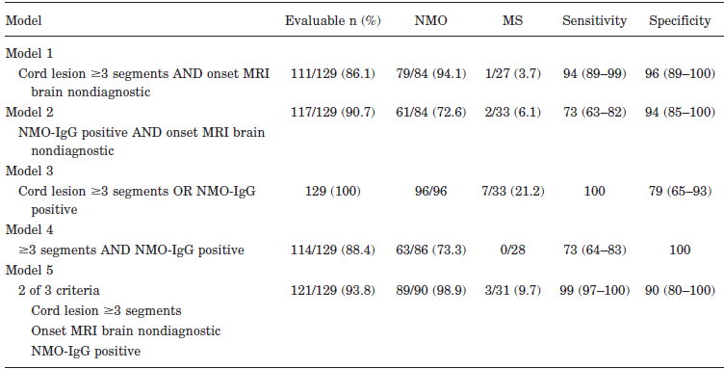
* Not all evaluated models are shown.
c. A patient with pre-test probability of having NMO of 0.2, has tested negative for NMO-IgG and does not have ≥ 3 segments of spinal cord involvement. What is her approximate post-test probability of NMO? [2]

d. What would that same patient's approximate post-test probability of NMO be if her NMO-IgG were positive? (Use model 6.) [2]

e. For part (d), did we need to assume that the NMO IgG and spinal cord involvement were independent tests for NMO? If so, do you think that assumption was reasonable? Explain. [2]

f. The authors do not provide confidence intervals for sensitivity for Model 3 nor for specificity for Model 4, perhaps because they could not figure out how to do so. Use the shortcut you learned in this class to estimate the lower limit of the 95% CI for each of those numbers. (Do not use Stata, which will give you the lower limit of the 1-sided 97.5% CI.) [2]

g. The choice of reference standard raises a concern about the possibility of biased results. What is the name of the bias that this choice of reference standard probably caused and how would you expect it to affect the reported performance of their predictive models? [2]

h. The footnote at the bottom of the table states "Not all evaluated models are shown."
What additional bias does this suggest the study might suffer from? [1]

i. What is at least one approach to avoiding the bias you mentioned in part h? [1]

2. With thanks to Caterina Liu
UroVysion to diagnose bladder cancer
A recent Wall Street Journal article (http://online.wsj.com/articles/how-medicare-self-referral-thrives-on-loophole-1414031401) describes a urology practice in Florida that is under investigation for questionable Medicare billing, in part related to its use of an expensive test for bladder cancer. The test is the computer-assisted version of UroVysion. Briefly, this urine test uses fluorescence in-situ hybridization (FISH) to assess for chromosomal abnormalities that suggest cancer. It is FDA-approved to detect bladder cancer recurrences and to diagnose previously undiagnosed bladder cancer in patients with blood in their urine.
One of the studies cited in the FDA approval report compares multiple tests for bladder cancer, including UroVysion.² Urine samples were obtained from 265 patients prior to cystoscopy + biopsy if indicated (gold standard test), of whom 146 had a prior history of bladder cancer, and 119 did not.
The authors report that 73 patients diagnosed with cancer on cystoscopy received the UroVysion test. Of these, 59 had positive findings on the UroVysion test. Of the 190 patients not diagnosed with cancer on cystoscopy, they excluded 110 with either a previous history of cancer or a positive cystoscopy for something else. Of the 80 remaining patients without history of bladder cancer and with negative cystoscopy findings, 78 received the UroVysion test and 75 tested negative.

a. Make a 2x2 table that summarizes the results of the UroVysion test compared with the gold standard. [1]

b. Calculate sensitivity and specificity of UroVysion for bladder cancer. [2]

c. The fact that urine samples were obtained from 265 patients prior to cystoscopy but only a selected 151 were included in your calculations of sensitivity and specificity above raises concern for what bias? How would that bias affect sensitivity and specificity? [3]

d. According the WSJ article, the pathologists in this practice billed more than any other practice in the country for UroVysion ($4 million total). “Catching bladder cancer early keeps patients alive by turning the disease ‘into a chronic illness’ instead of a death sentence, says Constantine Mantz, the company’s chief medical officer.” What are at least 3 possible biases that could lead to an apparent survival benefit from a more sensitive test for (and earlier diagnosis of) bladder cancer, even if it did not save any lives? [3]

e) Below are the data on incidence (new cases/100K), deaths, and 5-year survival from the National Cancer Institute's Surveillance Epidemiology and End Results (SEER) cancer registry (http://seer.cancer.gov/). Focus on the period after 1990, and assume that incidence, mortality, and 5-year survival have been flat. If we were to institute widespread urine screening for bladder cancer and the biases you mentioned in part d occurred, what effect would you expect this to have on reported incidence, survival and mortality? (You can keep your answer simple, i.e., consider all of the biases together rather than their individual effects.) [3]

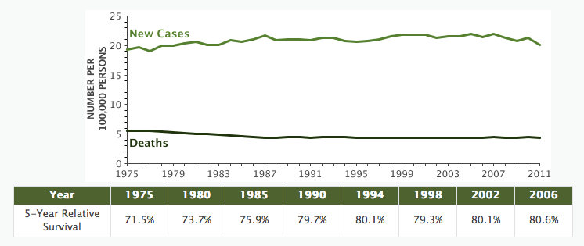

3. With thanks to Shalini Dixit, Emily Larimer, & Mariya Samoylova
Noninvasive ventilation for COPD
Patients with severe lung disease sometimes need to be hooked up to a breathing machine (mechanical ventilation) to get enough oxygen. Recently there has been increasing interest in delivering this ventilation through a mask over the nose and mouth (noninvasive ventilation, NIV) rather than through a tube in the trachea (invasive mechanical ventilation, IMV). Lindenauer et al.³ conducted a retrospective cohort study to compare the outcomes of patients treated with NIV to those treated with IMV. The study looked at 25,628 patients hospitalized for exacerbation of chronic obstructive pulmonary disease (COPD) who received IMV or NIV on the first or second hospital day at 420 US hospitals participating in the Premier Inpatient Database. The primary outcome was in-hospital mortality; secondary outcomes included hospital-acquired pneumonia, hospital stay length and cost, and 30-day readmission.

They found that in-hospital mortality was 857/17,978 = 4.8% in those treated with NIV compared with 661/7,650 = 8.6% in those treated with IMV (OR = 0.53; P<0.001). There were similar odds ratios for other outcomes.

a) The authors reported that "propensity matching attenuated these associations." What does this tell you about which patients are selected for NIV? [2]

b.) Pairwise matching on propensity scores led to exclusion of a greater proportion of NIV subjects (about 70%) than of IMV subjects (about 30%) and the total number of subjects analyzed in the study dropped from 25,628 to 10,450. Why? [2]

c) How does propensity-matching help with unmeasured confounders? [2]

4. With thanks to Sarah Averbach, Juno Obedin-Maliver, and Nika Seidman
Planned vaginal vs planned cesarean delivery for breech presentation
Women who have a fetus in the breech position (feet/bottom down, head up) at term can either plan to attempt a vaginal breech delivery or plan to deliver by cesarean section. Vaginal breech deliveries are less risky for mothers but may be more risky for infants.

a) The introduction to a randomized trial of planned vaginal breech delivery⁴ refers to prior cohort studies that concluded, “planned caesarean section is better than planned vaginal birth for fetuses that present as breech at term.” The authors in the same paper continue, “these studies are potentially biased because women were not allocated to different modes of delivery at random.” What type of confounding might occur in cohort studies comparing planned vaginal versus planned cesarean delivery for breech babies? In what direction would you expect the direction of bias to be? [2]

b) For their randomized controlled trial comparing planned vaginal delivery to planned cesarean delivery for singleton breech fetuses at term, Hannah et al enrolled 2088 subjects from 121 centers in 26 countries. The primary outcomes were perinatal mortality, neonatal mortality, serious neonatal morbidity, maternal mortality and serious maternal morbidity. If you were to design this study, how would you incorporate blinding? Who would be blinded, and for what outcomes? Why? [3]

c) The primary endpoint of this study was infant mortality at <28 days of age or “serious neonatal morbidity.” The authors defined “serious neonatal morbidity” as one or more of the following (list abbreviated for this question): spinal-cord injury, skull fracture, peripheral-nerve injury present at hospital discharge, seizure at <24 hours of age; Apgar score <4 at 5 minutes; stupor, decreased response to pain, or coma; intubation for >24 hours; tube feeding for >4 days; or admission to the intensive care unit for >4 days. What is the main advantage of using such a composite outcome? What is the main disadvantage? [2]

d) Even if a vaginal delivery route is initially planned, the plan can change during labor because of perceived danger to mother or fetus; in this case a cesarean section may be done on an urgent or emergent basis. After randomization 90% (941/1041) of women randomized to cesarean section delivered that way and 57% (591/1042) of those randomized to vaginal delivery had a vaginal delivery.
For the question of the effect of PLANNING a c-section vs. PLANNING a vaginal delivery) will an "Intention to Treat" analysis of this trial bias results towards finding no difference? [2]

e) The outcome of perinatal or neonatal mortality (death of the fetus after 22 weeks or of the newborn up to 28 days of age, excluding 5 subjects with lethal congenital anomalies) occurred in 3/1039 (0.3%) in the planned cesarean group and 13/1039 (1.3%) in the planned vaginal delivery group (RR =0.23; 95% CI 0.07-0.81, P=0.01).

i) What were the overall Relative Risk Reduction (RRR) and Absolute Risk Reduction (ARR) for perinatal/neonatal mortality? [2]

ii) How many women need to plan a caesarian delivery rather than a vaginal breech delivery to prevent one perinatal or neonatal death? [1]

iii) If you assume that cesarean deliveries themselves (rather than planning to do them) was what prevented the perinatal and neonatal deaths, how many cesarean deliveries did it take to prevent one perinatal or neonatal death? [2]?

iv) Extra credit: (Guess what Tom is thinking?) To which group of women would the NNT calculated in part iii above apply? [+2]

5. With thanks to Vratika Agarwal
Predicting stroke with Qstroke
The QStroke algorithm was designed to estimate risk of stroke or transient ischemic attack in patients without prior stroke or transient ischemic attack at baseline.⁵ The primary aim of the study was to compare the performance of QStroke with the Framingham stroke score in the full population free of stroke or transient ischemic attack. After deriving the Q stroke index in a derivation population, the authors validated it using 1.9 million patients aged 25-84 years with 12.7 million person years of follow-up who experienced 38,404 stroke events.

The graph below shows observed and predicted 10-year risks of stroke or transient ischemic attack in the validation cohort as a function of decile of predicted risks from the QStroke (top) and Framingham (bottom) risk prediction scores.

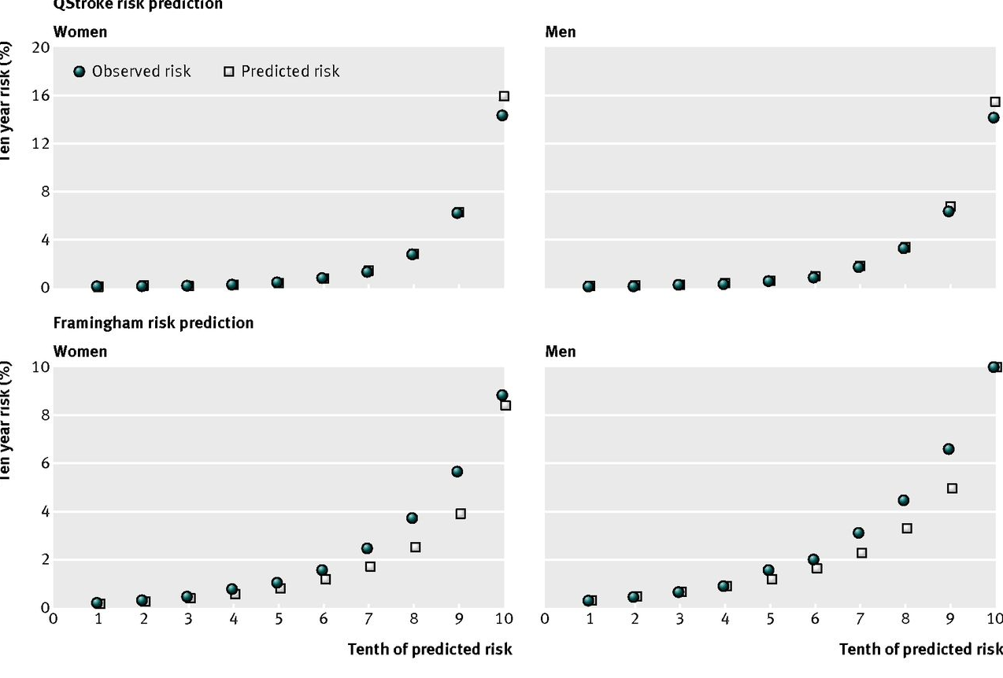

a) What are (at least) four steps the investigators needed to create a graph like those above in their validation cohort? [3]

b.) Which index is better calibrated in women (if you can tell)? Explain. [2]

c.) Which index has better discrimination in women (if you can tell)? Explain. (Hint- note the scales of the 2 graphs are different, and assume these are deciles of the POPULATION, i.e., 10% of the population is in each decile of predicted risk.) [2]

6. With thanks to Jenny Kaplan and Rachel Edlin
Diagnosing necrotizing fasciitis
Necrotizing fasciitis is a severe soft tissue infection requiring urgent operative debridement (removal) of infected tissue. Time to debridement greatly affects mortality, therefore early diagnosis is critical. However, diagnosis may be difficult and over-diagnosis of necrotizing fasciitis would lead to unnecessary surgery with potentially serious complications.

In 2004, the LIRNEC (Laboratory Risk Indicator for Necrotizing Fasciitis) score was introduced to predict necrotizing fasciitis in its early stages.⁶ To derive it, the authors identified 89 cases of necrotizing fasciitis (based on operative findings and pathology when available) and 225 randomly selected controls hospitalized for severe cellulitis or abscesses.

Laboratory tests done on admission (total white cell count, hemoglobin, sodium, glucose, serum creatinine, and C-reactive protein) were converted into categorical variables, assigned point values, and combined to form the LIRNEC score. Scores of under 5 were considered low risk, 6-7 moderate, and 8 and above high. Of the cases, 9 had scores ≤5, 9 had 6-7, and 71 had ≥8. In the controls, 218 had scores ≤5, 5 had 6-7, and 2 ≥8.

- Construct a 2x2 table with a cutoff of 6 or more points and calculate sensitivity, specificity, and likelihood ratios. [2]

- The authors report that with a cutoff of ≥ 6 points, positive predictive value of the LIRNIC score is 92% and negative predictive value is 96%. Do you agree with this estimate? [2]

- Assume that it is 10 times as bad to fail to operate on a patient with necrotizing fasciitis as it is to operate on a patient who does not have necrotizing fasciitis. If that is the case, what should be the treatment threshold probability for performing an operative debridement? [2]

- We now consider the “cost” of a tissue biopsy (a test) for diagnosis. Assume that you would be willing to do 200 tissue biopsies to avoid missing a necrotizing fasciitis diagnosis and that the tissue biopsy is a perfect test. Incorporate this test cost into a calculation to determine the range of prior probabilities of necrotizing fasciitis at which you would do a biopsy. (OK to use a spreadsheet, but write out inputs and explain results.) [2]

e. Repeat part d, but now assume that the tissue biopsy is only 50% specific (but still 100% sensitive). [2]

f. The area under the Receiver Operating Characteristic curve (AUROC) was 0.980 in the derivation cohort and 0.976 in the validation cohort. Based on the AUROC results, can we conclude that overfitting was not a major problem in the derivation of the LIRNEC score? Explain. [2].


7. With thanks to Elizabeth Wahl, who thanks Meera Sheffrin for showing her the article.
Smartphones and childhood injuries.
An article entitled “How an iPhone Can Lead to Broken Bones for Young Children” recently appeared in the New York Times (11 November 2014). The article cited the work of a Yale economics graduate student who was interested in the causal relationship between the CDC-reported increase in unintentional injuries in young children identified in the National Electronic Injury Surveillance System, and the increase in smartphone usage that occurred during the same time period (2006-2012).

Because a large, randomized trial investigating the effect of iPhone usage on unintentional injuries in children under 5 is not feasible, the author took another approach and made use of a natural experiment:

“...to circumvent these problems, I use the advent of Apple’s iPhone 3G combined with the rollout of AT&T’s 3G network…I match the rollout data to hospitals tracked by the National Electronic Injury Surveillance System. I am able to determine for all cases in the data from 2003 to 2012 whether the hospital was located in an area with access to 3G at the time of the injury. Using the hospital-level variation in 3G access, I find that smartphones increase injuries to children, particularly those younger than five, a group more at risk of injury in the absence of parental supervision.”

- What were the predictor (of interest) and the outcome variables in this study? [2]

- No data on actual smartphone usage was collected in this study. What was the instrumental variable that was used instead? [1]
c. What assumptions are needed to use this variable to establish causation? [3]

d. If parents who were browsing on their iPhone at the time of their child's injury were generally too embarrassed to report this to the staff in the ER, how would this affect the results of the study? [2]

e. Whether or not a 3G network service existed at the time and approximate location of the child's injury is obviously a weak surrogate for the risk factor of interest, which was actual iPhone usage at the time of the injury. How did this study get around that large degree of misclassification of exposure? [2]

f. The National Electronic Injury Surveillance System used by the investigator has data items for age of the child and location of the injury. If the hypothesis is that children under 5 playing in public playgrounds (as opposed to a school, where smartphone use by supervisors was felt to be less likely) are particularly susceptible to parental inattention, how could the author use these other data items to bolster his hypothesis? [2]

8. With thanks to Sachin Garg and Veeral Ajmera
Predicting fibrosis in nonalcoholic fatty liver disease
Nonalcoholic fatty liver disease (NAFLD) is an emerging epidemic. Likely because of the chronic liver inflammation associated with NAFLD, some patients develop progressive scarring in the liver (termed fibrosis) over time. The diagnosis and staging of the disease are done by liver biopsy, which involves placing a needle into the liver to obtain a piece of tissue for analysis under a microscope. Liver biopsy is invasive and can cause discomfort, bleeding or (rarely) death.

To find a non-invasive measure to predict the degree of fibrosis, Angulo et al⁷ constructed and validated a scoring system consisting of readily available clinical and laboratory data. The data were obtained on the date of a diagnostic liver biopsy in 480 consecutively sampled subjects undergoing liver biopsy at four centers.

Results from their study are shown in their Table 3:

Table 3. Predictive Value of the Scoring System Obtained from the Estimation Group (n = 480)
 | Low cutoff point  (< −1.455) | Indeterminate (−1.455–0.676) | High cutoff point  (> 0.676) | Total N
Total | 295 | 114 | 71 | 480
No significant fibrosis (stage 0–2) | 273 | 75 | 7 | 355
Significant fibrosis (stage 3–4) | 22 | 39 | 64 | 125
Sensitivity | 82% |  | 51%
Specificity | 77% |  | 98%
Positive predictive value | 56% |  | 90%
Negative predictive value | 93% |  | 85%
Likelihood ratio (+) | 3.567 |  | 25.966
Likelihood ratio (−) | 0.229 |  | 0.498
Interpretation | Absence of significant fibrosis (93% certainty) |  | Presence of significant fibrosis (90% certainty)
a. “Using the area under the ROC curve, 2 cutoff points were selected to identify the presence (greater than 0.676) and absence (less than −1.455) of significant fibrosis." (Excerpted from the article.)
Create a 2x2 table for each cutoff point (low and high) to predict patients with significant fibrosis. Clearly define what test values constitute a positive and negative test. [2]
b. Draw and label the axes and line segments (or inflection points) of an ROC curve that summarizes the discrimination of this scoring system using these 2 cut-points. [3] (You can draw it and paste a photo here if you want.)

c. What was the overall pre-test probability of significant fibrosis in the study population? [1]

d. The prevalence of significant fibrosis actually varied across the 4 centers that provided patients for this study, from 12.5% in Italy to 31% in Sydney. You are seeing a patient in Italy with a score of −0.4 on the scoring system described above. What is your best estimate of his post-test probability of significant fibrosis? [2]

e. Everyone in this study had a liver biopsy (the "gold standard"), and presumably some of the items in the scoring system were used to decide who got a biopsy. What bias would this cause and how would it be expected to affect the sensitivity and specificity of the predictive index? [2]

9. Adverse Events and Negligence in the Harvard Medical Practice Study
In the Harvard Medical Practice Study⁸ a stratified random sample of 31,429 hospital charts of patients hospitalized in New York (not Massachusetts) in 1984 were reviewed to assess the frequency of medical malpractice. An adverse event was defined as an injury caused by medical management rather than by the underlying disease. Negligence was defined as care that fell below the standard expected of physicians in the community.

The ultimate assessment of an adverse event or negligence was based on review by trained physician reviewers (Review Process A). To evaluate the reliability of these assessments, 318 charts from 2 hospitals were re-reviewed “by a team consisting of a medical-records-analysis supervisor, several physician-reviewers, and a physician-supervisor” (Review Process B). Table 5 from the paper follows:

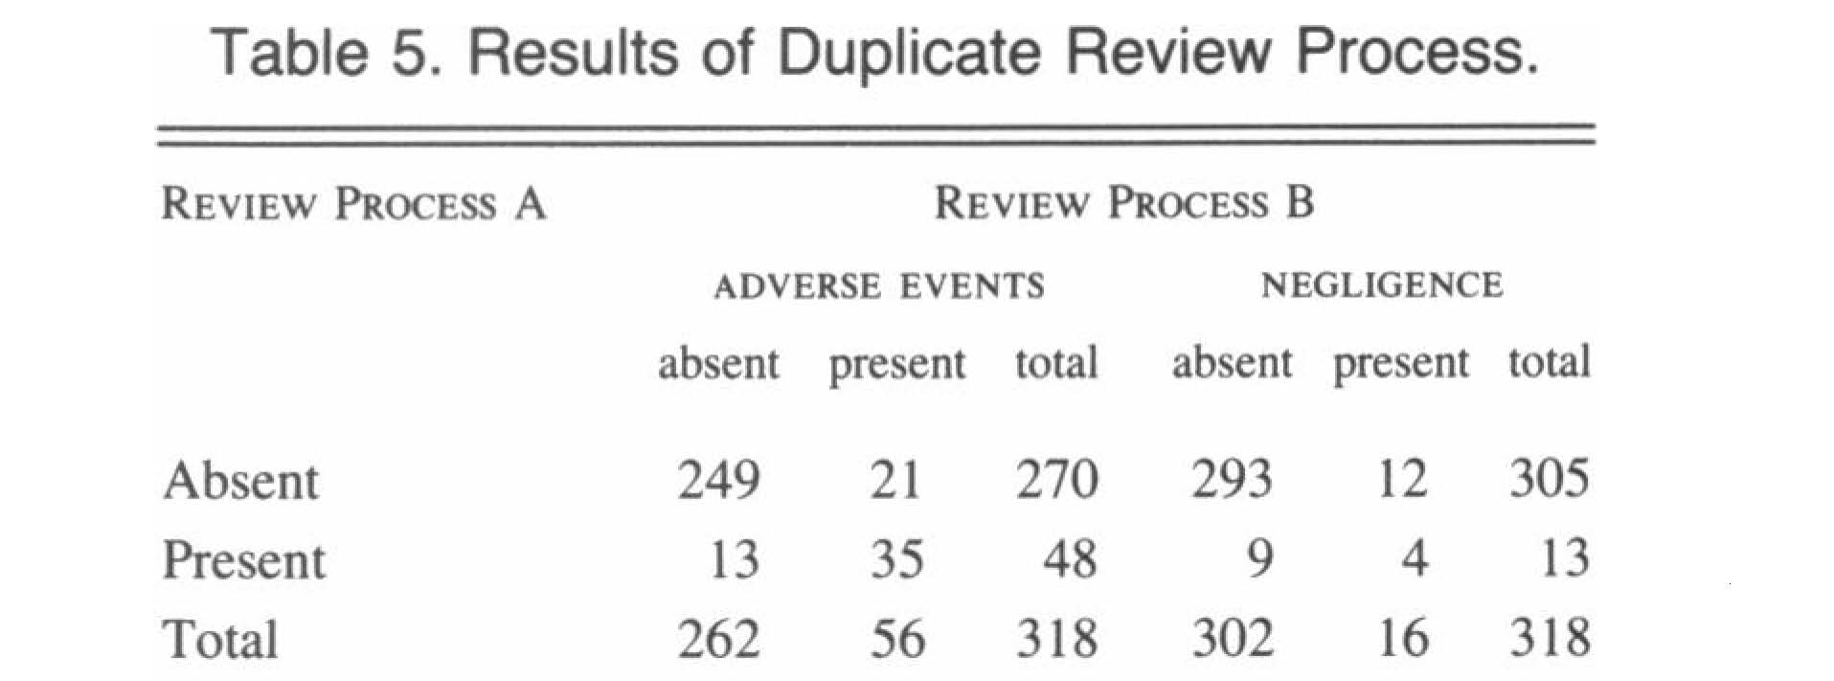

- What were observed agreement, expected agreement and kappa for adverse events? [3]

b.) Was there evidence of significant systematic (unbalanced) disagreement on negligence between Review Process A and Review Process B? Explain. [3]
c) The reviewers did not actually rate the cases as adverse event “present” or “absent;” they assigned a confidence score from 0-6 as to whether an adverse event had occurred. Ratings of 0-1 were treated as adverse event “absent,” and ratings 2-6 were treated as adverse event “present.” How could the authors have included the information from the confidence score to (probably) raise their Kappa value? [3]

CONGRATULATIONS! YOU'VE REACHED THE END OF THE EXAM‼

REFERENCES

1. Wingerchuk DM, Lennon VA, Pittock SJ, Lucchinetti CF, Weinshenker BG. Revised diagnostic criteria for neuromyelitis optica. Neurology. May 23 2006;66(10):1485-1489.
2. Halling KC, King W, Sokolova IA, et al. A comparison of BTA stat, hemoglobin dipstick, telomerase and Vysis UroVysion assays for the detection of urothelial carcinoma in urine. J Urol. May 2002;167(5):2001-2006.
3. Lindenauer PK, Stefan MS, Shieh MS, Pekow PS, Rothberg MB, Hill NS. Outcomes Associated With Invasive and Noninvasive Ventilation Among Patients Hospitalized With Exacerbations of Chronic Obstructive Pulmonary Disease. JAMA internal medicine. Oct 27 2014.
4. Hannah ME, Whyte H, Hannah WJ, et al. Maternal outcomes at 2 years after planned cesarean section versus planned vaginal birth for breech presentation at term: the international randomized Term Breech Trial. Am J Obstet Gynecol. Sep 2004;191(3):917-927.
5. Hippisley-Cox J, Coupland C, Brindle P. Derivation and validation of QStroke score for predicting risk of ischaemic stroke in primary care and comparison with other risk scores: a prospective open cohort study. BMJ. 2013;346:f2573.
6. Wong CH, Khin LW, Heng KS, Tan KC, Low CO. The LRINEC (Laboratory Risk Indicator for Necrotizing Fasciitis) score: a tool for distinguishing necrotizing fasciitis from other soft tissue infections. Crit Care Med. Jul 2004;32(7):1535-1541.
7. Angulo P, Hui JM, Marchesini G, et al. The NAFLD fibrosis score: a noninvasive system that identifies liver fibrosis in patients with NAFLD. Hepatology. Apr 2007;45(4):846-854.
8. Brennan TA, Leape LL, Laird NM, et al. Incidence of adverse events and negligence in hospitalized patients. Results of the Harvard Medical Practice Study I. N Engl J Med. Feb 7 1991;324(6):370-376.

