University of California, San Francisco
Interprofessional Obstetric Ultrasound Training Modules

- Indications for obstetrical ultrasound

Learning objectives:
- Understand and describe indications and rationale for use of diagnostic ultrasound in the first trimester, second, and third trimester of pregnancy
- Understand and describe common procedures in obstetrics and gynecology performed with ultrasound guidance
- Discuss ultrasound safety research
- Demonstrate principle of minimal exposure when ordering and doing ultrasounds

OUTLINE:

    - Background why we get ultrasounds in pregnancy. Only when medically indicated
    - Indications can be grouped according to trimester
    - Explain the different types of OB ultrasounds, give examples
      - OB US 1st trimester, with and without endovaginal scanning
      - NT ultrasound 11-14 weeks
      - Second trimester OB complete
        - Cx, uterus, adnexa, placenta, amniotic fluid, biometry, and fetal anatomy
4. Level 2 OB
      - Second and third trimester limited study
        - Requires a prior complete 2nd tri study/ unless emergency situations
        - Presentation only (clinic after 36 weeks and when admitted to L&D)
        - Minimal components of “limited OB study: Fetal number, cardiac activity, lie, placenta location, AF volume
5. Limited biometry study
6. BPP
    - Examples of use of ultrasound as an aid to common procedures in OB
      - ECV
      - Manual rotation of OP position
      - Verification of fetal position prior to operative vagianl delivery
      - Placental extraction
      - Postpartum IUD insertion
      - Amniocentesis (genetic amnio, fetal lung maturity, r/o infection)
      - CVS
5. Principles of minimal exposure
- Time, frequency of US, type of energy (use Doppler when necessary avoid in the first trimester)
6. Ultrasound safety
    - Research, regulation and oversight

- Documentation, communication, liability and risk reduction strategies

Learning objectives:
- Be able to perform data entry into ultrasound machine
- Be able to perform properly document and label ultrasound images obtained
- Understand principles of documentation, interpretation, communication and follow up of ultrasound findings
- Describe key elements of patient education regarding ultrasound examinations

OUTLINE

    - Data entry. Always start new study, close and save prior study.
    - Patient identification. Importance of the accession number
    - Patient clinical info (LMP or best available clinical dating EDD)
    - Concept of pictorial documentation: images must support diagnostic impression. Give 2 examples. Cephalic presentation. Intrauterine pregnancy.
    - Scanning planes are similar to the well-known anatomical planes: axial (transverse), sagittal (longitudinal), parasagittal, and coronal.
    - Proper probe orientation when scanning and capturing images (notch to the right when scanning transverse, notch up or cephalad when scanning longitudinal. Icon on screen to the right
    - Images must be labeled RT, LT, LONG, and/or TRANS. A third party must be able to view images and arrive at the same diagnostic impression as the operator performing the study.
    - Fetal structures are measured twice by convention (2 femur lengths, then show average, the work sheet)
    - Capture picture with and then without caliper placement (use cervical length as an example)
    - Diagnostic interpretation is consistent with pictorial documentation.
    - All ultrasound images and report must be securely stored as per local hospital or state requirements.
    - Abnormal findings must be communicated to referring provider in a timely fashion. This must be documented and timed.
    - Essential patient education and communication

- Ultrasound physics, equipment and optimizing image quality

Learning objectives:

    - Describe the physics of ultrasound examination
    - Become familiar with the commonly utilized transducers, and different types of ultrasound (2 dimensional, Doppler, M-mode) in obstetrics practice
  - Become familiar with various techniques to enhance image quality, and facilitate diagnostic interpretation

OUTLINE

- Physics of ultrasound
- Ultrasound wave frequency, image resolution and penetration
- Selecting a transducer
- Knobology
- Scanning technique

4. Normal first trimester ultrasound

Learning objectives:
- Describe and demonstrate the basic scanning techniques and imaging documentation in the first trimester
- Identify an intrauterine gestation
- Determine the fetal number and placentation type in multiple gestations
- Determine gestational age in the various stages of the first trimester

OUTLINE:

- Always start with transabdominal scanning. A full bladder is helpful. Obtain longitudinal and transverse views of the uterus.
- If transabdominal scanning is not possible (IUP not seen due to early GA or mother body habitus), endovaginal scanning is used. The bladder should be empty or nearly empty. In normal pregnancies, only a small proportion of women require endovaginal scanning.
- In real time, scan Long from top to bottom, from bottom to top, at least once. If US machine has video clip storage capability, document.
- In real time, scan Trans from top to Left to right, then right to left, at least once. If US machine has video clip storage capability, document.
- Documentation of IUP: this requires a) documentation of gestational sac and endocervix in SAME view (best seen in midline longitudinal view), and b) thick myometrium surrounding gestational sac. The myometrium is usually at least 5 mm thick (although measurement of this is usually not required if normal)
- Fetal number must be documented. For the diagnosis of twins, in the same view (image) to of the same fetal structures must be clearly visualized ( 2 CRL, or 2 head circumferences for example). Only report as twins is both fetuses are viable (a gestation with a normal developing 11 week fetus and a demised 8 week embryo is described as such, not reported as “twin gestation”
- If twins are seen, then must document type of placentation. Examples of di-di, mo-di, and mono-mono at different points in gestation (approx. 7 weeks, 10-14 weeks for each type should be sufficient)
- The landmarks utilized to determine of gestational age varies as gestational age progressed.
  - Before fetal structures can be visualized, gestational age is calculated by mean gestational sac diameter (MGSD). Show 2 examples (4 weeks (TV) and 5 weeks 5 days).
  - Embryo can be seen once it is about 2-3 mm in size. As soon as it becomes visible, the crown to rump distance is the most accurate way to determine gestational age. It is the best predictor of GA up to 12 weeks gestation, but it can used all the way to 14 weeks. It has a +/- accuracy of gestational age of 4-5 days up to 12 weeks but this accuracy diminishes sharply after 12 weeks due to flexion-extension movements of the fetus.
  - After 12 weeks, the BPD is the single best predictor of GA all the way up to term. Its accuracy in determination of GA is same as when compared against composite GA, and superior to other individual parameters.
- Cardiac activity must always be documented. In normal pregnancies, this can be seen as early when the embryo is only about 3 mm long (CRL) but more commonly it is easily recognized when the CRL is 5 mm or larger. Fetal cardiac activity can be documented by a) label image “+ FHM”, or storage of cine clip showing heart motion. DO NOT use color Doppler to document normal cardiac activity during the first trimester (principle of minimal energy exposure).

5 . Abnormal first trimester ultrasound

Learning objectives:
- Apply the new ultrasound diagnostic criteria for abnormal early pregnancy failure.
- Interpret the correlation between B HCG levels and sonographic findings in normal and abnormal pregnancies, including ectopic pregnancy.

OUTLINE

1. Ultrasound Findings Diagnostic of Pregnancy Failure

Recent research has shown that previously accepted criteria for ruling out a
viable pregnancy, are not stringent enough to avoid false positive test results. As a result a multispecialty panel made the following recommendations for diagnosis early pregnancy failure:
  - Crown–rump length of ≥7 mm and no heartbeat
  - Mean sac diameter of ≥25 mm and no embryo
  - Absence of embryo with heartbeat ≥2 wk after a scan that showed a gestational sac without a yolk sac
  - Absence of embryo with heartbeat ≥11 days after a scan that showed a gestational sac with a yolk sac

2. Findings Suspicious for, but Not Diagnostic of, Pregnancy Failure
  - Crown–rump length of <7 mm and no heartbeat
  - Mean sac diameter of 16–24 mm and no embryo
  - Empty amnion (amnion seen adjacent to yolk sac, with no visible embryo)
  - Enlarged yolk sac (>7 mm)
  - Small gestational sac in relation to the size of the embryo (<5 mm difference between mean sac diameter and crown–rump length)

The presence of any of the above signs are worrisome for early pregnancy failure but do not exclude the possibility of a normal, viable pregnancy. Thus, follow-up ultrasonography at 7 to 10 days to assess the pregnancy for viability is generally appropriate.

The hCG levels in viable intrauterine pregnancies, nonviable intrauterine pregnancies, and ectopic pregnancies have considerable overlap. A single hCG measurement does not distinguish among them.

- Discriminatory hCG level: the value above which an intrauterine gestational sac is consistently seen on ultrasonography in normal pregnancies. Recent research has shown that previously accepted values for the discriminatory hCG level are not as reliable for ruling out a viable pregnancy as originally thought.
- Several studies have documented cases in which an embryo with cardiac activity was seen on follow-up ultrasonography after initial ultrasonography showed no gestational sac with an hCG level above 2000 mIU per milliliter and even above 3000 mIU per milliliter.

- Ultrasound criteria for pregnancy of unknown location:
- No intrauterine fluid collection and normal (or near-normal) adnexa on ultrasonography
- Near-normal (i.e., inconsequential) adnexal findings include corpus luteum, a small amount of free pelvic fluid, and paratubal cyst.

- In a woman with a pregnancy of unknown location whose hCG level is more than 2000 mIU per milliliter, the most likely diagnosis is a nonviable intrauterine pregnancy, occurring approximately twice as often as ectopic pregnancy. The next step in management will depend on whether or not this is a desired or undesired pregnancy.
- Pregnancy of Unknown location AND desired pregnancy and hCG level > 2000 mIU/mL, the next step is to repeat hCG levels in 48 hrs.
  - A rise of less than 50% is consistent with an abnormal pregnancy (most likely non-viable intrauterine pregnancy, less likely EP).
  - A normal rise (>50% in 48 hours) can be seen in viable pregnancies as well as EP. A repeat ultrasound is recommended prior undergoing any further treatment options (even if the hCG level is > 3000)
- Pregnancy of Unknown location AND undesired pregnancy, the next step in management is manual uterine aspiration, regardless of the hCG level. Treatment will depend on the presence or absence of villi after the MUA procedure.

6. Limited second and third trimester ultrasound

Learning objectives:
- Apply basic scanning principles in the second and third trimester of pregnancy, including:
  - Maternal positioning
  - Bladder filling
  - Use of endovaginal scanning
- Obtain and interpret the basic requirements of the second and third trimester scan, including:
- Fetal number
- Fetal presentation
- Fetal cardiac activity
- Amniotic fluid volume
- Placental location

OUTLINE

- When scanning in 2nd and 3rd trimester is essential to remember these basic rules:
- Maternal positioning. Tilting woman by 10-15 degrees if >20 weeks.
- Bladder filling. After 14 weeks there generally no advantage by having the bladder full except when visualization of the lower uterine segment or cervix is desired by transabdominal scanning.
- Use of endovaginal scanning in the second and 3rd trimester is generally reserved for determining cervical length or placental location if transabdominal scan is non-diagnostic or equivocal.
- The basic requirements of the second and third trimester scan must include the following, and are described in detail in this module:
- Fetal number
- Fetal presentation
- Fetal cardiac activity
- Amniotic fluid volume
- Placental location
  - At least 2 transabdominal views, sagittal and coronal, are required

7. Fetal biophysical profile

Learning objectives:
- Learn and apply the standard and modified BPP techniques
- Describe clinical validation of the BPP and its correlation with perinatal death
- Learn and apply an evidence-based clinical management algorithm based on BPP scoring

OUTLINE:

- Background
- Introduced 1980 by Manning for evaluation of the health of the fetus
- 5 parameters:
  - Fetal breathing movements
  - Gross fetal movements
  - Fetal tone
  - Fetal heart rate
  - Fetal urine output (measured as amniotic fluid volume).
- The real time ultrasound component of the test last 30 minutes, although the average testing time is less than 8 minutes, as most fetuses have a normal response.
- Scoring system assigns 2 points if the biophysical parameter is present and 0 if it is not.
- Lower scores identify fetuses at risk of intrauterine death
- Allows for potential interventions to improve outcomes
- Has less false positives than NST (non-reactive NST is a false positive 75% of the time)

- Technique
a. The first step is usually a non-stress test (NST) which is considered reactive if:
  - FHT baseline is between 110-160 beats per minute
  - 2 or more FHR accelerations over a 20 minute period (an acceleration is defined as an increase in the fetal baseline rate of at least 15 beats per minute lasting at least 15 seconds)
- After the NST is performed, the real time sonography is done to evaluate the fetal biophysical activities.
- Evaluation of the amniotic fluid volume (see Module # 6 for further details). A score of 2 is obtained if there is at least one pocket of fluid that measures at least 1 cm in perpendicular planes.
- Fetal movements. 3 or more gross body movements is considered normal (score of 2). Simultaneous movements are counted as one. Gross movements of the trunk can be best appreciated in a transverse section of the fetal abdomen or thorax.
- Fetal breathing movements (FBM). Presence of at least 30 seconds of sustained FBM is scored as 2. The breath to breath interval should be less than 6 seconds. This can be best seen in a longitudinal view of the fetus demonstrating the stomach, diaphragm, and thorax, although a transverse view of the fetus at the level of the abdominal circumference is acceptable and allows for visualization of gross movements and tone simultaneously.
- Fetal tone. At least one episode of flexion-extension-flexion involving a limb.

These parameters are summarized in the following table:
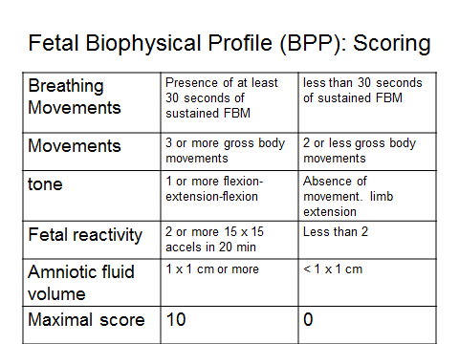

- Validation of the BPP.
  - Multiple large prospective studies among high risk populations have shown a strong inverse correlation between BPP score and perinatal death.
- In a study of 29 fetuses with a score of 0 (out of 10) nearly half (48%) had a perinatal death
- The incidence of IUFD was only 0.726 per 1,000, after a normal (8/ or 10 out of 10) BPP in a prospective study of 19,221 high risk pregnancies.

- Evidence-based algorithm (San Francisco General Hospital) for initial fetal surveillance strategy in high risk pregnancies:

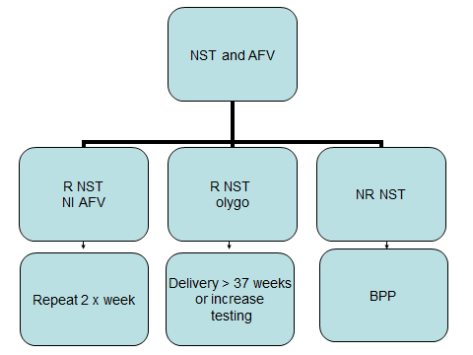

If BPP is abnormal (≤6/10), management is individualized based on gestational age, fetal + maternal status, and specific abnormal BPP parameters.

8. Second and third trimester fetal biometrics

Learning Objectives:
- Describe the accuracy of dating a pregnancy in the second and third trimester
- Apply practice standards when obtaining basic anthropometric parameters (BPD, HC, AC, FL)

OUTLINE

- This module will review the accuracy of gestational age determination and simple rules to obtain adequate fetal anthropometric parameters in the second and third trimester.
- Basic rules:
  - Blow up your image as big as you can get it in the screen
  - Obtain 2 different measurements for each parameter.
    - Use average of the 2 measurements.
    - If there is a significant discrepancy between the 2, one is incorrect. In this case, consider 3rd measurement and delete the erroneous one.
  - In cases where the fetal head is engaged, and a reliable BPD or HC measurement cannot be obtained, is preferable to estimate the fetal weight (and GA, if indicated) by using only the FL and AC.
- Parameters:
  - Biparietal diameter (BPD) can be measured from >12 weeks on and is the single best parameter for determining GA after 12 wks (which makes it the fastest too, and useful in acute cases).
- How to get “the perfect BPD”?
  - Midline Falx
  - Both thalami on each side of the falx
  - Cavum septum pellucidum
- Caliper placement
  - BPD: outer to inner
  - Head circumference (HC) is obtained in the same image as the BPD. Place the calipers outer to outer in two perpendicular planes bisecting the thalamus and the falx (use the ellipse function if available)
  - Abdominal circumference (AC)
- Landmarks:
  - Stomach should be in the left mid 1/3 of the abdomen
  - Left portal vein that is equidistant from lateral sides
  - Lungs , kidneys or heart should NOT be in the picture!
- AP + transverse diameters perpendicular to each other. Or use ellipse mode.
- Should be nice and round, with fat pad clearly visible. You may want to increase the contrast (Gain) so you can see the fat pad more clearly.
- Don’t place transducer over spine. If spine is up, scan from side.
  - Femur length:
- The femur should be lying close to a horizontal plane (US beam perpendicular to bone).
- Measure the femur that is up.
  - Estimated fetal weight (EFW):
- The AC is most important parameter in determining fetal weight but often the most difficult to obtain and most subject to error, particularly in late gestation or with olygohydramnios.
- In cases where the fetal head is engaged, and a reliable BPD or HC measurement cannot be obtained, is preferable to estimate the fetal weight (and GA, if indicated) by using only the FL and AC.

- Use of obstetrical ultrasound on the labor and delivery ward

Learning Objectives:
- Describe how and when to determine the fetal lie using ultrasound
- Describe the use of ultrasound before and during ECV for abnormal presentations
- Describe the use of ultrasound during manual rotation of posterior presentations
- Describe technique for ultrasound guided extraction of retained placenta
- Describe the technique for ultrasound guided IUD insertion

OUTLINE:

  - Determination of the fetal lie using ultrasound
  - All patients should have ultrasound verification of the fetal presentation upon admission, unless there is certainty of cephalic presentation by physical exam by an experienced provider.
  - In term patients, perform transverse scan at the level of the lower uterine segment holding the transducer in a perpendicular plane to the floor. Longitudinal mid sagittal views can also be helpful, especially if the presenting part is not engaged in the pelvis.

  - Use ultrasound before and during ECV for abnormal presentations
- Before ECV: it is essential to document and consider the following before proceeding with ECV:
- Confirm fetal lie, presentation
- Determine fetal head location, bladder, and fetal spine position. Consider which way to rotate the fetus manually based on fetal position.
- Document amniotic fluid volume since olygohydramnios is a relative contraindication and success rates are lower with fluid
- Determine placenta location. ECV success rates are higher when the placenta is posteriorly located.
- Recent determination of EFW (within the last 2 weeks or less)
- During ECV: with the use of ultrasound, an operator uses direct ultrasound guidance to orient the ECV operator and intermittently check the fetal heart rate during the procedure.
- Post-procedure:
- Confirm presentation is still cephalic (if successful)
- Type of breech presentation. Frank breech and complete breech presentation is compatible with a term vaginal breech delivery. In a viable fetus, footling breech is vaginal delivery is not recommended.
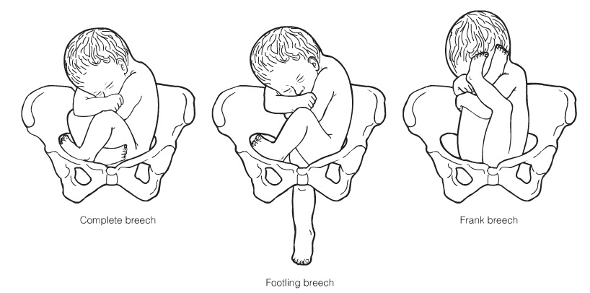

frank breech
footling breech
complete breech

  - Use of ultrasound during manual rotation of posterior presentations
- In patients with an abnormal labor curve or prolonged 2nd stage, posterior occiput position of the fetal head should be considered. Prior to manual rotation attempt, ultrasound confirmation of the fetal position and the fetal spine is recommended.

  - Technique for ultrasound guided IUD insertion:
- Using transabdominal scanning, identify the uterus scanning in a midline, sagittal plane. Both the uterine fundus and the lower uterine segment must be clearly seen before IUD insertion.
- Under direct ultrasound guidance, the IUD is inserted into the uterus and deployed near the fundus

  - Technique for ultrasound guided placental removal:
- Using transabdominal scanning, identify the uterus scanning in a midline, sagittal plane. Both the uterine fundus and the lower uterine segment must be clearly seen before instrumental removal of the placenta.
- Under direct ultrasound guidance, the Bierer forceps is gently introduced and the placenta is removed.

- Interprofessional obstetric ultrasound training and practice

Learning Objectives:

- Identify the basic competencies for limited obstetric ultrasound by interprofessional maternity care providers.
- Describe the research literature and professional guidelines and standards in obstetric ultrasound education and practice.
- Develop a personal plan to demonstrate initial and ongoing obstetric ultrasound competencies in accordance with the research literature and professional guidelines and standards.

OUTLINE

  - Review: What is basic or limited ultrasound?
  - Various types of OB ultrasound exam providers
  - Professional accountability and certification
  - Interprofessional guidelines and standards for obstetric ultrasound education and practice
  - Consultation, collaboration and referral
  - Interprofessional communication
  - Facilitators
- Interprofessional education
- Discuss obstetric ultrasound indications and findings using standard terminology and AIUM guidelines for documentation
- Written policies and procedures
  - Hindrances

