Health Disparities Research: Conceptual and Methodological Considerations
Homework 2
4/9/15

Questions Related to Week 2 Readings:

- Apply an ecological framework for a health outcome of interest to you by labeling specific influences for each level in the diagram below. Please identify your health outcome.

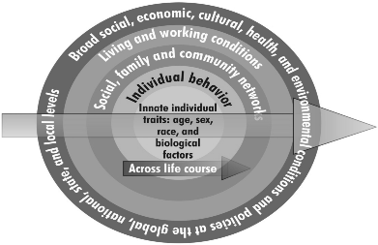

- Write a paragraph describing the extent to which an ecological framework has been applied to your area of research. Are there opportunities for improving our understanding of or approach to disparities in your area with a greater emphasis on an ecological framework? If so, how? If not, why not?

- Draw a conceptual model for disparities in health outcome of interest to you, as it relates to your research. Include multi-level ecological influences as appropriate.

- Describe in 1-3 sentences where your area of research or area of interest connects to the model.

- Is there a risk of committing a biologic fallacy in your areas of research? An individualistic fallacy? Why or why not?

Questions Related to Week 3 Readings:

- The Solid Facts document identifies 9 social factors. Pick 3 of these factors and describe how they could be important determinants of a health outcome of your choosing. The association could be reported in published research or it could be your hypothesized relationship.

- In the BMJ article, one of the key messages is that absolute differences in mortality between less and more advantaged groups increase at older ages. What do you think the mechanisms might be that would account for this observed difference? Consider the effect of employment in your answer.

