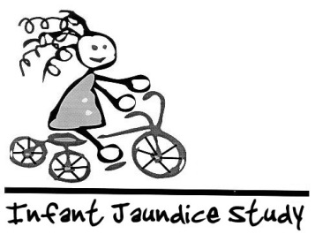
Infant Hyperbilirubinemia Study

Examination Data Form

DO NOT WRITE IN BOX
Child's Name Gilbert SubjectID 130349
PEDSID 813
Child's DOB 01/21/2013 Examiner ID 3
Child's Sex M
Latino/Hispanic? Yes No
Child’s Race Asian Black White Amer. Indian Other
Date of Exam 02/24/2018 Examiner's Name Elders
Weight in kg 36.4
SCORE 90
Height in cm 119

PEDS Rating: C-1
PEDSRating | PEDSRatingTxt
A-1 | High Risk - Need for speech and language evaluation
A-2 | High Risk - Need for testing by a developmental psychologist
B-1 | Moderate Risk - Non-dvelopmental concerns
B-2 | Moderate Risk -Behavioral issues and at least 1 developmental concern and
C-1 | Elevated Behavioral/Mental Health Risk - >= 4.5 years
C-2 | Elevated Behavioral/Mental Health Risk - < 4.5 years
E | Low Risk for Developmental or Behavioral Problems
Infant Hyperbilirubinemia Study
Examination Data Form

DO NOT WRITE IN BOX
Child's Name Honoria SubjectID 130294
PEDSID 203
Child's DOB 03/15/2013 Examiner ID 1
Child's Sex F
Latino/Hispanic? Yes No
Child’s Race Asian Black White Amer. Indian Other
Date of Exam 03/11/2016 Examiner's Name Koop
Weight in kg 16.0
SCORE ____
Height in cm 98

PEDS Rating: E
PEDSRating | PEDSRatingTxt
A-1 | High Risk - Need for speech and language evaluation
A-2 | High Risk - Need for testing by a developmental psychologist
B-1 | Moderate Risk - Non-dvelopmental concerns
B-2 | Moderate Risk -Behavioral issues and at least 1 developmental concern and
C-1 | Elevated Behavioral/Mental Health Risk - >= 4.5 years
C-2 | Elevated Behavioral/Mental Health Risk - < 4.5 years
E | Low Risk for Developmental or Behavioral Problems

Infant Hyperbilirubinemia Study
Examination Data Form

DO NOT WRITE IN BOX
Child's Name Honoria SubjectID 130294
PEDSID 583
Child's DOB 03/15/2013 Examiner ID 2
Child's Sex F
Latino/Hispanic? Yes No
Child’s Race Asian Black White Amer. Indian Other

Date of Exam 04/04/2017 Examiner's Name Antonia Coello Novello
Weight in kg 18.0
SCORE _______
Height in cm 104

PEDS Rating: E

PEDSRating | PEDSRatingTxt
A-1 | High Risk - Need for speech and language evaluation
A-2 | High Risk - Need for testing by a developmental psychologist
B-1 | Moderate Risk - Non-dvelopmental concerns
B-2 | Moderate Risk -Behavioral issues and at least 1 developmental concern and
C-1 | Elevated Behavioral/Mental Health Risk - >= 4.5 years
C-2 | Elevated Behavioral/Mental Health Risk - < 4.5 years
E | Low Risk for Developmental or Behavioral Problems
Infant Hyperbilirubinemia Study
Examination Data Form
DO NOT WRITE IN BOX
Child's Name Honoria SubjectID 130294
PEDSID 814
Child's DOB 03/15/2013 Examiner ID 7
Child's Sex F
Latino/Hispanic? Yes No
Child’s Race Asian Black White Amer. Indian Other

Date of Exam 03/18/2018 Examiner's Name Lushniak
Weight in kg 21.4
SCORE 125
Height in cm 112

PEDS Rating: E

PEDSRating | PEDSRatingTxt
A-1 | High Risk - Need for speech and language evaluation
A-2 | High Risk - Need for testing by a developmental psychologist
B-1 | Moderate Risk - Non-dvelopmental concerns
B-2 | Moderate Risk -Behavioral issues and at least 1 developmental concern and
C-1 | Elevated Behavioral/Mental Health Risk - >= 4.5 years
C-2 | Elevated Behavioral/Mental Health Risk - < 4.5 years
E | Low Risk for Developmental or Behavioral Problems

Infant Hyperbilirubinemia Study
Examination Data Form

DO NOT WRITE IN BOX
Child's Name Lucy SubjectID 45929
PEDSID 110
Child's DOB 08/31/2011 Examiner ID 2
Child's Sex F
Latino/Hispanic? Yes No
Child’s Race Asian Black White Amer. Indian Other
Date of Exam 10/07/2015 Examiner's Name Antonia Coello Novello
Weight in kg 15
SCORE 84
Height in cm 99

PEDS Rating: E

PEDSRating | PEDSRatingTxt
A-1 | High Risk - Need for speech and language evaluation
A-2 | High Risk - Need for testing by a developmental psychologist
B-1 | Moderate Risk - Non-dvelopmental concerns
B-2 | Moderate Risk -Behavioral issues and at least 1 developmental concern and
C-1 | Elevated Behavioral/Mental Health Risk - >= 4.5 years
C-2 | Elevated Behavioral/Mental Health Risk - < 4.5 years
E | Low Risk for Developmental or Behavioral Problems

Infant Hyperbilirubinemia Study
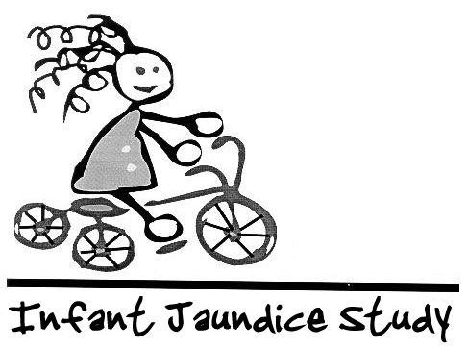
Examination Data Form

DO NOT WRITE IN BOX
Child's Name Lucy SubjectID 45929
PEDSID 412
Child's DOB 08/31/2011 Examiner ID 3
Child's Sex F
Latino/Hispanic? Yes No
Child’s Race Asian Black White Amer. Indian Other
Date of Exam 10/11/2016 Examiner's Name Elders
Weight in kg 17.3
SCORE 103
Height in cm 107

PEDS Rating: E

PEDSRating | PEDSRatingTxt
A-1 | High Risk - Need for speech and language evaluation
A-2 | High Risk - Need for testing by a developmental psychologist
B-1 | Moderate Risk - Non-dvelopmental concerns
B-2 | Moderate Risk -Behavioral issues and at least 1 developmental concern and
C-1 | Elevated Behavioral/Mental Health Risk - >= 4.5 years
C-2 | Elevated Behavioral/Mental Health Risk - < 4.5 years
E | Low Risk for Developmental or Behavioral Problems

