Epi 204 Chapter 4, Problem Set 4
Multi-level Tests
Due 1 pm 10/8/2015

Do problems 1, 3 and 4 from EBD Chapter 4.

Do additional problems 17 and 20 below
(You can use the grid below for your ROC curve for Problem 4.1. You can draw the ROC curve n it and then snap a photo from your cell phone and paste into your HW, if that is convenient.)

17. Grim Reaper’s Walking Speed
To estimate the walking speed of the Grim Reaper, Stanaway et al(14) studied walking speed as a predictor of mortality in 1705 Australian men at least 70 years old. Of the 1705, 266 died during follow up, so 1705 – 266 = 1439 survived. They treated walking speed (in meters/sec) as a continuous diagnostic test and created the ROC Curve for mortality below: Slower walking speed was a predictor of higher mortality in this study.

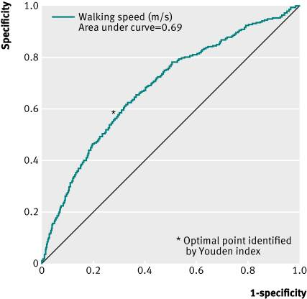

a) What are the two errors in the labeling of this figure? [1]


b) What part of the ROC curve refers to the slowest walking speeds? [1]

The authors found that although there were 266 deaths during follow-up, no one in the cohort who walked faster than 1.36 m/sec (about 3 miles per hour) died. They proposed the following explanation: "This supports our hypothesis that faster speeds are protective against mortality because fast walkers can maintain a safe distance from the Grim Reaper."

c) (Extra credit) By looking very closely at the ROC curve, estimate how many of the 1439 surviving men walked faster than 1.36 m/sec. [+2]

20. Predicting fibrosis in nonalcoholic fatty liver disease
(With thanks to Sachin Garg and Veeral Ajmera, veterans of Epi 204 in 2014.)
Nonalcoholic fatty liver disease (NAFLD) is an emerging epidemic. Likely because of the chronic liver inflammation associated with NAFLD, some patients develop progressive scarring in the liver (termed fibrosis) over time. The diagnosis and staging of the disease are done by liver biopsy, which involves placing a needle into the liver to obtain a piece of tissue for analysis under a microscope. Liver biopsy is invasive and can cause discomfort, bleeding or (rarely) death.
To find a non-invasive measure to predict the degree of fibrosis, Angulo et al⁷ constructed and validated a scoring system consisting of readily available clinical and laboratory data. The data were obtained on the date of a diagnostic liver biopsy in 480 consecutively sampled subjects undergoing liver biopsy at four centers.
Results from their study are shown in their Table 3:

Table 3. Predictive Value of the Scoring System Obtained from the Estimation Group (n = 480)
 | Low cutoff point  (< −1.455) | Indeterminate (−1.455–0.676) | High cutoff point  (> 0.676) | Total N
Total | 295 | 114 | 71 | 480
No significant fibrosis (stage 0–2) | 273 | 75 | 7 | 355
Significant fibrosis (stage 3–4) | 22 | 39 | 64 | 125
Sensitivity | 82% |  | 51%
Specificity | 77% |  | 98%
Positive predictive value | 56% |  | 90%
Negative predictive value | 93% |  | 85%
Likelihood ratio (+) | 3.567 |  | 25.966
Likelihood ratio (−) | 0.229 |  | 0.498
Interpretation | Absence of significant fibrosis (93% certainty) |  | Presence of significant fibrosis (90% certainty)
Note that +0.676 > -1.455 and -2.000 < -1.455 (i.e. don’t get confused because you are comparing negative and positive numbers).
- “…, 2 cutoff points were selected to identify the presence (greater than 0.676) and absence (less than −1.455) of significant fibrosis." (Excerpted from the article.)
Create a “likelihood ratio table” (LR table) with top row corresponding to “> 0.676”, middle row corresponding to “-1.455-0.676”, and bottom row corresponding to “< -1.455”. For each of these ranges (in each of the 3 rows), include the number of (D+) subjects with significant fibrosis and the proportion of the total number of D+ subjects. Also include the number of (D-) subjects without significant fibrosis and the proportion of the total number of D- subjects. Finally, calculate the likelihood ratios. Note that this test has 3 results and will have 3 LRs.

b. What was the overall pre-test probability of significant fibrosis in the study population?
c. The prevalence of significant fibrosis actually varied across the 4 centers that provided patients for this study, from 12.5% in Italy to 31% in Sydney. You are seeing a patient in Italy with a score of −0.4 on the scoring system described above. What is your best estimate of his post-test probability of significant fibrosis?

d. Create an “ROC table” showing the cumulative percentages from the LR Table from Part (b). There are 2 potential cutpoints. You could consider only > 0.676 “positive” for fibrosis, or you could consider ≥ -1.455 as “positive”.
e. Draw and label the axes and line segments (or inflection points) of an ROC curve that summarizes the discrimination of this scoring system using these 2 cut-points. (You can draw it and paste a photo here if you want.)

f) EXTRA CREDIT
Redraw the ROC curve in (e) but also include 2 additional separate ROC curves showing line segments corresponding to the LRs reported in Table 3 from the paper (reprinted above).

