Lab 1

Introduction to Google Earth Engine

Google Earth Engine is a planetary-scale platform for environmental data analysis. It brings together over 40 years of historical and current global satellite imagery, and provides the tools and computational power necessary to analyze and mine that vast data warehouse. Current applications include: detecting deforestation, classifying land cover and land cover change, estimating forest biomass and carbon, mapping the world’s roadless areas, and disease risk mapping.
This tutorial will introduce you to Google Earth Engine and its basic functionality, including exploring the Data Catalog and viewing datasets in the Workspace.

Home page
The Home page is where you will start when you first access Google Earth Engine. There you will see introductory text, a gallery of featured maps, and links to other important Earth Engine pages.
Let’s explore the Home page and find out a bit of what Earth Engine can do.
- Open your browser and go to http://earthengine.google.org. You will see the page below.

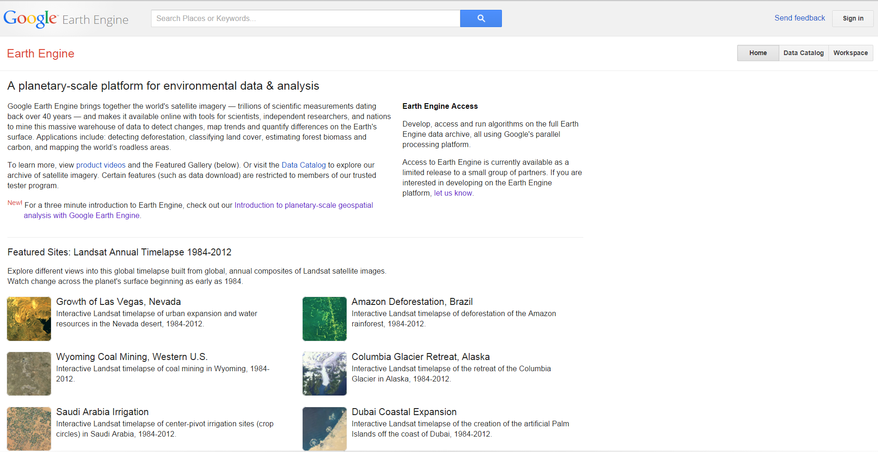

At the top of the page is a search bar, where you can search for places or datasets. For example, entering “Landsat” brings up datasets with Landsat in their name, description, or tags, while entering “Brazil” brings up locations with Brazil in their name. In the top right, there is a Sign in button, where Earth Engine partners can sign in.
Below the Sign in button are three buttons: Home (the page you’re on), Data Catalog, and Workspace. We’ll explore the latter two in the sections below.
The introductory text on the Home page gives an overview of Earth Engine as “a planetary-scale platform for environmental data and analysis.” It also provides links to product videos, news items, and other resources.
Below the introductory text is the Featured gallery, where you can quickly find examples of some of the best and latest analysis products produced by Google Earth Engine and the organizations using it. These include links to view massive datasets using the Google Earth plugin(available for Windows and Mac).
- Click on Global Roadless Areas: 1 km buffer to see the map shown below.

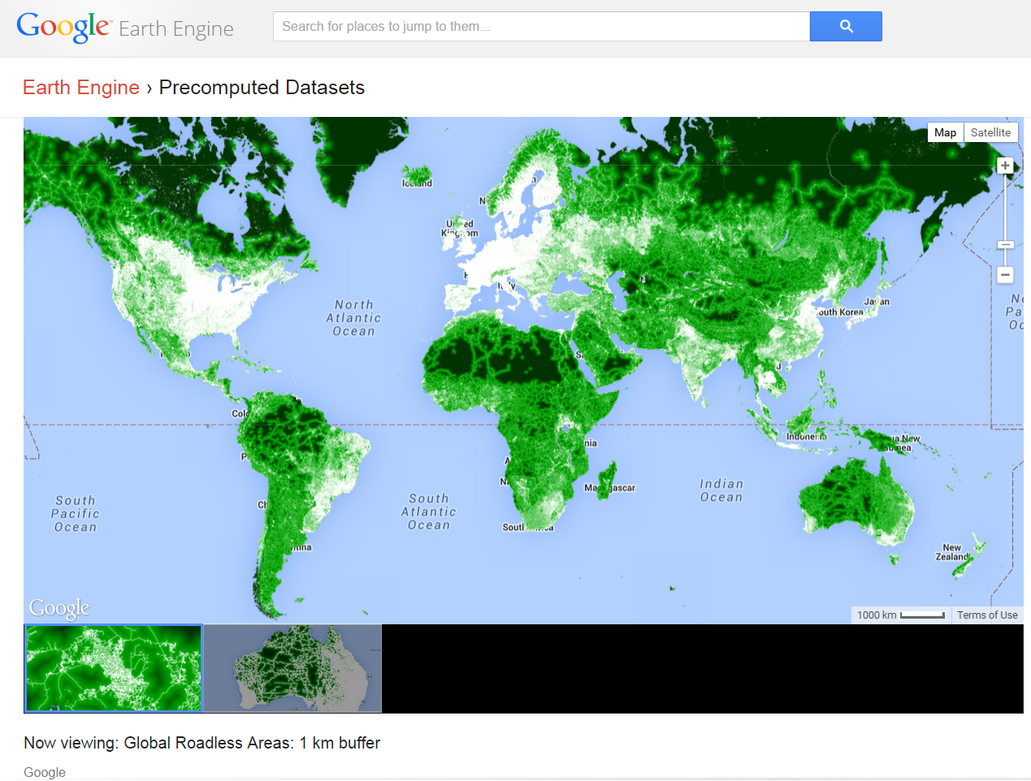

- Explore the map by panning and zooming Google Earth. You can use the controls in the upper right, or use your mouse to pan, and your mouse’s scroll wheel to zoom.
Other links in the Featured gallery will display timelapses of environmental change on massive scales. For most of the timelapses, clicking the link will show you an introductory video, like the one for the Drying of the Aral Sea shown below.

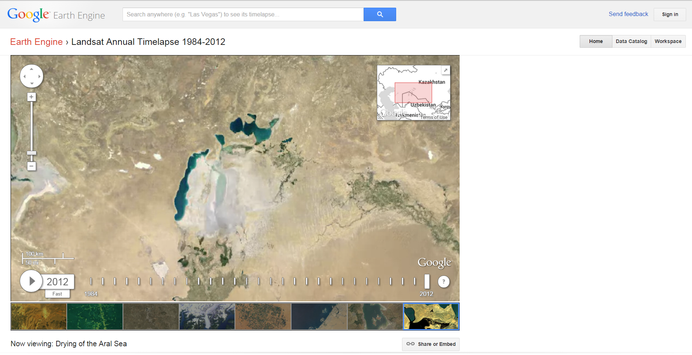

On the timelapse maps, you can zoom in, pan the map, pause the timelapse, and select the playback speed, as indicated above.

Data Catalog
The Data Catalog lists the datasets available for viewing and analysis in Google Earth Engine.
- Click on the Data Catalog button in the upper right of any Google Earth Engine page.
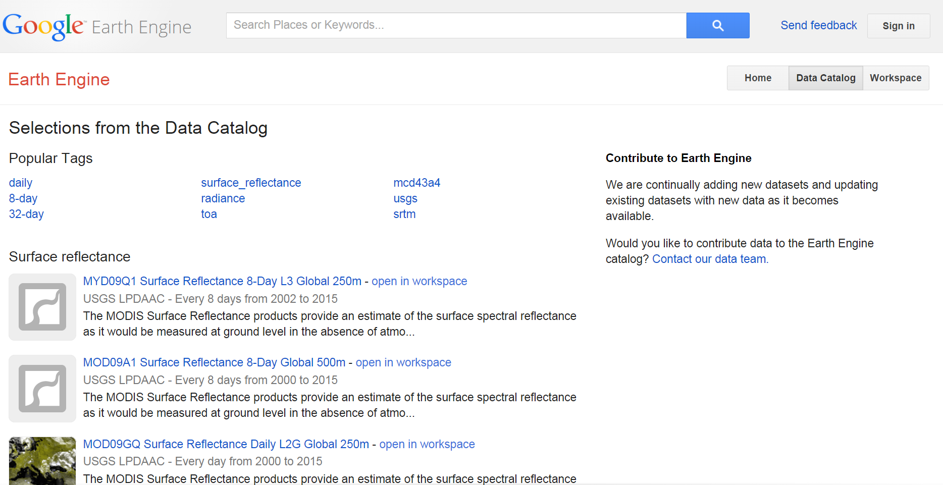

On the Data Catalog page you will see a list of Popular Tags, linking to datasets that have those tags applied. Below that is a list of various data types and multi-day mosaics, including brief descriptions of, and direct links to, a handful of the available datasets. These lists show or link to most of the datasets and mosaics available in Google Earth Engine. To access ALL available datasets, use the search bar at the top of the page.
- Click on a few of the popular tags to see what kinds of datasets they contain.
  - For example, toa brings up a list of datasets depicting “computed top-of-atmosphere reflectance.”
  - Clicking on usgs brings up a list of datasets from the USGS, including datasets from Landsat, MODIS, and products derived from those.
- On the Data Catalog page, click on the 32-day tag to bring up all the 32 day mosaics.
- Select the Landsat 5 32-Day NDVI Composite to open its detail page, shown below.
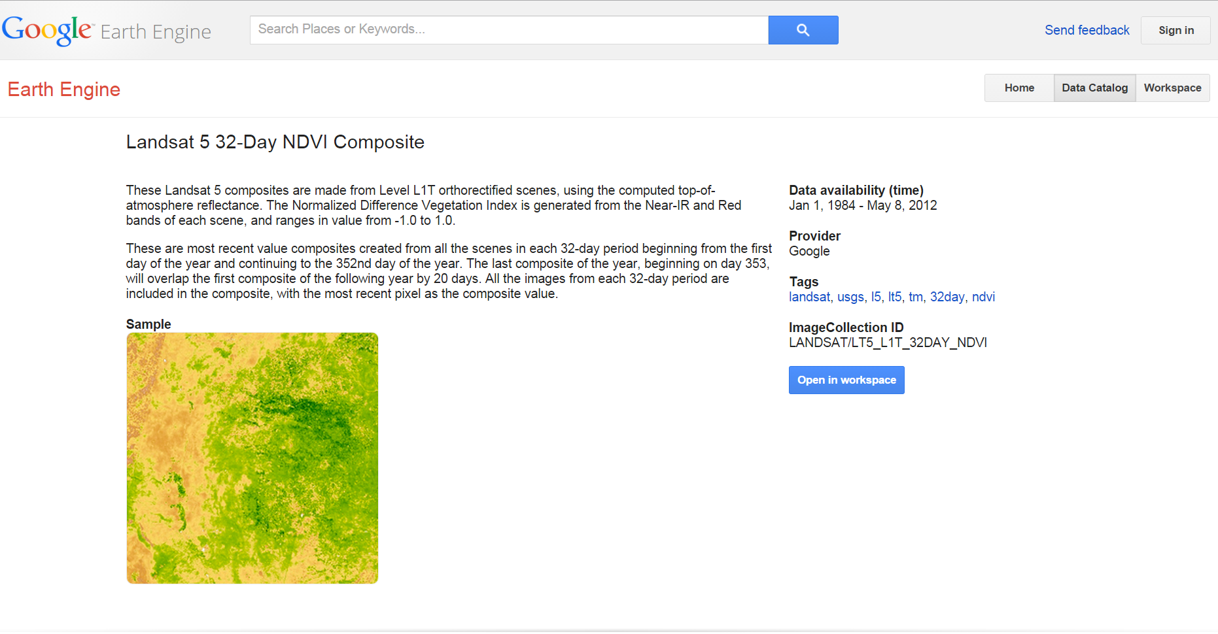
This page shows details about the selected dataset, including its name, a brief description, a sample image, and information such as which dates are available (Landsat 5 stopped sending data at the end of 2011; use Landsat 7 or MODIS data for more recent imagery), the provider’s name, and any tags for that dataset. There is also a blue Open in workspace button which can be used to add the dataset to your current workspace (more on that below).
- Return to the Data Catalog page by clicking your browser Back button twice, or by clicking the Data Catalog button in the upper right.

Workspace
The Workspace is where you manage, analyze, and visualize datasets in Google Earth Engine.
- Click on the Workspace button in the upper right of any Google Earth Engine page.
On the Workspace page, you will see a map on the right, and space for a list of data layers on the left. Unless you have already added a dataset to your workspace, your Data list will be empty, and the map will show the Google Maps terrain layer, as shown above.
As a reminder for navigating the Google Maps interface, here are some basics. You can move (pan) around the map by clicking and dragging anywhere on the map. To zoom in and out there are several techniques. You can always use the [+] and [-] zoom buttons and the zoom slider on the map to zoom in and out. You can also double-click anywhere on the map to zoom in. If your pointing device (mouse or track pad) has a right button, you can double-right-click on the map to zoom out. If you have a touch-screen device, you may be able to zoom with a pinch gesture, and if you have a mouse with a scroll wheel, the easiest way to zoom is to simply turn the wheel. To change the map background use the buttons in the upper right of the map to select either Map view or Satellite view. When selecting Map view, a checkbox will appear below the Map button to turn on/off Terrain instead of the usual road-map view. When selecting Satellite, a checkbox will appear below the Satellite button allowing you to turn on/off the Labels (borders, countries, cities, water bodies, etc.).

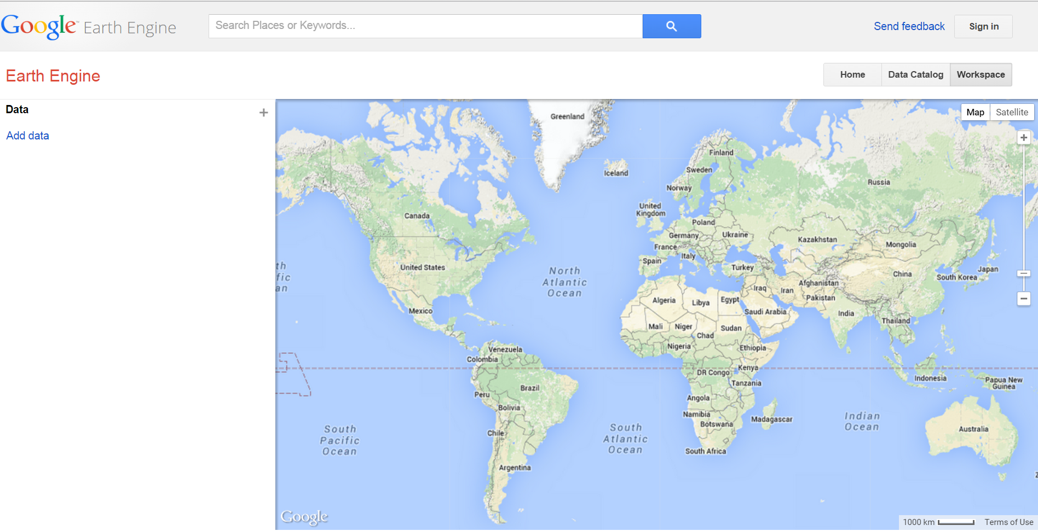

Adding a dataset to the Workspace
- Click the Data Catalog button to return to the Data Catalog page.
- Click to select MCD43A4 BRDF-Adjusted Reflectance 16-Day L3 Global 500m (currently at the top of the list under “Surface reflectance”). This is a MODIS derived layer that shows the color of the land surface over each 16 day period.
- On the dataset details page, click the blue “Open in Workspace” button. This will bring you to the Workspace, with the dataset visible as a layer.
- Alternatively, you can skip the details page and open the layer in your workspace directly from the Data Catalog by clicking the “open in workspace” link next to the dataset name.
You will see that the dataset is listed (MCD43A4...) in the Data layer list in the left-hand panel, and that the data is visible on the map.
- Pan and zoom the map to get a view of North America, something like what’s shown below, where you can see the brown desert and mountain regions, and the greener coasts and Midwest.
- Toggle off the visibility of the data layer by clicking the visibility button (eye icon) to the left of the data layer name (see below). You will see the Google Maps Terrain view revealed.
- Click the visibility button (eye icon) again to make the data layer visible on the map again.

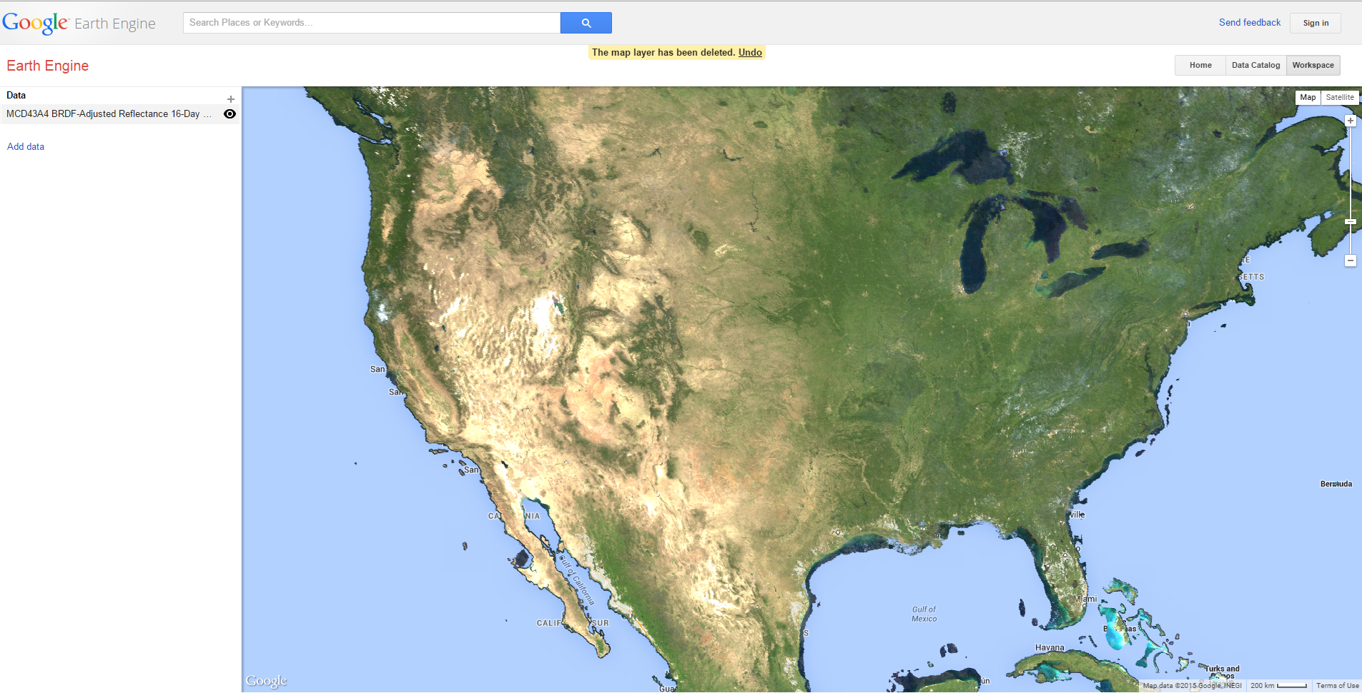
- Zoom as far as possible on a location of your choice to see the maximum resolution of the dataset. The MODIS data we’re using in this example has only moderate resolution (each pixel is 500 meters on a side). The Great Salt Lake and San Francisco Bay are good examples which are easy to find, and show a variety of colors.
- When you are ready, zoom back out to a view of the United States.
Note that some datasets can only be shown at certain zoom levels, and not at others. For example, if you are zoomed all the way out to a global view and try to see a Landsat 7 dataset, it will not be visible on the map. Don’t worry, it’s not broken! A yellow bar appears at the top of the map saying that you need to zoom in to view the data.

Adjusting the layer settings
Now we’ll adjust some settings to explore the data in more detail.
- Click on the Data layer name in the left-hand panel to bring up the Layer Settings, as shown below.
The Layer Settings allow you to customize a variety of parameters, including the date(s) for which data is shown.
- Look at the time slider and find the date range listed just below it. Note that the dates shown are the most recent 16 day period available. At the time of this writing, it listed “Aug 5 , 2015 – Aug 13, 2015.” This means that the data on the map is a visualization of these 16 days worth of BRDF-adjusted surface reflectance data (in this case, just 3 of the many bands).
- Change the time setting by dragging the time slider towards the left, and watch the data on the map change.
- The time slider indicates which time period you have selected, and the orange highlight on the slider bar indicates which date range is currently visible on the map (it sometimes takes a moment to catch up with the slider).
- To go farther back in time, or to select a specific date range, click on the Jump to date link below the time slider and use the calendar interface to select a date.
- When you have selected the date range you wish to show, click the Save button to save the Layer Settings. If you wish to return to your previous settings, click the Cancel button instead.
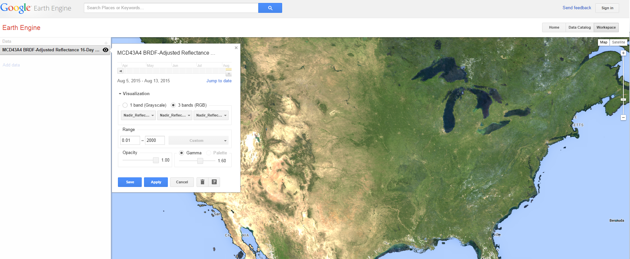

Adding more layers
You can view multiple data layers on your map at once by adding additional datasets.
There are several ways to add additional data layers in your Workspace. The first method is to return to the Data catalog, select another dataset, and use its Open in Workspace button. This will add the dataset to your workspace, as a layer above your current data layer(s). Note that the new layer will show on top of the previous layers on your map. See below for changing the order of the layers.
Another way to add additional datasets is directly from the search bar your Workspace. To start searching for a dataset to add, do one of the options below:
- Click in the Search bar
- Click the “+” button at the top right of your data layer list, or
- Click the Add data link at the bottom of your data layer list.
All three of these options will allow you to type your query in the Search bar, and select a dataset to add as a layer.
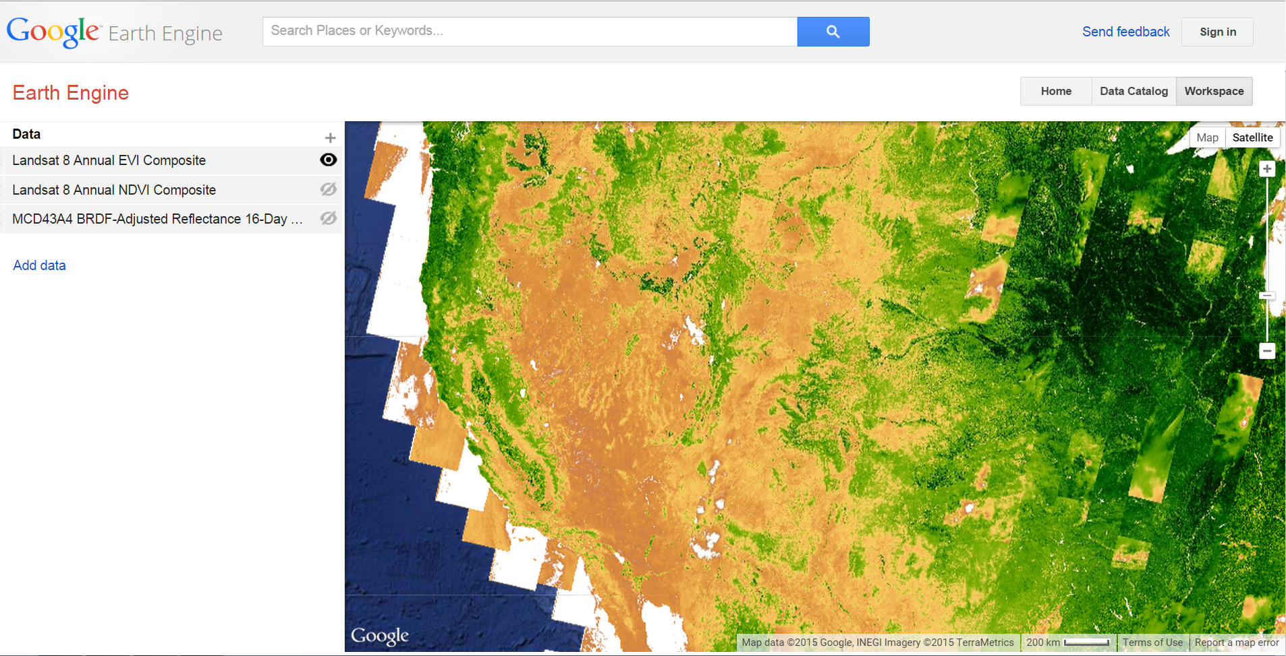

Below is an example of datasets as results for the search “modis”.

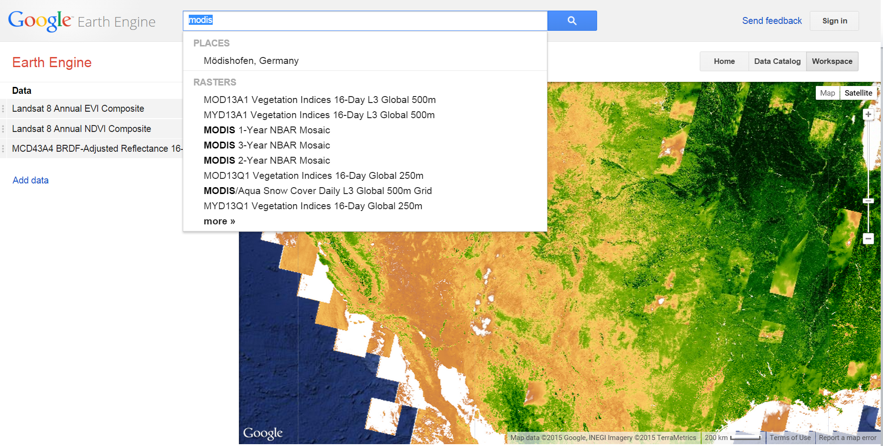

Duplicate Datasets
You can also add the same dataset twice, as two separate layers in your Workspace. One reason to do this would be to view two different time slices of the same dataset, to view change over time.
Re-ordering layers
When you have more than one dataset visible on your map, the one listed at the top of the Data layers list will be drawn on top of those below it. To change the ordering, use your mouse to click on the drag point to the left of the dataset name in the list, and drag it up or down in the list.

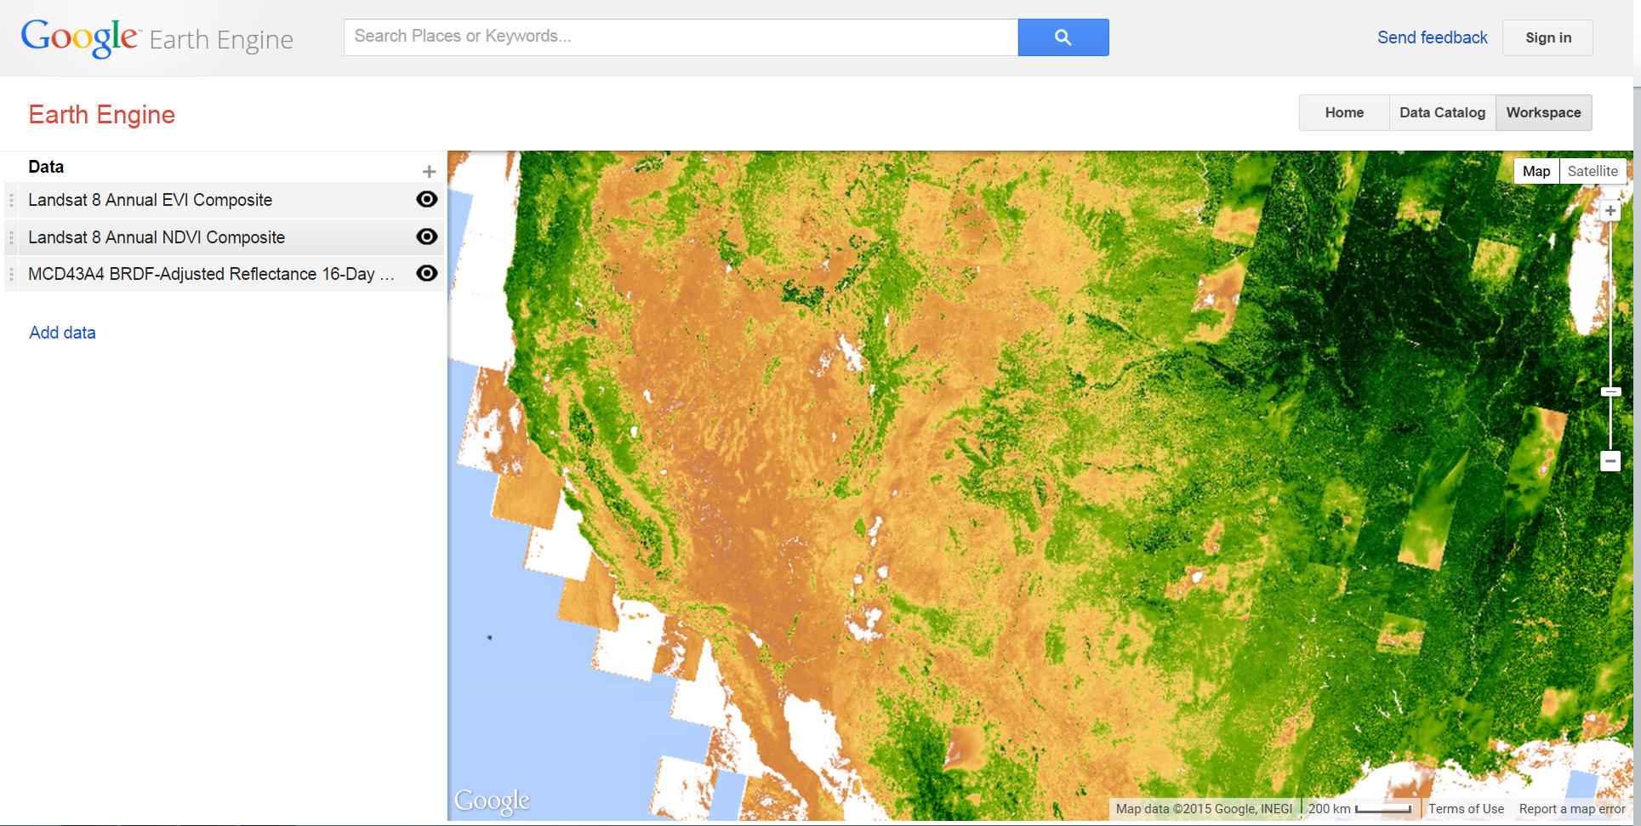

Removing a layer from the Workspace
To remove a data layer from your Workspace:
- Click on the data layer name in the Data list to bring up the Layer Settings dialog.
- Click the Delete button and the layer will be removed from your Data list and from the map.
- Note: If you want to turn off the layer to remove it from the map, but leave it in the Data list, click the visibility button (eye icon) next to the Data layer name.

