Lab 2

Google Earth Engine for Trusted Testers

This tutorial provides introduction to Google Earth Engine and introduces the basic functionalities available on Google Earth Engine. In addition to the publicly available functionality, it also gives an overview of some of the functionalities available to trusted testers of Google Earth Engine. Please request Trusted Tester account by filling in the following form: https://docs.google.com/forms/d/17-LSoJQcBUGIwfplrBFLv0ULYhOahHJs2MwRF2XkrcM/viewform.

Once you have access to the Google Earth Engine with their Trusted Tester account, so the first thing to do is sign in.

- Go to: http://earthengine.google.org
- Click on the Sign in link in the upper right corner of the page.
- Sign in with the Google account which you have registered with the Google Earth Engine Trusted Tester
Program.

Workspace Tools

Once you are signed in to Google Earth Engine, click on the Workspace button in the upper right. In your workspace you will see a number of new controls and features which were not present before you signed in:

Add Computation
The Add computation link is now visible in the left-hand panel, next to the Add data link. Click on this link to see numerous computation options which can be applied to your datasets. More information on how to use these tools will be the subject of another tutorial, which will be linked here once it is ready and published.

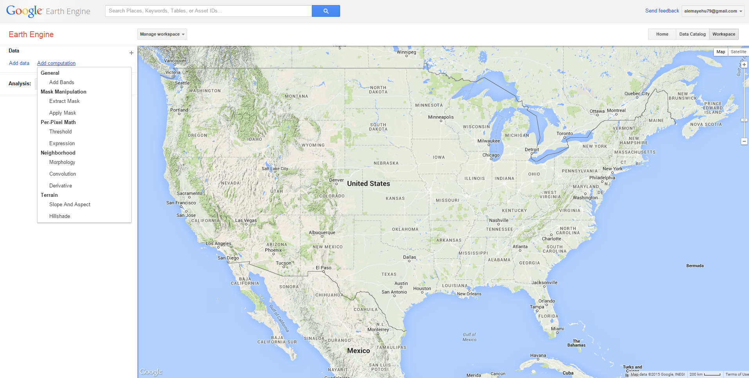

Analysis
The Analysis: dropdown is now visible at the bottom of the left-hand panel. It contains options for running your own analysis on the data in Google Earth Engine. Options currently include: Train a classifier, Cross-validate, and Compare.

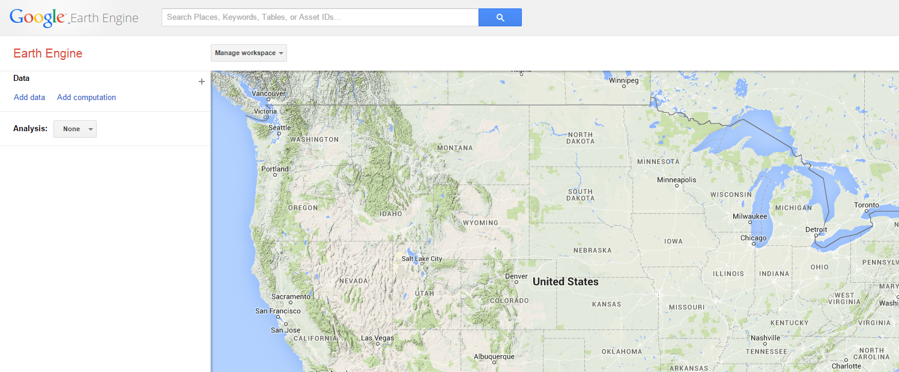

Manage Workspace
The Manage workspace dropdown is now visible above the map. It gives you access to a number of tools discussed below.

Managing your workspace
When signed-in, you will see a Manage workspace dropdown above the map in your Workspace. This provides options for saving and sharing the settings of your workspace.

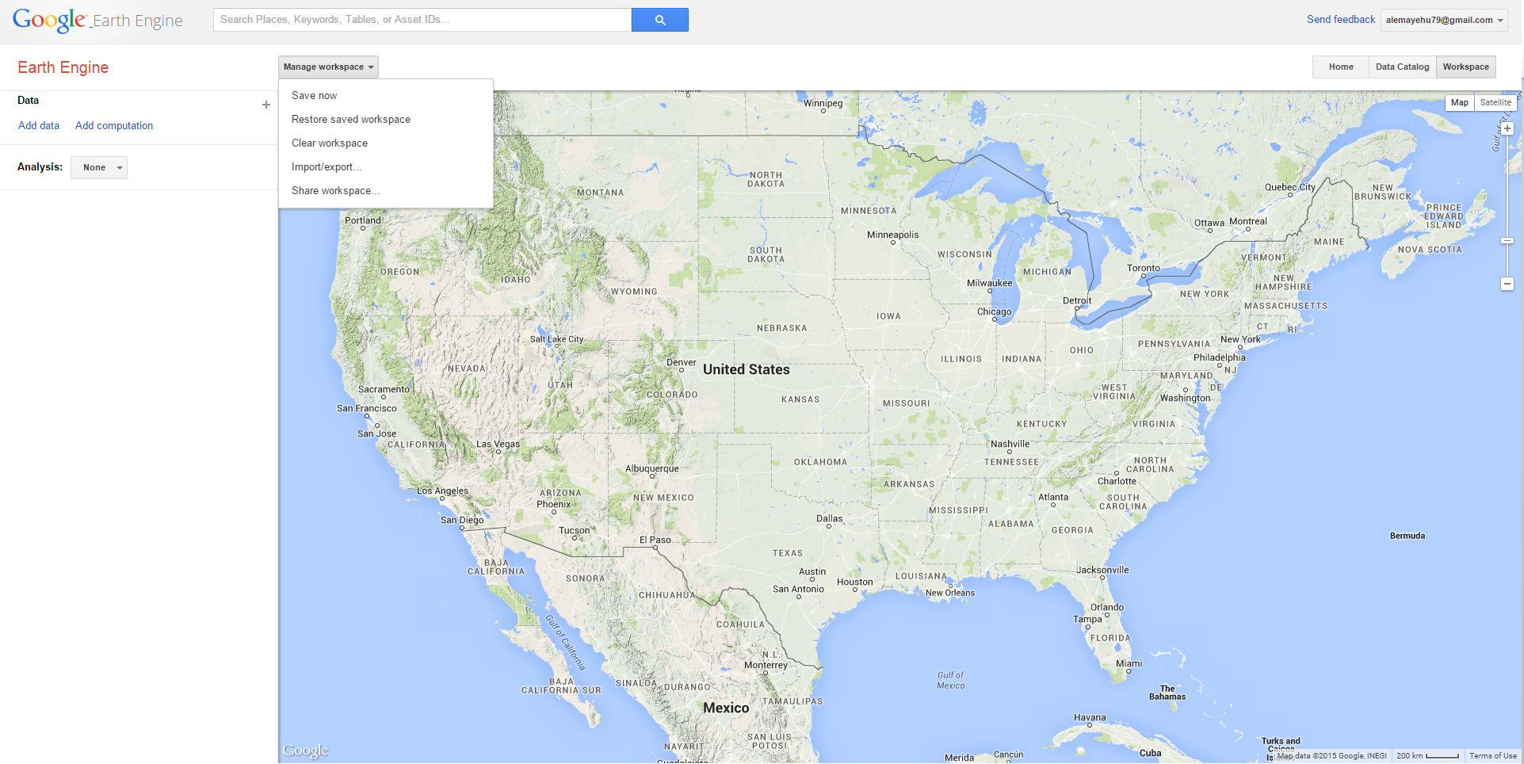

Save now
To save your current workspace settings, such as your view port, the data layers you have loaded, and the settings you have given them, click Manage workspace > Save now. This will save the current settings to your account.

Note that you can only save one set of workspace settings at a time, so saving will overwrite any previously saved workspace. If you want to save multiple workspaces, see the “Import/export” and “Share workspace” sections below.

Restore saved workspace
To restore the workspace settings which you saved, click Manage workspace > Restore saved workspace. This will overwrite your current workspace settings (viewport, layers, settings, etc.) and replace them with the workspace settings you had when you last saved.

Clear workspace
To clear your workspace, and reset it to the default, with no data layers loaded, click Manage workspace > Clear workspace.

Import/export...
To save your workspace settings more permanently, or to share them with others, you can export the settings as a JSON file. Click Manage workspace > Import/export.

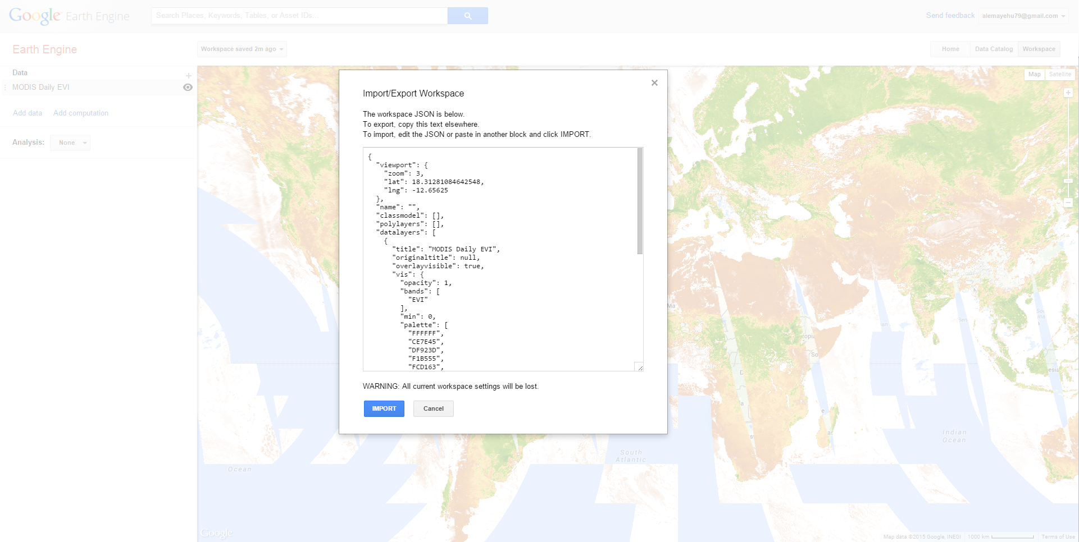

The Import/Export Workspace dialog is shown above. The text box in the dialog contains the workspace JSON code which describes your current workspace settings.

To Export your current workspace settings, select all (Ctrl-A on PC, Cmd-A on Mac) the workspace JSON text in the box, copy (Ctrl-C on PC, Cmd-A on Mac) it, and then paste (Ctrl-V on PC, Cmd-A on Mac) it into a text file on your computer, which you can save, email, or otherwise manage as you wish. When you have finished exporting, you can click Cancel to return to your current workspace.

To Import a workspace you previously saved as a JSON file, start by selecting all the text in the Import/Export box (Ctrl-A on PC or Cmd-A on Mac), and deleting it (press Delete or Backspace). Then copy/paste the previously saved workspace JSON text into the box and click the IMPORT button. Note that any data layers or other settings currently in your workspace will be lost, and replaced with the settings in the workspace JSON which you import.

To try importing a sample workspace JSON, copy the JSON file in the box below, and import it to your workspace using the instructions above. This is a simple example which shows just one layer: the SRTM Digital Elevation Model, with basic visualization parameters set.

{
"viewport": {
"zoom": 5,
"lat": 2.7455307188019904,
"lng": 37.8369140625
},
"name": "",
"classmodel": [],
"polylayers": [],
"datalayers": [
{
"title": "MODIS Daily EVI",
"originaltitle": null,
"overlayvisible": true,
"vis": {
"opacity": 1,
"bands": [
"EVI"
],
"min": 0,
"palette": [
"FFFFFF",
"CE7E45",
"DF923D",
"F1B555",
"FCD163",
"99B718",
"74A901",
"66A000",
"529400",
"3E8601",
"207401",
"056201",
"004C00",
"023B01",
"012E01",
"011D01",
"011301"
]
},
"layermode": "advisory-mode",
"datatype": "temporalcollection",
"periodstart": 1439942400000,
"periodend": 1440028800000,
"id": "MODIS/MYD09GA_EVI",
"assetid": "MODIS/MYD09GA_EVI/MYD09GA_005_2015_08_19"
}
],
"drawnpoints": [],
"drawnpolys": [],
"analysis": null
}

Share workspace...
To share your workspace with a colleague, you can get a URL which points to a copy of your current workspace. Simply click Manage workspace > Share workspace and then copy the URL provided. You can then share that URL with others via email or otherwise. Note that only other users with Trusted Tester accounts will be able to view the link.

The Share workspace URLs provide another way to save multiple workspaces for your own future reference, since you can simply save a copy of the URL for each set of workspace settings, instead of having to save the JSON from the Import/export dialog.

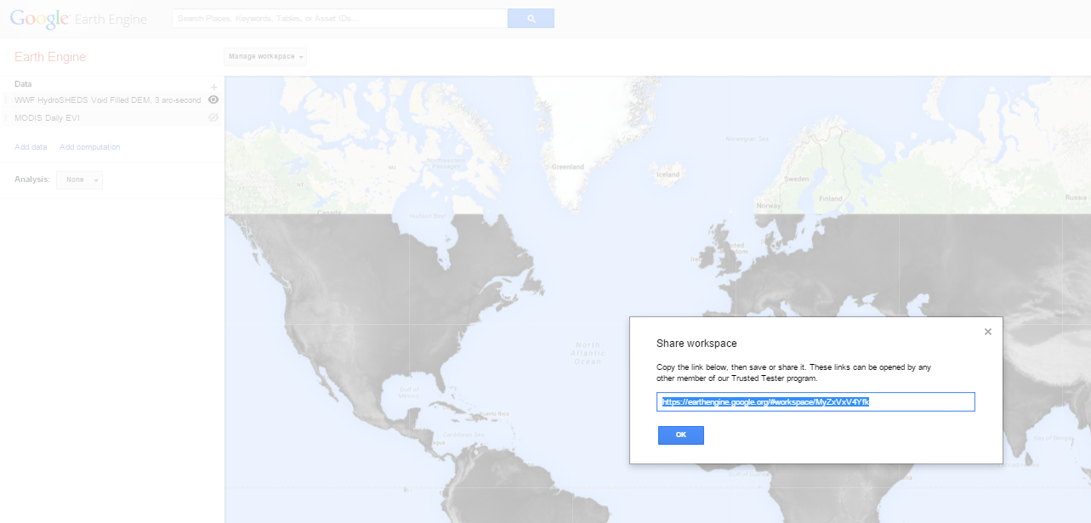

Data Download

When you are signed in with your Google Account, you get the option to download data layers which you have loaded in your workspace, including source data from the Google Earth Engine Data Catalog, as well as computed layers from your own analysis or classification.

- Select the data layer for which you want to download data, and click its name in the left-hand panel to open its Layer Settings dialog (#1 in the below).
- Click the Download button (downward pointing arrow) in the lower right of the dialog (#2 in the image below).

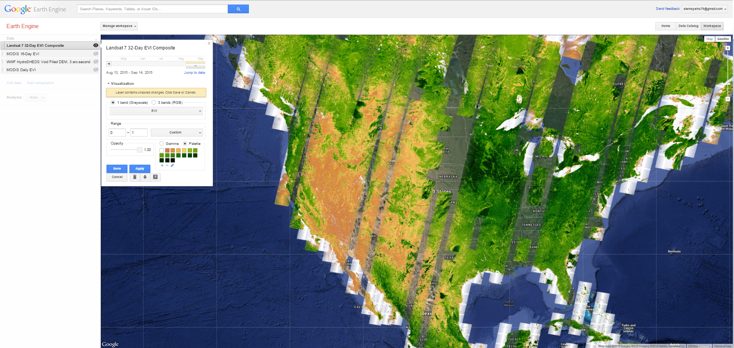

- You will see the download options appear in the left-hand panel, as shown below.

- Select which area you wish to download using the Region: button. For this exercise, select Draw Rectangle. On the map, click and drag to draw a box the size of a small state or a large city.
- Select the file format you want to download from the Format: dropdown. For this exercise, select GeoTiff (Raw).
- Select which Bands you wish to download using the Bands: button. Click on the button to see the options. For this exercise, leave the selection on All.
- Select the projection which you want the data to be in using the Projection: button. For this exercise, select WGS84.
- Set the resolution at which you want the data to be downloaded using the Resolution: box. For this exercise, leave the resolution at its default setting of 500.
- Click the Download button to start the download. A zip file will be downloaded by your browser, which you can open to find the datasets which you requested.

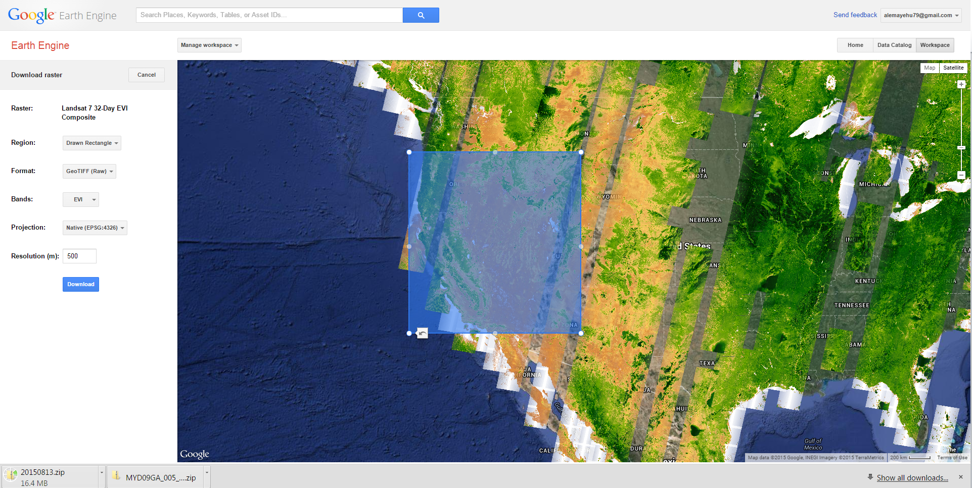
3

2
1

Note: The downloaded zip file will contain one file for each of the bands requested. The data in each file will use a data type specific to the data requested. Many of these data types are not viewable by ordinary image viewers such as the default tools in Windows, Preview in MacOS, or even Adobe Photoshop in many cases. For example, NDVI data is represented using floating point numbers, which most image readers will not understand. To view such downloaded files on your computer, you will need software which can view the relevant data type, or convert it to something simpler such as an RGB image which you can view in regular image viewers. Some software packages which can rescale images for viewing include QGIS, ENVI, ESRI/ArcGIS, and ERDAS.

Homework 1

- Download the following satellite derived products for Zambia and share your work space and submit your link.
  - MODIS 16-Day EVI (August 5 -13th, 2015)
  - MODIS 16-Day NDVI (August 5 -13th, 2015)
  - MODIS 16-Day NDWI (August 5 -13th, 2015)
  - MOD11A2 LST 8 Day (August 5 -13th, 2015)
  - GTOPO30: Global 30 arc-second Elevation

- Based on the links below fill in the missing characteristics of each satellites:
Landsat 8: http://landsat.usgs.gov/landsat8.php
MODIS: https://lpdaac.usgs.gov/dataset_discovery/modis
Skybox: http://www.skyboximaging.com/products/pixels

Satellite | Spatial resolution  What is the ground area represented by a pixel?  (e.g. 15m) | Temporal resolution  What is the revisit period?  (e.g. 10 days) | Radiometric Resolution  What is the number of divisions of a bit depth?  (e.g. 12bit) | Spectral resolution  How many bands does it contain?  (e.g. 7 bands)
Landsat 8

MODIS

Skybox

