Lab 3 Create Vector Data in Google Earth
- Download Google Earth using the following link: https://www.google.com/earth/
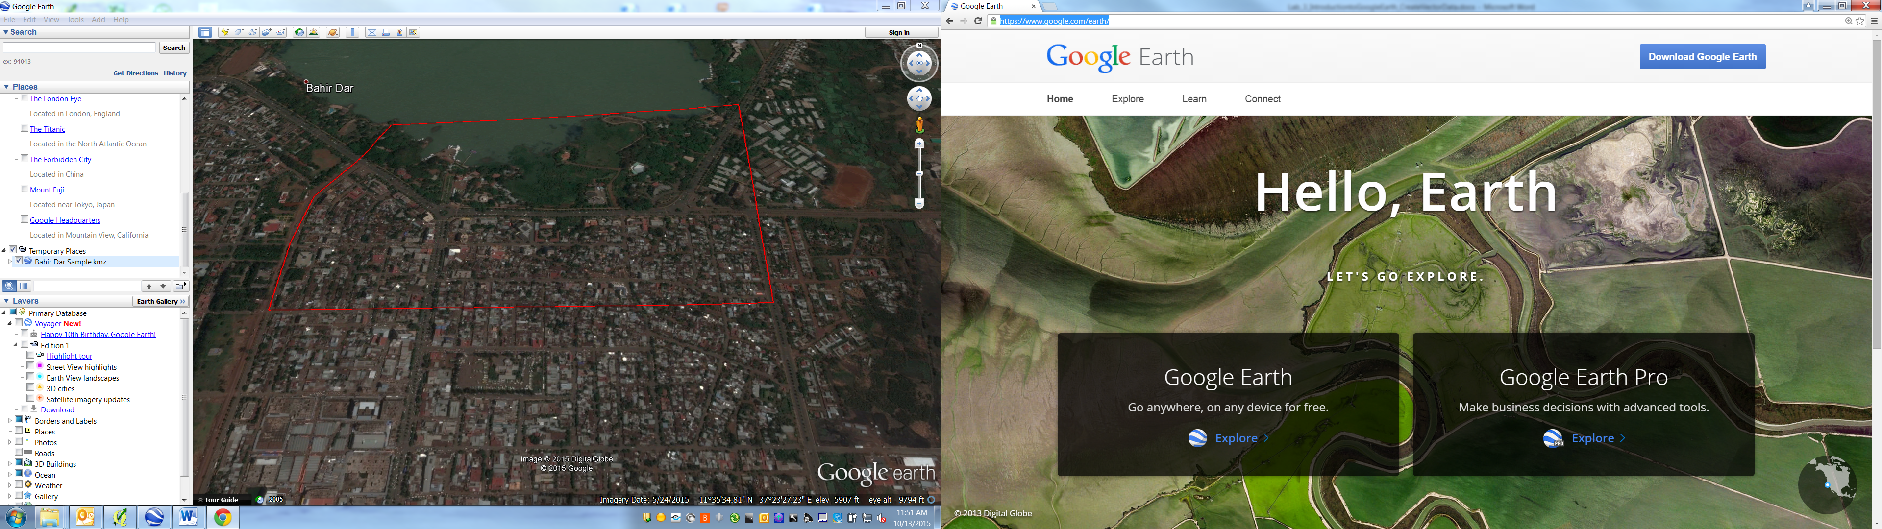

Open the KML layer provided “Bahir Dar Sample.kml” in Google Earth.

- Next zoom in within the Bahir Dar Sample boundary and digitize features including buildings, roads, trees etc. If there is only a single feature, digitize it as a point layer. If they are in groups or clusters, digitize them as a polygon feature.
- Use the Add Placemark button 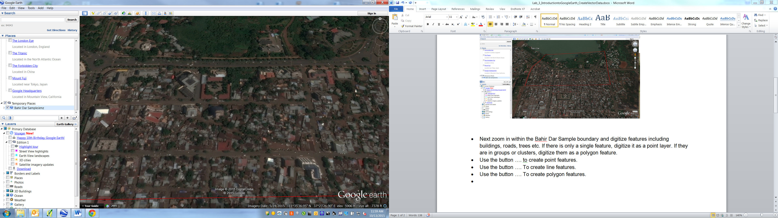 to create point features.
- Use the Add Path button to create line features.
- Use the Add Polygon button to create polygon features.

- Create a folder called “Lab 3 Google Earth” first as shown below.
- Click the folder you created and click the Add Placemark button to start digitizing a feature. In this case, we will digitize a church building.
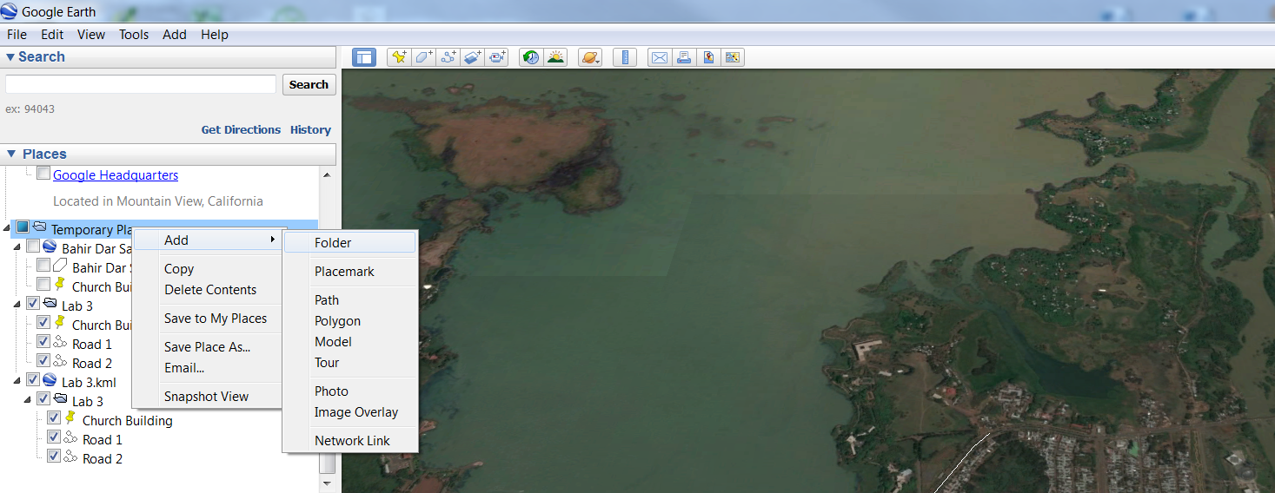
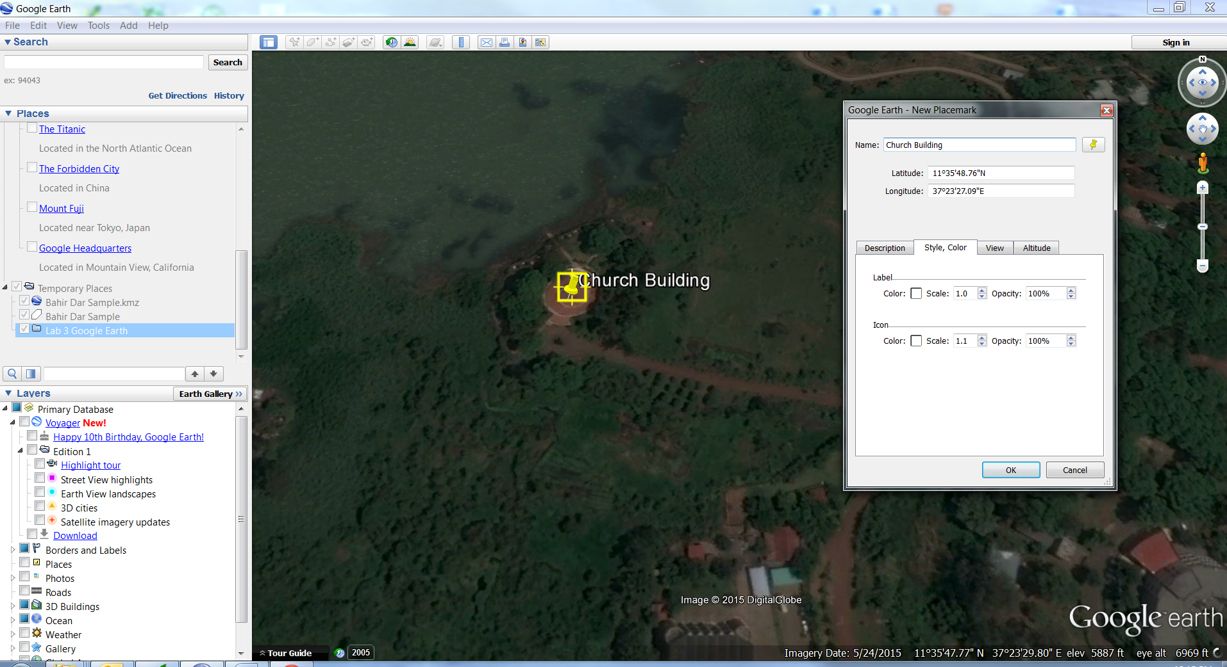
- Click the “Lab 3 Google Earth Folder” and Add Path button start digitizing a line feature. For example, digitize a road feature.
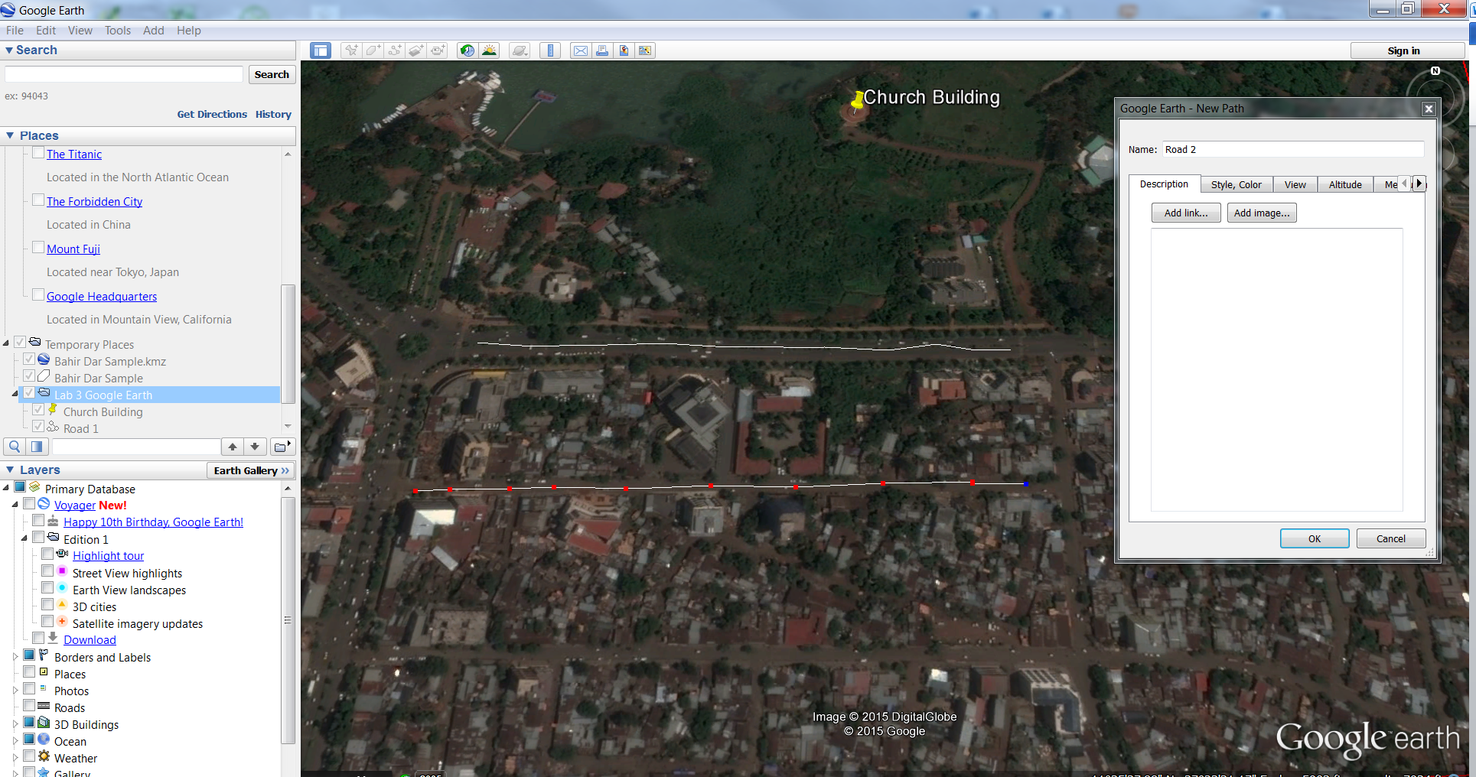

- Click the “Lab 3 Google Earth Folder” and click the Add Polygon button to create polygon features. For example, digitize a water body.
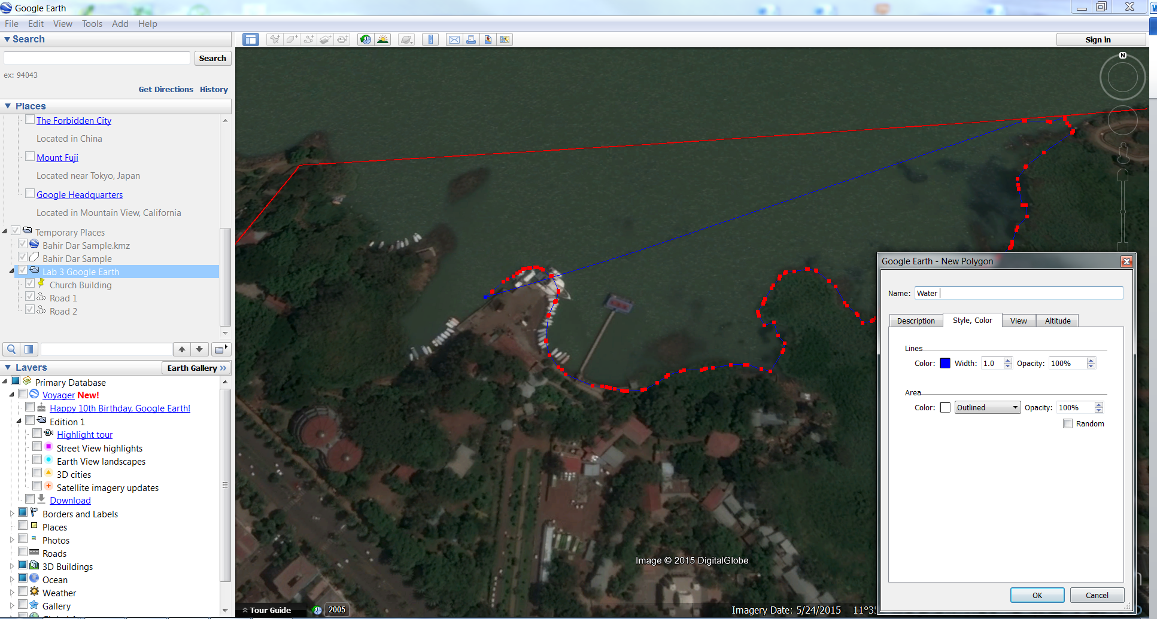

- Try to identify and digitize as many features as you can with in the Bahir Dar Sample region.
- Once you are done digitizing, save your work as a kml file (as shown below).

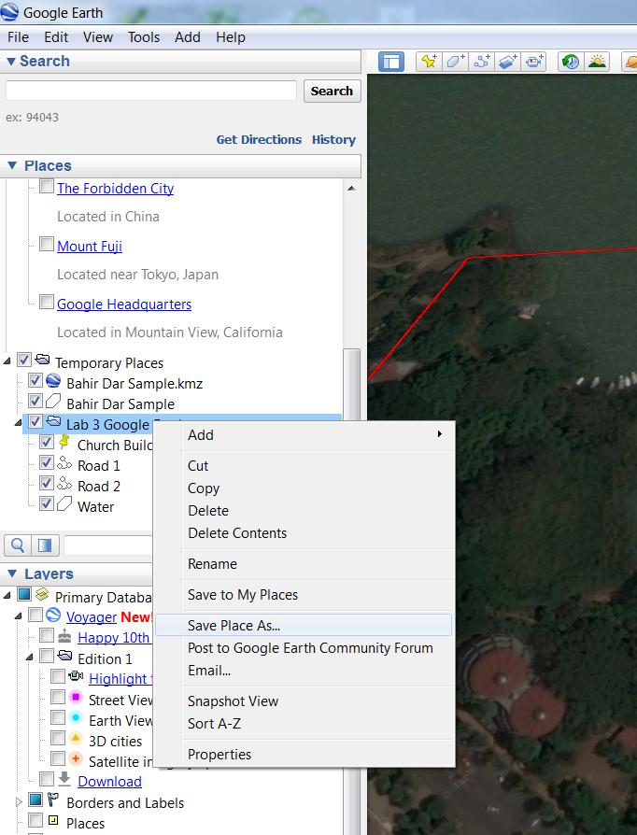

Homework 1
- Digitize features including buildings, roads, parking plots, and parks at the UCSF Mission Bay campus from Google Earth and save as KML file.

