Lab 1 Working with Vector Data in QGIS

Download and Install QGIS
- Use the following link to download QGIS: http://www.qgis.org/en/site/forusers/download.html
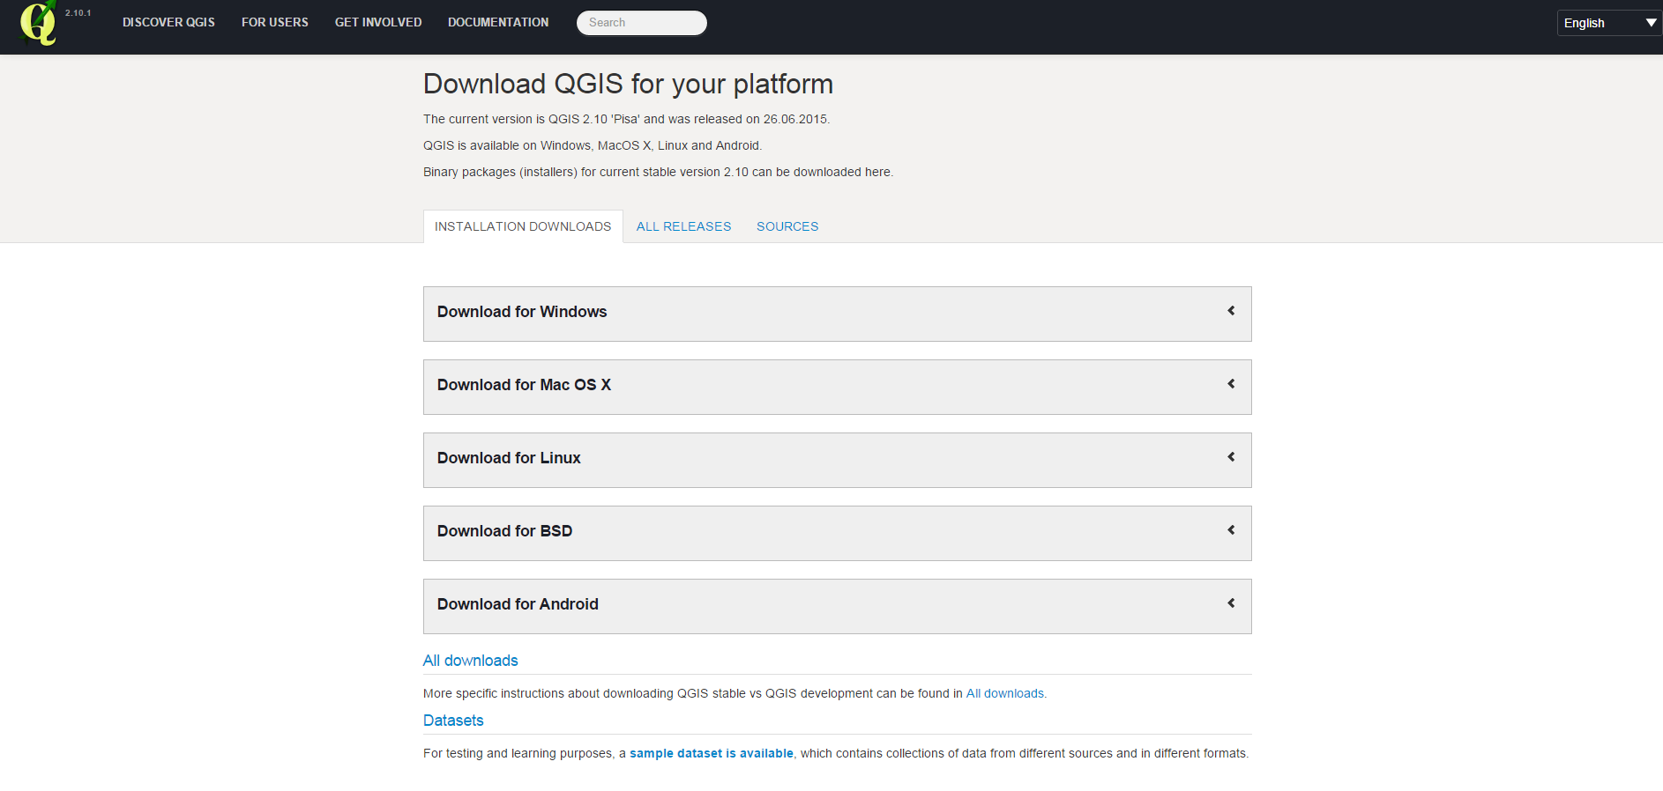
- Note that for MacOS X users please make sure you also download the file below:
http://www.kyngchaos.com/files/software/frameworks/PROJ_Framework-4.9.2-1.dmg
- You can optionally go to the following link to get the PROJ framework for MacOS X users:
http://www.kyngchaos.com/software/frameworks#gdal_complete
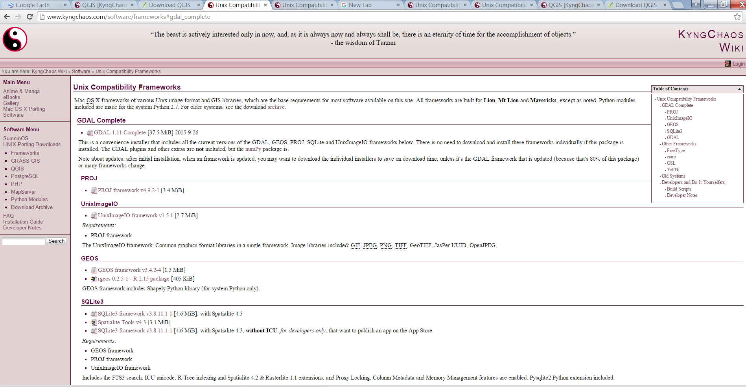
- Once you downloaded QGIS on your machine, double click to install it.

Task 1: Adding vector data
- Open QGIS Desktop.
- Using the Add Vector Layer button, add the shape files including Gambia_Point and GMB_adm0 to QGIS Desktop.
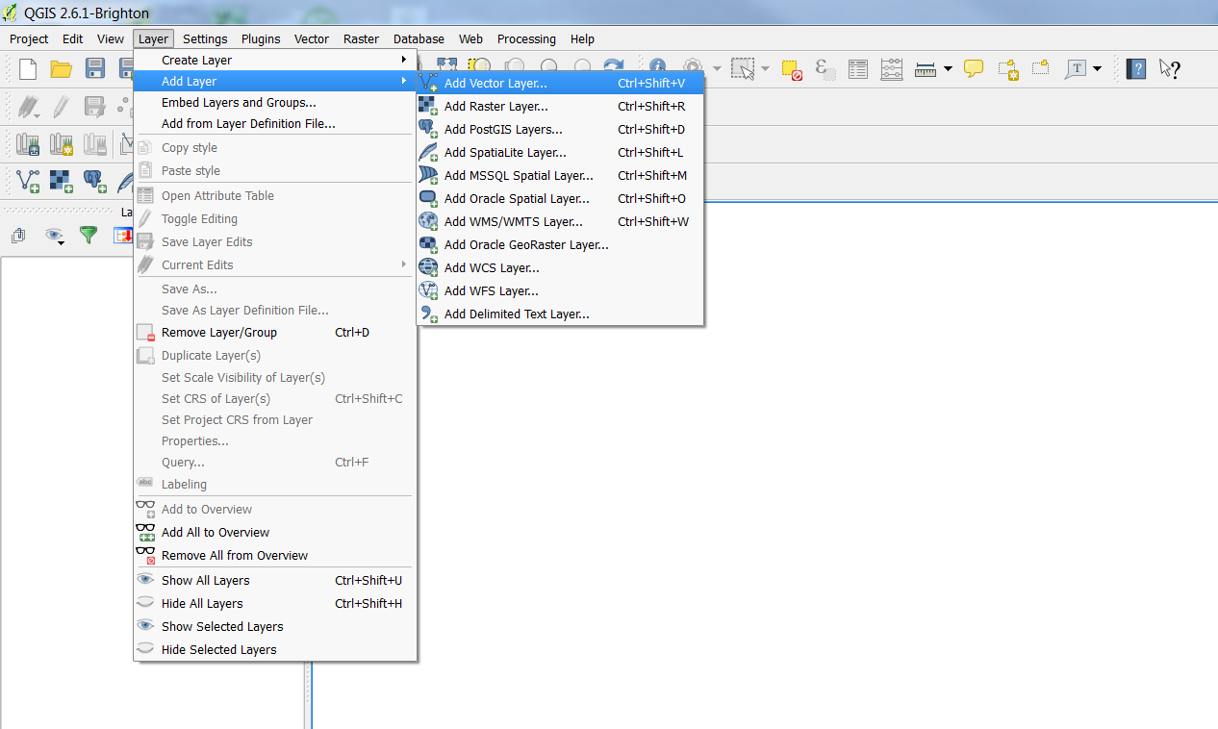

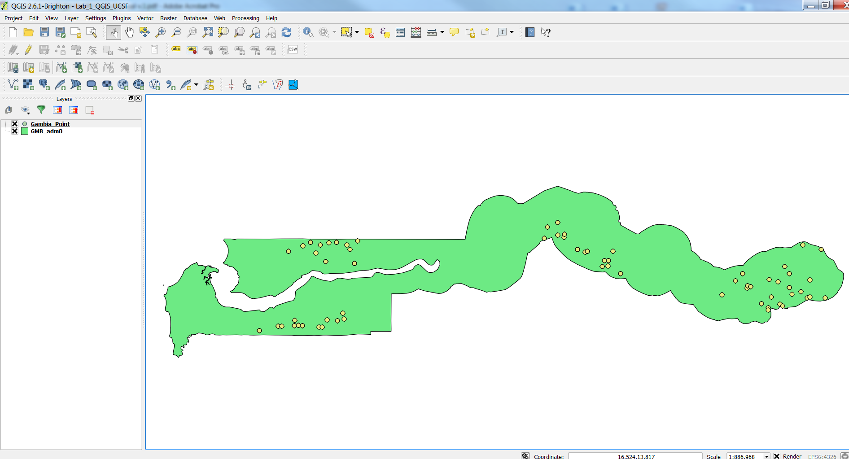
- Save the QGIS project. Click on Project | Save. From the menu bar.
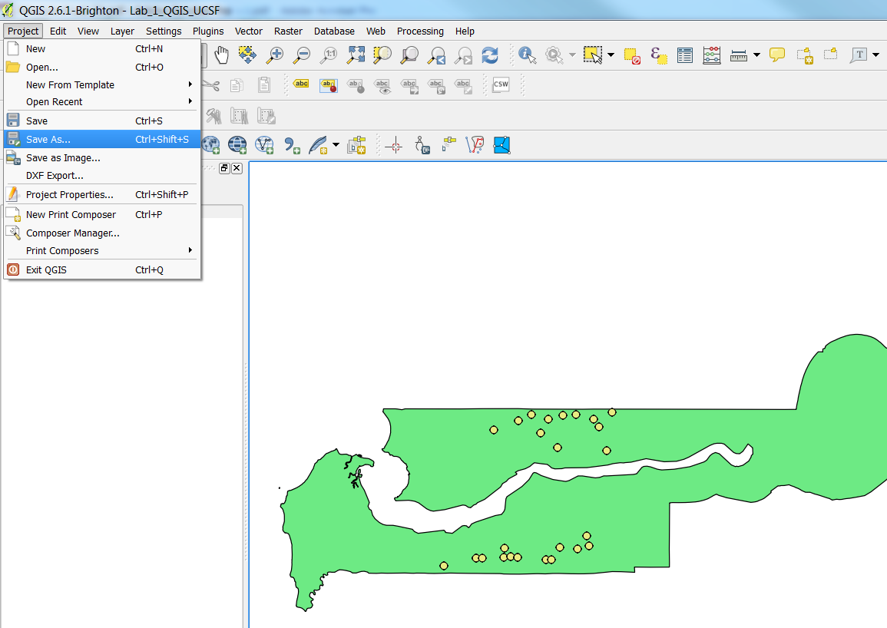

Task 2: Visualizing vector data
- Select the Gambia_Point layer from the Layers panel and drag it to the top position. You will see a blue line as you drag this layer up the list. Now all the data layers are in the correct order.
- Double click on the Gambia_Point layer to open the Layer Properties window.
- Click on the Style tab.
- Make sure you select Categorized and pos column.
- The 0 indicates negative cases and 1 indicates positive cases. Mark values that are 0 as blue and values that are 1 as red.
- Then click Apply | Ok.

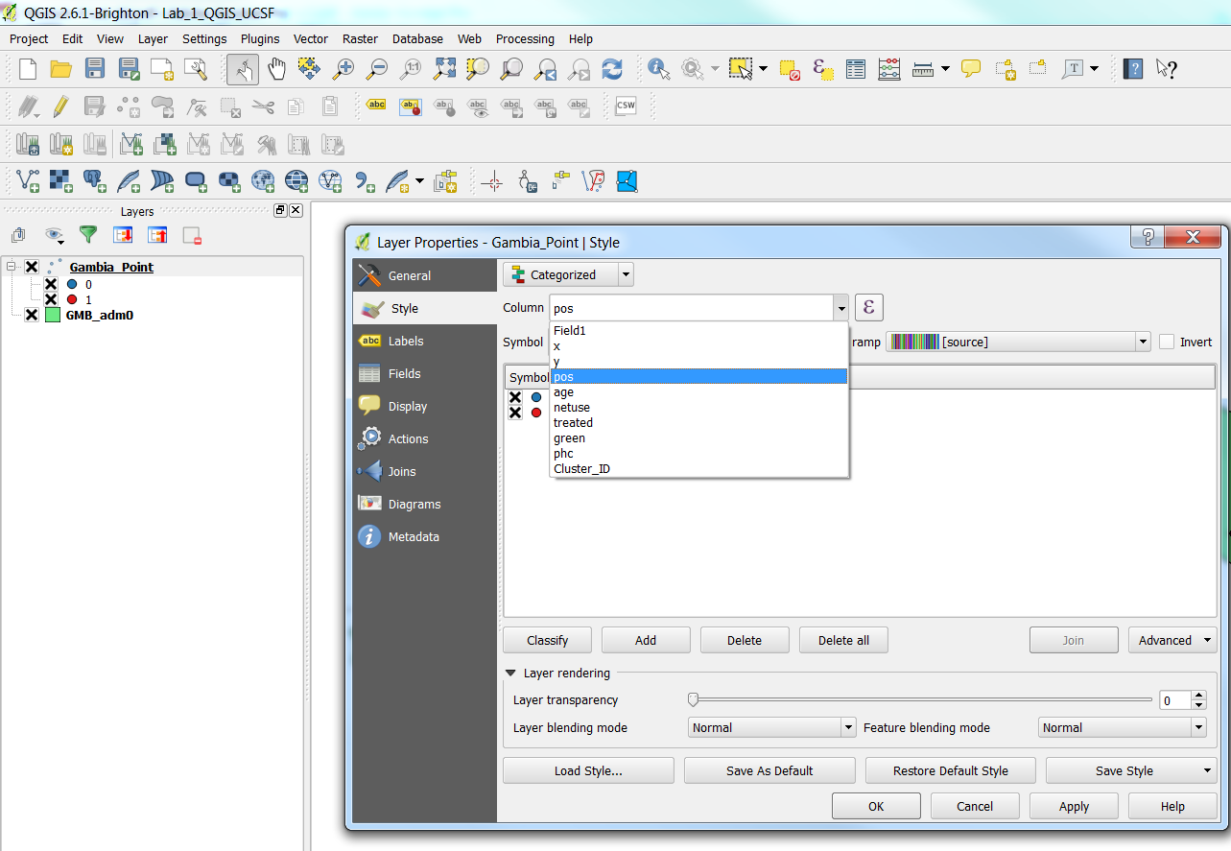

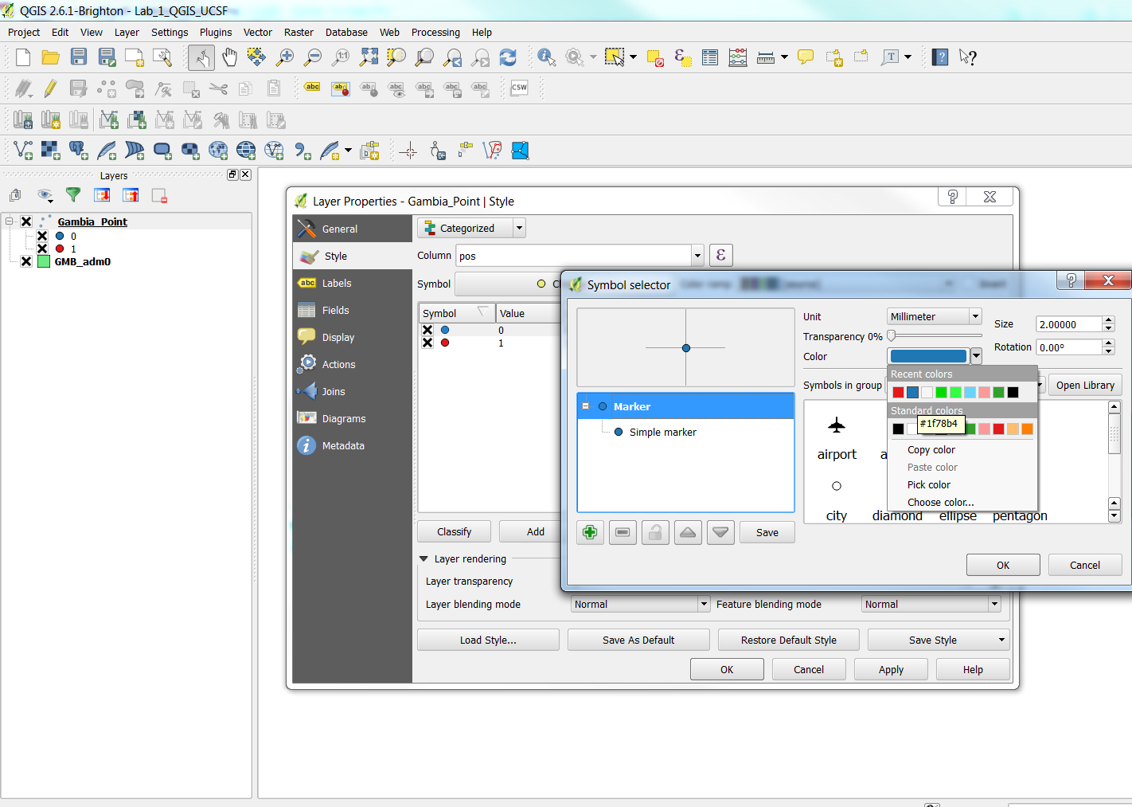
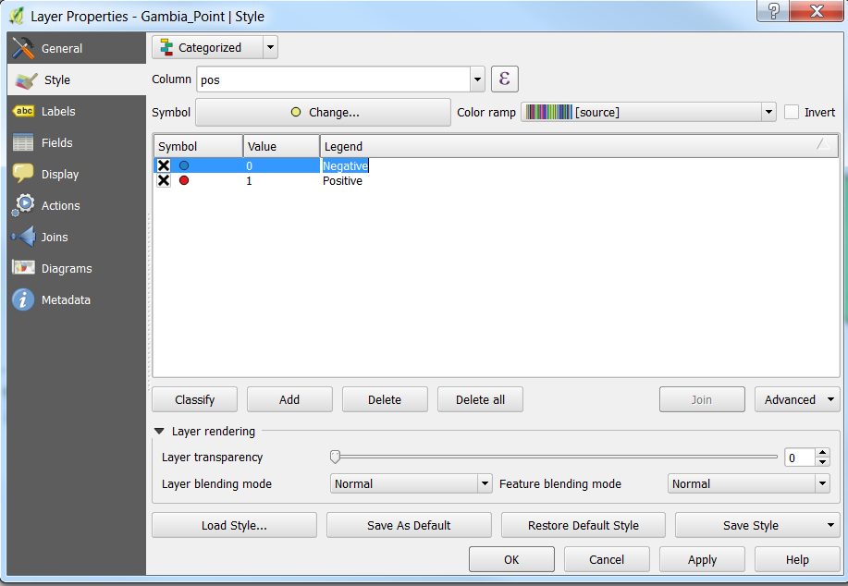

- Select the GMB_admin0 layer from the Layers panel and drag it to the bottom position.
- Double click on the GMB_admin0 layer to open the Layer Properties window.
- Click on the Style tab.
- Make sure you click Simple fill and choose No Bruch Fill style. This will create a transparent layer with a solid line boundary.
- Then click Apply | Ok.

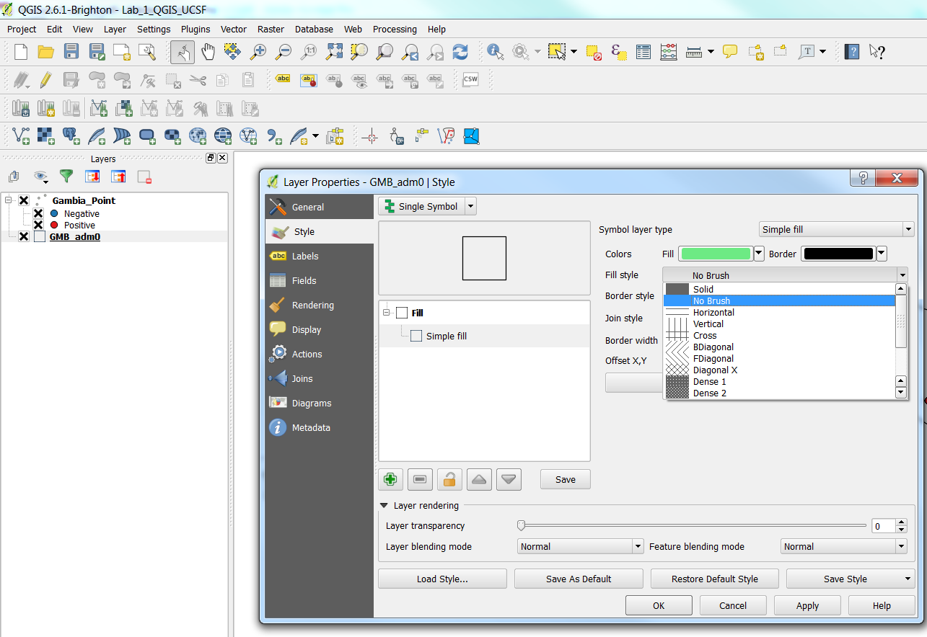

Task 3: Preparing a map
Now that you adjusted the styles of your data and can start to compose the map deliverable.
- From the menu bar choose Project | New Pint Composer.
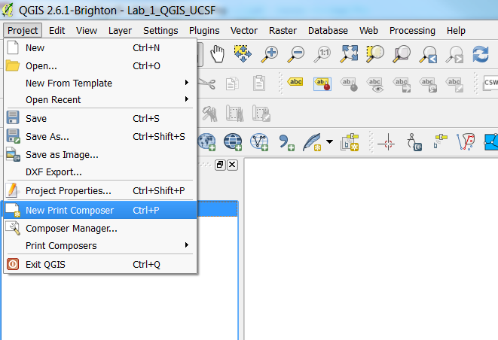
- Name the Composer “Lab 1 Gambia Vector Data” (as shown below).
- Click OK. The Printer Composer will open. This where you will design the map layout.
- On the Composition tab you can specify details about the overall composition.
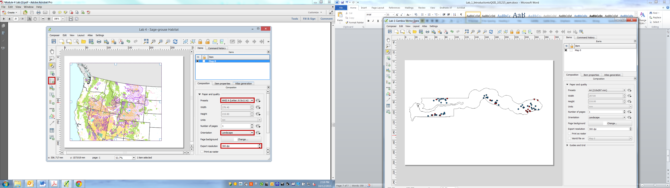

- Using the Add new map button 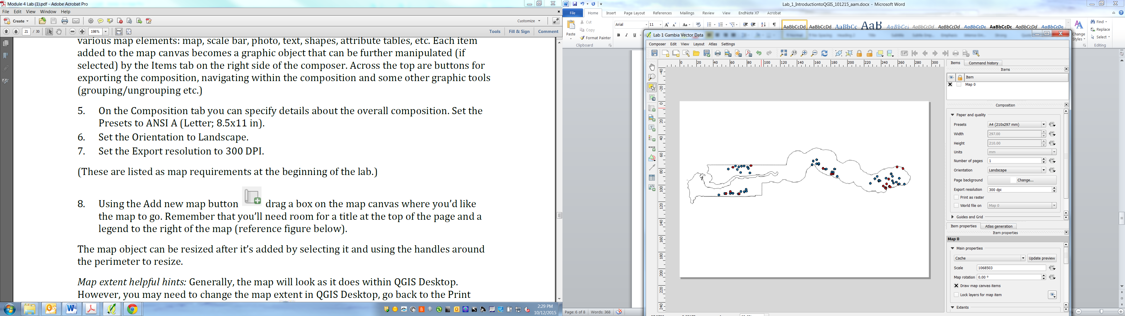 drag a box on the map canvas where you would like the map to go.
- The map object can be resized after it’s added by selecting it and using the handles around the perimeter to resize.
- You can use the Refresher view button to modify the map extent.
- Use the Layout menu to add other map layout elements.

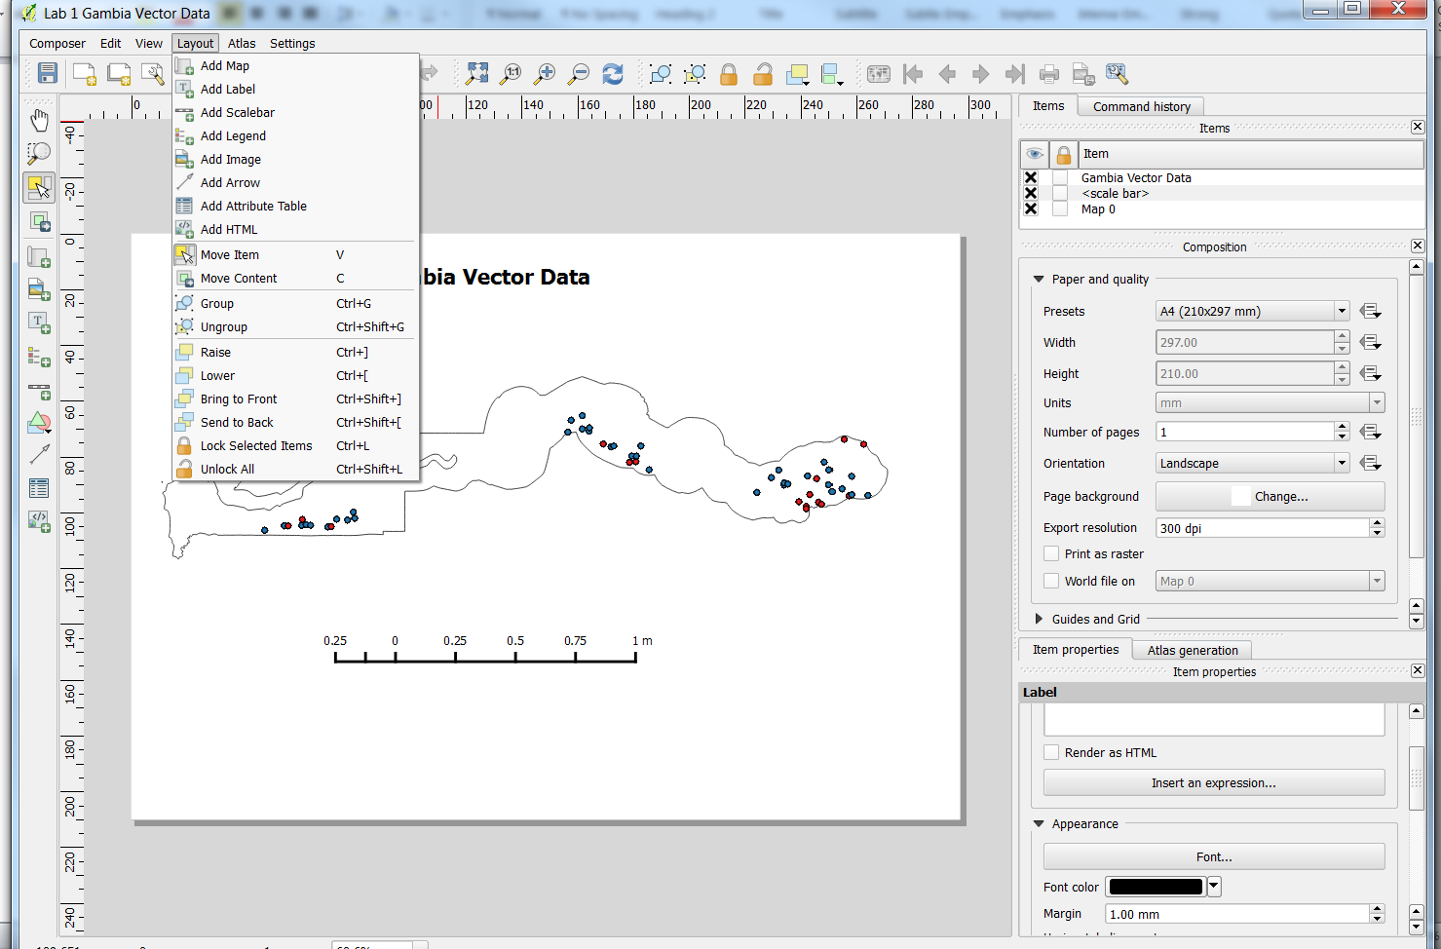

Export your map as pdf or bmp file (as shown below).
