Lab 2 Working with Raster Data in QGIS
- Adding raster data

- Download the “Landsat 8 Annual EVI Composite” data from Google Earth Engine using the link: https://earthengine.google.org/#workspace
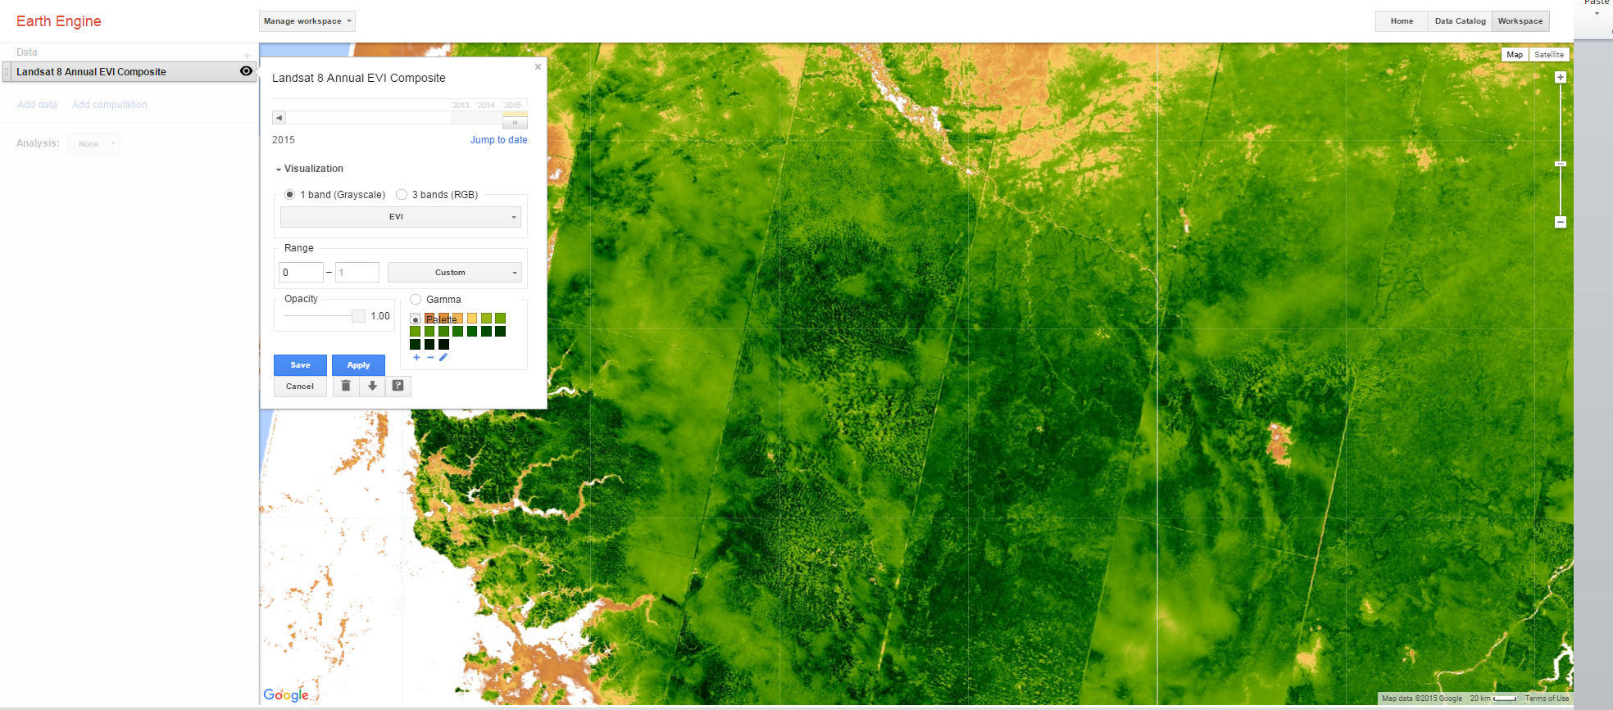

- Once you download the above data, open it in QGIS
- Using the Add Raster Layer button, add the EVI data that you have downloaded to QGIS Desktop.
- Save the QGIS project. Click on Project | Save. From the menu bar.
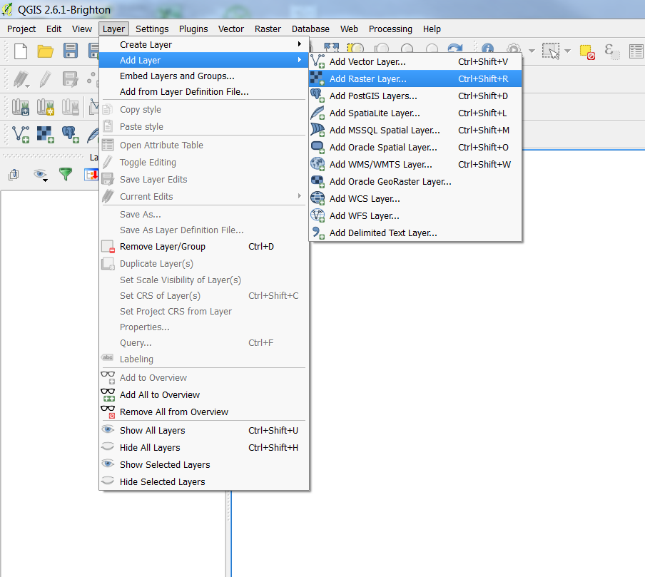
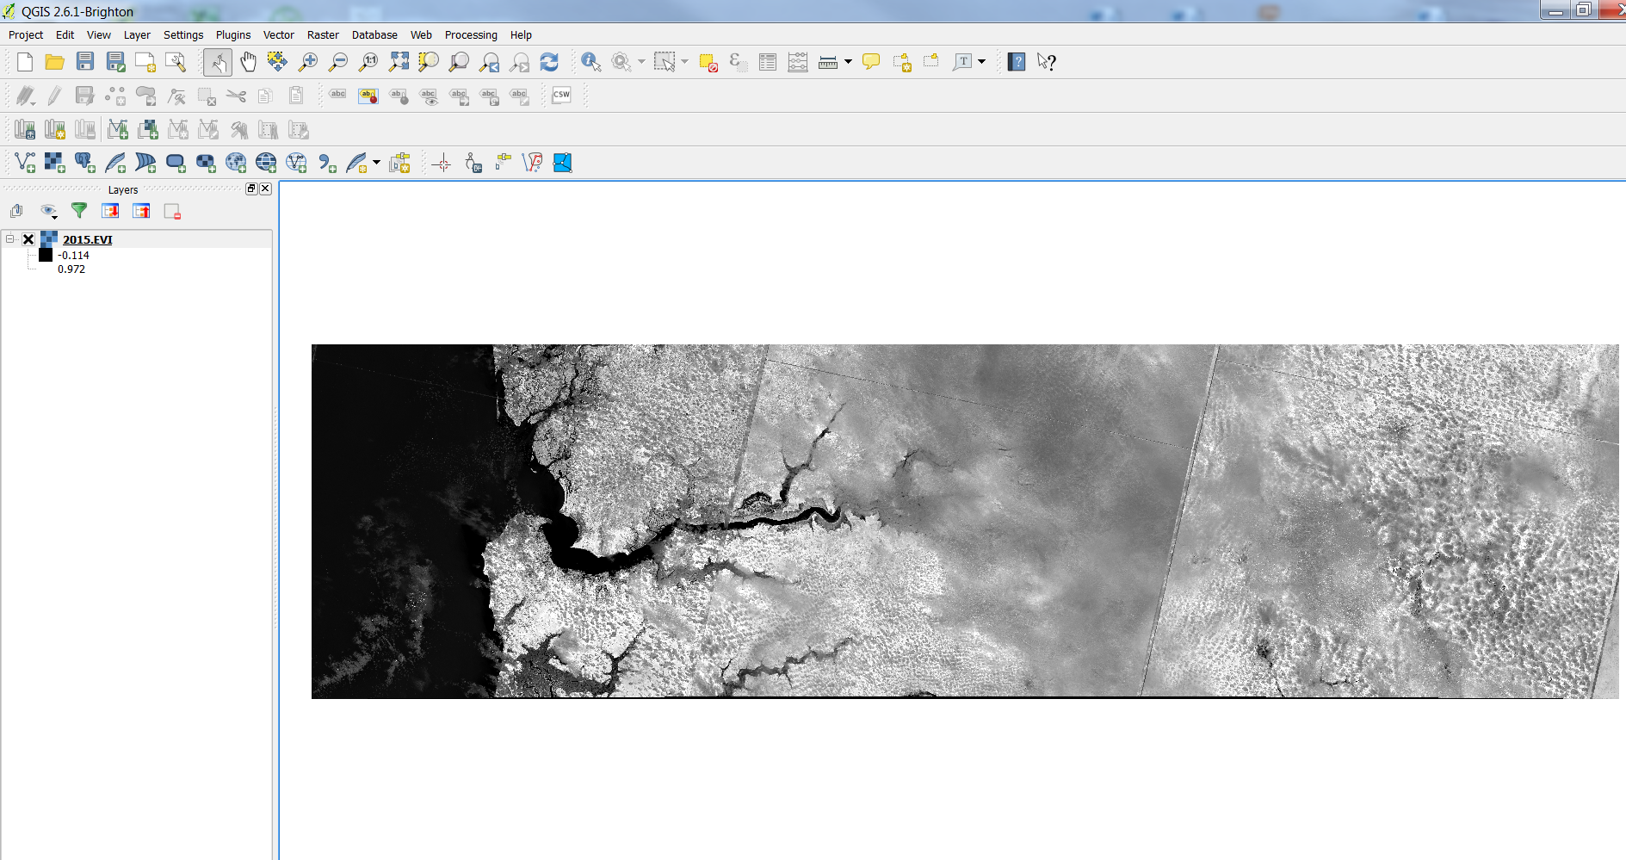
- Using the Add Vector Layer button, add the GMB_adm0 to QGIS Desktop.
- Using the clipper function clip the EVI data that is within the Gambia boundary (GMB_admin0).
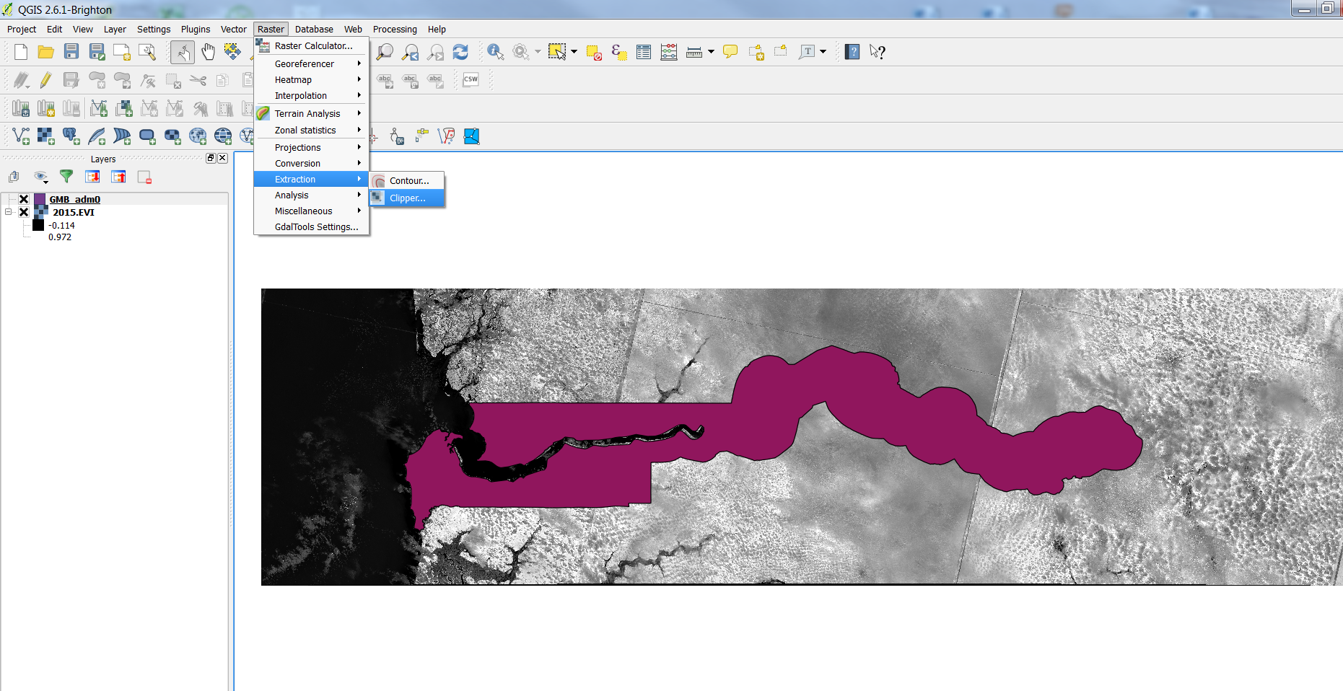

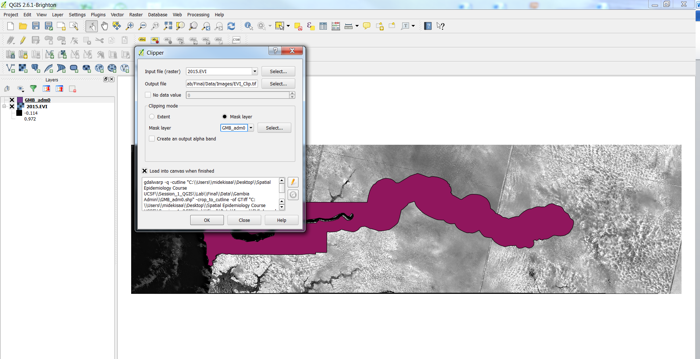

- Visualizing raster data
- Remove the original EVI data and the Gambia boundary data.
- Double click on the EVI raster layer to open the Layer Properties window.
- Click on the Style tab.
- Make sure you select Singleband pseudocolor and click Classifiy.
- Make sure you change the Opacity of the lowest class to 0 to change values with No Data to transparent.
- Then click Apply | Ok.
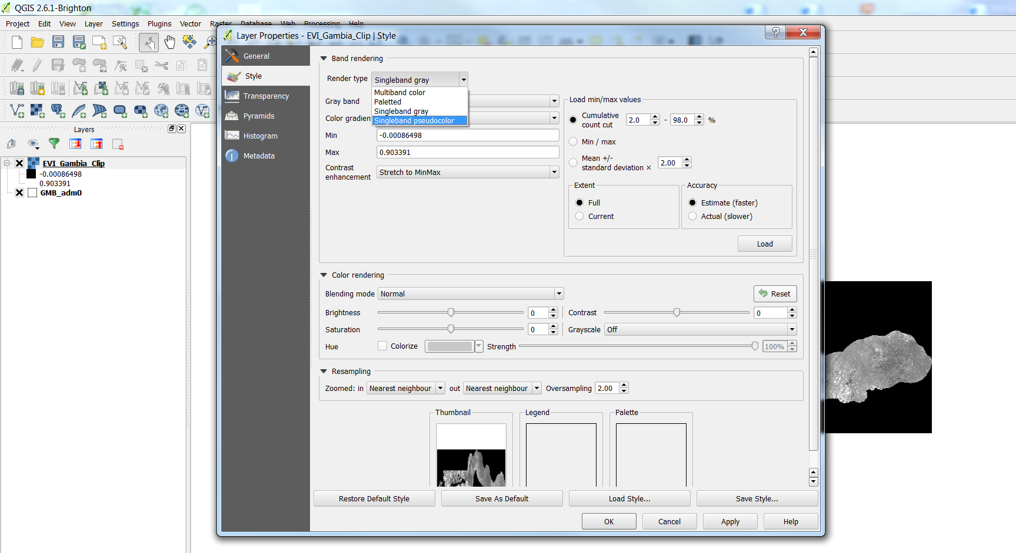

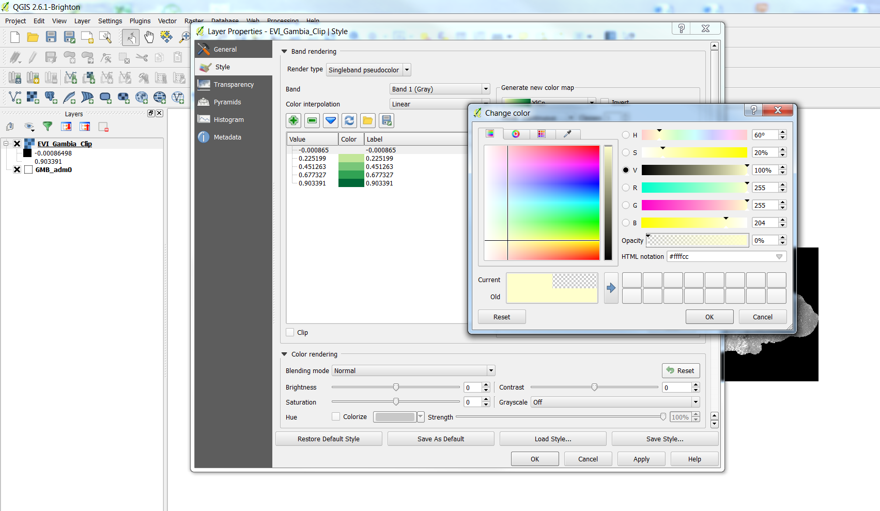

- Preparing a map
Now that you adjusted the styles of your raster data and can start to compose the map deliverable.
- From the menu bar choose Project | New Pint Composer.
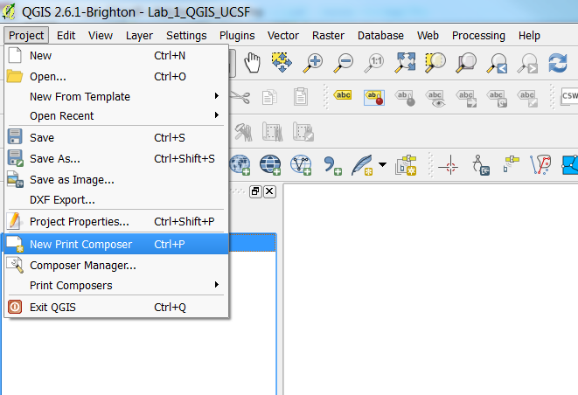
- Name the Composer “Lab 2 Gambia Raster Data” (as shown below).
- Click OK. The Printer Composer will open. This where you will design the map layout.
- On the Composition tab you can specify details about the overall composition.

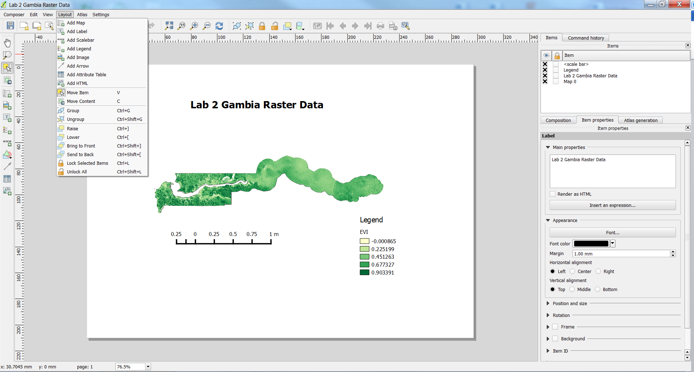
- Using the Add new map button 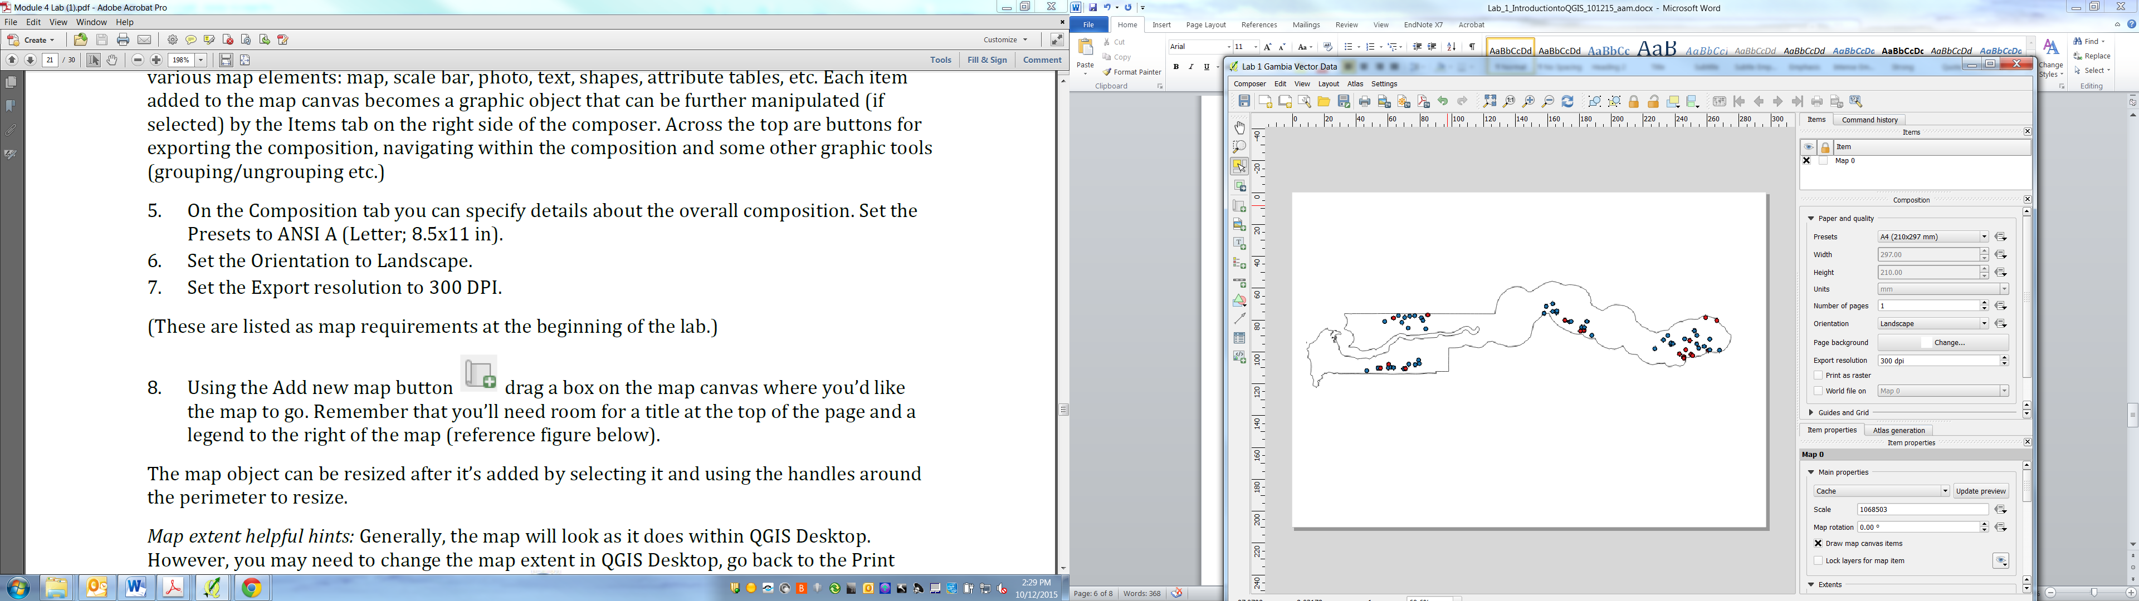 drag a box on the map canvas where you would like the map to go.
- The map object can be resized after it’s added by selecting it and using the handles around the perimeter to resize.
- You can use the Refresher view button 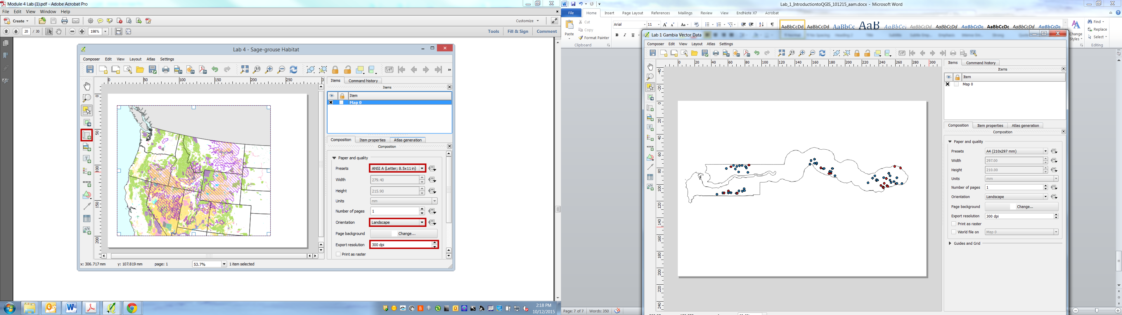 to modify the map extent.
- Use the Layout menu to add other map layout elements.

Export your map as pdf or bmp file (as shown below).
