Epi 204 Chapter 6, Problem Set 6
Studies of Diagnostic Tests
Due 1 pm 10/22/2015

Do problems 6.1 and 6.5 from EBD Chapter 6.

Do additional problems 6.6, 6.9, 6.11, and 6.12 below.

6.1. For each of the following study descriptions, name and briefly explain the bias most likely to account for the results:

a. A study on early treatment of lupus-related kidney disease (nephritis) compared patients who had a kidney biopsy early in their clinical course to patients biopsied late in their course. The study measured time to renal failure from the time of the biopsy and found that those biopsied earlier had a longer time to renal failure.

b. One way to screen for colon cancer is to have patients collect a small amount of stool on a Hemoccult® card that can be chemically tested for the presence of blood. A study of fecal occult blood screening finds a dose-response between the number of Hemoccult cards returned and decreased risk of lung cancer death.

c. A new policy requires all asthmatics to have a pCO₂ measured in the emergency department, with automatic admission to the ICU rather than the ward if the pCO₂ exceeds 45 mm Hg. (A pCO₂ > 45 mm Hg is an indication of increased severity.) Death rates from asthma in both the ICU and on the ward decline.

6.5. Mastroiacovo et al (Mastroiacovo et al 1992) studied the all-cause mortality of children with Down Syndrome (DS) in Italy. As expected, they found that the strongest predictor of death was congenital heart disease (CHD). They noted that DS patients with CHD in northern Italy had greater survival than those with CHD in southern Italy. Also, DS patients without CHD in northern Italy had greater survival that those without CHD in southern Italy. The authors suspect that medical care for the children in the South might not be as good. In the discussion they state:

"The insufficient resources for pediatric care available in the South could explain the low proportion of CHD diagnosed among DS infants (10.6% as compared with 21.7% in the North).

Explain how it is possible that the overall survival for DS patients (combining patients with and without CHD) in southern Italy could be just as high as in northern Italy?

6.6 CT Screening for Lung Cancer

The National Lung Screening Trial (NLST) randomized 53,454 current and former heavy smokers (minimum 30 pack-years) aged 55 to 74 years to either helical CT scanning or chest-x-rays yearly for 3 years.(1) Results for lung cancer mortality and total mortality, summarized below, show a 20% (relative) reduction on the risk of lung cancer death and a 6% decrease in all-cause mortality:

 | Lung Cancer Death
 | Yes | No | Total |  | Risk
CT | 356 | 26366 | 26722 |  | 1.33%
CXR | 443 | 26289 | 26732 |  | 1.66%
 |  |  | RRR= |  | 20%
 |  |  | ARR= |  | 0.32%
 | Death from Any Cause
 | Yes | No | Total |  | Risk
CT | 1877 | 24845 | 26722 |  | 7.02%
CXR | 2000 | 24732 | 26732 |  | 7.48%
 |  |  | RRR= |  | 6%
 |  |  | ARR= |  | 0.46%

- State whether each of the following statements is true or false; explain your answer

  - In this randomized trial, the favorable effect of annual CT screening on lung cancer mortality (compared with chest x-ray) cannot be explained by lead time bias, length bias, or volunteer bias.

  - The apparent reduction in lung cancer mortality in the group screened with CT could be due to "Sticky Diagnosis Bias."

  - "Slippery linkage bias" is unlikely to explain the apparent lung cancer mortality benefit, because the absolute risk reduction in all-cause mortality was even greater than the reduction in lung cancer mortality.
The following is taken from the CBS News story about the study: (http://www.cbsnews.com/stories/2010/11/04/eveningnews/main7023357.shtml)

“After 50 years of smoking, 67-year-old Steffani Torrighelli knew she was at high risk for lung cancer. Two years ago she enrolled in [the] study, and sure enough a CT scan picked up an early stage tumor before she had any symptoms… Since Torrighelli's lung surgery two years ago, she's cancer free and vigilant about screening."

b) Could Steffani's good outcome in this randomized trial be due to detection of pseudodisease? Explain.

Assume that the lung cancer mortality benefit resulted from 3 years of annual CT scanning.

- About how many screening CT scans were needed to defer one lung cancer death in the NLST?

d) Press reports say the scans cost about $300. What was the approximate cost of the screening CT scans per lung cancer death deferred?

e) (part e was not assigned as part of this problem set)

6.9 Prostate Cancer Screening

Andriole et al (4) reported the results of a randomized trial of prostate cancer screening with combination of prostate-specific antigen (PSA) testing and digital rectal examinations compared with usual care (which was whatever the physician usually did). The subjects were men aged 55 – 74 years. After 7 years of follow-up the results of an "intention to treat" analysis" were as follows:

 | Diagnosis of Prostate CA |  | Death From Prostate CA |  | Death from Other Causes |  | Total
Randomized To… | N | % | N | % | N | %
Annual PSA Screening | 2820 | 7.35% | 50 | 0.13% | 2544 | 6.63% | 38343
Usual Care | 2322 | 6.05% | 44 | 0.12% | 2596 | 6.77% | 38350

There were significantly more patients diagnosed with prostate cancer in the group randomized to annual screening (116 vs. 95 per 10,000 person-years, risk ratio 1.21 95% CI 1.15 – 1.28). There were also more prostate cancer deaths in the group randomized to screening (2.0 vs. 1.7 per 10,000 person-years, risk ratio 1.14 95% CI 0.76 - 1.70).

a. What are at least 3 possible explanations for the greater reported death rate from prostate cancer in the screened group? Include at least 1 named bias.

b.) (Part B was not assigned as part of this problem set)

- Figure 1A from the trial shows cumulative diagnoses of prostate cancers.
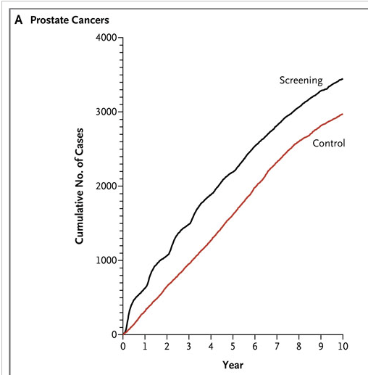
- Why is the screening line curvy and the control line more straight?

- What was the approximate "lead time" due to screening in the intervention group?

- As you may have heard, the U. S. Preventive Health Services Task Force recently recommended against prostate cancer screening. An editorial in USA today titled, "If PSA test saves lives, averages don't matter" the editors argue that it is better to know whether or not you have prostate cancer. Here's an excerpt from that editorial (available at: http://www.usatoday.com/news/opinion/editorials/story/2011-10-10/PSA-test-prostate-cancer/50723714/1)

The …U.S. Preventive Services Task Force, doesn't dispute that the test detects cancer. Instead, it argues, with a formidable arsenal of data, that the test leads to widespread over-treatment, which outweighs the benefits of early detection. Over the entire society, it says, there is no net gain and substantial damage to patients, ranging from needless worry, to impotence and incontinence, to death.

And therein lies a dilemma for the older-than-50 male, for whom averages mean little. If he isn't tested, he'll be spared the false positives the test commonly produces as well as treatment risk. On the other hand, if he has high-grade cancer, the disease might not be found until it has spread to other organs, which is fatal. The five-year survival rate for localized prostate cancer is 100%. Once the cancer reaches distant organs, the rate falls to 28.8%.

i.) Name and explain at least 2 biases that make the last two sentences misleading.

ii.) Do you agree with USA Today's position that men should get their PSA tested and then decide with their doctor what to do with the result? Why or why not?

11. Ovarian cancer screening
For the ovarian cancer portion of the Prostate, Lung, Colorectal and Ovarian (PLCO) screening trial, 78,216 women aged 55-74 years were recruited 1993-2001 at 10 US centers and randomized to be offered annual screening with transvaginal ultrasound and serum cancer antigen 125 (CA-125) vs. usual care. Mortality results for this trial were recently reported.(5)
a. (part a was not assigned as part of this problem set)
Figure 2 from the paper is reprinted below. The relative risk of being diagnosed with ovarian cancer was 1.21 (95% CI 0.99-1.48) and for ovarian cancer mortality the RR was 1.18 (95% CI 0.82, 1.71).

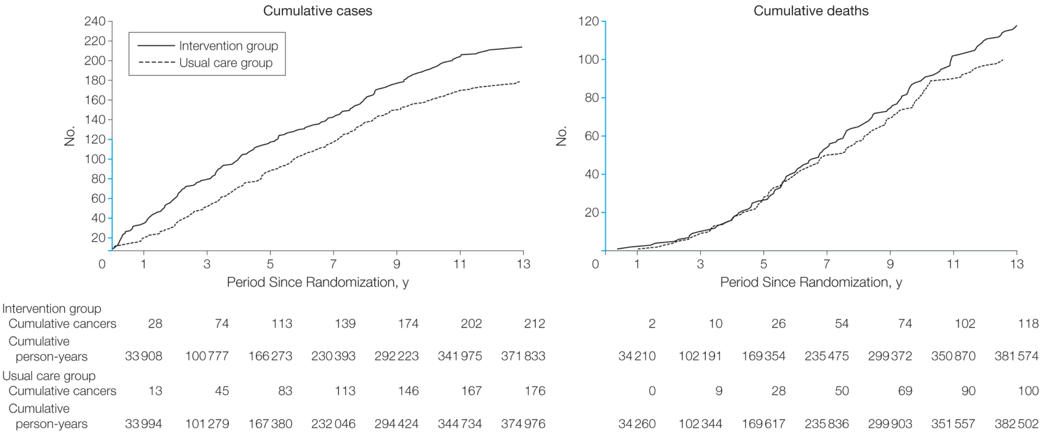

- Assume (as appears to be the case) that both curves level off over time and the usual care curve never catches the intervention curve. What is the most likely explanation (other than chance) for the excess of ovarian cancer diagnoses in the intervention group? Explain.

c). Complications associated with diagnostic evaluation for cancer occurred in 45% of the women diagnosed with ovarian cancer in the screening group, compared with 52% of the women diagnosed with ovarian cancer in the usual care group. Does this mean screening was not associated with an excess of complications from diagnostic evaluations for ovarian cancer?

6.12 With thanks to Caterina Liu
UroVysion to diagnose bladder cancer
A recent Wall Street Journal article describes a urology practice in Florida that is under investigation for questionable Medicare billing, in part related to its use of an expensive test for bladder cancer. The test is the computer-assisted version of UroVysion. Briefly, this urine test uses fluorescence in-situ hybridization (FISH) to assess for chromosomal abnormalities that suggest cancer. It is FDA-approved to detect bladder cancer recurrences and to diagnose previously undiagnosed bladder cancer in patients with blood in their urine.
One of the studies cited in the FDA approval report compares multiple tests for bladder cancer, including UroVysion.² Urine samples were obtained from 265 patients prior to cystoscopy + biopsy if indicated (gold standard test), of whom 146 had a prior history of bladder cancer, and 119 did not.
The authors report that 73 patients diagnosed with cancer on cystoscopy received the UroVysion test. Of these, 59 had positive findings on the UroVysion test. Of the 190 patients not diagnosed with cancer on cystoscopy, they excluded 110 with either a previous history of cancer or a positive cystoscopy for something else. Of the 80 remaining patients without history of bladder cancer and with negative cystoscopy findings, 78 received the UroVysion test and 75 tested negative.

a. Make a 2x2 table that summarizes the results of the UroVysion test compared with the gold standard.

b. Calculate sensitivity and specificity of UroVysion for bladder cancer.

c. The fact that urine samples were obtained from 265 patients prior to cystoscopy but only a selected 151 were included in your calculations of sensitivity and specificity above raises concern for what bias? How would that bias affect sensitivity and specificity?

d. According the WSJ article, the pathologists in this practice billed more than any other practice in the country for UroVysion ($4 million total). “Catching bladder cancer early keeps patients alive by turning the disease ‘into a chronic illness’ instead of a death sentence, says Constantine Mantz, the company’s chief medical officer.” What are at least 3 possible biases that could lead to an apparent survival benefit from a more sensitive test for (and earlier diagnosis of) bladder cancer, even if it did not save any lives?

e. Below are the data on incidence (new cases/100K), deaths, and 5-year survival from the National Cancer Institute's Surveillance Epidemiology and End Results (SEER) cancer registry (http://seer.cancer.gov/). Focus on the period after 1990, and assume that incidence, mortality, and 5-year survival have been flat. If we were to institute widespread urine screening for bladder cancer and the biases you mentioned in part d occurred, what effect would you expect this to have on reported incidence, survival and mortality? (You can keep your answer simple, i.e., consider all of the biases together rather than their individual effects.) [3]

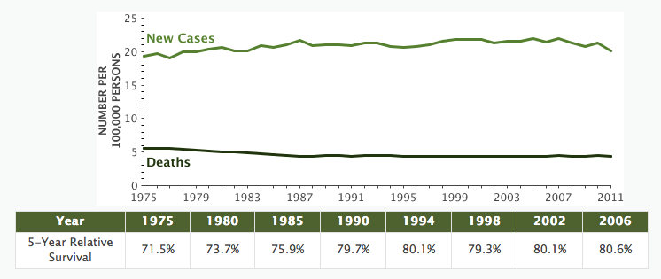

References:

Aberle DR, Adams AM, Berg CD, Black WC, Clapp JD, Fagerstrom RM, et al. Reduced lung-cancer mortality with low-dose computed tomographic screening. N Engl J Med. 2011 Aug 4;365(5):395-409.

Andriole GL, Grubb RL, 3rd, Buys SS, Chia D, Church TR, Fouad MN, et al. Mortality results from a randomized prostate-cancer screening trial. N Engl J Med. 2009 Mar 26;360(13):1310-9.

Buys SS et al. Effect of screening on ovarian cancer mortality: the Prostate, Lung, Colorectal and Ovarian (PLCO) Cancer Screening Randomized Controlled Trial. JAMA. 2011 Jun 8;305(22):2295-303

Mastroiacovo, P., R. Bertollini, et al. (1992). "Survival of children with Down syndrome in Italy." Am J Med Genet 42(2): 208-12

