Epi 204 Chapter 7 and 8, Problem Set 7
Prognostic Tests and Multivariable Models
Due 1 pm 10/22/2015

Do problems 7.2 and 7.5 from EBD Chapter 7.

Do problem 8.2 from EBD Chapter 8.

Do additional problems 7.12 and 7.13 below.

7.12. (From the 2013 final after editing) A recent New York Times story, “Risk Calculator for Cholesterol Appears Flawed” includes the following:

“Last week, the nation’s leading heart organizations released a sweeping new set of guidelines for lowering cholesterol, along with an online calculator meant to help doctors assess risks and treatment options. But, in a major embarrassment to the health groups, the calculator appears to greatly overestimate risk...”
“After they saw the guidelines and the calculator, Dr. Ridker and Dr. Cook evaluated it using three large studies... They knew the subjects’ characteristics at the start... Then they asked how many had heart attacks or strokes in the next 10 years and how many would the risk calculator predict.
“The answer was that the calculator overpredicted risk by 75 to 150 percent, depending on the population. A man whose risk was 4 percent, for example, might show up as having an 8 percent risk. With a 4 percent risk, he would not warrant treatment — the guidelines that say treatment is advised for those with at least a 7.5 percent risk and that treatment can be considered for those whose risk is 5 percent.”
  - Is this a problem with discrimination or calibration? Explain.

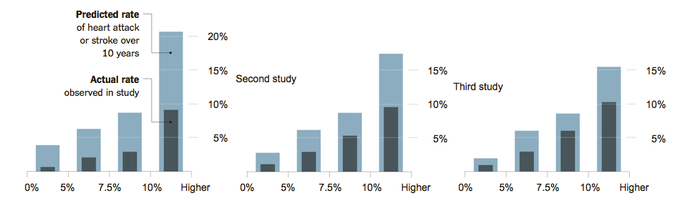
  - The guidelines recommend estimating each subject’s risk using a cardiovascular risk calculator, then managing based on whether the predicted 10-year risk is <5%, 5-7.4%, 7.5-9.9%, or ≥ 10%. The NYT article included a graph of the overestimation, above, which many of your instructors found confusing. Josh Galanter (faculty member for 2013 course) gallantly created a calibration plot from these data (below), which should look more familiar. Explain briefly, step by step, how the data to produce figures like these would be obtained. (Hint: the X-axis in each case groups patients with predicted risks in the categories above.)

  - If we assume that, in fact, the risk calculator is overestimating risk, what more do you need to know to conclude that using these overestimated risks with the treatment thresholds in the guidelines will lead to excessive treatment? Explain.

7-13. Schuetz et al (Epidemiol. Infect. (2008), 136, 1628–1637) compared 3 rules for predicting mortality in patients with community acquired pneumonia. The 3 rules were the Pneumonia Severity Index (PSI), the CURB65, and the CRB65 (which is CURB65 without the “U”). They used each of these 3 rules to predict risk of death in 371 patients with community–acquired pneumonia who were seen in the emergency department of a Swiss university hospital. Their calibration plots are shown on the next page.

All 3 rules divided the patients into 5 risk groups and, for all 3 rules, the predicted risks differed substantially from the actual mortality rate, so the authors re-calibrated the risk models.

a) Figure (c) is the calibration plot for the CRB65 rule. The open diamonds (◊) represent the original risk predictions prior to recalibration. Prior to recalibration, did the CRB65 rule overestimate or underestimate mortality risk? Explain briefly.

b) Figure (b) is the calibration plot for CURB65 (note the letter “U”). CURB 65 assigned only 3 patients to its highest risk group. How many of them died?

Note 1: The PSI is the same as the PORT Score described in Chapter 8 of Evidence-Based Diagnosis, Table 8.3, page 176.)
Note 2: the CRB65 is just the CURB65 without a lab test called the BUN.

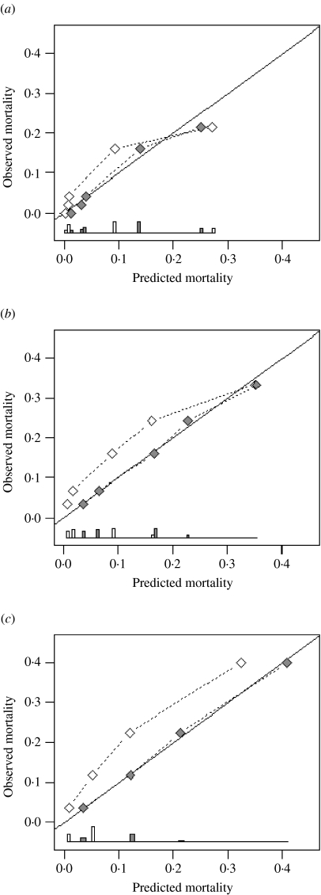

Agreement between predicted and observed 30-day mortality (calibration) for three pneumonia severity prediction rules (a) PSI, (b) CURB65 and (c) CRB65. Observed mortality is plotted according to classes of predicted risk for each prediction rule separately. The solid line of identity represents perfect calibration of predicted risk within new patients. Correction of miscalibration () after recalibration (◊).

The ROC curves are shown below:

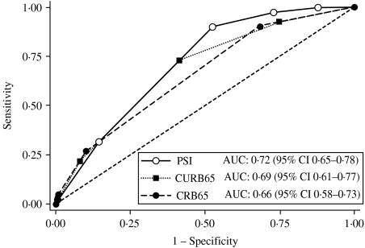

Receiver-operating characteristics analysis for 30-day mortality prediction with three pneumonia severity prediction rules (PSI, CURB65 and CRB65) in 373 patients with CAP.

c) Can you tell whether the above ROC curves were based on the pre-recalibration or post-recalibration risk predictions? Explain your answer.

d) Do the points on the PSI calibration plot represent approximate quintiles of risk? In other words, does each category of predicted risk contain roughly one-fifth of the population? How can you tell? (Hint: Looking at the ROC curve may help.)

e) Below is an enlarged version of the calibration plot for the PSI (the top figure from part b) with 3 original risk classes circled. Where on the ROC curve would the data corresponding to these 3 points at the lower left of the calibration curve be plotted? Draw a circle around the part of the ROC curve that corresponds to these 3 risk classes for the PSI.

f) The authors were interested in a rule that could identify pneumonia patients at such low risk of death that they could be discharged from the emergency department. Even after re-calibration, only one of the 3 rules could identify patients at low enough risk to send home. Which of the 3 rules was it? Explain how you know.

Kolata G, available at: http://www.nytimes.com/2013/11/18/health/risk-calculator-for-cholesterol-appears-flawed.html

