# | Pts Possible | Pts missed | Extra Credit
1 | 7
2 | 23
3 | 10
4 | 13
5 | 11
6 | 12
7 | 12
8 | 12
Total
Score
NAME _______________________
BRING THE EXAM ON PAPER to our last class or UPLOAD TO THE CLE SITE BEFORE 08:45 ON THURSDAY DECEMBER 3. Late exams cannot be accepted; submit EARLY to be safe if you won't be in class. Do NOT plan to print it at Mission Hall on 12/3.

Collaboration with others is NOT permitted. Answers must be in your own words. No exceptions. Really.

Please show your work.

1. Adding ezetimibe to simvastatin for acute coronary patients without high LDL
(with thanks to Katie Famous and Barbara Hamilton!)

Simvastatin and ezetimibe are two medications that lower serum cholesterol. Cannon et al.¹ enrolled 18,144 subjects who were recently hospitalized for acute coronary syndrome (“heart attack”) even though they had LDL levels (“bad” cholesterol) within goal recommendations. They randomized these subjects to either simvastatin alone or a combination of simvastatin and ezetimibe.

From the abstract: “The primary end point was a composite of cardiovascular death, unstable angina requiring rehospitalization, coronary revascularization (≥30 days after randomization), nonfatal myocardial infarction, or nonfatal stroke.”

In the results section, they report that after 7 years 2742 of 9077 of patients in the simvastatin group had the primary outcome, compared with 2572 of 9067 patients randomized to simvastatin-ezetimibe (Hazard ratio [HR] 0.94; P=0.016). When the composite outcome was broken down into its components, there was no statistically significant difference in death from cardiovascular causes (HR= 1.00; P=1.00), hospitalization for unstable angina (HR= 1.06, P=0.62), or coronary revascularization ≥30 days after randomization (HR = 0.95, P=0.11). Subjects in the simvastatin-ezetimibe group had lower incidence of nonfatal MI (HR =0.87; P=0.002). Nonfatal stroke is not specifically described, but there were fewer total strokes in the simvastatin-ezetimibe group (HR =0.86, P=0.05).

(a) What are the advantages and disadvantages of using a composite outcome for the primary end point? [2]

(b) The authors did an appropriate person-time analysis, but simply treating the outcome as dichotomous gives very similar results. Calculate the Relative Risk (RR), Relative Risk Reduction (RRR), and Absolute Risk Reduction (ARR) for the primary outcome from the numbers above. [3]

(c) What is the Number Needed to Treat (NNT)? Please give both a numerical value as well as one sentence describing this result. [2]

2. ED interpretation of CT scans for body packing (with thanks to Kimberly Kallianos)

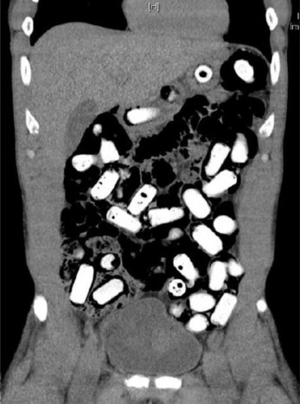Individuals suspected of drug smuggling by ingestion of drug packages (known as body packers) may be brought to emergency departments for abdominal computed tomography (CT) scanning. Emergency department clinicians may interpret these CT scans if formal radiology interpretation is not available overnight. Missing concealed drug packages has important clinical implications, as the packages may rupture leading to fatal overdose.
Asha et al ² investigated the sensitivity and specificity of emergency department physicians for the detection of concealed drugs using abdominal CT and evaluated whether different CT viewing settings influenced diagnostic performance. These settings were abdominal windows versus abdominal + lung windows with different windows varying in their gray scale and contrast settings. The study population consisted of 30 consecutive positive and 30 consecutive negative CT scans of patients suspected of concealing drugs, based on the formal radiology reports as the gold standard.
Figure Example of a positive CT scan for body packing.
A portion of Table 1 from the study is reproduced below:
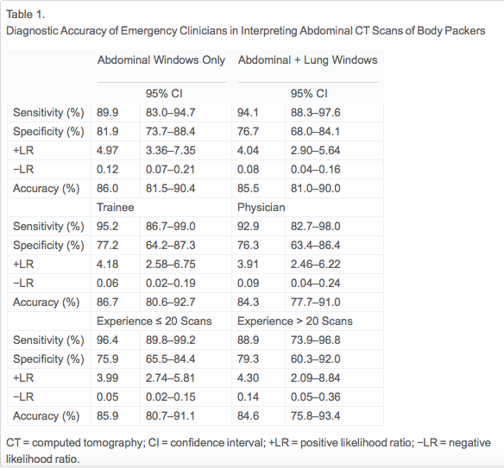

a. How does the design of this study influence the reported accuracy value reported by the authors? [2]
b. The authors, arguing for the use of abdominal + lung windows, wrote: “From an ED perspective, higher sensitivity is a desirable characteristic, as the risk of discharging a patient inadvertently with concealed drugs is lower, which is more important than the consequences of an increase in false positives, which would only result in the patient being kept in the hospital under observation until a formal radiology report was available. However, even with this higher sensitivity, the false-negative rate is too high to be acceptable. Based on our experience, where approximately 60 patients per year are brought for CT scanning and one in every four people is found to be concealing drugs, this would equate to a miss rate of about two cases per year. There would also be about 25 travelers held in police custody inappropriately.”
i. Create a 2x2 table describing the scenario presented above. [2]

ii. Are the authors' estimates of the miss rate and inappropriate police holds consistent with the prior probability they provided from their experience and the sensitivity and specificity they reported for CT using abdominal + lung windows in Table 1? [2]

c. Assume that the cost of discharging a patient with concealed drugs is 10 times greater than the cost of falsely detaining a patient until the morning for observation (the "treatment"). Assume there is no cost (T) of the CT scan.
i. What are the “no treat-test” and “test-treat” thresholds for when to perform abdominal CT using Abdomen + Lung windows from the paper's Table 1, assuming interpretation by emergency department physicians? You may check your work with the calculator, but do it by hand and show your work. [2]

ii. Explain what these thresholds mean. [2]
d. Repeat part c, but this time assume that the cost of the CT scan is 1/5 of the cost of an unnecessary overnight hospitalization. You can use the calculator and need not show your work. [2]

e. The authors reported that they measured inter-rater reliability of the ED physicians for whether the CT scan was or was not positive for packing. Here are simulated data:

 |  | ED Reader 2
 |  | Positive | Negative
ED Reader 1 | Positive | 52 | 13 | 65
ED Reader 1 | Negative | 17 | 33 | 50
 |  | 69 | 46 | 115

Calculate observed percent agreement, expected percent agreement, and kappa. [3]

f. The authors reported Kappa = 0.46 (95% CI 0.30−0.62, P<0.001). Which of the following statements about that Kappa and its 95% CI are true? Explain
i. The Kappa of 0.46 indicates agreement was worse than would be expected by chance alone, since by chance we would expect ~50% agreement. [2]
ii. If ED raters agreed that packing was to be expected in only about 25% of CT scans, then we would expect them to agree > 50% of the time, even if they did not know what they were doing. [2]
iii. The authors of this study could have obtained a higher Kappa value (without at all changing their study or their data) simply by calculating a quadratic-weighted Kappa. [2]
iv. If we were to repeat this study 100 times, we would expect the 95% confidence intervals of about 95 of the studies to include the population value for Kappa (i.e., the number the investigators are trying to estimate, assuming each study provides a valid estimate). [2]

3. Evaluation of a Breast/Ovarian Cancer Genetics Referral Screening Tool (with thanks to Yi-Hsuan Wu
Mutations in BRCA1 and BRCA2 (BRCA1/2) genes increase the risk of breast and ovarian cancer, but the genetic test for them is costly. There are models to assess the probability of carrying a BRCA1/2 mutation, but they are complicated. A referral screening tool (RST) was designed for use in primary care practice to help clinicians select patients for BRCA testing. Bellcross et al.³ evaluated the accuracy of the RST.
From the abstract:
Methods: The RST was administered to 2464 unselected women undergoing screening mammography. Detailed four-generation cancer pedigrees were collected by telephone interview on a random subset of 296 women. The pedigrees were analyzed using four established hereditary risk models (BRCAPRO, Myriad II, BOADICEA, FHAT), with a ≥10% BRCA1/2 mutation probability as the definition of “high risk.”
Results: The RST identified 6.2% of subjects as screen “positive” (high risk). … In comparison with the pedigree analyses, the RST demonstrated an overall (high risk by any model) sensitivity of 81.2%, specificity of 91.9%, [PPV of 80%, NPV of 92%], and discriminatory accuracy of 0.87.
a) Based on the abstract, what is the “gold standard” the authors used for calculating the overall sensitivity and specificity of the RST (the screening test)? [2]

The authors described selecting the 296 subjects for pedigree analysis by randomly sampling approximately 1/3 of them from the population group that was positive on the RST and 2/3 from the population group that was negative on the RST. They chose to take 1/3 of their sample (randomly) from the RST-positive group even though this group only represented 6.2% of the population, saying:
“The positive [group was] intentionally oversampled to provide a sufficient number of potentially high-risk pedigrees to adequately address sensitivity.”
b) If they did not take this oversampling into account when calculating sensitivity and specificity, would the described oversampling cause bias in the estimates of the sensitivity and specificity of the RST? If so, in which direction? [2]

The following table shows results in the sample (n= 296) consistent with what the authors reported
Sample |  | Risk based on pedigree analysis and risk models
 |  | High risk | Low risk | Total
RST | Positive | 69 | 17 | 86 | PPV= 80%
RST | Negative | 16 | 194 | 210 | NPV= 92%
RST | Total | 85 | 211 | 296
 |  | Sensitivity= 81.2% | Specificity= 91.9%
Now you want to know the sensitivity and specificity of RST in the mammography population (n= 2464) to see if the estimates of sensitivity and specificity in the sample were biased.

c) Given the percentage of subjects in the entire study identified as RST positive (6.2% in the abstract) and the predictive values observed, complete the following 2x2 table and calculate the sensitivity and specificity of RST in the mammography population. [Hint: First figure out how many in the entire population tested positive.][ 2]

Population |  | Overall risk by pedigree analysis
 |  | High risk | Low risk | Total
RST | Positive |  |  |  | PPV= 80%
RST | Negative |  |  |  | NPV= 92%
RST | Total |  |  | 2464
 |  | Sensitivity= | Specificity=

d) Compared to the sensitivity and specificity of the RST in the mammography population you obtained from (c), do you think the sensitivity and specificity of RST the authors reported in the abstract are biased? [2]

In the Results section the authors wrote:
“It should be noted that these predictive values are not representative of those that would be obtained in a general mammography population, as … high-risk subjects were intentionally oversampled. Using the prevalence of 6.2% RST screen-positive individuals in this study, and the overall sensitivity and specificity obtained, the PPV and NPV values expected in a general mammography population would be 0.39 and 0.78, respectively.”
e) With your answers from (b) to (d), do you agree with the authors that the PPV and NPV, not the sensitivity and specificity, are the measures needed to be adjusted to be representative of the ones in the mammography population? Why? [2]

4. Clinical prediction rule for testicular torsion (with thanks to Tom Gaither, James Salazar and Katherine Wai).
(Note: Testicular torsion (TT) is when the testicle twists upon itself, cutting off its blood supply. Once this occurs, we have 6 hours to operatively fix the testicle or it will result in testicular loss. Exploration means a surgery was done. Surgery is the gold standard for TT diagnosis).

Read the following abstract (Boettcher et al⁴) and answer the questions below.

Objective: To test the clinical and sonographic (ultrasound) predictors of testicular torsion (TT) with the aim of reducing negative exploration rates.
Patients and Methods: We performed a prospective study of all boys treated for ‘acute scrotum’ between January 2011 and April 2012 and clinical findings were documented. If available, ultrasonography was added to the diagnostic evaluation. A prediction of the diagnosis was based on clinical and sonographic features, and was followed by surgical exploration in all patients.
Results
104 patients were included. No single finding excluded TT. The clinical features (pain <24 hrs, nausea/vomiting, abnormal cremaster reflex, high position of the testis) appeared predictive (100% sensitivity) and the clinical scoring system was proven to be reliable, reducing the negative exploration rate by >55%. US alone was not able to identify all boys with TT.

Use the following 2x2 table to answer the questions.
Clinical features | TT | No TT | Total
Any of the 4 clinical features | 12 | 34 | 46
None of the 4 clinical features | 0 | 58 | 58
Total | 12 | 92 | 104

a. What is the specificity of the clinical prediction rule for TT? [1]

b. If your patient is a boy similar to the ones in this study with an acute scrotum and he has at least one of the 4 clinical features, what is your best estimate of his probability of testicular torsion? [1]

c. The authors report that ultrasound was 91% sensitive and 87% specific for TT. What effect would reliance on ultrasound rather than the clinical score be expected to have on the "negative exploration rate"? [1] (A qualitative answer is OK here.)

d. What would be the main disadvantage of using ultrasound compared with the prediction rule (neglecting costs and delays)? [1]

e. This study included consecutive boys with "acute scrotum" who were going to be explored surgically. The 4 clinical features included in the decision rule (pain <24 hours, nausea/vomiting, abnormal cremasteric reflex, high position of the testis) were undoubtedly used to help decide who had an “acute scrotum” and hence would be included in the study. What bias would that cause, and how would it be expected to affect the estimates of sensitivity and specificity of the clinical prediction rule for testicular torsion? [2]

So far, we have been discussing the real Boettcher study. Suppose that, to avoid the problem noted in Part e above, the same authors performed a new study including consecutive boys with a chief complaint of scrotal pain at triage whether or not the evaluating MD (or anybody else) thought the patient had an “acute scrotum.” Although all boys with a chief complaint of scrotal pain were included, those who were felt to have “acute scrotum” were taken to the operating room as in the real Boettcher study, but those who were not felt to have “acute scrotum” received a follow-up urological evaluation including ultrasound at 24 hours and again at 1 week. If either of these evaluations showed testicular torsion, absence of blood flow to the testis, or a non-viable testis, the patient was counted as having TT (i.e., D+). Otherwise, he was considered not to have TT (i.e, D-). Assume that TT sometimes resolves spontaneously (which is true), but doesn't develop in the week of follow-up among boys who did not already have it.

f) Compare this new study to a hypothetical study in which all the subjects receive surgical exploration regardless of whether they have “acute scrotum.” What is the name of the bias that the new study would have, and how would the clinical prediction rule’s sensitivity and specificity in the new study compare with the sensitivity and the specificity in the hypothetical study.[2]

g. The paper does not include information about how the clinical prediction rule was derived, but we do know that they examined at least 17 possible predictors, because they list that many in Table 2. What is the name for the problem this is likely to cause, which would lead to worse performance of their rule in other populations? [1]

h. Here is an imaginary addition to their methods section. "We developed our clinical prediction rule by developing and testing many such rules in a derivation dataset. The 4-symptom rule we report here was the one that performed best in a separate validation dataset." If the authors had validated their prediction rule in that way, would it prevent the problem described in part g? Explain. [2]

i. Among those with testicular torsion, 11/12 (91.7%) had pain duration < 24 hours. Using the shortcut in the text, what is the approximate lower limit of the 95% CI for the sensitivity of this finding? (You can check your work with the Stata cii command or on line at http://www.sample-size.net/confidence-interval-proportion/, but show the shortcut calculation.) [2]

5. Macitentan for pulmonary hypertension (with thanks to Mitchell Psotka)
Pulmonary arterial hypertension (PAH; high pressure in the arteries of the lungs), is a rare, debilitating, and fatal disease. Few medications improve the lives of these patients, and all are expensive. Furthermore, the only medication that decreases mortality is available only intravenously, which is difficult for patients and providers. Pulido et al⁵ recently reported on a randomized trial of a new oral medication, the endothelin receptor antagonist macitentan.

From the abstract:
Methods (abbreviated): We randomly assigned patients with symptomatic pulmonary arterial hypertension to receive placebo once daily, macitentan at a once-daily dose of 3 mg, or macitentan at a once-daily dose of 10 mg. The primary end point was the time from the initiation of treatment to the first occurrence of a composite end point of death, lung transplantation, initiation of treatment with intravenous therapy, or worsening of pulmonary arterial hypertension.
- Based on what you know so far, at the very least who is blinded in this study? [1] Hint posted on forum 11/24/15: "This is not meant to be tricky (or even very challenging). You don't need to look up the original article. One aspect of the study would (if done successfully) ensure that at least some of those involved with the study are blinded (otherwise it would be pointless)."

- Who else should be blinded and for which exposures and outcomes? [2]

- The authors conclude that “Macitentan significantly reduced morbidity and mortality among patients with pulmonary arterial hypertension in this event-driven study.” Based on the results in the table above, do you agree? [2]

- A pharmaceutical representative comes to your office and tells you that although macitentan is expensive ($7,337 for 30 10 mg tablets), treatment reduced the risk of trial endpoints ("All events related to PAH or death in table above) by 32% so the number needed to treat is not very high. Do you agree? (Note: Only the 10 mg dose of macitentan is available for prescription). [2]

- Based on your calculations, what is the approximate medication cost to prevent one patient from having an event, assuming 90 weeks of treatment? (The study was 100 weeks, but subjects who died before the end of the study would not incur treatment costs, so 90 weeks of treatment would be a better estimate.) [2]

(f) There were 14 deaths due to PAH in the placebo group and 7 in the macitentan 10 mg/d group (P=0.07), so that the null hypothesis of no difference in PAH mortality was not rejected. What would be the most clinically relevant way to express this negative result? [2]

6. Predicting chemotherapy toxicity in older adults (with thanks to Melisa Wong and Xiao Wei).

Older adults with cancer may be at higher risk of side effects from chemotherapy than younger, fit patients. Oncologists often use the Karnofsky Performance Status (KPS) score to assess a patient’s overall fitness to help them decide if a patient is a good candidate for chemotherapy. The KPS score ranges (in increments of 10) from 0 (dead) to 100 (normal, no complaints, no evidence of disease). A score of 70 on the KPS means able to care for self, but unable to carry on normal activity or to do active work.

Hurria et al⁶ developed a chemotherapy toxicity score to predict the risk of grade 3 to 5 toxicity (grade 3 is a severe side effect, grade 5 is death). The score has 11 items: age, type of cancer, number of chemotherapy drugs, dosing, hemoglobin, creatinine clearance, hearing impairment, recent falls, social support, ability to perform instrumental activities of daily living, and ability to walk one block.

The chemotherapy toxicity score was tested in 500 patients age > 65 with cancer. All patients received chemotherapy and their observed grade 3 to 5 toxicities were recorded.
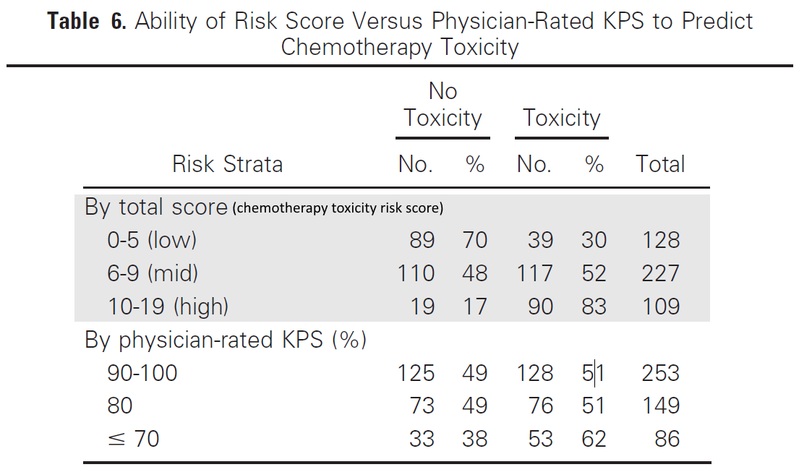
a) Using the data provided in Table 6 above, plot the ROC curve for the chemotherapy toxicity risk score and the ROC curve for physician-rated KPS. Plot both curves on the same ROC template below. Clearly label which ROC curve corresponds to which score and the line segments of each curve. (Note the KPS is just a score in increments of 10, not a percent; the table is mislabeled.)[5]
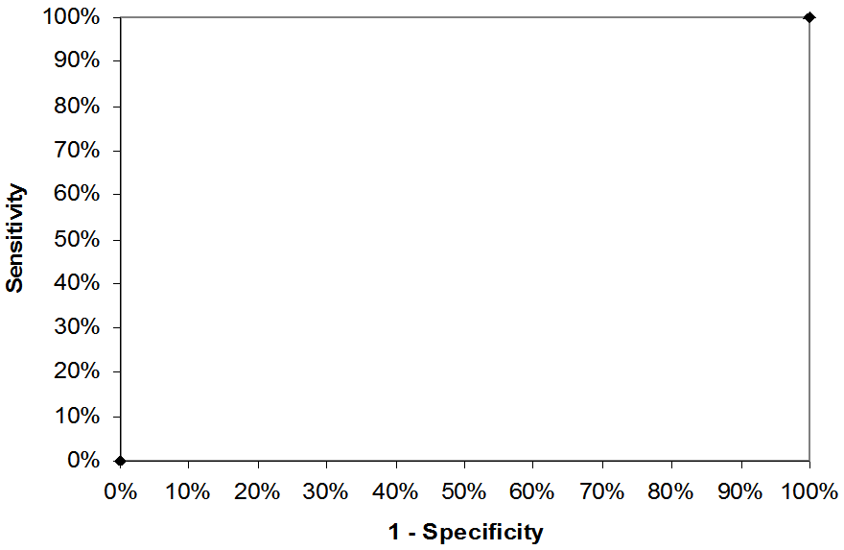

b) Which score (chemotherapy toxicity risk score or physician-rate KPS score) better discriminates between those who will and will not develop chemotherapy toxicity? Explain your answer. [2]

c.) If your patient has a pre-test probability of a grade 3-5 toxicity of 15% and a chemotherapy toxicity risk score of 7, based on this study what is your best estimate of her post-test probability of toxicity? (Show all steps of your work.) [3]

d.) If the clinicians caring for the patients, did use the KPS score, but used it not only to select subjects for chemotherapy, but to reduce the dose in those at perceived higher risk of toxicity, how could that have affected the discrimination of the KPS in this study? [2]

e.) (Extra credit) Could the investigators' choice of the 2 cut-offs (3 intervals) reported in Table 6 for the KPS have made it look substantially worse than it really is? That is, could they substantially increase the area under the ROC curve by adding more points or changing the cutoffs? Explain [+3]

7. USPSTF recommendations and PSA screening
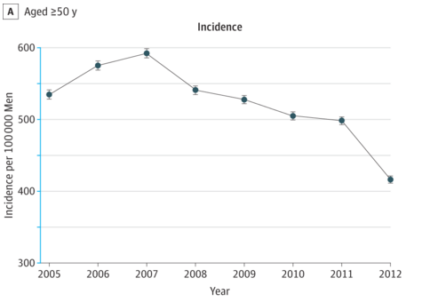Jemal et al ⁷ recently (JAMA, 11/17/15!) reported that following recommendations against prostate-specific antigen (PSA) screening by the US Preventive Services Task Force (USPSTF), both PSA screening and prostate cancer incidence declined. However, it is not yet clear whether this is a cause for concern or for celebration.
A.) For each of the following statements about hypothetical additional data, explain whether it would raise concern that we should be screening more (BAD), celebrate that we are screening less (GOOD), or provide no useful information to answer the question (NOT HELPFUL). (HINT: What this means is: Prostate cancer screening declined. You don't know if this is good or bad. Read the three statements. Does the information presented in each statement help you decide whether the decline in prostate cancer is good or bad? or is the information presented not helpful to make this call?)

- While the overall incidence of prostate cancer has declined, the proportion of prostate cancers that already had distant metastases at the time of diagnosis has increased. [2]

- Over the next 5-10 years, prostate cancer mortality (per 100,000) increases compared with when PSA screening was more common. [2]

- 5-year survival for patients with prostate cancer declines over the next 5 years. [2]

B.) Indicate whether each of the statements below is true or false, and explain your answer.

- One reason why we might see an apparent decline in prostate cancer mortality is that decreased screening could lead to a reduction in sticky diagnosis bias. [2]

- One reason why we might see real decline in prostate cancer mortality is from less treatment of pseudodisease. [2]

- There could be a slight decrease in mortality due to causes other than prostate cancer with less screening, because of previous slippery linkage bias. [2]

8. French cohort study of screening for PDA
During fetal life, blood is shunted from the pulmonary artery to the aorta via the ductus arteriosus (there's no point having all of the blood go to the lungs, since the fetus is not breathing). Once the baby is born, the ductus is supposed to close, but sometimes that doesn't happen, especially in preterm babies, and they have a patent ductus arteriosus (PDA). Whether or not to treat PDA's with medicine or surgery and even whether to look for them is controversial. Roze et al⁸ examined whether screening for PDA with ultrasound in the first 3 days affected treatment for PDA and in-hospital mortality among infants born at 24-28 weeks gestation. They used propensity matching to compare outcomes among 605 infants who were screened and 605 infants who were not, matching on the propensity score for screening. From the abstract:

RESULTS Among the 1513 preterm infants with data available to determine exposure, 847
were screened for PDA and 666 were not; 605 infants from each group could be paired.
Exposed infants were treated for PDA more frequently during their hospitalization than
nonexposed infants (55.1%vs 43.1%; odds ratio [OR], 1.62 [95%CI, 1.31 to 2.00] …Exposed infants had a lower hospital death rate (14.2%vs 18.5%; OR, 0.73 [95%CI, 0.54 to 0.98]; ARR, 4.3 [95%
CI, 0.3 to 8.3]).

a. PDA treatment was significantly more common among the "exposed" (screened) infants. Why didn't the propensity matching lead to equal numbers of treated infants in the two groups? [2]
b. Many infants in both groups did not have a PDA diagnosed. Should diagnosis of PDA have been included in the propensity score? Why or why not? [2]

c. Before matching the exposed infants had higher propensity scores than the unexposed infants. Why would that be the case? [2]

d. To supplement their propensity analysis, the authors also did an instrumental variable analysis, using neonatal unit preference for early screening (in quartiles) as the instrument for actual screening. An alternative approach would be to use screening itself as an instrument for PDA treatment in the propensity-matched groups.
i. If we used this latter approach, what would we need to assume about the relation between PDA treatment, screening, and in-hospital mortality? (Hint: You can that PDA treatment is the exposure, screening is the instrument and mortality is the outcome.) [2]

ii. If the assumption(s) above are valid, what would the estimated effect of PDA treatment on mortality need to be to yield the 4.3% absolute risk reduction observed by the authors for PDA screening? (Hint: the answer is an absolute risk reduction and you can calculate it from numbers above.) [2]

iii. To which subset of treated infants would that estimate apply? [2]

REFERENCES

1. Cannon CP, Blazing MA, Giugliano RP, et al. Ezetimibe Added to Statin Therapy after Acute Coronary Syndromes. N Engl J Med. 2015;372(25):2387-2397.
2. Asha SE, Cooke A. Sensitivity and Specificity of Emergency Physicians and Trainees for Identifying Internally Concealed Drug Packages on Abdominal Computed Tomography Scan: Do Lung Windows Improve Accuracy? J Emerg Med. 2015;49(3):268-273.
3. Bellcross CA, Lemke AA, Pape LS, Tess AL, Meisner LT. Evaluation of a breast/ovarian cancer genetics referral screening tool in a mammography population. Genet Med. 2009;11(11):783-789.
4. Boettcher M, Krebs T, Bergholz R, Wenke K, Aronson D, Reinshagen K. Clinical and sonographic features predict testicular torsion in children: a prospective study. BJU international. 2013;112(8):1201-1206.
5. Pulido T, Adzerikho I, Channick RN, et al. Macitentan and morbidity and mortality in pulmonary arterial hypertension. N Engl J Med. 2013;369(9):809-818.
6. Hurria A, Togawa K, Mohile SG, et al. Predicting chemotherapy toxicity in older adults with cancer: a prospective multicenter study. J Clin Oncol. 2011;29(25):3457-3465.
7. Jemal A, Fedewa SA, Ma J, et al. Prostate Cancer Incidence and PSA Testing Patterns in Relation to USPSTF Screening Recommendations. JAMA. 2015;314(19):2054-2061.
8. Roze JC, Cambonie G, Marchand-Martin L, et al. Association Between Early Screening for Patent Ductus Arteriosus and In-Hospital Mortality Among Extremely Preterm Infants. JAMA. 2015;313(24):2441-2448.

