# | Pts Possible | Pts missed | Extra Credit
1 | 6
2 | 15
3 | 16
4* | 10
5 | 8
6 | 10
7 | 13
8* | 14
9 | 8
Total
Score
* 2 points extra credit
KEY
This Make-Up Exam has problems of equal difficulty that I replaced the I replaced the elbow extension test problem the elbow-extension test problem elbow-extension test problem the original Final Exam.

Collaboration with others is NOT permitted. Answers must be in your own words. Do not try to find the answers by searching for old finals or problems sets. No exceptions. Really.

Please show your work.

1. NINDS Study
A New York Times article (5/28/2007) summarized the results of the NINDS randomized blinded trial of t-PA (tissue plasminogen activator) within 3 hours of symptom onset in acute ischemic stroke.¹ The following follows the wording of the original Times article, but we changed the numbers.
In 1995, after 40 years of trying to find something to break up blood clots in the brain, the cause of most strokes, researchers announced that tPA worked. A large federal study showed that, without it, about one patient in four escaped serious injury. With it, one in three escaped. The drug had a serious side effect — it could cause potentially life-threatening bleeding in the brain in about 5 percent of patients.
Use the numbers in this quote to answer the following questions.

- What was the risk of serious injury in the placebo group? [1]

b) What was the risk of serious injury in the t-PA group? [1]

c) What is the absolute risk reduction (ARR) and number needed to treat (NNT) with tPA to prevent one ischemic stroke patient from suffering serious injury? [2]

d) What is tPA’s absolute risk increase (ARI) for serious intracranial bleed (“bleeding in the brain”)? What is the number needed to harm? [2]

2. Malaria Test
Investigators did a study at mobile clinics in rural Uganda on the accuracy of a rapid test for malaria in febrile adult HIV patients. The gold standard for diagnosis of malaria was a “thick smear” at a distant central laboratory. You may assume that this is an appropriate gold standard and that they tested a consecutive sample of qualifying patients.

In the absence of a rapid test, the clinicians in the mobile clinics have to decide whether to treat presumptively for malaria while awaiting the thick smear result. Assume that it is 9 times as bad to delay treatment of malaria in someone who has it as it is to treat someone presumptively who does not have it.

- What is the threshold probability for presumptive treatment? [1]

Prior to doing the study, the authors estimated that the prevalence of malaria in the study subjects (febrile adult HIV patients presenting to the mobile clinics) would be approximately 40%.

- If that 40% prior probability was correct, in the absence of a rapid test should the clinicians be treating the patients presumptively for malaria? Why? [1]

c) Do you agree with the following sentence from the paper? Explain. [1]

“A point-of-care rapid diagnostic test with high specificity would allow clinicians to "rule out" malaria and to focus on the correct detection and management of other febrile illnesses.”

From the abstract,

“Two hundred forty-six samples were analyzed, including 14 (5.7%) which were thick-smear positive for … malaria. Sensitivity of Binax Now® compared with thick smear was 92.9% (95% CI: 66.1–99.8), specificity 97.8% (95% CI: 95.0–99.3), positive and negative predictive values were 72.2% (95% CI: 46.5–90.3) and 99.6% (95% CI: 97.6–99.9), respectively.”

- Fill in the following 2×2 table with the absolute numbers of malaria patients, assuming the sensitivity and specificity are correct. [4]

 |  | Thick Smear
 |  | Positive | Negative | Total
Rapid  Test | Positive
Rapid  Test | Negative

- Are their estimates of positive and negative predictive value correct? [2]

f.) Assume that the malaria rapid diagnostic test is costless. Using the misclassification cost ratio provided in part (a) and the information about accuracy provided in part (d), calculate the No Treat—Test and Test—Treat thresholds for the Binax Now® rapid diagnostic test. Show your work. [4]

From the paper’s conclusion:

“[The] rapid diagnostic test served as an effective point-of-care tool for fever management in HIV-positive adults in a malaria-endemic area. Its high negative predictive value of 99.2% indicates that in similar populations of febrile outpatient HIV-positive adults, a negative rapid test can be useful for "ruling out" malaria at the point of care.”

The authors are saying that, in the absence of a rapid test, they should treat presumptively while awaiting the thick smear result, but if they have the test available, they can do the test and withhold presumptive treatment when it is negative.

g) Making the same assumptions as you did in part a), comment on whether you agree with the authors:

i) if their previous estimate of prior probability (40%) was correct [1]

ii) if the actual prior probability they found in their study was correct. [1]
.

3. In an often-quoted paper, Elmore et al ² reported on the inter- and intra-rater reliability and accuracy of the mammogram for diagnosing breast cancer. They compared the readings by 10 radiologists on 150 mammograms.

Here is a simulated table comparing the mammogram readings of Radiologist A and Radiologist B.

 |  | Radiologist B
 |  | Normal | Benign | Indeterminate | Malignant
Radiologist A | Normal | 35 | 6 | 2 | 2 |  | 45
Radiologist A | Benign | 34 | 15 | 4 | 2 |  | 55
Radiologist A | Indeterminate | 0 | 0 | 4 | 1 |  | 5
Radiologist A | Malignant | 1 | 19 | 0 | 25 |  | 45
 |  | 70 | 40 | 10 | 30 |  | 150

- How many complete disagreements were there? Express this as a percent of the total.[2]

- How many complete agreements were there? Express this as a percent of the total.[2]

- How many complete agreements were expected based on the marginals? Express this as percentage.[4]

d) What is (unweighted) kappa?[4]

The authors reported a linear weighted kappa of 0.49. The simulated table above produces a very similar linear weighted kappa.

e) In the table below, show the weighting system used to calculate linear weighted kappa.[4]

Weights |  | Radiologist B
 |  | Normal | Benign | Indeterminate | Malignant
Radiologist A | Normal
Radiologist A | Benign
Radiologist A | Indeterminate
Radiologist A | Malignant

f) Was the linear weighted kappa of 0.49 higher or lower than your answer to part (d)? Briefly explain the difference.[4]

4. Bhandari et al³ prospectively studied 163 consecutive infants who were evaluated for sepsis and correlated blood test results with diagnoses of confirmed and suspected sepsis.

Table 3 from that paper is shown below:

- Can positive and negative predictive value be estimated from this study design? Explain. [2]

b. The ANC (absolute neutrophil count) was defined a priori as abnormal if it was <7,500 or >14,500 cells/mm³. The cutoff for the CD64 index was chosen after looking at the data. How does this affect the comparison between the two? [2]

c. The sensitivity and specificity estimates in Table 3 above include as D+ individuals both those with "suspected sepsis" and those with confirmed sepsis. The methods section of the paper states:

"Of infants with negative culture results, those with a positive sepsis score (≥ 2 of the hematologic criteria enumerated above) were categorized as having suspected sepsis, whereas the remaining infants were categorized as having no sepsis."

What bias could this cause, and how would you expect it to affect the results in Table 3? [3]

d. Below are ROC curves for the 5 individual tests in Table 3 of the paper. Unlike the sensitivity and specificity estimates in Table 3, which included as D+ both infants with “suspected sepsis” and infants with sepsis confirmed by culture, these ROC curves only counted as D+ sepsis confirmed by culture. Based on these curves (not any data provided above or in the paper), how many infants do you think had sepsis confirmed by culture? Explain how you can tell without referring back to the paper. (Note you can see the colors of the lines in the electronic version of the final on the Epi 204 web site, but you do not need to in order to answer this question.) [3]

e. (EXTRA CREDIT) The row labeled "ANC and CD64" shows 95% sensitivity and 57% specificity for the combination of the two tests. The investigators do not indicate how the two tests were combined, i.e., whether the test pair was considered positive if either test was positive (in which case the row might better be labeled 'ANC or CD64') or whether it was only considered positive if both tests were positive. From the sensitivity and specificity reported in that row of the table, what can you tell about how the tests were combined? [+2]

5. Low Risk Appendicitis Rule
In order to decrease CT imaging in children, Kharbanda et al developed a decision rule for predicting children at low enough risk for appendicitis to discharge without imaging (but precautions to return if worse). They developed the rule in a dataset of children with possible appendicitis and validated it in a similar group. Here is the rule and the results from the validation dataset. (ANC stands for absolute neutrophil count, which is the count of a particular type of white blood cells. RLQ stands for the Right Lower Quadrant of the abdomen.)

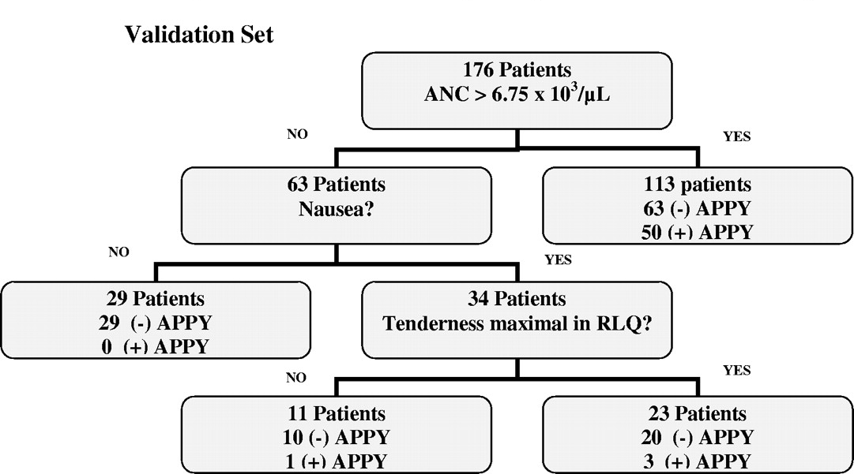
Anupam B. Kharbanda et al. Pediatrics 2005;116:709-716

a) Is following statement TRUE or FALSE? Explain your answer. [1]

This rule was likely created using logistic regression.

b) As you see, the rule divides the population into 4 groups. The 2 groups on the left of the figure are the “Low Risk” groups. A child with an ANC count of 5.0 x 10³ /uL is nauseated but does not have RLQ (right lower quadrant) tenderness. Is she considered low risk? [1]

In 2012, the same investigators attempted to validate the rule in a much larger population, but of the 573 children assigned to the low-risk group 42 (7.3%) had appendicitis. This number was felt to be too high, so the authors refined the rule.

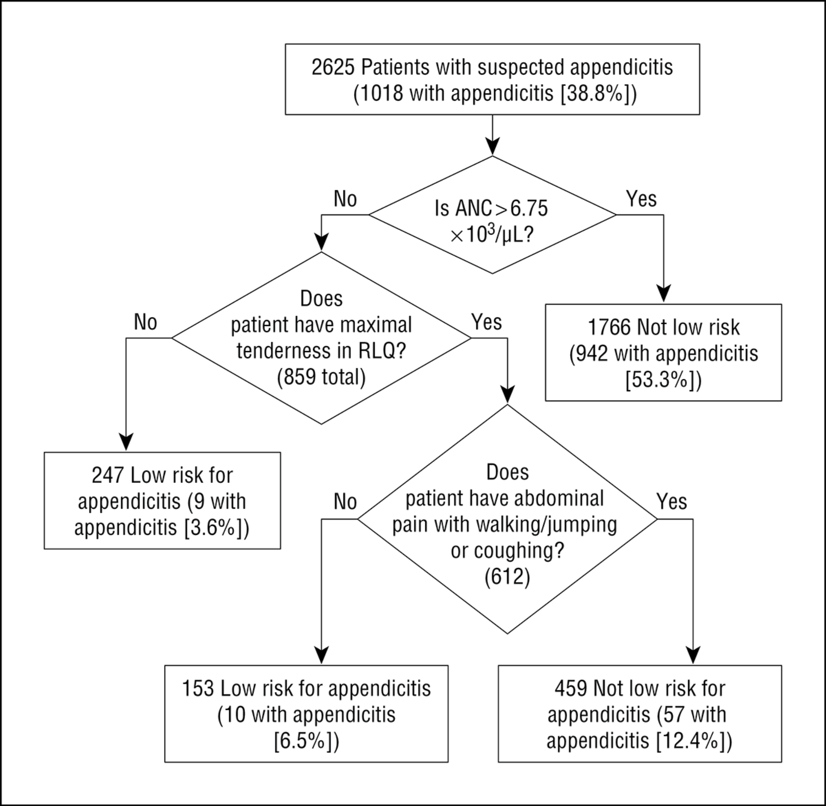

If you compare the original and refined rules, you will see that the nausea question has been removed and a new question has been added. With this refinement the proportion with appendicitis in the “Low Risk” group was 4.8%.

c) Would it be fair characterize the refined rule as a “clinical decision rule validated in a dataset of 2625 patients with suspected appendicitis? If not, why not? [2]

Assume the risks reported in the tree for the refined rule are perfectly accurate. For example, you can assume that the true average risk of appendicitis in patients categorized by the refined rule as “Low Risk” is (10 + 9)/(247 + 153) = 4.8%. Further assume that your risk threshold for further work-up is 5%.

For each of the following patients, choose between DISCHARGE and WORK-UP.

d) A child with an ANC count of 9.0 x 10³ /uL who does not have RLQ (right lower quadrant) tenderness? [2]

- A child with an ANC count of 5.0 x 10³ /uL who is maximally tender in the RLQ but does not have any pain on walking, jumping, or coughing.[2]

6. CALFRAST
A quick screening test for hearing loss is the Calibrated Finger Rub Auditory Screening Test (CALFRAST). The examiner with arms extended stands facing the patient and rubs her fingers together strongly and asks it the patient can hear the rubbing sound on each side. Because this strong stimulus is presented about 70 cm from the patient's ear, it is called CALFRAST Strong 70. If the patient can hear the finger rubbing, the examiner repeats the test at the quietest level the examiner can hear (CALFRAST Faint 70). Torres-Russotto et al⁴ recently reported test characteristics for the CALFRAST, using audiometry as the gold standard, with normal hearing defined as < 25 decibel loss at 1000, 2000 and 4000 Hz.

Results from a consecutive sample of consenting patients are summarized in Table 2 from that study:

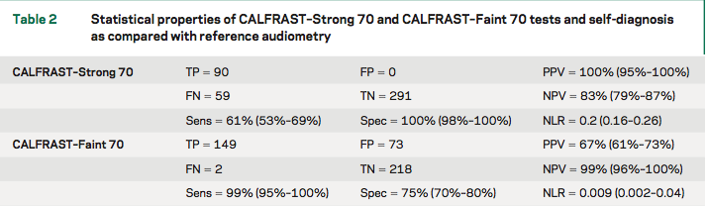

- Draw and label an ROC curve that summarizes the accuracy of the CALFRAST Faint 70 and Strong 70 results summarized above as a single test. [4]
HINTS: 1) There are 2 fewer subjects for the STRONG 70 than the FAINT 70. You can ignore this and just use the percentages calculated by the authors in Table 2 above. 2) For this problem we are asking you to consider the CALFRAST as a SINGLE MUTLI-LEVEL test, where not hearing a strong stimulus is a more abnormal result than not hearing a faint stimulus.
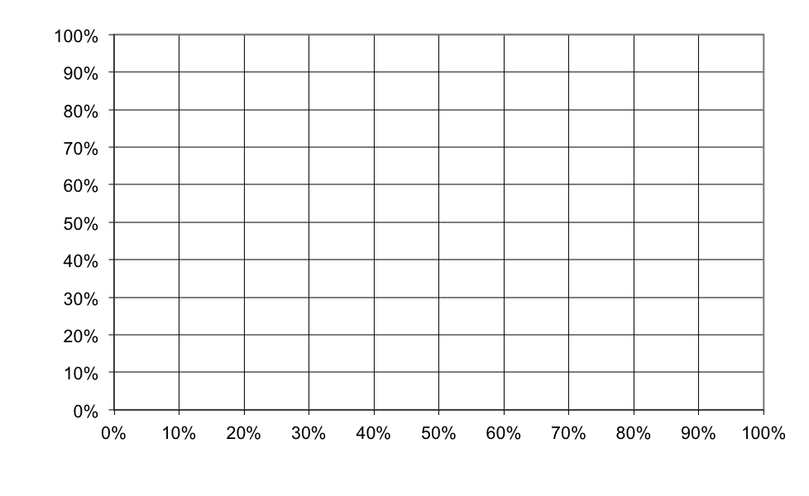
The study also examined the patient’s self assessment of hearing compared with the same gold standard, as shown in the continuation of Table 2 below.

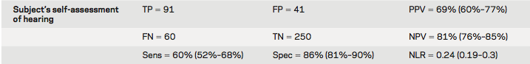

b. You are seeing a patient similar to those included in this study whose self-assessment is that his hearing is OK. What would be that patient's prior probability (before the CALFRAST) of ≥ 25 dB hearing loss? [2]

c. Suppose a patient with a 20% prior probability of hearing loss can hear the strong stimulus, but not the weak stimulus. What is your best estimate that he has significant (at least 25 decibels) hearing loss? [4]

7. Cervical Cancer Screening In India

In the developing world, cervical cancer death rates have not decreased the way they have in the developed world. A cluster-randomized trial in India showed that a one-time HPV screening program reduced cervical cancer death rates compared with usual care.⁵ Simplified results are shown in the following table:

 | N | Avg Follow-up (yr) | Cervical Cancers Diagnosed | Cervical Cancer Deaths | Deaths/ 1000 women
Offered HPV Screening | 34126 | 7.9 | 127 | 34 | 1.0
Control | 31488 | 7.9 | 118 | 64 | 2.0
P =0.0006
a) Number Needed to Screen: How many women need to be offered HPV screening to prevent one cervical cancer death at 7.9 years of follow-up? [2]

b) The above represents an “intention-to-treat” analysis. Roughly 80% of the women who were offered HPV screening received it and none of the control group received HPV screening. Would the true number needed to screen be higher or lower than the number calculated in part (a)? [2]

Roughly the same number of cervical cancers were diagnosed in the group offered HPV screening and the control group (127 vs. 118). The table below shows the distribution of cancer diagnoses by stage at diagnosis.

Stage At Diagnosis | HPV Screening or Control? | HPV Screening or Control?
1A | 6% | 37%
1B | 22% | 26%
≥II | 69% | 31%
Unknown | 3% | 6%

c) Which column do you think represents the group offered HPV Screening? Explain your choice. [2]

d) In the following table, state whether the listed factor could explain why this study found that HPV screening REDUCED cervical cancer mortality. Briefly explain your answer. [9]

 | Explains Finding That HPV Screening Reduces deaths
 | Yes/No | Explain Answer
Volunteer Bias
Lead-Time Bias
Length Bias
Stage Migration Bias
Pseudodisease
Sticky Diagnosis Bias
Slippery Linkage Bias
Crossover Between Groups
Chance

8. Investigators from the National Heart, Lung and Blood Institute Acute Respiratory Disease Syndrome Network used data from one of their clinical trials ("ARMA") to develop a predictive index for mortality in patients with acute lung injury⁶. The model assigns a total of zero to 5 points, as shown in Table 2, reprinted from the paper below:
For example, a 55 year old with a bilirubin of 2.5, net fluid balance of +1500 ml and a hematocrit of 23 would have 1+1+0+1 = 3 points on this scale. Mortality predicted from the model, along with mortality observed in ARMA and in a second clinical trial ("ALVEOLI") used to validate the results are shown in Table 3:

a. Which of the following statements about this study are true? Explain your answers.

- Table 3 shows that the calibration of the model was similar in the two groups of patients (ARMA and ALVEOLI). [2]

- Recursive partitioning is a good way to develop point scores for a prognostic index like this. [2]
iii. Lack of blinding of treating clinicians to the components of the score may have led to improved prediction [2]

iv. Lack of blinding of those ascertaining outcome to the components of the score may have led to improved prediction [2]
v. Table 3 would be more relevant to practicing clinicians if it also included the negative likelihood ratio for each row. [2]

b. Figure 2 from that paper compares ROC curves for the new index with that of the Acute Physiology Assessment and Chronic Health Evaluation (APACHE) score in the development (ARMA) and validation (ALVEOLI) cohorts.
i. Is the lower area under the ROC curve for the custom model in the validation dataset (compared with the development cohort) expected? Why? [2]

- Why are the curves for the custom model so much smoother than those for APACHE (in both panels)? [2]
c.) EXTRA CREDIT: How can the discrimination in the ALVEOLI population be worse than that in the ARMA population, when the range of observed probabilities of mortality is actually a little wider than in the ARMA population? [+2]

9. Doll and Hill’s 1950 Case-Control Study of Smoking and Lung Cancer

In 1950, Drs. Doll and Hill did a case-control study of the association between smoking and lung cancer among patients and London hospitals. The cases were hospitalized with lung cancer; the controls were sex- and age-matched patients hospitalized for another reason.

Here are the results for male patients.

 | Male Patients
 | Lung Cancer | Non-cancer
Smoker | 647 | 622
Non-Smoker | 2 | 27
 | 649 | 649 | 1298

a) What percent of the male lung cancer cases smoked? Calculate a 95% confidence interval for this proportion using the approximation in Chapter 11 of the textbook, Stata, or an online calculator. Report your answer out to 4 significant digits, e.g. 90% (85% - 95%) [2]

Here are the results for the female patients.

 | Female Patients
 | Lung Cancer | Non-cancer
Smoker | 41 | 28
Non-Smoker | 19 | 32
 | 60 | 60 | 120

Odds | 2.2 | 0.9 | 2.5 | 95% CI 1.1 – 5.6

For (b) and (c), state whether the statement is True or False and explain why

b) The odds ratio of 2.5 means that the probability of smoking in female lung cancer patients (cases) was two and a half times higher than in female non-cancer patients (controls). [2]

c) The P-value for this odds ratio is less than 0.05. [2]

d) The 95% confidence interval for the odds ratio of 1.1 to 5.6 means that the there is a 95% chance that the true odds ratio is between 1.1 and 5.6. [2]

REFERENCES

1. NINDS. Tissue plasminogen activator for acute ischemic stroke. The National Institute of Neurological Disorders and Stroke rt-PA Stroke Study Group. N Engl J Med. 1995;333(24):1581-1587.
2. Elmore JG, Wells CK, Lee CH, Howard DH, Feinstein AR. Variability in radiologists' interpretations of mammograms. N Engl J Med. 1994;331(22):1493-1499.
3. Bhandari V, Wang C, Rinder C, Rinder H. Hematologic profile of sepsis in neonates: neutrophil CD64 as a diagnostic marker. Pediatrics. 2008;121(1):129-134.
4. Torres-Russotto D, Landau WM, Harding GW, Bohne BA, Sun K, Sinatra PM. Calibrated finger rub auditory screening test (CALFRAST). Neurology. 2009;72(18):1595-1600.
5. Sankaranarayanan R, Nene BM, Shastri SS, et al. HPV screening for cervical cancer in rural India. N Engl J Med. 2009;360(14):1385-1394.
6. Cooke CR, Shah CV, Gallop R, et al. A simple clinical predictive index for objective estimates of mortality in acute lung injury. Crit Care Med. 2009;37(6):1913-1920.

Blood is taken from the patient and sent to a central laboratory where it is spread onto a microscope slide and examined for the malaria parasite by a trained microscopist.

