Please spend no more than 1 hour on this quiz or note the answers you completed after the 1 hour mark. This is open book.
A 2013 Cochrane review meta-analysis evaluated the effects of Vitamin C use on incidence of the common cold. The researchers evaluated placebo-controlled randomized trials testing 0.2 g/day or more of vitamin C. They used a pooled fixed-effects model to estimate the risk ratio for the probability of experiencing a cold while taking vitamin C (versus placebo). They identified 5 trials with a total of 598 participants undergoing intense acute physical activity (e.g., running a marathon), and reported a pooled effect estimate of RR=0.48 (95% CI: 0.36 to 0.64).
- What is the standard error of the effect estimate (hint: natural logs are easy to calculate in excel)?

- What is the 68% CI for the RR?

- Suppose I find out about 2 new trials, each with 2000 marathon runners, and estimate the RR for each. I calculate an inverse-variance weighted (fixed effects) pooled effect estimate for my new trials of RR= 1.2 (95% CI: 0.6, 2.4) and want to incorporate the new results into the previous meta-analysis. Take a guess at the new effect estimate, based on eyeballing the CIs. Best ballpark RR=?

- Now calculate a pooled effect estimate, using an inverse variance weighted estimate. RR=

- Give some possible reasons the uncertainty in the effect estimate for the new trials (each with n=2000) larger than the uncertainty from the original studies (which totaled only 598 individuals)?

Consider the (slightly edited) abstract and table 1 below.

Association of Leisure-Time Physical Activity With Risk of 26 Types of Cancer in 1.44 Million Adults
Moore et al JAMA Int Med 2016
Objective To determine the association of leisure-time physical activity with incidence of common types of cancer.
Design, Setting, and Participants We pooled data from 12 prospective US and European cohorts with self-reported physical activity (baseline 1987-2004). We used multivariable Cox regression to estimate hazard ratios (HRs) and 95% confidence intervals for associations of leisure-time physical activity with incidence of 26 types of cancer. Leisure-time physical activity levels were modeled as cohort-specific percentiles on a continuous basis and cohort-specific results were synthesized by random-effects meta-analysis. Hazard ratios for high vs low levels of activity are based on a comparison of risk at the 90th vs 10th percentiles of activity. Exposures Leisure-time physical activity of a moderate to vigorous intensity.
Results A total of 1.44 million participants (median [range] age, 59 [19-98] years; 57% female) and 186 932 cancers were included. High vs low levels of leisure-time physical activity were associated with lower risks of 13 cancers: esophageal adenocarcinoma (HR 0.58, 95% CI 0.37-0.89), liver (HR 0.73, 95% CI 0.55-0.98), lung (HR 0.74, 95% CI 0.71-0.77), kidney (HR 0.77, 95% CI 0.70-0.85), gastric cardia (HR 0.78, 95% CI 0.64-0.95), endometrial (HR 0.79, 95% CI 0.68-0.92), myeloid leukemia (HR 0.80, 95% CI 0.70-0.92), myeloma (HR 0.83, 95% CI 0.72-0.95), colon (HR 0.84, 95% CI 0.77-0.91), head and neck (HR 0.85, 95% CI 0.78-0.93), rectal (HR 0.87, 95% CI 0.80-0.95), bladder (HR 0.87, 95% CI 0.82-0.92), and breast (HR 0.90, 95% CI 0.87-0.93). Leisure-time physical activity was associated with higher risks of malignant melanoma (HR 1.27, 95% CI 1.16-1.40) and prostate cancer (HR 1.05, 95% CI 1.03-1.08).

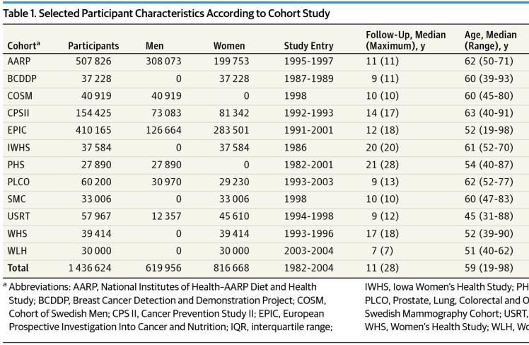

- Would you conclude from these results that the effect of physical activity is larger (better) for esophageal adenocarcinoma (HR 0.58, 95% CI 0.37-0.89) than for colon cancer (HR 0.84, 95% CI 0.77-0.91)? Explain.

- For each possible source of (selection) bias below, discuss why you consider it a potential concern in this study or why you consider it unimportant in this study. If you argue that it is a potential concern, discuss the likely direction of the bias.
- Differential survival to the time of study initiation

- Differential enrollment in the study

- Differential attrition from the study after enrollment

- Differential mortality after enrollment

- The authors examined 26 types of cancer and used a criterion of p<.05 to conclude that there was an association. Suppose in fact physical activity has no association with any type of cancer in the population; what are the chances they would have found at least one significant association in this analysis?

- Suppose they had located additional data sources to address this question, and repeated the study with 4 million people. With this new source of data (still assuming there is no association in the population, but they have a sample of 4 million) what are the chances they would have found at least one significant association in this analysis?

- Do you have concerns about the construct, internal, or external validity in this study? If so, summarize (1-2 sentences) each.

