DAGitty.net, v2.3

DAGitty.net is open source software to create and analyze directed acyclic graphs (DAGs). Once users become familiar with setting up (creating) the DAGs, the interface is an easier and more flexible method of drawing DAGs than, say, the drawing tools in Microsoft Word. The real utility of DAGitty.net, however, is its analytic capability. Notably, the software can analyze very complex DAGs and assist users in the identification of minimally sufficient sets of variables for adjustment in order to estimate the total causal effect of exposure on disease, as well as direct effects. Follow the steps below to create your own DAG.

Note: Because DAGitty.net is relatively new and open source, you might encounter various deficiencies in terms of browser compatibility, cryptic error messages, or help availability. In other words, there may be bugs. If you cannot get the program to run in your computing environment, you might try another browser, seek assistance from a colleague, or try another computer. The developer, Dr. Johannes Textor, is also interested in hearing about bugs such that his team can address them. His e-mail address is on the website or you can tweet him.

- Go to DAGitty.net

- Click on Version “2.3: Released 2015-08-19”
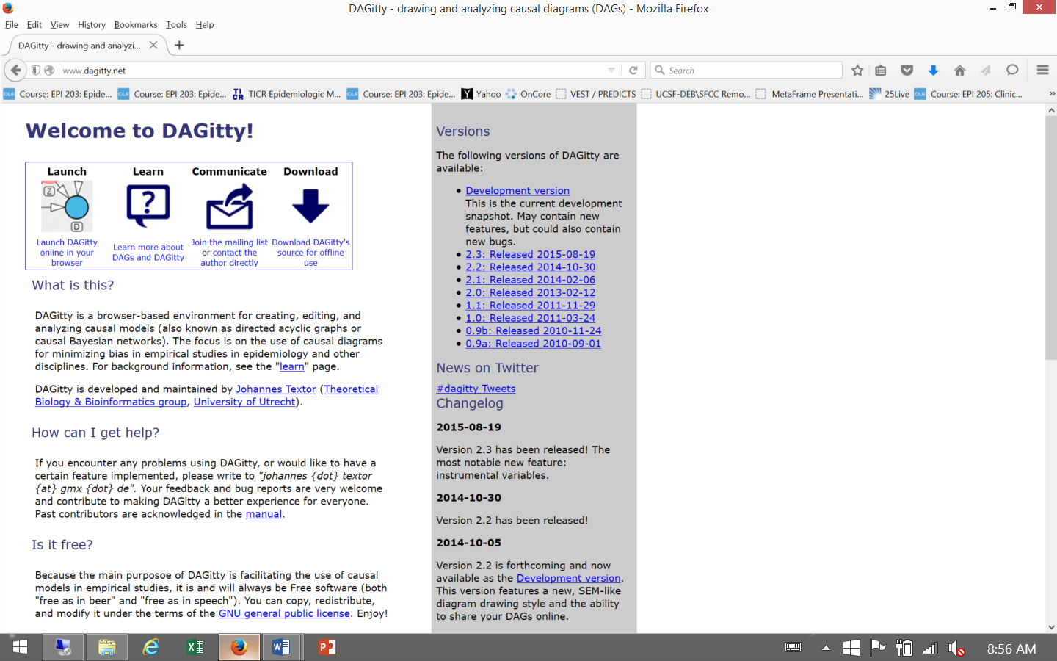
This will take you to the web-based version of the software. We don’t recommend trying to download the application for offline use.

- To create a new DAG: click on Model/New model
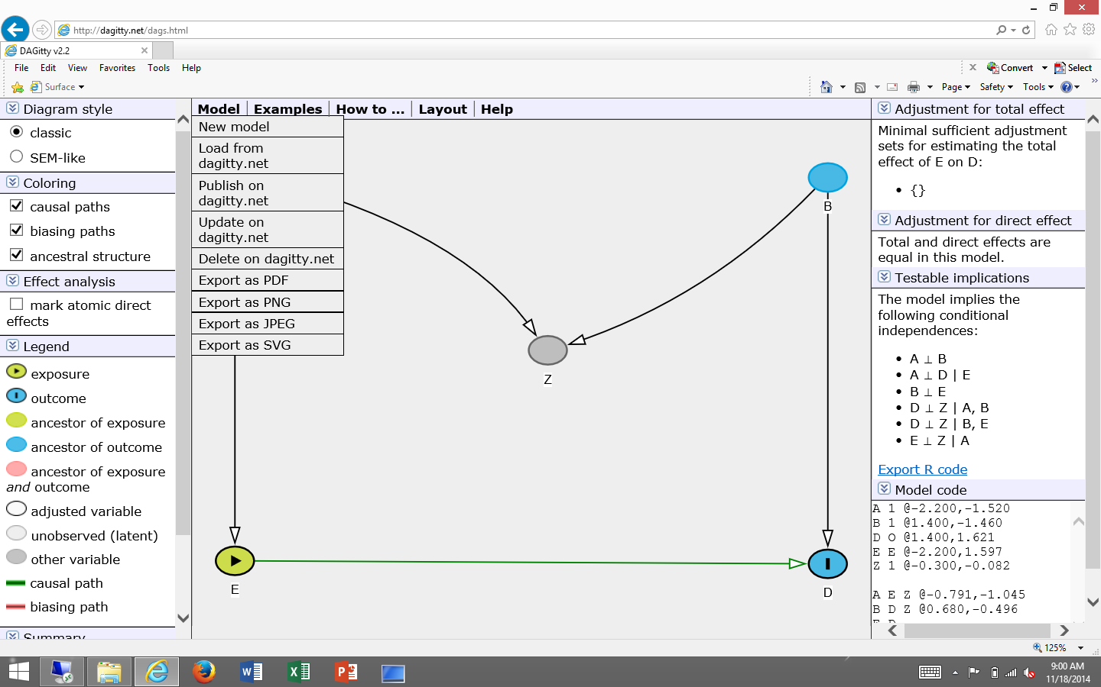
You may get a message from your browser that the site is “using a scripted window to ask you for information. If you trust this website, click here to allow scripted windows…”. Go ahead and click on this message to proceed and click on “Allow Scripted Windows” when prompted.

- Enter the exposure variable
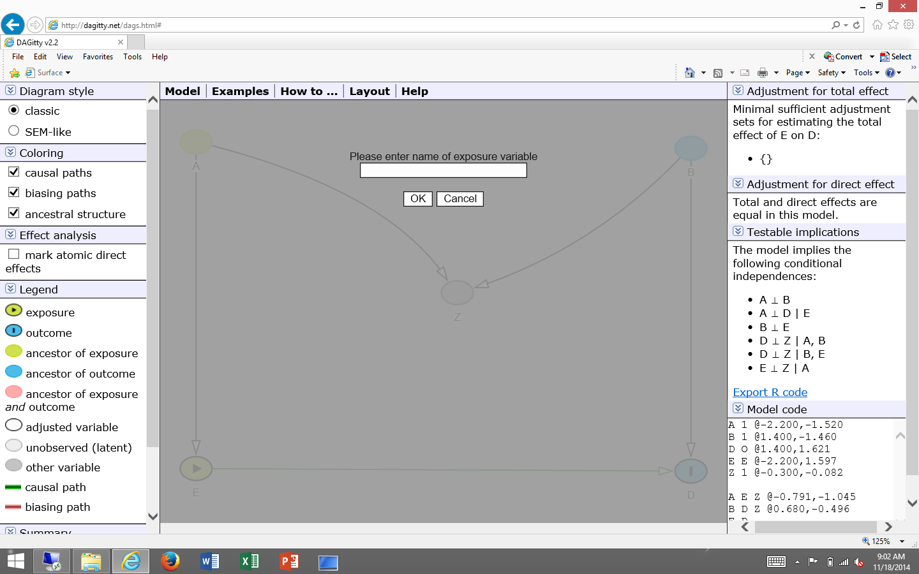
Type in the name of variable, allowing for spaces between words (e.g., “Carrying Matches”).
If both words do not show up in the DAG, you may need to place underscores between the words
(e.g., “Carrying_Matches”).

- Enter the outcome variable
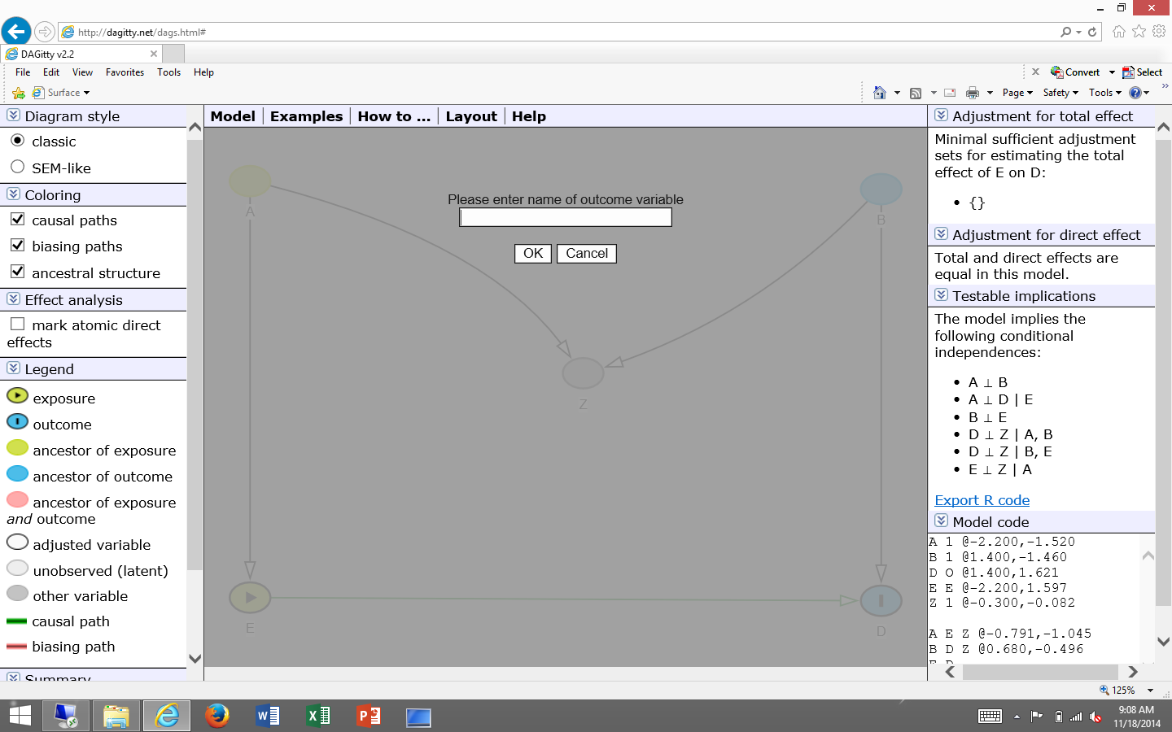

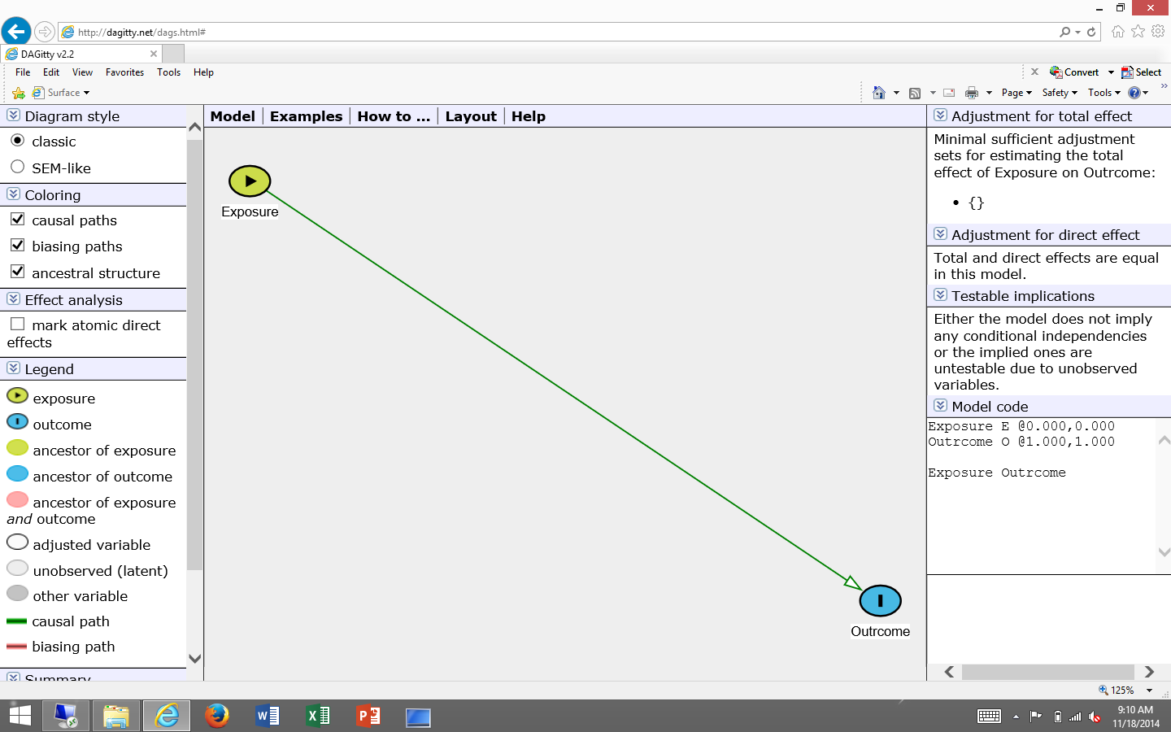
At this point, you should see the exposure variable in green connected by a directed edge to the outcome variable in blue. You can move the nodes from place to place by simply dragging the node on the screen with your mouse.

6) Adding other nodes and edges: Click on How to/Add a variable
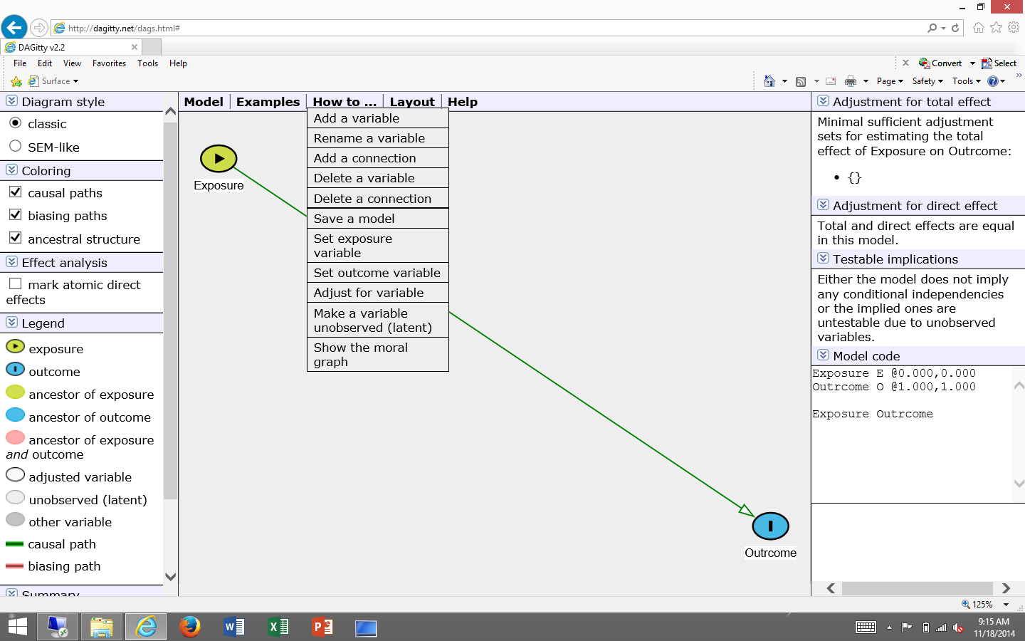

7) Adding nodes: Click OK, then double-click anywhere in the grey area

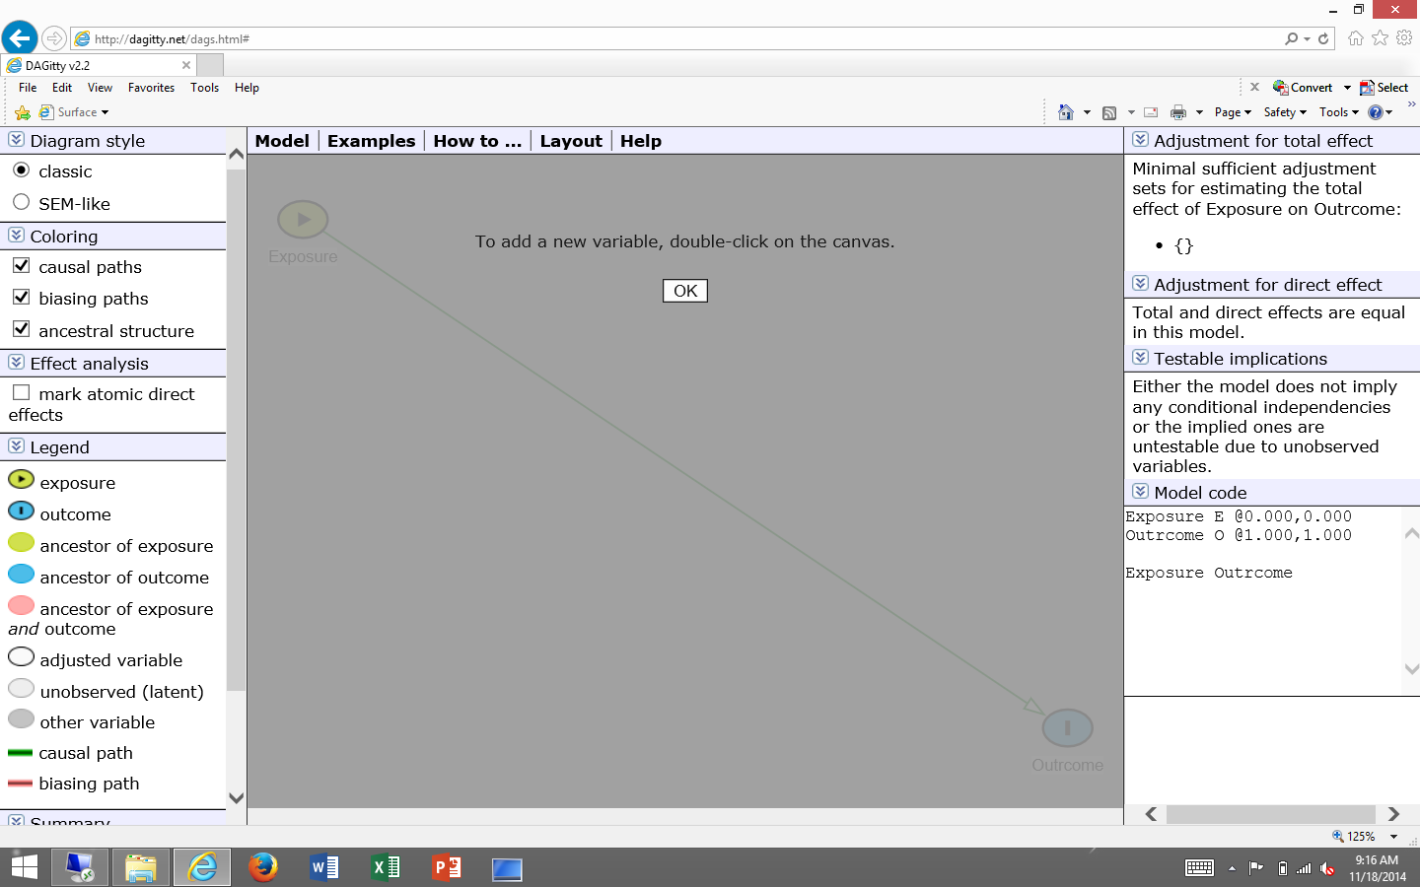

8) Adding nodes: Enter the variable name for your new node

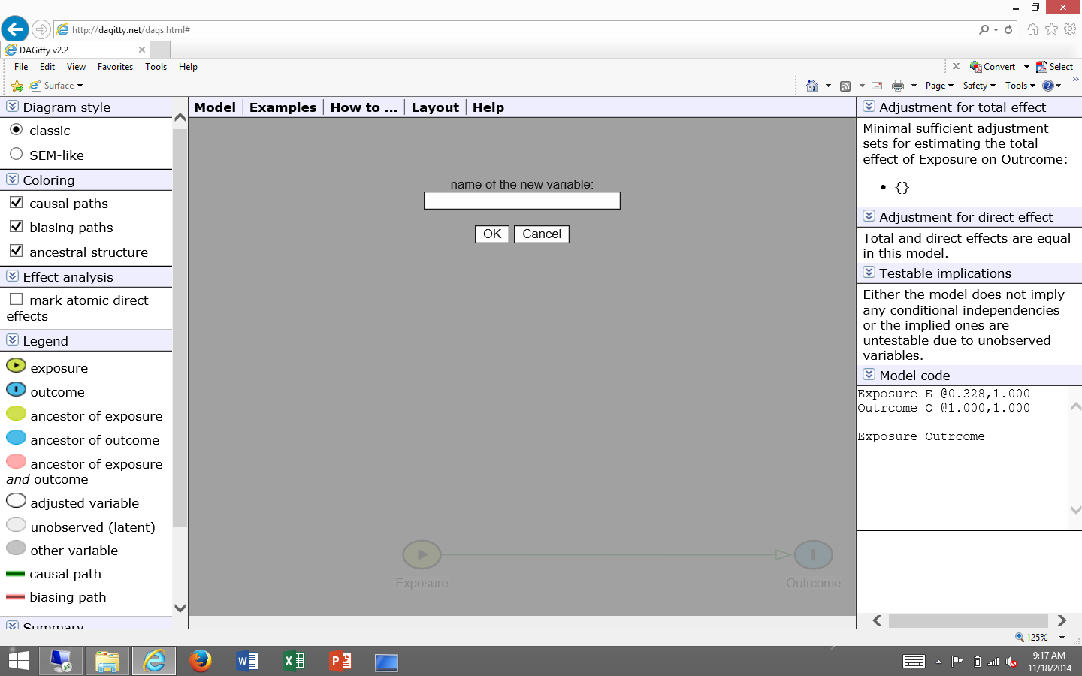

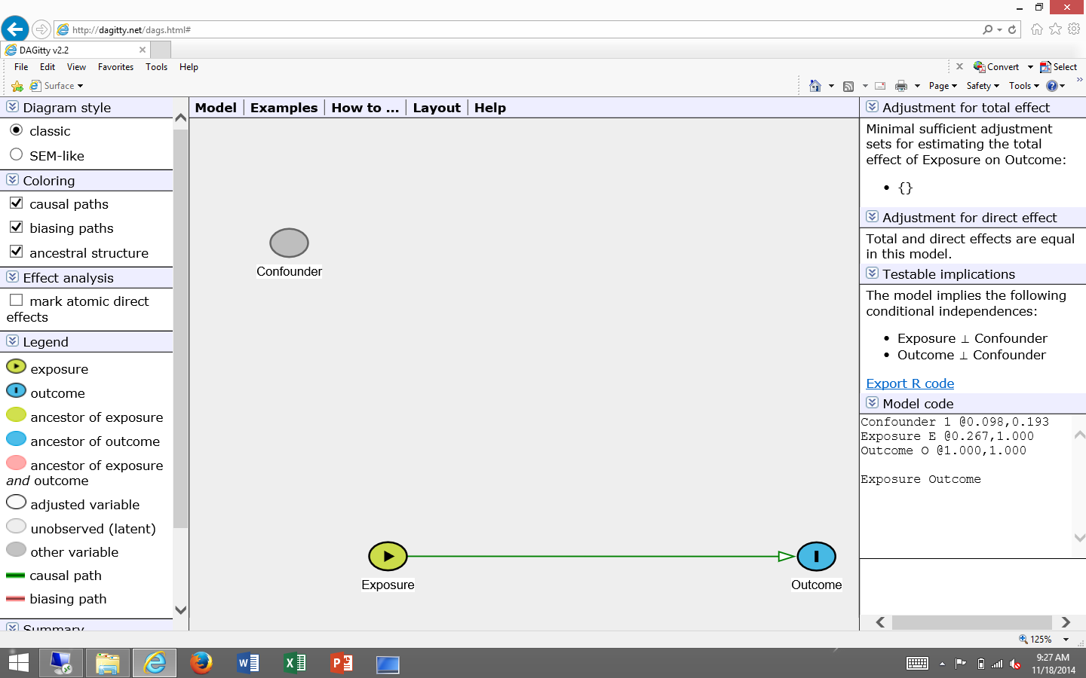
Your new node will appear on the canvas.

NOTE: at any time, you can reformat the DAG by clicking on a node with your mouse and moving it around.

9) Adding edges: Click How to/Add a connection

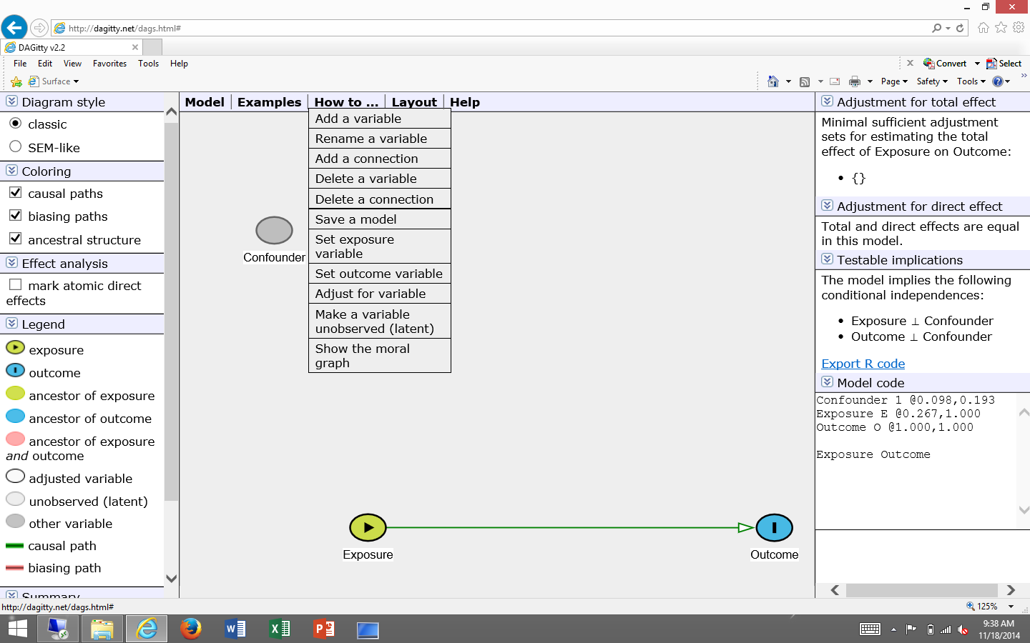

10) Adding edges: Click OK; then double-click on the node that you want to connect to another node; double-click on the other node (i.e., variable that the arrow will point to)
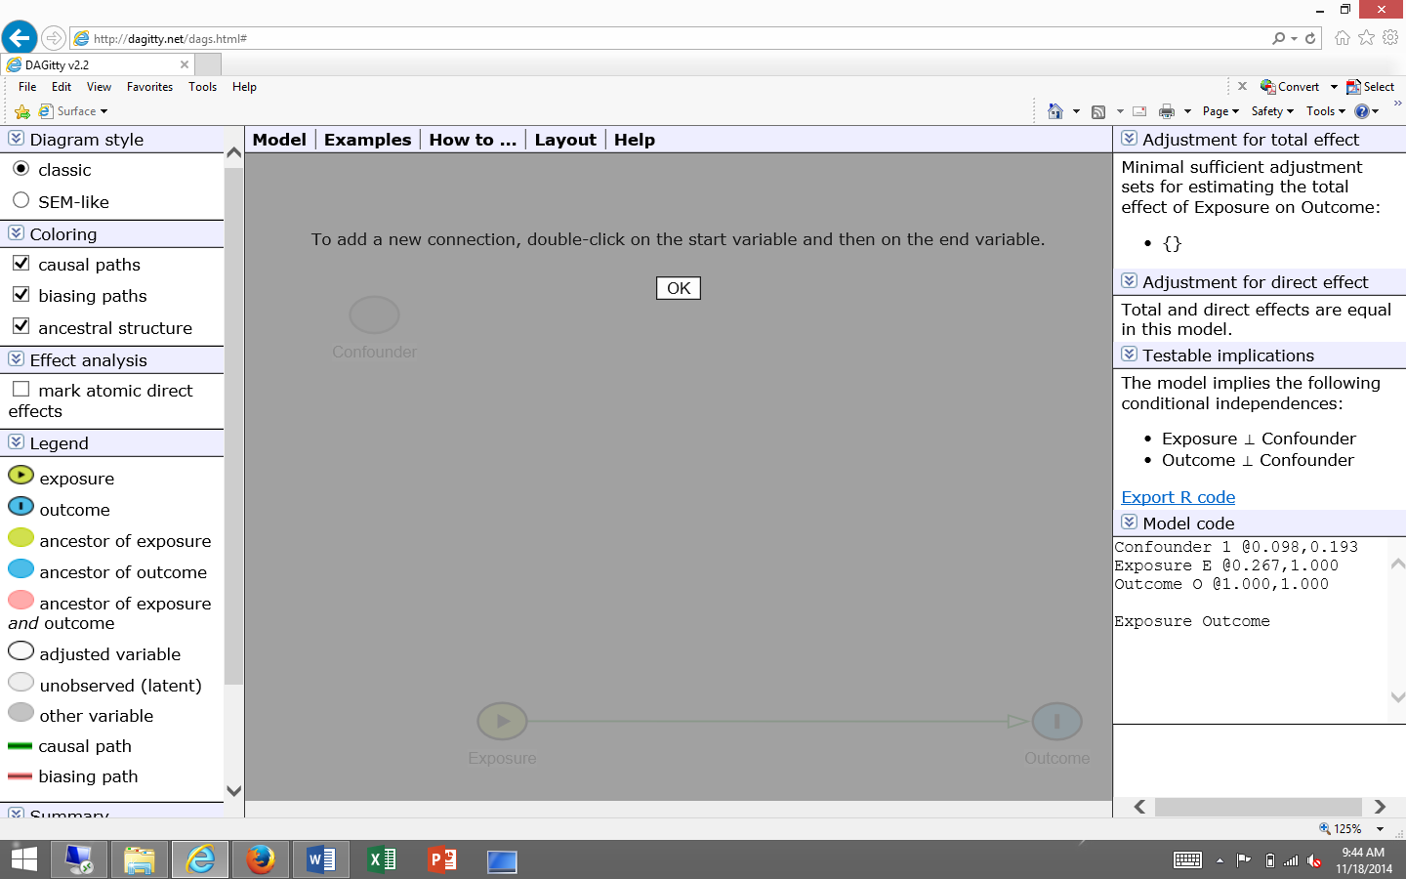
ALTERNATIVE METHOD: Click OK; then single-click on the node you want to connect to another node; press the ‘c” key; single-click on the other node (i.e., variable that the arrow will point to); press the ‘c” key

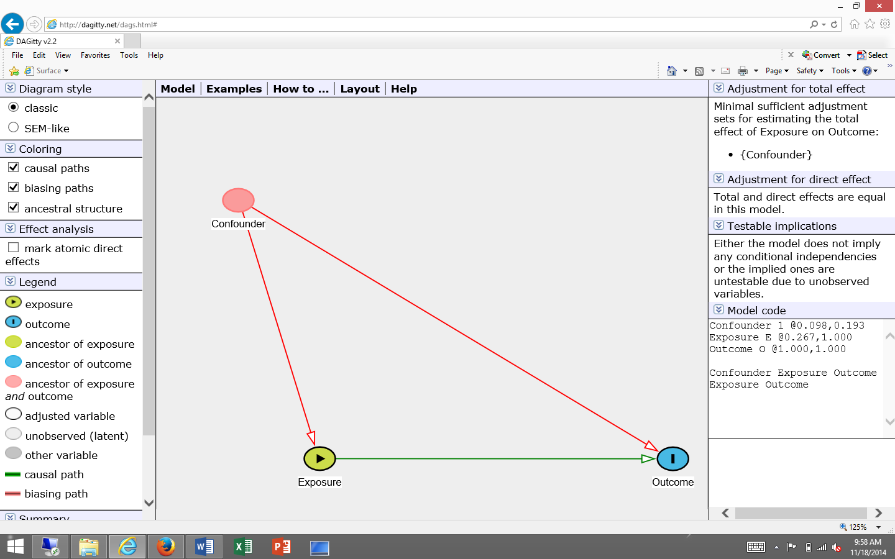

11) Saving a DAG: 2 options
OPTION 1

- Option 1: Copy the Model code and paste the “code” in a document (e.g., MS Word) to save it.

To later resurrect your saved DAG: open a new DAGitty.net window and paste the saved “code” into the Model code box (i.e., replace the sample text in the box with your “text data”) and click Update DAG.

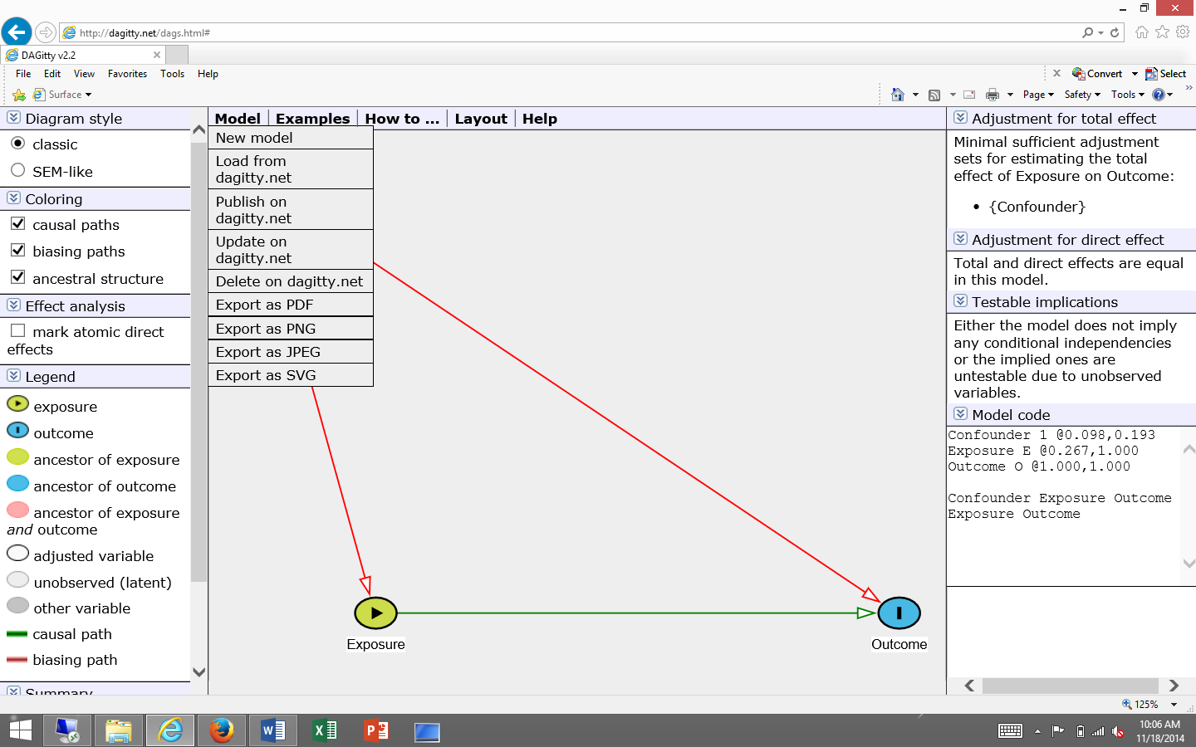
OPTION 2

- Option 2: click on Model/Publish on Dagitty.net, then name your DAG (model title)
Optional: Link it to your e-mail address. Providing your e-mail address will allow you to modify and delete your published model later on.

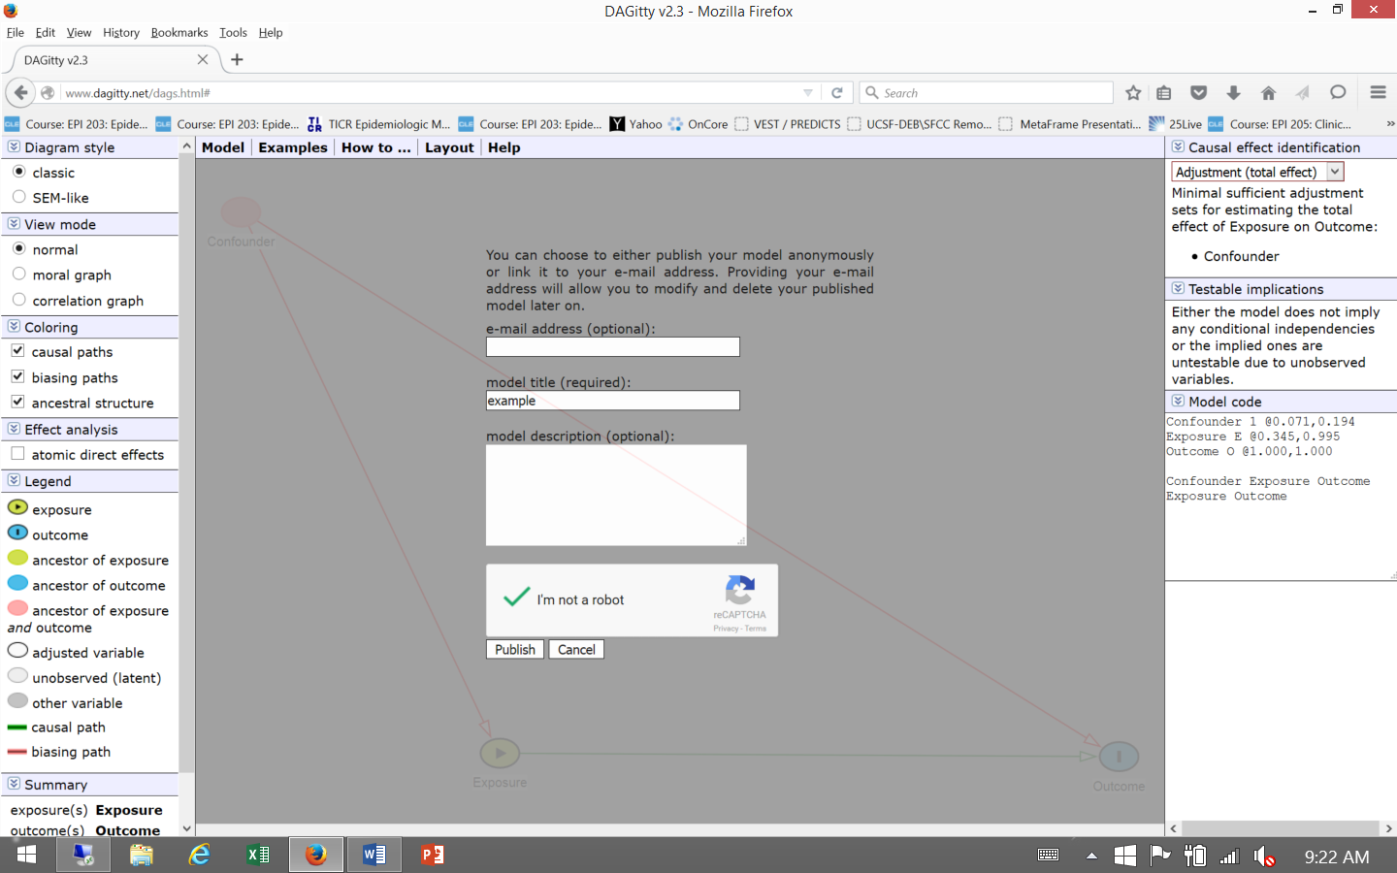
Write down/save the URL pathway (e.g., dagitty.net/mLOUxP). This is saving the DAG on the Dagitty.net server. We have every reason to believe that this is secure, but if you have a highly confidential DAG you might want to be cautious.

To later resurrect your saved DAG: click on Model/Load from Dagitty.net and enter your URL.

12) Saving your DAG as an image file/Printing a DAG:

- Click on Model
- Export as a PDF, jpg, png, svg. Be aware of the default folder where your browser typically saves downloads.

