Pair and Share Case Study: Mr. Hernandez

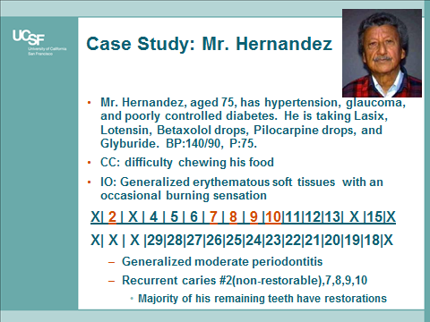
- According to the Seattle Care Pathway, what is Mr. Hernandez’s level of dependency? Why?
  - No dependency
  - Pre-dependency
  - Low dependency
  - Medium dependency
  - High dependency

- Using the Seattle Care Pathway, discuss the considerations below that should be included in his assessment.
  - Oral
  - Systemic
  - Medications
  - Psychological
  - Social
  - Elder abuse

- Using the Seattle Care Pathway, what preventive recommendations will you make?
  - Caries
  - Periodontitis
  - Xerostomia

- Using the Seattle Care Pathway, what treatment recommendations will you make?
  - Palliative
  - Shortened dental arch
  - Comprehensive care

- Using the Seattle Care Pathway, what considerations will you have to take into account when communicating with Mr. Hernandez?
- Write a consult regarding your concerns to Mr. Hernandez’s primary care provider using the ISBAR format (Identify, Situation, Background, Assessment, Recommendation).

