Biostat 202

Hwk #3: Data Visualization & More

Biostat 202: Opportunities and Challenges of “Big Data”
Due Wednesday, August 17th by Midnight

For this homework we will also use the data from the National Electronic Injury Surveillance System (NEISS) that you used for Hwk #1 ( http://www.cpsc.gov/en/Research--Statistics/NEISS-Injury-Data/ ). We will be interested in creating plots of the data and examining how to evaluate models graphically.

Open your stream from Hwk #2. I have also included the data as an Excel file in Hwk #2 if you prefer to use this instead of the .csv file. You should have the recoded variables for admit, Head, Toe and Age already in your Type node.

1. Using the codes in the table below from the NEISS codebook, choose two more ‘Body Part Affected’ codes and create new variables as you did in Hwk #2 for Head & Toe. Q1. Which areas of the body did you choose? Do you think that injuries to these new areas are likely to involve hospitalization?

2. Using the codes in the table below from the NEISS codebook, choose three diagnoses from the ‘Diagnosis’ table and create variables. Q2. Which three diagnoses did you choose? Do you think any of these are related to the body parts chosen above?

3. Attach a Binning node from Field Ops and create Age groups to use in analyses that will not accept continuous data. Create 10 bins (or groups)

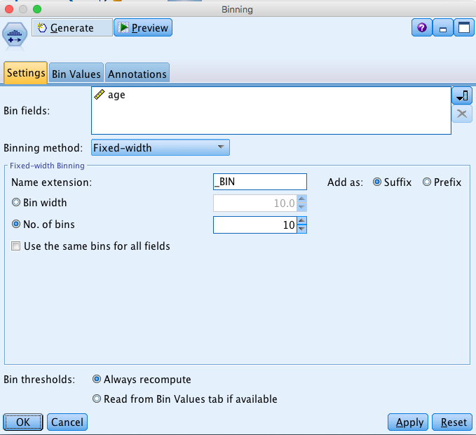

Attach a Type node following all your reclassification nodes and binning node. For the plots and models, we will use the following variables: a continuous Age field ranging from 1 to 107, an admit variable (0/1), 4 body part variables (0/1), 3 diagnosis variables (0/1), a gender variable (0, 1, 2), and an Age_bin for our age groups. Run an Audit node and then get a distribution of your new age_BIN variable by double clicking on the bar chart for the variable. Q3. By binning by number of bins rather than the actual distribution of Age, what is this distribution telling you about the population?

4. Attach a web graph to your Type node and include the variables above (except Age). Use the bar below the web to examine how the variables are related. Q4. Which variables show relationships? Are they variables that occur together or that do not occur together? Why would links between diagnoses and body parts that are not related be stronger than those that are related?

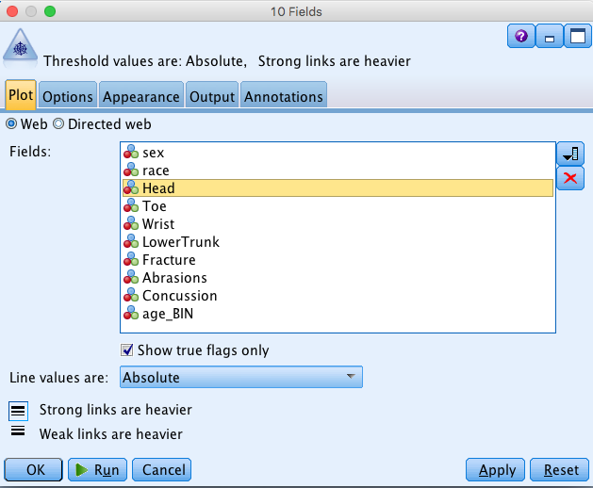

5. Create a Collection graph (from the Graph tab): Collect Concussion Over Age and Overlay Sex (Color) and Panel admit. Q5. What does this tell you about concussions by age and admission to the hospital?

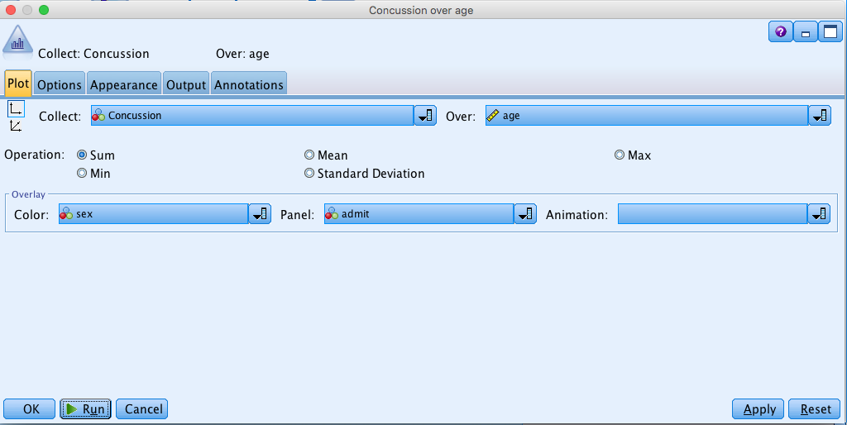

6. Finally, fit a Logistic model and a Neural net with admit as the Target and using your new diagnosis and body_part variables as well as Age and Sex. Attach Analysis nodes and Evaluation graphs to each model. Q6. Are there differences in the accuracy of the models? Do the Evaluation plots differ? Are these models better than those fit for last week’s homework? Attach the Neural model gem to the Logistic model gem and run an Analysis node. This will tell you how much your 2 models agree. Do they agree? You can also do this with your Evaluation plots.
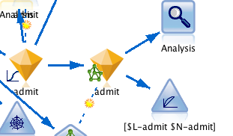

7. The data collection from the Health eHeart study (co-led by Mark Pletcher) generated a Fitbit dataset that recorded the number of steps taken each minute for a number of participants across a number of days. Participants contributed between 10 and 2000 days each.

The data available are the date of the measurement, listed in the format (“29mar2013”), which minute during the day the steps were recorded (from 1 to 1400 = 60minutes*24hours) and the number of steps for that date and that minute. Because the data is massive (an individual with 2000 days would contribute almost 3 million rows of data), minutes with no activity are left out of the dataset.

Suppose we wanted to see if activity patterns differed between individuals with different levels of severity of multiple sclerosis. Summarizing the data simply as average number of steps per day (a single variable) may too coarsely summarize the information. It may be that different levels of disease are associated with different patterns during the day or during the week. Suppose we want to manipulate the data to reduce it to a more manageable size, recording (for each person) the average number of steps for each minute during a week. That is, we want to reduce the data to (7 days)*(1440 minutes) = 10,080 values per person by averaging across the same time during the day and day during the week. Said another way, suppose we want to have average step counts for Monday at 12:01 am, Monday at 12:02 am, …, Sunday at 11:59pm, Sunday at 12:00 midnight. Q7. Describe the steps you would need to go through to compute those averages. No programming required!

For #1
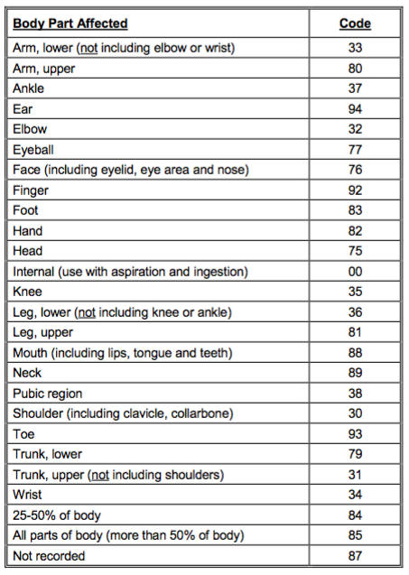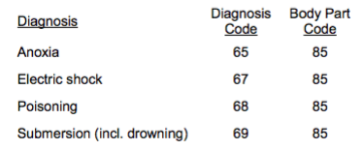

For #2
