EPI 204 Chapter 4 Problems:
Assigned problems: 1, 4, 17, 21.
1. You are developing a new home pregnancy test, which gives a digital readout of pregnancy peptide (in arbitrary units). Results on 10 women with early pregnancy, and 10 non-pregnant controls are shown below:
Pregnant Not Pregnant
4 1
7 1
15 2
18 3
20 5
23 7
23 13
26 16
30 17
32 21
a. Draw an ROC curve for this test. [2]
You can use the grid for your ROC curve. You can draw the ROC curve on it and then snap a photo from your cell phone and paste into your HW, if that is convenient.
b. Estimate the area under the ROC curve. (Hint: count boxes.) [1]
TP (Sensitivity)
(Sens

c. Now RANK the list you created for part A. Remember the HIGHEST number gets rank #1. You can write the ranks next to the values in your list. [1]

d. Now calculate the RANK SUM, S, as well as S_{min} and S_{max}. [2]

e. Now use the formula given in chapter 4 to determine the area under the ROC curve from these ranks. You should get the same answer you got for part b above. Isn't that satisfying? [1]

f. Now make likelihood ratios for test results <10, 10-20, and >20. (Hint: with a tiny sample size like this, you need to pay attention to > vs ≥.) [3]

g. One of your sexually active patients has missed a period. Based on your experience, you estimate there is a 50:50 chance she is pregnant. Her result on the test above is 7 (i.e., <10). How would you revise her odds of pregnancy? What is the probability that she is pregnant? [2]

h. Do you think this test will be clinically useful? Explain. [2]

4. Consider a ballot initiative proposed in California several years ago, to allow a jury to convict a defendant if only 10 jurors agreed that he or she was guilty, rather than requiring all 12 jurors to agree, as is presently the case. Simplify this problem by ignoring mistrials and considering only two possible verdicts: guilty and not guilty. In this analogy, a truly guilty defendant is like a patient with the disease, and an innocent defendant is like a patient without the disease, and a conviction by the jury is like a positive test.

- If you continue with the diagnostic test analogy, what would you call the proportion of innocent defendants that are acquitted? [1]

- If your goal were to maximize "sensitivity," would you tend to favor the initiative? Why or why not? [1]

- A key question in evaluating this initiative is: what is the trade-off between "true positives" and "false positives"? That is, how much do you increase your chance of convicting someone who is innocent in order to convict more people who are guilty? This trade-off can be visualized with ROC curves. Draw two hypothetical ROC curves for this problem, labeling the axes and the points "10" and "12" on the curve for the number of jurors needed to convict. Make the first ROC curve one that would lead you to support the initiative, and the other ROC curve one that would lead you to oppose it. (Label the curves "Support" and "Oppose." You can put them in the same chart if you want.) Explain your answer. [4]

- One reason why rational people might disagree on whether to support such an initiative is that their estimates of the shape of the ROC curve differ. Suppose two people agree completely on the ROC curve. What are two reasons why they might still disagree on whether to support the initiative? [2]

4-17 Grim Reaper’s Walking Speed
To estimate the walking speed of the Grim Reaper, Stanaway et al(1) studied walking speed as a predictor of mortality in 1705 Australian men at least 70 years old. Of the 1705, 266 died during follow up, so 1705 – 266 = 1439 survived. They treated walking speed (in meters/sec) as a continuous diagnostic test and created the ROC Curve for mortality below: Slower walking speed was a predictor of higher mortality in this study.

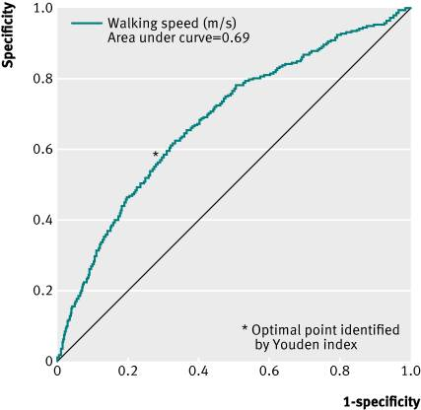

a) What are two errors in the labeling of this figure? [1]

b) What part of the ROC curve refers to the slowest walking speeds? [1]

The authors found that although there were 266 deaths during follow-up, no one in the cohort who walked faster than 1.36 m/sec (about 3 miles per hour) died. They proposed the following explanation: "This supports our hypothesis that faster speeds are protective against mortality because fast walkers can maintain a safe distance from the Grim Reaper."

c) (Extra credit) About how many men walked faster than 1.36 m/sec? (Again, of the 1705, 266 died during follow up, so 1705 – 266 = 1439 survived.) [+2]

4.21 (revised from 4.16 by TN)
A pulmonary embolism (PE) is a blood clot in the lungs. There are many risk factors, including age >65 years, recent surgery, cancer, and a previous deep vein thrombosis (DVT) or PE. It is an important consideration in the differential diagnosis of acute chest pain or shortness of breath because it is treatable (with anticoagulants) and can cause death if the diagnosis is missed. The “gold standard” to make the diagnosis is a CT scan, but this entails cost and radiation, so we would prefer not to do it if the probability PE is low enough. For this problem, we’ll say we should do a CT scan if the probability of PE is ≥ 5%, i.e., we are willing to do up to 20 CT scans to diagnose one PE.) D-Dimer is a fibrin degradation product present in blood when there is a blood clot. It is used clinically to help estimate the likelihood of a PE.

Duriseti and Brandeau(2) published a detailed evaluation of different strategies for diagnosing pulmonary embolism (PE). They estimated that among patients at risk of PE, the sensitivity of D-Dimer level ≥ 500 µg/L was 98.1% and the specificity was 45.8%.
  - What would be the LR+ for a D-Dimer level ≥ 500 µg/L? [1]
  - Julie, who is 67 years old and has acute chest pain and shortness of breath, but who has no other PE risk factors or signs except her age, so that her prior probability of PE is about 10%.(3) Her D-Dimer level is 575 µg/L. Based on the LR calculated in part A, should she get a CT scan? [1]
  - The D-Dimer test is not naturally dichotomous, so the cutoff chosen to define a positive test will determine the sensitivity and specificity, as shown in the (corrected) table from Duriseti and Brandeau below:
D-dimer Level: lower limit for abnl | Sensitivity for PE, % | Specificity for PE, %
Cutoff I (200 μg/L) | 99.9 | 8.31
Cutoff II (350 μg/L) | 99.8 | 30.0
Cutoff III (500 μg/L) | 98.1 | 45.8
Cutoff IV (650 μg/L) | 92.1 | 63.1
Cutoff V (800 μg/L) | 80.0 | 76.1

Use the table above to estimate what percent of patients with a PE will have a D-Dimer level between 500 and 649 µg/L, as Julie does. [1]
  - Now estimate what percent of subjects without a PE will have a D-Dimer level in that range? [1]
  - Use the general definition of a LR to calculate the LR for having a D-Dimer level between 500 and 649 µg/L. [2]
  - Use the LR from part e to estimate the posterior probability that Julie has a PE, given her prior probability of 10% and her D-Dimer of 575 µg/L. [2]
  - Recall that the threshold for ordering a CT scan was a 5% probability of PE. Should she get a CT scan? Discuss how the answers to parts b and f differ. Which estimate should you use? [3]
  - The following ROC curve is based on the data in the table above.
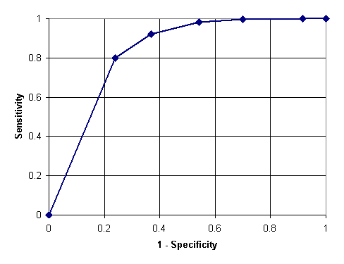

 |  | b | c | d |  | e
 | a
h.1 Which interval (provide the letter) on the curve corresponds to the D-Dimer interval between 500 and 650 μg/L? [1]
h.2 Which D-Dimer levels corresponds to the letter a? [1]

REFERENCES

1. Stanaway FF, Gnjidic D, Blyth FM, Le Couteur DG, Naganathan V, Waite L, et al. How fast does the Grim Reaper walk? Receiver operating characteristics curve analysis in healthy men aged 70 and over. BMJ. 2011;343:d7679.
2. Duriseti RS, Brandeau ML. Cost-effectiveness of strategies for diagnosing pulmonary embolism among emergency department patients presenting with undifferentiated symptoms. Ann Emerg Med. 2010;56(4):321-32 e10.
3. Le Gal G, Righini M, Roy PM, Sanchez O, Aujesky D, Bounameaux H, et al. Prediction of pulmonary embolism in the emergency department: the revised Geneva score. Ann Intern Med. 2006;144(3):165-71.

