Dear Faculty,

We are so excited to have you participate in our third annual interprofessional session on antimicrobial stewardship, "Learning about Antimicrobial Stewardship with its Key Players: Physicians and Pharmacists”; previous sessions were a hit with students and demonstrated a significant positive impact on the students’ assessments of their ability to work in interprofessional teams!

This session is designed to teach medical students and pharmacists about the core principles of antimicrobial stewardship, how they can make good decisions on antibiotic use (and the consequences of poor choices), and recognize how the skill sets of the pharmacist and physician are complementary within patient care.

The students will be using an on-line, “choose your own adventure” style program to go through each of these cases. Therefore, each group may have done something different so during the discussion you will need to address each of the potential options. We have summarized the cases in below but included an appendix with details of case questions in case it comes up or you want to review in more detail. At the end of the last case there will also be some discussion questions about systems approaches to antimicrobial stewardship. We will need to leave 7-8 minutes at the end of the session for them to complete an on-line questionnaire so we can get feedback.

These pharmacy students and medical students have not worked together before and we will ask you to organize an ice-breaker at the beginning.

Please let us know if you have any questions or concerns. Thank you so much for taking time out of your busy schedule to lead this session!

BACKGROUND

What do the medical students know about bacteria, antibiotics, and antimicrobial stewardship?
The medical students to date have been taught about all the types of bacteria and antimicrobials. They have been introduced to the concepts of empiric therapy, starting with broad-spectrum antibiotics and narrowing when they have culture results. They should have an idea of which bacteria cause the common types of infections including pharyngitis, UTIs, and hospital acquired infections. They may have some difficulty picking antibiotics to treat these syndromes and struggle with antibiotic spectrum. They may have less background regarding drug interactions and dosing.

What do the pharmacy students know about bacteria, antibiotics, and antimicrobial stewardship?
The pharmacy students have had a microbiology course and should know about common pathogenic bacteria. They have a general understanding of concepts of empiric therapy but have not had much practice applying these. They have learned about antibacterials with fairly detailed discussion of spectrum of activity, pharmacokinetics, dosing, and drug interaction. At this point in their training they may not have a strong command of the likely pathogens for pharyngitis, UTI, and hospital-acquired infections, and may not be very familiar with concepts of colonization versus infection.

How did the students prepare for this session?
- They watched an introductory video: http://youtu.be/zbE6-bnuCcM
- They did an on-line independent learning module
- They worked through Case A and submitted their answers individually

How should I prepare for this lesson?
- The cases themselves involve basic infectious diseases pharmacotherapy principles. The key principles to be emphasized are set out in the boxes below if you would like to review.
- The branched-logic format of the cases is somewhat novel. The format allows the students to see the consequences of their different management approaches. Reviewing the case overviews and the case maps and questions is recommended before the session.
- If you would like to see the entire preparatory module the students took, you may access it via CLE at: https://courses.ucsf.edu/course/view.php?id=1805
- They will also have a follow-up discussion about Case B about systems approaches to antimicrobial use. See the Appendix if you would like to review the discussion points ahead of time. The instructor guide provides some points for consideration in the discussion.

INTRODUCTIONS AND ICEBREAKER (5-10 minutes)

- Students have been broken up into 4 mixed school break-out groups per your roster, please ask them to break into these groups now
- Please introduce yourself to the students, explain your clinical role and how you work with physicians or pharmacists in terms of antimicrobial use
- Give a clear outline for the activities today, ideally write the outline out on the board
  - Overview/Introductions (5-10 minutes)
  - Student small groups review their answers to case A together (5-10 minutes)
  - Discussion of Case A with large group (10-15 minutes)
  - Student small groups do on-line case B together (10-15 minutes)
  - Discussion of Case B with large group (20-25 minutes)
  - Present Systems Approaches questions to group; students discuss in small groups (5-10 minutes)
  - Discussion of Systems Approaches questions with large group (10-15 minutes)
  - Complete on-line post-session survey (5-10 minutes)
- Icebreaker within break-out group, pick a partner, do a 1 minute interview and then introduce your partner to the rest of the group, repeat (5 minutes)
- One student in each group (someone with a laptop) should be designated as the “navigator”” who will access the case online and submit the group’s answers

CASE A (5-10 minutes for student collaboration, 10-15 minutes large group discussion)

- Instruct the navigator for each small group to navigate to the “Case A Group Answers” link on the CLE page and submit their consensus case answers as the group discusses.
- After ~5-10 minutes working in their small groups, ask each small group to report back to the larger group with their recommendations. Ask them how they came to their conclusions. Use their reports as a starting point to address the discussion points below.
- If there are any discussion points not addressed in the course of the answers the groups gave, attempt to work them in to the discussion

Case A overview: Patient presents to clinic with signs/symptoms of pharyngitis and meets Centor criteria to have culture obtained. Student is asked about whether to swab and/or give empiric therapy for group A strep pharyngitis. Student’s decision around antibiotics is complicated by a mild (non-IgE) allergy to penicillin and a potential drug interaction (clarithromycin) with warfarin. First discussion will be around this topic. Cephalexin is the drug of choice, penicillin contraindicated due prior rash (pharmacy calls and recommends other option), clarithromycin has an interaction with warfarin (patient gets severe hematoma), and levofloxacin is overly broad (patient who get this develops C diff). If levofloxacin is selected, students should correctly select a test for C. diff disease, and vancomycin as the therapeutic option of choice (because metronidazole would interact with the patient’s warfarin).

See the Case A map and Questions in the Appendix for detailed breakdown of the case.

Discussion Points:

Discussion: All students needed to decide when to treat for pharyngitis.

When to treat (and not treat) for possible streptococcal pharyngitis?
Pharyngitis is a very common clinical syndrome and can be due to viral infections as well as bacteria (most common bacteria, Streptococcus pyogenes (Group A strep)). To help determine who needs testing for Group A strep clinicians look to see if patients have ≥ 3 Centor Criteria (tonsillar exudates, tender anterior cervical adenopathy, fever, absence of cough).

Our patient had all 4 Centor criteria so testing was appropriate and empiric treatment would be reasonable as long as final decision is based on lab results.

Treatment for Group A strep pharyngitis:
- First line: penicillin or amoxicillin
- Second-line: cephalexin
- Third-line: azithromycin, clarithromycin, clindamycin

Discussion: All students needed to address this issue when making antibiotic choice.

Types of allergic reactions with B-lactam antibiotics?
IgE-mediated: Prior history of hives or anaphylaxis would lead most providers to avoid using penicillins as well as cephalosporins and carbapenems due to possible cross-reactive allergy. A desensitization protocol (infusing increasing amounts of drug slowly) in a monitored setting may be an alternative.
Non-IgE-mediated reactions: For patients with more minor, non-IgE-mediated reactions, such as rash to penicillin, use of a different B-lactam like a cephalosporin or carbapenem is reasonable.

Discussion: Students who picked clarithromycin will experience their patient having complications from high INR.

What antibiotics are commonly associated with drug-drug interactions?
Some antibiotics have important interactions with other medications. In this case, clarithromycin, a potent inhibitor of CYP450 enzymes, inhibits the metabolism of warfarin and results in an increase INR and complications. Many antibiotics interact with warfarin and use of these drugs together needs to be done thoughtfully. Other drugs that commonly cause interactions are rifampin, many antiretrovirals, and azole antifungals.

Discussion: Students who picked levofloxacin will experience their patient developing C difficile infection.

Risk factors for Clostridium difficile colitis?
Everyone should already understand how C. diff colitis develops. However, many of them may think that that only clindamycin is the only risk factor for C. diff infection. It should be emphasized to the students that cephalosporins and fluoroquinolones are more frequently associated with C. diff colitis and that using the most narrow spectrum antibiotic possible may prevent this infection.

CASE B (10-15 minutes for student collaboration, 20-25 minutes large group discussion)

- Instruct the navigator for each small group to navigate to the “Case B” module on the CLE page to submit their group consensus case answers
- After ~10-15 minutes working in their small groups, ask each small group to report back to the larger group with their recommendations. Ask them how they came to their conclusions. Use their reports as a starting point to address the discussion points below
- If there are any discussion points not addressed in the course of the answers the groups gave, attempt to work them in to the discussion

Case B overview: Patient admitted for elective hip surgery has altered mental status due to opiods, which resolves with dose reduction. A UA/urine culture is taken in the setting of altered mental status (since resolved) and reveals pyuria and bacteriuria. She has asymptomatic bacteriuria and students need to decide if treatment is warranted. They are given the options to treat with ciprofloxacin vs. no treatment vs. repeat culture and then decide. Later on the patient develops hospital-acquired pneumonia and those who received ciprofloxacin have an infection with MDR-pseudomonas (only susceptible to carbapenems) while those who did not treat asymptomatic bacteriuria have infection with pan-susceptible Klebsiella. The students are asked to pick empiric therapy for hospital-acquired pneumonia before they receive any culture data. Options include vanco, vanco + pip-tazo, vanco + meropenem, vanco + levofloxacin, or ceftriaxone. Outcomes of patient based on treatment choice listed below.

See the Case B map and Questions in the Appendix for detailed breakdown of the case

Did student treat ASB with cipro in question 1? | Pathogen causing pneumonia in question 2
Yes | Pseudomonas, only susceptible to carbapenem
No | Klebsiella, susceptible to all antibiotics except ampicillin

Pathogen: Pseudomonas

Answer given | Outcome
Vancomycin + meropenem | Patient survives, case concludes
Cetriaxone | Patient dies (withdrawal of care after progressive sepsis)
Vancomycin + levofloxacin | Patient dies (withdrawal of care after progressive sepsis)
Vancomycin | Patient dies (withdrawal of care after progressive sepsis)
Vancomycin + pip-tazo | Patient dies (withdrawal of care after progressive sepsis)

Pathogen: Klebsiella

Answer given | Outcome
Vancomycin + meropenem | Patient survives, opportunity for de-escalation
Cetriaxone | Patient survives, opportunity for de-escalation
Vancomycin+levofloxacin | Patient survives, opportunity for de-escalation
Vancomycin | Patient dies (withdrawal of care after progressive sepsis)
Vancomycin + pip-tazo | Patient survives, opportunity for de-escalation

Among the students who did not give ciprofloxacin and in turn had Klebsiella the patient survived (unless they gave vancomycin monotherapy) and additional decisions on antibiotics need to be made based on susceptibilities. The Klebsiella isolate was susceptible to all antibiotics except for ampicillin. They should all stop the vancomycin and ideally narrow down to cefazolin, if you they decide to continue a broader agent such as ceftriaxone, levofloxacin, pip-tazo, or meropenem they will develop candidemia.

Discussion Points:

Discussion: All students need to decide whether to treat asymptomatic bacteriuria.

What should students know about asymptomatic bacteriuria (ASB)?
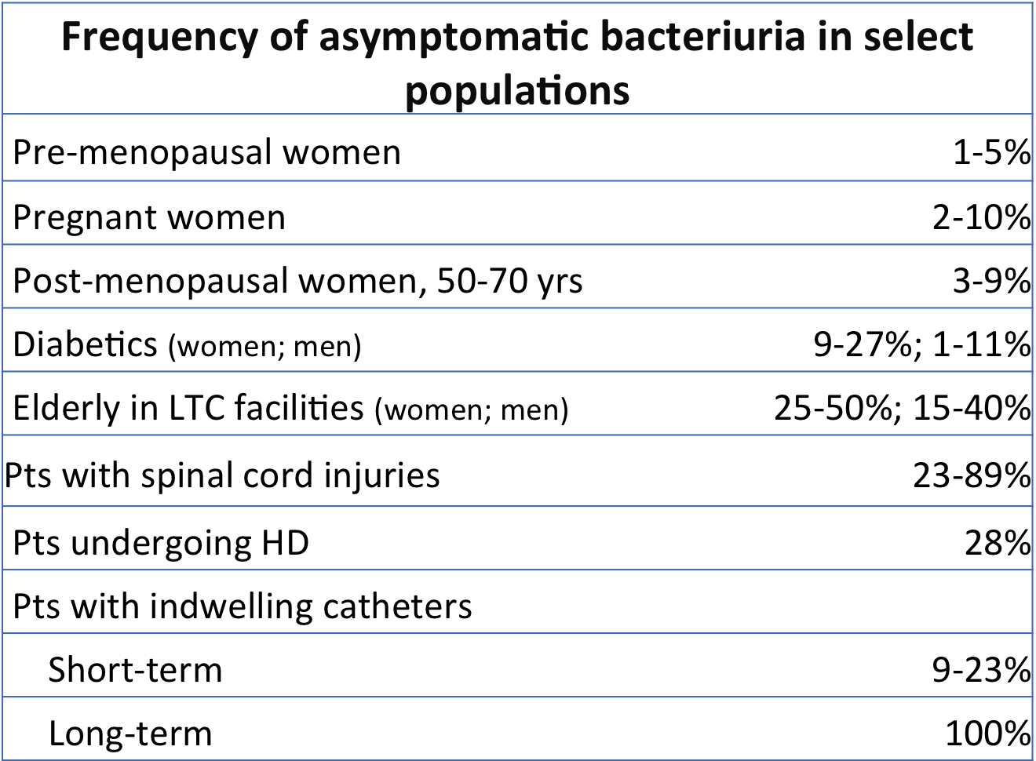
- Definition: No signs or symptoms of UTI plus bacteriuria
- ASB is very common in many populations (see table)
- Pyuria is frequently present (>50%); should not influence treatment decision
- Studies in women with DM have shown that there is no benefit to treatment with antibiotics (same rate later of symptomatic UTI)
- One of the most common ways that antibiotics are misused in the inpatient and outpatient setting
- Do treat pregnant women, patients undergoing urologic procedures and neutropenic patients
- It can be hard to determine who to treat in patients who are unable to tell you about signs/symptoms, often a diagnosis of exclusion

Discussion: All students will need to address this issue.

What organisms cause hospital-acquired pneumonia and what’s an appropriate empiric regimen? Did ciprofloxacin use influence the empiric regimen chosen?

The two bacteria that drive the empiric therapy for hospital-acquired pneumonia are Staphylococcus aureus (MRSA until proven otherwise) and Pseudomonas aeruginosa, although other Gram-negative rods, like Klebsiella, E. coli, and Acinetobacter can also cause infection. Vancomycin or linezolid plus piperacillin-tazobactam or cefepime or a carbapenem would be an appropriate first-line regimen.

Discussion: Some students will experience their patient having MDR Pseudomonas.

What are risk factors for infection with MDR Pseudomonas infection ?
The primary risk factor in this case is prior antibiotic exposure. Note that exposure to one class of drugs can select for pathogens resistant to other classes as well (in this case, fluoroquinolone exposure selects for an organism resistant to multiple classes). This can occur because of overlapping resistance mechanisms (e.g. efflux pump overexpression that confers fluoroquinolone resistance effects multiple classes) or because multiple resistance mechanisms accumulate in organisms.

Discussion: Some students will need to address this issue.

What is de-escalation of antibiotics and why is it done?
De-escalation (also known as “narrowing” or “streamlining”) an antibiotic regimen involves changing from a broad-spectrum regimen to a more narrow-spectrum one. This usually takes place in the context of knowing the identity and antibiotic susceptibility of the infecting pathogen; however in some cases it can occur in the absence of positive microbiology data. An important caveat to streamlining is that the narrower-spectrum drug should be expected to be similarly effective as the initial drug (considering factors such as bactericidal activity and penetration to the site of infection).

Use of narrower-spectrum antibiotics reduces the risk to the patient of superinfection with resistant bacteria, development of Clostridium difficile disease, and development of fungal superinfection.

Discussion: Some students will have patients who develop Candidemia.

What are risk factors for candidemia in hospitalized patients?
- Broad-spectrum antibacterial use
- Intra-abdominal surgery
- Receipt of total parenteral nutrition
- Presence of intravascular catheters
- Immunosuppression

Systems Approaches Questions and Discussion (5-10 minutes for student collaboration, 10-15 minutes large group discussion)

- After the group has worked through and discussed Case B, indicate that we are going to move on to discussing systems approaches to antimicrobial stewardship
- Provide the “Systems Approaches to Antimicrobial Use” handout to the students. Read/paraphrase the handout and questions.
- Tell the groups they have 5-10 minutes to discuss the questions and formulate some solutions. Ask one member of each group to serve as the recorder for their group’s work.
- Ask each group to discuss some of their ideas.

Systems Approaches overview: We are asking students to consider systems approaches to antimicrobial stewardship, instead of just the individual clinicians’ responsibilities. They had some introduction to these concepts in their learning module, but you may need to provide examples of “systems approaches” in other contexts: the “surgical time-out” might be a good example. There are no right answers here, but we want students to think about antimicrobial stewardship more broadly than just on a patient level. We are also asking them to imagine what types of conflict might arise and how such conflicts could be effectively managed.

Points that may come up in discussion regarding systems approaches:
-Improving clinician education: improving clinician knowledge of antimicrobial use is important. However, most clinicians are required to have expertise in a variety of areas and thus may be challenged in having comprehensive knowledge about antimicrobials. Studies of educational interventions in antimicrobial stewardship show that the effects of single interventions tend to be of limited duration.
-Point-of-care decision support: the ready availability of quickly accessible knowledge at the point of decision-making may improve antimicrobial prescribing. This could range from guidelines or quick-references available to clinicians, all the way through tools integrated into the medical record that can provide patient-specific recommendations.
-Availability of expert consultation: consultation with expert clinicians in infectious diseases can improve antimicrobial use. However, this availability is a limited resources in the face of the huge rate of antimicrobial use – approximately half of hospitalized patients receive antimicrobials. Thus, formal consultation with ID expert clinicians is typically available only for complex cases.
-Audit and feedback: strategies where clinicians monitor antimicrobial use and provide recommendations for quality improvement on an individual case basis is termed “audit and feedback”. In this strategy typically pharmacists perform the monitoring, usually of selected antimicrobial agents and provide feedback in partnership with ID physicians. Clinicians are usually not compelled to act on the feedback, but in most studies acceptance of recommendations is high. There is a component of “surveillance” or “second-guessing” the medical teams’ decisions.
-Restriction/prior authorization of antimicrobials: in this strategy, the use of certain antimicrobials is restricted to approval by an infectious diseases clinician. This strategy has the advantage of providing most direct control over antimicrobial use, but requires the near-constant availability of clinicians to provide timely approval. It also can be perceived as limiting the autonomy of the healthcare team over their patient’s care.

Points that may come up in discussion regarding conflicts and strategies for their management:
-Conflict: The patient’s healthcare team may be frustrated by the perception of second-guessing or loss of autonomy that come with some stewardship approaches. Strategy: The care of the individual patient needs to be stressed as the primary goal of stewardship interventions; “preserving antibiotic use” in general is a secondary goal that is addressed only when it will not significantly impact the care of the patient in question. In many cases, strategies such as streamlining antibiotic use are clearly benefit the current patient (reductions in superinfections such as C. diff) and future patients (slowing the rate of increase in resistance through overall reductions in broad-spectrum antibacterial use).
-Conflict: Sometimes not all relevant information may be available to the stewardship team at the time they are contacting the provider. Strategy: Stewardship clinicians should be humble in their initial contact with the team: “I see this patient is still on meropenem despite their cefazolin-susceptible isolate. Is there something I’m not seeing in the chart that is leading you all to continue the meropenem?”
-Conflict: The patient’s care team may not agree with the recommendations of the stewardship clinicians. Strategy: Stewardship clinicians need to have a flexible approach to managing individual cases and not “win the battle, lose the war.” At the same time, they need to have the confidence and authority to follow through when patient safety is at risk. Involving frontline clinicians in helping to develop the guidelines that the stewardship team is enforcing goes a long way towards improving their legitimacy (e.g. have the GI docs help write the institutional guidelines for antibiotic use in intra-abdominal infections).

Wrap-up and Post-session Survey (5-10 minutes)

If there is time remaining, please feel free to answer questions or facilitate discussion. 5- 10 minutes before the end of the session please direct students to fill out their post-session survey. EACH STUDENT should complete a wrap-up survey independently.

This wrap-up survey was sent to students’ email addresses during the session. Their UCSF email account should have received an email from Qualtrics that contains an individualized link to complete the survey.
- If there are students who did not receive the email or cannot access the survey they can complete a paper version of the survey – there are several copies in your packet.
- Students may complete the survey later but we want to encourage the students to finish the survey during class. It takes <5 minutes in most cases.

If the students ask, yes, it is the same survey they took before the workshop!

THANK YOU FOR HELPING OUR STUDENTS LEARN ABOUT APPROPRIATE ANTIBIOTIC USE!

Appendix: Case Maps and Questions

Case A Map
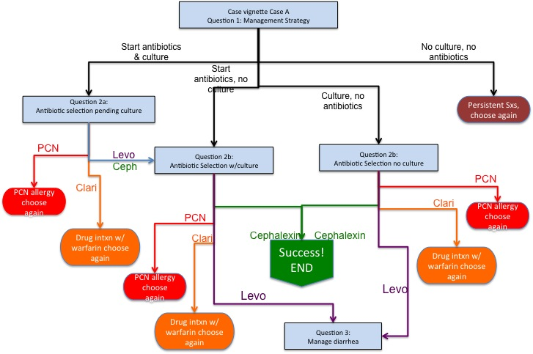

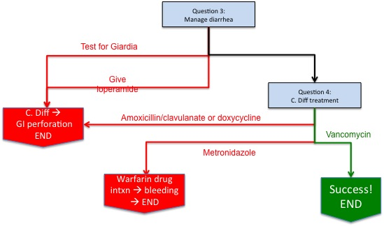

Case A vignette:

Tina is a 45 year-old female who presents to the family medicine clinic. Her chief complaint is a two-day history of sore throat. She says her throat became painful upon waking two mornings ago. She has pain on swallowing and speaking and missed work today. She denies nasal congestion or a cough.

Physical exam is positive for a temperature of 38.4 degrees Celsius, mild enlargement of the cervical lymph nodes, and she has evidence of bilateral tonsillar erythema and exudate.

Tina is hoping for an antibiotic prescription so that she can "get over this and get back to those dummies at work."

Tina's past medical history is significant for a deep venous thrombosis four weeks ago acquired after an all-weekend TV marathon on her couch, for which she is receiving warfarin. She also has a history of a penicillin allergy, which she describes as a non-itchy rash, which was not hives, and got better without treatment.
Question 1: What is the best management strategy for Tina?
- Obtain a throat swab for culture now. Provide Tina with an antibiotic prescription to fill, and advise her you will call her if she can stop the antibiotics
- Obtain a throat swab for culture now. Advise Tina you will call in an antibiotic prescription for her if the culture turns positive
- Do not perform a throat culture. Provide Tina with an antibiotic prescription to fill and advise her to call the clinic if her symptoms do not improve in 3 days
- Do not perform a throat culture. Advise Tina that her infection is most likely due to a virus, that antibiotics are not necessary, and that she can take over-the-counter medications like ibuprofen to help with her pain until it resolves
Question 2a: Which antibiotic would you recommend for Tina?
- Start penicillin
- Start cephalexin
- Start clarithromycin
- Start levofloxacin

Question 2b: 48 hours later, the results of the throat culture are back from the lab. Streptococcus pyogenes (aka Group A Strep) is growing. What would you like to do now?
- Start penicillin
- Start cephalexin
- Start clarithromycin
- Start levofloxacin

Question 2c: Which antibiotic would you recommend for Tina?
- Start penicillin
- Start cephalexin
- Start clarithromycin
- Start levofloxacin

Question 3: Ten days later Tina comes in for an unscheduled visit. Her chief complaint is a three day history of profuse, watery, crampy diarrhea accompanied by fevers. She completed her antibiotic treatment for pharyngitis yesterday. "Now my throat is fine but I'm pooping up a storm. You have any idea what it's like having diarrhea around a bunch of writers? They never give me a break!"
What is your recommended management strategy?
- Send a stool sample for Giardia testing.
- Recommend loperamide (Imodium) for control of diarrhea.
- Send a stool sample for Clostridium difficile testing.

Question 4: The next day the stool test for Clostridium difficile came back positive. What antibiotic would you recommend for treatment of this infection?
- Amoxicillin/clavulanic acid
- Vancomycin
- Metronidazole
- Doxycycline

Case B Map

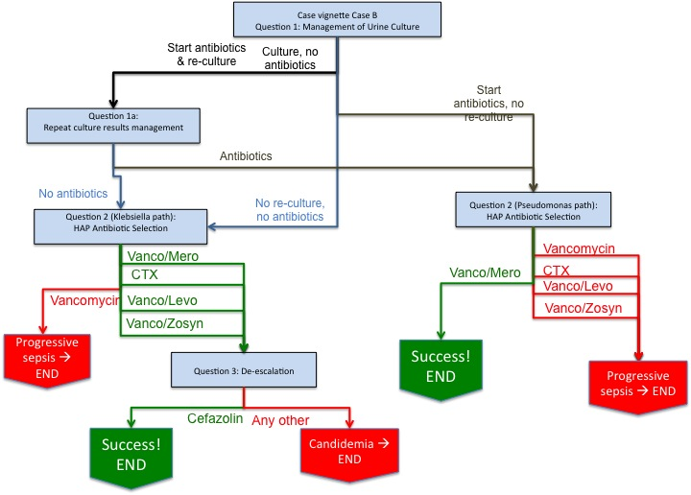

Case B vignette:

DG is an 81 year-old female with diabetes and chronic renal insufficiency who presents for an elective total hip replacement. The surgery went well per the orthopedic surgeon and she was taken to the hospital floor for recovery.
The following morning DG was found to be confused by her nurse. She was afebrile and otherwise vital signs were stable. She was taking her regular medications, which included a beta-blocker for hypertension and a statin for hyperlipidemia. She was also on a standing dose of morphine for post-operative pain. In her work-up for confusion she had a chemistry panel, a urinalysis/urine culture, and blood cultures.
Later that morning, her pharmacist noted that her morphine dose was excessive for her creatinine clearance and the pain medication dosing was reduced. Her confusion cleared later that day.
The next morning her urinalysis and urine culture from yesterday returned.
- Urinalysis: 50 WBC/hpf; 0 RBC/hpf and culture: > 100,000 CFU/ml of E. coli
Question 1: What is your recommended management strategy?
- Do not repeat urine culture, start ciprofloxacin
- Repeat urine culture, start ciprofloxacin
- Repeat urine culture, do not start antibiotics
- Do not repeat culture, do not start antibiotics

Students who choose to repeat the urine culture will get

Question 1a:
24 hours later DG's repeat urine culture and urinalysis return (see results below). DG has remained afebrile and free from confusion. She denies any pain on urination or increased urinary frequency.
Urinalysis:
- 50 WBC/high power field (normal < 5 WBC/high power field)
- 0 RBC/high power field (normal 0 RBC/high power field)
Urine culture
- > 100,000 colony forming units/ml of E. coli
- Start or continue ciprofloxacin to complete a 7-day course
- Discontinue ciprofloxacin or do not start ciprofloxacin

Later that week DG was sent to a rehabilitation facility but was transferred back several days after developing shortness of breath, cough, fever, and hypotension.
DG was directly admitted to the Intensive Care Unit where her temperature was 39C, HR 120, BP 87/55, RR 22, oxygen saturation 89% on room air.
Chest x-ray revealed bilateral infiltrates concerning for pneumonia or edema.
Question 2: Which empiric antimicrobial regimen would you recommend?
- Vancomycin plus meropenem
- Ceftriaxone
- Vancomycin plus levofloxacin
- Vancomycin
- Vancomycin plus piperacillin-tazobactam

Question 3 (only for Klebsiella group): Over the next two days DG's condition stabilizes and she is transferred out of the ICU. The results of a respiratory culture obtained after arrival to the ICU are now growing Klebsiella pneumoniae, with the following susceptibility results:
Susceptible: ampicillin/sulbactam, cefazolin, ceftriaxone, ciprofloxacin, gentamicin, levofloxacin, meropenem, piperacillin/tazobactam, trimethoprim-sulfamethoxazole
Resistant: ampicillin
What is your recommended antimicrobial regimen to complete DG's therapy course?
(Antibiotic regimens vary based on initial choice. Best choice is de-escalation to cefazolin)

Systems Approaches to Appropriate Antimicrobial Use Discussion

These cases illustrate some of the potentially avoidable complications of inappropriate antimicrobial use. In addition to causing direct harm to the treated patients, there is potential for transmission of the drug-resistant organisms to other patients (e.g. Clostridium difficile, multidrug-resistant Pseudomonas). Healthcare systems have an obligation to reduce the likelihood of harms due to drug resistance in all patients.

In the context of the cases that we have discussed today, discuss the points below. Try and imagine how such issues would play out in the cases discussed (i.e. at the various decision points you were faced with):

-What are some systems approaches that could have improved the appropriateness of therapy in these scenarios? Who would be involved in implementing these strategies?

-What types of conflict might arise between the personnel implementing systems strategies (e.g. ID physicians and pharmacists) and the patient’s healthcare team? How could such conflicts be effectively managed?

Brainstorm with your group and be prepared to discuss your ideas with the larger group.

