Epi 204 Chapter 7 and 8, Problem Set 7
Prognostic Tests and Multivariable Models
Due 1 pm 10/27/2016

Do problems 7.2, 7.5, 7.9 7.12 and 7.13 below.

7.2: 6 points

7.5: 6 points
7.9 8 points

7.12: 7 points

7.13: 10 points

Total 37 points

7.2 [6 points total] Cytomegalovirus (CMV), like the chickenpox virus, varicella, is a virus to which most women have already been exposed before pregnancy. However, as with varicella, a pregnant woman with a first-time infection can pass the virus to the fetus. This congenital infection can lead to complications, including hearing loss. One way to test for congenital infection is to look for the virus in the baby's urine (viuria). Fowler et al.(Fowler, Stagno et al. 1992) ¡studied the risk of hearing loss in infants and children with congenital CMV. Here is an excerpt from the paper's Methods section:
Of the children in the study, 172 were identified through the obstetrical services at hospitals where we screened newborns for viuria to detect congenital CMV infection. Twenty-five additional congenitally infected newborns were referred to us by other hospitals or because the mother had evidence of infection on serologic screening or had illness during pregnancy or because elevated cord-blood levels of IgM or rheumatoid factor or symptoms of congenital infection in the newborn led to virologic testing.
a) Comment on the inclusion criteria for the 172 + 25 = 197 subjects in the study. What effect might the sample selection process have had on the results? [2]

b) Overall, hearing loss occurred in 24 of 197 (12%) infants in this study. If you are seeing an infant with congenital CMV picked up on routine screening, what would you calculate as the lowest and highest risks of sensorineural hearing loss consistent with this study? (Ignore random error, i.e., do not do confidence intervals. We are just looking for the effect of the sampling scheme.) [2]

c) Repeat part (b), but this time assume the infant was referred because of symptoms of congenital CMV. [2]

7.5 [6 points total] People with cancer that spreads to bone can have fractures and severe bone pain. Brown et al. (2003) investigated a measure of bone resorption, urinary N-telopeptide excretion (Ntx), as a predictor of these complications. Bisphosphonates are drugs used to strengthen bones and reduce fractures in people with osteoporosis. From the abstract:
A total of 121 patients had monthly measurements of Ntx during treatment with bisphosphonates. All skeletal-related events, plus hospital admissions for bone pain and death during the period of observation, were recorded… Patients with baseline Ntx values ≥ 100 nmol/ mmol creatinine (representing clearly accelerated bone resorption) were 19.48 times (95% CI 7.55, 50.22) more likely to experience a skeletal-related event/ death during the first 3 months than those with Ntx < 100 (P < 0.001). In a multivariate logistic regression model, Ntx was highly predictive for events/ death. N-telopeptide appears useful in the prediction of patients most likely to experience skeletal complications and thus benefit from bisphosphonate treatment.
a) The “events” that the Ntx predicted included death. How might this have affected the results? (Explain how it could have either decreased or increased the apparent strength of the association.) [2]
b) Here are the study results at 3 months: Do you agree with the authors' statement: " Patients with baseline Ntx values ≥ 100 nmol/ mmol creatinine… were 19.48 times… more likely to experience a skeletal-related event/ death during the first 3 months than those with Ntx < 100…” ? [2]
 | Skeletal Complication (0-3 months)
NTX | Yes | No | Total
≥ 100 | 41 | 15 | 56
< 100 | 8 | 57 | 65
Total | 49 | 72 | 121

c) The last sentence of the abstract states: “N-telopeptide appears useful in the prediction of patients most likely to experience skeletal complications and thus benefit from bisphosphonate treatment.” Do you agree that the study provides information on who might most benefit from bisphosphonate treatment? Why or why not? [2]

7.9. During a rainy month, you watch the weather report and decide whether to carry an umbrella. Your decision is irrevocable in that, if you decide not to carry an umbrella and head off to work and it rains, you can’t change your mind.

You are willing to carry an umbrella and not use it 3 times for every time you carry and umbrella and use it. In other words, being in the rain without an umbrella is exactly 3 times as bad as carrying an umbrella unnecessarily.

The Channel 2 weatherman predicts a 33% chance of rain on every single day of the month. The Channel 3 weatherman predicts a 50% chance of rain on two-thirds of the days and a 100% chance of rain on one third of the days. At the end of the month it turns out that it rained on 10 out of 30 days. It also turns out that every time the Channel 3 weatherman predicted a 50% chance of rain, it didn’t rain; and every time he predicted a 100% chance of rain, it did.

- What is your threshold probability of rain for carrying an umbrella? [1]

- If you watched and believed Channel 2, how many days of the month did you carry an umbrella? [1]

- If you watched and believed Channel 3, how many days of the month did you carry an umbrella? [1]

- What is the average predicted chance of rain for Channel 2? What is it for Channel 3? [2]

- Which weatherman was better calibrated? [1]

- Which channel should you watch next month and why? [2]

7.12. [7 points total] (From the 2013 final after editing) A recent New York Times story, “Risk Calculator for Cholesterol Appears Flawed” includes the following:

“Last week, the nation’s leading heart organizations released a sweeping new set of guidelines for lowering cholesterol, along with an online calculator meant to help doctors assess risks and treatment options. But, in a major embarrassment to the health groups, the calculator appears to greatly overestimate risk...”
“After they saw the guidelines and the calculator, Dr. Ridker and Dr. Cook evaluated it using three large studies... They knew the subjects’ characteristics at the start... Then they asked how many had heart attacks or strokes in the next 10 years and how many would the risk calculator predict.
“The answer was that the calculator overpredicted risk by 75 to 150 percent, depending on the population. A man whose risk was 4 percent, for example, might show up as having an 8 percent risk. With a 4 percent risk, he would not warrant treatment — the guidelines that say treatment is advised for those with at least a 7.5 percent risk and that treatment can be considered for those whose risk is 5 percent.”
  - Is this a problem with discrimination or calibration? Explain. [2]
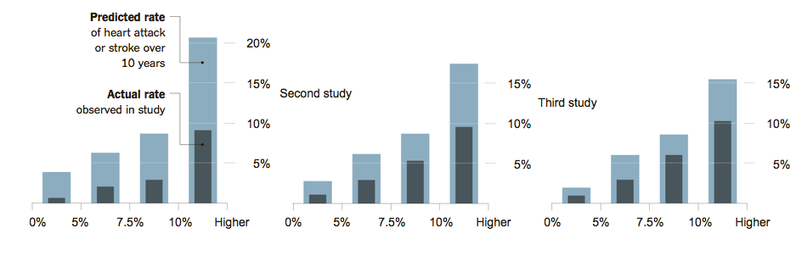
  - The guidelines recommend estimating each subject’s risk using a cardiovascular risk calculator, then managing based on whether the predicted 10-year risk is <5%, 5-7.4%, 7.5-9.9%, or ≥ 10%. The NYT article included a graph of the overestimation, above, which many of your instructors found confusing. Josh Galanter gallantly created a calibration plot from these data (below), which should look more familiar. Explain briefly, step by step, how the data to produce figures like these would be obtained. (Hint: the X-axis in each case groups patients with predicted risks in the categories above.) [3]

  - If we assume that, in fact, the risk calculator is overestimating risk, what more do you need to know to conclude that using these overestimated risks with the treatment thresholds in the guidelines will lead to excessive treatment? Explain. [2]

7-13. [10 points total] Schuetz et al (Epidemiol. Infect. (2008), 136, 1628–1637) compared 3 rules for predicting mortality in patients with community acquired pneumonia. The 3 rules were the Pneumonia Severity Index (PSI), the CURB65, and the CRB65 (which is CURB65 without the “U”). They used each of these 3 rules to predict risk of death in 371 patients with community–acquired pneumonia who were seen in the emergency department of a Swiss university hospital. Their calibration plots are shown on the next page.

All 3 rules divided the patients into 5 risk groups and, for all 3 rules, the predicted risks differed substantially from the actual mortality rate, so the authors re-calibrated the risk models.

a) Figure (c) is the calibration plot for the CRB65 rule. The open diamonds (◊) represent the original risk predictions prior to recalibration. Prior to recalibration, did the CRB65 rule overestimate or underestimate mortality risk? Explain briefly. [2]

b) Figure (b) is the calibration plot for CURB65 (note the letter “U”). CURB 65 assigned only 3 patients to its highest risk group. How many of them died? [1]

Note 1: The PSI is the same as the PORT Score described in Chapter 8 of Evidence-Based Diagnosis, Table 8.3, page 176.)
Note 2: the CRB65 is just the CURB65 without a lab test called the BUN.

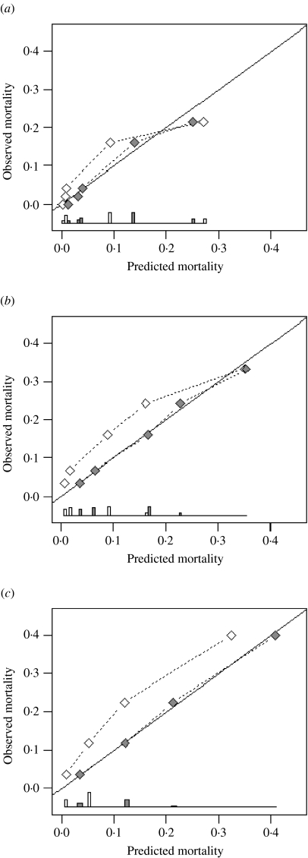
Agreement between predicted and observed 30-day mortality (calibration) for three pneumonia severity prediction rules (a) PSI, (b) CURB65 and (c) CRB65. Observed mortality is plotted according to classes of predicted risk for each prediction rule separately. The solid line of identity represents perfect calibration of predicted risk within new patients. Correction of miscalibration () after recalibration (◊).

The ROC curves are shown below:

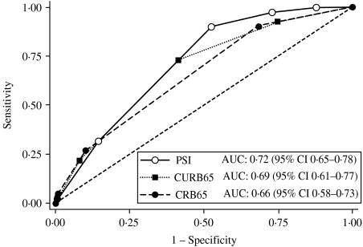

Receiver-operating characteristics analysis for 30-day mortality prediction with three pneumonia severity prediction rules (PSI, CURB65 and CRB65) in 373 patients with CAP.

c) Can you tell by looking at the ROC curves whether they were based on the pre-recalibration or post-recalibration risk predictions? Explain your answer. [2]

d) Do the points on the PSI calibration plot represent approximate quintiles of risk? In other words, does each category of predicted risk contain roughly one-fifth of the population? How can you tell? (Hint: Looking at the ROC curve may help.) [2]
e) Below is an enlarged version of the calibration plot for the PSI (the top figure from part b) with 3 original risk classes circled. Where on the ROC curve would the data corresponding to these 3 points at the lower left of the calibration curve be plotted? Draw a circle around the part of the ROC curve that corresponds to these 3 risk classes for the PSI. [1]

f) The authors were interested in a rule that could identify pneumonia patients at such low risk of death that they could be discharged from the emergency department. Even after re-calibration, only one of the 3 rules could identify patients at low enough risk to send home. Which of the 3 rules was it? Explain how you know. [2]

REFERENCES

Fowler, K. B., S. Stagno, R. F. Pass, W. J. Britt, T. J. Boll and C. A. Alford (1992). "The outcome of congenital cytomegalovirus infection in relation to maternal antibody status." N Engl J Med 326(10): 663-667.

Kolata G, available at: http://www.nytimes.com/2013/11/18/health/risk-calculator-for-cholesterol-appears-flawed.html

