Clinical Epidemiology 2016

HW#8, Chapters 8 and 9−ANSWERS

Due 1 PM 11/3/16

Multiple Tests and Randomized Trials.

Do (indicated portions of) problems 8.2 [5], 8.6 [8], 9.1 [6], 9.16 [4], 9.17 [2], 9.19 [2], 9.20 [10+2] and 9.22 [6] below. [43+2 possible]

8.2 [5 points] Kawasaki disease is an acute febrile illness in children of unknown cause that includes a rash, conjunctivitis, inflammation of mucous membranes, swollen lymph nodes, and swelling of hands and feet. Affected children are treated with intravenous immune globulin (IVIG) to prevent coronary artery aneurysms, the most serious complication of the disease. Using data from the intervention groups of two randomized controlled trials of IVIG, Beiser et al. (1998) developed an instrument to predict which children with Kawasaki disease would develop coronary artery aneurysms. The predictive instrument they developed is shown below (from Beiser et al. 1998. Used by permission.):

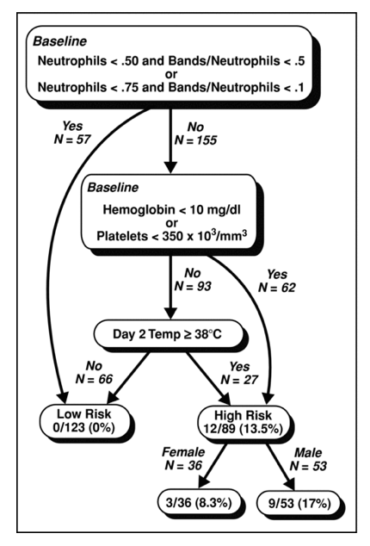

Neutrophils (also known as polymorphonuclear leukocytes) are one kind of white blood cell (WBC). Bands are immature neutrophils. “Neutrophils < 0.5” means that, based on the WBC count differential, < 50% of the WBCs are neutrophils. “Bands/neutrophils <. 5” means that, of all the neutrophils, fewer than 50% are bands.
a) Deleted
b) Assume you are treating a child like those included in the study. His initial blood work shows a hemoglobin of 11.2 g/ dL, 600,000 platelets, and 13,000 WBCs/ mm3, with 8,000 (61.5%) neutrophils of which 1,000 (1,000/ 8,000 = 12.5%) are bands. On day 2 of the illness, his temperature is 38.1 ° C. Would you classify him as high or low risk? [1]

c) Now imagine the same patient, only this time he only has 5,000 neutrophils/ mm3. He therefore is at low risk, regardless of his temperature on day 2. Does this mean you don't need to treat him with IVIG? [2]

d) In a study such as this, it is important that the clinical prediction rule be validated on a group of patients separate from the group used to derive it. The abstract of the study states:
“The instrument was validated in 3 test data sets…[ it] performed similarly in the 3 test data sets; no patient in any data set classified as low risk developed coronary artery abnormalities.”
However, the “Methods” section states:
“We developed many such [sequential classification] processes, each using a different combination of risk factors… Instruments that performed well on the development data set were validated using each of the 3 test data sets.”
Is there a problem here? If so, what is it and how would it affect the results? [2]

8-6. [8] McIsaac Score and Rapid Antigen Detection Test
Tanz et al. (1) studied the sensitivity and specificity of a rapid antigen detection test for group A strep in 1848 children 3 to 18 years of age who were evaluated for acute pharyngitis; a laboratory throat culture was the "gold standard." They found that the sensitivity of rapid antigen detection depended on the prior probability of strep throat, which was estimated using the McIsaac Score. The McIsaac score gives 1 point for each of the following items (range of scores 0 to 5):
- history of temperature of >38°C
- absence of cough
- tender anterior cervical lymph nodes
- tonsillar swelling or exudates
- age of <15 years
- For this part, ignore the rapid antigen test and consider the McIssac Score as a single test for strep (as determined by the gold standard throat culture). If clinicians used some of the same items listed above to decide which children to enroll in the study, what bias would this cause, and how would it affect the apparent sensitivity and specificity of a McIsaac score ≥ 3 as a test for strep throat? [2]

b. (skipped)
c. Table 5 from that paper is reprinted below. The text says: "Table 5 shows that McIsaac scores >2 were significantly associated with positive results for each diagnostic test."

TABLE 5. Odds Ratios for Positive Diagnostic Test Results With McIsaac Scores of >2
Test | Odds Ratio (95% CI) | P
Rapid Antigen | 3.44 (2.66–4.44) | <.001
Throat culture | 2.81 (3.20–3.60) | <.001

The baseline score level was 0 to 2.

  - Describe the meaning of the odds ratio of 3.44 in a sentence. (Hint: include the comparison group.) [2]

ii. What is an obvious error in the table? [1]

iii. As we saw in Chapter 5 (pages 105-106), the term "spectrum bias" is sometimes used to describe non-independence (conditional on disease status) between two tests, where one test is a clinical assessment like the McIsaac score (or prior probability of UTI based on symptoms) and the other test is a laboratory test like the rapid Strep antigen test (or urinalysis). Does the odds ratio of 3.44 provide evidence of this type of nonindependence beween the McIsaac Score and the rapid antigen test? Explain. [3]

9-1. Otitis Media with Effusion (OME) is very common in infants and young children. The basic problem is that the Eustachian tube does not work well, and the kids get fluid and negative pressure in the middle ear, which can cause mild to moderate conductive hearing loss and an increased risk of acute (purulent) otitis media (ear infection).

A controversial clinical trial(2) found that, in children who had OME for 3 months, resolution rates at 4 weeks were about 30% with the antibiotic amoxicillin (with or without an antihistamine/decongestant) and about 14% with placebo.

a. Using the conventions suggested in the chapter (RR is the risk of something bad in the treatment group relative to the control group), what are the relative risk (RR), the relative risk reduction (RRR), the absolute risk reduction (ARR), and the number needed to treat (NNT) to prevent one persistent effusion? (2 points, ½ for each)

b. Why are the RRR and ARR so similar in this case? (1 point)

The reason why the study was so controversial is that one of the investigators (Erdem Cantekin) so disagreed with the other investigators that he published an alternative report on the same study in JAMA (3-5) after the other investigators reported the results in the New England Journal. One of Cantekin's main points was that blinding was suspect and no benefit was apparent when the outcome was assessed objectively (by tympanometry). After excluding 43 children (13.3% of the placebo group and 7.4% of amoxicillin group; P = .122) who had developed acute otitis media during the follow-up period, he came up with the following numbers (simplified from his Table 3).

Outcome Measure | Amoxicillin (%) | Placebo (%) | Difference (%) | P
Normal by otoscopy | 35.2 | 19.2 | 16.0 | .004
Normal by algorithm (defined in protocol) | 25.6 | 13.9 | 11.7 | .027
Normal by tympanometry | 17.8 | 10.0 | 7.8 | .121
Normal by hearing test | 21.9 | 18.0 | 3.9 | .611
Hearing improved > 10 dB | 31.5 | 32.5 | -1.0 | .311

c) Do you agree with the decision to exclude children who developed acute otitis during the follow-up period? What effect might this have had on the results tabulated above? (3 points)

9-16. Occasionally, due to fetal stress during labor, the fetus passes meconium stools, staining the normally clear amniotic fluid. It is thought (though now longer universally accepted) that if newborns inhale this meconium with their first breaths it can injure their lungs, causing meconium aspiration syndrome (MAS), a potentially life-threatening disorder. For this reason, when babies are born through meconium-stained amniotic fluid, the delivering clinician often tries to suction any meconium out of the nose and mouth before the babies take their first breath.

Vain et al (6) did a randomized trial of such suctioning to prevent MAS. Here is a 2x2 table summarizing the results of this study:

 | MAS | No MAS | Total | Risk
Suction | 52 | 1211 | 1263 | 4.12%
No Suction | 47 | 1204 | 1251 | 3.76%
Total | 99 | 2415 | 2514

From the “Results” section:

“ …26 (2%) infants assigned no suction received intrapartum suctioning, mostly because the obstetrician demanded suctioning just as the child's head was being delivered, and were also analyzed as part of the no-suction group. These events occurred at several institutions early in the study period. Consequently, no further infants delivered by the non-compliant obstetricians were enrolled.”

a. Why not analyze these 26 infants who did receive suctioning in the suction group, or at least drop them from the analysis altogether? (2 points)

b. If we assume there are other risk factors for MAS that obstetricians could observe, would dropping them from the analysis likely favor suction or no suction? (2 points)

  - Effects of Iron Therapy on Iron Deficient Children

Oski and Honig (7) did a randomized controlled trial to determine the short term (5- to 8-day) effect of intramuscular iron on mental and physical development indexes in iron deficient children aged 9 to 26 months. The pre-test was administered, then the patient received study drug (intramuscular iron in the “experimental” group and intramuscular saline in the control group). The post-test was administered 6-9 days later. The results are displayed in Table II reprinted below:
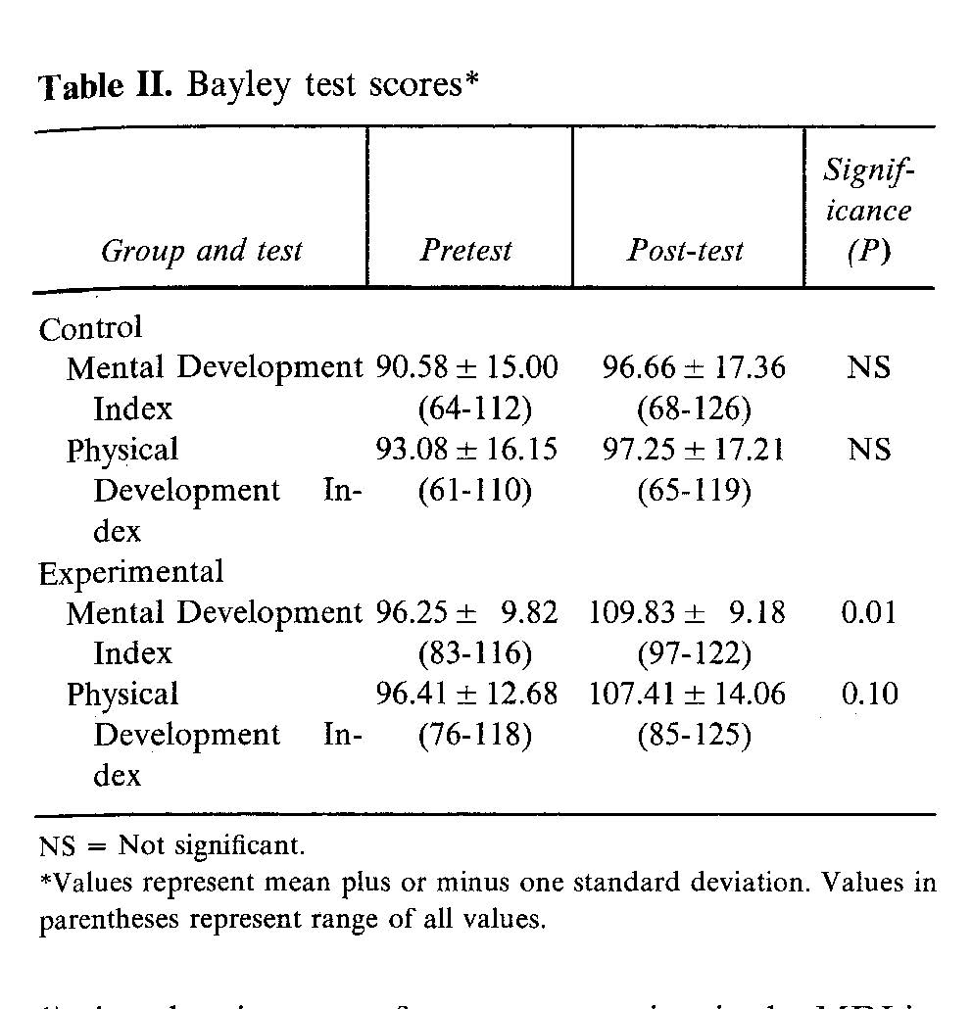
From the abstract: "Children treated with iron showed a significant increase in their scores on the Mental Development Index averaging a mean gain of 13.6 points in a mean time of 6.8 days..." On the other hand, there was no significant increase in the placebo group.

"These findings support the hypothesis that iron deficiency in infants produced developmental alterations and that these changes are rapidly reversible with iron therapy."

Do the P-values provided by the authors allow them to draw these conclusions? Explain. (2 points)

9.19. Lyme disease is an infection with a spirochete bacterium acquired from a tick bite. Most patients recover after treatment of the acute infection with antibiotics, but some can develop chronic symptoms, or "post Lyme syndrome," one symptom of which can be severe fatigue. The STOP-LD trial(8) was a randomized, double-blind trial of a long course of IV ceftriaxone (an antibiotic).

The results section includes:
Masking. At … 6 months 69% (18/26) of the ceftriaxone vs 32% (7/22) of the placebo group correctly guessed their treatment assignment (p = 0.004).
In the discussion they wrote:
"The observation that more of the ceftriaxone than placebo treated groups correctly guessed their treatment assignment could mean that masking may have been compromised."
Does the comparison above (P=0.004) support the authors' concern that masking may have been compromised? Explain. (2 points)

9.20 With thanks to Sarah Averbach, Juno Obedin-Maliver, and Nika Seidman (students in 2014 course) Planned vaginal vs planned cesarean delivery for breech presentation
Women who have a fetus in the breech position (feet/bottom down, head up) at term can either plan to attempt a vaginal breech delivery or plan to deliver by cesarean section. Vaginal breech deliveries are less risky for mothers but may be more risky for infants.

a) For their randomized controlled trial comparing planned vaginal delivery to planned cesarean delivery for singleton breech fetuses at term, Hannah et al (9) enrolled 2088 subjects from 121 centers in 26 countries. The primary outcomes were perinatal mortality, neonatal mortality, serious neonatal morbidity, maternal mortality and serious maternal morbidity. If you were to design this study, how would you incorporate blinding? Who would be blinded, and for what outcomes? Why? [3]

b) The primary endpoint of this study was infant mortality at <28 days of age or “serious neonatal morbidity.” The authors defined “serious neonatal morbidity” as one or more of the following (list abbreviated for this question): spinal-cord injury, skull fracture, peripheral-nerve injury present at hospital discharge, seizure at <24 hours of age; Apgar score <4 at 5 minutes; stupor, decreased response to pain, or coma; intubation for >24 hours; tube feeding for >4 days; or admission to the intensive care unit for >4 days. What is the main advantage of using such a composite outcome? What is the main disadvantage? [2]

c) Even if a vaginal delivery route is initially planned, the plan can change during labor because of perceived danger to mother or fetus; in this case a cesarean section may be done on an urgent or emergent basis. After randomization 90% (941/1041) of women randomized to cesarean section delivered that way and 57% (591/1042) of those randomized to vaginal delivery had a vaginal delivery. For the question of the effect of PLANNING a c-section vs. PLANNING a vaginal delivery will an "Intention to Treat" analysis of this trial bias results towards finding no difference? [2]

d) The outcome of perinatal or neonatal mortality (death of the fetus after 22 weeks or of the newborn up to 28 days of age, excluding 5 subjects with lethal congenital anomalies) occurred in 3/1039 (0.3%) in the planned cesarean group and 13/1039 (1.3%) in the planned vaginal delivery group (RR =0.23; 95% CI 0.07-0.81, P=0.02).

i) What were the overall Relative Risk Reduction (RRR) and Absolute Risk Reduction (ARR) for perinatal/neonatal mortality? [2]

ii) How many women need to plan a caesarian delivery rather than a vaginal breech delivery to prevent one perinatal or neonatal death? [1]

iii) (Extra credit) Because of the crossover between groups, the actual number of additional Cesarean deliveries needed to prevent one perinatal or neonatal death was less than the number calculated above. Taking that crossover into account how many additional cesarean deliveries did it take to prevent one perinatal or neonatal death by planning a Cesarean delivery? [+2]?

From the 2015 Final Exam:
9.22. Macitentan for pulmonary hypertension (with thanks to Mitchell Psotka)
Pulmonary arterial hypertension (PAH; high pressure in the arteries of the lungs), is a rare, debilitating, and fatal disease. Few medications improve the lives of these patients, and all are expensive. Furthermore, the only medication that decreases mortality is available only intravenously, which is difficult for patients and providers. Pulido et al(10) recently reported on a randomized trial of a new oral medication, the endothelin receptor antagonist macitentan.

From the abstract:
Methods (abbreviated): We randomly assigned patients with symptomatic pulmonary arterial hypertension to receive placebo once daily, macitentan at a once-daily dose of 3 mg, or macitentan at a once-daily dose of 10 mg. The primary end point was the time from the initiation of treatment to the first occurrence of a composite end point of death, lung transplantation, initiation of treatment with intravenous therapy, or worsening of pulmonary arterial hypertension. Results are shown below:

- The authors conclude that “Macitentan significantly reduced morbidity and mortality among patients with pulmonary arterial hypertension in this event-driven study.” Based on the results in the table above, do you agree? [2]

- A pharmaceutical representative comes to your office and tells you that although macitentan is expensive ($7,727 for 30 10 mg tablets), treatment reduced the risk of trial endpoints ("all events related to PAH or death in table above) by 32% so the number needed to treat is not very high. Do you agree? [2]
- What is the approximate medication cost to prevent one patient from having an event (trial endpoint), assuming 90 weeks of treatment? (The study was 100 weeks, but subjects who died before the end of the study would not incur treatment costs, so 90 weeks of treatment might be a better estimate.) [2]

REFERENCES

1. Tanz RR, Gerber MA, Kabat W, Rippe J, Seshadri R, Shulman ST. Performance of a rapid antigen-detection test and throat culture in community pediatric offices: implications for management of pharyngitis. Pediatrics. 2009;123(2):437-44.
2. Mandel EM, Rockette HE, Bluestone CD, Paradise JL, Nozza RJ. Efficacy of amoxicillin with and without decongestant-antihistamine for otitis media with effusion in children. Results of a double-blind, randomized trial. N Engl J Med. 1987;316(8):432-7.
3. Cantekin EI, McGuire TW, Griffith TL. Antimicrobial therapy for otitis media with effusion ('secretory' otitis media). JAMA. 1991;266(23):3309-17.
4. Cantekin EI, McGuire TW, Potter RL. Biomedical information, peer review, and conflict of interest as they influence public health. JAMA. 1990;263(10):1427-30.
5. Rennie D. The Cantekin affair. JAMA. 1991;266(23):3333-7.
6. Vain NE, Szyld EG, Prudent LM, Wiswell TE, Aguilar AM, Vivas NI. Oropharyngeal and nasopharyngeal suctioning of meconium-stained neonates before delivery of their shoulders: multicentre, randomised controlled trial. Lancet. 2004;364(9434):597-602.
7. Oski FA, Honig AS. The effects of therapy on the developmental scores of iron-deficient infants. J Pediatr. 1978;92(1):21-5.
8. Krupp L, Hyman L, Grimson R, al. e. Study and treatment of post Lyme
disease (STOP-LD) A randomized double masked clinical trial. Neurology. 2003;60:1923-30.
9. Hannah ME, Hannah WJ, Hewson SA, Hodnett ED, Saigal S, Willan AR. Planned caesarean section versus planned vaginal birth for breech presentation at term: a randomised multicentre trial. Term Breech Trial Collaborative Group. Lancet. 2000;356(9239):1375-83.
10. Pulido T, Adzerikho I, Channick RN, Delcroix M, Galie N, Ghofrani HA, et al. Macitentan and morbidity and mortality in pulmonary arterial hypertension. N Engl J Med. 2013;369(9):809-18.

At Target/CVS with coupon on GoodRx 10/25/16

