# | Pts Possible | Pts missed | Extra Credit
1 | 10
2 | 8
3 | 15
4 | 5
5 | 10
6 | 19
7 | 14
8 | 5
9 | 8
10 | 6
11 | +4
Total | 100 + 4
Score
NAME _______________________
BRING THE EXAM ON PAPER to our last class or UPLOAD TO THE CLE SITE BEFORE 08:45 ON THURSDAY DECEMBER 1. Late exams cannot be accepted; submit EARLY to be safe if you won't be in class. Do NOT plan to print it at Mission Hall on 12/1.

Collaboration with others is NOT permitted. Answers must be in your own words.

Please show your work. Pay attention to words in italics.

1. Pain over speed bumps and diagnosis of acute appendicitis
(with thanks to Kali Zhou, Michelle Gomez Mendez, John Sy, and Benjamin Lee)

Acute appendicitis is an important cause of emergency department visits for abdominal pain. In an Ig-Nobel prize-winning (see http://www.improbable.com/ig/winners/) article, researchers looked into utilizing speed bumps as a potential diagnostic tool for acute appendicitis.¹ The abstract is reproduced below.

Objective: To assess the diagnostic accuracy of pain on travelling over speed bumps for the diagnosis of acute appendicitis.
Setting: Secondary care surgical assessment unit at a district general hospital in the UK
Participants: 101 patients aged 17-76 years referred to the on-call surgical team for assessment of possible appendicitis.
Main outcome measures: Sensitivity, specificity, positive and negative predictive values, and positive and negative likelihood ratios for pain over speed bumps in diagnosing appendicitis, with histological diagnosis of appendicitis as the reference standard.
Results: The analysis included 64 participants who had travelled over speed bumps over their journey to the hospital. Of these, 34 had a confirmed histological diagnosis of appendicitis, 33 of whom reported increase pain over speed bumps. The sensitivity was 97% (95%CI 85-100%), and the specificity was 30% (15% to 49%). The positive predictive value was 61% (47% to 74%), and the negative predictive value was 90% (56% to 100%). The likelihood ratios were 1.4 (1.1 to 1.8) for a positive test result and 0.1 (0.0 to 0.7) for a negative result. Speed bumps had a better sensitivity and negative likelihood ratio than did other clinical features assessed, including migration of pain and rebound tenderness.
Conclusions: Presence of pain while travelling over speed bumps was associated with an increased likelihood of acute appendicitis. As a diagnostic variable, it compared favorably with other measures commonly used in clinical assessment. Asking about speed bumps may contribute to clinical assessment and could be useful in telephone assessment of patients.

A. Below is a 2 × 2 table that summarizes the results on the 64 patients analyzed. Are their values for positive and negative predictive value correct? [2]

 | Appendicitis | No Appendicitis | Total
Positive | 33 | 21 | 54
Negative | 1 | 9 | 10
Total | 34 | 30 | 64

B. 33 patients did not recall having travelled over speed bumps and were excluded from the study. If many of them had, in fact, gone over speed bumps, but did not remember (because it didn't hurt) what kind of bias would result from excluding these patients from the study, and how would it affect reported sensitivity and specificity? [2]

C. Assume that those excluded from the study because they did not remember traveling over speed bumps were otherwise similar (in terms of appendicitis risk) to those who remembered traveling over speed bumps, but not feeling pain. How would the exclusion of these subjects affect the point estimate and 95% confidence interval of the negative predictive value? [2]
D. Another possibility is that the reason why those 33 patients did not recall going over speed bumps was that they deliberately avoided them because they thought it would hurt. If just this (and not forgetfulness from part A) caused some of the 33 patients to be excluded, how would that affect the reported sensitivity and specificity (compared with including them and counting them as positive for pain over speed bumps)? [2] (Hint: don't try to name this bias.)
E. The diagnosis of appendicitis was confirmed histologically (i.e., by examination of the removed appendix under a microscope) in all cases. However the diagnosis of no appendicitis was sometimes made clinically (e.g., pain resolved without surgery). If appendicitis sometimes resolved spontaneously and those with positive speed bump tests were more likely to have appendectomies, what bias would that cause, and how would it affect reported sensitivity and specificity? [2]
2. Unconditional prenatal income supplement and birth outcomes

Brownell et al ² tested whether simply giving poor mothers in Mantoba, Canada some extra money (about $80/month, amounting to about a 10% increase in their monthly income) would improve their birth outcomes. The abstract of the study is excerpted below:

BACKGROUND AND OBJECTIVES: Perinatal outcomes have improved in developed countries but remain poor for disadvantaged populations. We examined whether an unconditional income supplement to low-income pregnant women was associated with improved birth outcomes.

METHODS: This study included all mother-newborn pairs (2003-2010) in Manitoba, Canada, where the mother received prenatal social assistance, the infant was born in the hospital, and the pair had a risk screen (N = 14 591). Low-income women who received the income supplement (Healthy Baby Prenatal Benefit [HBPB], n = 10 738) were compared with low-income women who did not receive HBPB (n = 3853) ... Covariates from risk screens were used to develop propensity scores and to balance differences between groups in regression models….

RESULTS: HBPB was associated with reductions in low birth weight ([adjusted risk ratio] aRR, 0.71 [95% CI, 0.63-0.81]), preterm births (aRR, 0.76 [95% CI, 0.69-0.84]) and small for gestational age births (aRR, 0.90 [95% CI, 0.81-0.99]) …
CONCLUSIONS: Receipt of an unconditional prenatal income supplement was associated with positive outcomes. Placing conditions on income supplements may not be necessary to promote prenatal and perinatal health.
a.) This was an observational study, not a randomized trial. Could confounding by indication explain these favorable results? Explain. [2]
b.) The authors created a propensity score to deal with the possibility of confounding. What would be the characteristics of variables would they would want to include in their propensity score? [2]
c.) Imagine that Martha has a propensity score of 0.7. Explain in words what that would mean. [2]
d.) The HBPB program began in Manitoba in 2001. If we can assume that nothing else affecting birth outcomes changed between pre- and post 2001, would it be a good idea to include births from before 2001 in the study, and then include year of birth as a predictor variable in the propensity score? Explain. [2]

3. Measuring disease activity in rheumatoid arthritis. (Thanks to Zara Izadi.)
Clinical Disease Activity Index (CDAI) and 28-joint Disease Activity Score based on erythrocyte sedimentation rate (DAS28ESR) are two measures used for assessment of disease activity in Rheumatoid Arthritis (RA). The internationally agreed on standard of good practice, often referred to as “treat-to-target,” recommends that all patients be treated to a level that will restore physical function. Although both disease activity measures have a result category called "remission," it is not clear how well it corresponds to restoration of physical function.
Your colleague has done a preliminary analysis of your RA patients and is ready to publish her findings in an abstract. An excerpt from the abstract reads:
“In patients with DAS28ESR remission (n=40), those who also achieved CDAI remission (n=18) experienced improved physical function (p<0.05). In patients with CDAI remission (n=24), those who also achieved DAS28ESR remission (n=18) did not experience further improvements in physical function.”

After reading the above excerpt you set out to compare these two measures of disease activity.
- [2] Using predefined cut-offs you dichotomize both measures into ‘remission’ and ‘active disease.’ What is the concordance rate between the two criteria? What is kappa? [2]
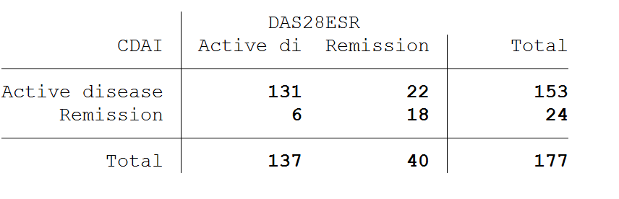

- Are the disagreements balanced or unbalanced? How would this affect your interpretation of a study of the prevalence of "active disease" in patients with RA, if assessment was using the DAS28ESR? [2]

- Assume that you have a (dichotomous) gold standard measure of restored physical functioning and instead of dichotomizing the disease activity scales, you divide each scale into 4 categories: ‘remission’, ‘low’ disease activity, ‘moderate’ disease activity and ‘high’ disease activity. You use these cateogories to plot Receiver Operator Curves (ROCs) for both criteria. Label the four categories of disease activity on these ROC curves. [2]
Here are some labels and ovals you can drag to different parts of the curve (only if it saves you time):
High
Moderate
Low
Remission
d. Which scale is better at discriminating between RA patients who do and do not have poor physical functioning when it indicates remission? Explain. [2]
e. Which is better when it indicates high disease activity? Explain. [2]

f. Your colleague suggests that instead of dividing these scales into 4 categories, you just use 3.
i. Based on the ROC curve above, which two CDAI groups would you combine? [1]

ii. Which two DAS28ESR groups would you combine? [1]

g. The data used to create the DAS28ESR ROC curve above are summarized in the table below. Assume you have a patient with a prior probability of poor physical functioning of 0.5, who had a "Moderate" DAS28ESR score. What would be the best estimate for her posterior probability of poor physical functioning? [3]
Abnormal if ≥ | Sensitivity | 1-Specificity
Remission | 100% | 100%
Low | 85% | 47%
Moderate | 72% | 17%
High | 28% | 0%

4. Agreement on the diagnosis of dysplastic Barrett’s Esophagus with Narrow Band Imaging. From a problem by Suzanne Sharpton, Eric Bomberg & Alon Vaisman

Barrett’s esophagus is a precursor for esophageal cancer, which is the most rapidly increasing cancer in the United States. Patients diagnosed with Barrett’s esophagus undergo routine endoscopic surveillance, with the goal of detecting dysplasia (which has a high risk of evolving into cancer) or cancer in situ (in the early stage when treatment is can still be curative).

To increase the yield of surveillance endoscopy in Barrett’s esophagus, some gastroenterology groups are interested in narrow band imaging (NBI). Interpretation of NBI requires examining for specific mucosal patterns (i.e. irregular, nodular) and vascular patterns (i.e. degree of irregularity of vessels) characteristic of Barrett’s epithelium.

Two expert gastroenterology attendings from a national gastroenterology working group were asked to classify the histopathology of 130 NBI images into one of the following categories based on their review of images: 1=non-dysplastic BE, 2=dysplastic BE, 3=esophageal carcinoma in situ (early cancer), or 4=indeterminate/uncertain. The results are shown below.

 | Attending 2
Attending 1 | 1 | 2 | 3 | 4 | Total
1 | 10 | 4 | 0 | 15 | 29
2 | 15 | 15 | 4 | 5 | 39
3 | 6 | 15 | 26 | 4 | 51
4 | 2 | 1 | 0 | 8 | 11
Total | 33 | 35 | 30 | 32 | 130

a. What is the observed % agreement? (Show your work) [1]

b. What % agreement would be expected based on the marginals? (Show your work) [1]

c. What is the unweighted Kappa? (Show your work) [1]

d. Linear weighted Kappa would use the following weights.
Ratings weighted by:
1.0000 0.6667 0.3333 0.0000
0.6667 1.0000 0.6667 0.3333
0.3333 0.6667 1.0000 0.6667
0.0000 0.3333 0.6667 1.0000
Would linear weighted Kappa be preferable to unweighted Kappa in this case? Why or why not? [2]

5. Tailored vs Standard Chemotherapy for High-Risk Early Breast Cancer
Investigators from Sweden, Germany and Austria studied the effect of "tailored" chemotherapy in which higher doses are given to those who can tolerate them, compared with standard chemotherapy. ³ As expected, there was greater toxicity in the tailored group. The primary efficacy endpoint was breast cancer recurrence-free survival (BCRFS). There were 3 secondary endpoints.
Cumulative incidence curves for the efficacy endpoints are shown below.
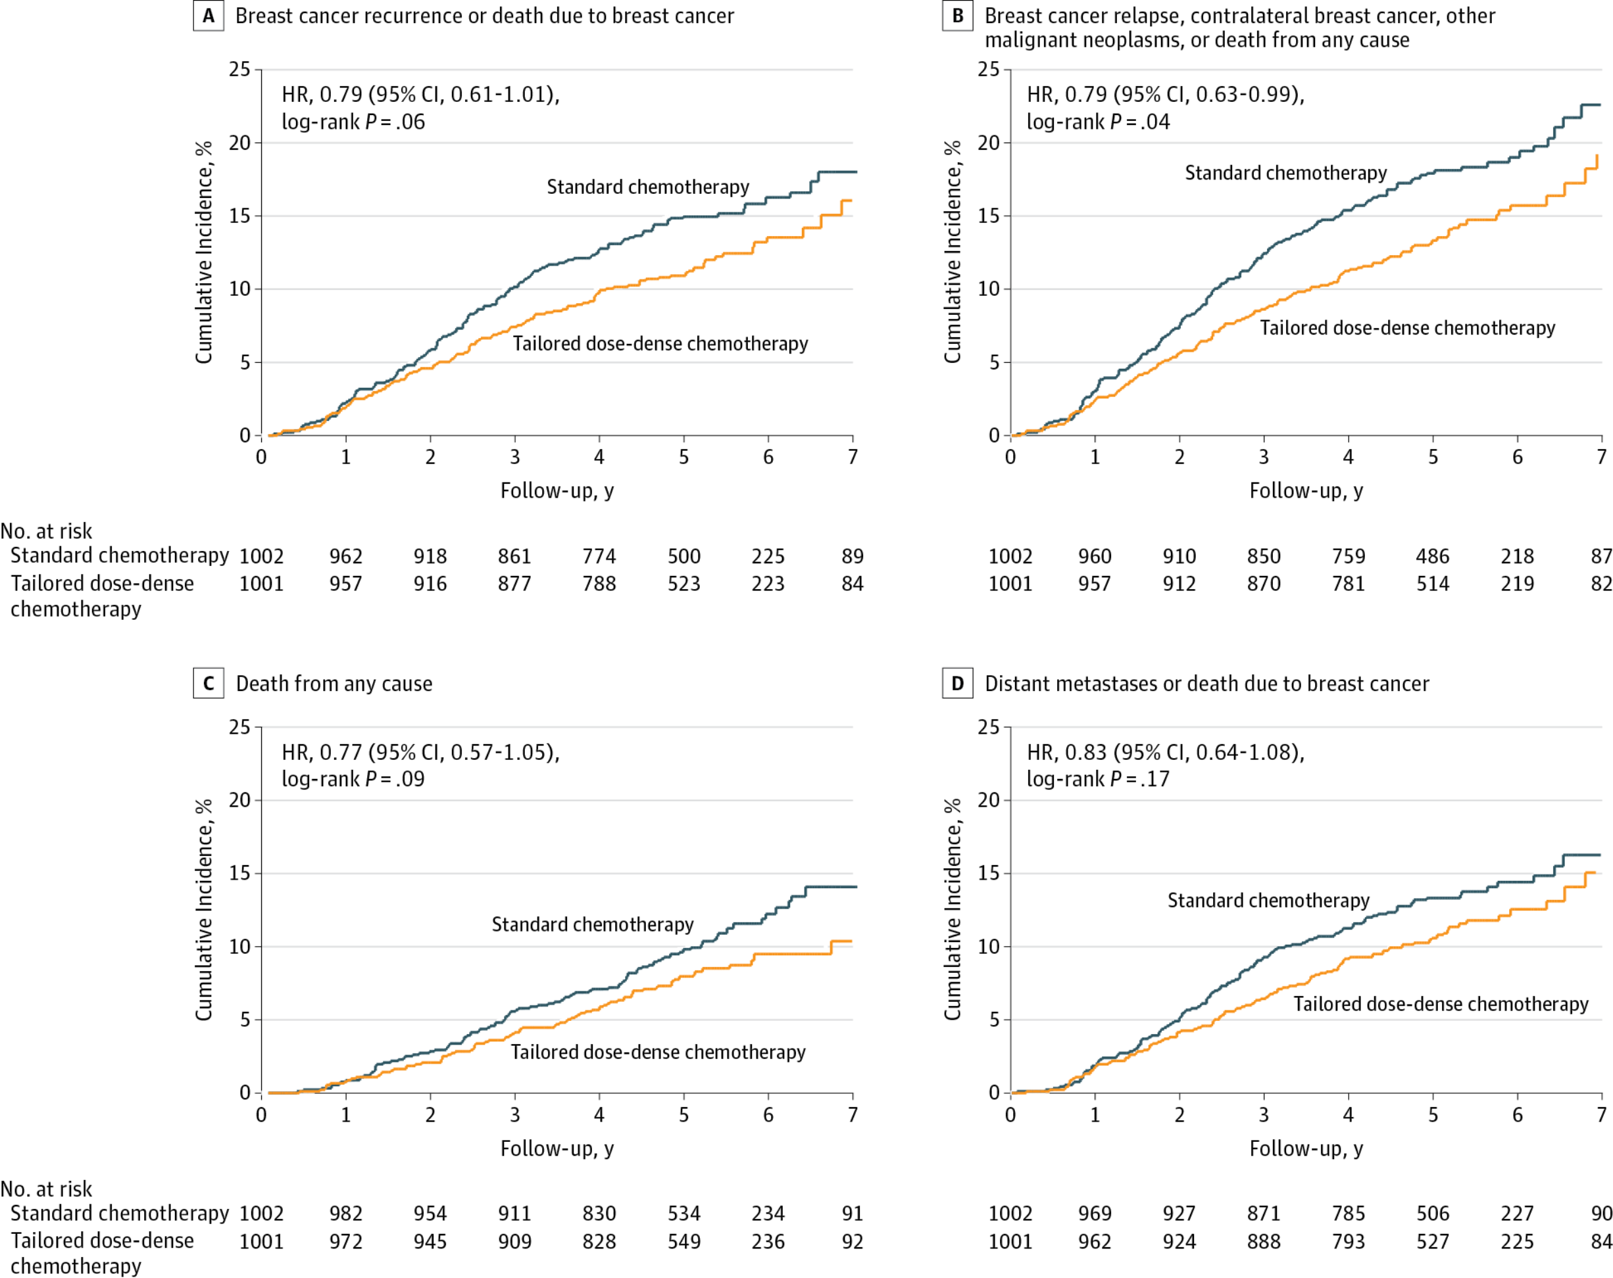Figure 2 Cumulative Incidence Curves of Efficacy End Points in the Intention-to-Treat Population. Cumulative incidence curves are shown for the end point for breast cancer recurrence–free survival (primary end point) (A), the end point for event-free survival (B), the end point for overall survival (C), and the end point for distant disease–free survival (D) after a median follow-up of 5.3 years (interquartile range, 4.5-6.1 years) in the tailored dose-dense group and the standard chemotherapy (control) group. HR indicates hazard ratio.
Answer the following True/False questions and provide an explanation for your answer.
- Although the P-value of 0.06 for (primary outcome) BCRFS was considered not statistically significant, there still is a (1− 0.06 =) 94% chance that the probability of BCRFS is lower with standard than with tailored chemotherapy. [2]

- Although 4 different outcomes were examined, the alpha value for rejection of the null hypothesis for the primary outcome need not be adjusted. [2]
- The abstract states: "The groups did not differ in overall survival (HR, 0.77; 95% CI, 0.57-1.05; P=.09…)" This means that tailored chemotherapy did not increase survival in this study. [2]
- A correct interpretation of this 95% confidence interval for this null result is that if we were to repeat this study 100 times, we would expect 95% of the studies to have a 95% CI that includes the null value (i.e., overlaps 1), as this one does. [2]
Careful examination of the primary and secondary outcomes of this study reveals that many of the same events are included in more than one outcome. In fact, breast cancer deaths are counted in all four outcomes. (This is a fact, not a question.)
E Because of the above fact, it would be less important to do some kind of adjustment for multiple comparisons than if all outcomes were independent. [2]

6. Long-acting injectable (LAI), aripiprazole lauroxil for acute schizophrenia in adults (with thanks to Kat Dang)
Approximately 80% of patients with schizophrenia relapse within 5 years despite the availability of effective oral medications. Relapse of patients is often associated with poor adherence and worsening of long-term functional and mental outcomes. Meltzer et al.⁴ reported a randomized double-blind trial to determine the efficacy of the long-acting injectable (LAI), aripiprazole lauroxil, on acute exacerbation of schizophrenia in adults ages 18-70. Alkermes, Inc sponsored the trial and all patients were seen at Alkermes, Inc research sites in 7 countries. Patients were randomized to receive either 441 mg of aripoprazole lauroxil , 882 mg of aripoprazole lauroxil or matching placebo via intramuscular injection once a month for 12 weeks.
  - Out of the 622 subjects who enrolled and received baseline measurements, only 360 subjects completed the study. Drop out rates were 77/207 (37.2%), 73/208 (35.1%) and 112/207 (54%) subjects from the 441 mg, 882 mg and placebo groups, respectively. What approach can you take to estimate the maximum potential effect that loss to follow-up can have on a study? Explain. [2]
  - Serious adverse events were reported in 11 patients, but in only 1 patient was the event considered by the investigators to be related to study drug. In analyzing adverse events, should the investigators include only events that they believe were related to study drug? Why or why not? [2]
  - Figure 3 of the paper shows the proportions of subjects reporting "improved or very much improved" in the 3 groups. Subjects with missing values (because they dropped out) were assumed ("imputed") to have no improvement. Although the raw numbers are not given, from measuring the heights of the bars at day 85, it looks like about 82/196 (42%) of subjects on aripiprazole 441 mg and 40/196 (20%) of subjects on placebo had the outcome of "Very Much or Much Improved" on the Clinical Global Impressions Improvement Scale. Create a 2 x 2 table with the results above using the conventions preferred for this class (outcome is something bad, drug is in numerator) and calculate the RR, RRR, ARR. [5]

d. Calculate the NNT and use that number in a sentence that explains what it means, including all relevant information for understanding that NNT. [2]
e. Use Stata (or the software package of your choice) to help you calculate 95% CI for the NNT. Show your work. [2]
f. With a coupon from GoodRx.com, a monthly injection of 441 mg aripiprazole lauroxil costs about $1120 at CVS/Target (11/13/16). What is the approximate medication cost to get one patient much improved or very much improved after 3 months of treatment (assuming full adherence, i.e., 3 shots), compared with placebo? [2]
g. The calculation in part F was based on a comparison with placebo. But there are inexpensive drugs known to be effective for acute schizophrenia. How would the calculation in part F change if the comparison group had been an active drug with similar efficacy? Explain briefly. [2]
h. The US has a low and declining number of inpatient psychiatric beds,⁵ and according to our local expert (Raj) patients with acute schizophrenia are commonly discharged after only 3 days in the hospital. However, in this study, patients were hospitalized at least 2 weeks, and not discharged until "the study investigator determined that they were clinically stable." Furthermore, "In addition to intramuscular study drug, patients received oral study drug daily administered in a double-blind fashion for the first 3 weeks after randomization to achieve early therapeutic exposure to aripiprazole from the combined release of aripiprazole lauroxil and oral aripiprazole..."
How would these differences between the treatment of patients in the study and the way they would be likely to be treated in the "real world" affect the estimated NNT? Explain briefly. [2]

7. New "HS index" for hereditary spherocytosis. (Thanks to Nicole Weiss, Shab Peyvandi and Katie Wysham )
Hereditary spherocytosis (HS) is a cause of hemolytic anemia (low blood count due to destruction of red cells), occurring in approximately 1 in 2,000 people. It is caused by defective red blood cell membranes that result in fragile red blood cells. These fragile red blood cells break down easily, causing anemia and sometimes jaundice. HS can be diagnosed by several different tests. Once diagnosed, treatments may include folic acid, blood transfusions, and splenectomy.
Christensen et al.⁶ recently published a study of infants up to 3 months old who had complete blood counts (CBCs) for various reasons, evaluating the accuracy of a new "HS index" as a screening tool for HS. The HS index is the ratio of the hemoglobin concentration in the cells to the volume of the red blood cells, i.e., the mean corpuscular hemoglobin concentration (MCHC) divided by the mean corpuscular volume (MCV). Both the MCHC and MCV are obtained from a CBC. The authors reported that an HS index ≥0.36 had 97% sensitivity and 99% specificity for hereditary spherocytosis, as well as an NPV of >99% and a PPV of 7%.

Results from the study are displayed below. (Note: data were extrapolated from study text and numbers of patients were doubled to facilitate rounding in subsequent questions)
 | HS + | HS –
HS index ≥0.36 | 64 | 818 | 882
HS index <0.36 | 2 | 81,074 | 81,076
 | 66 | 81,892 | 81,958

- Why is the negative predictive value of ">99%" provided by the authors unhelpful? [2]

- Osmotic fragility is one test used to confirm the diagnosis of hereditary spherocytosis. Assume that missing a diagnosis of HS by not performing the osmotic fragility test is 9 times as bad as unnecessarily performing osmotic fragility testing. Also assume that the CBC is costless because it is usually obtained for other reasons, such as evaluation for infection or in the setting of significant jaundice. At what probability threshold would we perform osmotic testing? [2]

- At what range of prior probabilities of hereditary spherocytosis would the HS index be helpful in deciding whether to pursue further testing? Provide the numbers and a sentence explaining what they mean. [3]

- Jaundice in the newborn period increases the likelihood of hereditary spherocytosis. As such, the authors would like to combine the presence of significant jaundice with their HS index to determine if this will help with the decision to pursue osmotic fragility testing in a newborn. First, they need to know whether the presence of significant jaundice (which they define as jaundice severe enough to need phototherapy) and the HS index are independent tests. They divide their cohort into two groups, based on presence of significant jaundice:

Babies with jaundice needing phototherapy |  |  |  | Babies with no jaundice needing phototherapy
 | HS + | HS – |  |  | HS + | HS –
HS index ≥0.36 | 35 | 19 |  | HS index ≥0.36 | 29 | 799
HS index <0.36 | 1 | 1,865 |  | HS index <0.36 | 1 | 79,209
 | 36 | 1,884 |  |  | 30 | 80,008

Are the occurrence of jaundice needing phototherapy and the HS index independent? How can you tell? [2]

- Assume the prior probability in your population (though not in the current study; see next problem) is 0.05%. Thus, the prior probability is low enough that you wouldn’t perform the HS index on every newborn. But, what if you had a baby with jaundice needing phototherapy? Would an HS index help you decide whether to pursue further testing for HS? [3]

Hint: first calculate the likelihood ratios for jaundice by filling out table below from above data
 | HS + | HS –
Jaundice needing phototherapy
No or insignificant jaundice

- This study includes only infants who had a CBC, and you notice that the prevalence of hereditary spherocytosis in the study population is 0.08%, which is higher than the 0.05% prevalence in the overall population of the United States. Could inclusion of only subjects who had a CBC account for an artificially high prevalence in the study population? Explain. [2]

8. Financial incentives for smoking cessation

Halpern et al.⁷ compared the effects of 4 different incentive programs with usual care to try to get people to stop smoking. The full article is on the course website; an abstract that should have all you need is excerpted below.

BACKGROUND: Financial incentives promote many health behaviors, but effective ways to deliver health incentives remain uncertain.

METHODS: We randomly assigned CVS Caremark employees and their relatives and friends to one of four incentive programs or to usual care for smoking cessation. Two of the incentive programs targeted individuals, and two targeted groups of six participants. One of the individual-oriented programs and one of the group-oriented programs entailed rewards of approximately $800 for smoking cessation; the others entailed refundable deposits of $150 plus $650 in reward payments for successful participants. Usual care included informational resources and free smoking-cessation aids.

RESULTS: Overall, 2538 participants were enrolled. Of those assigned to reward-based programs, 90.0% accepted the assignment, as compared with 13.7% of those assigned to deposit-based programs (P<0.001). In intention-to-treat analyses, rates of sustained abstinence from smoking through 6 months were higher with each of the four incentive programs (range, 9.4 to 16.0%) than with usual care (6.0%) (P<0.05 for all comparisons); the superiority of reward-based programs was sustained through 12 months. Group-oriented and individual-oriented programs were associated with similar 6-month abstinence rates (13.7% and 12.1%, respectively; P=0.29). Reward-based programs were associated with higher abstinence rates than deposit-based programs (15.7% vs. 10.2%, P<0.001). However, in instrumental-variable analyses that accounted for differential acceptance, the rate of abstinence at 6 months was 13.2 percentage points (95% confidence interval, 3.1 to 22.8) higher in the deposit-based programs than in the reward-based programs among the estimated 13.7% of the participants who would accept participation in either type of program.

CONCLUSIONS: Reward-based programs were much more commonly accepted than deposit-based programs, leading to higher rates of sustained abstinence from smoking…

For simplicity, because the group vs individual differences were insignificant, we will reduce the 5 possible treatment arms to 3: Reward-based incentives, Deposit-based incentives and Usual Care. The basic idea is that people who enroll in the reward-based programs get a reward if they quit smoking, and have nothing to lose if they don't. People in the deposit based programs had to put up $150 of their own money, which they got back (with an additional $650) only if they were successful. Not surprisingly, many more assigned to the reward-based programs accepted the assignment, but among those who accepted, the quit rates were lower.

a. Only 13.7% of those assigned to deposit-based programs accepted the assignment and enrolled. Would an intention-to-treat analysis of the effect of offering a deposit-based program (vs usual care) be biased towards the null? Explain. [2]
b. From the paper: "In standard per-protocol analyses, 52.3% of those who accepted deposits versus 17.1% of those who accepted rewards had sustained abstinence through 6 months." Does this analysis show that deposit-based incentives are more effective than reward-based incentives? Why or why not? [2]
c. The authors also reported an instrumental variable analysis. What should they have used as their instrument? [1]

9. Predicting positive sentinel node biopsies in women with breast cancer

As part of her research into whether she should have an axillary node dissection, our friend with breast cancer from HW #1, problem 4 reviewed an article describing a "validated nomogram for risk estimation."⁸ Investigators for that study derived a nomogram to predict sentinel lymph node (SLN) metastases from 3,786 sequential SLN biopsies. They then validated the nomogram on the next 1,545 SLN biopsies. (They converted their prediction rule into a web-based calculator; you can see it here: http://nomograms.mskcc.org/breast/BreastSLNodeMetastasisPage.aspx.) The authors reported, "The nomogram was accurate and discriminating, with an area under the receiver operating characteristic curve of 0.754 when applied to the validation group."
For questions a and b, indicate whether the statement is true or false and explain your answer.
- (T/F) The area under the receiver operating characteristic curve of 0.754 in the validation group indicates good but not outstanding calibration. [2]
- (T/F) If their goal was to create score by adding up points for various risk factors (as they did), they were right to use logistic regression rather than recursive partitioning. [2]
The calibration plot for their nomogram is shown below.
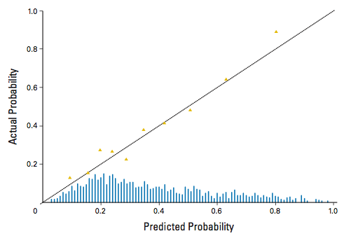
c. The yellow triangles represent deciles of risk. Describe the steps needed to create this plot, including the histogram at the bottom. [4]

10. A recent (11/16/16) news story (http://www.ctvnews.ca/health/toronto-oncologist-plans-study-to-test-which-prostate-cancer-screening-is-better-1.3163013) reports investigators are recruiting for a new clinical trial of prostate cancer screening. Per the ClinicalTrials.Gov website (https://clinicaltrials.gov/ct2/show/NCT02799303), the investigators "seek to study whether prostate cancer screening using multiparametric prostate magnetic resonance imaging (mpMRI) improves the detection rate of clinically-significant prostate cancer (defined as Gleason score ≥7 on prostate biopsy) compared with prostate cancer screening using prostate-specific antigen (PSA)."

A. Let's suppose that the study comes out as the investigators hope, and in fact the detection rate for clinically-significant prostate cancer is statistically and clinically significantly higher in the mpMRI group. What are at least 2 additional things you would want to know before recommending mpMRI over PSA for prostate cancer screening? [2]
B. The story reports that the clinical trial is being supported by Jerry Howarth, "the voice behind the Toronto Blue Jays," whose own prostate cancer was diagnosed by MRI. Jerry's tumor was identified by screening, rather than symptoms. Tumors identified by screening are more likely to be curable than tumors that present with symptoms, simply because screening preferentially identifies tumors with a better prognosis. What is the name of the bias that this phenomenon causes? [1]
C. What phenomenon could cause Jerry to believe prostate cancer screening and treatment had saved his life, when actually it did him no good at all? [1]

D. Imagine that the study has been completed, and the authors did additional long-term follow-up in order to be able to look at mortality from prostate cancer. They find that prostate cancer mortality is significantly reduced in the group randomized to mpMRI, compared with PSA. What bias do you still need to worry about before concluding that the mpMRI actually saved lives? Explain. [2]

11. [EXTRA CREDIT +3] Finding the murder weapon (drastically shortened from a problem by Samuel Zetumer & Fanny Elahi)

Michael Shleitz – part time thug and full time low-life – sits across from you in police detention. He was found, drunk as a skunk, near the scene of a gruesome murder. Three blocks away from the back alley where he was found lays the body of his high school sweetheart Mary Liebowitz. Her friends, shocked and dismayed at the news of her murder, described her as “someone who was headed places.” Not anymore. Forensics estimates that at 2 am last night, Mary’s life was gruesomely cut short. Literally. While they have not been able to find the murder weapon - a thin blade given the size and shape of the wound - they suspect that the killer could not have gone far.

You, the chief of police, are looking at the only suspect to date. Due to some liberal political non-sense in the eighties, police departments in California have only 48 hours to convince the district attorney to press charges on any suspect detained at the station.

You look at your records of arrests and the proportion of them that resulted in a guilty verdict. Over the course of about thirty years of police experience (Christ, has it been that long?) you estimate that about 20% of similarly detained suspects are guilty of the suspected crime. Over the next two days, the likelihood that this man killed the girl will go up and down as you find out more information, depending on what you do. You can…

Action 1: Case the suspect’s apartment for a murder weapon. If you find something resembling the stiletto that was used for this gruesome crime, this street rat is almost certainly going to get the book thrown at him (LR+ = 10). If you don’t find anything resembling the thin blade that apparently killed the victim, it doesn’t tell you much about Mikey’s innocence. The negative likelihood ratio (LR−) for this action is only 0.909.

Question: What is the likelihood that you will find something resembling the stiletto in Mikey's apartment? [+4]

(There were many more actions and questions; perhaps Sam and Fanny can post for your vacation pleasure.)
REFERENCES

1. Ashdown HF, D'Souza N, Karim D, Stevens RJ, Huang A, Harnden A. Pain over speed bumps in diagnosis of acute appendicitis: diagnostic accuracy study. BMJ. 2012;345:e8012.
2. Brownell MD, Chartier MJ, Nickel NC, et al. Unconditional Prenatal Income Supplement and Birth Outcomes. Pediatrics. 2016;137(6).
3. Foukakis T, von Minckwitz G, Bengtsson NO, et al. Effect of Tailored Dose-Dense Chemotherapy vs Standard 3-Weekly Adjuvant Chemotherapy on Recurrence-Free Survival Among Women With High-Risk Early Breast Cancer: A Randomized Clinical Trial. JAMA. 2016;316(18):1888-1896.
4. Meltzer HY, Risinger R, Nasrallah HA, et al. A randomized, double-blind, placebo-controlled trial of aripiprazole lauroxil in acute exacerbation of schizophrenia. J Clin Psychiatry. 2015;76(8):1085-1090.
5. Bastiampillai T, Sharfstein SS, Allison S. Increase in US Suicide Rates and the Critical Decline in Psychiatric Beds. JAMA. 2016.
6. Christensen RD, Hassan Y, Henry E, Baer V, Bennet S. A simple method for screening newborn infants for hereditary spherocytosis. J Applied Hematol. 2013;27-32.
7. Halpern SD, French B, Small DS, et al. Randomized trial of four financial-incentive programs for smoking cessation. N Engl J Med. 2015;372(22):2108-2117.
8. Bevilacqua JL, Kattan MW, Fey JV, Cody HS, 3rd, Borgen PI, Van Zee KJ. Doctor, what are my chances of having a positive sentinel node? A validated nomogram for risk estimation. J Clin Oncol. 2007;25(24):3670-3679.

