Biostat 202

Hwk #4: Regression and Classification

Biostat 202: Opportunities and Challenges of “Big Data”

For this homework we will use the “student-.csv” dataset available on the CLE

This data examines student achievement in mathematics at two secondary education Portuguese schools [1]. The data attributes include student grades, demographic, social and school related features. The data was collected using school reports and questionnaires.

Attribute Information:
# Attributes for both student-mat.csv (Math course) and student-por.csv (Portuguese language course) datasets:
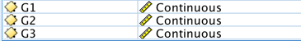
1) school - student's school (binary: 'GP' - Gabriel Pereira or 'MS' - Mousinho da Silveira)
2) sex - student's sex (binary: 'F' - female or 'M' - male)
3) age - student's age (numeric: from 15 to 22)
4) address - student's home address type (binary: 'U' - urban or 'R' - rural)
5) famsize - family size (binary: 'LE3' - less or equal to 3 or 'GT3' - greater than 3)
6) Pstatus - parent's cohabitation status (binary: 'T' - living together or 'A' - apart)
7) Medu - mother's education (ordinal: 0 - none, 1 - primary education (4th grade), 2 - 5th to 9th grade, 3 - secondary education or 4 - higher education)
8) Fedu - father's education (ordinal: 0 - none, 1 - primary education (4th grade), 2 - 5th to 9th grade, 3 - secondary education or 4 - higher education)
9) Mjob - mother's job (nominal: 'teacher', 'health' care related, civil 'services' (e.g. administrative or police), 'at_home' or 'other')
10) Fjob - father's job (nominal: 'teacher', 'health' care related, civil 'services' (e.g. administrative or police), 'at_home' or 'other')
11) reason - reason to choose this school (nominal: close to 'home', school 'reputation', 'course' preference, or 'other')
12) guardian - student's guardian (nominal: 'mother', 'father' or 'other')
13) traveltime - home to school travel time (ordinal: 1 - <15 min., 2 - 15 to 30 min., 3 - 30 min. to 1 hour, or 4 - >1 hour)
14) studytime - weekly study time (numeric: 1 - <2 hours, 2 - 2 to 5 hours, 3 - 5 to 10 hours, or 4 - >10 hours)
15) failures - number of past class failures (ordinal: n if 1 <= n < 3, else 4, i.e., if n >= 4 failures = 4)
16) schoolsup - extra educational support (binary: yes or no)
17) famsup - family educational support (binary: yes or no)
18) paid - extra paid classes taken in math (binary: yes or no)
19) activities - extra-curricular activities (binary: yes or no)
20) nursery - attended nursery school (binary: yes or no)
21) higher - wants to take higher education (binary: yes or no)
22) internet - Internet access at home (binary: yes or no)
23) romantic - in a romantic relationship (binary: yes or no)
24) famrel - quality of family relationships (ordinal: from 1 - very bad to 5 - excellent)
25) freetime - free time after school (ordinal: from 1 - very low to 5 - very high)
26) goout - going out with friends (ordinal: from 1 - very low to 5 - very high)
27) Dalc - workday alcohol consumption (ordinal: from 1 - very low to 5 - very high)
28) Walc - weekend alcohol consumption (ordinal: from 1 - very low to 5 - very high)
29) health - current health status (ordinal: from 1 - very bad to 5 - very good)
30) absences - number of school absences (numeric: from 0 to 93)
Target variables:
31 G1 - first period grade (numeric: from 0 to 20)
31 G2 - second period grade (numeric: from 0 to 20)
32 G3 - final grade (numeric: from 0 to 20, output target) -> target!

We will focus on predicting student’s final grades G3:
Data Preparation
- (1 points). Read the dataset in from the course website. It is called student-mat.csv. Were there any issues that you encountered when reading in the data?
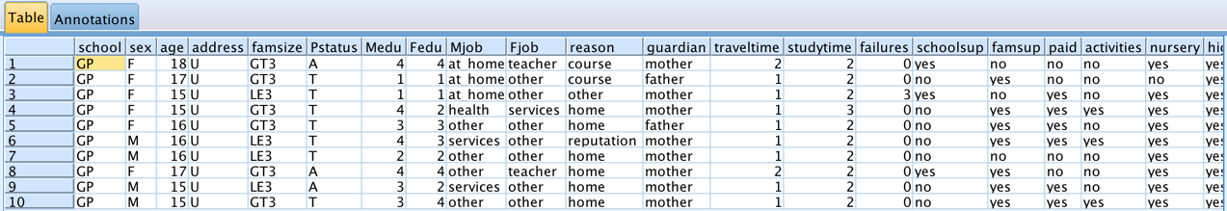

Everything seems to have imported correctly.

- (1 point). Add a Derive Node after the Type Node to create a new binary (Flag) variable Pass3 that is equal to “pass” when G3 >= 10 and equal to “fail” when G3 < 10 – this derived variable will be used in the classification questions where the goal is to predict which children will have low scores so that they can receive interventional help (about the bottom 3rd).
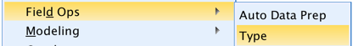
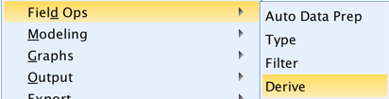

->

Two ways to do this:

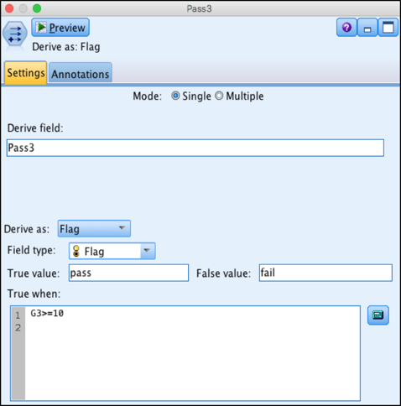

Use the 'Derive as Flag' and set True value to 'pass' and False value to 'fail'

Or...
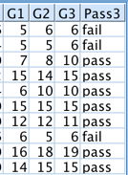
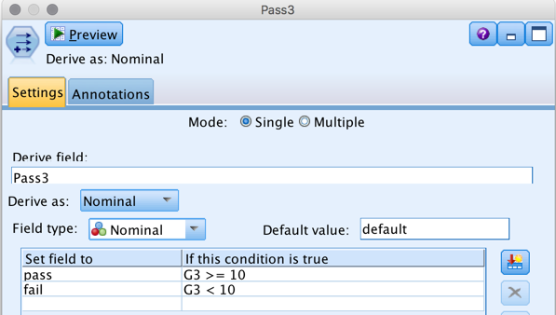

-Set Derive field to Pass3
-Derive as Nominal
-Set fields as listed above
-Check with data audit and set the type to flag!

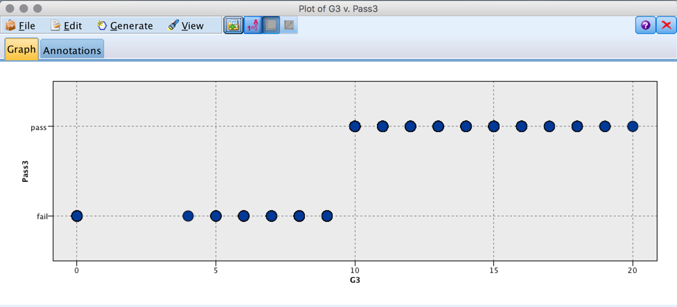

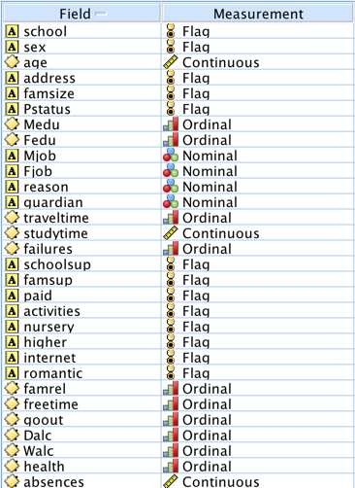
- (1 point). Use the Type node to appropriately set the Measurement type and Roles of all variables (based on above).

Initially set G3 as the outcome (“Target”) variable and set G1 and G2 to have the Role “None”

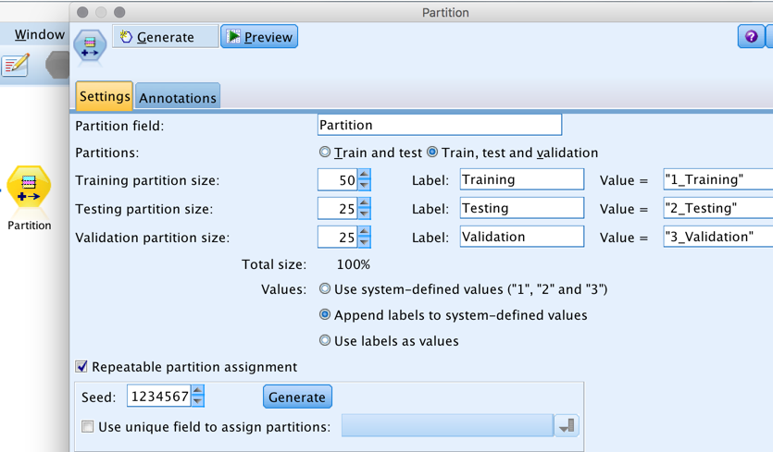

- (1 point). Partition the data so that you have 50% training, 25% test, and 25% validation

Regression
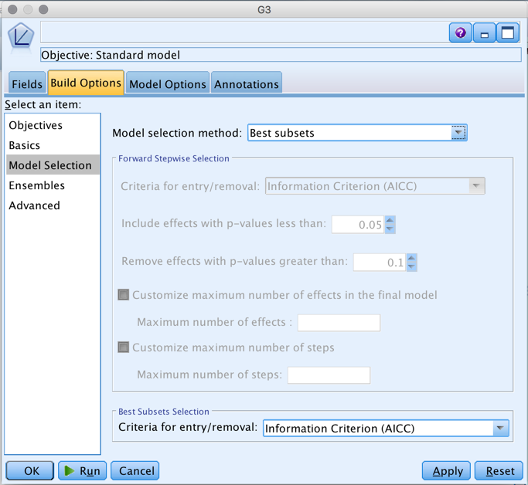
- (1 point) Add a Linear Node and build a model using “Best subsets” for Model Selection, and Best Subsets Selection with Criteria for entry/removal of “Information Criterion (AICC)”. Otherwise use default settings.

- (4 points) Describe the quality of the model fit based on the output of the golden nugget.

What are the 3 most important predictors and what effect do they have on the outcome G3? (Note that this model represents the ideal goal of being able to predict student grades using only demographic variables.)
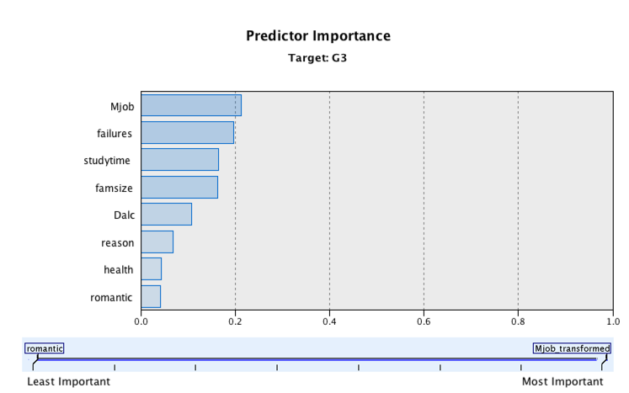

Mjob [mother's job ( 'teacher', 'health' care related, civil 'services' (e.g. administrative or police), 'at_home' or 'other') was the most important predictor, followed by failures (number of past class failures) and studytime (weekly study time)

Attach an Analysis Node and determine the Mean Absolute Error in what IBM Modeler calls the “Validation set” (this would be the test set in the conventional training-validation-test definition).
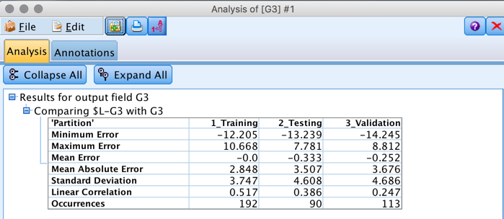

The Mean Absolute Error in the "Validation Set" is 3.676

- (3 points) Add in G2 as a predictor.

Compare this model with the previous model when G2 was not included. G2 is now the most important predictor in the model, followed by absences (number of school absences), Dalc (workday alcohol consumption), and failures (number of past class failures)
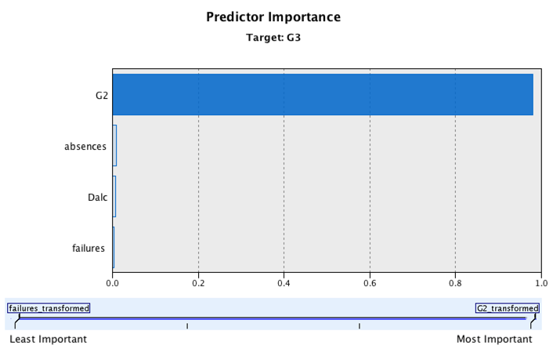

Comment on the differences between the models (including the Model Summary and change in Mean Absolute Error).

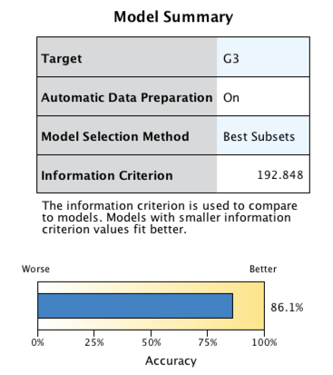
The summary for the first model (without G2) was only 23.5% accurate, but after adding G2 as a predictor, the model accuracy improved to 86.1%.
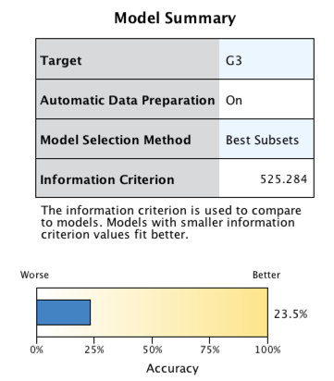

The Mean Absolute Error also reduced from 3.676 to 1.273.
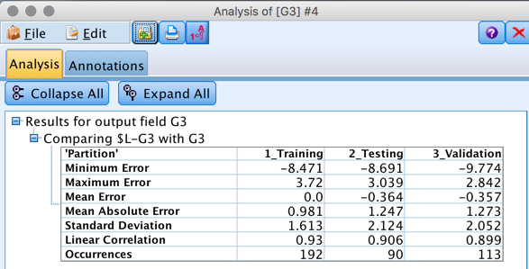

Why do you think the difference is so substantial? The score on G2 (second period grade) is a better predictor for G3 (final grade) than any of the demographic characteristics.

Classification
- (1 points). Go back into the Type node so that Pass3 can be set as the outcome flag variable and each of G3, G2, and G1 are set to have Role “None”

- (2 points). Fit a support vector machine to the partitioned data. Use the default settings except that in the Analyze tab check “Calculate predictor importance”. Do any predictors stand out?

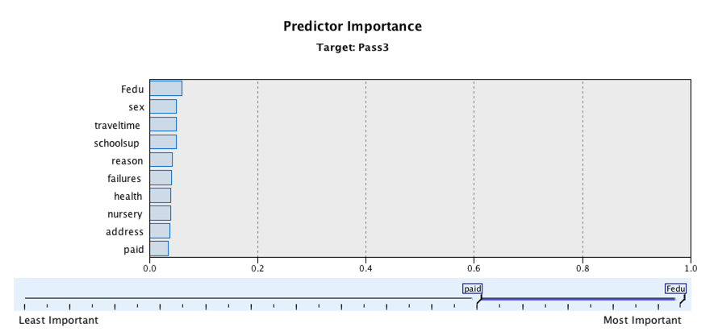
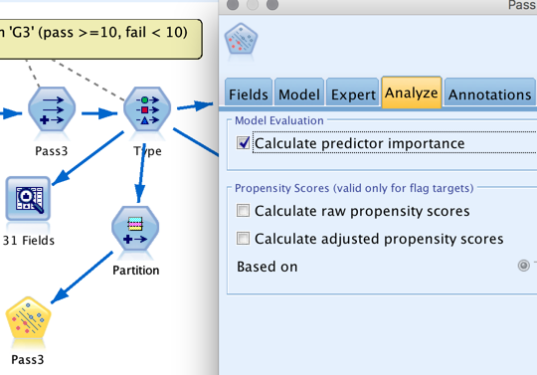
None of the predictors stand out very much. Fedu (father's education) suddenly became the most important predictor.

- (3 points). Add an Analysis Node.

What is the prediction accuracy in the validation set? (Note that the validation set in Modeler is the final “test” set in conventional machine learning terminology.)
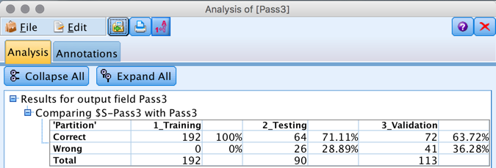

The prediction accuracy in the validation set is 63.72%.

- (3 points). Add G2 as a predictor and re-run the SVM. Look at the predictor importances.

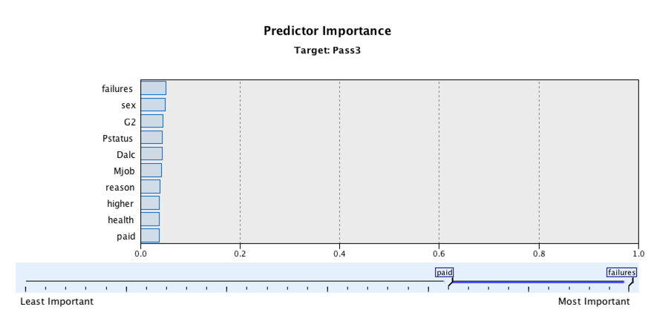

How far down the list does G2 come?

It has dropped below failures and sex to position three.

What is the difference in prediction accuracy between this model and the one without G2 in the model?
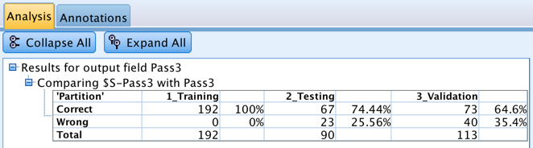

There is not much of a difference between the two (with G2 as a predictor or not).

Are you surprised by this result? I am. There was a huge difference between the two linear models (with and without G2), so intuitively it seems like there would be more of a difference between the models. SVM is a 'black box' procedure according to the text (here is a tutorial on SVM that explains the method further).

The Support Vector Machine (SVM) is a supervised learning method that generates input-output mapping functions from a set of labeled training data. The mapping function can be either a classification function or a regression function. For classification, nonlinear kernel functions are often used to transformed input data to a high-dimensional feature space in which the input data become more separable compared to the original input space. Maximum-margin hyperplanes are then created. The produced model depends on only a subset of the training data near the class boundaries.
Similarly, the model produced by Support Vector Regression ignores any training data that is sufficiently close to the model prediction. (Support Vectors can appear only on the error tube boundary or outside the tube.)

- (3 points). Repeat 9, 10, and 11 for the C5.0 classifier.
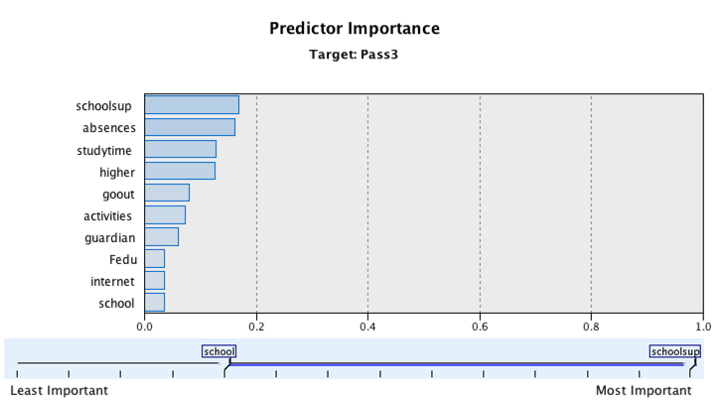
12a. (2 points). Fit a C5.0 classifier to the partitioned data. Use the default settings except that in the Analyze tab check “Calculate predictor importance”. Do any predictors stand out?

In the C5.0 classifier node, the schoolsup (extra educational support), absences (number of school absences), and studytime (weekly study time) were the top three important predictors.

12b. (3 points). Add an Analysis Node. What is the prediction accuracy in the validation set? (Note that the validation set in Modeler is the final “test” set in conventional machine learning terminology.)
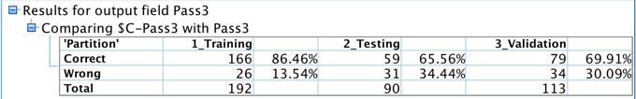
The validation set is correct 69.91% of the time without G2 in the model.

12c. (3 points). Add G2 as a predictor and re-run the C5.0. Look at the predictor importances.
How far down the list does G2 come?

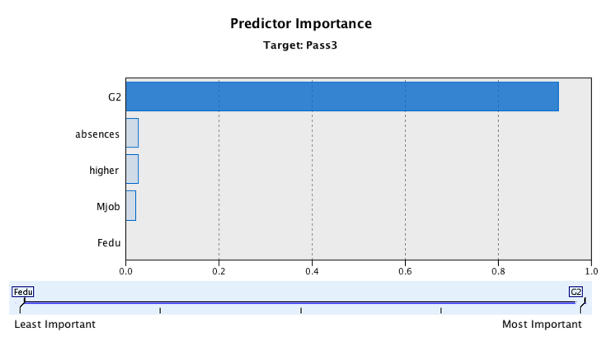

G2 didn't go down in position; it is back up at the top. Absences is now in the number 2 spot and higher is in the number 3 spot.

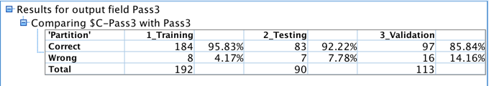
What is the difference in prediction accuracy between this model and the one without G2 in the model?

Without G2 in the model the validation accuracy was 69.91%, with G2 in the model it is 85.84%.

Does C5.0 do better or worse than SVM in terms of validation set classification accuracy (with and without G2 as a predictor)?

C5.0 does better than SVM in terms of validation set classification.

C5.0 Node
Note: This feature is available in SPSS Modeler Professional and SPSS Modeler Premium.
This node uses the C5.0 algorithm to build either a decision tree or a rule set. A C5.0 model works by splitting the sample based on the field that provides the maximum information gain. Each subsample defined by the first split is then split again, usually based on a different field, and the process repeats until the subsamples cannot be split any further. Finally, the lowest-level splits are reexamined, and those that do not contribute significantly to the value of the model are removed or pruned.

Note: The C5.0 node can predict only a categorical target. When analyzing data with categorical (nominal or ordinal) fields, the node is more likely to group categories together than versions of C5.0 prior to release 11.0.
C5.0 can produce two kinds of models. A decision tree is a straightforward description of the splits found by the algorithm. Each terminal (or "leaf") node describes a particular subset of the training data, and each case in the training data belongs to exactly one terminal node in the tree. In other words, exactly one prediction is possible for any particular data record presented to a decision tree.
In contrast, a rule set is a set of rules that tries to make predictions for individual records. Rule sets are derived from decision trees and, in a way, represent a simplified or distilled version of the information found in the decision tree. Rule sets can often retain most of the important information from a full decision tree but with a less complex model. Because of the way rule sets work, they do not have the same properties as decision trees. The most important difference is that with a rule set, more than one rule may apply for any particular record, or no rules at all may apply. If multiple rules apply, each rule gets a weighted "vote" based on the confidence associated with that rule, and the final prediction is decided by combining the weighted votes of all of the rules that apply to the record in question. If no rule applies, a default prediction is assigned to the record.

Example. A medical researcher has collected data about a set of patients, all of whom suffered from the same illness. During their course of treatment, each patient responded to one of five medications. You can use a C5.0 model, in conjunction with other nodes, to help find out which drug might be appropriate for a future patient with the same illness.

Requirements. To train a C5.0 model, there must be one categorical (i.e., nominal or ordinal) Target field, and one or more Input fields of any type. Fields set to Both or None are ignored. Fields used in the model must have their types fully instantiated. A weight field can also be specified.

Strengths. C5.0 models are quite robust in the presence of problems such as missing data and large numbers of input fields. They usually do not require long training times to estimate. In addition, C5.0 models tend to be easier to understand than some other model types, since the rules derived from the model have a very straightforward interpretation. C5.0 also offers the powerful boosting method to increase accuracy of classification.

Cross-validation
- (5 points). Consider the following algorithm:
  - Screen the predictors: perform separate analysis for each predictor to determine whether it is correlated with the class label. Select a subset of “good” predictors that show fairly strong correlation with the class labels (e.g. correlation > 0.8)

  - Using just this subset of predictors, build a classifier.

  - Use cross-validation to estimate the unknown tuning parameter of the classifier.

  - Use cross-validation again to estimate the prediction error of the final model.

Do you see a problem with this algorithm?

If so, what would you need to do to fix it?

I need to split them up into different files. A training set used to build a predictive model, and a classifier built using the correlations between particular elements. The other file would be the test set, which would be used to gauge how well the classifier from the training set was working, by feeding in the attributes and outputting predictions for each one. Cross-validating without creating a test and training set would result in overfitting.

[1] P. Cortez and A. Silva. Using Data Mining to Predict Secondary School Student Performance. In A. Brito and J. Teixeira Eds., Proceedings of 5th FUture BUsiness TEChnology Conference (FUBUTEC 2008) pp. 5-12, Porto, Portugal, April, 2008, EUROSIS, ISBN 978-9077381-39-7.

