Biostat 202

Martin Frigaard's Hwk #5: Regression and Classification

Biostat 202: Opportunities and Challenges of “Big Data”

For this homework we will use the “breastcancer.csv” dataset available on the CLE. The Wisconsin Diagnostic Breast Cancer (WDBC) dataset contains features that are computed from a digitized image of a fine needle aspirate (FNA) of a breast mass. They describe characteristics of the cell nuclei present in the image.

Attribute Information: The dataset consists of an Record ID (idno) in the first column followed by image features each graded from 1 to 10: "ClumpThickness", "CellSizeUniformity", "CellShapeUniformity", "MarginalAdhesion", "SingleEpithelialCellSize", "BareNuclei", "BlanChromatin", "NormalNucleoli", "Mitoses". -> continuous
The final variable indicates the diagnosis “Class” as to whether the sample is “benign” or “malignant” -> binary

Clustering
- (1 point). Read the dataset in from the course CLE. It is called “breastcancer.csv”.
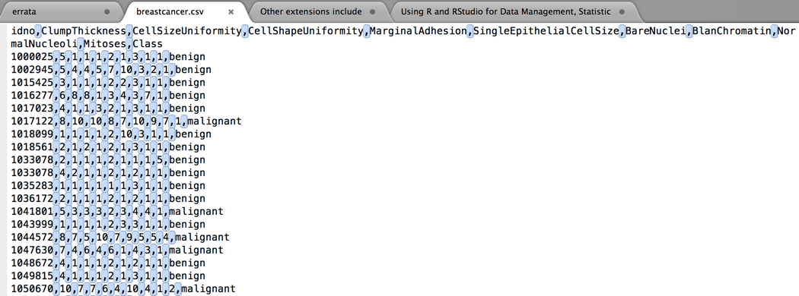

this looks like an actual .csv file (separated by commas)

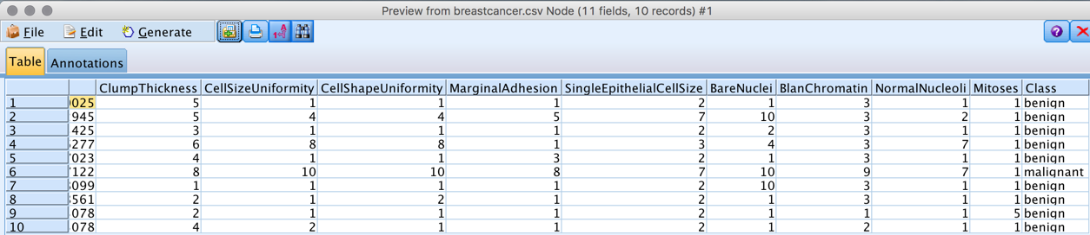
Looks like everything was entered correctly.

- (1 point). Use the type node to set the variables appropriately.

The image features should be considered as continuous variables with Role as Input.
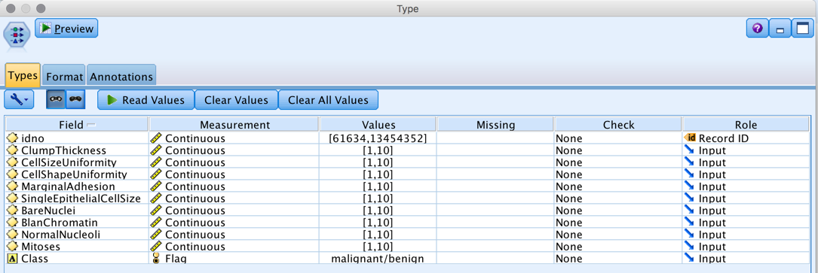

- (2 points). Partition the data as Training (60%) / Test (40%)
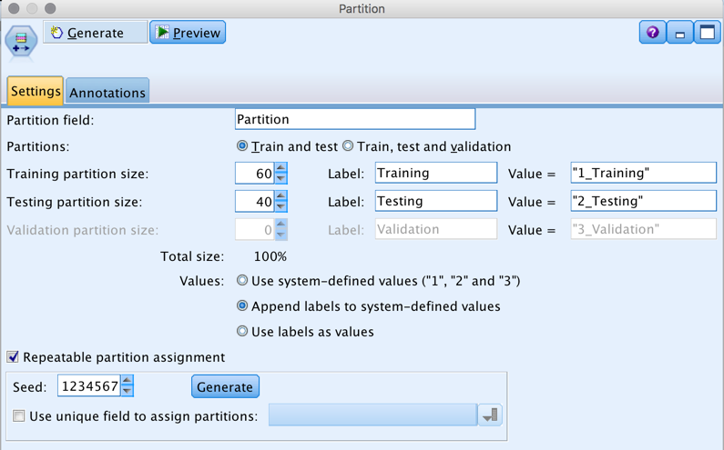

- (3 points). Run K-means algorithm with K = 2, 5, 8, 12.
K-Means Node
The K-Means node provides a method of cluster analysis. It can be used to cluster the dataset into distinct groups when you don't know what those groups are at the beginning. Unlike most learning methods in IBM SPSS Modeler, K-Means models do not use a target field. This type of learning, with no target field, is called unsupervised learning. Instead of trying to predict an outcome, K-Means tries to uncover patterns in the set of input fields. Records are grouped so that records within a group or cluster tend to be similar to each other, but records in different groups are dissimilar.
K-Means works by defining a set of starting cluster centers derived from data. It then assigns each record to the cluster to which it is most similar, based on the record's input field values. After all cases have been assigned, the cluster centers are updated to reflect the new set of records assigned to each cluster. The records are then checked again to see whether they should be reassigned to a different cluster, and the record assignment/cluster iteration process continues until either the maximum number of iterations is reached, or the change between one iteration and the next fails to exceed a specified threshold.
Note: The resulting model depends to a certain extent on the order of the training data. Reordering the data and rebuilding the model may lead to a different final cluster model.
Requirements. To train a K-Means model, you need one or more fields with the role set to Input. Fields with the role set to Output, Both, or None are ignored.
Strengths. You do not need to have data on group membership to build a K-Means model. The K-Means model is often the fastest method of clustering for large datasets.
K-Means Node Model Options
Model name
You can generate the model name automatically based on the target or ID field (or model type in cases where no such field is specified) or specify a custom name.
Use partitioned data. If a partition field is defined, this option ensures that data from only the training partition is used to build the model.
Specified number of clusters. Specify the number of clusters to generate. The default is 5.
Generate distance field. If this option is selected, the model nugget will include a field containing the distance of each record from the center of its assigned cluster.
Cluster label. Specify the format for the values in the generated cluster membership field. Cluster membership can be indicated as a String with the specified Label prefix (for example "Cluster 1",
"Cluster 2", and so on), or as a Number.

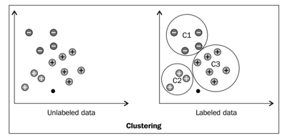
Note: If you want to include nominal (set) fields in your model but are having memory problems in building the model or the model is taking too long to build, consider recoding large set fields to reduce the number of values, or consider using a different field with fewer values as a proxy for the large set. For example, if you are having a problem with a product_id field containing values for individual products, you might consider removing it from the model and adding a less detailed product_category field instead.
Optimize. Select options designed to increase performance during model building based on your specific needs.
- Select Speed to instruct the algorithm to never use disk spilling in order to improve performance.
- Select Memory to instruct the algorithm to use disk spilling when appropriate at some sacrifice to speed. This option is selected by default.
Note: When running in distributed mode, this setting can be overridden by administrator options specified in options.cfg.

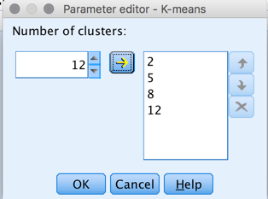

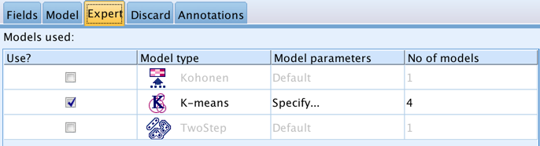

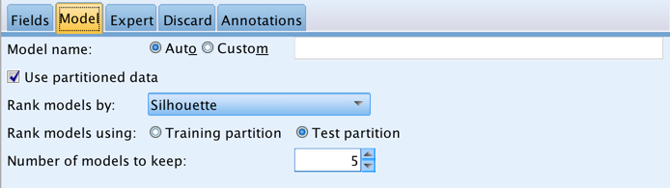

- (2 points). Which one of the 4 models has the lowest Silhouette score based on each of the Training and Test datasets?
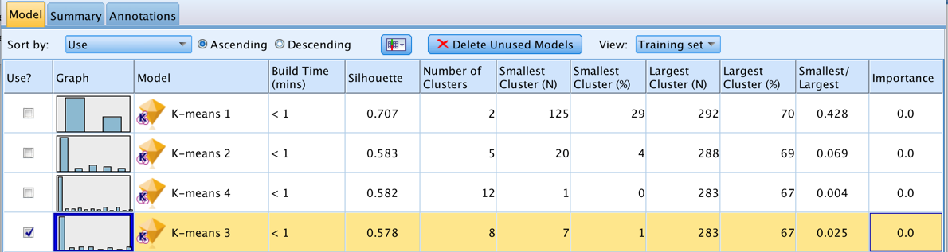

The lowest Silhouette score was in the 8 cluster model for the training set.

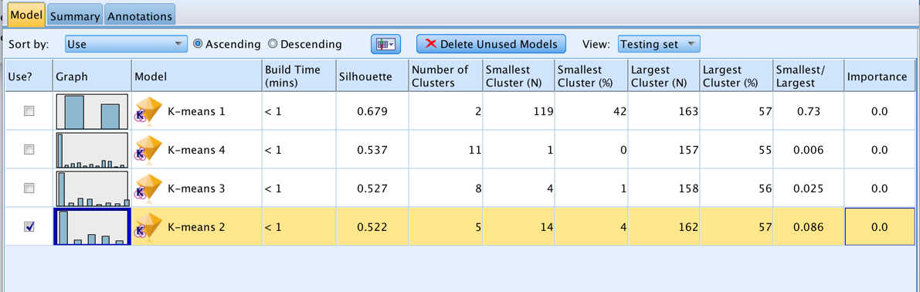

And 5 for the testing set.

- (2 points). Why might the number of clusters in the Test set be less than the number of clusters that were fit in the Training set?

The testing set had fewer observations (40%) and could create fewer clusters.

- (4 points). Given the observed Silhouette scores, describe how might you now go about finding the single best value of K (i.e. for all possible numeric choices of K)?
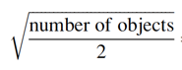
-> this is the method recommended by Mardia et al., but the text doesn't recommend using it because "we have to describe the characteristics of each cluster based on our knowledge" and the dataset doesn't allow this level of precision.

sqrt(699/2) = 18.69 -> this number would be far too high to explain the characteristics of each cluster.

From text, see below:
The k cluster centers are deﬁned as follows (see IBM (2015a), p. 229):
(a) The values of the ﬁrst record in the dataset are used as the initial cluster center.
(b) Distances are calculated from all records to the cluster centers so far deﬁned.
(c) The values from the record with the largest distance to all cluster centers are used as a new cluster center.
(d) The process stops if the number of clusters equals the number predeﬁned by the user, i.e., until k cluster centers are deﬁned.

This means that if the clusters are built with the first record of the dataset, we want to run multiple iterations to ensure our first record wasn't an outlier or that their wasn't something in the way the dataset was ordered influencing the clusters.

*also "The result depends to some extent on the order of the objects in the dataset. This is also because the ﬁrst record is being used as the initial cluster." Random seeds with partitioning ensure the order of the dataset doesn’t influence the clustering.

- (3 points) What is the purpose of partitioning the dataset even though there is no gold-standard outcome to test against?

The primary reason we partition (i.e. split) data into a training and testing set is to avoid overfitting. This happens when we create a model that works very well on the data you built it in, but it can't generalizes very well to new data.

Even if we don't have an outcome/predictor combination, the clustering is still going to be building the best algorithm on the data it sees. Keeping some of the data 'hidden' allows the algorithm (clustering) to be tested on data is hasn't seen.

Classification
- (1 point). Edit the Type Node such that Class is set to the Target variable.
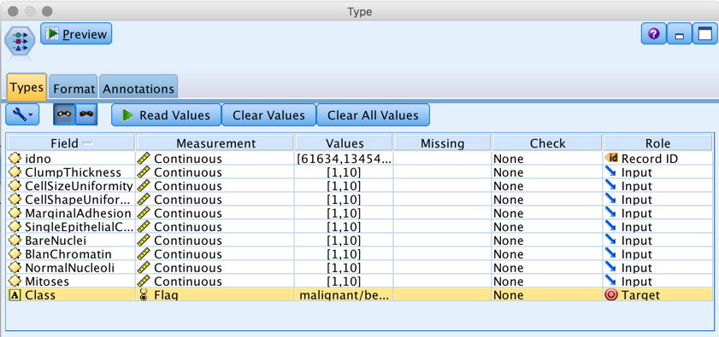

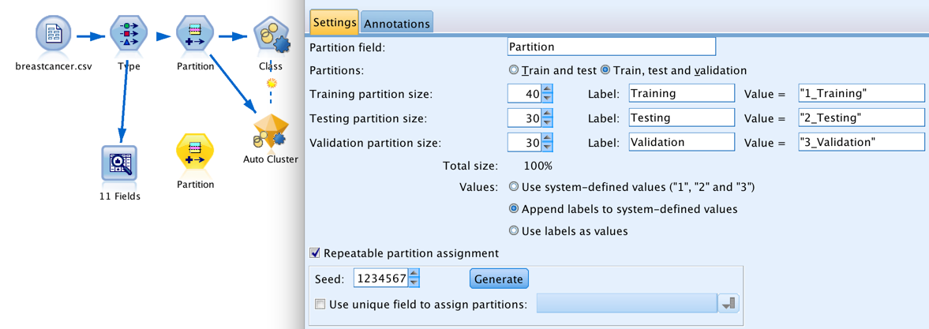
- (2 points). Partition the data as Training (40%) / Test (30%) / Validation (30%)

- (2 points). Fit Logistic Regression, C5.0, Neural Networks, and Bayesian Networks with the default settings and with the Target variable as “Class”.
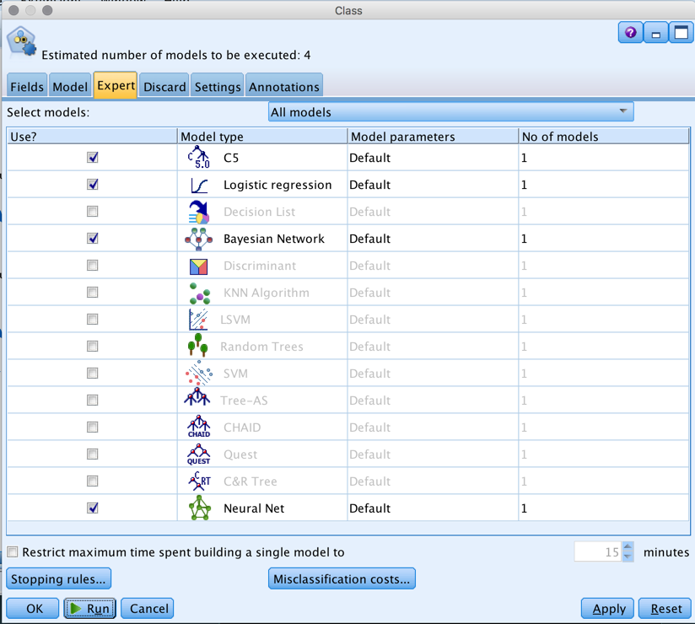

- (2 points). Which model performs best in the Training Set and which model performs best in the Test Set in terms of overall accuracy (based on the View selector in the Model Tab)?
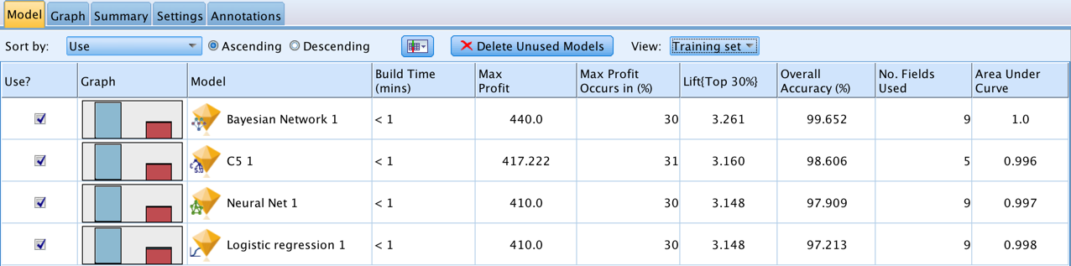
The Bayesian Network model does best in the training set, but the Logistic Regression model does best in the testing set.

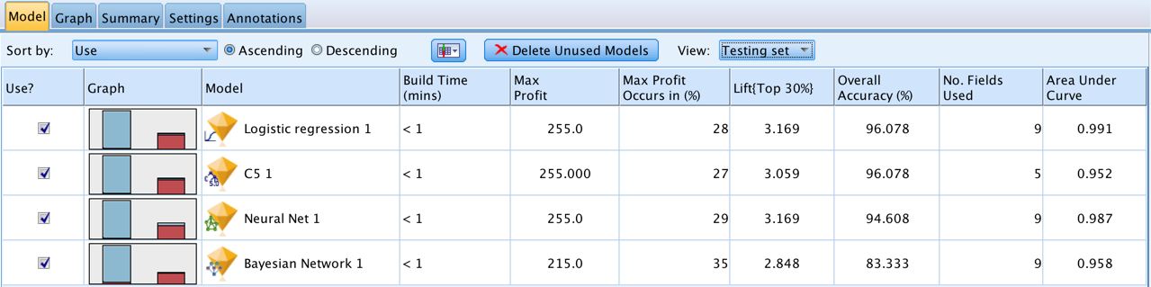

- (4 points). Examine the results with an Analysis Node.
What kind of accuracy do we see in the Bayesian Network model for, a) the Training set, b) the Testing set, and c) the Validation set?
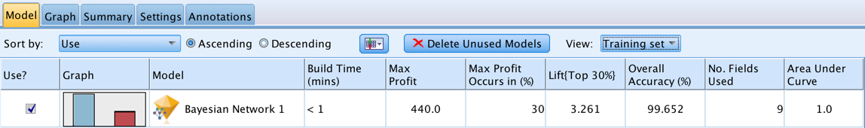

The Bayesian Network does progressively worse in each dataset.
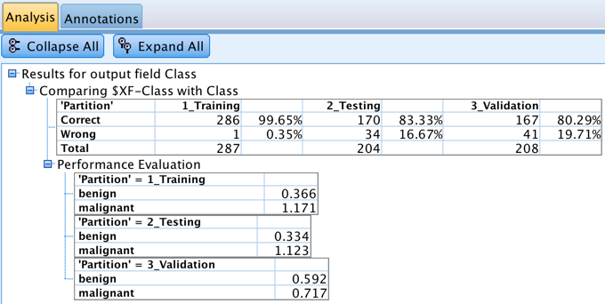

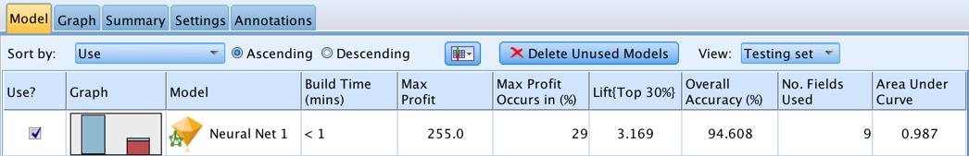
(Note that I am using IBM Modeler specification of training/test/validation.) Do the same accuracy comparison for the Neural Network. Briefly comment on the differences in results.

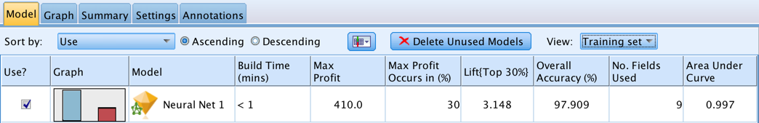

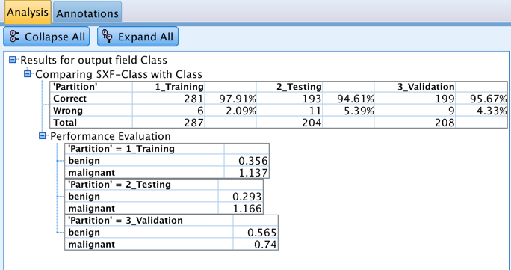

We can see the Neural Net model does not change much between the training, testing and validation sets.

These differences might be due to the Bayesian Network overfitting the data, and the Neural Network being a better fit.

Or the Neural Network might just be a better algorithm to fit the data.

