Epi 204 Chapter 2 Problem Set
Dichotomous Tests
Due 1 pm 9/28/2017

Ch02-07.Q. Are negative and positive tests always equally informative? If not, give a REAL example (not dependent on prior probability) of a test that is very informative if positive, but not if negative. What are the characteristics of such a test?

Ch02.16.Q BinaxNow® Malaria Test
Mills et al(Mills, Kagaayi et al.) did a study at mobile clinics in rural Uganda on the accuracy of a rapid test for malaria (Binax Now® Malaria) in febrile adult HIV patients. The gold standard for diagnosis of malaria was a “thick smear” at a distant central laboratory. You may assume that this is an appropriate gold standard and that they tested a consecutive sample of qualifying patients.

In the absence of a rapid test, the clinicians in the mobile clinics have to decide whether to treat presumptively for malaria while awaiting the thick smear result. Assume that it is 15 times as bad to delay treatment of malaria in someone who has it as it is to treat someone presumptively who does not have it.

a) What is the threshold probability for presumptive treatment?

Prior to doing the study, the authors estimated that the prevalence of malaria in the study subjects (febrile adult HIV patients presenting to the mobile clinics) would be approximately 40%.

b) If that 40% prior probability was correct, in the absence of a rapid test should the clinicians be treating the patients presumptively for malaria? Why?

c) Do you agree with the following sentence from the paper? Explain.

“A point-of-care rapid diagnostic test with high specificity would allow clinicians to "rule out" malaria and to focus on the correct detection and management of other febrile illnesses.”

From the abstract,

“Two hundred forty-six samples were analyzed, including 14 (5.7%) which were thick-smear positive for … malaria. Sensitivity of Binax Now® compared with thick smear was 85.7% (95% CI: 57.2–98.2), specificity 97.8% (95% CI: 94.9–99.3), positive and negative predictive values were 70.6% (95% CI: 44.0–89.7) and 99.1% (95% CI: 96.8–99.9), respectively.”

- Fill in the following 2×2 table with the absolute numbers of malaria patients, assuming the sensitivity and specificity are correct.

 |  | Thick Smear
 |  | Positive | Negative | Total
Rapid  Test | Positive
Rapid  Test | Negative
 |  |  |  | 246

- Are their estimates of positive and negative predictive value correct?

f.) Assume that the Binax Now® rapid diagnostic test is costless. Using the misclassification cost ratio provided in part (a) and the information about accuracy provided in part (d), calculate the No Treat—Test and Test—Treat thresholds for the Binax Now® rapid diagnostic test. Show your work.

From the paper’s conclusion:

“The Binax Now® Malaria rapid diagnostic test served as an effective point-of-care tool for fever management in HIV-positive adults in a malaria-endemic area. Its high negative predictive value of 99.2% indicates that in similar populations of febrile outpatient HIV-positive adults, a negative Binax-M test can be useful for "ruling out" malaria at the point of care.”

The authors are saying that, in the absence of a rapid test, they should treat presumptively while awaiting the thick smear result, but if they have the test available, they can do the test and withhold presumptive treatment when it is negative.

g) Making the same assumptions as you did in part a), comment on whether you agree with the authors:

i) if their previous estimate of prior probability (40%) was correct
ii) if the actual prior probability they found in their study was correct.

Ch02.19.Q Accuracy of “Classic Triad” for Spinal Epidural Abscess
Spinal epidural abscess (SEA) is a rare but potentially devastating infection in the space next to the spinal cord. Davis et al(Davis, Wold et al. 2004) did a case-control study of the accuracy of the “classic triad” of fever, spine pain, and neurologic deficit to predict spinal epidural abscess in emergency department patients. From the abstract: “Controls were hand-matched 2:1 to each SEA patient based on age and gender…. A total of 63 SEA patients were hand-matched to 126 controls with spine pain.” The results were as follows:

 |  | Spinal Epidural Abscess
 |  | Yes | No
"Classic Triad" | Present | 5 | 1 | 6
"Classic Triad" | Not Present | 58 | 125 | 183
 |  | 63 | 126
The authors’ Table 1 reports a positive predictive value of the “classic triad” as 5/6 or 83.3%.

- What is the sensitivity of the “classic triad” for spinal epidural abscess?

- What is the specificity of the “classic triad” for spinal epidural abscess?

- What proportion of this study sample had spinal epidural abscess?

Your ED patient has a history of IV drug abuse and needle sharing and is therefore at risk for spinal epidural abscess. He has the classic triad of fever, spinal pain, and neurologic deficit.

d. Based on the results of this study, what is the best estimate for your patient’s probability of spinal epidural abscess?

02.51Q Breast/Ovarian Cancer Test With Oversampling of Positives
(with thanks to Yi-Hsuan Wu, MAS 2017)
Mutations in BRCA1 and BRCA2 (BRCA1/2) genes increase the risk of breast and ovarian cancer, but the genetic test for them is costly. There are models to assess the probability of carrying a BRCA1/2 mutation, but they are complicated, requiring a very detailed family history. A referral screening tool (RST) was designed for use in primary care practice to help clinicians select patients for BRCA testing (Figure). Bellcross et al.(Bellcross, Lemke et al. 2009) evaluated the accuracy of the RST.
Figure 5.21: BRCA testing referral tool.
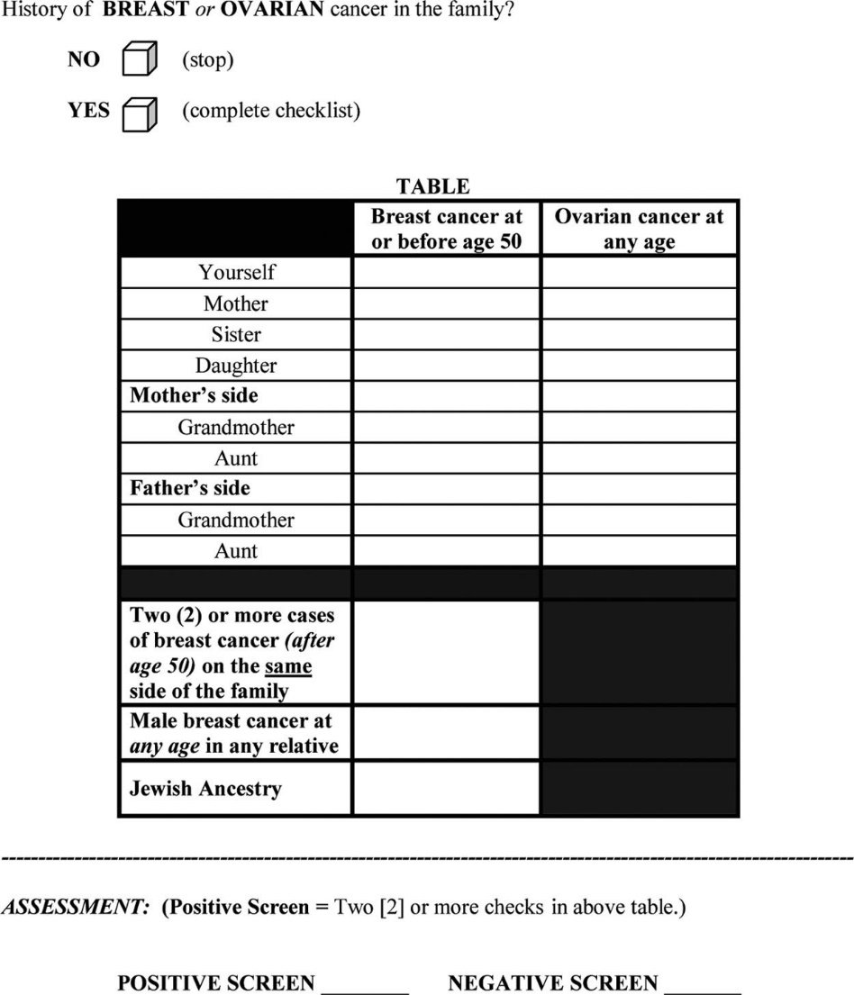
From the abstract:
Methods: The RST was administered to 2464 unselected women undergoing screening mammography. Detailed four-generation cancer pedigrees were collected by telephone interview on a random subset of 296 women. The pedigrees were analyzed using four established hereditary risk models (BRCAPRO, Myriad II, BOADICEA, FHAT), with a ≥10% BRCA1/2 mutation probability using any [established] model as the definition of “high risk.”
Results: The RST identified 6.2% of subjects as screen “positive” (high risk). … In comparison with the pedigree analyses, the RST demonstrated an overall (high risk by any model) sensitivity of 81.2%, specificity of 91.9%, [PPV of 80%, NPV of 92%], and discriminatory accuracy of 0.87.
For the pedigree analysis the authors chose to oversample (randomly) from the RST-positive group even though this group only represented 6.2% of the population, saying:
“The positive [group was] intentionally oversampled to provide a sufficient number of potentially high-risk pedigrees to adequately address sensitivity.”
- Is the sampling in this study cross-sectional, case-control, or test result-based (index positive-negative)?
The following table shows results in the sample (n= 296) consistent with what the authors reported:
Sample |  | Risk based on pedigree analysis and risk models
 |  | High risk | Low risk | Total
RST | Positive | 69 | 17 | 86 | PPV= 80%
RST | Negative | 16 | 194 | 210 | NPV= 92%
RST | Total | 85 | 211 | 296
 |  | Sensitivity= 81.2% | Specificity= 91.9%
Now you want to know the sensitivity and specificity of RST in the underlying mammography population (n= 2464) to see if the estimates of sensitivity and specificity in the sample were biased.
b) Given the percentage of subjects in the entire study identified as RST positive (6.2% in the abstract) and the predictive values observed, complete the following 2x2 table and calculate the sensitivity and specificity of RST in the mammography population. [Hint: First figure out how many in the entire population tested positive.]
c) Compared to the sensitivity and specificity of the RST in the mammography population you obtained from (b), do you think the sensitivity and specificity of RST the authors reported in the abstract are biased?

In the Results section the authors wrote:
“It should be noted that these predictive values are not representative of those that would be obtained in a general mammography population, as … high-risk subjects were intentionally oversampled. Using the prevalence of 6.2% RST screen-positive individuals in this study, and the overall sensitivity and specificity obtained, the PPV and NPV values expected in a general mammography population would be 0.39 and 0.78, respectively.”
d) With your answers from (a) to (c), do you agree with the authors that the PPV and NPV, not the sensitivity and specificity, are the measures needed to be adjusted to be representative of the ones in the mammography population? Why?

Ch02.53.Q. CT Brain and Lumbar Puncture for SAH

Case: A 62 year-old man with no significant medical problems presents (walks in) to the emergency department with a headache of approximately 24 hours’ duration. He has no prior history of headaches. It is not clear whether the headache came on suddenly. His neurological exam is normal.

Clinical Information: Patients presenting to the emergency department with an acute onset, new (not recurrent) headache and a normal neurological exam are at risk for subarachnoid hemorrhage (SAH) (bleeding around the brain).

A common teaching in emergency medicine is that non-contrast CT of the brain is 90% sensitive and 100% specific for SAH in patients with a normal neurological exam. In other words, in patients with SAH, the CT will be falsely negative 10% of the time. In patients without SAH, the CT will never be falsely positive. The pretest probability of SAH in a patient such as the one described above is about 3% (McCormack and Hutson 2010).

You obtain a non-contrast CT of the brain that is normal.

- A physician (who has not taken Epi 204) knows the “false negative rate” of the CT scan for SAH is 10%. Since the patient had a negative test, the physician assumes the patient has a 10% chance of SAH. Is the physician correct? If not, explain why not.

- What is the CT scan’s LR(-) (likelihood ratio of a negative CT for SAH)?

c. What is the post-CT probability of SAH? (Pre-test probability was 3% )

The complimentary test for SAH to CT brain (with its perfect specificity and imperfect sensitivity) is lumbar puncture (LP), which is considered to have perfect sensitivity and imperfect specificity (67%)(McCormack and Hutson 2010). The 100% sensitivity and 67% specificity were measured in a population of headache patients with negative head CTs.

Assume that, whatever your post-test probability after the negative head CT was in part (b), it was too high to allow sending the patient home, so an LP is performed and is negative.

d. Now, what is the post-LP probability of SAH (after negative head CT and negative LP?

REFERENCES

Bellcross, C. A., A. A. Lemke, L. S. Pape, A. L. Tess and L. T. Meisner (2009). "Evaluation of a breast/ovarian cancer genetics referral screening tool in a mammography population." Genet Med 11(11): 783-789.
Davis, D. P., R. M. Wold, R. J. Patel, A. J. Tran, R. N. Tokhi, T. C. Chan and G. M. Vilke (2004). "The clinical presentation and impact of diagnostic delays on emergency department patients with spinal epidural abscess." J Emerg Med 26(3): 285-291.
McCormack, R. F. and A. Hutson (2010). "Can computed tomography angiography of the brain replace lumbar puncture in the evaluation of acute-onset headache after a negative noncontrast cranial computed tomography scan?" Acad Emerg Med 17(4): 444-451.
Mills, L. A., J. Kagaayi, G. Nakigozi, R. M. Galiwango, J. Ouma, J. P. Shott, V. Ssempijja, R. H. Gray, M. J. Wawer, D. Serwadda, T. C. Quinn and S. J. Reynolds (2010). "Utility of a point-of-care malaria rapid diagnostic test for excluding malaria as the cause of fever among HIV-positive adults in rural Rakai, Uganda." Am J Trop Med Hyg 82(1): 145-147.

Blood is taken from the patient and sent to a central laboratory where it is spread onto a microscope slide and examined for the malaria parasite by a trained microscopist.
If you are wondering whether that 100% sensitivity is biased, you are right to wonder. This may be an extreme example of incorporation bias if people with negative LPs are assumed to be negative for SAH and therefore not followed any further. You can’t determine the sensitivity of a test if your study design already assumes that it has no false negatives.

