Epi 204 Chapter 4 Problem Set
Bias in Studies of Test Accuracy
Due 1 pm 10/19/2017
EBD-2 Ch06 Problems 8, 9, 12, 52

Ch06.08.Q Weatherman
During a rainy month, you watch the weather report and decide whether to carry an umbrella. Your decision is irrevocable in that, if you decide not to carry an umbrella and head off to work and it rains, you can’t change your mind.

You are willing to carry an umbrella and not use it 3 times for every time you carry an umbrella and use it. In other words, being in the rain without an umbrella is exactly 3 times as bad as carrying an umbrella unnecessarily.

The Channel 2 weather man predicts a 33% chance of rain on every single day of the month. The Channel 3 weather man predicts a 50% chance of rain on two-thirds of the days and a 100% chance of rain on one third of the days. At the end of the month it turns out that it rained on 10 out of 30 days. It also turns out that every time the Channel 3 weather man predicted a 50% chance of rain, it didn’t rain; and every time he predicted a 100% chance of rain, it did.

- What is your threshold probability of rain for carrying an umbrella?

- If you watched and believed Channel 2, how many days of the month did you carry an umbrella?

- If you watched and believed Channel 3, how many days of the month did you carry an umbrella?

- What is the average predicted chance of rain for Channel 2? What is it for Channel 3?

- Which weather man was better calibrated?

- Which channel should you watch next month?

Ch06.09.A ABCD2 Score
The ABCD2 Score was developed to stratify risk of stroke in patients after a transient ischemic attack (TIA).

For your information, here is how the ABCD2 score is calculated.
Risk Factor |  |  | Points
Age
 |  | ≥ 60 years | 1
Blood Pressure
 |  | SBP ≥ 140 or DBP ≥ 90 | 1
Clincal features of TIA
 |  | Unilateral weakness (with or without speech impairment) | 2
 |  | Speech impairment without unilateral weakness | 1
Duration
 |  | TIA duration ≥ 60 minutes | 2
 |  | TIA duration 10-59 minutes | 1
Diabetes
 | Diabetes diagnosed by a physician |  | 1
 | Total ABCD2 Score |  | 0 – 7

Here are the risks of stroke associated with different ranges of ABCD2 score. We will focus on 2-day stroke risk.

Score | % of TIA Patients | 2-day Stroke Risk | 90-Day Stroke Risk
0-3 | 34% | 1.0% | 3.1%
4-5 | 45% | 4.1% | 9.8%
6-7 | 21% | 8.1% | 17.8%

One of the main reasons for hospitalizing a patient after TIA is to enable treatment with thrombolytics if the patient has a subsequent stroke in the next 2 days.

- Assume you are willing to admit an additional 25 patients to the hospital for 2 days in order to avoid discharging one from the emergency department who goes home to have a stroke in the next 2 days. What is your ABCD2 score cutoff for hospitalization?

- The above table of 2-day stroke risks can be converted into an ROC table and an ROC curve. Without doing any calculations, what do you expect the AUROC to be?

- < 0.5
- 0.5 – 0.75
- 0.75- 0.9
- 0.9-1

We will convert the table of 2-day risks above into an ROC table and calculate the area under it.

First, order the results from most to least abnormal:

Score | % of TIA Patients | 2-day Stroke Risk
6-7 | 21% | 8.10%
4-5 | 45% | 4.10%
0-3 | 34% | 1.00%

Next, calculate the individual cell percentages.

Score | D+ | D- | % of TIA Patients
6-7 | 1.70% | 19.30% | 21%
4-5 | 1.85% | 43.16% | 45%
0-3 | 0.34% | 33.66% | 34%
 | 3.89% | 96.11% | 100.00%

Then, calculate the column percentages.

Score | D+ | D-
6-7 | 43.77% | 20.08%
4-5 | 47.48% | 44.90%
0-3 | 8.75% | 35.02%
 | 100.00% | 100.00%

Finally, change them to cumulative percentages.

Score | D+ | D-
≥ 6 | 43.77% | 20.08%
≥ 4 | 91.25% | 64.98%
 | 100.00% | 100.00%

- Use the above ROC Table to plot the ROC curve on the grid below.

- If you didn’t admit any TIA patients (“No Treat”), what proportion would have a stroke within 2 days?

- If you admitted all TIA patients (“Treat All”), what proportion would you admit unnecessarily?

Remember that an unnecessary admission of a TIA patient who doesn’t have a stroke in the next 2 days is 1/25 as bad as failing to admit someone who has a stroke in the next 2 days.

- Calculate the Net Benefit of the Treat All strategy relative to the treat none. Net Benefit = (Patients Treated Appropriately – C/B × Patients Treated Unnecessarily)/(All Patients).

- Calculate the Net Benefit of a hospitalization strategy using the ABCD2 cutoff in (a). Is it higher or lower than the NB of the “Treat All” strategy?

- Finally, calculate the standardized NB (NB/Prevalence) of your strategy. Interpret this in words.

Ch06.12.Q Penumonia Mortality
Schuetz et al (Schuetz, Koller et al. 2008) compared 3 rules for predicting mortality in patients with community acquired pneumonia. The 3 rules were the Pneumonia Severity Index (PSI), the CURB65, and the CRB65 (which is CURB65 without the “U”). They used each of these 3 rules to predict risk of death in
373 patients with community–acquired pneumonia who were seen in the emergency department of a Swiss university hospital. 41 patients died within 30 days. Their calibration plots are shown on the next page.

All 3 rules divided the patients into 5 risk groups and, for all 3 rules, the predicted risks differed substantially from the actual mortality rate, so the authors re-calibrated the risk models.

a) Figure (c) is the calibration plot for the CRB65 rule. The open diamonds (◊) represent the original risk predictions prior to recalibration. Prior to recalibration, did the CRB65 rule overestimate or underestimate mortality risk? Explain briefly.

b) Figure (b) is the calibration plot for CURB65 (note the letter “U”). CURB 65 assigned only 3 patients to its highest risk group. How many of them died?

note: The PSI is the same as the PORT Score described in Chapter 8 of Evidence-Based Diagnosis, Edition 1, Table 8.3, page 176.)
note: the CRB65 is just the CURB65 without a lab test called the BUN.

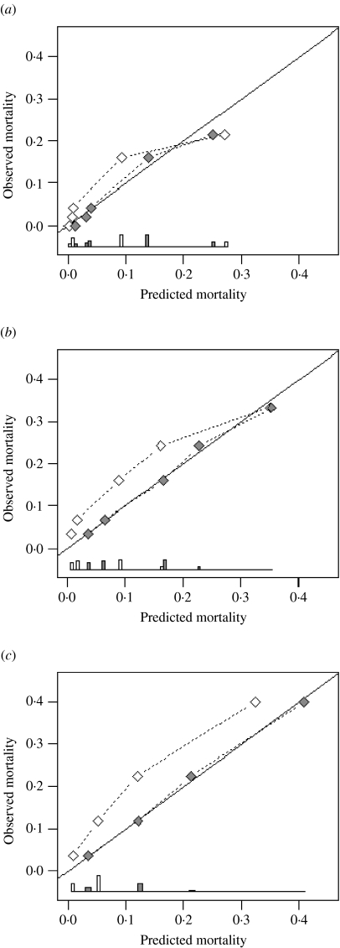

Agreement between predicted and observed 30-day mortality (calibration) for three pneumonia severity prediction rules (a) PSI, (b) CURB65 and (c) CRB65. Observed mortality is plotted according to classes of predicted risk for each prediction rule separately. The solid line of identity represents perfect calibration of predicted risk within new patients. Correction of miscalibration () after recalibration (◊).

The ROC curves are shown below:

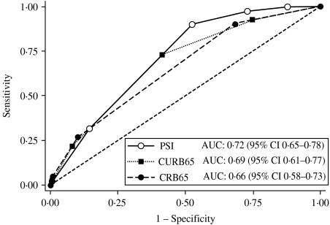

Receiver-operating characteristics analysis for 30-day mortality prediction with three pneumonia severity prediction rules (PSI, CURB65 and CRB65) in 373 patients with community acquired pneumonia.

c) Do you think the above ROC curves were based on the pre-recalibration or post-recalibration risk predictions? Explain your answer.

d) The AUROC for the PSI was greater than the AUROC for CURB65, but the points on the CURB65 calibration curve are more spread out. How can this be?

e) Below is an enlarged version of the calibration plot for the PSI with 3 risk classes circled. Draw a circle around the part of the ROC curve that corresponds to these 3 risk classes.

f) The authors were interested in a rule that could identify pneumonia patients at such low risk of death that they could be discharged from the emergency department. Even after re-calibration, only one of the 3 rules could identify patients at low enough risk to send home. Which of the 3 rules was it? Explain how you know.

Ch06.52.Q. QRISK2 vs. NICE Framingham Risk model

Collins and Altman (Collins and Altman 2012) compared the performance of the QRISK2-2011 score for predicting the 10-year risk of cardiovascular events with the NICE (National Institute for Health and Clinical Excellence) version of the Framingham equation. They applied both models in an independent UK cohort of patients from general practice that included more than 2 million patients (11.8 million person-years) with more than 90,000 cardiovascular events.

The models were applied separately to men and women. The calibration plots showing deciles of risk are below.

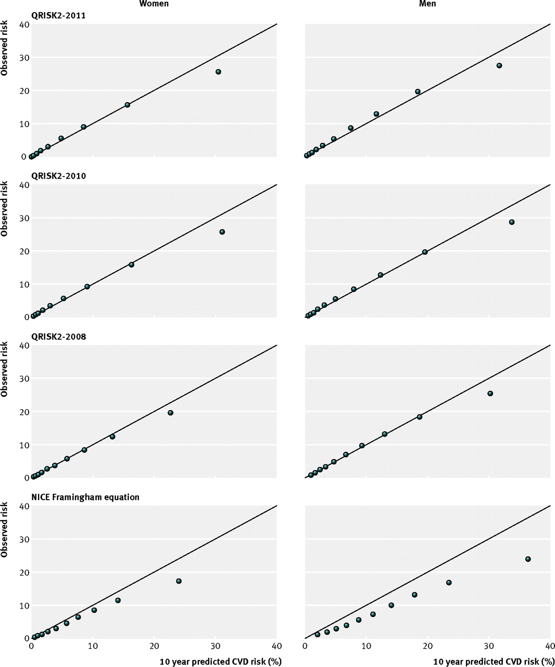

- Which risk prediction model, QRISK2-2011 or NICE Framingham, was better calibrated? Explain your answer.

- For men, were the NICE Framingham equation’s risk estimates too high or too low? Explain.

For men aged 35-74, the AUROCs were 0.771 (0.769 to 0.773) for QRISK2-2011 and 0.750 (0.747 to 0.752) for NICE Framingham. You randomly select two men aged 35-74, one from among those who had cardiovascular events (D+), and one from among those who didn’t (D-).

- What is the probability that the D+ individual would have a higher QRISK2 score than the D- individual?

- What is the probability that the D+ individual would have a higher NICE Framingham score than the D- individual?

- Which had better discrimination, QRISK-2 or NICE Framingham?

Below are the decision curves for women and men aged 34 – 75 years.

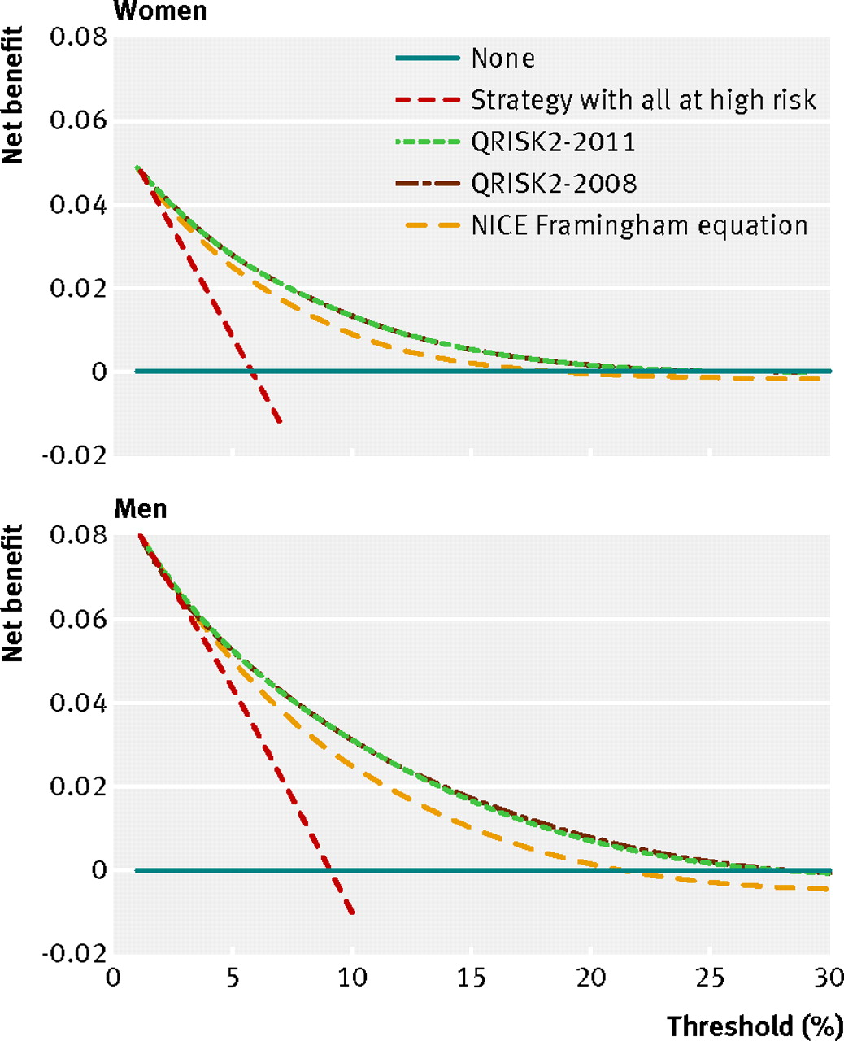

Recall that the “Strategy with all at high risk” (Treat All) calculates net benefit as

Net Benefit: P – C/B×(1-P)

where P is the overall proportion of the population who end up having the outcome. It may also be referred to as the cumulative incidence or observed overall risk.

f) Assuming the Treat All curve crosses the horizontal axis at Threshold = 9%, what is the overall observed 10-year risk P of CV events for men in this population?

- Why is the net benefit associated with the NICE Framingham model lower than the net benefit associated with the QRISK-2 model? Is the problem primarily with calibration or discrimination?

Collins, G. S. and D. G. Altman (2012). "Predicting the 10 year risk of cardiovascular disease in the United Kingdom: independent and external validation of an updated version of QRISK2." BMJ 344: e4181.
Schuetz, P., M. Koller, M. Christ-Crain, E. Steyerberg, D. Stolz, C. Muller, H. C. Bucher, R. Bingisser, M. Tamm and B. Muller (2008). "Predicting mortality with pneumonia severity scores: importance of model recalibration to local settings." Epidemiol Infect 136(12): 1628-1637.

