Epi 204 Problem Set 6
Due 1 pm 10/26/2017
EBD-2 Ch 6 and 7
06.53, 07.02, 07.06, 07.09

Ch06.53.Q A 2013 New York Times story, “Risk Calculator for Cholesterol Appears Flawed” included the following:

“Last week, the nation’s leading heart organizations released a sweeping new set of guidelines for lowering cholesterol, along with an online calculator meant to help doctors assess risks and treatment options. But, in a major embarrassment to the health groups, the calculator appears to greatly overestimate risk...”
“After they saw the guidelines and the calculator, Dr. Ridker and Dr. Cook evaluated it using three large studies... They knew the subjects’ characteristics at the start... Then they asked how many had heart attacks or strokes in the next 10 years and how many would the risk calculator predict.
“The answer was that the calculator overpredicted risk by 75 to 150 percent, depending on the population. A man whose risk was 4 percent, for example, might show up as having an 8 percent risk. With a 4 percent risk, he would not warrant treatment — the guidelines that say treatment is advised for those with at least a 7.5 percent risk and that treatment can be considered for those whose risk is 5 percent.”
  - Is this a problem with discrimination or calibration? Explain.
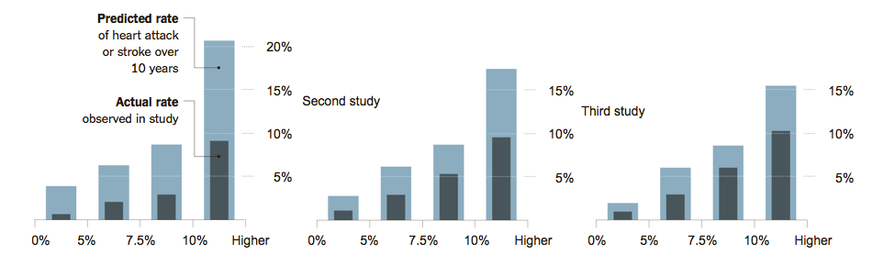
  - The guidelines recommend estimating each subject’s risk using a cardiovascular risk calculator, then managing based on whether the predicted 10-year risk is <5%, 5-7.4%, 7.5-9.9%, or ≥ 10%. The NYT article included a graph of the overestimation, above, which many of your instructors found confusing. Josh Galanter (faculty member for 2013 course) gallantly created a calibration plot from these data (below), which should look more familiar. Explain briefly, step by step, how the data to produce figures like these would be obtained. (Hint: the X-axis in each case groups patients with predicted risks in the categories above.)

  - If we assume that, in fact, the risk calculator is overestimating risk, what more do you need to know to conclude that using these overestimated risks with the treatment thresholds in the guidelines will lead to excessive treatment? Explain.

Ch07.02.Q Kawasaki Disease

Kawasaki disease is an acute febrile illness in children of unknown cause that includes a rash, conjunctivitis, inflammation of mucous membranes, adenopathy and swelling of hands and feet. Affected children are treated with intravenous gamma globulin (IVGG) to prevent coronary artery aneurysms, the most serious complication of the disease. Using data from the intervention groups of two randomized controlled trials of IVGG, Beiser et al(Beiser, Takahashi et al. 1998) developed an instrument to predict which children with Kawasaki disease would develop coronary artery aneurysms. The predictive instrument they developed is shown below:
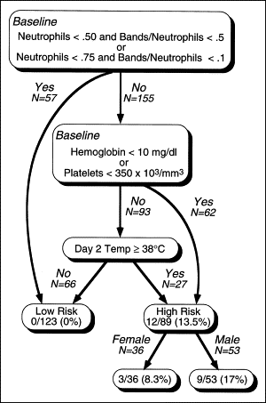

From Figure 1. Beiser AS, et al. Am J Cardiol. 1998 May 1;81(9):1116-20. Need Permission. Neutrophils (also known as polymorphonuclear leukocytes) are one kind of white blood cell. Bands are immature neutrophils. “Neutrophils < 0.5” means that, based on the white blood cell count differential, less than 50% of the white cells are neutrophils. “Bands/neutrophils < .5” means that, of all the neutrophils, fewer than 50% are bands.

a.) What type of analysis do you think the investigators did to come up with this figure?

b.) Assume you are treating a child like those included in the study. His initial CBC shows a hemoglobin of 11.2 g/dL, 600,000 platelets and 13,000 white blood cells/mm³, with 8,000 (61.5%) neutrophils of which 1,000 (1000/8000 = 12.5%) are bands. On day 2 of the illness his temperature is 38.1° C. Would you classify him as high- or low- risk ?
c.) Now imagine the same patient, only this time he only has 5,000 neutrophils/mm³. He therefore is at low risk regardless of his temperature on day 2. How does this help you manage your patient? For example, does this mean you don't need to treat him with IVGG?
d) In a study such as this, it is important that the clinical prediction rule be validated on a group of patients separate from the group used to derive it. The abstract of the study states:

"The instrument was validated in 3 test data sets…[it] performed similarly in the 3 test data sets; no patient in any data set classified as low risk developed coronary artery abnormalities."
However, the methods section states:

"We developed many such [sequential classification] processes, each using a different combination of risk factors…Instruments that performed well on the development data set were validated using each of the 3 test data sets."

Is there a problem here? If so, what is it and how would it affect the results?

Ch07.06.Q McIsaac Score and Rapid Antigen Detection Test

Tanz et al.,(Tanz, Gerber et al. 2009) studied the sensitivity and specificity of the rapid antigen detection test for group A strep in 1848 children 3 to 18 years of age who were evaluated for acute pharyngitis; a laboratory throat culture was the "gold standard." They found that the sensitivity of the rapid antigen test depended on the prior probability of strep throat, which was estimated using the Mc Isaac Score. The McIssac Score gives 1 point for each of the following items (range of scores 0 to 5):

- history of temperature of >38°C
- absence of cough
- tender anterior cervical lymph nodes
- tonsillar swelling or exudates
- age of <15 years
- For this part, ignore the rapid antigen test and consider the McIssac Score as a single test for strep (as determined by the gold standard throat culture). If clinicians used some of the same items listed above to decide which children to enroll in the study, what bias would this cause, and how would it affect the apparent sensitivity and specificity of a McIsaac score ≥ 3 as a test for strep throat?

Recall that the study showed that the sensitivity and specificity of the rapid antigen detection test varied with the prior probability of strep. In other words, the sensitivity and specificity were different depending on the McIsaac clinical symptom score.

- Using terminology from EBD-2 Chapter 7 on combining tests, how can we describe the relationship between the McIsaac Score and the rapid antigen detection test?

- Table 5 from that paper is reprinted below. The text says: "Table 5 shows that McIsaac scores >2 were significantly associated with positive results for each diagnostic test. No other information about the odds ratios in Table 5 is included.
TABLE 5 Odds Ratios for Positive Diagnostic Test Results With McIsaac Scores of >2
Test | Odds Ratio (95% CI) | P
Rapid Antigen Teat | 3.44 (2.66–4.44) | <.001
Throat Culture | 2.81 (3.20–3.60) | <.001

The baseline score level was 0 to 2.

  - What is being compared in this table?

  - Look at the point estimates and confidence intervals in the table. What is the obvious error?

  - The term "spectrum bias" is sometimes used to describe non-independence (conditional on disease status) between two tests, where one test is a clinical assessment like the McIsaac score and the other test is a laboratory test like the rapid antigen test. Does the odds ratio of 3.44 provide evidence of non-independence between the McIsaac Score and the rapid antigen test? (Assume that the odds ratio of 3.44 for the rapid antigen test and the odds ratio of 2.81 for the throat culture are the same, i.e., that the difference is due to chance.) Explain your answer..

Ch07.09.Q Predicting perineal lacerations
Hamilton et al. (Hamilton, Smith et al. 2011) studied predictors of third and fourth degree perineal lacerations (TFPL) among 25,150 women who vaginally delivered term (≥ 37 weeks) cephalic presenting singleton births at 4 hospitals in the Baltimore- Washington DC area. They used 16 possible predictor variables and came up with the chart reprinted below. The large numbers in each box are estimated probabilities. Thus, the 3.5% in position A reflects the overall prevalence of TFPL just after delivery.

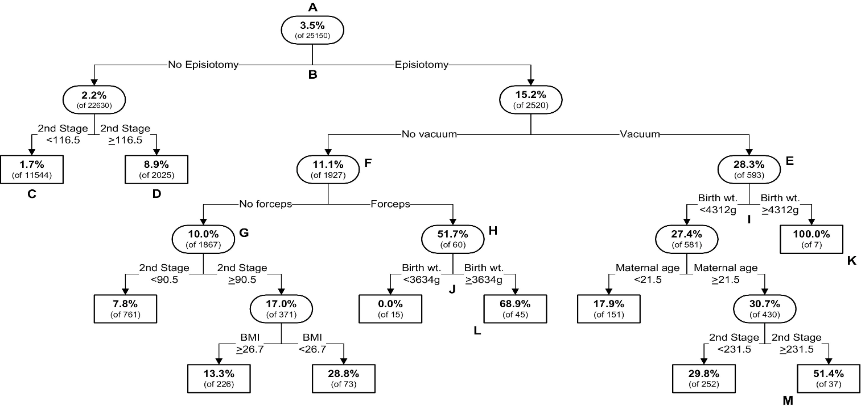
a.) What analytic technique is used to generate figures like this?
b.) What would be your estimate of the risk of a TFPL for a woman similar to those in this study with no episiotomy, no vacuum delivery, no forceps, a BMI of 30 and a 115-minute second stage?
c.) The cutoffs in the figure above (e.g., birth weight ≥ 3634 g) are not round numbers. Why is this?

d.) The figure above was developed on the entire dataset of 25,150 births, i.e., there was no separate validation dataset. If the figure above were applied to a new population of births, how would you expect its performance to differ?
e.) One possible use of this type of research is to help clinicians who are managing labor to estimate the risk that a woman in labor will develop a TFPL, to aid in delivery decisions. Why is inclusion of birth weight in several branch points problematic for this?

Beiser, A. S., M. Takahashi, A. L. Baker, R. P. Sundel and J. W. Newburger (1998). "A predictive instrument for coronary artery aneurysms in Kawasaki disease. US Multicenter Kawasaki Disease Study Group." Am J Cardiol 81(9): 1116-1120.
Hamilton, E. F., S. Smith, L. Yang, P. Warrick and A. Ciampi (2011). "Third- and fourth-degree perineal lacerations: defining high-risk clinical clusters." Am J Obstet Gynecol 204(4): 309 e301-306.
Tanz, R. R., M. A. Gerber, W. Kabat, J. Rippe, R. Seshadri and S. T. Shulman (2009). "Performance of a rapid antigen-detection test and throat culture in community pediatric offices: implications for management of pharyngitis." Pediatrics 123(2): 437-444.

Kolata G, available at: http://www.nytimes.com/2013/11/18/health/risk-calculator-for-cholesterol-appears-flawed.html

