Using a longitudinal cohort design with a sample of 1,000 ninth graders followed through high school and another sample of 1,000 young adults followed for five years:
Aim 1: Determine adolescents’ and young adults’ perceptions of risk for disease, addiction, and death; acceptability; and benefits of using conventional, new, and emerging tobacco products that come on the market during the course of this research.
Aim 2: Determine the predictive relationships among perceptions of tobacco-related risks, benefits, and acceptability of tobacco products, and the onset, continuation, cessation, relapse, switching, and dual use of tobacco products.
Aim 3: Identify contextual factors (exposure to pro-tobacco media, anti-tobacco media, warning labels, and smoking images in the media and on the Internet) that influence perceptions of risks, benefits, acceptability, and subsequent tobacco use.

Conceptual Model
For the proposed study, we bring together the literature addressing the relationship between tobacco-related perceptions and tobacco use with the literature on tobacco marketing to develop and test a novel model of adolescent and young adult tobacco use, including the onset, continuation, cessation, relapse, dual use, and switching of tobacco products, integrating factors addressed by multiple projects in this TCORS. Grounded in behavioral decision theory, including the Theory of Planned Behavior ^{33, 34} and the Hypothetical Model of Tobacco Consumer Response,³⁵ this Tobacco Consumer Decision-Making Model (Figure 2) argues that decisions to use tobacco are shaped by tobacco-related risk and benefit perceptions and perceived acceptability of the tobacco product. These perceptions are influenced by exposure to tobacco marketing campaigns and anti-tobacco marketing efforts. Figure 2 presents the model with notations for the aims and hypotheses to be tested in this study (the Analysis Plan details the specific hypotheses to be tested).
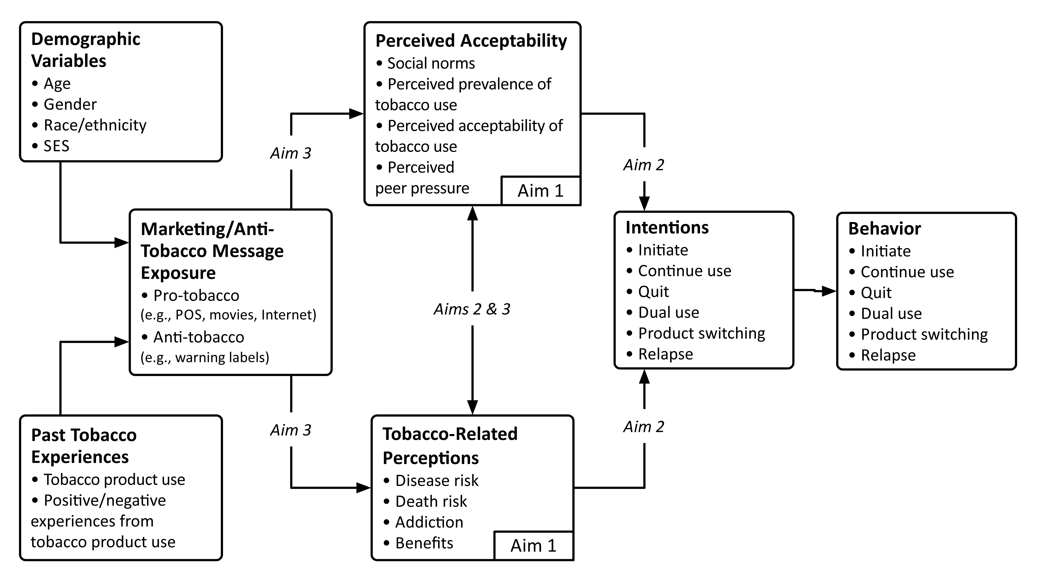
Figure 2. Tobacco Consumer Decision-Making Model. This model of adolescents’ and young adults’ tobacco decision-making shows our hypothesized relationships among study variables: 1) adolescents and young adults will perceive greater risk from cigarettes than other tobacco products (Aim 1, Hypothesis 1); 2) perceptions of tobacco-related risks and benefits and acceptability will influence tobacco use intentions and behavior (Aim 2, Hypothesis 2a-d); and 3) these perceptions and perceived acceptability will be shaped by marketing and anti-tobacco message exposure (Aim 3, Hypothesis 3a-c). Note: This figure does not show all theoretical relationships among model variables but focuses on the relationships most relevant to our study.

Table 3. List of Variables and Related Measurement Tools
Variable | Measure | Response choices
Demographics  (Aims 1-3) | - Date of birth  - Grade  - Ethnicity (Hispanicity) & Race  - Parent’s education level  - Parents’ marital status  - Country of birth  - Language spoken at home  - Parental immigration | - Open response  - Forced choice  - 13 categories  - 11 choices: >8th grade to post-graduate  - Married, partnered, divorced, widowed, etc.  - US or Outside US  - English or Not English  - Born in US or Not
Past Tobacco Use  (Aims 1-3) | - Use of cigarettes, e-cigarettes, small cigars, snus, dissolvables, compressed tobacco | - Incidence (ever), frequency, age of onset, last event  - Smoked in past 30 days  - Smoked at least 100 cigarettes in lifetime  - Dual use  - Product switching; relapse
Experience with Tobacco-Related Outcomes  (Aims 1-2) | - Experience with tobacco-related positive and negative consequences associated with tobacco use | - Positive consequences: Incidence (ever), frequency, age of occurrence, last event of: felt relaxed, looked more grown up, felt thinner, felt more socially accepted after smoking.^{6, 7}  - Negative consequences: Incidence (ever), frequency, age of occurrence, last event of: gotten into trouble, had trouble exercising, had trouble breathing, had a bad cough, lost friends because of smoking.^{6, 7}
Nicotine Dependence  (Aims 1-2) | - Loss of autonomy over nicotine use  - Compulsion to smoke to achieve pleasure and avoid withdrawal symptoms | - Hooked on Nicotine Checklist (HONC): 10-item dichotomously scored theory-based measure  - Fagerstrom Tolerance Questionnaire (FTQ): will use both the adult and adolescent modified surveys⁴⁸
Perceptions of Tobacco-Related Risks and Benefits  (Aims 1-3) | - Perceptions of risk associated with tobacco use  - Perceptions of benefits associated with tobacco use | - Likelihood of experiencing tobacco-related social outcomes from using each tobacco product (i.e. getting into trouble, having friends upset with you) and health outcomes (e.g. becoming addicted, getting lung cancer, having a heart attack, getting a bad cough, being thinner, dying, and being harmed in any way).³⁶  - Relative Risk – expected chance of negative outcomes vs. positive outcomes; and for one tobacco product compared to another  - Likelihood of experiencing tobacco-related social and health benefits from using each tobacco product, such as feeling more relaxed, looking cool, looking grown up, losing weight, and fitting in.³⁶
Perceived Acceptability  (Aims 1-3) | - Perceived prevalence of tobacco use for each product  - Perceived acceptability of tobacco use for each product  - Tobacco use and related outcomes among peers, siblings, parents, other family members, other adults | - Rates of use of each tobacco product (e.g., out of 100 peers my age, how many are using e-cigarettes?^{6,1836}  - How much do (your friends, parents, siblings, other adults) think it is OK for you to use tobacco? 5-point Likert scale  - Any tobacco use by peers, siblings, parents, other family members, other adults: Yes/No; Incidence (ever), frequency, age of onset of tobacco-related outcomes
Exposure to Pro- and Anti- tobacco media and advertisements (Aim 3) | - Self-reported exposure  - Advertising receptivity  - Ownership of promotional material | - Have you seen any advertisements for cigarettes, e-cigarettes, small cigars, snus, dissolvable, compressed tobacco in: newspapers, magazines, billboards, movie theaters, buses or trains, in stores, near stores, endorsements by celebrities, on tobacco websites, on any Internet website, at any sporting event, other? (Dichotomously Yes/No for each, followed by number of times exposed);  - Similar questions will be asked about exposure to anti-tobacco ads and warning labels  - Receipt of direct mail advertisements for tobacco products (Yes/No)  - Minimal receptivity (cannot name most advertised brands); Low (can name a brand but does not have a favorite ad); Moderate (can name a brand and has a favorite ad); High (has or is preparing to use a tobacco promotional item)⁴⁹  - Self-report ownership of tobacco promotional items (lighter, jacket, hat, shirt) Yes/No
Behavioral Intentions  (Aims 1-3) | - Chance you will use any tobacco product, including cigarettes, e-cigarettes, cigarillos, smokeless tobacco, snus, dissolvables, or compressed tobacco  - Chance you will switch to another tobacco product, or use more than one tobacco product | - Percent chance will use each product: ever, over next six months, as an adult  - Level of planning to use each product: 5-pt scale  - Commitment not to use: 5-pt scale⁵⁰

