Epi 204
Problem Set 7
Randomized Controlled Trials
Due 11/2/2017 at 1 pm
Chapter 8 Problems 14, 16, 17, 19, 20,

Ch08.14.Q. Clopidogrel (Plavix) for TIA
The Fast Assessment of Stroke and TIA to prevent Early Recurrence (FASTER) Trial was a randomized controlled trial of clopidogrel (Plavix®) vs. placebo to prevent stroke at 90 days in patients within 24 hours of a Transient Ischemic Attack (TIA; a temporary neurologic deficit that can be a sign of an impending stroke).(Kennedy, Hill et al. 2007) All patients in the trial received aspirin. Here are the results:

 | Stroke | No Stroke | TOTAL
Clopidogrel | 14 | 184 | 198
Placebo | 21 | 173 | 194

A report referring to this study stated

“… clopidogrel combined with aspirin reduced the 90-day risk of stroke by 36% compared to aspirin alone in a pilot trial of 392 patients treated acutely after minor stroke or TIA, and it was well tolerated.”

a) To what measure of treatment effect (e.g. RR, OR, RRR, ARR, etc.) does the 36% refer?

b) Based on this study result, how many TIA patients do we have to treat with clopidogrel plus aspirin instead of aspirin alone to prevent 1 from having a stroke in the subsequent 90 days?

c. You can get 90 Plavix® tablets at InternationalPharmacy.com for about $1000, or at Costco for the bargain price of $613.65. Based on this study, what is the approximate medication cost to prevent one stroke at 90 days in TIA patients treated if you use brand name Plavix® from Costco? (The full 90-day course actually requires 97 pills, but you can ignore that for this problem.) Is Plavix® cost effective?

d. Now go to the website GoodRx.com, enter "Plavix" in the search box and put "97" for the quantity along the left margin. How much would the full course of 97 generic clopidogrel pills cost at Safeway (or whatever place is cheapest? It was Safeway on 10/29/15.) Do you want to change your answer to the last part of part c?
Ch08.16.Q Meconium Aspiration
Occasionally, due to fetal stress during labor, the fetus passes meconium stools, staining the normally clear amniotic fluid. It is thought (though no longer universally accepted) that if newborns inhale this meconium with their first breaths it can injure their lungs, causing meconium aspiration syndrome (MAS), a potentially life-threatening disorder. For this reason, when babies are born through meconium-stained amniotic fluid, the delivering clinician often tries to suction any meconium out of the nose and mouth before the babies take their first breath.

Vain et al (Vain, Szyld et al. 2004) did a randomized trial of such suctioning to prevent MAS. Here is a 2x2 table summarizing the results of this study:

 | MAS | No MAS | Total | Risk
Suction | 52 | 1211 | 1263 | 4.12%
No Suction | 47 | 1204 | 1251 | 3.76%
Total | 99 | 2415 | 2514

a) What is the Risk Ratio (RR) for MAS of suctioning compared to not suctioning?

b) What is the Absolute Risk Reduction of suctioning compared to not suctioning.

From the “Results” section:

“ …26 (2%) infants assigned no suction received intrapartum suctioning, mostly because the obstetrician demanded suctioning just as the child's head was being delivered, and were also analyzed as part of the no-suction group. These events occurred at several institutions early in the study period. Consequently, no further infants delivered by the non-compliant obstetricians were enrolled.”

- Why not analyze these 26 infants who did receive suctioning in the suction group, or at least drop them from the analysis altogether?

- Would dropping them from the analysis would favor suction or no suction?

Ch08.17.Q Effects of Iron Therapy on Iron Deficient Children

Oski and Honig (Oski and Honig 1978) did a randomized controlled trial to determine the short term (5- to 8-day) effect of intramuscular iron on mental and physical development indexes in iron deficient children aged 9 to 26 months. The pre-test was administered, then the patient received study drug (intramuscular iron in the “experimental” group and intramuscular saline in the control group). The post-test was administered 6-9 days later. The results are displayed in Table II reprinted below:
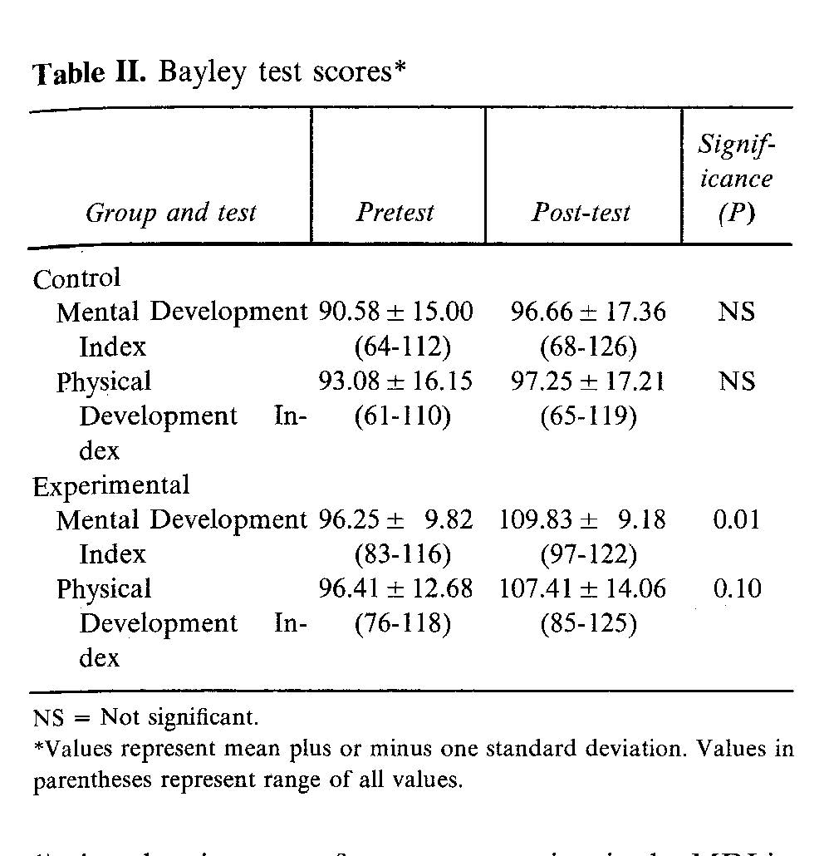

- What was the change in the mental development index in the experimental group?

- What was the change in the mental development index in the control group?

- Based on the p values reported above, is the change that you calculated in (a) statistically significantly different from the change that you calculated in (b)?

Ch08.19.Q Masking in Lyme Disease Trial
Lyme disease is an infection with a spirochete bacterium acquired from a tick bite. Most patients recover after treatment of the acute infection with antibiotics, but some can develop chronic symptoms, or "post Lyme syndrome," one symptom of which can be severe fatigue. The STOP-LD trial a randomized, double-blind trial of a long course of IV ceftriaxone (an antibiotic).

The results section includes:
Masking. At … 6 months 69% (18/26) of the ceftriaxone vs 32% (7/22) of the placebo group correctly guessed their treatment assignment (p = 0.004).
In the discussion they wrote:
"The observation that more of the ceftriaxone than placebo treated groups correctly guessed their treatment assignment could mean that masking may have been compromised."
Does the comparison above (P=0.004) support the authors' concern that masking may have been compromised? Explain.

Ch08.20.Q. Planned C-Section
With thanks to Sarah Averbach, Juno Obedin-Maliver, and Nika Seidman (students in 2014 course)

Planned vaginal vs planned cesarean delivery for breech presentation
Women who have a fetus in the breech position (feet/bottom down, head up) at term can either plan to attempt a vaginal breech delivery or plan to deliver by cesarean section. Vaginal breech deliveries are less risky for mothers but may be more risky for infants.

- For their randomized controlled trial comparing planned vaginal delivery to planned cesarean delivery for singleton breech fetuses at term, Hannah et al (Hannah, Hannah et al. 2000) enrolled 2088 subjects from 121 centers in 26 countries. The primary outcomes were perinatal mortality, neonatal mortality, serious neonatal morbidity, maternal mortality and serious maternal morbidity. If you were to design this study, how would you incorporate blinding? Who would be blinded, and for what outcomes? Why?

- The primary endpoint of this study was infant mortality at <28 days of age or “serious neonatal morbidity.” The authors defined “serious neonatal morbidity” as one or more of the following (list abbreviated for this question): spinal-cord injury, skull fracture, peripheral-nerve injury present at hospital discharge, seizure at <24 hours of age; Apgar score <4 at 5 minutes; stupor, decreased response to pain, or coma; intubation for >24 hours; tube feeding for >4 days; or admission to the intensive care unit for >4 days. What is the main advantage of using such a composite outcome? What is the main disadvantage?

- Even if a vaginal delivery route is initially planned, the plan can change during labor because of perceived danger to mother or fetus; in this case a cesarean section may be done on an urgent or emergent basis. After randomization 90% (941/1041) of women randomized to cesarean section delivered that way and 57% (591/1042) of those randomized to vaginal delivery had a vaginal delivery. For the question of the effect of PLANNING a c-section vs. PLANNING a vaginal delivery will an "Intention to Treat" analysis of this trial bias results towards finding no difference?

- The outcome of perinatal or neonatal mortality (death of the fetus after 22 weeks or of the newborn up to 28 days of age, excluding 5 subjects with lethal congenital anomalies) occurred in 3/1039 (0.3%) in the planned cesarean group and 13/1039 (1.3%) in the planned vaginal delivery group (RR =0.23; 95% CI 0.07-0.81, P=0.02).

- What were the overall Relative Risk Reduction (RRR) and Absolute Risk Reduction (ARR) for perinatal/neonatal mortality?

- How many women need to plan a caesarian delivery rather than a vaginal breech delivery to prevent one perinatal or neonatal death?

- (Extra credit) Because of the crossover between groups, the actual number of additional Cesarean deliveries needed to prevent one perinatal or neonatal death was less than the number calculated above. Taking that crossover into account how many additional cesarean deliveries did it take to prevent one perinatal or neonatal death by planning a Cesarean delivery? [+2 extra credit points]?

Hannah, M. E., W. J. Hannah, S. A. Hewson, E. D. Hodnett, S. Saigal and A. R. Willan (2000). "Planned caesarean section versus planned vaginal birth for breech presentation at term: a randomised multicentre trial. Term Breech Trial Collaborative Group." Lancet 356(9239): 1375-1383.
Kennedy, J., M. D. Hill, K. J. Ryckborst, M. Eliasziw, A. M. Demchuk and A. M. Buchan (2007). "Fast assessment of stroke and transient ischaemic attack to prevent early recurrence (FASTER): a randomised controlled pilot trial." Lancet Neurol 6(11): 961-969.
Oski, F. A. and A. S. Honig (1978). "The effects of therapy on the developmental scores of iron-deficient infants." J Pediatr 92(1): 21-25.
Vain, N. E., E. G. Szyld, L. M. Prudent, T. E. Wiswell, A. M. Aguilar and N. I. Vivas (2004). "Oropharyngeal and nasopharyngeal suctioning of meconium-stained neonates before delivery of their shoulders: multicentre, randomised controlled trial." Lancet 364(9434): 597-602.

Note: I had a hard time believing this disparity, so I called a Safeway pharmacy and verified the price. Please share the GoodRx website with your patients and family! Don't we have an amazing healthcare system?

