Epi 204
Problem Set 8
Randomized Controlled Trials
Due 11/9/2017 at 1 pm
EBD-2 Chapter 10 Problems 6, 9, 10, 11

Ch10.06.Q. CT Screening for Lung Cancer
The National Lung Screening Trial (NLST) randomized 53,454 current and former heavy smokers (minimum 30 pack-years) aged 55 to 74 years to either helical CT scanning or chest-x-rays yearly for 3 years.(Aberle, Adams et al. 2011) Results for Lung cancer mortality and total mortality are summarized below:

 | Lung Cancer Death
 | Yes | No | Total | Risk
CT | 356 | 26366 | 26722 | 1.33%
XR | 443 | 26289 | 26732 | 1.66%
 |  |  | 53454
 |  |  | ARR= | 0.32%
 | Death from Any Cause
 | Yes | No | Total | Risk
CT | 1877 | 24845 | 26722 | 7.02%
XR | 2000 | 24732 | 26732 | 7.48%
 |  |  | 53454
 |  |  | ARR= | 0.46%

- State whether each of the following statements is true or false; explain your answer

    - The favorable effect of annual CT screening on lung cancer mortality (compared with chest x-ray) can be explained by lead-time bias or length bias.

- Even though this is a randomized trial, a within-group comparison in the CT scan group would find longer survival in those whose cancer was detected by scanning (compared with those presenting with symptoms) at least partly due to length-time bias.

- The apparent reduction in lung cancer mortality in the CT screened group could be due to "Sticky Diagnosis Bias."

iv. Because there was a trend towards decreased mortality due to causes other than lung cancer in the CT scan group, "slippery linkage bias" is unlikely to explain the apparent lung cancer mortality benefit.

b) The following is taken from the CBS News story about the study: (http://www.cbsnews.com/stories/2010/11/04/eveningnews/main7023357.shtml)

" After 50 years of smoking, 67-year-old Steffani Torrighelli knew she was at high risk for lung cancer. Two years ago she enrolled in [the] study, and sure enough a CT scan picked up an early stage tumor before she had any symptoms… Since Torrighelli's lung surgery two years ago, she's cancer free and vigilant about screening."

Could Steffani's good outcome in this randomized trial be due to detection of pseudodisease? Explain.

c) Assume that the lung cancer mortality benefit resulted from 3 years of annual CT scanning.
About how many screening CT scans were needed to defer one lung cancer death in the NLST? (Provide the number of scans – not number of people who get scanned.)

d) Press reports say the scans cost about $300 each. What was the approximate cost of the screening CT scans per lung cancer death deferred?
e. Table 3 of the paper is summarized below. Compared with annual chest x-rays, how many additional invasive diagnostic procedures (percutaneous cytologic examinations or biopsies, bronchoscopies and surgical procedures) were required per lung cancer death deferred?

Excerpted from Table 3
 | CT | CXR
Total N | 26722 | 26732
Percutaneous Cytologic Examinations or biopsies | 322 | 172
Bronchoscopies | 671 | 225
Surgical procedures | 713 | 239
Total | 1706 | 636
Risk of Invasive Diagnostic Procedure | 6.4% | 2.4%

Ch10.09.Q Prostate Cancer Screening

Andriole et al (Andriole, Grubb et al. 2009) reported the results of a randomized trial of prostate cancer screening with combination of prostate-specific antigen (PSA) testing and digital rectal examinations compared with usual care (which was whatever the physician usually did). The subjects were men aged 55 – 74 years. After 7 years of follow-up the results of an "intention to treat" analysis" were as follows:

 | Diagnosis of Prostate CA |  | Death From Prostate CA |  | Death from Other Causes |  | Total
Randomized To… | N | % | N | % | N | %
Annual PSA Screening | 2820 | 7.35% | 50 | 0.13% | 2544 | 6.63% | 38343
Usual Care | 2322 | 6.05% | 44 | 0.12% | 2596 | 6.77% | 38350

There were significantly more patients diagnosed with prostate cancer in the group randomized to annual screening (116 vs. 95 per 10,000 person-years, risk ratio 1.21 95% CI 1.15 – 1.28). There were also more prostate cancer deaths in the group randomized to screening (2.0 vs. 1.7 per 10,000 person-years, risk ratio 1.14 95% CI 0.76 - 1.70).

  - What are 3 possible explanations for the greater reported death rate from prostate cancer in the screened group? Include at least 1 named bias.

  - As mentioned above, the prostate cancer death rate was approximately 2.0 per 10,000 person-years. If a new intervention completely eliminated prostate cancer death, how many men per year would have to receive this intervention to prevent one death?

c) Figure 1A from the trial shows cumulative diagnoses of prostate cancers.

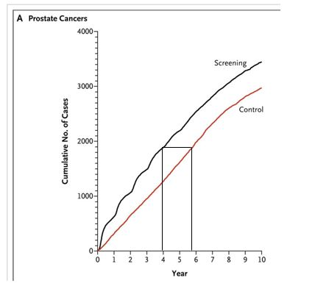
- Why is the screening line curvy and the control line more straight?

- What was the approximate "lead time" due to screening in the intervention group?

- As you probably heard, the U. S. Preventive Health Services Task Force recommended against prostate cancer screening. In an editorial in USA today titled, "If PSA test saves lives, averages don't matter", the editors argued that it is better to know whether or not you have prostate cancer. Here's an excerpt from that editorial (available at: http://www.usatoday.com/news/opinion/editorials/story/2011-10-10/PSA-test-prostate-cancer/50723714/1)

The …U.S. Preventive Services Task Force, doesn't dispute that the test detects cancer. Instead, it argues, with a formidable arsenal of data, that the test leads to widespread over-treatment, which outweighs the benefits of early detection. Over the entire society, it says, there is no net gain and substantial damage to patients, ranging from needless worry, to impotence and incontinence, to death.

And therein lies a dilemma for the older-than-50 male, for whom averages mean little. If he isn't tested, he'll be spared the false positives the test commonly produces as well as treatment risk. On the other hand, if he has high-grade cancer, the disease might not be found until it has spread to other organs, which is fatal. The five-year survival rate for localized prostate cancer is 100%. Once the cancer reaches distant organs, the rate falls to 28.8%. [Emphasis added.]

For purposes of argument, assume that it takes prostate cancer exactly 7 years from the moment it has spread to distant organs until it kills the patient and that it is equally likely to be detected any time during those 7 years.

i) If treatment of prostate cancer has no effect on survival, what proportion of men whose prostate cancer is detected in distant organs will survive for 5 years or more?

ii) If treatment of prostate cancer has no effect on survival, what proportion of men whose prostate cancer is detected before it has spread to distant organs will survive 5 years or more?

iii) Even if treatment of prostate cancer has no effect on survival, could lead-time bias explain the 5-year rates quoted in the last 2 sentences of the USA Today editorial?

iv) Even if treatment of prostate cancer has no effect on survival, could length-time bias explain the 5-year rates quoted in the last 2 sentences of the USA Today editorial?

v.) Do you agree with USA Today's position that men should get their PSA tested and then decide with their doctor what to do with the result? Why or why not?

Ch10.10.Q. Melanoma Screening

- During the period from 1973 to 2001 the incidence of melanoma in children (0-19 years) increased by about 3% annually. Over that same period, overall 5-year survival increased by about 4% annually. (Strouse JJ et al. J Clin Oncol 2005;23:4735-41.) Which of the biases discussed in Chapter 6 would cause this combination of increasing incidence and improved survival? Explain.

- Lewis reported trends in pediatric melanoma mortality in the US (Dematologic Surg 2008;34:152-59). From 1968 to 2004, (cause-specific) mortality from melanoma declined steadily, from about 3.5 per 10 million population to 1.5 per 10 million (a decrease averaging 2.3%/year). How does this observation fit with your answer to part A?

Ch10.11.Q. Ovarian cancer screening

For the ovarian cancer portion of the Prostate, Lung, Colorectal and Ovarian (PLCO) screening trial, 78,216 women aged 55-74 years were recruited 1993-2001 at 10 US centers and randomized to be offered annual screening with transvaginal ultrasound and serum cancer antigen 125 (CA-125) vs. usual care. Mortality results for this trial were recently reported.(5)
Figure 2 from the paper is reprinted below. The relative risk of being diagnosed with ovarian cancer was 1.21 (95% CI 0.99-1.48) and for ovarian cancer mortality the RR was 1.18 (95% CI 0.82, 1.71).

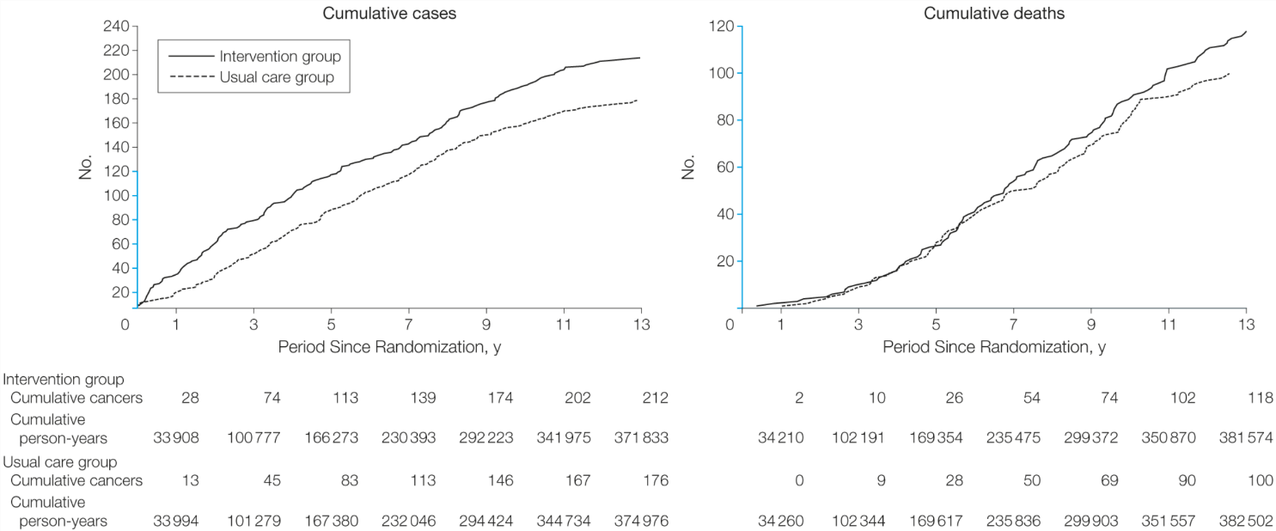

- Assume (as appears to be the case) that both curves level off over time and the usual care curve never catches the intervention curve. What is the most likely explanation (other than chance) for the excess of ovarian cancer diagnoses in the intervention group? Explain.

.

- The difference in ovarian cancer mortality between the intervention and usual care groups could have been due to chance. Could a higher cause-specific mortality rate also be explained by the following? For each possible option, say yes or no and explain your answer.

- Sticky diagnosis bias

- Slippery linkage bias

- Pseudodisease

- Length-time bias

c) Complications associated with diagnostic evaluation for cancer occurred in 45% of the women diagnosed with ovarian cancer in the screening group, compared with 52% of the women diagnosed with ovarian cancer in the usual care group. Does this mean screening was not associated with an excess of complications from diagnostic evaluations for ovarian cancer?

