Epi 204
Problem Set 9
Alternatives to RCTs, P-Values, and Confidence Intervals
Due 11/16/2017 at 1 pm
EBD-2 Chapter 11 Problems 8, 11, 12, 16

Ch11.08.Q. Prophylactic Penicillin in Sickle Cell Anemia

Children with sickle cell anemia are treated with penicillin to prevent infections with Streptococcus pneumoniae ("pneumococcus") to which they are particularly susceptible. Review the following abstract excerpt, addressing the question: "when is it safe to discontinue penicillin prophylaxis?"

Falletta, J. M., G. M. Woods, et al. (1995). "Discontinuing penicillin prophylaxis in children with sickle cell anemia. Prophylactic Penicillin Study II." J Pediatr 127(5): 685-90.

OBJECTIVE: To evaluate the consequences of discontinuing penicillin prophylaxis at 5 years of age in children with sickle cell anemia who had received prophylactic penicillin for much of their lives.

DESIGN: Randomized, double-blind, placebo-controlled trial….

PATIENTS: Children with sickle cell anemia …who had received prophylactic penicillin therapy for at least 2 years immediately before their fifth birthday and had received the 23-valent pneumococcal vaccine between 2 and 3 years of age and again at the time of randomization. Of 599 potential candidates, 400 were randomly selected and followed for an average of 3.2 years....

INTERVENTIONS: After randomization, patients received the study medication twice daily--either penicillin V potassium, 250 mg, or an identical placebo...

MAIN OUTCOME MEASURES: The primary end point was… bacteremia or meningitis caused by Streptococcus pneumoniae ...

RESULTS: Six children had a systemic infection caused by S. pneumoniae, four in the placebo group (2.0%; 95% confidence interval 0.5%, 5.0%) and two in the continued penicillin prophylaxis group (1.0%; 95% confidence interval 0.1%, 3.6%) with a relative risk of 0.5 (95% confidence interval 0.1, 2.7).

CONCLUSION: Children with sickle cell anemia who have not had a prior severe pneumococcal infection or a splenectomy and are receiving comprehensive care may safely stop prophylactic penicillin therapy at 5 years of age...

a.) There were 200 children in each group. Use the numbers in the abstract to help you interpret the Stata output below. What was the absolute difference in risk between the groups, and what is its 95% CI?

. csi 2 4 198 196

| Exposed Unexposed | Total
-----------------+------------------------+----------
Cases | 2 4 | 6
Noncases | 198 196 | 394
-----------------+------------------------+----------
Total | 200 200 | 400
| |
Risk | .01 .02 | .015
| |
| Point estimate | [95% Conf. Interval]
|------------------------+----------------------
Risk difference | -.01 | -.0338037 .0138037
Risk ratio | .5 | .0926272 2.69899
Prev. frac. ex. | .5 | -1.69899 .9073728
Prev. frac. pop | .25 |
+-----------------------------------------------
chi2(1) = 0.68 Pr>chi2 = 0.4107

b) The methods section of the paper indicates that they assumed that the S. pneumoniae bacteremia or meningitis rate in the placebo group over 3 years would be about 12%, that they wished to detect a 67% decrease (to 4%) with penicillin, and calculated that a sample size of 200 per group would give about 80% power to detect this decrease at 2-tailed alpha = 0.05.

Assume for this problem that a difference between groups smaller than what the investigators used for their sample size calculation (8%) would not be clinically significant. Did they have enough subjects to conclude that discontinuing penicillin at age 5 is safe? Explain.

c.) The outcome variable was bacteremia or meningitis caused only by S. pneumoniae. What would be a better choice of outcome variable for the study?

Ch11.11.Q RCT of Weight Loss Drug

Despres et al (Despres, Golay et al. 2005) did a randomized controlled trial of the effect of a new diet medication (Rimonabant, a selective cannabinoid-1 receptor blocker) versus standard therapy on 12-month change in waist circumference in 687 overweight and obese individuals. The ≈345 subjects in each group (treatment and control) had their changes in waist circumference measured and averaged to get the sample mean waist circumference change for each group.

Here are the results from the study formatted to look like Stata output:

Weight Circumference Comparison
 | N | Δ (cm) | SD | SEM
Rimonabant* | 345 | -3.5 | 6.0 | 0.32
Placebo | 342 | -2.4 | 5.7 | 0.31
Combined | 687 | -3.0 | 5.9 |  | [95% Conf. Interval]
Diff |  | -1.1 |  | 0.45 | -1.98 | -0.228
Deg Freedom | 685 |  | t | -2.46
 |  |  | P | 0.028
* 5 mg daily

- Based on this study, what is the best point estimate for the effect of Rimonobant on waist circumference after 12 months?

(b) – (e) TRUE or FALSE
State whether the following statements are true or false and briefly explain why.

- Since the threshold for rejecting the null hypothesis is 0.05, the P value should be reported as “P< 0.05” instead of "P = 0.028."

- Assuming there is no true effect of the diet medication, the probability of getting a group difference exactly equal to 1.1 cm by chance alone is 0.028.

Assume that, based on its costs and side effects (nausea), this medication is only worth taking if (on average) it can be expected to provide at least 2 cm of decrease in waist circumference.

- This trial supports the use of this diet pill.

Ch11.12.Q. Epidural analgesia and C-section rates (adapted from a problem by Susan Lee).
The effect of epidural analgesia on the progress of labor has generated considerable controversy. Previous observational studies have found that women who receive epidurals for labor analgesia have longer labors and higher rates of caesarean sections than women that do not receive epidurals.

Zhang et al. took advantage of a policy change in 1993 within the US Department of Defense requiring the availability of on-demand labor epidural analgesia in military centers to study this concern at the Tripler Army Medical Center. Prior to this policy change, epidural rates for labor analgesia were < 1%. After implementation of the new policy, the epidural rate climbed to > 70% within one year, levelling off at 84% by 1995. They found no difference in C-section delivery rates in women with delivery in the year prior to policy change (1993) compared with delivery in 1995 (after the policy change), as shown in figure 1.

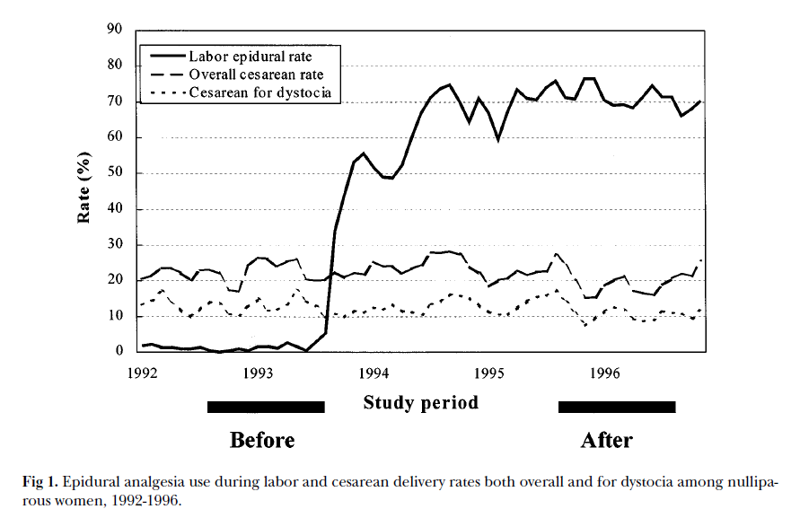
a) We can think of this study as using an instrumental variable to study the effect of a treatment on an outcome. What are the treatment, the instrumental variable and the outcome variable for this study?

b) In order for an instrumental variable to be used to estimate the effect of a treatment, what assumption is required about its relation to the outcome?

c) Suppose a nearby hospital with 5,000 deliveries a year has had a stable epidural rate of 50% for the last 5 years. Why not take advantage of its large sample size and estimate the effect of epidural analgesia on C-section rates by comparing C-section rates among all the women that did vs. did not receive epidural analgesia for labor at this other site?

d) The observed rates of C-section were 14.4% of 507 deliveries before and 12.1% of 581 deliveries after the policy change. Although not provided by the authors, this is an absolute risk reduction of 2.35%, with a 95% CI of (-1.7% to 6.4%). For each of the following statements about this risk difference and 95% CI, read the statement carefully, indicate whether it is true or false and explain.

i. The difference does not appear to be statistically significant at the α =0.05 level.
ii. The 95% CI means that if we could repeat this study many times, we would expect the observed risk difference to fall in this interval about 95% of the time.
iii. The range of changes in C-section rates consistent with this study is between a 1.7% decrease and a 6.4% increase after the policy was implemented.

iv. The effect of epidural analgesia on the C-section in this study was a 2.35% decrease (95% CI from a 6.4% decrease to a 1.7% increase).

11.16.Q. Study 239 Paroxetine in Adolescents
EBD-2 Chapter 8 mentions Study 239, a Glaxo–Smith–Kline-funded randomized, double-blind study that compared the antidepressants paroxetine and imipramine with placebo in adolescents with major depression.
The Results section of that paper states:
Serious adverse effects occurred in 11 [of 93] patients in the paroxetine group, 5 [of 95] in the imipramine group, and 2 [of 87] in the placebo group . . . The serious adverse effects in the paroxetine group consisted of headache during discontinuation taper (1 patient) and various psychiatric events (10 patients) . . . Of the 11 patients, only headache (1 patient) was considered by the treating investigator to be related to paroxetine.

Although no P-values for adverse events are presented in the paper, if we compare the proportion with serious adverse events with paroxetine (11 of 93) to that with placebo (2 of 87) using Stata, we get the following output:
. csi 11 2 82 85, ex

| Exposed Unexposed | Total
-----------------+------------------------+------------
Cases | 11 2 | 13
Noncases | 82 85 | 167
-----------------+------------------------+------------
Total | 93 87 | 180
| |
Risk | .1182796 .0229885 | .0722222
| |
| Point estimate | [95% Conf. Interval]
|------------------------+------------------------
Risk difference | .0952911 | .0224934 .1680887
Risk ratio | 5.145161 | 1.173574 22.55732
Attr. frac. ex. | .8056426 | .1479022 .9556685
Attr. frac. pop | .6816976 |
+-------------------------------------------------
1-sided Fisher's exact P = 0.0124
2-sided Fisher's exact P = 0.0188

a) The calculation above entirely ignores the fact that there was an imipramine group. If that group were included, the investigators would want to make three comparisons: paroxetine vs. imipramine, paroxetine vs. placebo, and imipramine vs. placebo. Using the Bonferroni correction for testing these three hypotheses at α = 0.05, a 2-tailed P-value of 0.05/3 = 0.0167 would be required to reject the null hypothesis, and results above would not be statistically significant. Do you think the Bonferroni correction is appropriate in this case? Why or why not?

The Discussion states:
"Because these serious adverse events were judged by the investigators to be related to treatment in only 4 patients (Paroxetine, 1; imipramine, 2; placebo, 1), causality cannot be determined conclusively."

b) Do you agree? How should the judgments of the investigators regarding whether adverse events were treatment-related be factored into judgments about causality of adverse events, assuming blinding was maintained?
c) Does your answer to part b change if you believe blinding of outcome ascertainment was compromised in this industry-sponsored trial?

Despres, J. P., A. Golay and L. Sjostrom (2005). "Effects of Rimonabant on Metabolic Risk Factors in Overweight Patients with Dyslipidemia." N Engl J Med 353(20): 2121-2134.

Zhang J, Yancey MK, Klebanoff MA, Schwarz J, Schweitzer D. Does epidural analgesia prolong labor and increase risk of cesarean delivery? A natural experiment. Am J Obstet Gynecol 2001;185(1):7-7.

