Assignment 6_2017 Due date: Thursday, November 2, 2017 10:30 a.m.

- Using the Muhlhofer seizure recurrence dataset:

  - Test whether seizure recurrence is independent of gender (male), death, released to Home, or any of the comorbidities. Interpret the results in terms of the Null hypothesis of no relationship between seizure recurrence and the other variables. . tab SzRecurrence48Hrs male, chi exact

SzRecurren | male
ce48Hrs | Female Male | Total
-----------+----------------------+----------
No | 39 42 | 81
Yes | 10 17 | 27
-----------+----------------------+----------
Total | 49 59 | 108

Pearson chi2(1) = 1.0086 Pr = 0.315
Fisher's exact = 0.376
1-sided Fisher's exact = 0.218
We fail to reject the null hypothesis that there is no relationship between seizure recurrence and gender.
. tab SzRecurrence48Hrs Death, chi exact

SzRecurren | Death
ce48Hrs | No Yes | Total
-----------+----------------------+----------
No | 76 5 | 81
Yes | 22 5 | 27
-----------+----------------------+----------
Total | 98 10 | 108

Pearson chi2(1) = 3.6735 Pr = 0.055
Fisher's exact = 0.117
1-sided Fisher's exact = 0.068
We fail to reject the null hypothesis that there is no relationship between seizure recurrence and death.

. tab SzRecurrence48Hrs Home, chi exact

SzRecurren | Home
ce48Hrs | No Yes | Total
-----------+----------------------+----------
No | 45 36 | 81
Yes | 21 6 | 27
-----------+----------------------+----------
Total | 66 42 | 108

Pearson chi2(1) = 4.2078 Pr = 0.040
Fisher's exact = 0.044
1-sided Fisher's exact = 0.032
We reject the null hypothesis that there is no relationship between seizure recurrence and release to home.

. tab SzRecurrence48Hrs LiverDz, chi exact

SzRecurren | LiverDz
ce48Hrs | No Yes | Total
-----------+----------------------+----------
No | 46 35 | 81
Yes | 21 6 | 27
-----------+----------------------+----------
Total | 67 41 | 108

Pearson chi2(1) = 3.7874 Pr = 0.052
Fisher's exact = 0.067
1-sided Fisher's exact = 0.041

We fail to reject the null hypothesis that there is no relationship between seizure recurrence and liver disease.
. tab SzRecurrence48Hrs RenalDz, chi exact

SzRecurren | RenalDz
ce48Hrs | No Yes | Total
-----------+----------------------+----------
No | 58 23 | 81
Yes | 19 8 | 27
-----------+----------------------+----------
Total | 77 31 | 108

Pearson chi2(1) = 0.0151 Pr = 0.902
Fisher's exact = 1.000
1-sided Fisher's exact = 0.542

We fail to reject the null hypothesis that there is no relationship between seizure recurrence and renal disease.

. tab SzRecurrence48Hrs PulmDz, chi exact

SzRecurren | PulmDz
ce48Hrs | No Yes | Total
-----------+----------------------+----------
No | 59 22 | 81
Yes | 21 6 | 27
-----------+----------------------+----------
Total | 80 28 | 108

Pearson chi2(1) = 0.2571 Pr = 0.612
Fisher's exact = 0.801
1-sided Fisher's exact = 0.408
We fail to reject the null hypothesis that there is no relationship between seizure recurrence and pulm disease.

. tab SzRecurrence48Hrs DM, chi exact

SzRecurren | DM
ce48Hrs | No Yes | Total
-----------+----------------------+----------
No | 60 21 | 81
Yes | 18 9 | 27
-----------+----------------------+----------
Total | 78 30 | 108

Pearson chi2(1) = 0.5538 Pr = 0.457
Fisher's exact = 0.466
1-sided Fisher's exact = 0.305

We fail to reject the null hypothesis that there is no relationship between seizure recurrence and dm.

. tab SzRecurrence48Hrs HO_DVT, chi exact

SzRecurren | HO_DVT
ce48Hrs | No Yes | Total
-----------+----------------------+----------
No | 74 7 | 81
Yes | 24 3 | 27
-----------+----------------------+----------
Total | 98 10 | 108

Pearson chi2(1) = 0.1469 Pr = 0.701
Fisher's exact = 0.708
1-sided Fisher's exact = 0.478

We fail to reject the null hypothesis that there is no relationship between seizure recurrence and hx of DVT.
. tab SzRecurrence48Hrs CA, chi exact

SzRecurren | CA
ce48Hrs | No Yes | Total
-----------+----------------------+----------
No | 69 12 | 81
Yes | 26 1 | 27
-----------+----------------------+----------
Total | 95 13 | 108

Pearson chi2(1) = 2.3611 Pr = 0.124
Fisher's exact = 0.178
1-sided Fisher's exact = 0.111

We fail to reject the null hypothesis that there is no relationship between seizure recurrence and cancer.

. tab SzRecurrence48Hrs CNS_Tumor, chi exact

SzRecurren | CNS_Tumor
ce48Hrs | No Yes | Total
-----------+----------------------+----------
No | 29 52 | 81
Yes | 8 19 | 27
-----------+----------------------+----------
Total | 37 71 | 108

Pearson chi2(1) = 0.3426 Pr = 0.558
Fisher's exact = 0.644
1-sided Fisher's exact = 0.367

We fail to reject the null hypothesis that there is no relationship between seizure recurrence and CNS tumor.

. tab SzRecurrence48Hrs Dementia, chi exact

SzRecurren | Dementia
ce48Hrs | No Yes | Total
-----------+----------------------+----------
No | 74 7 | 81
Yes | 25 2 | 27
-----------+----------------------+----------
Total | 99 9 | 108

Pearson chi2(1) = 0.0404 Pr = 0.841
Fisher's exact = 1.000
1-sided Fisher's exact = 0.601

We fail to reject the null hypothesis that there is no relationship between seizure recurrence and dementia.

  - Test whether the percent of males, death, released to Home, and any of the comorbidities are different by seizure recurrence is independent of gender (male), death, released to Home, and any comorbidity. Interpret the results in terms of the Null hypothesis and how it differs from (a). . prtest SzRecurrence48Hrs, by(male)

Two-sample test of proportions Female: Number of obs = 49
Male: Number of obs = 59
------------------------------------------------------------------------------
Group | Mean Std. Err. z P>|z| [95% Conf. Interval]
-------------+----------------------------------------------------------------
Female | .2040816 .0575756 .0912356 .3169277
Male | .2881356 .0589618 .1725725 .4036987
-------------+----------------------------------------------------------------
diff | -.084054 .0824102 -.245575 .0774671
| under Ho: .0836929 -1.00 0.315
------------------------------------------------------------------------------
diff = prop(Female) - prop(Male) z = -1.0043
Ho: diff = 0

Ha: diff < 0 Ha: diff != 0 Ha: diff > 0
Pr(Z < z) = 0.1576 Pr(|Z| > |z|) = 0.3152 Pr(Z > z) = 0.8424

. prtest SzRecurrence48Hrs, by(Death)

Two-sample test of proportions No: Number of obs = 98
Yes: Number of obs = 10
------------------------------------------------------------------------------
Variable | Mean Std. Err. z P>|z| [95% Conf. Interval]
-------------+----------------------------------------------------------------
No | .2244898 .0421482 .1418808 .3070987
Yes | .5 .1581139 .1901025 .8098975
-------------+----------------------------------------------------------------
diff | -.2755102 .1636352 -.5962293 .0452088
| under Ho: .1437472 -1.92 0.055
------------------------------------------------------------------------------
diff = prop(No) - prop(Yes) z = -1.9166
Ho: diff = 0

Ha: diff < 0 Ha: diff != 0 Ha: diff > 0
Pr(Z < z) = 0.0276 Pr(|Z| > |z|) = 0.0553 Pr(Z > z) = 0.9724

. prtest SzRecurrence48Hrs, by(Home)

Two-sample test of proportions No: Number of obs = 66
Yes: Number of obs = 42
------------------------------------------------------------------------------
Variable | Mean Std. Err. z P>|z| [95% Conf. Interval]
-------------+----------------------------------------------------------------
No | .3181818 .0573324 .2058124 .4305512
Yes | .1428571 .0539949 .037029 .2486853
-------------+----------------------------------------------------------------
diff | .1753247 .0787557 .0209664 .3296829
| under Ho: .0854704 2.05 0.040
------------------------------------------------------------------------------
diff = prop(No) - prop(Yes) z = 2.0513
Ho: diff = 0

Ha: diff < 0 Ha: diff != 0 Ha: diff > 0
Pr(Z < z) = 0.9799 Pr(|Z| > |z|) = 0.0402 Pr(Z > z) = 0.0201

. prtest SzRecurrence48Hrs, by(LiverDz)

Two-sample test of proportions No: Number of obs = 67
Yes: Number of obs = 41
------------------------------------------------------------------------------
Variable | Mean Std. Err. z P>|z| [95% Conf. Interval]
-------------+----------------------------------------------------------------
No | .3134328 .056673 .2023558 .4245099
Yes | .1463415 .0551993 .0381528 .2545302
-------------+----------------------------------------------------------------
diff | .1670914 .0791126 .0120336 .3221492
| under Ho: .0858585 1.95 0.052
------------------------------------------------------------------------------
diff = prop(No) - prop(Yes) z = 1.9461
Ho: diff = 0

Ha: diff < 0 Ha: diff != 0 Ha: diff > 0
Pr(Z < z) = 0.9742 Pr(|Z| > |z|) = 0.0516 Pr(Z > z) = 0.0258

. prtest SzRecurrence48Hrs, by(RenalDz)

Two-sample test of proportions No: Number of obs = 77
Yes: Number of obs = 31
------------------------------------------------------------------------------
Variable | Mean Std. Err. z P>|z| [95% Conf. Interval]
-------------+----------------------------------------------------------------
No | .2467532 .0491309 .1504585 .343048
Yes | .2580645 .0785898 .1040313 .4120978
-------------+----------------------------------------------------------------
diff | -.0113113 .0926834 -.1929673 .1703448
| under Ho: .0921057 -0.12 0.902
------------------------------------------------------------------------------
diff = prop(No) - prop(Yes) z = -0.1228
Ho: diff = 0

Ha: diff < 0 Ha: diff != 0 Ha: diff > 0
Pr(Z < z) = 0.4511 Pr(|Z| > |z|) = 0.9023 Pr(Z > z) = 0.5489

. prtest SzRecurrence48Hrs, by(PulmDz)

Two-sample test of proportions No: Number of obs = 80
Yes: Number of obs = 28
------------------------------------------------------------------------------
Variable | Mean Std. Err. z P>|z| [95% Conf. Interval]
-------------+----------------------------------------------------------------
No | .2625 .0491927 .1660841 .3589159
Yes | .2142857 .0775443 .0623017 .3662698
-------------+----------------------------------------------------------------
diff | .0482143 .0918316 -.1317723 .2282009
| under Ho: .0950799 0.51 0.612
------------------------------------------------------------------------------
diff = prop(No) - prop(Yes) z = 0.5071
Ho: diff = 0

Ha: diff < 0 Ha: diff != 0 Ha: diff > 0
Pr(Z < z) = 0.6940 Pr(|Z| > |z|) = 0.6121 Pr(Z > z) = 0.3060

. prtest SzRecurrence48Hrs, by(DM)

Two-sample test of proportions No: Number of obs = 78
Yes: Number of obs = 30
------------------------------------------------------------------------------
Variable | Mean Std. Err. z P>|z| [95% Conf. Interval]
-------------+----------------------------------------------------------------
No | .2307692 .0477057 .1372678 .3242706
Yes | .3 .083666 .1360176 .4639824
-------------+----------------------------------------------------------------
diff | -.0692308 .0963111 -.2579971 .1195355
| under Ho: .0930261 -0.74 0.457
------------------------------------------------------------------------------
diff = prop(No) - prop(Yes) z = -0.7442
Ho: diff = 0

Ha: diff < 0 Ha: diff != 0 Ha: diff > 0
Pr(Z < z) = 0.2284 Pr(|Z| > |z|) = 0.4568 Pr(Z > z) = 0.7716

. prtest SzRecurrence48Hrs, by(HO_DVT)

Two-sample test of proportions No: Number of obs = 98
Yes: Number of obs = 10
------------------------------------------------------------------------------
Variable | Mean Std. Err. z P>|z| [95% Conf. Interval]
-------------+----------------------------------------------------------------
No | .244898 .0434393 .1597586 .3300373
Yes | .3 .1449138 .0159742 .5840258
-------------+----------------------------------------------------------------
diff | -.055102 .1512844 -.351614 .2414099
| under Ho: .1437472 -0.38 0.701
------------------------------------------------------------------------------
diff = prop(No) - prop(Yes) z = -0.3833
Ho: diff = 0

Ha: diff < 0 Ha: diff != 0 Ha: diff > 0
Pr(Z < z) = 0.3507 Pr(|Z| > |z|) = 0.7015 Pr(Z > z) = 0.6493

. prtest SzRecurrence48Hrs, by(CA)

Two-sample test of proportions No: Number of obs = 95
Yes: Number of obs = 13
------------------------------------------------------------------------------
Variable | Mean Std. Err. z P>|z| [95% Conf. Interval]
-------------+----------------------------------------------------------------
No | .2736842 .0457431 .1840293 .3633391
Yes | .0769231 .0739053 -.0679287 .2217748
-------------+----------------------------------------------------------------
diff | .1967611 .0869162 .0264085 .3671138
| under Ho: .1280498 1.54 0.124
------------------------------------------------------------------------------
diff = prop(No) - prop(Yes) z = 1.5366
Ho: diff = 0

Ha: diff < 0 Ha: diff != 0 Ha: diff > 0
Pr(Z < z) = 0.9378 Pr(|Z| > |z|) = 0.1244 Pr(Z > z) = 0.0622

. prtest SzRecurrence48Hrs, by(CNS_Tumor)

Two-sample test of proportions No: Number of obs = 37
Yes: Number of obs = 71
------------------------------------------------------------------------------
Variable | Mean Std. Err. z P>|z| [95% Conf. Interval]
-------------+----------------------------------------------------------------
No | .2162162 .067677 .0835716 .3488608
Yes | .2676056 .0525401 .1646289 .3705824
-------------+----------------------------------------------------------------
diff | -.0513894 .0856776 -.2193144 .1165355
| under Ho: .0877976 -0.59 0.558
------------------------------------------------------------------------------
diff = prop(No) - prop(Yes) z = -0.5853
Ho: diff = 0

Ha: diff < 0 Ha: diff != 0 Ha: diff > 0
Pr(Z < z) = 0.2792 Pr(|Z| > |z|) = 0.5583 Pr(Z > z) = 0.7208

. prtest SzRecurrence48Hrs, by(Dementia)

Two-sample test of proportions No: Number of obs = 99
Yes: Number of obs = 9
------------------------------------------------------------------------------
Variable | Mean Std. Err. z P>|z| [95% Conf. Interval]
-------------+----------------------------------------------------------------
No | .2525253 .043665 .1669435 .338107
Yes | .2222222 .1385799 -.0493894 .4938338
-------------+----------------------------------------------------------------
diff | .030303 .1452963 -.2544725 .3150786
| under Ho: .1507557 0.20 0.841
------------------------------------------------------------------------------
diff = prop(No) - prop(Yes) z = 0.2010
Ho: diff = 0

Ha: diff < 0 Ha: diff != 0 Ha: diff > 0
Pr(Z < z) = 0.5797 Pr(|Z| > |z|) = 0.8407 Pr(Z > z) = 0.4203

  - How do the odds change for seizure recurrence as you move from Death in hospital, released to Rehab, and released Home? You can use the tabodds command here. . tabodds SzRecurrence48Hrs Death, or

---------------------------------------------------------------------------
Death | Odds Ratio chi2 P>chi2 [95% Conf. Interval]
-------------+-------------------------------------------------------------
No | 1.000000 . . . .
Yes | 3.454545 3.64 0.0564 0.889517 13.416141
---------------------------------------------------------------------------
Test of homogeneity (equal odds): chi2(1) = 3.64
Pr>chi2 = 0.0564

Score test for trend of odds: chi2(1) = 3.64
Pr>chi2 = 0.0564

. tabodds SzRecurrence48Hrs Rehab_Disability, or

---------------------------------------------------------------------------
Rehab_Disa~y | Odds Ratio chi2 P>chi2 [95% Conf. Interval]
-------------+-------------------------------------------------------------
No | 1.000000 . . . .
Yes | 2.050000 2.41 0.1205 0.812269 5.173780
---------------------------------------------------------------------------
Test of homogeneity (equal odds): chi2(1) = 2.41
Pr>chi2 = 0.1205

Score test for trend of odds: chi2(1) = 2.41
Pr>chi2 = 0.1205

. tabodds SzRecurrence48Hrs Home, or

---------------------------------------------------------------------------
Home | Odds Ratio chi2 P>chi2 [95% Conf. Interval]
-------------+-------------------------------------------------------------
No | 1.000000 . . . .
Yes | 0.357143 4.17 0.0412 0.127171 1.002991
---------------------------------------------------------------------------
Test of homogeneity (equal odds): chi2(1) = 4.17
Pr>chi2 = 0.0412

Score test for trend of odds: chi2(1) = 4.17
Pr>chi2 = 0.0412

  - How large a sample size per group would we need to have 90% power and 0.05 level of significance to see a significant difference in the percent having seizure recurrence for pre-existing liver disease or not? . prtest SzRecurrence48Hrs, by(LiverDz)

Two-sample test of proportions No: Number of obs = 67
Yes: Number of obs = 41
------------------------------------------------------------------------------
Variable | Mean Std. Err. z P>|z| [95% Conf. Interval]
-------------+----------------------------------------------------------------
No | .3134328 .056673 .2023558 .4245099
Yes | .1463415 .0551993 .0381528 .2545302
-------------+----------------------------------------------------------------
diff | .1670914 .0791126 .0120336 .3221492
| under Ho: .0858585 1.95 0.052
------------------------------------------------------------------------------
diff = prop(No) - prop(Yes) z = 1.9461
Ho: diff = 0

Ha: diff < 0 Ha: diff != 0 Ha: diff > 0
Pr(Z < z) = 0.9742 Pr(|Z| > |z|) = 0.0516 Pr(Z > z) = 0.0258

. power twoproportions 0.146, test(chi2) diff(0.167) power(0.9)

Performing iteration ...

Estimated sample sizes for a two-sample proportions test
Pearson's chi-squared test
Ho: p2 = p1 versus Ha: p2 != p1

Study parameters:

alpha = 0.0500
power = 0.9000
delta = 0.1670 (difference)
p1 = 0.1460
p2 = 0.3130
diff = 0.1670

Estimated sample sizes:

N = 264
N per group = 132
The sample size of 264 patients (132 for those with liver disease and 132 in those without) will be sufficiency to detect a difference of 16% in seizure recurrence with power of 90% and 5% significance. This 16% represents the difference between 31% seizure recurrence rate in those without liver disease and those with liver disease

- Read the Tajeu article on misuse of odds ratios. What is the biggest misuse and how is this biasing the interpretation of disease/diagnosis risks? What should the authors of the articles Tajeu analyzes done instead? Odds ratios no longer approximate the relative ratio when the outcome is not rare (ex: Obesity). However, they are often presented like relative risk ratios by publications and the lay media even when the outcome prevalence is > 10%.
The tendency to misuse ORs as study outcome prevalence rates increase leads to over or underinflation of the OR in relation to the RR. The effect size is often exaggerated.
Authors advocate prudent use of OR and when using it, clear statements that it is describing odds and not risks. There are also mathematical ways to adjust ORs to approximate RRs. They advocate presenting risk differences. Other statistical techniques can be used to estimate magnitude of association like the modified Poisson regression or Mantel-Haenszel estimate. In general, when the outcome prevalence is > 10%, researchers should be cognizant about how the media will interpret the ORs.

- Read the Kimmick paper and use the data from Table 2:

Calculate the Fisher’s Exact test result from Table 3 as well as calculating the proportions test. Are the chi-squared, Fisher’s Exact, and proportions test all similar? If the original hypothesis was an increase in Hot Flashes, would your conclusion be stronger?

Hot Flash | Ca + | Ca-
+ | 15 | 19
- | 7 | 31

The results are all similar.

Chi square

. tabi 15 19 \ 7 31, chi2

| col
row | 1 2 | Total
-----------+----------------------+----------
1 | 15 19 | 34
2 | 7 31 | 38
-----------+----------------------+----------
Total | 22 50 | 72

Pearson chi2(1) = 5.5841 Pr = 0.018

Fisher’s exact
. tabi 15 19 \ 7 31, chi exact

| col
row | 1 2 | Total
-----------+----------------------+----------
1 | 15 19 | 34
2 | 7 31 | 38
-----------+----------------------+----------
Total | 22 50 | 72

Pearson chi2(1) = 5.5841 Pr = 0.018
Fisher's exact = 0.023
1-sided Fisher's exact = 0.017
Proportions test
tabi 15 19 \ 7 31, col

+-------------------+
| Key |
|-------------------|
| frequency |
| column percentage |
+-------------------+

| col
row | 1 2 | Total
-----------+----------------------+----------
1 | 15 19 | 34
| 68.18 38.00 | 47.22
-----------+----------------------+----------
2 | 7 31 | 38
| 31.82 62.00 | 52.78
-----------+----------------------+----------
Total | 22 50 | 72
| 100.00 100.00 | 100.00

. prtesti 22 .6818 50 0.38

Two-sample test of proportions x: Number of obs = 22
y: Number of obs = 50
------------------------------------------------------------------------------
| Mean Std. Err. z P>|z| [95% Conf. Interval]
-------------+----------------------------------------------------------------
x | .6818 .0993041 .4871675 .8764325
y | .38 .068644 .2454602 .5145398
-------------+----------------------------------------------------------------
diff | .3018 .12072 .0651932 .5384068
| under Ho: .1277228 2.36 0.018
------------------------------------------------------------------------------
diff = prop(x) - prop(y) z = 2.3629
Ho: diff = 0

Ha: diff < 0 Ha: diff != 0 Ha: diff > 0
Pr(Z < z) = 0.9909 Pr(|Z| > |z|) = 0.0181 Pr(Z > z) = 0.0091

If the original hypothesis was increase in hot flashes, at this time it is unknown whether the correlation would be stronger. It is possible that more ppl would report increases in hot flashes but in a proportional manner in both those taking Ca and not taking Ca so not changes. We need more information.

Test the hypothesis that there is a significant difference in Life-disrupting hot flashes vs. Hot flashes using calcium supplementation. We currently do not have that information in the article. Table 2 only gives % of ppl with life disrupting vs non disrupting hot flashes but it did not divide the group into people who were or were not using calcium supplements.

Overall Life disrupting hot flashes occurred in 17% of the women. If I believe that these occurred less often in those women taking calcium supplements, how large a sample would I need to see a 5% change in Life disrupting hot flashes if my previous research shows that 20% of women without calcium supplements have Life disrupting hot flashes. Keep significance at 0.05 but vary power from 90%, 85%, to 80%. Power 90%
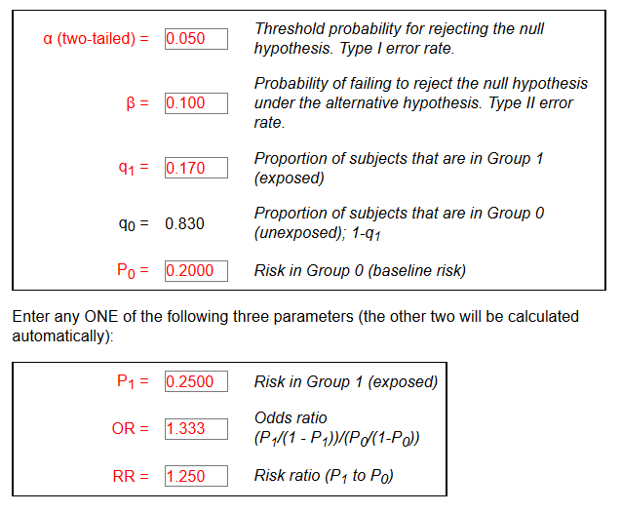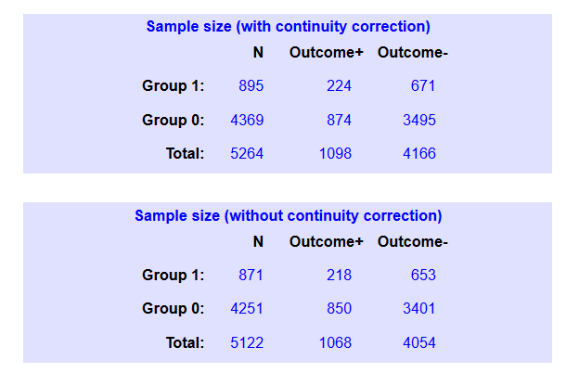
Power 85%
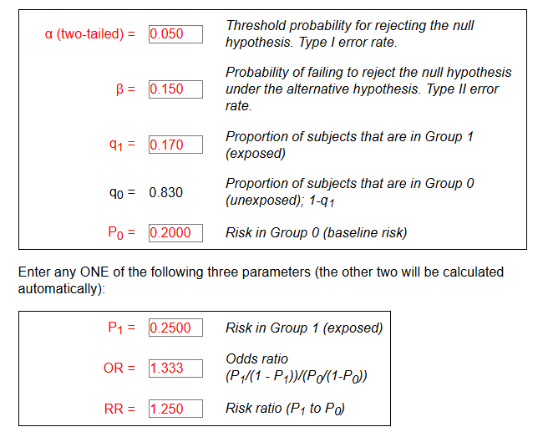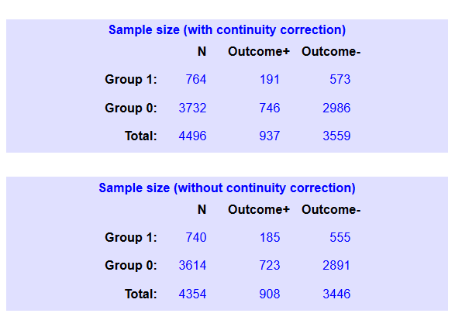
Power 80%

