# | Pts Possible | Pts missed | Extra Credit
1 | 12
2 | 15
3 | 12
4 | 10
5 | 12*
6 | 9
7 | 4*
8 | 16*
9 | 10*
Total
Score
* 2 Extra credit points possible
DUE 11/30/2017 8:45 am

If you attend the final exam review session, please bring a hard copy of your exam to turn in. If you cannot attend, please upload your exam on the course syllabus site. To allow a margin for computer and internet problems, we recommend uploading the exam on 11/29/2017.

Collaboration with others is NOT permitted. Answers must be in your own words. Do not try to find the answers by searching for old finals or problems sets. No exceptions. Really.

Please show your work.

F1. PUCAI [12 points]
Adapted from a question by Jacob Robson.
When it is bad, ulcerative colitis causes frequent, bloody stools and abdominal pain. However, due to modesty, patients have trouble quantifying their symptoms sufficiently to help their clinicians to make treatment decisions. Therefore, Turner et al (Turner, Otley et al. 2007)created a Pediatric Ulcerative Colitis Activity Index (PUCAI ) with specific questions about symptoms. However, it is time consuming for physicians to go through the PUCAI with patients/parents. Wouldn’t it be great if the patients could reliably report the PUCAI directly to their doctors? (Former UCSF pediatric resident) Jennifer Lightdale et al (Lee, Colman et al. 2011) looked at this very question in 2011, dividing the PUCAI scores into 3 disease activity groups. Results are shown in Table 2 below.

- What was the observed percent complete agreement in this study? [1]

b.) What percent complete agreement would be expected from the marginals? [1]

c.) The researchers report an unweighted Kappa statistic of 0.78. Is their calculation correct (± 0.01)? Show work. [2]

- Is the disagreement between patient- and physician-completed PUCAI scores balanced? Support your answer with numbers from the table and explain in what this means.[2]

- The researchers are disappointed that, based on their Kappa, their agreement is only “substantial.” They feel like they deserve half credit when ratings are off by one category, such as when the MD classifies the disease as inactive and the patient classifies it as mild. Show a weighting scheme that reflects this.[2]

- Calculate a weighted Kappa using that weighting scheme. Use Excel, Stata, an online calculator, a hand-held calculator, or just paper and pencil, but show us enough of your work/output to allow us to identify possible errors. [4]

F2. ADA Test for TB Meningitis (With thanks to Kristen Krysko) [15 points]

In 2013, researchers in Peru tested the validity of using spinal fluid adenosine deaminase (ADA) results to diagnose tuberculosis (TB) meningitis in patients presenting with a high clinical suspicion for this condition (Solari, Soto et al. 2013). TB meningitis is an infection in the space surrounding the brain and spinal cord that often results in headaches and neurologic deficits such as limb weakness or speech/vision problems. It is more common in developing countries.

This condition is difficult to diagnose as there is no definitive diagnostic test available (even biopsy can miss cases), so clinicians may treat if the clinical suspicion is high even if the diagnosis is not confirmed. Thus, the investigators in this study did not have a definitive diagnostic test to compare spinal fluid results to when studying the accuracy of ADA in the spinal fluid as a test for TB meningitis. They did, however, assign the final diagnosis the same way on everyone, using a data analyst blinded to the results of the CSF parameters being evaluated.

- What type of bias can occur in a study of diagnostic tests like this, in which it is difficult to be certain of the diagnosis of TB meningitis even with the best tests available? How would you expect sensitivity and specificity to be affected if errors on the index test (ASA) and the final diagnosis assignment (described above) are independent (conditional on true disease status)? [2]

- The test characteristics of adenosine deaminase (ADA) greater than 6 U/l are shown below. Using this cut-off, is the ADA test result more helpful if positive or negative and does it help you rule in or rule out TB meningitis? (You may ignore the concerns raised in Part (a) and assume that these are valid test characteristics.) [2]

- The ADA row in the table above shows sensitivity, specificity and likelihood ratios for ADA dichotomized at >6 U/l. Does the area under the ROC curve in that row also assume that the ADA was dichotomized at that point? How can you tell?[2]

- In this sample of patients in Peru, the proportion ultimately considered to have TB meningitis was 38%. Assume this is the prior probability of TB meningitis. Based on the results in the table in part b), what is the post-test probability of having TB meningitis if ADA>6 U/l? (Again, assume the test characteristics in the table are valid.)[2]

- Treatment of TB meningitis involves many months of treatment with potentially toxic therapies, but failing to treat someone with TB meningitis can be fatal. Assume for the purpose of this question that the cost of failing to treat someone with TB meningitis is two times as bad as treating someone who does not have TB. What is the treatment threshold probability? [2]

- Would you treat a patient with ADA>6 U/l based on your calculations in part c) and d)? What if the ADA were <=6 U/I? [2]

- ADA is a continuous measure and you would like to create 3 intervals, normal, indeterminate, and abnormal, with interval LRs 0.1, 1, and 10.7. If the authors had included an appropriately labeled ROC curve for ADA, explain how you would use it to determine whether it is possible to create an interval with LR= 0.1, and if so how you would select the cut-off. [3]

F3. Emergency room bedside ultrasound to detect renal colic (Chris Carlos, Patrick Ahearn, Diana Kwong)[12 points]

Renal colic, one-sided back pain (flank pain) caused by urinary tract obstruction from a kidney stone (aka ureteral stone), is a common emergency department presentation. Computed tomography (CT) is considered the gold standard for the diagnosis of ureteral stone and can provide information on stone size and location. However, many patients diagnosed with ureteral stones will have recurrent episodes and may receive multiple CTs throughout their lifetime, adding to costs, increased length of stay, and radiation exposure. A bedside ultrasound performed by emergency room physicians can look for the presence of hydronephrosis (urine backing up into the kidney and causing it to swell). This is an alternative to CT for diagnosing ureteral stones that is lower cost and without radiation exposure.

Leo et. al 2017 (Leo, Langlois et al. 2017) sought to determine the test characteristics of bedside ultrasound in diagnosing ureteral stone. They enrolled and performed a bedside ultrasound on 302 consecutive adult ED patients with complaints of flank pain who also had a CT. Even though the study had 302 patients, they presented the following results for a subset of 166 patients in Table 3b:

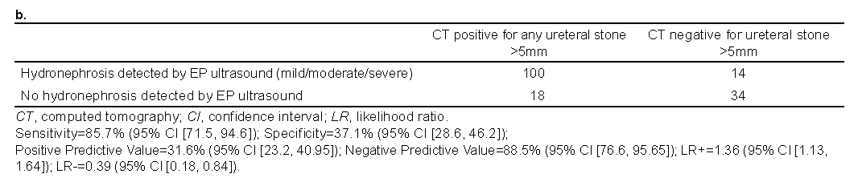

There are two features of this table that you should ignore:
1) “> 5mm” is incorrect. Assume that the numbers in the table apply to CT positive or negative for any ureteral stone.
2) We have not explained how they chose this subset of 166 patients. Don’t worry about that and assume that the CT scan is a valid gold standard for the presence of ureteral stone in this group.

- Assuming that a CT scan is the gold standard for detection of a ureteral stone, use the numbers in the table above to calculate the sensitivity, specificity, LR(+), and LR(-) of an ultrasound finding of hydronephrosis in detection of a ureteral stone. Do your calculations agree with those underneath the table?[3]

- There were 302 – 166 = 136 patients who were enrolled in the study but not included in the table above. Their CT scans were all negative for ureteral stone. Assume that their ultrasounds were also negative for hydronephrosis. What is the sensitivity and specificity of hydronephrosis on ultrasound for ureteral stone as determined by the gold standard CT?[3]

.

- Pretend you are an emergency physician seeing a patient with severe flank pain. You hope he has a ureteral stone, because although ureteral stones are painful, you can treat the pain, and ureteral stones essentially never kill the patient. Conversely, other potential causes of severe flank pain can kill the patient. You do an ultrasound and see hydronephrosis. You are relieved, but you would still like to know the probability that he does NOT have a stone and therefore might have something really bad. Based on this study and the assumption in (b) above, what is the probability that he does NOT have a ureteral stone? [3]
NOTE: Assume that your patient’s pre-ultrasound probability of ureteral stone is the same as the prevalence of ureteral stone in this 302-subject study.

- The patient scenario is the same as above, but you do an ultrasound that is negative for hydronephrosis. Now, you are really worried, because his pain might be caused by something a lot worse than a ureteral stone. Based on this study and the assumption in (b) above, what is the probability that he does NOT have a ureteral stone?[3]

F4. CALFRAST [10 points]
A quick screening test for hearing loss is the Calibrated Finger Rub Auditory Screening Test (CALFRAST). The examiner with arms extended stands facing the patient and rubs her fingers together strongly and asks if the patient can hear the rubbing sound on each side. Because this strong stimulus is presented about 70 cm from the patient's ear, it is called CALFRAST Strong 70. If the patient can hear the finger rubbing, the examiner repeats the test at the quietest level the examiner can hear (CALFRAST Faint 70). Torres-Russotto et al (Torres-Russotto, Landau et al. 2009) reported test characteristics for the CALFRAST, using audiometry as the gold standard, with normal hearing defined as < 25 decibel loss at 1000, 2000 and 4000 Hz.

Results from a consecutive sample of consenting patients are summarized in Table 2 from that study:

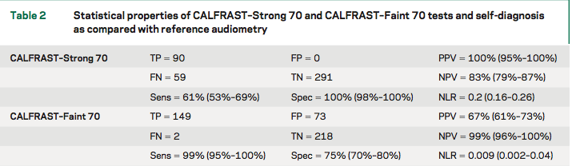

- Consider CALFRAST as a single multi-level test where Strong and Faint are 2 results for the same test. Not hearing a strong stimulus is a more abnormal result than not hearing a faint stimulus. Draw and label an ROC curve that summarizes the accuracy of the CALFRAST Faint 70 and Strong 70 results summarized above as a single test. [4]
NOTE: There are 2 fewer subjects for the STRONG 70 than the FAINT 70. You can ignore this and just use the percentages calculated by the authors in Table 2 above.

The study also examined the patient’s self assessment of hearing compared with the same gold standard, as shown in the continuation of Table 2 below.

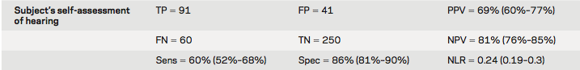

b. You are seeing a patient similar to those included in this study whose self-assessment is that his hearing is OK. What would be that patient's prior probability (before the CALFRAST) of ≥ 25 dB hearing loss? [2]

c. Suppose a patient with a 20% prior probability of hearing loss can hear the strong stimulus, but not the weak stimulus. What is your best estimate that he has significant (at least 25 decibels) hearing loss? [4]

F5. MPM [12 points + 2 Extra Credit]

The Mortality Probability Model at intensive care unit (ICU) admission, MPM₀, is a logistic regression model that predicts the risk of ICU death based on variables available within 1 hour of ICU admission. MPM₀ was developed using data on ICU patients treated in 1989-1990 and updated in 2007 using the Project Impact dataset of 125,000 ICU patients treated between 2001 and 2004 (Higgins, Teres et al. 2007). In both the 2007 paper and this question, the original model from the 1990s is called “MPM-II” and the updated model is called “MPM-III”. MPM-III was derived using 60% of the Project Impact dataset and validated using the other 40% of the dataset. Here are the calibration plots of the original model (MPM II) and the updated model (MPM III) in the validation dataset.

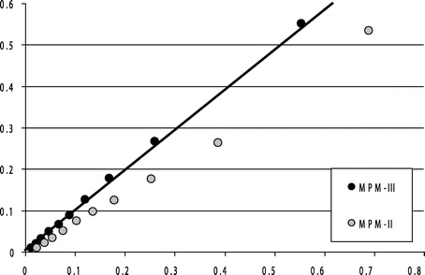
Xa text here
Figure 1. Calibration plot of Mortality Probability Admission Model (MPM-III) and Mortality Probability Model version 2 (MPM-II) on 2001-2004 Project IMPACT validation data. Graphic representation of calibration; database collapsed into ten equal sample sizes. Line at 45 degrees represents identity, circles represent population deciles. The MPM-III model (dark circles) calibrates well. The light circles define the relationship between predicted and actual mortality outcomes when MPM-II model is applied to the same dataset (2001-2004 data from Project IMPACT). Actual mortality is below the line of identity except at the lowest deciles of risk, demonstrating that MPM-II no longer calibrates.
Although the paper does not label the axes, this is a traditional calibration plot in which the vertical axis represents observed mortality and the horizontal axis represents predicted mortality. We added the X for part (b) below.
The updated model, MPM-III, and the original model, MPM-II, assigned the same individuals to the same decile of risk. For example, if MPM-II assigned Patient 99001 to the 3rd risk decile, MPM-III also assigned the patient to the 3rd risk decile.

- The caption says that “actual mortality is below the line of identity except at the lowest deciles of risk, demonstrating that MPM-II no longer calibrates.” Does this mean that MPM-II underestimated risk in this validation dataset? Briefly explain your answer.[2]

The following table gives the approximate range of MPM-III predicted risks for each decile in the validation dataset.

Decile | MPM-III Predicted Risk
1 | 0%-1.4%
2 | 1.5%-2.4%
3 | 2.5%-4%
4 | 5%-6%
5 | 7%-8%
6 | 9%-10%
7 | 11%-15%
8 | 16%-24%
9 | 25%-34%
10 | > 35%

- Which decile of MPM-III predicted risk does the point marked X in the calibration plot correspond to? Briefly explain your answer.[2]

Having only the MPM-III risk decile assignments, not the exact risk predictions, we created the following ROC curve. (This means that, if Subject 99001’s MPM-III predicted risk was 0.032, all we had was 2.5%-4%.)

- Based on the ROC curve for MPM-III, what is the interval likelihood ratio associated with the decile of risk that you answered for (b) above. (The decile of risk corresponding to the X on the calibration plot. (We are looking for a rough estimate like 8, 4, 2, 1, ½ = 0.5, ¼ = 0.25, 1/8 =0.125.) Briefly explain your answer.[2]

- The area under the ROC curve for the updated model (MPM-III) is 0.81. The ROC curve for the earlier model (MPM-II) is not shown. What is the best estimate for the area under the ROC curve for MPM-II. Briefly explain your answer. [2]

Here are simulated decision curves based on this dataset.

- Which decision curve, “Treat All”, “MPM-A”, or “MPM-B” corresponds to the original model, MPM-II? Explain your answer. [2]

- What proportion of the ICU patients in this dataset died in the ICU? Explain. [2]

- [Extra Credit] Using your answer to (f) as the pre-MPM probability of ICU death and your answer to (c) as the interval likelihood ratio, what is the probability of ICU death in a patient assigned to the 9th risk decile by MPM-III. Show your calculations. [+2 EC]

F6. USPSTF recommendations and PSA screening [9 points]

Jemal et al (Jemal, Fedewa et al. 2015) reported that following recommendations against prostate-specific antigen (PSA) screening by the US Preventive Services Task Force (USPSTF), both PSA screening and prostate cancer incidence declined. However, it is not yet clear whether this is a cause for concern or for celebration.

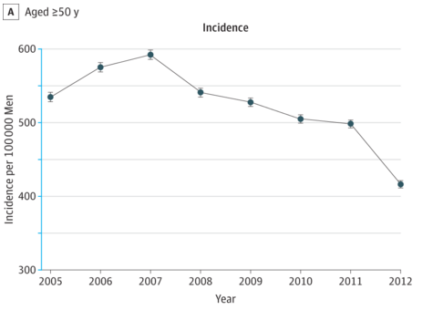

a.) For each of the following statements about hypothetical additional data, explain whether it would raise concern that we should be screening more (BAD), celebrate that we are screening less (GOOD), or provide no useful information to answer the question (NOT HELPFUL).

    - While the overall incidence of prostate cancer has declined, the proportion of prostate cancers that already had distant metastases at the time of diagnosis has increased. [1]

    - Over the next 5-10 years, prostate cancer mortality (per 100,000) increases compared with when PSA screening was more common. [1]

    - 5-year survival for patients with prostate cancer declines over the next 5 years. [1]

b) Indicate whether each of the statements below is true or false, and explain your answer.

- One reason why we might see an apparent decline in prostate cancer mortality is that decreased screening could lead to a reduction in sticky diagnosis bias. [2]

- One reason why we might see real decline in prostate cancer mortality is from less treatment of pseudodisease. [2]

- There could be a slight decrease in mortality due to causes other than prostate cancer, because of the previous slippery linkage bias. [2]

F7. Acetaminophen and ADHD [4 points, +2 EC]

This month’s Pediatrics has an interesting article (Ystrom, Gustavson et al. 2017) linking maternal prenatal exposure to acetaminophen (APAP) with attention deficit hyperactivity disorder (ADHD) in the offspring. The authors reported that the hazard ratio for ≥ 29 days of APAP use during pregnancy was 2.2 (95% CI 1.50 – 3.24).
a) One possibility is that it is not the medication itself, but rather the reason why the mothers took it (i.e., they were sick) that could be responsible for the association between APAP and ADHD in the offspring. What is the specific term used to describe this particular problem? [2]
b) Interestingly, the authors found that the hazard ratio for paternal APAP use ≥ 29 days was 2.1 (95% CI: 1.36 – 3.13). If we were to assume that the association with father’s APAP use could not be causal, how would that affect your conclusions about maternal use? [2]

c) (Extra Credit) One way to control for the problem mentioned in part A is to stratify on possible reasons for APAP use and compare e.g., offspring of women with headaches during pregnancy who took APAP with offspring of women with headaches who did not. The authors did this by asking the mothers if they had any of 128 medical conditions during pregnancy and controlling for the presence or absence of each of these conditions in their multivariable analysis. We bolded “presence or absence” to indicate that these were binary predictors. If one of the conditions was headache, a woman with any headache during pregnancy was coded as “1” for headache, otherwise she was coded as “0”. Interestingly short-term use (< 8 days) of APAP appeared protective against ADHD (HR 0.90, 95% CI 0.81 -1.00). Do you believe the authors control for the presence or absence of conditions such as headache that might cause both APAP use and ADHD was sufficient to address the problem in part (a)? Explain. [+2 points]

F8. RCT of evolocumab plus statin therapy (with thanks to Christopher Groh and Nalini Colaco) [16 points + 2EC]

LDL cholesterol (bad cholesterol) is a well-known risk factor for cardiovascular disease. For many years, the cornerstone of LDL treatment has been statin-based therapy. Statins are one of the few lipid lowering therapies with well-established evidence for decreasing cardiovascular events. However, statins have well established side-effects including risk of diabetes, myalgias (muscle pain), or rarely, rhabdomyolysis (muscle damage). Recent discoveries have shown that PCSK9 plays an integral role in LDL metabolism. This has spawned a variety of new lipid-targeting therapies within the class of medication PCSK9 Inhibitors that are more potent in LDL reduction than statins. The clinical outcome performance of this class of drugs has been minimally studied. Evolocumab is one such agent that has been studied in cardiovascular outcomes.

A 2017 study (FOURIER) (Sabatine, Giugliano et al. 2017) was a randomized trial of evolocumab plus a statin vs. placebo plus a statin in high-risk patients who had a previous cardiovascular event. The following outcomes were obtained after an average follow up of roughly 24 months:
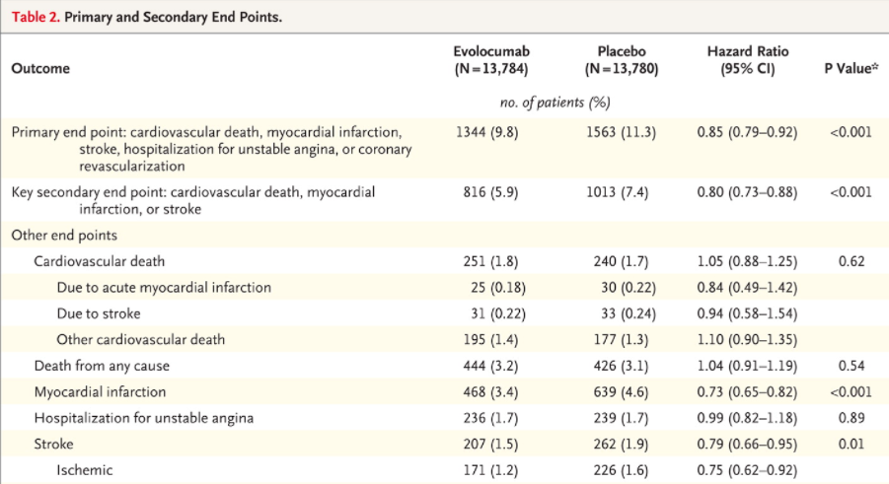

Note: myocardial infarction is a heart attack, unstable angina is almost a heart attack, coronary revascularization would imply a coronary stent placement or bypass surgery.

- What is the difference in the definition of the “Primary end point” and the “Key secondary end point”? Which end point do you prefer? Why? [2]

- In the evolucomab group there were 816 key secondary endpoints and 251 cardiovascular deaths. In the placebo group there were 1013 key secondary endpoints and 240 cardiovascular deaths. How could the placebo group have fewer cardiovascular deaths but more key secondary endpoints? Is the difference in the composition of the key secondary endpoints a chance finding? Explain. [2]

- If one considers estimates within the 95% confidence interval to be consistent with the study results, what is the lowest number needed to treat for 2 years to prevent one death from any cause consistent with the study’s results? [2]
(Note that we have provided the Stata output.)

. csi 444 426 13340 13354

| Exposed Unexposed | Total
-----------------+------------------------+------------
Cases | 444 426 | 870
Noncases | 13340 13354 | 26694
-----------------+------------------------+------------
Total | 13784 13780 | 27564
| |
Risk | .0322113 .0309144 | .0315629
| |
| Point estimate | [95% Conf. Interval]
|------------------------+------------------------
Risk difference | .0012969 | -.002831 .0054248
Risk ratio | 1.041951 | .9141891 1.187568
Attr. frac. ex. | .040262 | -.0938655 .1579432
Attr. frac. pop | .0205475 |
+-------------------------------------------------
chi2(1) = 0.38 Pr>chi2 = 0.5380

- Regardless of your answer to (a) calculate the relative risk reduction for evolocumab therapy in comparison to placebo for the “Key secondary end point”. [2]

- Calculate the absolute risk reduction for evolocumab therapy in comparison to placebo for the “Key secondary end point”.[2]

- Calculate the number needed to treat for 24 months to prevent one “Key secondary end point”[2]

- Your clinic patient who recently had a myocardial infarction and is already on a statin called pravastatin (40mg/day) wants to take evolocumab. His insurance is unwilling to cover this new medication and he will have to pay out of pocket. Interestingly, your patient happens also to be an economist and is curious as to the financial burden of such a novel medication. Evolocumab is an injectable monoclonal antibody that is estimated to cost $14,350 for an annual set of injections. What is the cost of preventing a “Key secondary end point” at 24 months? [2]

- The PROVE-IT TIMI 22 Trial compared your patient’s statin, pravastatin 40mg/day, to a different statin, atorvastatin 80mg/day, in an even higher risk population.
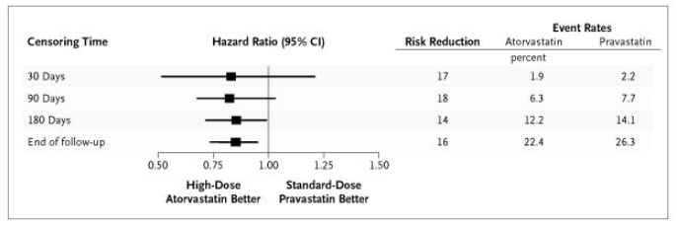

For purposes of this question, assume that your patient’s risk of a “Key secondary endpoint” is the same as in the placebo group of the 2017 FOURIER Trial (Table 2 in the stem of this problem), but the relative risk reduction at “End of follow-up” (24 months) in the PROVE-IT TIMI 22 Trial applies to your patient. How many people like your patient do you need to switch from pravastatin 40 mg/day to atorvastatin 80 mg/day for 24 months to prevent one “Key secondary endpoint” [2]

g) (EXTRA CREDIT) From GoodRx.com: Pravastatin = $11.69 for 30 days; Atorvastatin = $11.15 for 30 days. What is the cost per “Key secondary endpoint” prevented at 24 months of switching from Pravastatin to Atorvastatin? [+2 EC]

F9. PCI for Angina (Based on a problem submitted by Jessie Carr) [10 points +2 EC]
Clinical background: In the context of this question, “angina” refers to chest pain caused by lack of blood supply to the heart muscle resulting from a blockage or narrowing of an artery. The arteries to the heart muscle are called “coronary arteries”.
Al-Lamee et al. (Al-Lamee, Thompson et al. 2017)recently published the results of the ORBITA trial to study percutaneous coronary intervention (PCI), which involves threading a catheter through a groin artery and placing a stent in one or more coronary arteries, vs. a placebo procedure for angina relief. While PCI has been widely used for angina for decades, there have been no controlled trials showing it works. The authors randomized 200 patients with stable angina and blockage in a single coronary vessel to PCI or placebo (sham procedure) after an intensive medication optimization phase. Six weeks later, they assessed numerous endpoints related to heart function and exercise. Their primary endpoint was exercise time, i.e. how many seconds the subjects could exercise on a treadmill before needing to stop due to symptoms or blood pressure changes or EKG abnormalities.
- An excerpt from Table 3, showing results for the primary endpoint is pasted below. For each of the following statements, indicate if it is true or false and explain your answer. Again, the (s) after “Exercise time” stands for seconds.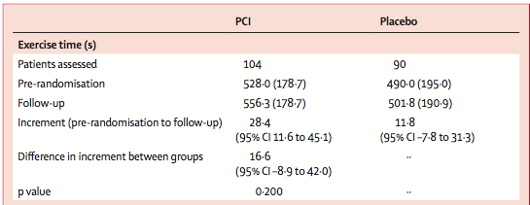
- The difference in increment between groups suggests that the number needed to treat (for each one who benefits over 6 weeks) is about 6. [2]
- P= 0.200 indicates that there would be a 20% chance of observing a between-groups difference in the increment of exercise time at least as large as was observed in this study if the true between-group difference were zero (i.e., if PCI had the same effect as the sham procedure). [2]

- The increment in exercise tolerance time in the PCI group compared to placebo was statistically significant at α = 0.05. [2]

- About 95% of those randomized to PCI had an increase in their exercise tolerance between 11.6 seconds and 45.1 seconds. [2]
Hint: Recall that the 95% confidence interval is the sample mean ± 2×SEM, where SEM = Standard Error of the Mean. SEM = sample standard deviation / √N . where N = sample size.

b. A press release from the Society for Cardiovascular Angiograpy and Interventions (SCAI) includes the following:

“We applaud the investigators for their innovative use of a sham procedure, but we’re concerned about the reliability and interpretation of the findings. The number of patients studied was very small, so the study is far from conclusive. The primary endpoint used, exercise tolerance, is imprecise and very subjective: patient tolerance of exercise normally varies from week to week, so differences of a few seconds in exercise tolerance are hard to interpret,” said SCAI President Kirk N. Garratt, MD, MSc, FSCAI. “Despite this, the improvement in exercise time among PCI patients was almost 2.5 times greater than in sham patients, suggesting PCI led to incremental improvement."

- Dr. Garratt is suggesting that the study was underpowered. We don’t know what a clinically significant difference in exercise time is. Let’s assume that it is 30 seconds. Assuming a non-informative prior probability (which means you can rely on the confidence interval), did the study have sufficient power to rule out an effect size of that magnitude? Explain. [2]

- Do you agree Dr. Garratt’s critique of the primary endpoint (how many seconds the subjects could exercise on a treadmill before needing to stop due to symptoms or blood pressure changes or EKG abnormalities)? Why or why not? [+2 EC]

References:
REFERENCES

Al-Lamee, R., D. Thompson, H. M. Dehbi, S. Sen, K. Tang, J. Davies, T. Keeble, M. Mielewczik, R. Kaprielian, I. S. Malik, S. S. Nijjer, R. Petraco, C. Cook, Y. Ahmad, J. Howard, C. Baker, A. Sharp, R. Gerber, S. Talwar, R. Assomull, J. Mayet, R. Wensel, D. Collier, M. Shun-Shin, S. A. Thom, J. E. Davies, D. P. Francis and O. investigators (2017). "Percutaneous coronary intervention in stable angina (ORBITA): a double-blind, randomised controlled trial." Lancet.
Higgins, T. L., D. Teres, W. S. Copes, B. H. Nathanson, M. Stark and A. A. Kramer (2007). "Assessing contemporary intensive care unit outcome: an updated Mortality Probability Admission Model (MPM0-III)." Crit Care Med 35(3): 827-835.
Jemal, A., S. A. Fedewa, J. Ma, R. Siegel, C. C. Lin, O. Brawley and E. M. Ward (2015). "Prostate Cancer Incidence and PSA Testing Patterns in Relation to USPSTF Screening Recommendations." JAMA 314(19): 2054-2061.
Lee, J. J., R. J. Colman, P. D. Mitchell, M. L. Atmadja, A. Bousvaros and J. R. Lightdale (2011). "Agreement between patient- and physician-completed Pediatric Ulcerative Colitis Activity Index scores." J Pediatr Gastroenterol Nutr 52(6): 708-713.
Leo, M. M., B. K. Langlois, J. R. Pare, P. Mitchell, J. Linden, K. P. Nelson, C. Amanti and K. A. Carmody (2017). "Ultrasound vs. Computed Tomography for Severity of Hydronephrosis and Its Importance in Renal Colic." West J Emerg Med 18(4): 559-568.
Sabatine, M. S., R. P. Giugliano, A. C. Keech, N. Honarpour, S. D. Wiviott, S. A. Murphy, J. F. Kuder, H. Wang, T. Liu, S. M. Wasserman, P. S. Sever, T. R. Pedersen, F. S. Committee and Investigators (2017). "Evolocumab and Clinical Outcomes in Patients with Cardiovascular Disease." N Engl J Med 376(18): 1713-1722.
Solari, L., A. Soto, J. C. Agapito, V. Acurio, D. Vargas, T. Battaglioli, R. A. Accinelli, E. Gotuzzo and P. van der Stuyft (2013). "The validity of cerebrospinal fluid parameters for the diagnosis of tuberculous meningitis." Int J Infect Dis 17(12): e1111-1115.
Torres-Russotto, D., W. M. Landau, G. W. Harding, B. A. Bohne, K. Sun and P. M. Sinatra (2009). "Calibrated finger rub auditory screening test (CALFRAST)." Neurology 72(18): 1595-1600.
Turner, D., A. R. Otley, D. Mack, J. Hyams, J. de Bruijne, K. Uusoue, T. D. Walters, M. Zachos, P. Mamula, D. E. Beaton, A. H. Steinhart and A. M. Griffiths (2007). "Development, validation, and evaluation of a pediatric ulcerative colitis activity index: a prospective multicenter study." Gastroenterology 133(2): 423-432.
Ystrom, E., K. Gustavson, R. E. Brandlistuen, G. P. Knudsen, P. Magnus, E. Susser, G. Davey Smith, C. Stoltenberg, P. Suren, S. E. Haberg, M. Hornig, W. I. Lipkin, H. Nordeng and T. Reichborn-Kjennerud (2017). "Prenatal Exposure to Acetaminophen and Risk of ADHD." Pediatrics 140(5).

