Molecular and Genetic Epidemiology
Assignment 3
Answers

C. Problems

1. Suppose we are considering a Mendelian fully penetrant autosomal trait. If two recessive parents have the disorder, than what, if anything, can you say about their children? [Since recessive, and both parents have the trait, then both parents are homozygous for the deleterious allele, mother-father: AA-AA. Thus so must the offspring must also be homozygous for the deleterious allele, AA, and hence they must also have the trait.] What if the trait were dominant? [i.e., what if both parents still have the trait, but now it is dominant? Then we could not say for certain. If both parents are heterozygous affecteds (Aa-Aa), an unaffected offspring (aa) is possible. If one or both parents are homozygous affecteds (AA-Aa or AA-AA), then the offspring will have at least one copy and be affected (if the parents are AA-Aa, then the child has one or two copies, and if AA-AA the child will have two copies).] Now, suppose a child has a recessive trait, what, if anything, can you say about their parents? [Since the child is AA, we know they obtained an A allele from both parents, and so both were at least carriers of the allele, but we cannot say if they were homozygous (e.g., AA, and hence affected) or heterozygous (e.g., Aa, and hence not affected).] What if it were dominant? [i.e., the child has the trait, but it is now a dominant trait. Then we know that the child is either AA or Aa. At the very least, they got a deleterious allele from one of the parents, and hence that parent is affected. It's possible the other parent could be affected as well, but not necessarily so.]

2. What can you say about the following families – are they dominant (assuming fully penetrant disease), recessive (assuming fully penetrant disease), neither dominant nor recessive (assuming fully penetrant disease), or impossible to tell?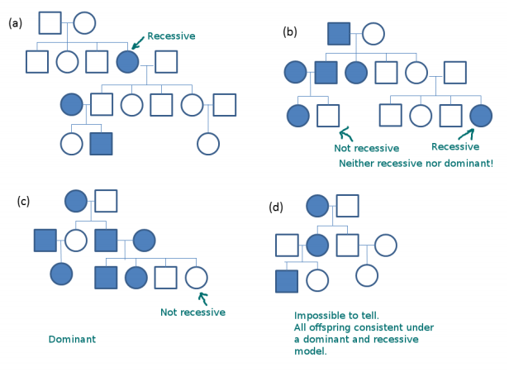

3. Assume that a case/control study has been conducted and a SNP (X) genotyped (with 0, 1, or 2 risk alleles). Compute the odds ratios for the table below and the corresponding confidence intervals. Compute chi square tests for codominant, dominant and recessive modes of inheritance. Discuss the results in terms of plausibility of a model.

X=0 X=1 X=2
Cases 500 350 120
Controls 521 270 130

Note: to get the OR and the CI in STATA, one can use:
. cci (# exposed cases) (# unexposed cases) (# exposed controls) (# unexposed controls)

Co-dominant model
 | X_0 | X_1 | X_2 | Total
Case | 500 | 350 | 120 | 970
Control | 521 | 270 | 130 | 921
 | 1021 | 620 | 250 | 1891
Odds Ratios | 1 | 1.35 | 0.96
 |  | Overall Expected
 | 523.7 | 318.0 | 128.2
 | 497.3 | 302.0 | 121.8
Chi-square p-value |  | 7.1E-03
Dominant model
 | X_0 | X_1 | X_2 | Total
Case | 500 | 470 | 0 | 970
Control | 521 | 400 | 0 | 921
 | 1021 | 870 | 0 | 1891
Odds Ratios | 1 | 1.22
 |  | Overall Expected
 | 523.7 | 446.3 | 0.0
 | 497.3 | 423.7 | 0.0
Chi-square p-value |  | 2.8E-02
Recessive model
 | X_0 & X_1 | X_2 |  | Total
Case | 850 | 120 | 0 | 970
Control | 791 | 130 | 0 | 921
 | 1641 | 250 | 0 | 1891
Odds Ratios | 1 | 0.86
 |  | Overall Expected
 | 841.8 | 128.2 | 0.0
 | 799.2 | 121.8 | 0.0
Chi-square p-value |  | 2.6E-01
Based on the test results and the trends in the OR it seems heterozygous disadvantage is a plausible model.

