Molecular and Genetic Epidemiology
Assignment 4
Due by noon on Monday before next class

A. Textbook

Read Austin chapter 9.

B. Designing your own mini-array for a gene using LD-LINK

We are going to explore creating the part of a GWAS array to tag variants in the LDLR gene, or you may use whatever is your favorite gene (e.g., the top hit from part C if you like), but you will have to get the rs #’s for that gene which can be a bit more work. These are going to be very open-ended questions with the goal to make you think more about the problem. Please do not get frustrated if it does not seem like there is a clear answer (there isn’t, as there never is in research either).

Think back to how you characterized your gene in the last homework. What part of this gene might you want to try to capture and why?

[ANSWER]

How would multiple gene transcripts affect any of your thoughts?

[ANSWER]

For simplicity here, we’ve decided that we want to capture the entire gene. What are the start and end positions (and in what build) of the gene (hint, ucsc genome browser, or 1000 genomes browser)?

[ANSWER]

For this next piece, you can either

A. Recommended: Open the ldl.txt file and copy the rs #’s in it.

OR

B. If you are really wanting to have a challenge / you can even just try a little bit of this to get the flavor of it / really, just don’t worry about this at all, no really, don’t worry about it:
Go to the 1000 Genomes Project Browser (http://grch37.ensembl.org/Homo_sapiens/Info/Index). Search for your gene (e.g., LDLR). Click on the result. Click on the  icon, choose a feature file csv output format, go with forward strand, and enter an upstream/downstream value if you wish. Further go ahead and only use variants in this file that have rs #’s for simplicity (there will be a lot that do not, these will tend to be those with lower frequencies; LD link cannot handle these, though you might want to in practice). You will have to find a way to extract these rs #’s, essentially like the ldl.txt file that we provide.

Now navigate to the LDlink SNP clip page
https://analysistools.nci.nih.gov/LDlink/?tab=snpclip
and paste the rs #’s in, following the following instructions as depicted here:

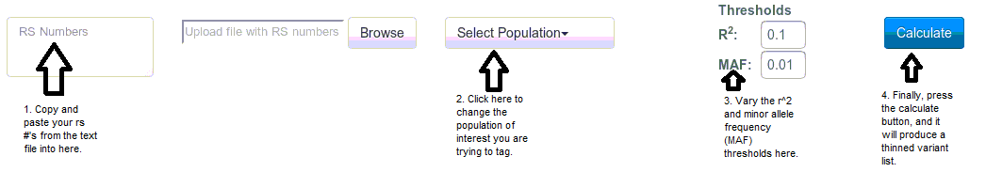

First try EUR (European ancestry; click on the “selected” box) with r²=0.8 and MAF=0.05. How many variants do you need?

[ANSWER]

How many variants do you need if you drop MAF=0.01? Back to MAF=0.05, what if r²=0.3? Why does this happen?

[ANSWER]

Back to r²=0.8 and MAF=0.05. How many variants are necessary for the AFR, AMR, EAS, and SAS populations? Why does this happen?

[ANSWER]

What are some tradeoffs of each of these designs?

[ANSWER]

C. UKB Project – A Manhattan and Q-Q plot for your disease

Produce/download Manhattan and Q-Q plots for your disease, via one of the two options:

The Lee group at Michigan has uploaded their GWAS results to:
https://www.dropbox.com/sh/wuj4y8wsqjz78om/AAACfAJK54KtvnzSTAoaZTLma?dl=0

Or you can use the Stanford Biobank Engine (seems to require a google account):
https://biobankengine.stanford.edu/search

Paste in the Q-Q plot below.

[ANSWER]

How does the Q-Q plot look?

[ANSWER]

Paste in the Manhattan plot below.

[ANSWER]

Roughly how many unique loci (i.e., unique jets of points, this is not a well-defined term) does there appear to be?

[ANSWER]

D. Howework Problems – Revisiting GWAS QC

1. One of the first steps in running a genome-wide association study (GWAS) is doing quality control to remove indivduals and SNPs that are bad. We are showing you a small excerpt – what would you do with the following individuals and why?
[ANSWER]
2. Again, we show you a small excerpt. Which of the following SNPs and why? Recall for the HWE test, the null is that they are in Hardy-Weinberg equilibrium, which is a good thing.
[ANSWER]
3. Why do we typically run a GWAS adjusting for principle components?
[ANSWER]
4. Look at the following QQ-plot. The inflation factor is lambda=1.001. Does it look ok?
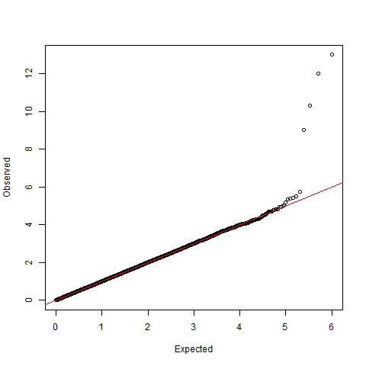
[ANSWER]
5. Suppose an excerpt of your SNPs were the following. Are any of them significant? (Assume a bonferroni correction of 0.05/1,000,000=5x10⁻⁸). If it is, write out, in words, what the OR means, if this is on the additive genetic scale. Also, if it is, what gene is it in?
[ANSWER]
6. Look at the QQ-plot. The smallest p-values observed are the ones along the y-axis; they are sorted by their -log_10 p-values. This means that the highest SNP has p-value 1x10⁻¹³, the next has p-value 1x10⁻¹², then 1x10⁻¹¹, then 1x10⁻⁹, before it goes to roughly noise. Suppose I told you that these SNPs were, in fact, all very close to each other. Do you think that I have found multiple different loci, or do you think that I found just one locus, and why (it's possibly both)? [Hint: think about LD.]

[ANSWER]

