Epi 218 Lab 5
Second Access SQL Lab

Filtering by Form,

Queries, and Reports
(Expected Time: 50 minutes)

In Lab 4, you created a database with two dynamic tables and one static lookup table, and you entered information from paper data collection forms into the two dynamic tables – both directly and via a form/subform. In this lab, you will make a copy of an existing database and use it to filter data by form. You will also learn how to create a query and a report based on that query. Finally, you will learn to import new subject records into the database and append them to the subject table.

This lab is associated with an online CLE quiz. For your notes, the quiz questions are also on the last 2 pages of these instructions, but please make sure to transcribe you answers into the online CLE quiz. At two points in the quiz, you are asked to upload a file reporting on subject counts by race. The first file is made before importing a new group of subjects, and the second file is made after the import. The counts will be therefore be different.

One way to get to the syllabus site:
- Make a new tab in IE
- Go to “courses.ucsf.edu”
- Search for "epi 218."

Objectives
- Filter by form.
- Create a query.
- Create a report based on the query.
- Import an Excel spreadsheet containing new subject records.
- Append (INSERT) new subject records to the subject table.

Apply “Filter by Form” on the subjects in a copy of the Infant Jaundice Study database

- Log into MyResearch. (It is also possible to do this lab on your local hard drive if you have a Windows computer with Microsoft Office Professional installed.) Get a copy of the file “InfantJaundiceStudyLab5.accdb” from the course website (leave the website open in your browser, as you’ll need to download a second file later in the lab). (Remember, all files with real patient data should be on your MyResearch drive, which is secure and backed up.) Rename your copy (call it “InfantJaundiceLab5Lastname.accdb”), and double-click on your copy to open it.
- A “Main” form opens. (If you see a security warning with an option to “Enable Content,” enable content now.) Click on the button that says “Database Master Form”. This button is on the “Main” form and opens the “master” form showing all the subjects in the database with “excluded/non-excluded” status, “hyperbili” (yes/no) and “status” within the study protocol, among other fields.
If the form doesn’t open, it is because Access is blocking the database code. There will be a “Security Warning” below the “Ribbon” near the top of the page. Click on “OptionsEnable this content” and try again. (If you get asked, “Make this a trusted document?” choose “Yes”.)
- A record count appears at the bottom of the “Master” form’s window.

Quiz: How many subject records are there in the database?

- We will learn a little about filtering data using a form; we will limit the master list to those subjects who are still included in the study. In the “HomeSort & Filter” section of the Ribbon, click on the “Advanced” button and select “Filter by Form”.

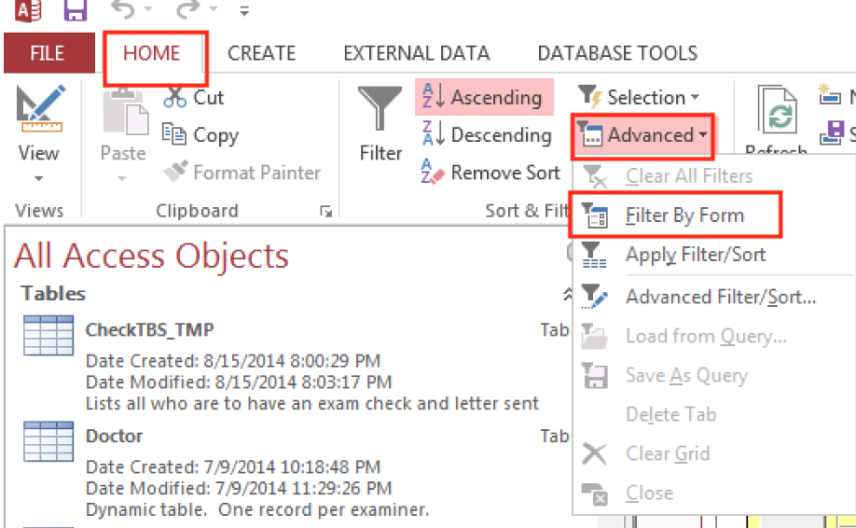
- The form you just had open will show but will be blank. This is used to enter the criteria needed for the filter.
- On the filter form, check and uncheck the “Excluded” box. You want to filter for records where “Excluded” is false. Apply the filter by clicking “Toggle Filter” in the “Sort & Filter” section of the Ribbon. Notice that the funnel icon appears at the bottom of the form, showing that this form has an applied filter.
  - Gray means “do not filter records based on this field”
  - Checked means “display record only if this field is true”
  - Unchecked means “display only if this field is false”.
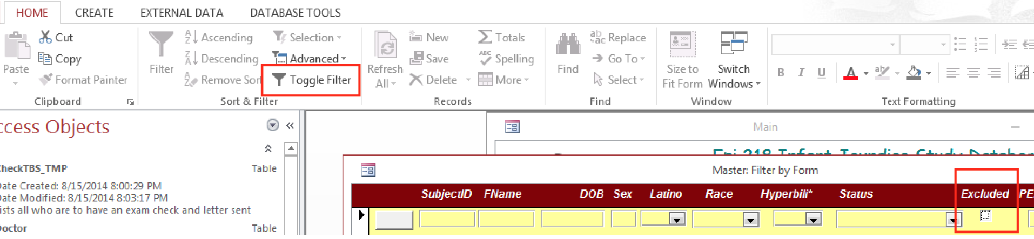

Quiz: How many included (“Excluded”=false) subjects are there in the database?

Design tip: Use checkbox controls like the control for “Excluded” sparingly if at all.

- Add a second filter criterion. Again, click on “Advanced” and select “Filter by Form”, but in addition to requiring “Excluded” to be false, require “Hyperbili” to be “Yes”.

Quiz: How many included subjects were exposure-positive (hyperbili = yes)?

- Quiz: List the SubjectIDs and first name(s) of included exposure-positive subject(s) with race categorized as “Other”. For the online quiz, you just need the SubjectIDs, sorted in ascending order. To leave a field blank, enter “999999” (six nines).

________________________________________________
_________________________________________________
_________________________________________________

Filtering by form is easy to understand and extremely limited. In Part B, we will introduce a much more powerful tool: SQL queries.

- Now, remove the filter by de-selecting “Toggle Filter”.
- Close the “Master” form. Close the “Main” form. Do not close the database or Access.
- The Navigation Pane is on the left side of the screen. (If it is closed, click on the “>>” button. The F11 key also works.)

Design a Simple Query
Access uses SQL (Structured Query Language —pronounced “sequel”), the universally accepted tool for querying relational databases. Other SQL-based programs include Oracle, MySQL, MariaDB, SQL Server, and PostGreSQL. Access is the only integrated desktop database that is relational and SQL-based, and it provides an elegant graphical query design tool that enables you to write SQL statements without knowing any command-line SQL!

- In our first query, we will simply list all subjects with Race categorized as “Other” (RaceCode=8). We are no longer restricting this to included exposure-positive subjects.
- On the Ribbon’s “Create” tab, click “Query Design.” In the “Show Table” dialog box, add the “IJSSubject” table and close the dialog box. You are now looking at the Access Query Designer, the nice graphical tool that obviates the need for you to learn command-line SQL.
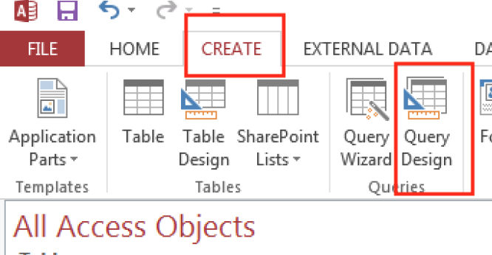

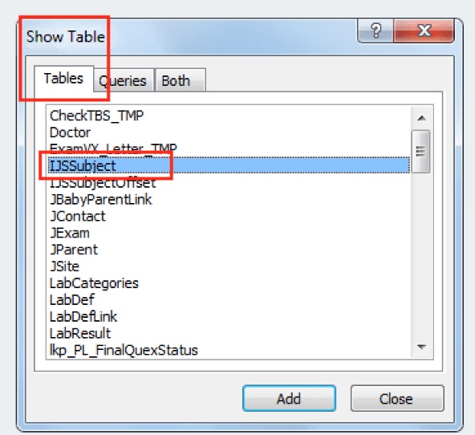
- The upper panel should show you the “IJSSubject” table. Below you see a grid with rows labeled “Field”, “Table”, “Sort”, “Show”, and “Criteria”.
- Move the “Race” field from the “IJSSubject” table to the “Field” row of the grid by either double-clicking on it or dragging and dropping.
- Move the asterisk (“*”) from the “IJSSubject” table onto the grid by either double-clicking on it or dragging and dropping. (The asterisk appears at the very top of the table, before any of the named fields.) This means you have chosen all the fields from the table to display in the query.
- Limit “Race” to “Other” by typing “8” (no quote marks) in the criteria row of the grid under the “Race” field. (If you check the “lkpRace” table, you will see that “8” corresponds to “Other”.)
- Uncheck the “Show” box under “Race”. (This field will already be displayed as part of the asterisk “*”; there is no reason to display it twice.)
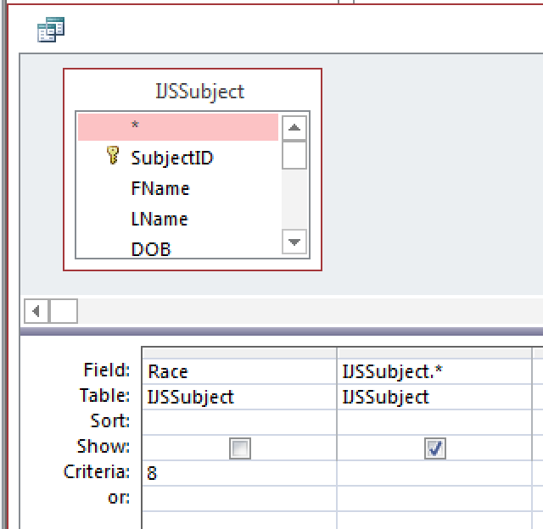
- From the Design option on the ribbon, select the “Datasheet View” (View Datasheet View) or click the “Run” button (which looks like an exclamation mark).
- Make sure the query displays the same included exposure-positive subject(s) as you found in A-8, Q4 above, plus any other potential subjects with Race = Other.
- Quiz: If you created the query correctly, you should see at least one additional study subject besides the subject(s) you identified earlier. His name is Christopher Boone (SubjectID #37330). Examine his data in the query. Which of the following accurately describes this subject?
- He was included in the study but was not exposure-positive (no neonatal hyperbilirubinemia).
- He was included in the study and was exposure-positive (yes neonatal hyperbilirubinemia), but his Race wasn’t “Other”.
- He was excluded.
- None of the above
- View the SQL (Structured Query Language) for your query by choosing HomeViewSQL View. Access created this SQL statement from the dragging-and-dropping that you did in the Visual Query Designer. The SQL statement is the command that actually specifies the query results you get. Copy and paste the SQL here. (In Windows, Copy is Control-c and Paste is Control-v.)

Quiz: SQL to select all subjects with Race = “Other”

_________________________________________________
Note: You just pasted a SQL command that should look something like
“SELECT [fields] FROM [table] WHERE [conditions]”. You did not paste data. A SQL SELECT Query is not data; it is a recipe for filtering, sorting, and combining existing data from the tables in your database, and as we will see later, for doing calculations based on existing data. People who use statistical packages have trouble understanding that a SQL query simply displays data from one or more existing tables; it does not create or store a new table. If the data in the underlying table (e.g., IJSSubject) gets updated, re-running the query will display the updated data.

- Close the query and save as “qryLastnameOtherSubjects”. (The only reason to save it is because you might want to come back to it at some point. You will not need to turn it in.)

Build a “SELECT/GROUP BY” Query for a Report

- Now you want to report on the numbers of included subjects by race. You will create a new SELECT Query using the SQL “GROUP BY” statement as the basis for your report.
- Create a new query in “Design View”. In the “Create” ribbon, click on “Query Design” again. Next, in the “Show Table” dialog box, add the “IJSSubject” table and close the dialog box. Once again, you are looking at the Access Query Designer.
- Move the “Race”, “SubjectID”, and “Excluded” fields from the “IJSSubject” table to the “Field” row of the grid (much as you did before). Be sure to have “Race” on the left, “SubjectID” in the middle, and “Excluded” on the right in the grid.
- This time, you do not want a list of the records; instead, you want a breakdown of the number of included subjects by race. To get this, click “Design → ∑ Totals”. You will see a new “Totals” row in the query design grid.
- In the “Totals” row of the query design grid, leave “Group By” in the “Totals” row of the “Race” column. (This will summarize the data for each race in the study.)
- In the “SubjectID” column, change “Group By” to “Count”. (This will count the number of subjects for each race.)
- In the “Excluded” column, change “Group By” to “Where” and type “False” in the “Criteria” row. Uncheck the ‘Show’ box in the “Excluded” column. (This will limit the query to subject records for which the subject was not excluded.)

- To view the results of your query, click “Design” on the ribbon and either change to datasheet view or “run” the query (by clicking on the exclamation mark “!”).

  - You may get an error box telling you “Infant Jaundice Study Lab 5 can’t display the field for which you entered Where in the Total Row”. If you get this error dialog, click “OK”, go back to Design view, and make sure that the ‘Show’ box for “Excluded” is not checked.
Quiz: How many subjects had the Race field blank? ____________________
(More on this later.)

- Quiz: As in the previous section, view your SQL code by choosing the “SQL View”.

SQL to count the included subjects by Race

_________________________________________________
Note the “Group By” clause at the end of the SQL statement.

- Close and save the query as “qryLastnameCountsByRace”.

Create a Report

The Navigation Pane on the left side of the Access window can display just some of your Access objects (Tables, Queries, Forms, Reports) or all of them. We suggest clicking on the gray bar at the top of the Navigation Pane and setting it to display “All Access Objects” by “Object Type” (of note, this may already be selected):

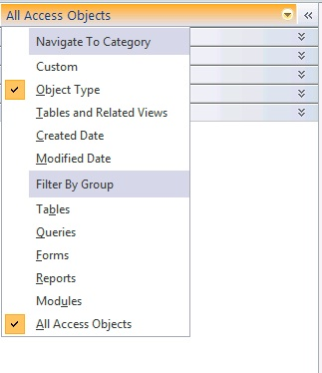
Then, collapse all of the categories until you are looking for an object in a particular category.

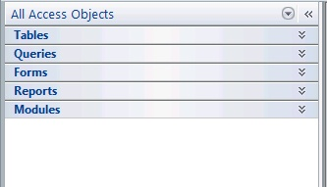

- In the Navigation Pane, select the query you just created (qryLastnameCountsByRace) and be sure it is highlighted.
- On the Ribbon’s “Create” tab, select “Report.” Your report will appear in Report View.
- What if you want to insert a row in the report to total the subjects over all the races?
- Switch to Design View.
- By default, Access put a report control containing “=Count(*)” in the “Report Footer”. This just counts how many distinct races exist in the dataset (there are five of them). You want to count the total number of subjects in the dataset instead.
- Click on the control. In the left-hand “Property Sheet” panel, change the ‘Control Source’ (2nd row) from “=Count(*)” to “=Sum([CountOfSubjectID])”.
- The Race control displays the numeric code for race. One way to have it display the text instead is to change the properties of the control. Click on the control for Race. In the property sheet panel’s Format tab change the “Column Widths”.
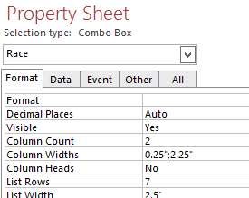

Set the first column width to 0 instead of 0.25.

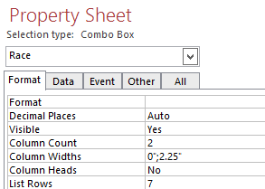

- Change back to Report view.
- Note what else you would like to change about the report. For example, you probably want to change the label containing the report title from “qryLastnameCountsByRace” to “Subject Counts by Race” and move the total number of subjects so that it lines up under the subject counts by race. You probably also want to add a label such as “Number of Subjects” to the control you just modified. To do this, make sure you are in Design View. In the Report Design Tabs > Design ribbon, choose the ‘label’ button (it looks like Aa). Next, use the cross cursor to draw out where you would like your label to appear on the report.
- Switch back to Design View and make these changes. You will have trouble moving the “total number of subjects” control independently of the rest of the first column. That is because Access puts it in a “Control Layout” by default. The easiest thing is to remove the layout as follows:
- Click on the control you want to move; on the Ribbon’s “Arrange” tab in the “Table” section, click “Remove Layout.”
- Of note, you can always check how your report looks by switching back and forth between the Design View and the Report View
- Now you can move the total control independently and line it up under the second column. Try to make the report look good enough to submit as part of a quarterly submission to the NIH or another funding agency. (But it’s okay to have a row where “Race” is blank.)
The NIH has adopted the 1997 OMB standards for collecting and presenting data on race and ethnicity. The 1997 OMB revised minimum standards include two ethnic categories (Hispanic or Latino, and Not Hispanic or Latino) and five racial categories (American Indian or Alaska Native, Asian, Black or African-American, Native Hawaiian or Other Pacific Islander, and White).
The original registration system that provided these records did not follow those standards. Instead, it categorized “Hispanic/Latino” as a race. So, once we updated the ethnicity field, we had nothing to enter for race, since it was not one of the 5 OMB categories. Instead of categorizing these subjects as “Other” or “Unknown”, we just left the “Race” field blank.
- Once your report is in final form, save it as “rptLastnameCountsByRace”.
- If you would like a paper copy of your report, print it out. (Not possible in Mission Hall.) But to complete this assignment, you must save the report as an “rtf” (rich text format) file.
- Do this by selecting your report “rptLastnameCountsByRace” (not your query “qryLastnameCountsByRace”) in the navigation pane.
- From the Ribbon’s “External Data” tab, in the “Export” section choose “Word” (NOT “Word Merge”). (In Access 2010, you must select “More” to see the “Word” option.)
- Quiz: Name the file LastnameCountsByRace1.rtf. Upload this file within the CLE quiz (Question 9). You are about to import data on a new group of subjects. After the import, the subject counts will change, so be careful to save this file. Consider uploading it within the CLE quiz now.

E. Import Subject Records in an Excel Spreadsheet

- Suppose you receive an Excel spreadsheet from the health system’s registration system containing the subject-specific information on 124 additional study subjects born in 2012 and 2013 to include in the study. You need to import this Excel file and append the 124 subject records to the “IJSSubject” table.
- Obtain the Baby2012-13.xlsx file from the syllabus area of the course website. Note the folder name to which you saved the file.
- Import the file into the Access database. On the Ribbon’s “External Data” tab, in the “Import” section, choose “Excel”. Browse to “Baby2012-13.xlsx” and choose “Import the source data into a new table in the current database”. (This option may already be selected.) Click “OK” to continue.
- An “Import Spreadsheet Wizard” should open up. The spreadsheet you downloaded is structured nicely with columns and column headers that closely resemble a database table; because of this, the import wizard will have no problem detecting how the dataset is laid out. Keep clicking “Next” until you get to where it suggests letting Access add a primary key. Instead, select “Choose my own primary key” and specify “SubjectID” (this may already be selected). Then click “Next” and “Finish”. Close the Wizard without checking the “Save Import Steps” option.
- In the Navigation Pane, choose “Tables”. You should now be able to find and open a table named “Baby2012-13”. The table should contain records for 124 subjects born in 2012 and 2013. By sorting on the “hyperbili” column (click arrow on column header; sort largest to smallest), you can determine how many of the new subjects had neonatal hyperbilirubinemia (hyperbili = 1). (Note that a record count appears at the bottom of the window. If you click into a record, you can see where it is in the record count.)

Quiz: How many of the 124 study subjects born in 2012 and 2013 had neonatal hyperbilirubinemia (hyperbili = 1)? __________________

Close the “Baby2012-13” table without saving changes to the table design.

F. Append (INSERT) New Records to the Table of Study Subjects
You have now brought the new study subjects into the database, but you imported them to a new table; they are not yet in the database’s Subject table. In this step, you will add the records you just imported from Excel into the main subjects table by creating an “Append Query” (aka SQL “INSERT” statement) which copies records from one table to another.
- Create a new query in “Design View”. (“Create” tab, “Queries” section, “Query Design”) Add the “Baby2012-13” table that you just imported.
- Convert the query from a “SELECT” query to an “Append” query. (Append queries use the SQL “INSERT” command to add records to an existing database table.) On the Ribbon’s “Design” tab, in the “Query Type” section, choose “Append.” For “Table name” choose “IJSSubject,” because you want to append to the “IJSSubject” table. Click “OK” to continue.
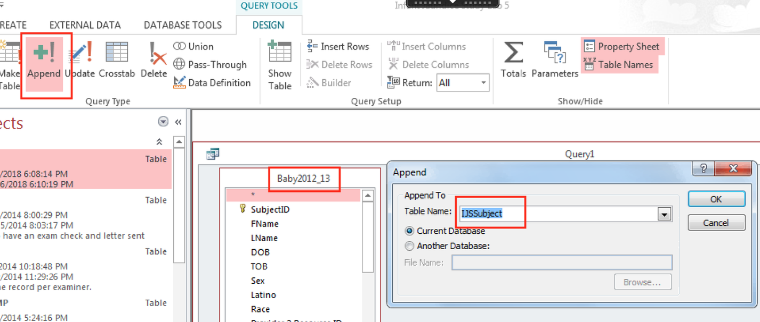
- Move the “*” from the table Baby2012_13 into the Field row of the Access Query Design grid, either by double-clicking or dragging and dropping. This means that you want to append all the fields from the “Baby2012-13” table to the “IJSSubject” table. (Fortunately, the field names from the spreadsheet match the field names in the database table; otherwise, you’d have to do a bit of work to rename the fields in this query.)
- Run the query by clicking on the exclamation mark “!” in the Design section of the ribbon. This should append 124 rows. (Note: If you get an error message saying that you can’t append the records due to key violations, then you already appended the new subject records. It is nice that Access won’t allow you to append them again, otherwise you might keep adding duplicate records to the dataset.)
- Display the SQL INSERT statement that you just executed (“SQL View”), copy it (Control-c), and paste (Control-v) into your worksheet or directly into the online quiz.

Quiz: SQL INSERT statement:
__________________________________________
__________________________________________

_________________________________________

- Close the query. Save it under qryLastnameBaby2012-13Append only so that it will be available if you need it later.

G. Re-Run the Report After Adding the New Records

- Re-run the report “rptLastnameCountsByRace” that you created in Part D of this lab. (In the Navigation Pane, view Reports, and double-click on rptLastnameCountsByRace”.)

Notice that the numbers have changed since the last time you ran the report. You did not have to change anything in the report design. It will summarize the data as updated. This is one of the beauties of database queries and reports; they are dynamic.

- Export it to an rtf file as you did in Part D, but this time name the rtf file “LastnameCountsByRace2.rtf”.

- Quiz: Upload “LastnameCountsByRace2.rtf” made after importing and the new records within in the CLE quiz, Question 12.

Lab 5 Worksheet

A. Filter by Form

3. How many subject records are there in the database? _____________

6. How many included (not excluded) subjects are there in the database?
_____________

7. How many included subjects were exposure-positive (hyperbili = yes)? __________

8. List the SubjectIDs and first name(s) of included exposure-positive subject(s) with race categorized as “Other”. For the online quiz, you just need the SubjectIDs, sorted in ascending order. To leave a field blank, enter “999999”.

_________________________________________________
_________________________________________________
_________________________________________________

B. Simple SELECT Query

10. Which of the following accurately describes Christopher Boone (SubjectID #37330)?

- He was included in the study but was not exposure-positive (no neonatal hyperbilirubinemia).
- He was included in the study and was exposure-positive (yes neonatal hyperbilirubinemia), but his Race wasn’t “Other”.
- He was excluded.
- None of the above

11. SQL to select all subjects with Race = “Other”

_________________________________________________

C. SELECT/GROUP BY Query

8. How many subjects had the Race field blank? ____________________

9. SQL to count the included subjects by Race
_________________________________________________

Create a Report

15. Upload the file “LastnameCountsByRace1.rtf” to the course syllabus site.

Import New Records

5. How many of the 124 study subject born in 2012 and 2013 had neonatal hyperbilirubinemia (hyperbili = 1)? __________________

F. Append (INSERT) New Records to the Table of Study Subjects

5. SQL INSERT statement:
__________________________________________

__________________________________________

__________________________________________

G. Re-Run the Report After Adding the New Records

2. To complete this assignment upload “LastnameCountsByRace2.rtf,” made after importing the new records, to the course syllabus site.

We wouldn’t normally include the subject’s name here, but this is a de-identified database. Christopher Boone is the protagonist in “The Curious Incident of the Dog in Nighttime” by Mark Haddon.

