Epi 218 Lab 6

Creating SQL Queries to Summarize Results and Export to Stata (or another statistical package)
(Expected Time: 55 minutes)

In this lab, you will use SQL queries to summarize your study results and export query results to a statistical analysis package. These instructions use Stata, but feel free to use another statistical package, such as SAS or SPSS.

Note #1: As with Labs 1, 3, and 5, this lab is associated with an online CLE quiz. We have provided a worksheet at the end of the lab that you may use to keep track of this lab’s “deliverables”, but please complete the online CLE quiz with your results, where indicated.

Note #2: Command vs Control -- In the Windows environment, even if you are using a remote desktop client on your Mac, copy is Control-C and paste is Control-V. On your Mac, copy is Command-C and Command-V. Some of us refer to the Command key on the Mac keyboard the "Propeller" key.

Objectives
- Create a query to summarize the study results for a continuous outcome.
- Export the results of a SELECT query to a statistical analysis package.
- Analyze the data.
- Repeat for a categorical outcome.

Download the completed database
For this portion of the assignment you will be using Microsoft Access. We recommend using Access on MyResearch (Mac users will have no choice). If you do use MyResearch, note that all your downloads will have to be carried out using a browser within MyResearch.
- Download InfantJaundiceDatabaseComplete.accdb from the course website, as you did with a different database in Lab 5. This new file contains the database after data collection has been completed. When you open the database, a “Main” form should automatically open.
- When you open the database, you may get a “Security Warning” just under the ribbon that says, “Certain content in the database has been disabled.” Choose “Options””Enable this content” or just click the “Enable content” button. See Lab 5 for more details.
- Close the “Main” form. (In Lab 5, you used the database forms to view and filter data. Now, you will use database queries to summarize the study results and export data to Stata.)

Create a query to summarize IQ by hyperbili

Create a new query in Design View. On the Ribbon’s “Create” tab, choose “Query Design”. You will now design a query to calculate statistics on IQ results grouped by hyperbili exposure.

Add the “IJSSubject” and “WPPSI” tables to the upper panel of the Access Query Designer. Close the “Show Table” box.

From the “IJSSubject” table, add the “Hyperbili” field to the query design grid either by double-clicking on it or by dragging and dropping it on the grid.

From the “WPPSI” table, add the “IQFullEntered” field to the grid. Repeat this 4 more times so you have 5 copies of the “IQFullEntered” field in your query. You will soon see why.

Make this a “Totals” (aka “SELECT/GROUP BY”) query using “Show/Hide—∑Totals” (located on the Ribbon’s “Design” tab).

In the “Totals” row of the query design grid, leave “Group By” in the “Hyperbili” column.

In the 5 “IQFullEntered” columns, change “Group By” to “Count”, “Avg”, “StDev”, “Min”, and “Max”. Your query should now look something like this:

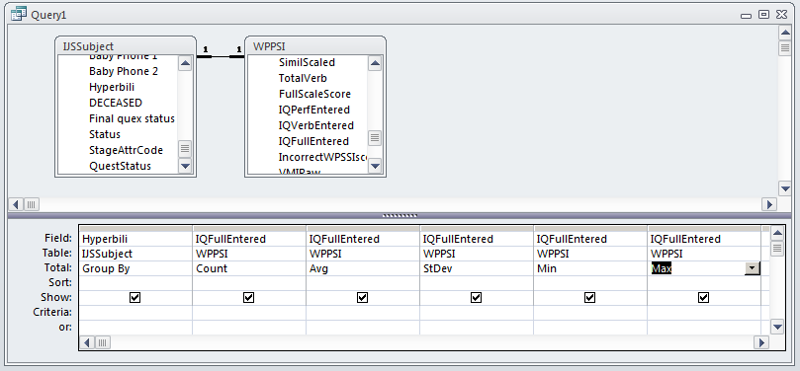

Switch from query design view to datasheet view. “Home” “View””Datasheet”.

You should see the same mean IQ results presented in Table 3 of the Newman NEJM paper.

Enter these results in table form into the worksheet at the end of this document or directly into the online quiz.

Save the query as “qryLastnameLab6Table3”.

View the SQL behind the query. Copy and paste the SQL into the worksheet or directly into the online quiz.
*If you are having trouble with the copy and paste functionality and are using a Mac, remember to use ‘CTRL-C’ and ‘CTRL-V’, not Command. If you are still having trouble, type the SQL statement directly into the worksheet/online quiz

(Knowing how to use the Access query design grid to build up a SQL statement may be useful to you in the future. Unfortunately, other RDBMS systems require you to type out your SQL statements. If you are forced to learn to write SQL, try
Rockoff, L. (2016). The language of SQL. Indianapolis, IN, Addison-Wesley Professional.)

Create a “view” (SELECT query) to export to Stata for analysis

- Create a new query in Design view. You will design this query to return a listing of all subjects, with the ID, exposure status and IQ score for each.
- Add the “IJSSubject” and “WPPSI” tables to the upper panel of the Access Query Designer. Close the “Show Table” box.
- From the “IJSSubject” table, add the “SubjectID” and “Hyperbili” fields to the grid.
- From the “WPPSI” table, add the “IQFullEntered” field to the grid.
- Make sure that the “Totals” row does NOT appear, because you will be exporting individual records, not grouping for analysis. (We are not asking for the SQL here, but in SQL terms this is a SELECT query without a GROUP BY clause.) Save the query created in Part C as “qryLastnameLab6C” in case you need it later.
- Switch from query design view to datasheet view. You should see as many records as there are subjects with measured IQ outcomes.
- With the query in datasheet view, highlight all the data by clicking the square at the top, left-most corner of the screen (next to the SubjectID column heading). Copy the data (“Clipboard” section “Copy” or Ctrl+C).
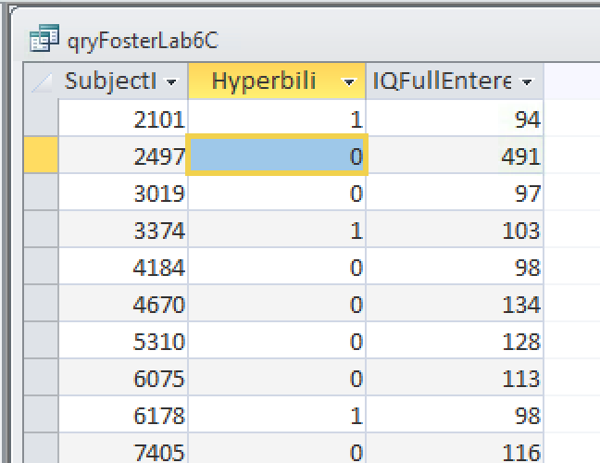

- Leave Access open, but minimize it so you can start working with your statistical package. Now you need to open Stata. Stata is available within MyResearch. Use StataSE because you do not need StataMP for this analysis. However, StataMP will work too.
- If you are using Access within MyResearch, consider using the copy of Stata within MyResearch, because you won’t be able to copy from Access in MyResearch and paste into Stata on your local drive. You will have to export to a csv or Excel file in MyResearch, download using MyTransfer, and then copy and paste into your local installation of Stata.
- In Stata, open the Editor Window (Window – Data Editor or Ctrl+8).

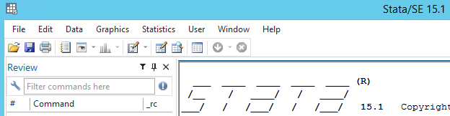

Paste the data into the data editor (“Ctrl+v” on a PC or Remote Desktop). If prompted by Stata, select the option to treat the first row as “Variable names.” Now close the Editor Window, and the Command Window should appear. You have successfully exported data into a statistical package. Again, you can’t copy from MyResearch and paste into Stata installed locally on your laptop.

D. Statistical Analysis (Continuous Outcome Measure)

You can now perform your analysis using the “ttest” command. Using the menus:

“Statistics””Summaries, tables, & tests””Classical tests of hypotheses””t tests (mean-comparison test). Click the option “Two-sample using groups” . “Variable name” = “iqfullentered”; “Group variable name = “hyperbili”; Press “OK.”

-- Or --

Using Stata command syntax:
ttest iqfullentered, by(hyperbili)
(Note: Stata—unlike Access—is case sensitive.)

Write two sentences summarizing the study results that would be appropriate for the “Results” section of an abstract. If you go to the worksheet at the end of this document you can simply fill in the blanks and choose one of the options (was significantly higher/was significantly lower/was not significantly different).

Enter these results directly into the online quiz.

The important question to answer is whether babies with neonatal hyperbilirubinemia, when evaluated at age 5 and compared with unexposed babies from the same birth cohort, had worse IQ scores, better IQ scores, or the same IQ scores. Note that the answer above includes group sizes, effect direction, effect size, variability of the outcome, and statistical significance or confidence intervals.

(In Access, close the query that you just saved as “qryLastnameLab6C.”)

E. Create a query to summarize neuro exam impression by hyperbili

We are now going to repeat the same process with the categorical outcome of the neurological exam. We could have written a query or “view” to display both the IQ field and the neuro result field in the same set of rows and columns. Because some subjects had IQ exams but not neuro exams and other subjects had neuro exams but not IQ exams, this requires a SQL join that we want to avoid. If you are curious, see the query called “MAK_IQ_NeuroExamImpression”.

- Return to the Access database that you minimized earlier. Create a new query in Design View. On the Ribbon’s “Create” tab, choose “Query Design”. You will design this query to give frequencies of neuro exam results, broken down by exposure.
- Add the “IJSSubject” and “NeuroExam” tables to the upper panel of the Access Query Designer.
- From the “IJSSubject” table, add the “SubjectID” and “Hyperbili” fields to the query design grid.
- From the “NeuroExam” table, add the “Overall5” and “Overall” fields to the grid. Make sure “Overall5” is to the left of “Overall”. (“Overall5” stores the code (1-4) for the overall impression of the neurologist. “Overall” stores the corresponding text and was included in the “NeuroExam” table unnecessarily; but it does make things more convenient for this lab.)
- Make this a “Totals” (aka “SELECT/GROUP BY”) query using “Show/Hide—∑Totals” (as you did in part B).
- In the “Totals” row of the query design grid, change “Group By” to “Count” in the “SubjectID” column. Leave “Group By” in the “Hyperbili”, “Overall5”, and “Overall” columns. It should look something like this:

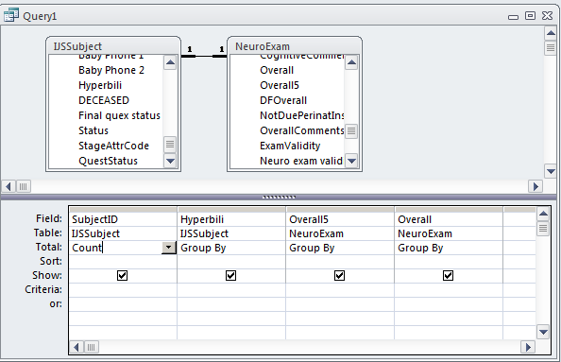

- View this query in Datasheet view to see how the data is presented so far. You can see the outcomes of neuro exams for both exposed and unexposed subjects, but the data could be presented more clearly.
- Return to Design view. Make this a “Crosstab” query using “Design—Query Type—Crosstab”.
- In the “Crosstab” row of the query grid, set “SubjectID” = Value (this is the count of subjects); “Hyperbili” = column heading; “Overall5” = Row Heading; “Overall” = Row Heading to make a query that looks like this:
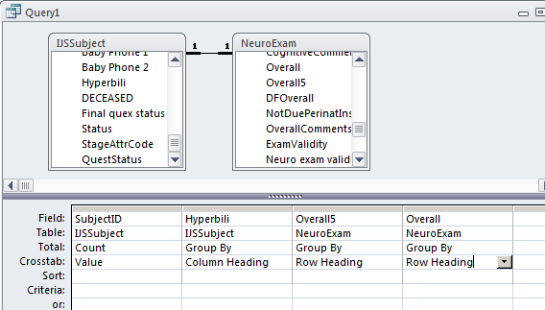

- Switch from query design view to datasheet view. “View””Datasheet View”.
- You should see the same neuro exam results presented in Table 4 of the Newman NEJM paper. Do you recall creating a pivot table in Excel to get similar results in Lab 3? Can you see any advantages or disadvantages to getting these results via an Access query?
- Save the query as “qryLastnameLab6Table4”.
- Optional: View the SQL behind the query. (We are not asking you to copy it.)
- Enter these results in table form into the worksheet or directly into the online quiz.

F. Create a “view” (SELECT query) to export to Stata for analysis

Another way of analyzing your data is to export mostly-raw data from Access to a statistical package like Stata. You will now repeat (and extend) the analysis from the last query by using this approach.
- Create a new query in Design view.
- Add the “IJSSubject” and “NeuroExam” tables to the upper panel of the Access Query Designer. Close the “Show Table” box.
- From the “IJSSubject” table add the “SubjectID” and “Hyperbili” fields to the query.
- From the “NeuroExam” table, add the “Overall5” and “Overall” fields to the grid.
- Also add the following field: NotNormal: -([Overall5]<>1)
  - You will need to type these characters manually into the “field” cell at the top of the first empty column on the grid. You will see the use of this field momentarily.
- Make sure that the “Totals” row does NOT appear, because you will be exporting individual records, not grouping for analysis. The query will look something like this:

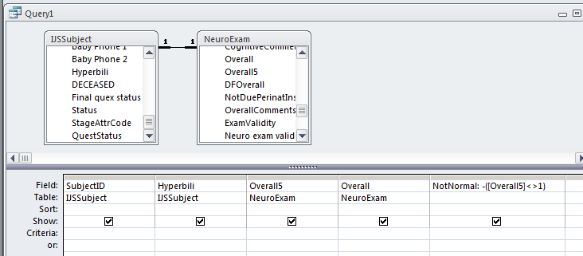

- Switch from query design view to datasheet view. You should see as many records as there are subjects with measured neuro exam outcomes.
- Note the “NotNormal” field. Make sure you understand what the values mean and how they’re related to the formula you typed into the NotNormal field. (If you’re curious: the minus sign in that formula was added because Access, unlike most SQL engines, stores a “True” value as -1. The minus sign simply converts -1 to 1, which is a more standard way of storing “True.”)
- With the query in datasheet view, highlight all the data by clicking the square at the top, left-most corner of the screen (next to the SubjectID column heading). Copy the data (“Clipboard” “Copy” or Ctrl+c )
- Leave Access open, but minimize it so you can start working with your statistical package. If Stata is still open, clear the Stata table and paste the new data into it. You can clear the stata table from the command line by typing ‘clear’ into the command line and hitting Enter. Otherwise, re-open Stata and paste in the new data. Remember to “treat the first row as variable names.”
- Now close the Stata Editor Window, and the Command Window should appear.

G. Statistical Analysis (Categorical Outcome Measure)

You can now perform your analysis using the “tab” command. You can do this using menus or using the command line.

Using the menus:

“Statistics””Summaries, tables, & tests””Frequency tables” ”two-way table with measures of association”. . “Row variable” = “overall5”; “Column variable” = “hyperbili”. Check the box “Pearson’s chi-squared” under “Test statistics”.
Check the box "within-column relative frequencies" under "cell frequencies"
Press “OK.”

Using Stata command syntax:

tab overall5 hyperbili, chi2 column
(Note: Stata—unlike Access—is case sensitive.)

Copy these results to the worksheet or enter them directly into the online quiz.

Specifically test the hypothesis that the proportion with “NotNormal” differs between the exposed and unexposed groups. Again, you can do this using menus or using the command line.

Using the menus:

“Statistics””Epidemiology and Related” ”Tables for Epidemiologists””Cohort Study Risk-Ratio etc”
“Case variable” = “notnormal”; “Exposed Variable” = “hyperbili”. Then click OK.

Using Stata command syntax:

cs notnormal hyperbili

Report the risk ratio of “NotNormal.” This is the risk ratio in the exposed group (with “hyperbili” = 1) versus the unexposed group and provide the 95% confidence interval.

- Use these results to complete the table in the worksheet, or enter the appropriate results directly to the online quiz.

Again, the important question to answer is whether babies with neonatal hyperbilirubinemia, when evaluated at age 5 and compared with unexposed babies from the same birth cohort, had worse neurologic outcomes, better neurologic outcomes, or the same neurologic outcomes.
This completes Lab 6. You now know how to create Access queries and export to Stata. Make sure you have completed the Lab 6 Quiz on the CLE Syllabus site.
EPI 218 Lab 6 Worksheet
This is to help you keep track of your answers, but please complete the online quiz.

Create a query to summarize IQ by hyperbili

Results of qryLastnameLab6Table3 query:

Hyperbili | Count | Avg | StDev | Min | Max
0
1

SQL for qryLastnameLab6Table3 query:

D. Statistical Analysis (Continuous Outcome Measure)

(Report real numbers to 1 decimal place, e.g. 105.9, not 105.93 or 105.)

WPPSI IQ scores were obtained on ________ (N) subjects at age 5 years, ____ exposed and _____ unexposed. The mean (+SD) IQ score in the exposed group, ____ (mean)+/- __ (SD) was statistically significantly higher/was statistically significantly lower/was not statistically significantly different from the mean in the unexposed group, ___._ (mean) +__._, (SD) -- difference _____ (95% CI ____ – _____).

Create a query to summarize neuro exam impression by hyperbili

Results of “qryLastnameLab6Table4” query:

Overall5 | Overall | 0 | 1
1
2
3
4

G. Statistical Analysis (Categorical Outcome Measure)

Fill out this table or paste from Stata:

Neurological Outcome | No Neonatal Hyperbilirubenima  n (%) | Yes Neonatal Hyperbilirubenima  n (%)
1 Normal
2 Normal or questionable
3 Abnormal with minimal disability
4 Abnormal with moderate disability

p-value = ______

Report the risk ratio of “NotNormal” in the exposed group (with “hyperbili” = 1) versus the unexposed group and provide the 95% confidence interval. (Do not paste from Stata.)

Risk Ratio for NotNormal: _______ (95% CI _____ - ________)

