Effect Modification & Interaction (47 points)

Key Words
Additive interaction
Antagonism
Biologic Interaction
Effect modification
Heterogeneity of Effects
Interaction
Multiplicative interaction
Synergism
RERI – relative excess risk due to interaction

Objectives

- To understand the difference between effect modification and interaction
- To practice estimation of additive and multiplicative interaction
- To understand and practice calculating different measures of interaction, including the RERI, additive, and multiplicative interaction
- To understand the scale dependence of effect-measure modification

Assigned Readings

Chapter 5, Rothman/Greenland/Lash 2008, Modern Epidemiology 3rd edition

Turner MC et al, “Interactions between cigarette smoking and fine particulate matter in the Risk of Lung CancerMortality in Cancer Prevention Study II.”AJE 2014 https://www.ncbi.nlm.nih.gov/pubmed/25395026

Assignment

1a. Describe the difference between effect modification and interaction. (2 points)

1b. Define antagonism and synergism, in the context of interaction. (2 points)

2. Compare and contrast the sufficient cause and counterfactual models of biologic interaction. (4 points)

The following questions (3a-3c) are based on the data from the Health Effects of Arsenic Longitudinal Study, Araihazar, Bangladesh. The study examined risks of pre-malignant skin lesions from arsenic exposure from drinking water (measure by either water arsenic concentrations or by cumulative arsenic index). The research also wanted to examine risk modifications by gender. In the table below we show stratum-specific prevalence odds ratios (POR) from the analysis of baseline data from this cohort study.

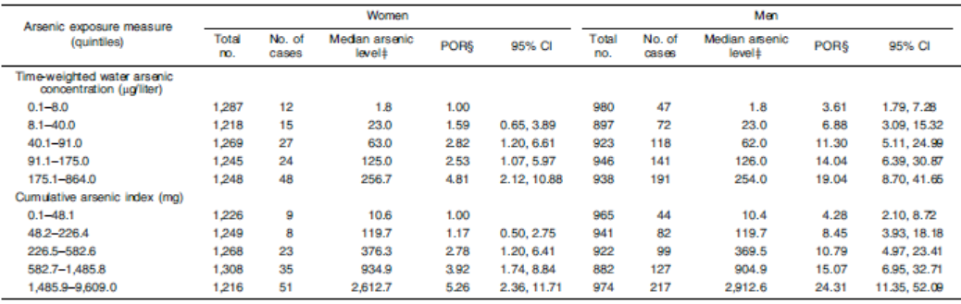

3. Using the data from the table above:

- Estimate dose-category-specific relative excess risks due to interaction (RERI) for the time-weighted water arsenic concentration. Show your calculations. (2 point)

- Using an example for time-weighted water arsenic category 91.1-175.0 microg/Liter, interpret your RERI. (1 point)

- Comment on the type of interaction observed in this study for the measure of arsenic exposure with gender. (1 point)

The following questions (4-5) are based on the data from Collaborative Group for the Study of Stroke in Young Women. In the table below we show estimates of risk ratios of stroke by exposure to oral contraceptives and presence or absence of hypertension. The risk ratio for those who are hypertensive and used oral contraceptives is 13.6.

Oral contraceptive use | No hypertension | Hypertension
Nonusers | 1.0 | 6.9
Users | 3.1 | 13.6

4. Estimate the following indices, show your math and explain your reasoning.

- Estimate the proportion of stroke cases among hypertensive women who use oral contraceptives that is attributable to the causal role of oral contraceptives. Please show your work and explain your answer. (3 points)

- Estimate the proportion of stroke cases among hypertensive women that use oral contraceptives that is attributable to having hypertension. Please show your work and explain your answer. (3 points)

- Based on your responses to #1 and #2, how much of the risk of stroke would you eliminate by intervening on both hypertension and oral contraception use? Please show your work and briefly discuss your result. (3 point)

5. In an analysis of the effect of oral contraceptives on stroke based on the data in the table above, suppose that you were interested in the oral contraceptive effect and wished only to control for possible confounding by hypertension using stratification. What would be the stratum-specific risk ratio estimates for oral contraceptive use for the two strata of hypertension? (2 points)

For questions 6-8, use STATA to analyze simulated data based on a case-control lung cancer study using the Interaction.xls dataset available on the CLE. You will be estimating additive and multiplicative interaction. Hint: the Knol et al. 2007 (optional reading) paper may be helpful for this question.

Note that these simulated data are restricted to Caucasians and so population stratification is not likely an issue in the analyses you will run. The assumption that the outcome is rare is very reasonable here. The data consists of the following variables:

Variable in Dataset Description
case lung cancer
snp 0 vs. 1/2 C alleles at rs8034191
smoking 1=ever smoker; 0=never smoker
sex 1=male 2=female
colgrad 1=college graduate 0=not college graduate
age in years

Hint: Interaction terms can be programmed easily into STATA. Try to program with the single # versus the double ## in your interaction terms (i.e. snp#smoking v. snp##smoking). Do you notice the difference in the output?

6. What is the estimated relative risk (approximation with odds ratios is sufficient) for each of the following after controlling for sex, age, and college graduation status compared to non-smokers without the SNP:
  - SNP & non-smoker (1 point):
  - Smokers without the SNP (1 point):
  - SNP & smoker (1 point):
Please provide your STATA output (1 point).

7. Calculate an estimate and a 95% confidence interval for the multiplicative interaction between the SNP and smoking on lung cancer on the odds ratio scale using logistic regression, adjusted for sex, age and college graduation status. Show you Stata commands and explain your findings. (4 points)

8. Calculate the RERI. Show your calculations and explain your findings. We will calculate the 95% CI for the RERI in class. (3 points)

The next set of questions (9-13) pertain to the Turner et al study, AJE 2014
9. Describe the study objective and study population. What were the exposures and primary outcome(s) and how were they measured? (4 points)

10a. Draw a DAG to illustrate the interaction and the outcome of interest. You can ignore drawing in all of the confounding variables. (2 point)

10b. Do you believe all potential confounders were considered? Why or why not? (2 points)

11. Describe the measures of interaction calculated in his study. What were the study’s primary findings? (2 points)

12. Given your knowledge of causal theories and the methods of the current study, do you believe causal inferences can be made about the study conclusion? Justify your response. (2 points)

13. What is the advantage of presenting additive versus multiplicative interaction? (1 point)

