Molecular and Genetic Epidemiology
Assignment 7
Due by noon on Monday before next class

A. Reading

Austin Ch. 7

B. Your project

Can you find any local admixture analysis done for your project? How does the number of hits for local admixture analysis compare to GWAS for your trait?

[answer]

C. UKB Project

The groups we have been looking at summary statistics on have been focused on “white British European-ancestry samples”. What parts of the genome are we missing because of this?

[answer]

D. Admixture analysis

Suppose we are interested in looking at the ancestry of the 1000 Genomes Project individuals. From the 1000 Genomes webpage, what are the population groups, and the population supergroups and their meanings (http://www.internationalgenome.org/faq/which-populations-are-part-your-study/)?

[answer]

Now that we know which populations are in the dataset, we’ve downloaded the data, and run the software program Admixture on a thinned genotype dataset. One of the issues with this program is that we must prespecify the number of ancestral populations, K, in the group. As such, we have run several different values of K=2, 3, 4, 5:

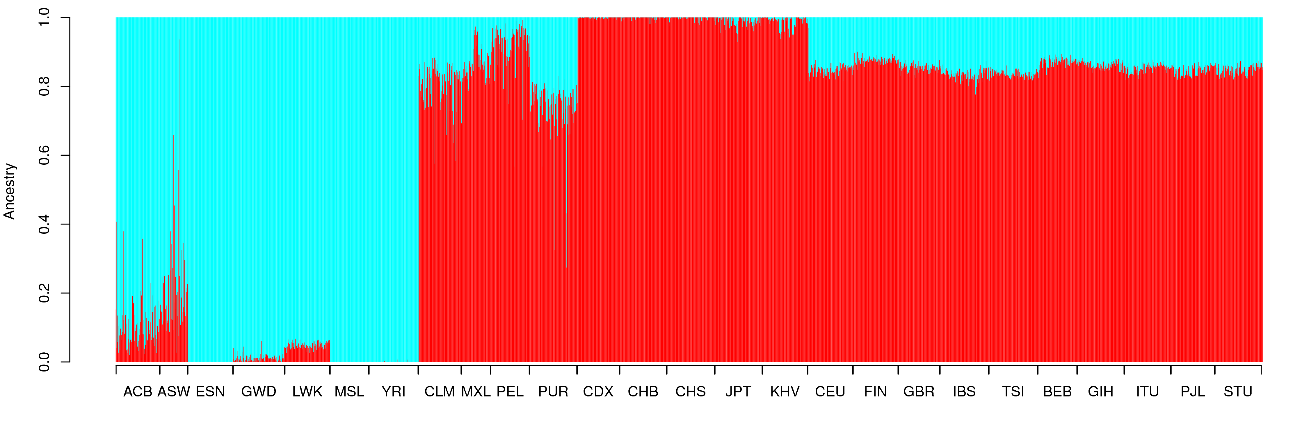
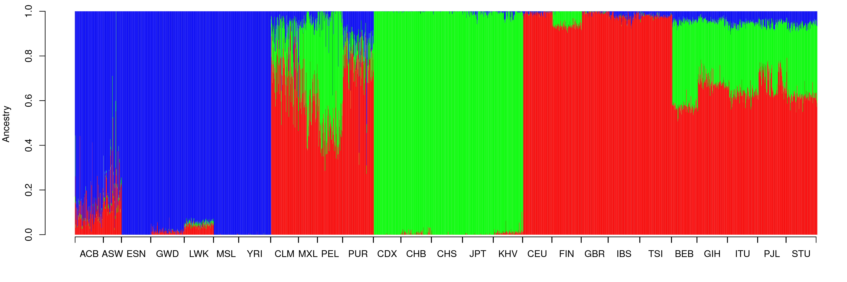
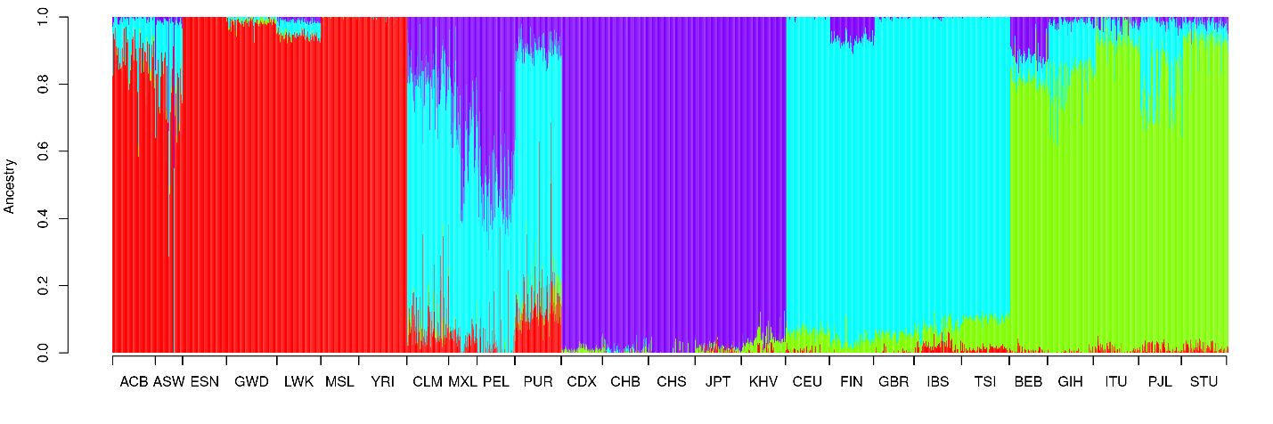
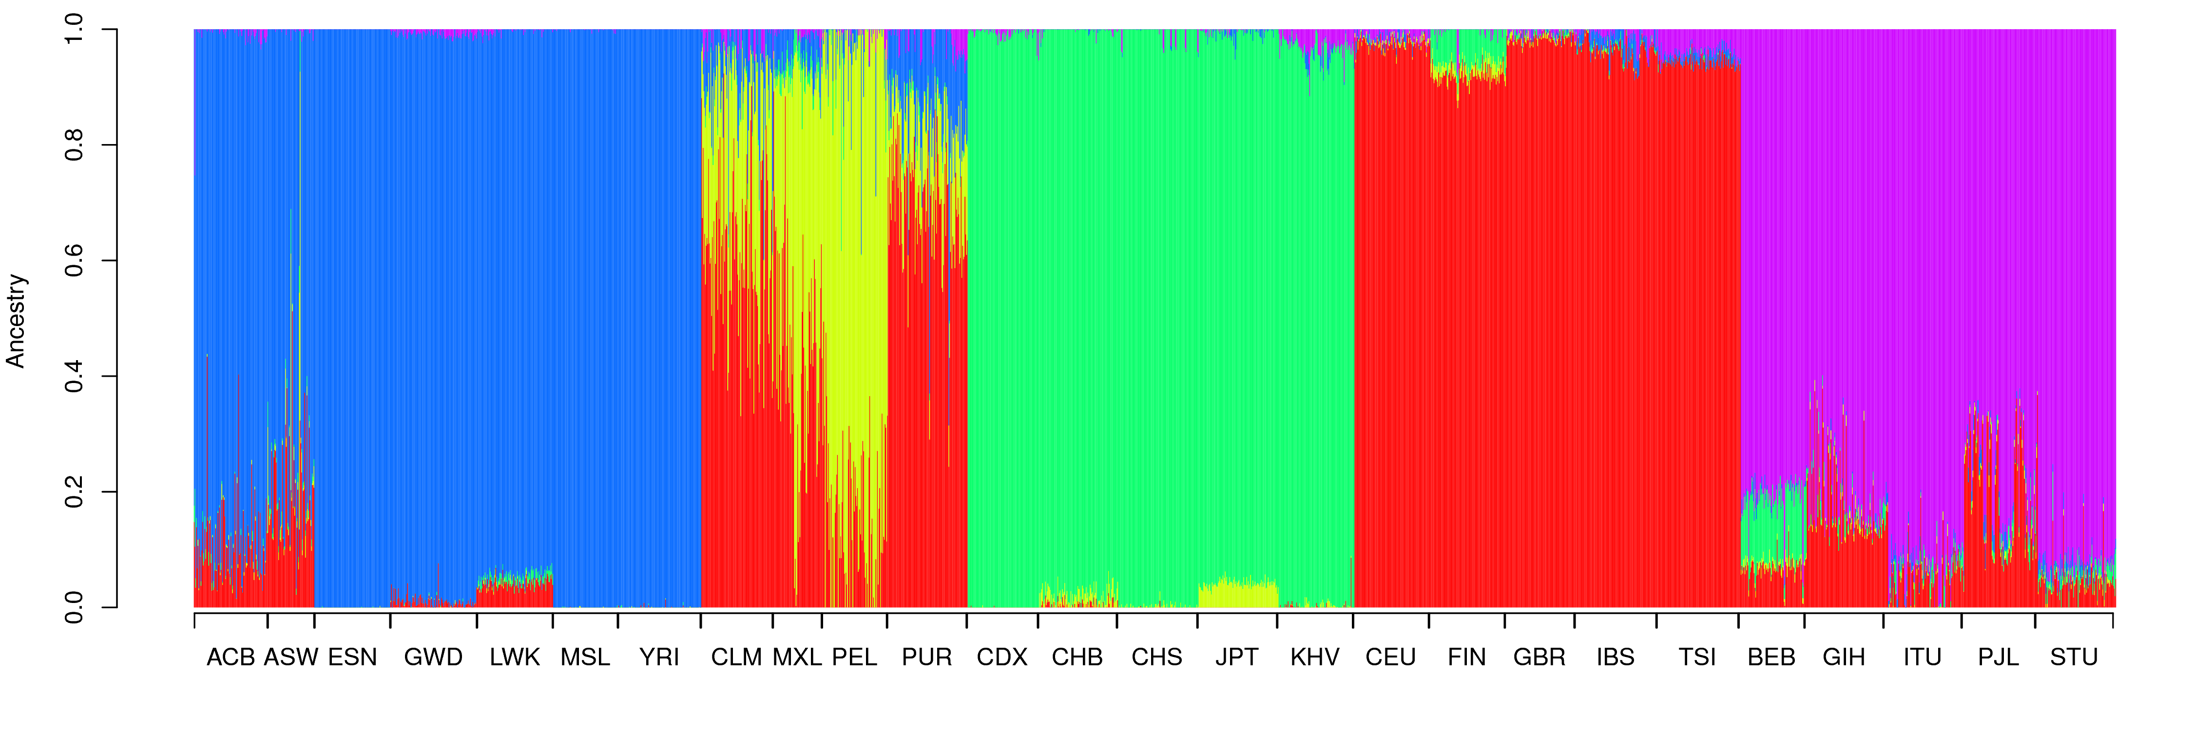For each value of K, what ancestral groups are each color capturing?

[answer]

Overall, do you see a separation/differences amongst all of the supergroups? Amongst all of the groups?

[answer]

If you recall previously in the course we looked at principal component analysis, and saw how that separated out the different ancestries. We’ve also done that here, for comparison to admixture analysis. Below is a plot of the first two principal components:

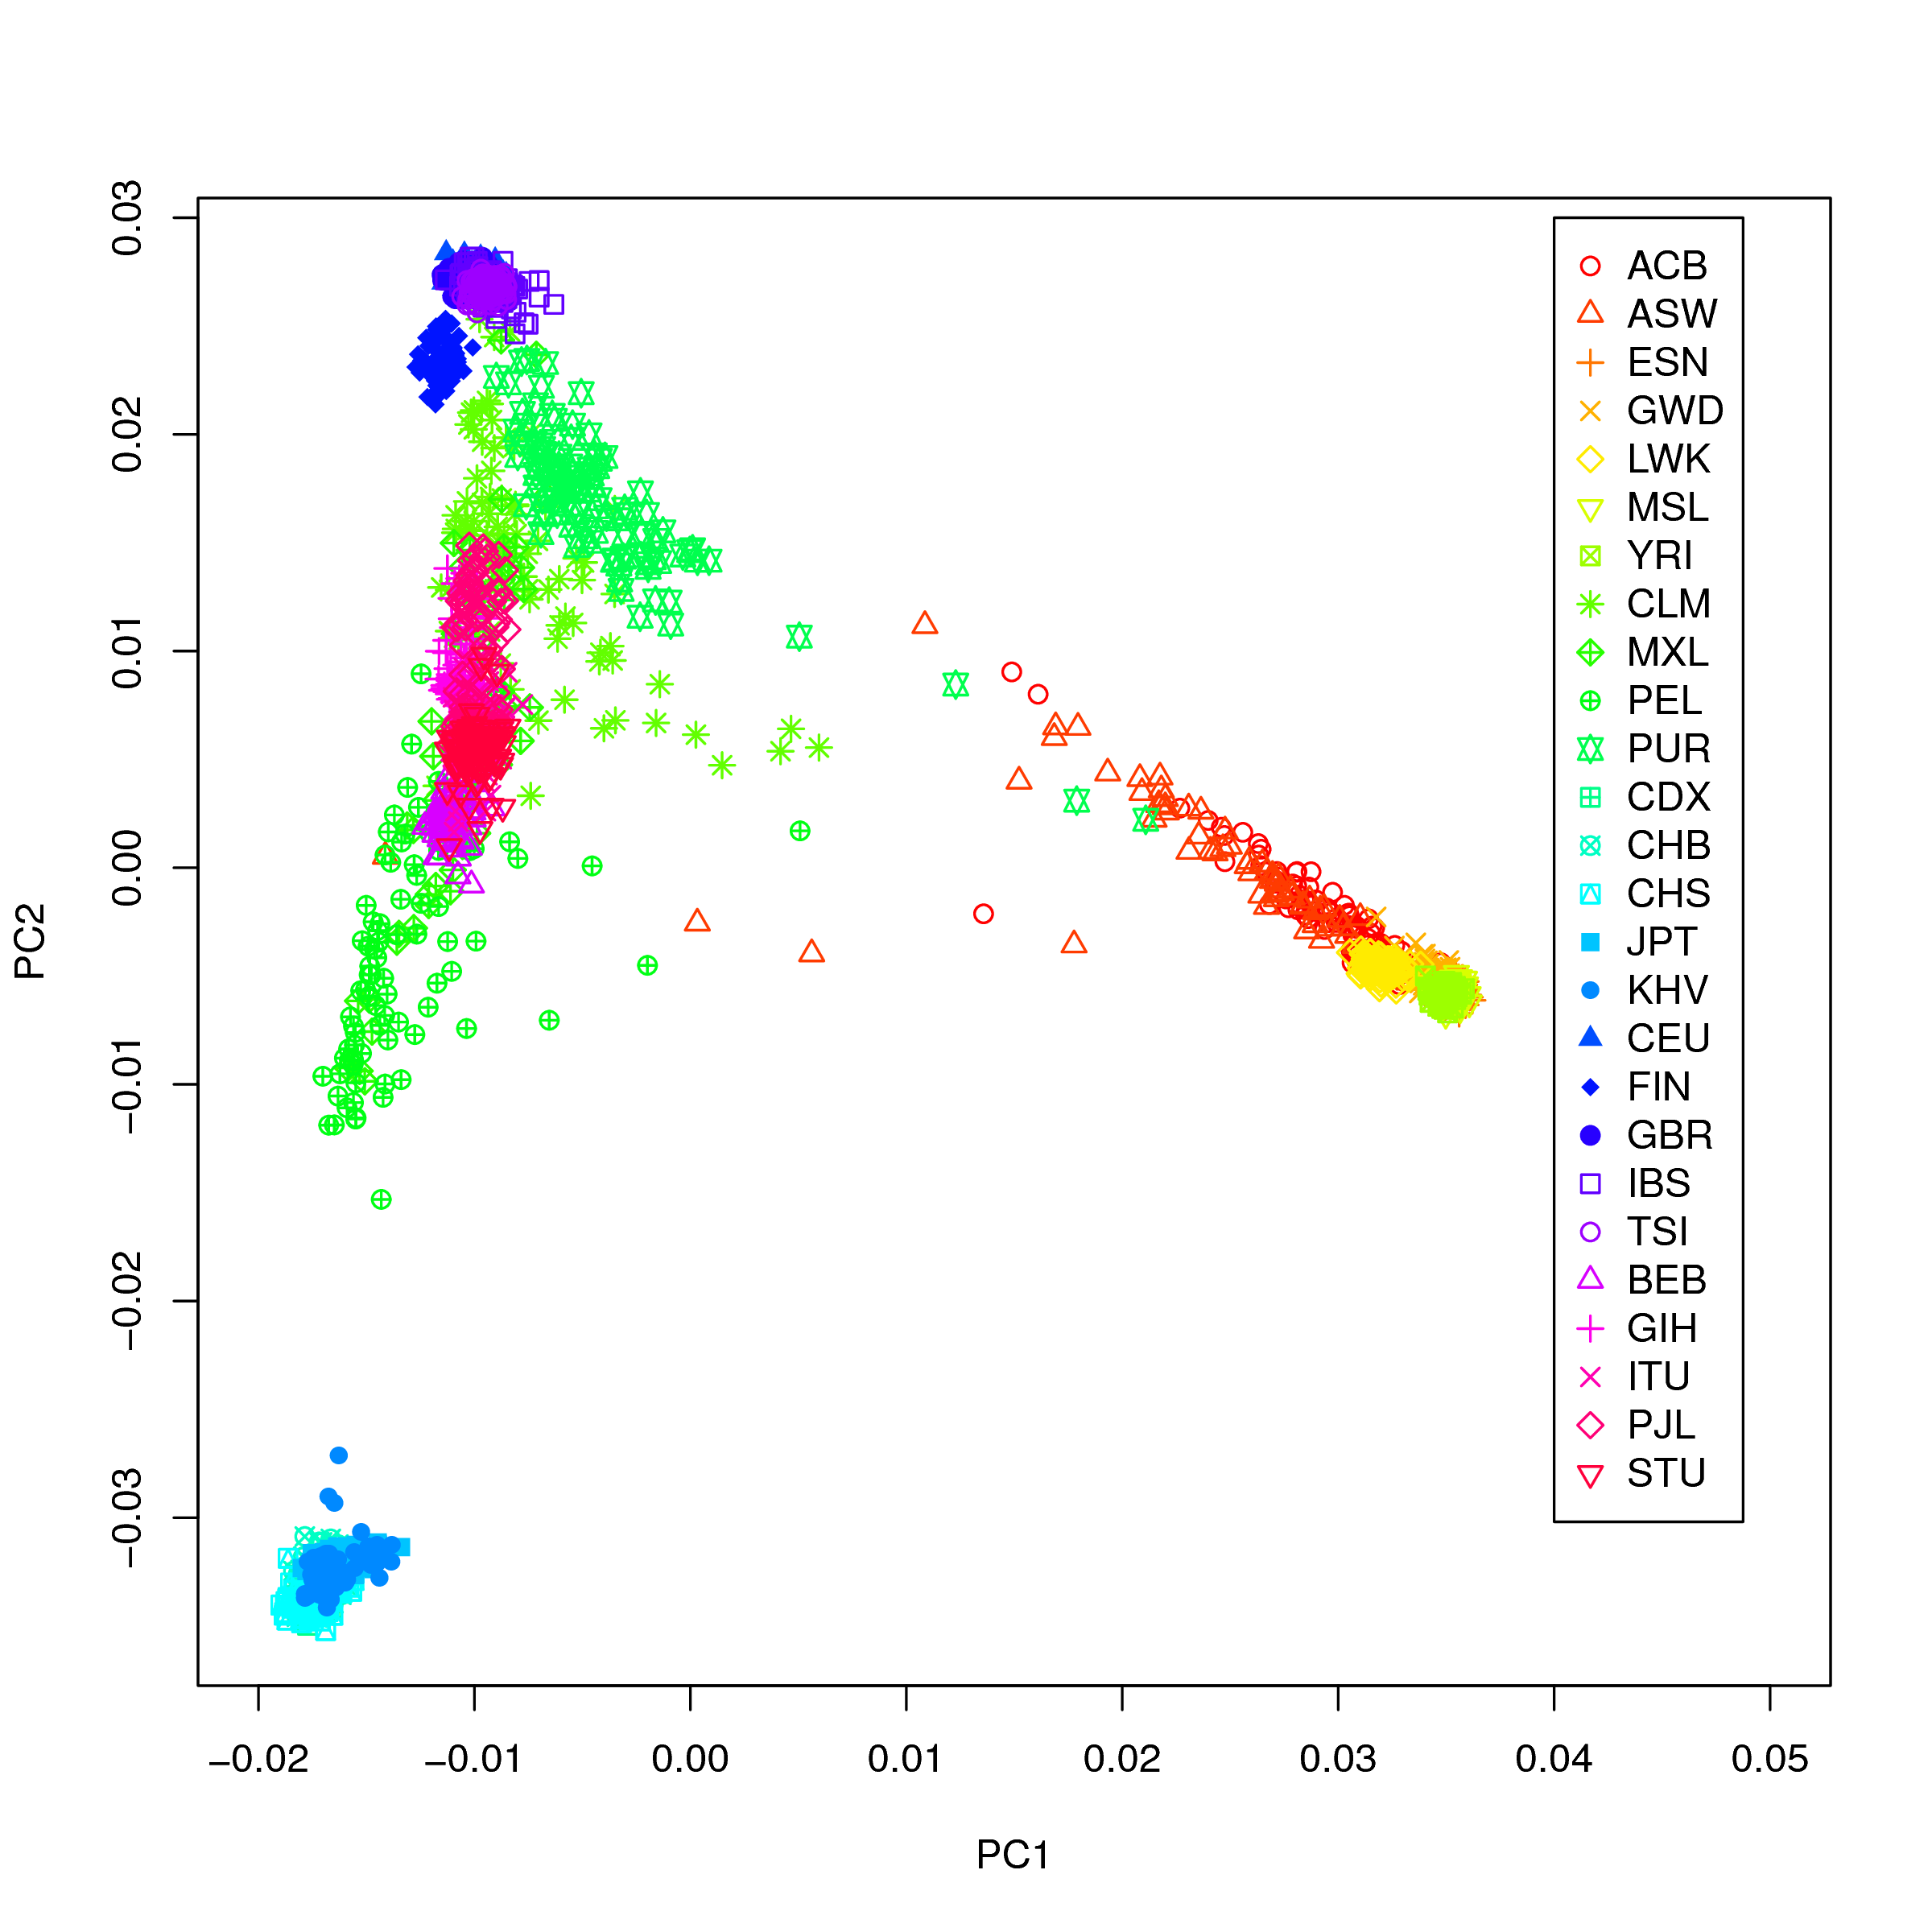
Do you see a separation amongst all of the supergroups? Amongst the groups?

[answer]

What if I told you that the correlation between the PCs and each of the three ancestries (for K=3) is:

PC | K | Correlation
1 | 1 | -0.468
1 | 2 | -0.587
1 | 3 | 0.994
2 | 1 | 0.883
2 | 2 | -0.810
2 | 3 | -0.110
3 | 1 | -0.0083
3 | 2 | 0.0062
3 | 3 | 0.0023

Do you see any relationship between the ancestry principal components and the Admixture ancestry estimates?

[answer]

E. Admixture mapping questions

1. What is the most important covariate in any genomic association study?

[answer]

2. There are both common and rare variants. Which of the two tend to be pan-ethnicity versus race/ethnicity specific? Which of the two are more abundant in the genome?

[answer]

3. True or False. Race/ethnicity differences in disease prevalence are highly confounded between genes and environment, and a group difference alone does not indicate a source for that difference.

[answer]

