6 Risk Predictions

Introduction
In previous chapters, we discussed issues affecting evaluation and use of diagnostic tests: how to assess test reliability and accuracy, how to combine the results of tests with prior information to estimate disease probability, and how a test’s value depends on the decision it will guide and the relative cost of errors. In this chapter, we move from diagnosing prevalent disease to predicting incident outcomes. We will discuss the difference between diagnostic tests and risk predictions and then focus on evaluating predictions, specifically covering calibration, discrimination, net benefit calculations, and decision curves.
Keep in mind throughout that, although we may have other reasons to estimate the risk of an outcome, our main purpose is to guide decisions: statin treatment for people at high risk for coronary artery disease, hospital admission for transient ischemic attack (TIA) patients at high risk for stroke, intensive care unit (ICU) admission for pneumonia patients with high mortality risk, and so on.

Risk predictions versus diagnostic tests
“Prediction is difficult, especially about the future.”
-- variably identified as a Danish saying or attributed to Niels Bohr, Yogi Berra, Mark Twain, Casey Stengel, Sam Goldwyn, Dan Quayle, Will Rogers, Winston Churchill, Woody Allen, ….
We originally called this chapter “Prognostic Tests”, but prognosis is “a forecasting of the probable course and termination of an illness” (Webster’s Unabridged Dictionary 2001), which means predicting incident outcomes in sick people. The tests and risk models discussed here are not necessarily applied to sick people. In fact, the incident outcome being predicted may be the development of a disease. Except for a brief section at the end of the chapter, we are still talking about a dichotomous state: heart attack vs. no heart attack, stroke vs. no stroke, ICU death vs. survival. The distinction between a diagnostic test and a risk prediction is that, at the time of the test, the condition being predicted does not yet exist; future random events occur to the subject to determine whether he develops it. (Figure 6.1)

Figure 6.1 A chance event determines whether the subject develops the condition (red sector). At the time of the prediction, the event has yet to occur. We think of predictors as indicating the size of the red sector, but there still will be a spin of the needle.
When we did a diagnostic test, we generally assumed that the subject was already either D+ or D-, and the gold standard could determine which. Even when we talked about using clinical follow-up to determine disease status, we assumed that the disease was already present at the time of the index test. Referring to Figure 6.1, at the time of the diagnostic test, the needle has already spun, and we are just trying to figure out where it ended up. At the time of the prediction, the needle hasn’t spun yet, and we are trying to figure out the proportion of the area in the red sector corresponding to the outcome.
By our definition of prediction, there is no immediately applicable gold standard; the only way to determine outcomes is through follow-up over time. For studies of diagnostic tests, the time frame is generally cross-sectional; for studies of predictions, it is longitudinal. In other words, studies of predictive accuracy are necessarily cohort studies. Moreover, since we make the prediction before a random event determines the subject’s outcome, the only way we can perform perfectly is by chance (usually in a small sample). We still use ROC curves to evaluate predictions, but the AUROCs tend to be lower than for diagnostic tests. (Table 6.1)
Table 6.1 Diagnosis vs. Prediction
 | Diagnosis | Prediction
Purpose | Identify Prevalent Disease | Predict Incident Disease/Outcome
Chance Event Occurs to Subject | Prior to Test | After Test
Study Time Frame | Cross-Sectional | Longitudinal (Cohort)
Maximum Obtainable AUROC | 1 (gold standard) | Almost always <1 (no clairvoyance)
Test Result | +/-, ordinal, continuous (use P(D+) and LR(r) to estimate risk) | Risk group (obtained directly for categorical variables and by grouping similar results for continuous variables)

With diagnostic tests, we often assume that likelihood ratios are independent of pre-test probability. This permits us to estimate the individual subject’s pre-test probability and use the likelihood ratio of the test result to update it. Studies of prediction often assume that all subjects come from a common population with a given average probability of the outcome and estimate risk directly. In the next chapter, we will discuss ways to generate risk estimates, including logistic regression and tree methods. In this chapter, we won’t worry about whether the risk estimates came from updating a pre-test probability using a likelihood ratio or from the latest predictive analytic model; we will focus on how accurate and useful they are.

Quantifying the accuracy of predictions
To assess a predictive test or risk model, we assemble a cohort, use the model to estimate the risk of each subject, then follow the subjects over time and see who develops the outcome. Ideally, treatment of subjects should be independent of predicted risk and follow-up should be complete. For now, we will assume both.
We prefer real to contrived examples and will discuss many real-world risk prediction models, but a fictitious disease with a known underlying risk distribution is the best way to introduce the evaluation of risk predictions. Our fictitious disease is mastate cancer. We assume that everyone with mastate cancer gets a mastatectomy. At this point, the tumor tissue can be sent to one of 3 different commercial laboratories (like OncotypeDx mentioned in Chapter 1, Problem 4) to estimate the likelihood of recurrence. A high likelihood of recurrence may justify chemotherapy. If we could do a Total Body Dissection (TBD) we would know that there are actually 3 different prognostic groups, but the morbidity of a TBD is too high, so we want to just use the tumor tissue. The TBD would divide the population (N=300) into the 3 equal-sized risk groups shown in Figure 6.2. The predictions being compared are the 5-year mastate cancer mortality estimates from three different labs marketing DNA tests.
Commercial lab | Risk Group A  (N=100) | Risk Group B  (N=100) | Risk Group C (N=100)
Bleakhaus, Inc | Risk = 50% | Risk = 35% | Risk = 20%
AgnoSIA, Inc | Risk = 20%
PolyANA, Inc | Risk = 25% | Risk = 10% | Risk = 5%
 | Spin the Needles
Recurrences | 33 | 17 | 11
Figure 6.2 Contrived example (mastate cancer) to illustrate evaluating risk predictions. The population of 300 subjects consists of 3 equal-sized subject groups. Different labs provide independent risk estimates. We follow the subjects over time and observe how many in each group develop a recurrence.
Predictive accuracy has two dimensions: calibration and discrimination. Calibration refers to how well the risk prediction matches the actual proportion that develops the outcome; discrimination refers to how well the test differentiates between subjects more and less likely to have the outcome.

Calibration
Because each individual subject either will or will not develop the outcome, calibration is measured by comparing the predicted risk to the proportion that develops the outcome in sub-groups of subjects. For example, in a cohort of HIV+ subjects who are starting combination anti-retroviral therapy, the predicted 10-year mortality in those with CD4 counts <500 /uL might be 18%.[1] If the observed mortality in that group after 10 years were 17% to 19%, calibration would be good; the observed proportion who died would match the predicted probability of death.
Calibration is often measured by dividing the population into quantiles of risk and comparing the predicted and observed incidence proportions. Since the incidence proportion is a roughly continuous measurement between 0 and 1, it would be natural to evaluate calibration using a modified Bland-Altman plot (Chapter 5) with observed proportion on the X-axis and the difference between predicted and observed proportions on the Y-axis. In our mastate cancer example, the population divides conveniently into tertiles of risk. In each tertile, we can plot the difference between each lab’s risk prediction and the actual proportion with the outcome. (Figure 6.3) We like the plot in Figure 6.3 because it is easy to see that Bleakhaus over-estimates risk, and PolyANA underestimates risk. Also, the vertical distance corresponding to the difference between predicted and actual risk is perpendicular to the horizontal zero-difference line.

Figure 6.3 Modified Bland-Altman-style calibration plot of the difference between predicted risk and observed risk (Y-axis) versus observed risk (X-axis) for the fictional mastate cancer example. Mean bias = 15% (Bleakhaus), 0% (Agnosia), and -7% (PolyANA).
Unfortunately for us, the standard plot for assessing calibration of risk predictions puts predicted risk on the X-axis and observed risk on the Y-axis. The difference between the predicted and observed risk is the horizontal or vertical distance from the 45-degree diagonal. (Figure 6.4) The points for Bleakhaus, which overestimated risk, are below and to the right of the diagonal, while the points for PolyANA, which underestimated risk, are above and to the left.

Figure 6.4 Standard calibration plot of observed risk (Y-axis) versus predicted risk (X-axis) for the fictional mastate cancer example. (Error bars = 95% confidence intervals.)

The easiest way to assess the calibration of a risk model is to visually inspect a plot like Figure 6.4 (or maybe Figure 6.3), but you may encounter numerical quantities used to assess calibration such as the mean bias, mean absolute error, and Brier score.

Mean Bias, Mean Absolute Error, and Brier Score
You may encounter numerical quantities used to assess calibration, among which are the mean bias, mean absolute error, and Brier score. The mean bias for a risk prediction is similar to the mean bias for a continuous measurement calibrated against a reference standard (Chapter 5), except now the reference standard is the observed outcome, coded as 1 if it occurred and 0 if it didn’t. For a given individual, the error is the difference between that individual’s risk prediction and the outcome observed. If the risk estimate is 20% and the outcome did not occur, the error is 0.2 - 0 = 0.2; if the outcome occurred, the error is 0.2 - 1 = -0.8. To get the mean bias, just average the individual errors across the entire population. If individuals are assigned to risk groups, this is algebraically equivalent to the weighted average of predicted group risk minus observed group risk across all risk groups or the difference between the overall average predicted risk (R) and the population proportion with the outcome (P). The mean bias (R-P) ranges from –P (if R=0) to 1-P (if R = 1) and provides a sense of whether the risk estimates tend to be too high or too low, but of course large overestimates can balance out large underestimates. For example, the mean bias will be 0 if the risk model overestimates risk by 40% in 1/3 of the population and underestimates risk by 20% in 2/3 of the population.

Because of this, some people use the mean absolute error (MAE) to assess calibration. This just means taking the absolute value of each individual’s error before averaging. Another way to get rid of the minus sign is to square the error before averaging. This mean squared error is called the Brier Score. Here are the mean bias, MAE, and Brier Score for the three fictitious genetic labs.

Table 6.2Mean Bias, Mean Absolute Error, and Brier Score
 | Mean Bias | Mean Absolute Error | Brier Score
Bleakhaus | 0.15 | 0.39 | 0.18
AgnoSIA | 0.00 | 0.32 | 0.16
PolyANA | -0.07 | 0.27 | 0.16

You might think the MAE or Brier Score could be 1, but that would require perfect reverse discrimination: assigning risk=0 to all outcome-positive individuals and risk=1 to all outcome-negative individuals. We have already said that perfect discrimination would require a crystal ball. More realistically, both MAE and Brier Score will vary between 0 and the larger of P and 1-P. Some authors will say that the MAE varies between 0 and 2P(1-P) and the Brier Score varies between 0 and P(1-P). This assumes that P is known at the time of the risk predictions so that the worst a model can do is predict risk = P in everybody as did AgnoSIA. AgnoSIA’s MAE = 2×0.2(1-0.2) = 0.32 and Brier Score = 0.2(1-0.2) = 0.16. Note that these are clearly not the maximum possible values since Bleakhaus had higher MAE and Brier Score.

As AgnoSIA illustrates, if you have a good estimate for the overall proportion of the population who will have the outcome and simply use that as your risk estimate for each individual, your calibration will be perfect, at least in terms of the calibration plot and mean bias. But the purpose of assessing risk is to improve decision making. In our mastate cancer example, we are trying to decide who needs chemotherapy. For this purpose, a risk model that does not discriminate between high- and low-risk individuals is useless.

Discrimination
Discrimination refers to how well the predictor can separate the patient’s probability of developing the outcome from the average probability (the proportion in the entire population who develop the outcome) to values closer to zero and 1. In the example of HIV+ people with CD4 counts <500 /uL who had a predicted 18% mortality rate, discrimination could be improved by further subdividing the CD4 count into smaller categories, so that subjects with CD4 counts <50, who have the worst prognosis, would not be lumped together with those with counts from 350 to 499, whose prognosis is better.[1]
We can then express the discrimination of a predictive test or risk model using our old friend from Chapter 3, the AUROC. Instead of comparing test results in disease and non-diseased, we compare the results in those who did and did not develop the outcome, and the varying risk threshold for calling the test “positive” is what traces out the ROC curve.
We emphasize that the AUROC only measures how well the predictor discriminates between those who do and those who don’t develop the outcome; it says nothing about calibration. Recall from Chapter 3 that the ROC curve depends only on the ranking of individual measurements (in this case, risk estimates) and not their actual values. Given any pair of subjects with opposite outcomes (e.g., one who died and one who survived), the AUROC is the probability that the one who developed the outcome was assigned a higher risk than the one who did not.
In Chapters 2 and 3 on diagnostic tests, we calculated post-test probability by going horizontally across a table with D+ and D− as the column headings and test results as the row headings. This required that sampling be cross-sectional. For a predictive test, calibration is assessed going horizontally across a table with outcome positive and negative as the column headings and assigned risk groups as the row headings. Since studies of predictive accuracy are necessarily cohort studies and rarely sample separately on outcome, it is natural to present results in a calibration table such as Table 6.3 for Bleakhaus.

Table 6.3 Calibration Table for Bleakhaus
 |  |  |  |  | Outcome
Bleakhaus's Prediction |  |  |  | N |  | Yes |  | No | Proportion with Outcome |  | Predicted - Observed
50% |  |  |  |  | 100 |  | 33 | 67 | 33% | 17%
35% |  |  |  |  | 100 |  | 17 | 83 | 17% | 18%
20% |  |  |  |  | 100 |  | 11 | 89 | 11% | 9%
Total | 300 |  |  |  |  | 61 |  | 239 | 20%
As with a diagnostic test, creating an ROC table for a prediction means going vertically and calculating cumulative column percentages. (Table 6.4) If a risk prediction from Bleakhaus of 50% or greater is considered “positive”, the sensitivity is 33/61 = 54% and 1 – specificity is 67/239 = 28%. If the threshold is 35%, then the values are (33+17)/61 = 82% and (67 + 83)/239 = 63%. The corresponding ROC curve (Figure 6.5) has AUROC = 0.65.
Table 6.4 ROC Table for Bleakhaus
 | Outcome Positive |  | Outcome Negative
Bleakhaus's Prediction | N | Sensitivity | N | 1- Specificity
50%+ | 33 | 54% | 67 | 28%
35%+ | 50 | 82% | 150 | 63%
20%+ | 61 | 100% | 239 | 100%

Figure 6.5 ROC Curve for Bleakhaus (or PolyANA). AUROC = 0.65.
Since PolyANA divided the population into exactly the same risk groups and ranked them the same way, we do not need to re-calculate Table 6.4 for PolyANA; all we need to do is change the row labels to PolyANA’s risk predictions, substituting 25%, 10%, and 5% for 50%, 35%, and 20%. The ROC curve and AUROC are the same. Again, the ROC curve reflects only the risk rankings, not the calibration of the risk estimates. Trying to create an ROC curve for AgnoSIA is pointless since it assigned the same risk to all members of the population; the only possible points are sensitivity = 0%, 1 – specificity = 0% and sensitivity = 100%, 1-specificity = 100%. Drawing the 45-degree diagonal line between these 2 points might imply that you could actually choose a cutoff that would allow say 50% sensitivity and 50% (1 – specificity).

Box 6.1: Calibration and discrimination for prognosis of low back pain
Dutch investigators studied predictors of prognosis in patients presenting to general practitioners with low back pain (Jellema et al. 2007). They developed a clinical prediction rule that provided an estimated probability of an “unfavorable course,” defined as back pain perceived by the subject as at most “slightly improved,” at subsequent follow-up visits. The prediction rule was based on answers to a baseline questionnaire covering things like radiation of the pain, previous history of back pain, and general health. (Clinical prediction rules are discussed in Chapter 7.) They also asked the general practitioners to estimate the probability of restricted functioning at 3 months to the nearest 10% (i.e., on an 11-point scale: 0%, 10%, 20%, 30% . . . 100%). The calibration of the two methods is illustrated in Figures 6.6a and 6.6b.

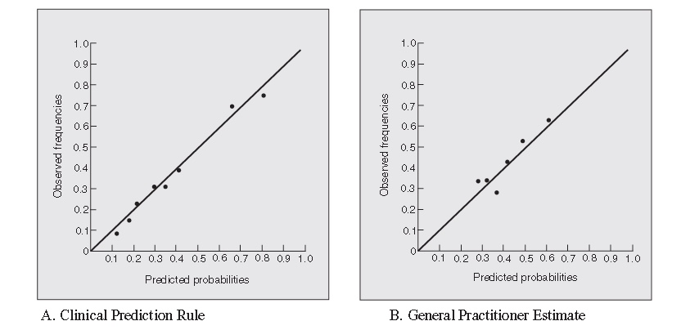
Figure 6.6 Predicted probability plotted against observed frequency of continued low back pain among subjects seen by Dutch general practitioners. Both sets of predicted probabilities are well calibrated, but the clinical prediction rule discriminates better, as shown by the greater vertical spread in observed frequencies. From Jellema et al. (2007).
Calibration was good for both – most of the points are close to the line that represents perfect calibration. However, you can see that discrimination of the clinical prediction rule (Fig. 7.1a) was better than the practitioners’ estimates, because it yielded a wider range of predicted probabilities with greater vertical spread in observed frequencies. Remember, discrimination is the ability to move probabilities away from the mean probability toward 0 and 1. This improved discrimination was reflected in a higher area under the ROC curve (AUROC): 0.75 (95% CI 0.69 to 0.81) for the clinical prediction rule, compared with 0.59 (95% CI 0.52 to 0.66) for the general practitioner’s estimate. However, a major limitation, clearly acknowledged by the authors, is that the clinical prediction rule was evaluated in the same dataset used to develop it. As we will see in Chapter 7, this overestimates the performance of a risk model. In addition, the clinical prediction rule and the clinicians were being asked to predict slightly different outcomes.
[End Box 6.1]

ROC Curves and Calibration Plots
Calibration plots like Figure 6.4 allow visual assessment of discrimination as the vertical spread of points. (Box 6.1) (In a modified Bland-Altman-like plot such as Figure 6.3, it is the horizontal, not vertical, spread that represents discrimination.) Compare the calibration plots for Bleakhaus and PolaANA in Figure 6.4 with their common ROC curve in Figure 6.5. Note that points on the calibration plot correspond to segments on the ROC curve, and calibration points that are higher and to the right correspond to ROC segments that are lower and to the left. As mentioned in Boxes 6.1 and 6.2, the vertical spread of points on the calibration plot gives us a sense of the discrimination of the test, but this assumes that the points represent equal numbers of individuals. Under this assumption, it is possible to create a table like 6.3 from the calibration plot, convert it to a table like 6.4, and draw the ROC curve. Going the other direction -- from the ROC curve to the calibration plot -- additionally requires the overall proportion of subjects with the outcome and the predicted risk associated with each segment of the curve (in order to get the calibration point’s X-axis coordinate).

Box 6.2: Calibration and Discrimination in the ICU Mortality Probability Model

The Mortality Probability Model at ICU admission, MPM₀, is a logistic regression model that predicts the risk of ICU death based on variables available within 1 hour of ICU admission. MPM₀ was developed using data on ICU patients treated in 1989-1990 and was updated in 2007. In 2007, the original model from the 1990s, “MPM-II”, and the updated model, “MPM-III”, were evaluated in approximately 50,000 patients from the Project Impact dataset of ICU patients treated between 2001 and 2004 [2]. Here (with the original caption) are the calibration plots of the original model (MPM II) and the updated model (MPM III). Although the paper does not label the axes, this is a traditional calibration plot in which the vertical axis represents observed mortality and the horizontal axis represents predicted mortality.

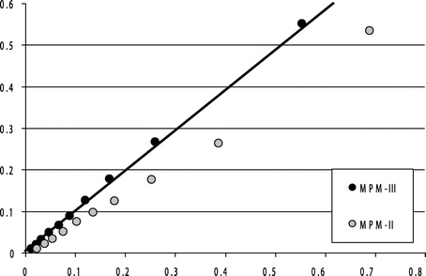
Figure and caption from Higgins et al (2007). Calibration plot of Mortality Probability Admission Model (MPM-III) and Mortality Probability Model version 2 (MPM-II) on 2001-2004 Project IMPACT validation data. Graphic representation of calibration; database collapsed into ten equal sample sizes. Line at 45 degrees represents identity, circles represent population deciles. The MPM-III model (dark circles) calibrates well. The light circles define the relationship between predicted and actual mortality outcomes when MPM-II model is applied to the same dataset (2001-2004 data from Project IMPACT). Actual mortality is below the line of identity except at the lowest deciles of risk, demonstrating that MPM-II no longer calibrates.

Since the calibration points represent deciles of risk, the vertical spread of points does provide a reasonable measure of discrimination. On visual inspection, the vertical spread looks similar between MPM-II and MPM-III, and the ranking is obviously the same, so the ROC curves and AUROCs for these 2 models will be very similar. The real difference between MPM-III and MPM-II is improved calibration, not improved discrimination.

End Box 6.2

Risk ratios, rate ratios, and hazard ratios
Although use of the AUROC to quantify discrimination is common and easy to understand, choosing one time point to evaluate the outcome may lead to loss of information. For example, making survival dichotomous at 10 years equates a death at 1 week with a death at 9.9 years, and a death at 10.1 years with >20-year survival. One approach to this problem is to make a whole family of ROC curves for outcomes occurring at different time periods (e.g., 1-, 5-, 10-, and 20-year survival).
Some studies merely identify significant predictors of an outcome and report relative measures like risk ratios, rate ratios, or hazard ratios. These measures all express the likelihood of developing the outcome in people who have a risk predictor compared with those who do not. As with the use of ROC curves, the use of risk ratios requires evaluating for the outcome at a single time point, which leads to loss of information about when the outcome occurred. Rate ratios and hazard ratios can take into account variable times to the outcome. But the relative risk, rate ratio, or hazard ratio alone is not that useful for clinical decision making. Patients want to know their absolute risks. They do not just want to know if their chance of dying in the next 5 years is half (or twice) as high as someone else’s; they want to know what their chance of dying (or expected survival time) actually is – that is, their prognosis, and clinical decisions should be based on absolute rather than relative risks.

Assessing the value of predictions
Many predictors are available at little cost or risk; variables such as age, current symptom burden, extent of disease, and functional status are often highly predictive of outcome. We should use this information to help people obtain an accurate assessment of their risk. Patients may value prognostic information beyond its ability to help with clinical decision-making because not all decisions are clinical (e.g., whether to take early retirement, sell the house, or move up the date of the family reunion). On the other hand, some prognostic tests are risky or expensive. For these tests, value mainly depends on whether and to what extent they help improve clinical decisions.
The first step in evaluating a risk model is to identify the treatment or management decision the risk estimate is supposed to guide. In Chapter 2 we looked at how the value of doing a test varied with the prior probability of disease. The answer depended on estimates of C, the cost or “regret” associated with treating someone without disease, and B, the cost of failing to treat someone with the disease. These misclassification costs determined the treatment threshold probability C/(C+B). Net benefit calculations and decision curves show how the value of doing the predictive test varies with the treatment threshold in a population that has a given overall proportion P that develops the outcome. However, you may find understanding the next section on net benefit calculations and decision curves more challenging than the other material in this chapter. One reason is that we will need to move from minimizing expected regret (as in Chapters 2 and 3) to maximizing expected net benefit. This is just a change in terminology required for consistency with other risk-model discussions [3]. Another reason is that the discussion contains more algebra than we would have liked. We have marked the next section with an asterisk, and you may want to skip it until you encounter a net benefit calculation or decision curve that you need to understand.

Beginning of Asterisked Section

Net Benefit Calculations and Graphs*
Recall that the regret graphs from Chapters 2 and 3 had probability of disease P(D+) on the X-axis and expected cost on the Y-axis. B was the cost of failing to treat a D+ subject and C was the cost of treating a D- subject unnecessarily. “No Treat” was optimal as long as P×B < (1 – P)×C. The threshold probability P_{TT} was C/(C+B). (Figure 6.6.A) Now, to create a net benefit graph, we compare everything relative to the “No Treat” strategy (to which we assign expected regret = 0). “No Treat” is optimal as long as (1 – P)×C - P×B > 0. (Figure 6.6.B) Next, we flip everything over, so that the Y-axis becomes expected net benefit and higher on the graph is better. “No Treat” is optimal as long P×B - (1 – P)×C > 0. (Figure 6.6.C) Lastly, we divide through by B so that the net benefit of treating a D+ subject is 1 and the net benefit of treating a D- subject is –C/B.
Expected Net Benefit of treating = P – (C/B)×(1-P)
“No Treat” is optimal as long as expected net benefit is < 0. (Figure 6.6D) Since all we have changed is the accounting, the treatment threshold probability P_{TT} remains C/(C+B). Also, remember converting from probability to odds, so treatment threshold odds P_{TT}/(1- P_{TT}) = C/B.
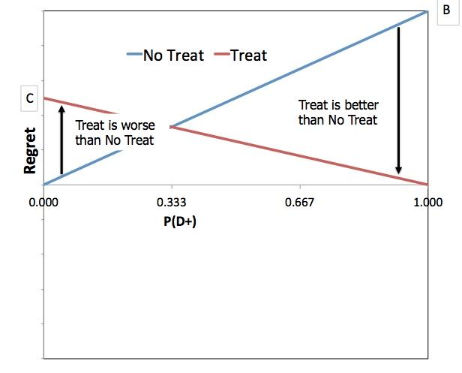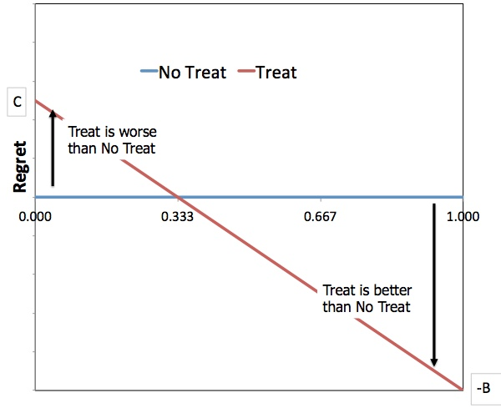
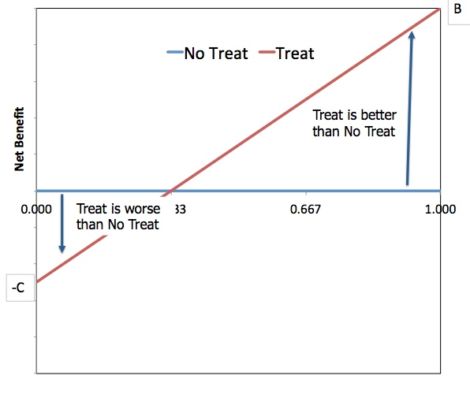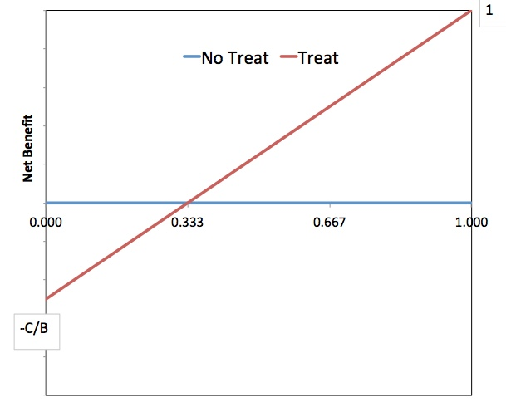
Figure 6.6 Treatment threshold probability (0.333 in these figures) stays the same whether minimizing expected regret (Panels A and B) or maximizing expected net benefit (Panels C and D). Panel A: Treat when (1-P)×C < P×B. Panel B: Treat when (1-P)×C - P×B < 0. Panel C: Treat when P×B - (1-P)×C > 0. Panel D: Treat when P – (C/B)×(1-P) > 0.
Now, we are ready to calculate the standardized net benefit associated with a risk model. Here are the steps:
- Obtain the risk prediction r_{i} for each of the N individuals in an untreated cohort (r₁, r₂, …, r_{N-1}, r_{N}).
- Choose a risk threshold for treatment, R_{TT} = C/(C+B).
- For individual i, if r_{i} > R_{TT} and the outcome occurred, classify as a true positive (TP); if r_{i} > R_{TT} and the outcome did not occur, classify as a false positive (FP).
- Calculate the population net benefit (NB):
NB = TP/N – (C/B)×FP/N
TP = true positives (depends on C/B)
FP = false positives (depends on C/B)
N = number of individuals in the population
C/B = treatment threshold odds = R_{TT}/(1- R_{TT})
- Since the maximum possible value for NB is equal to the proportion P of the population that ultimately has the outcome, divide NB by P to calculate the standardized net benefit (sNB). (sNB = NB/P) :
sNB = TP/(P×N) – (C/B)×FP/[(1-P)×N]×(1-P)/P

An equivalent expression for sNB uses “TPR” instead of TP/(P×N), “FPR” instead of FP/[(1-P)×N], and R_{TT}/(1- R_{TT}) instead of C/B, so you might see
sNB = TPR - FPR×[R_{TT}/(1- R_{TT})]×(1-P)/P
- The sNB calculation is the standardized net benefit relative to not treating anybody (“Treat None”). The sNB of treating everybody (“Treat All”) is
sNB(Treat All) = 1 – R_{TT}/(1- R_{TT})×(1-P)/P
and should always be calculated.

Comments on the Standardized Net Benefit Calculation
- The population net benefit calculation assumes that the risk threshold R_{TT} should be the same for every individual, which is equivalent to assuming that C/B is the same.
- Since Step 4 above involves comparing each individual’s predicted risk to R_{TT} = C/(C+B), changing C/B changes the number of true positives (TP) and false positives (FP). Increasing C/B raises the treatment threshold, and thus lowers both TP and FP. Since the alternative expressions TPR and FPR above depend on TP and FP, they also decrease as C/B increases.
- The standardized net benefit of treating everybody, sNB(Treat All), is zero when R_{TT} = P, i.e., when the risk threshold based on misclassification costs C/B equals the proportion in the population with the outcome.
We can calculate NB and sNB for each mastate cancer DNA lab’s risk predictions. (Table 6.5) Assume that giving chemotherapy to someone who will otherwise die from a mastate cancer recurrence is worth giving chemotherapy to three people who will not die of a recurrence. In other words, C/B = 1/3. The risk threshold R_{TT} = C/(C+B) = 25%. Since Bleakhaus’s predicted risks for Group A (50%) and Group B (35%) are both greater than 25%, the 50 outcomes in those two groups are true positives and the other 150 subjects in those groups are false positives. Since Bleakhaus’s predicted risk for Group C (20%) is less than 25%, the subjects in that group do not count as either true positives or false positives. At a tradeoff of 1:3, the 150 false positives exactly balance out the 50 true positives and the net benefit for Bleakhaus is 0. Since AgnoSIA’s predicted risk for all subjects (20%) is less than 25%, the net benefit for AgnoSIA is the same as “Treat None”, which is 0. Since PolyANA’s predicted risk of 25% for Group A is the same as R_{TT}, we will count the 33 outcomes in the group as true positives and the 67 others as false positives leading to NB = 33/300 – (1/3)×67/300 = 0.036 and sNB = 0.036/0.2 = 0.175. The “Treat All” strategy would result in 61 true positives and 239 false positives for NB and sNB of -0.062 and -0.306.

Table 6.5Net Benefit Calculations for 3 Different Risk Predictions

Rtt = 25% (C/B = 1/3) |  |  | Bleakhaus |  |  | AgnoSIA |  |  | PolyANA |  |  | Treat All
Group | N | Outcomes | Prediction | TP | FP | Prediction | TP | FP | Prediction | TP | FP |  | TP | FP
A | 100 | 33 | 50% | 33 | 67 | 20% | 0 | 0 | 25% | 33 | 67 |  | 33 | 67
B | 100 | 17 | 35% | 17 | 83 | 20% | 0 | 0 | 10% | 0 | 0 |  | 17 | 83
C | 100 | 11 | 20% | 0 | 0 | 20% | 0 | 0 | 5% | 0 | 0 |  | 11 | 89
Overall | 300 | 61 |  | 50 | 150 |  | 0 | 0 |  | 33 | 67 |  | 61 | 239
 | NB = TP/N - (C/B)×FP/N |  |  | 0.00 |  |  | 0.00 |  |  | 0.036 |  |  | -0.062
 | sNB = NB/P |  |  | 0 |  |  | 0 |  |  | 0.175 |  |  | -0.306

At a misclassification cost ratio (C:B) of 1:3, PolyANA’s predictions had the highest net benefit. However, if we are willing to treat 9 with chemotherapy unnecessarily to treat one who would die otherwise (C:B = 1:9), the risk threshold R_{TT} is 10%. Given that all of their risk predictions are greater than 10%, Bleakhaus and AgnoSIA have the same NB and sNB as Treat All, which turn out to be 0.115 and 0.565. Meanwhile, the values for PolyANA are lower (0.111 and 0.546). So while PolyANA’s predictions had the highest net benefit with one misclassification cost ratio, they had the lowest net benefit with another. In the next section we will cover decision curves, which display net benefit over a range of misclassification cost ratios. (Figure 6.7)

Decision Curves

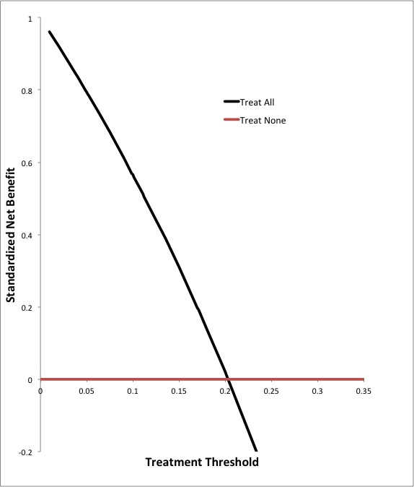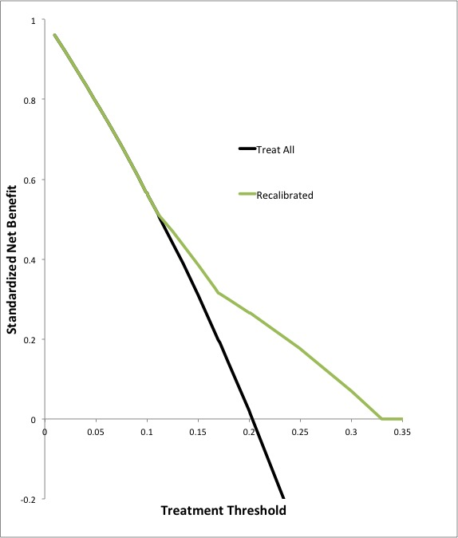

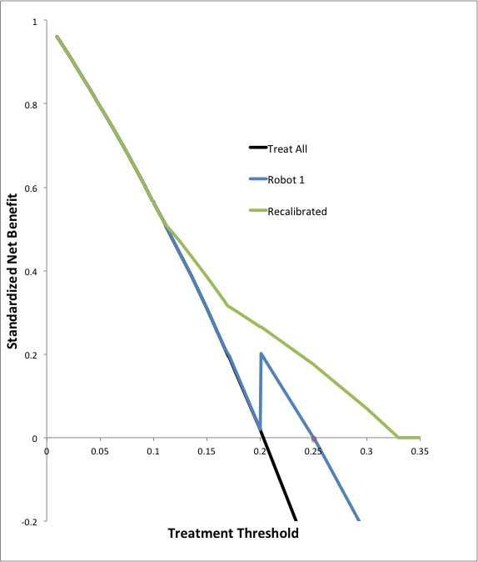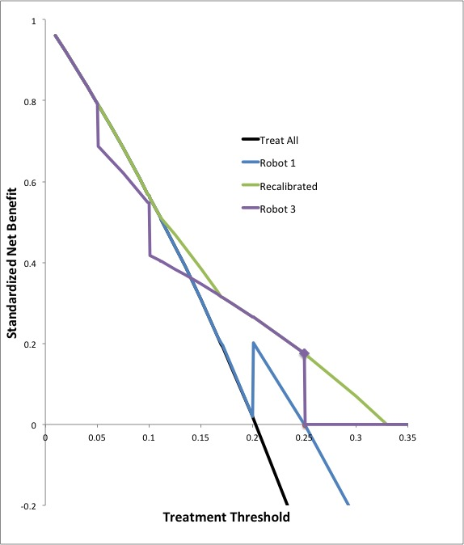
Figure 6.7 MAK Note: Legend error -- “Robot 1” = Bleakhaus and “Robot 3” = PolyANA. Decision curves display the standardized net benefit (sNB) of a risk model in a sample population as a function of the treatment threshold risk R_{TT} = C/(C+B). In this example, the population only has 3 recognizable risk groups and the proportion who developed the outcome, P is 0.2. Panel A: The sNB of the “Treat None” strategy is defined to be 0. The sNB of the “Treat All” strategy is 1 – R_{TT}/(1- R_{TT})×(1-P)/P. Note that sNB(Treat All) = 0 when R_{TT} = P. Panel B: A perfectly calibrated model that only divides the population into 3 risk groups will have two R_{TT} ranges where it has sNB > sNB(Treat All) and sNB > 0 . As R_{TT} increases, false positives (FPs) first outweigh true positives (TPs) in the lowest risk group, then in both the lowest and the intermediate risk groups. When R_{TT} increases above the risk in the highest risk group, the sNB is 0. Panel C: A model (Bleakhaus) that consistently overestimates risk can have a negative sNB when R_{TT} is high. Panel D: A model that consistently underestimates risk (PolyANA) can have sNB < sNB(“Treat All”) when R_{TT} is low.

Decision curves display the standardized net benefit (sNB) of a risk model in a sample population as a function of the treatment threshold risk R_{TT} = C/(C+B). The appearance of the decision curve depends on P, the proportion of the sample population that developed the outcome. For reference, the plot always includes the sNB of the “Treat All” strategy (1 – R_{TT}/(1- R_{TT})×(1-P)/P) which crosses the X-axis (sNB = 0) at R_{TT} = P. (Figure 6.7 A)
Net benefit calculations and decision curves can reflect discrimination. In our contrived example, the population has only 3 recognizable risk groups: low, intermediate, and high. This is like using a 3-level variable to predict risk. A perfectly calibrated model (Figure 6.7 B) can improve over both “Treat None” and “Treat All” strategies for two ranges of risk thresholds. Reading the decision curve from right to left, at a high R_{TT}, the sNB is the same as “Treat None”, i.e., sNB = 0. At a certain R_{TT} (0.33 in this example), true positives (TPs) first outweigh false positives (FPs) in the highest risk group yielding an sNB > 0. Then at a lower R_{TT} (0.17 in this example), TPs outweigh FPs in both the high and the intermediate risk groups. Finally, for R_{TT} below the risk in the lowest risk group, the sNB of the model is the same as “Treat All”. A well-calibrated model that divided the population into more widely separated risk groups or a greater number of risk groups, would provide greater sNB at a wider range of risk thresholds.
Net benefit calculations and decision curves can also reflect calibration. A model (Bleakhaus) that consistently overestimates risk can have a negative sNB when R_{TT} is high. This corresponds to the idea that overestimating risk leads to overtreatment. (Figure 6.7 C). Box 6.3 shows how a decision curve reflects overestimation of cardiovascular risk by the NICE-Framingham equation. A model that consistently underestimates risk (PolyANA) can have sNB < sNB(“Treat All”) when R_{TT} is low, corresponding to the idea that underestimating risk leads to undertreatment. Figure 6.7 D).

Recalibration
Recalibration means keeping the same model-defined risk groups but adjusting each group’s risk estimate to the observed proportion with the outcome in that group. We did that in Figure 6.7 B to show how the decision curve for a well-calibrated model can reflect discrimination. It seems circular to recalibrate a model before evaluating its performance or comparing it to other models using net benefit calculations or decision curves. You can’t see how well a model predicts the risk of an outcome by peeking to see who had the outcome and then changing the model’s risk estimates. As demonstrated by the ICU Mortality Probability Model (Box 6.2), the difference between two models may reside almost entirely in better calibration. After recalibrating, the models will look equivalent. If you want to focus on discrimination alone, use the ROC curve. On the other hand, once you have evaluated your models and chosen the one to use going forward, it makes perfect sense to recalibrate it.

Box 6.3 QRISK2 vs. NICE Framingham Risk model
Collins and Altman [4] compared the performance of the QRISK2 score for predicting the 10-year risk of cardiovascular events with the NICE (National Institute for Health and Clinical Excellence) version of the Framingham equation. Presumably, these risk estimates would guide an intervention such as statin therapy. They applied both models in an independent UK cohort of subjects from general practice that included more than 2 million subjects (11.8 million person-years) with more than 90,000 cardiovascular events. The models were applied separately to men and women. Below are the decision curves for women and men aged 34 – 75 years.

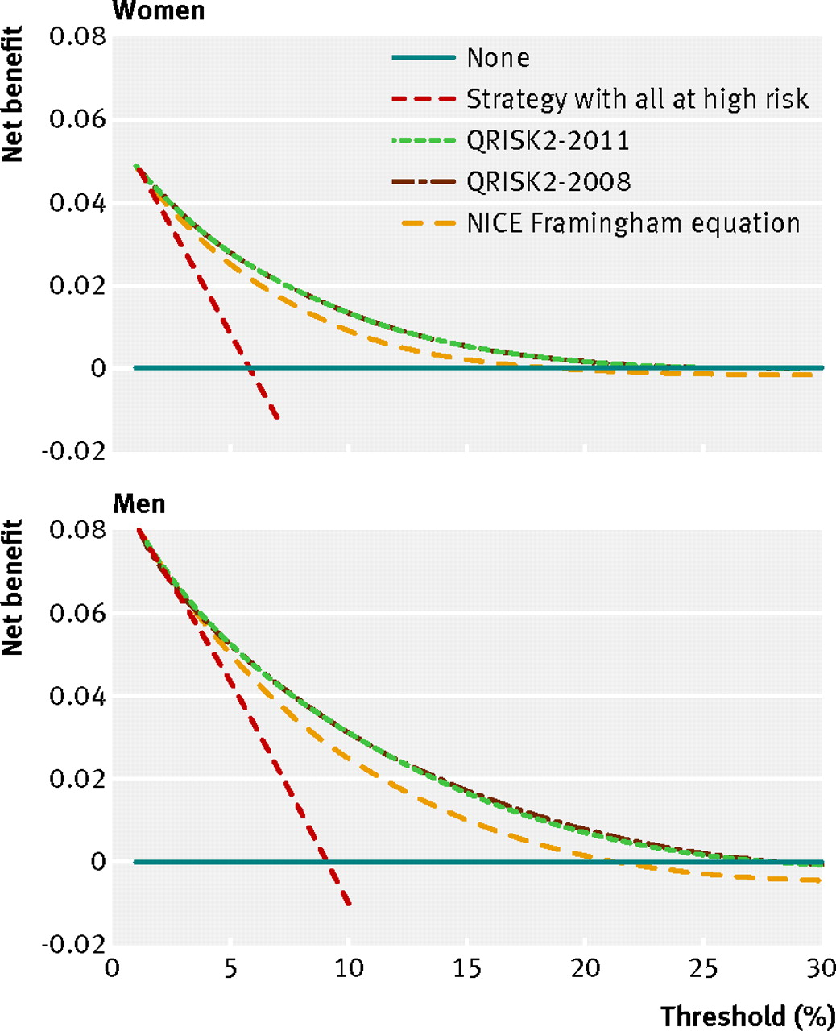

Figure 6.8 Decision curves for NICE-Framingham equation, QRISK2-2008, and QRISK2-2011 in predicting 10-year risk of cardiovascular events in participants aged 34-75 years in an independent UK cohort of subjects from general practice. QRISK2-2011 is a refinement of QRISK2-2008 with a richer characterization of smoking status. [4] Used with permission.

The Y-axis on these curves is net benefit, not standardized net benefit. Therefore, even when C=0, the best you can do by treating all is P. In the legend, the “Treat All” curve is labeled “Strategy with all at high risk”. Based on where the “Treat All” curves cross the X-axis, the proportion of women with a cardiovascular event at 10 years was about 6%, while the proportion of men was about 9%. We can also see that the NICE-Framingham equation over-estimates risk because at high risk thresholds it has negative net benefit, i.e. it would lead to over-treatment. Both models would increase net benefit at a risk threshold greater than about 4% by identifying low-risk individuals for whom the costs and risks of treatment outweigh the benefits.

End Box 6.3

End of asterisked section.

Critical appraisal of studies of prediction
We have seen that the prototypical study of a predictive test or risk model is a cohort study. The risk predictions should be based on information that was available at inception, and subjects should be treated similarly and followed for occurrence of the outcome. We now highlight several issues that arise commonly in evaluating studies of prediction.

Effects of treatment
If the outcome being predicted is preventable, then its likelihood will be affected by treatment. If subjects at highest risk receive more aggressive treatment and the treatment is effective, the discrimination of the risk model is attenuated and the predicted risks may be too high. There is also the possibility of a self-fulfilling prophecy. A study of prognostic factors in elderly ICU subjects would likely find associations with mortality either for factors that really do predict mortality or for factors that treating physicians strongly believe predict mortality, because having many of the latter factors may lead to withdrawal of life support.

Loss to follow-up
Subjects lost to follow-up add uncertainty to estimates of predictive accuracy. This is a particular problem if there is reason to believe they differ in important ways from subjects with complete follow-up. One way to get some limits on the degree to which subjects lost to follow-up could affect the study results is to recalculate the proportion with the outcome (e.g., death) first assuming that all those missing had the outcome and then assuming none did. For example, consider a follow-up study of 200 subjects, of whom 60 died, 120 survived, and 20 could not be accounted for at 5 years. If the subjects lost to follow-up are simply not counted, mortality would be 60/180 = 33%. If all 20 subjects lost to follow-up are assumed to have died, the observed mortality would be 80/200 = 40%, and if none had died, it would be 60/200 = 30%. Thus, the largest effect of loss-to-follow-up in this example would be to decrease apparent mortality from 40% to 33% or increase it from 30% to 33%. If this very conservative approach still yields useful predictive information, you are on firm ground. A less conservative approach would be to assign the missing subjects the lowest and highest plausible event rates (rather than the rates of 0% and 100% used above). For more on the sensitivity of study results to incomplete follow-up, see Chapter 8.

Overfitting
With the exception of the clinical prediction model for subjects with low back pain discussed in Box 6.1, all the examples in this chapter have been about evaluating risk models in samples separate from the ones in which they were developed. In the next chapter, we will discuss developing a risk model in a derivation sample and testing it in a validation sample. Testing a model in the sample in which it was developed overestimates performance even more severely than recalibrating prior to evaluation. If you look at enough variables, you are bound to find some combination that is associated with adverse outcomes in one particular sample. You can also find the best weighting scheme for the variables and select the cut-offs that best separate those who develop the outcome from those who don’t. To be convincing, the risk model developed in one study needs to be restudied in another dataset, separate from the one in which it was derived, using the same variable weights and cut-offs to define abnormal results (Hilsenbeck et al. 1992).

Publication bias
Publication bias occurs when studies that have favorable results are published preferentially over those that do not. Although publication bias is a problem for all types of studies, it may be a particular problem for studies of risk markers. This is fairly understandable – it is hard to get very excited about submitting or reading a paper about factors that are worthless for predicting an outcome. On the other hand, if you look at enough possible risk predictors in enough different ways, it is easy to find a few that are strongly associated with the outcome. These few predictors may be mentioned in the abstract of a paper, so a PubMed or Google Scholar search should identify prior studies that mention them. In contrast, all of the possible candidate predictors that were not associated with outcome in a study will be harder to find. They may or may not be listed in a table or mentioned in the “Methods” section of the current paper, but more significantly, evidence of their lack of association with outcome is unlikely to be found with a search. Publication bias is a significant problem for meta-analyses of studies of prediction (Kyzas et al. 2005).
Keep in mind that clinically useful information about risk does not just come from studies that focus primarily on prediction. Much valuable information can be obtained from the outcomes in either control or treated groups in randomized trials (depending on whether the subject of interest will be treated or not). Randomized trials (as discussed in Chapter 8) have the advantages that ascertainment of outcome is more complete and more objective than is typical of less rigorous designs.

Quantifying new information
Many studies identify findings and markers that statistically significantly predict outcome. However, the key questions are how much new information a test provides beyond what was already known, and how valuable that information is. Watch out for two ways the apparent predictive ability of a test can be inflated. First, if measurements of other variables that predict risk are absent, coarse or imprecise, the apparent contribution of the new test will be larger, because information from the other variables will be incompletely taken into account in multivariate models. Second, the apparent predictive ability of a test can be inflated by comparing risk at extremes of the test, such as reporting the hazard ratio for a comparison between the highest and lowest quintiles of the measurement. Box 6.4 illustrates both of these problems.

Comparing a risk model with and without a new predictor requires using the two models to predict risk in a cohort (with data available at inception) and then comparing the risk predictions to the actual outcomes. We can compare calibration using calibration plots and possibly the measures (Mean Bias, Mean Absolute Error, and Brier Score) described in Appendix 6.1. We can compare discrimination using ROC curves and the area under them. Comparing standardized net benefit (sNB) requires specifying the treatment threshold (P_{TT}) or, equivalently, the relative misclassification costs (C/B), but decision curves can demonstrate the sensitivity of sNB to P_{TT}. Two additional measures, the net reclassification index (NRI) and integrated discrimination improvement (IDI), have been proposed to quantify the difference in predictive accuracy between two models. As explained in Appendix 6.2, we join several other authors [5-7] in discouraging the use of the NRI and IDI.

Genetic tests
Because there seems to be so much interest and excitement (and hype!) about new genetic tests, we should clarify how they differ from other tests discussed in this book. A large part of the excitement about genetic tests relates to the possibility of greater understanding of underlying molecular mechanisms of disease. The hope is that, by identifying alleles of specific genes that cause or predispose to disease, we may be able to learn what these genes do and understand how variations in their expression can lead to ill health. Although so far the track record of success in this area is underwhelming, undoubtedly some genetic tests have value for this purpose. Because the goal in this situation is improved understanding of disease rather than assisting with clinical decisions, assessment of these tests and the studies that describe them requires specific content knowledge about the underlying biology and is not covered in this book.
Box 6.4: Example of a prognostic test study
Paik et al. (2004) reported on the ability of a multigene assay (much like OncoType Dx or the mastate cancer example) to predict recurrence of tamoxifen-treated, node-negative breast cancer. They used the assay to create a “recurrence index,” which they then classified as low-, intermediate-, or high-risk. The 10-year Kaplan–Meier estimates of distant recurrence rates were 6.8%, 14.3%, and 30.5% in the three groups, respectively. When entered into a Cox proportional hazard model, the recurrence index was a strong, independent predictor of prognosis, with a hazard ratio of 3.21 per 50-point change in the index (P < 0.001).
A strength of this study is that all of the decisions about how to create the index from the results of individual gene tests, including the cut-offs, were made in advance. This should reduce overfitting. However, the reported hazard ratio of 3.2 is impossible to interpret without knowledge of the meaning of a 50-point change in the index. (The hazard ratio for a 25-point change would be √3.2, or about 1.8.) In this study, a 50-point difference in the index was a large difference: 51% of the subjects had scores less than 18 and only 12% had scores over 50. On the other hand, the authors simply dichotomized age (at 50 years) and tumor size (at 2 cm). By failing to capture all information in these covariates, they may have inflated the apparent predictive power of their new index. A Letter to the Editor by Goodson (2005) brings up a similar point with respect to the pathological grading of the tumors. Again, if the pathologists grading the tumors are not very good at that task, the recurrence index will look better in comparison. Supplementary appendices to the paper indicate that the agreement on tumor differentiation (in three categories) was only fair (kappa = 0.34–0.37), supporting Goodson’s concern. Finally, the authors do not indicate the degree to which adding their test to what was already available improved discrimination, how this would improve decisions, or how these better decisions might improve outcomes. These are relevant considerations because, at the time of the study, the test (patented and/or owned by many authors of the study; Paik et al. 2004) was being sold for $3,500 (Tanvetyanon 2005).
End of Box 6.4
In contrast, other genetic tests may have the potential to improve health by allowing better estimates of the probability of various diseases either being present already or developing in the future. The evaluation and interpretation of these genetic tests is the same as for any other test – it involves asking the same questions about the information different test results provide: how likely a particular subject is to have a result that is informative, how the test will improve clinical decisions, and the estimated impact of these improved decisions on clinically relevant outcomes.
In interpreting studies of genetic tests, and gauging which of the two purposes above may be most relevant, it is helpful to ignore low P-values and look for clinically meaningful measures of effect size. For example, consider a report of risk alleles for multiple sclerosis (MS) identified by a genome-wide study (Hafler et al. 2007). No disease-causing mutations for MS have been identified; it is thought that multiple common polymorphisms work in concert to increase susceptibility to the disease. The investigators reported associations between MS and multiple single-nucleotide polymorphisms. Most P values for the single-nucleotide polymorphisms they found were in the 10^{–4} to 10^{–8} range, although the authors reported a P-value of 8.94 × 10^{–81} for the HLA-DRA locus. However, the corresponding odds ratios for most of the risk alleles were only 1.08 to 1.25, and the odds ratio for the HLA-DRA locus was only 1.99. It is hard to make a case that odds ratios of this magnitude could be helpful clinically, and the authors do not do so. Rather, the hope is that these results may contribute to better understanding of the pathogenesis of MS.

Predicting Continuous Outcomes
It is also possible to assess the accuracy of a prediction in individual subjects when the outcome variable of interest is continuous. For example, you might predict that a woman with osteoporosis will lose 0.5 cm of height per year, or that a pregnant woman with diabetes will have a 4-kg baby. For subjects with incurable disease, an estimated survival time (typically in months) is also a continuous outcome. In the case of a continuous outcome, the accuracy in individual subjects can be assessed by the difference between what was predicted and what was observed, and the mean and distribution of these differences can be studied in groups of subjects. A graph with the difference between predicted and observed outcomes on the Y-axis versus observed outcome on the X-axis produces a modified Bland-Altman plot similar to those discussed in Chapter 5.

Summary of key points
1. Risk predictions differ from diagnostic tests because their goal is to predict events that may happen in the future rather than to identify conditions already present.
2. Studies of the value and accuracy of risk predictions generally require longitudinal follow-up of groups of subjects.
3. The potential value of risk predictions is related to both their calibration to the actual proportions with the outcome and their discrimination between those more and less likely to develop the outcome.
4. Calibration plots and ROC curves are useful in evaluating risk predictions.
5. The Standardized Net Benefit (sNB) estimates the value of treating a population according to a risk model relative to not treating anyone. It requires specification of relative misclassification costs, which is equivalent to specifying a treatment threshold risk.
6. Decision curves plot the sNB of treating according to the risk model over a range of misclassification cost ratios (risk thresholds). They should always include a curve representing the sNB of the “Treat All” strategy.
7. In appraising a study of a risk model, we should assess whether the study sample was separate from the one used to develop the model, treatment was independent of predicted risk, and follow-up was adequate.
8. Genetic tests whose purpose is to inform clinical decision making are critically appraised and used in the same way as other prognostic tests.

Appendix 6.1 Net Reclassification Index and Integrated Discrimination Improvement

The net reclassification index (NRI) was proposed to quantify the difference in predictive accuracy between two risk models, often a base model with and without an added predictor. The first use of the NRI was to quantify the improvement in accuracy from adding HDL cholesterol to the Framingham risk model for coronary heart disease events. [8] Assume that a single risk threshold divides the population into a low-risk and a high-risk group. TPR (= sensitivity) is the proportion of outcome-positive individuals assigned to the high-risk group and FPR (= 1 – specificity) is the proportion of outcome-negative individuals assigned to the high-risk group. The risk model without the added predictor has TPR₀ and FPR₀; with the added predictor, it has TPR₁ and FPR₁. The two-category NRI is given by

NRI = (TPR₁ - TPR₀) - (FPR₁ - FPR₀)

In Chapter 3 we briefly mentioned Youden’s Index: sensitivity + specificity – 1. The two-category NRI is the difference in Youden’s Index between the model with and without the added predictor.

If the new model with the added predictor is perfect (TPR₁ = 1, FPR₁ = 0) and the base model is equivalent to the “Treat None” strategy (TPR₀ = 0, FPR₀ = 0), then the NRI = 1. Although an NRI of 2 is a mathematical possibility, it would require that the base model be perfectly wrong (TPR₀ = 0, FPR₀ = 1). If that were the case, you could use either the base model or the new model, since both discriminate perfectly. If you use the base model, just treat whenever it says not to treat and vice versa.

It is instructive to compare the two-category NRI to the difference in standardized net benefit (sNB) between two risk models. Recall that the sNB is given by:

sNB = TPR - FPR×[R_{TT}/(1- R_{TT})]×(1-P)/P

R_{TT} = risk threshold = C/(C+B)

TPR = sensitivity (at R_{TT})

FPR = 1 – specificity (at R_{TT})

P = proportion of the population with the outcome

The difference in sNB is given by

ΔsNB = (TPR₁ - TPR₀) - (FPR₁ - FPR₀) ×[R_{TT}/(1- R_{TT})]×(1-P)/P

Remember that R_{TT}/(1- R_{TT}) = C/B, the misclassification cost ratio.

ΔsNB = (TPR₁ - TPR₀) - (FPR₁ - FPR₀) ×[C/B] × (1-P)/P

Comparing the NRI to ΔsNB, we see that ΔsNB weights the change in FPR by both C/B and the odds of not having the outcome, (1-P)/P. This weighting makes sense to us, since the effect of a change in the FPR should depend on what proportion of the population will be affected by a false positive and by the relative cost of treating someone unnecessarily. Consider a situation in which the proportion of the population who develop the outcome is high and it is much worse to fail to treat than to treat unnecessarily. In such a case, a change that leads to a small decrease in the TPR may not be worth even a large decrease in the FPR. ΔsNB will reflect this and be negative, but the NRI will be positive, because it weights decreases in the TPR and the FPR equally. Above we said that, when C:B = 1:9 (R_{TT} = 0.1), PolyANA’s risk prediction has a lower sNB than the “Treat All” strategy (ΔsNB = -0.019), but PolyANA’s NRI is 0.19.

The NRI is also defined when there are more than two risk groups. For example, there might be low-, medium-, and high-risk groups. The NRI still does not weight errors by the proportion of the population affected or by relative misclassification costs, but presumably it is worse to misclassify an outcome-positive individual as low risk than it is to misclassify him as medium risk. Similarly, it is worse to misclassify an outcome-negative person as high risk than to misclassify him as medium risk.

Two additional proposed measures to quantify the improvement in predictive accuracy are the “Category-free” NRI and Integrated Discrimination Improvement (IDI), which are calculated as follows:

- For each individual in the population, obtain the risk predictions r₀ without the new predictor and r₁ with the new predictor.
- Determine the proportion Q+ of the outcome-positive population with r₁ > r₀ and the corresponding proportion Q- of the outcome-negative population (with r₁ > r₀).
- Calculate the mean predicted risks in the outcome-positive and outcome negative populations: r₀+, r₁+, r₀-, r₁- .
For the new model to be better than the old, we would like to see r₁ > r₀ in people who ultimately have the outcome but not in people who don’t have the outcome, so the category-free NRI is defined as

Category-free NRI = 2×(Q+ - Q-)

Even without considering relative misclassification costs and the proportion with the outcome, Pepe and colleagues showed that a new model specifically designed to contain no additional information beyond the base model will have a positive category-free NRI.[7]

Similarly, we would like the new model to have higher average risk in the outcome positive group and lower average risk in the outcome-negative group, so the Integrated Discrimination Improvement is defined as

IDI = (r₁+ − r₀+) - (r₁- − r₀-)

Mean bias is given by

- r+) ×P + (0 − r₁-) × (1−P)

where P is the proportion with the outcome.

Difference in mean bias is given by

− [(r₁+ − r₀+) × P - (r₁- − r₀-) × (1−P)]

If the proportion with the outcome is 0.5, then the IDI is the same as the decrease in the mean bias that results from adding the new predictor.

The categorical NRI, category-free NRI, and IDI are problematic metrics. They do not account for the proportion of the population affected by a classification error or the relative costs of different types of error. They have been shown to yield results favorable to a new risk marker even when the risk marker was specifically designed to contain no new information.[5-7] That's why, even though they are more widely used than sNB, we've relegated them to an appendix in this chapter.

References

1. May MT, Vehreschild JJ, Trickey A, Obel N, Reiss P, Bonnet F, et al. Mortality According to CD4 Count at Start of Combination Antiretroviral Therapy Among HIV-infected Subjects Followed for up to 15 Years After Start of Treatment: Collaborative Cohort Study. Clin Infect Dis. 2016;62(12):1571-7.
2. Higgins TL, Teres D, Copes WS, Nathanson BH, Stark M, Kramer AA. Assessing contemporary intensive care unit outcome: an updated Mortality Probability Admission Model (MPM0-III). Crit Care Med. 2007;35(3):827-35.
3. Vickers AJ, Van Calster B, Steyerberg EW. Net benefit approaches to the evaluation of prediction models, molecular markers, and diagnostic tests. BMJ. 2016;352:i6.
4. Collins GS, Altman DG. Predicting the 10 year risk of cardiovascular disease in the United Kingdom: independent and external validation of an updated version of QRISK2. BMJ. 2012;344:e4181.
5. Hilden J, Gerds TA. A note on the evaluation of novel biomarkers: do not rely on integrated discrimination improvement and net reclassification index. Stat Med. 2014;33(19):3405-14.
6. Kerr KF, Janes H. First things first: risk model performance metrics should reflect the clinical application. Stat Med. 2017;36(28):4503-8.
7. Pepe MS, Fan J, Feng Z, Gerds T, Hilden J. The Net Reclassification Index (NRI): a Misleading Measure of Prediction Improvement Even with Independent Test Data Sets. Stat Biosci. 2015;7(2):282-95.
8. Pencina MJ, D'Agostino RB, Sr., D'Agostino RB, Jr., Vasan RS. Evaluating the added predictive ability of a new marker: from area under the ROC curve to reclassification and beyond. Stat Med. 2008;27(2):157-72; discussion 207-12.

Epidemiologists and statisticians sometimes use the term “prediction” to describe studies that relate predictor variables to outcome variables without seeking to draw causal inferences. Cross-sectional studies of diagnostic tests would be included under that prediction rubric because they are not concerned with causality. (In fact, causality is from disease to test.) In this text we use prediction in the usual way, to refer to prediction of future outcomes.
Quantiles are population groups of equal size. If you divide the population into 10 risk groups, they are called deciles; 5 groups, quintiles; 3 groups, tertiles; floor groups, floor tiles; etc.
The 45-degree diagonal makes an isosceles right triangle, so the horizontal and vertical distances are the same.
In a cohort study, sampling separately on outcome is called a nested case-control sampling.
The AUROC would be the same if the scores were only in deciles, but each subject's actual risk prediction (rather than just the decile) was used to calculate the AUROC.
Recall that we used “cost” to include everything bad about the test, not just the dollar cost.
In fact, these decision curves were adjusted for varying lengths of follow-up using Kaplan-Meier methods, so these aren’t actually the proportions with the outcome at 10 years, but the proportion who would have the outcome at 10 years assuming those who were followed for shorter than 10 years (censored observations) would have had the same pattern of CV event occurrence as those who were followed longer.
The investigators could have treated tumor size the way they treated their recurrence index, as a continuous variable, and reported the hazard ratio per 10-cm increase in tumor size!
We find it amusing that the significance was reported with 3 digits when the exponent was − 81!
At a risk threshold R_{TT} = 0.1, PolyANA’s TPR = 0.82 and FPR = 0.63, so Youden’s Index = 0.82- 0.63 = 0.19. For “Treat All”, TPR = 1, FPR = 1, so Youden’s Index = 0.

