Epi 204 -- Problem Set #8
Chapter 10 Problems (Screening)
Due 11/15/2018 1 pm [42 points]
- The Multicentre Aneurysm Screening Study (Ch10.03.A. ) [8 points]
The Multicentre Aneurysm Screening Study (MASS) (Ashton et al 2002)was a randomized trial of the effectiveness of ultrasound screening for abdominal aortic aneurysm in reducing aneurysm-related mortality. Men aged 65-74 were randomized to either receive an invitation for an abdominal ultrasound scan or not. Aneurysm-related and overall mortality in the two randomization groups are reported below:
MASS Study
 | N |  | AAA-related Deaths | % | Total Deaths | %
Invited |  | 33,839 | 65 | 0.19% | 3,750 | 11.08%
Not Invited |  | 33,961 | 113 | 0.33% | 3,855 | 11.35%
 | 67,800 |  | 178 |  | 7,605

a. Does screening appear to be effective in reducing aneurysm-related deaths? Explain. [2]

b. You can see that in those invited for screening there were 48 fewer AAA deaths (113-65) and 105 fewer total deaths (3855-3750). Thus, there were (105-48=) 57 fewer non AAA deaths in those invited for screening. Which of the following do you think are the most likely explanations for this? Volunteer or Selection Bias; Lead-Time Bias; Length-Time Bias; Stage Migration Bias; Misclassification of Outcome; Misclassification of Exposure; Cointerventions; Chance. (Explain your response.) [2]

The authors also did a within groups analysis in the invited group only, comparing those who did and did not get the ultrasound scan. Results are summarized below, same format as before:

MASS Study -- Invited Group Only
 | N | AAA Death | % | Total Death | %
Scanned | 27,147 | 43 | 0.16% | 2,590 | 9.54%
Not Scanned | 6,692 | 22 | 0.33% | 1,160 | 17.33%
 | 33,839 | 65 |  | 3,750

c. The total (not AAA-) mortality rate in the invited patients who were not scanned was almost double that of the invited patients who were scanned (17.33% vs. 9.54%). Again, which of the following explanations are most likely responsible for this difference? Volunteer or Selection Bias; Lead-Time Bias; Length-Time Bias; Stage Migration Bias; Misclassification of Outcome; Misclassification of Exposure; Cointerventions; Chance. (Explain your response.) [2]

d) This was a randomized trial, so the safest way to analyze the data is by group assignment – an "Intention to Treat" analysis. Nonetheless, it is sometimes of interest to compare groups according to how they were actually treated, an "As Treated" analysis. Do you believe the "As Treated" comparison of AAA deaths (not total deaths) between the scanned and not scanned patients within the Invited group is biased? Why or why not? [2]

- Down Syndrome Mortality. (Ch10.05) [4 points]
Mastroiacovo et al (Mastroiacovo et al 1992) studied the all-cause mortality of children with Down Syndrome (DS) in Italy. As expected, they found that the strongest predictor of death was congenital heart disease (CHD). They noted that DS patients with CHD in northern Italy had greater survival than those with CHD in southern Italy. Also, DS patients without CHD in northern Italy had greater survival that those without CHD in southern Italy. The authors suspect that medical care for the children in the South might not be as good. In the discussion they state:
"The insufficient resources for pediatric care available in the South could explain the low proportion of CHD diagnosed among DS infants (10.6% as compared with 21.7% in the North).
Explain how it is possible that the overall survival for DS patients (combining patients with and without CHD) in southern Italy could be just as high as in northern Italy? [3 points]

- CT Screening for Lung Cancer (Ch10.06.A.) [12 points]
The National Lung Screening Trial (NLST) randomized 53,454 current and former heavy smokers (minimum 30 pack-years) aged 55 to 74 years to either helical CT scanning or chest-x-rays yearly for 3 years.(Aberle, Adams et al. 2011) There was a statistically significant (P=0.004) 20% relative risk reduction in the CT group. Results for lung cancer mortality and total mortality are summarized below.

 | Lung Cancer Mortality
 | Yes | No | Total | Risk
CT | 356 | 26,366 | 26,722 | 1.33%
X-Ray | 443 | 26,289 | 26,732 | 1.66%
Total | 799 | 52,655 | 53,454
 |  |  | ARR= | 0.32%
 | Total Mortality
 | Yes | No | Total | Risk
CT | 1,877 | 24,845 | 26,722 | 7.02%
X-Ray | 2,000 | 24,732 | 26,732 | 7.48%
Total | 3,877 | 49,577 | 53,454
 |  |  | ARR= | 0.46%
- State whether each of the following statements is true or false; explain your answer.

    - The favorable effect of annual CT screening on lung cancer mortality (compared with chest x-ray) can be explained by lead-time bias or length bias. [1]

- Even though this is a randomized trial, a within-group comparison in the CT scan group of those diagnosed with lung cancer would probably find longer survival in those whose cancer was detected by scanning (compared with those presenting with symptoms) at least partly due to length-time bias. [1]

iii. The apparent reduction in lung cancer mortality in the CT screened group could be due to "Sticky Diagnosis Bias." [1]
iv. Because there was a trend towards decreased mortality due to causes other than lung cancer in the CT scan group, "slippery linkage bias" is unlikely to explain the apparent lung cancer mortality benefit. [1]

b) The following is taken from the CBS News story about the study: (http://www.cbsnews.com/stories/2010/11/04/eveningnews/main7023357.shtml)

" After 50 years of smoking, 67-year-old Steffani Torrighelli knew she was at high risk for lung cancer. Two years ago she enrolled in [the] study, and sure enough a CT scan picked up an early stage tumor before she had any symptoms… Since Torrighelli's lung surgery two years ago, she's cancer free and vigilant about screening."

Could Steffani's good outcome in this randomized trial be due to detection of pseudodisease? Explain. [2]

c) Assume that the lung cancer mortality benefit resulted from 3 years of annual CT scanning.
About how many screening CT scans were needed to defer one lung cancer death in the NLST? [2]

d) Press reports say the scans cost about $300 each. What was the approximate cost of the screening CT scans per lung cancer death deferred? (This is analogous to CBOP from Chapter 8.) [2]
e. Table 3 of the paper is summarized below. Compared with annual chest x-rays, how many additional invasive diagnostic procedures (percutaneous cytologic examinations or biopsies, bronchoscopies and surgical procedures) were required per lung cancer death deferred? [2]

Excerpted from Table 3
 | CT | CXR
Total N | 26,722 | 26,732
Percutaneous Cytologic Examinations or biopsies | 322 | 172
Bronchoscopies | 671 | 225
Surgical procedures | 713 | 239
Total | 1706 | 636
Risk of Invasive Diagnostic Procedure | 6.4% | 2.4%

- Melanoma Screening (Ch10.10.A.) [6 points]

- During the period from 1973 to 2001 the incidence of melanoma in children (0-19 years) increased by about 3% annually. Over that same period, overall 5-year survival increased by about 4% annually. (Strouse JJ et al. J Clin Oncol 2005;23:4735-41.) Which of the biases discussed in Chapter 10 would cause this combination of increasing incidence and improved survival? Explain. [3]

- Lewis reported trends in pediatric melanoma mortality in the US (Dematologic Surg 2008;34:152-59). From 1968 to 2004, (cause-specific) mortality from melanoma declined steadily, from about 3.5 per 10 million population to 1.5 per 10 million (a decrease averaging 2.3%/year). How does this observation fit with your answer to part A? [3]

- Ch10.11.A. Ovarian cancer screening [12 points]

For the ovarian cancer portion of the Prostate, Lung, Colorectal and Ovarian (PLCO) screening trial, 78,216 women aged 55-74 years were recruited 1993-2001 at 10 US centers and randomized to be offered annual screening with transvaginal ultrasound and serum cancer antigen 125 (CA-125) vs. usual care. The initial mortality results for this trial were reported in 2011, [1] and 15-year follow-up in 2016.[2]
Figure 2 from the 2011 paper is reprinted below. The relative risk of being diagnosed with ovarian cancer was 1.21 (95% CI 0.99-1.48) and for ovarian cancer mortality the RR was 1.18 (95% CI 0.82, 1.71).

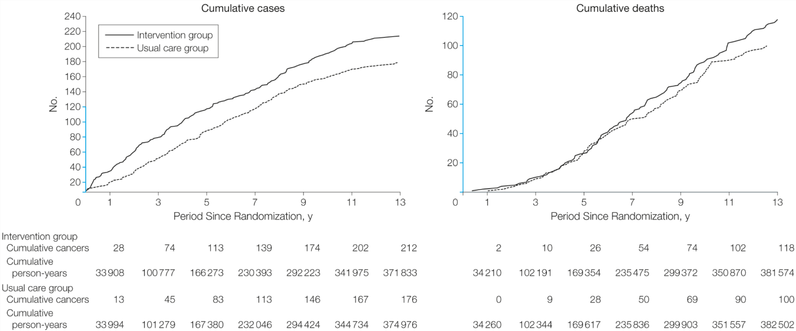
Figure 2. Ovarian Cancer Cumulative Cases and Deaths. Reproduced with permission from JAMA.2011.305(22):2295-2303. Copyright©(2011) American Medical Association. All rights reserved.

- Assume (as appears to be the case) that both curves level off over time and the usual care curve never catches the intervention curve. What is the most likely explanation (other than chance) for the excess of ovarian cancer diagnoses in the intervention group? Explain. [2]

- The difference in ovarian cancer mortality between the intervention and usual care groups could have been due to chance. Could a higher cause-specific mortality rate be explained by the following? For each possible option, say yes or no and explain your answer.

- Sticky diagnosis bias [1]

- Slippery linkage bias [1]

- Overdiagnosis [1]

- Length-time bias [1]

c) Complications associated with diagnostic evaluation for cancer occurred in 45% of the women diagnosed with ovarian cancer in the screening group, compared with 52% of the women diagnosed with ovarian cancer in the usual care group. Do these point estimates suggest that screening was not associated with an excess of complications from diagnostic evaluations for ovarian cancer? [2]

d. The report of the extended follow-up includes Figure 2b below, which compares ovarian cancer survival among those in the intervention arm whose ovarian cancer was diagnosed by screening with those whose cancer was diagnosed by other means. Survival was longer for screening detected cancers (log rank test P=0.04).

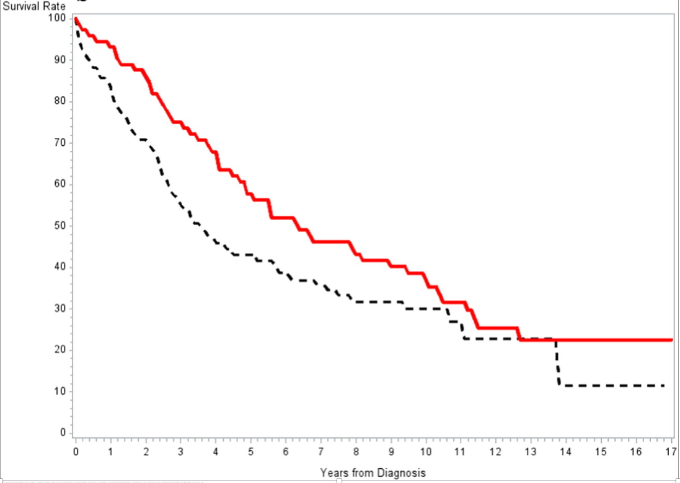
Fig. 2b) Ovarian cancer-specific survival by mode of detection in the intervention arm. Red (solid) line is for screen detected cases, black (dotted) line is for non-screen detected cases.
Reprinted from Gyenecologic Oncology, 143(2): 270-5, Extended mortality results for ovarian cancer screening in the PLCO trial with median 15 years follow-up. Copyright 2016, with permission from Elsevier.

- With survival curves like Figure 2b sample size diminishes over time, so it's hard to tell whether differences after about 10 years are real. But let's suppose that after 12 years the survival curves actually come together and that leveling off of the red screen-detected cancer survival curve is due to luck. If that were the case, would this figure be more consistent with overdiagnosis or lead time bias? (Explain your response.) [2]
- Repeat the question above, but now assume that survival really does level off at a little over 20% in the screen detected group, but not in the other group. Now would the figure be more consistent with overdiagnosis or lead time bias? (Explain your response.) [2]

REFERENCES

1. Buys SS, Partridge E, Black A, Johnson CC, Lamerato L, Isaacs C, et al. Effect of screening on ovarian cancer mortality: the Prostate, Lung, Colorectal and Ovarian (PLCO) Cancer Screening Randomized Controlled Trial. JAMA. 2011;305(22):2295-303.
2. Pinsky PF, Yu K, Kramer BS, Black A, Buys SS, Partridge E, et al. Extended mortality results for ovarian cancer screening in the PLCO trial with median 15years follow-up. Gynecol Oncol. 2016;143(2):270-5.

