Molecular and Genetic Epidemiology
Assignment 7
Due by noon on Monday before next class

A. Reading

Austin Ch. 7

B. Your project

Can you find any local admixture analysis done for your project? How does the number of hits for local admixture analysis compare to GWAS for your trait?

[answer’s vary]

C. UKB Project

The groups we have been looking at summary statistics on have been focused on “white British European-ancestry samples”. What parts of the genome are we missing because of this?

Missing variants that are too rare in European ancestry and are more prevalent in the other groups.

D. Admixture analysis

Suppose we are interested in looking at the ancestry of the 1000 Genomes Project individuals. From the 1000 Genomes webpage, what are the population groups, and the population supergroups and their meanings (http://www.internationalgenome.org/faq/which-populations-are-part-your-study/)?

“
Population Code | Population Description | Super Population Code
CHB | Han Chinese in Beijing, China | EAS
JPT | Japanese in Tokyo, Japan | EAS
CHS | Southern Han Chinese | EAS
CDX | Chinese Dai in Xishuangbanna, China | EAS
KHV | Kinh in Ho Chi Minh City, Vietnam | EAS
CEU | Utah Residents (CEPH) with Northern and Western European Ancestry | EUR
TSI | Toscani in Italia | EUR
FIN | Finnish in Finland | EUR
GBR | British in England and Scotland | EUR
IBS | Iberian Population in Spain | EUR
YRI | Yoruba in Ibadan, Nigeria | AFR
LWK | Luhya in Webuye, Kenya | AFR
GWD | Gambian in Western Divisions in the Gambia | AFR
MSL | Mende in Sierra Leone | AFR
ESN | Esan in Nigeria | AFR
ASW | Americans of African Ancestry in SW USA | AFR
ACB | African Caribbeans in Barbados | AFR
MXL | Mexican Ancestry from Los Angeles USA | AMR
PUR | Puerto Ricans from Puerto Rico | AMR
CLM | Colombians from Medellin, Colombia | AMR
PEL | Peruvians from Lima, Peru | AMR
GIH | Gujarati Indian from Houston, Texas | SAS
PJL | Punjabi from Lahore, Pakistan | SAS
BEB | Bengali from Bangladesh | SAS
STU | Sri Lankan Tamil from the UK | SAS
ITU | Indian Telugu from the UK | SAS
These populations have been divided into 5 super populations
- AFR, African
- AMR, Ad Mixed American
- EAS, East Asian
- EUR, European
- SAS, South Asian”

Now that we know which populations are in the dataset, we’ve downloaded the data, and run the software program Admixture on a thinned genotype dataset. One of the issues with this program is that we must prespecify the number of ancestral populations, K, in the group. As such, we have run several different values of K=2, 3, 4, 5:

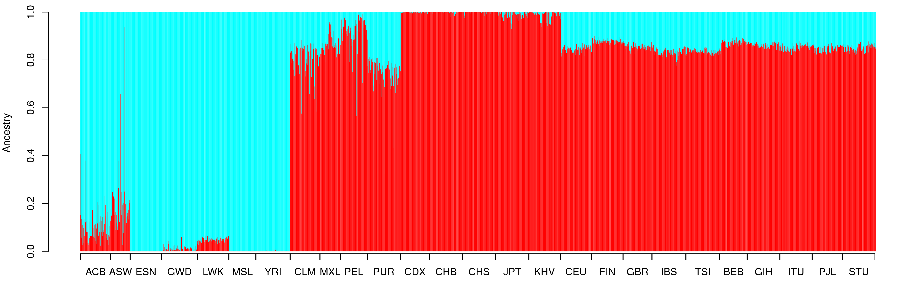
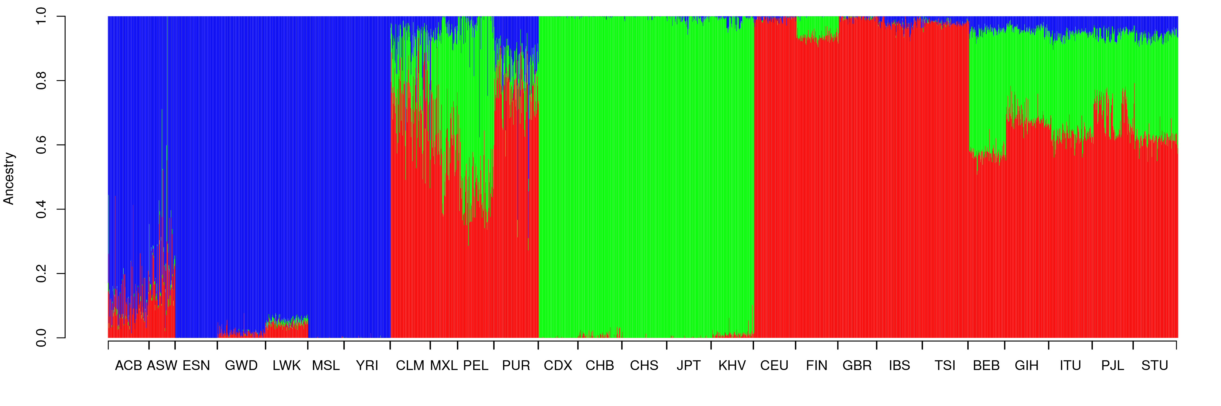
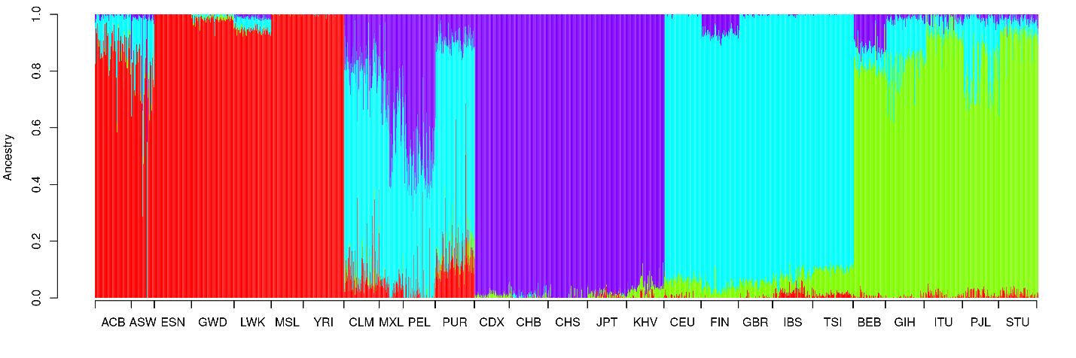
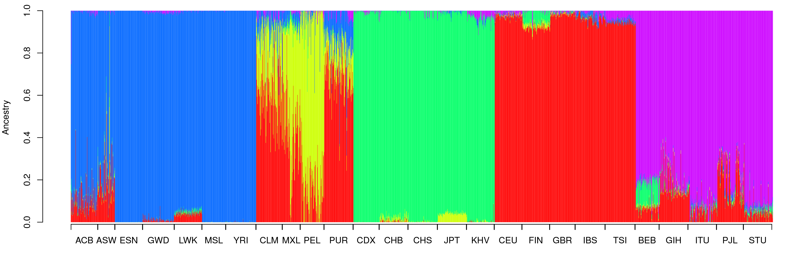For each value of K, what ancestral groups are each color capturing?

K=2: African and non-African
K=3: African, European, Asian
K=4: African, European, East Asian, South Asian
K=5: African, European, East Asian, South Asian, ?

Overall, do you see a separation/differences amongst all of the supergroups? Amongst all of the groups?

Aside from K=2, the different supergroups tend to have patterns different from each other. Within each supergroup, we see some different proportions within some of the different groups as well.

If you recall previously in the course we looked at principal component analysis, and saw how that separated out the different ancestries. We’ve also done that here, for comparison to admixture analysis. Below is a plot of the first two principal components:

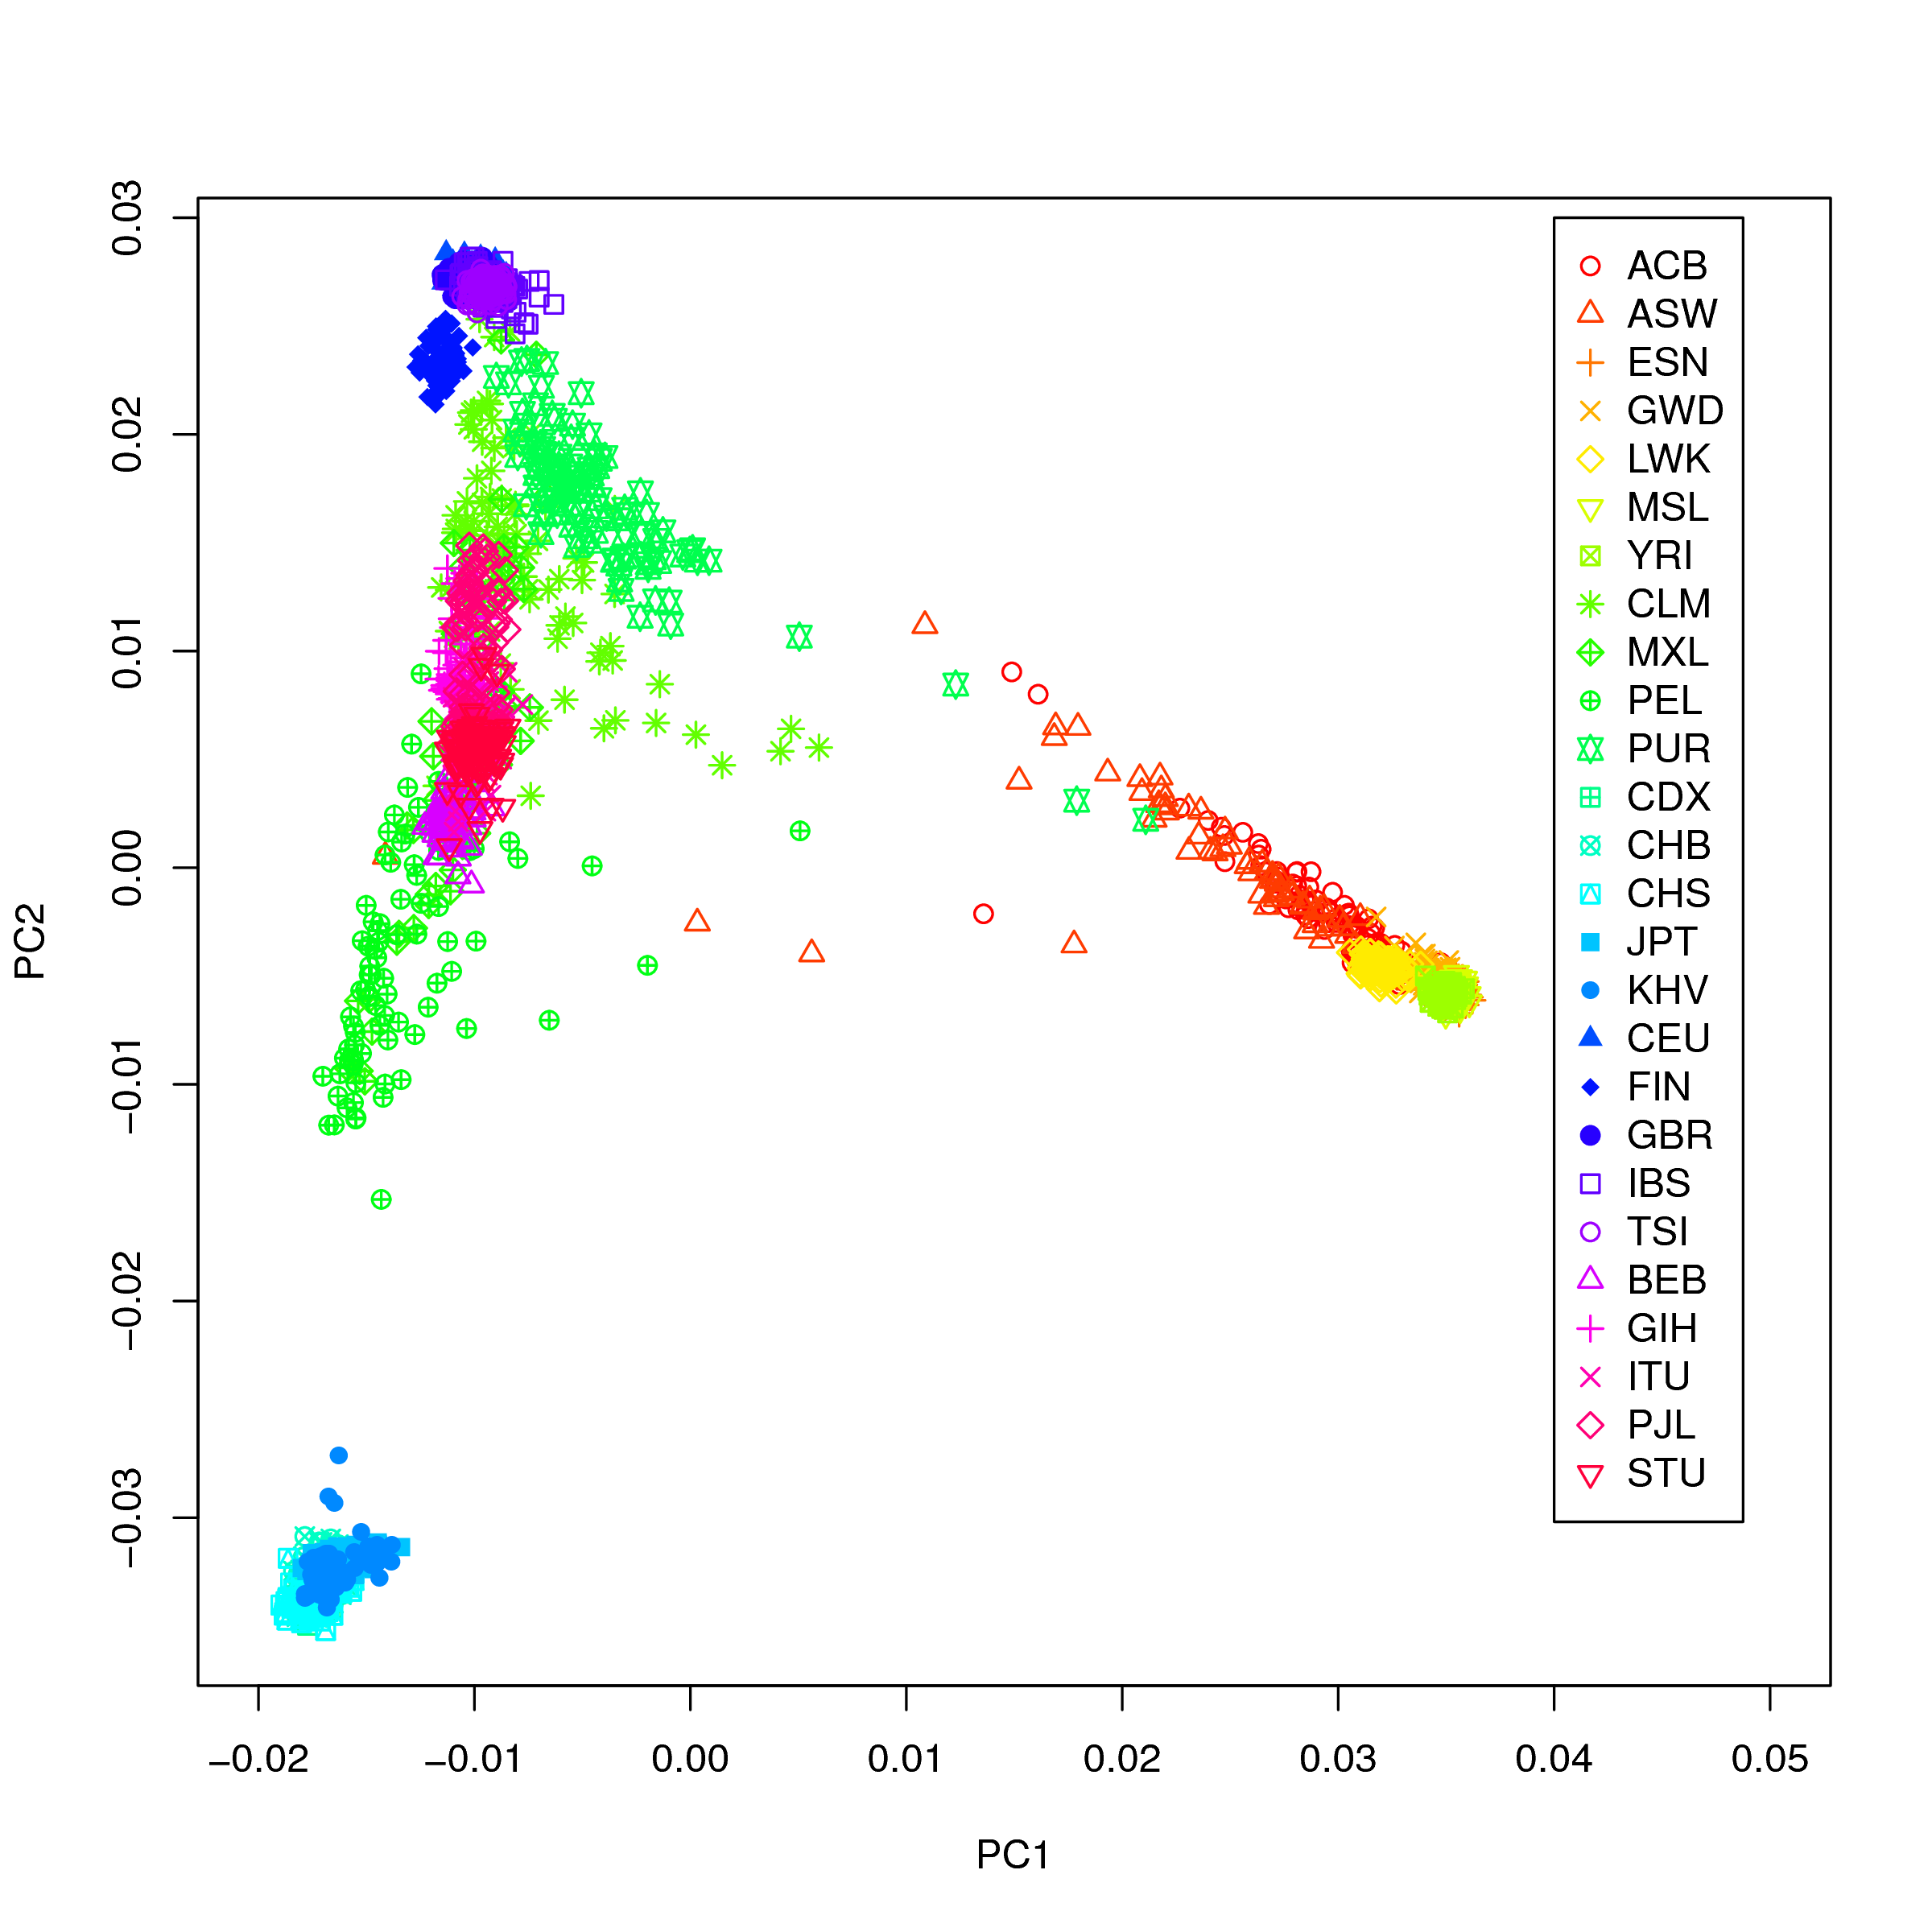
Do you see a separation amongst all of the supergroups? Amongst the groups?

Most of the AFR, EUR, EAS, and SAS groups show up as distinct clusters from each other. The AMR group overlaps some with the SAS and touching into the EUR, and spreading out across all groups.

What if I told you that the correlation between the PCs and each of the three ancestries (for K=3) is:

PC | K | Correlation
1 | 1 | -0.468
1 | 2 | -0.587
1 | 3 | 0.994
2 | 1 | 0.883
2 | 2 | -0.810
2 | 3 | -0.110
3 | 1 | -0.0083
3 | 2 | 0.0062
3 | 3 | 0.0023

Do you see any relationship between the ancestry principal components and the Admixture ancestry estimates?

Yes! PC1 looks to represent AFR ancestry (positive PC1). This correlates highly with the third ancestry component (which shouldn’t surprise you is the blue in the figure!). There is also some correlation between PC2 and the groups. PC3 seems pretty uncorrelated with them.

E. Admixture mapping questions

1. What is the most important covariate in any genomic association study?

Ancestry.

2. There are both common and rare variants. Which of the two tend to be pan-ethnicity versus race/ethnicity specific? Which of the two are more abundant in the genome?

Common variants tend to be more pan-ethnicity. Rare variants tend to be more race/ethnicity specific, and are more abundant in the genome.

3. True or False. Race/ethnicity differences in disease prevalence are highly confounded between genes and environment, and a group difference alone does not indicate a source for that difference.

True! A difference between two groups can be environmental, it doesn’t necessarily imply that there must be a genetic difference between the groups.

