EPI 214 support documents:
PowerPoint: https://ucsf.box.com/s/1nc5y52kk3w4f5j6mqor7cty6d7xvw94
Extensive search handout: https://ucsf.box.com/s/hdb0n3uwj6lzokk4xwexry9u5fvvp5sq
RefWorks handout: https://ucsf.box.com/s/ybkafgowgin7r7fovcaksn96cji02q6u
Systematic review library guide: http://guides.ucsf.edu/systematic
My email: evans.whitaker@ucsf.edu

What is your question?

Which is better for fever in children Tylenol or Advil?

What are the concepts in your question?

fever, children, Tylenol, Advil

You can use PICO for this:

PICOTT | Wording | Notes
P problem or population | Fever in children | This is really two concepts in one
I Intervention or Exposure | Tylenol | Remember synonyms
C Comparison | Advil | Remember synonyms
O Outcomes of interest | Duration of fever  Amount of fever  Comfort  Satisfaction of patient/parent  Adverse effects | Multiple outcomes, maybe exclude this one, at least initially…
T Type of question | Therapy | Others are: diagnosis, prognosis, etiology, etc.
T Type of study | RCT preferred | Systematic review done about this?  Is a cohort acceptable?

Qualitative SR?
Use SPIDER rather than PICO: see http://www.nccmt.ca/knowledge-repositories/search/191

What databases will you search?

This is a biomedical question. PubMed and Embase make the most sense to search

Will you “handsearch” = cited reference searching and possibly searching of TOCs of highly relevant journals for a chosen time period.

Will look at refs of highly relevant articles in Web of Science

Will you search grey literature? For emerging fields looking at conference proceedings for relevant conferences for last 2-3 years may be worth doing. Can use Google with search domains to do this as well. That is by adding site: and then a domain to the end of your Google search you can limit to .edu, or .gov, or country website (like co.uk for the UK or .es for Spain)

Not emerging field, will not plan to include this type of information. Other topics, it makes sense to use to use Google with domains to find white papers from .gov, .org, .edu.

“Build out” each concept:

Search controlled vocabulary, add the synonyms you know or find, remember quotation marks, and other punctuation as needed.

For PubMed:

“Fever”[mesh] OR fever or pyrexia or hyperpyrexia

Child* (finds child OR children OR childhood) OR toddler OR teen OR teenage* OR adolescen* OR toddler OR infant

Acetaminophen OR Tylenol OR Panadol OR paracetamol OR…(19 synonyms found in MeSH)

Ibuprofen OR Motrin OR Advil

Assemble your search: Use AND, OR, ( )

(“Fever”[mesh] OR fever or pyrexia or hyperpyrexia)
AND
(Child* (finds child OR children OR childhood) OR toddler OR teen OR teenage* OR adolescen* OR toddler OR infant)
AND
(Acetaminophen OR Tylenol OR Panadol OR paracetamol)
AND
(Ibuprofen OR Motrin OR Advil)

I look at results before limiting to Publication Types

Embase
Copy your PubMed search here:
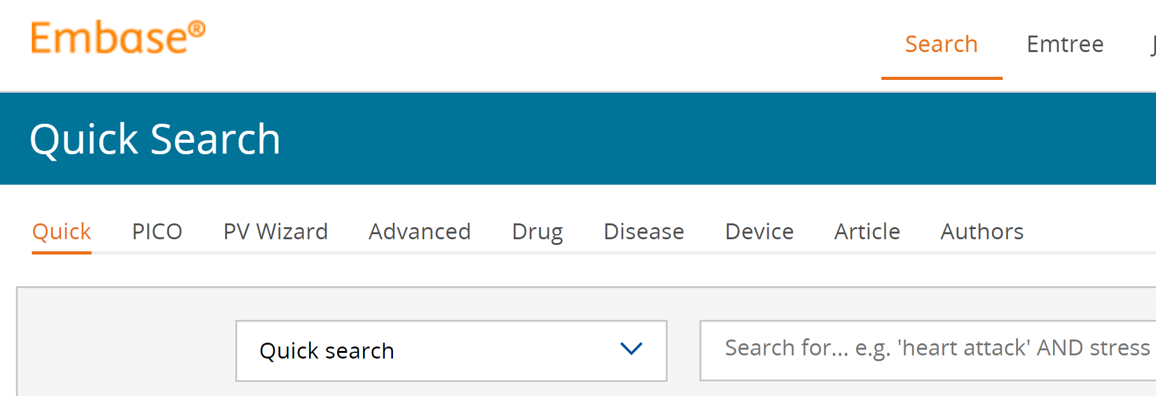
Find Emtree for each concept and add those. Remove the PubMed punctuation, like [mesh], [ti], and other things in square brackets. Embase can be very picky and sometimes you need to replace double quotes with single quotes. [ti] becomes :ti
Various search types for Embase
Emtree is MeSH for Embase

Web of Science
Copy your PubMed search here:

Take out all the PubMed specific stuff. Basically this means anything with square brackets around it [ ]

Also use WoS as a cited reference search. Search for articles you plan to include in your systematic review by copying and pasting their titles. If WoS can’t find it shorten the title as occasionally long titles or those with colons will confuse the search engine. Once you have located the article click on its title and look for citation patterns.

RefWorks:
Import results from each database (this is usually done without weeding out results in the reference manager). Put the results from each database in its own folder. At the same time write down the date of the search, the search strategy and the number of items found.

You will then use RefWorks to remove duplicates… good RefWorks tutorials here: https://www.youtube.com/playlist?list=PLyN7Mmvg_0of4d81CN6kZ5NrSuH5sv6iF
RefWorks handout here: https://ucsf.box.com/s/ybkafgowgin7r7fovcaksn96cji02q6u

Covidence:
Set up a free account at Covidence.org
Create your systematic review project
Import your list of deduplicated references from RefWorks as an RIS file. Note: Covidence can also eliminate duplicates
Set your screening parameters (one reviewer)
You can add inclusion and exclusion critieria and more…

Same advice for DistillerSR and Rayyan. Google searches will easily locate these three pieces of software.

