Library 101
On Campus: Use UCSFwpa network, not UCSFguest
Off Campus: Use MyAccess, not PulseSecure or remote.ucsf.edu
Bookmark three things in your browser:
library.ucsf.edu
pubmed.ucsf.edu
uptodate.ucsf.edu
Add the “bookmarklet" for off-campus access: https://www.library.ucsf.edu/services/remote
UCSF Library Catalog
Use this for electronic books: 1. Go to library.ucsf.edu. 2. From Search & Find tab, select UCSF Library Catalog. 3. Change tab to Keyword. 4. Search (see icons above)

Created and maintained by National Library of Medicine and National Center for Biotechnology Information (NLM and NCBI respectively) PM is the grand-daddy of biomedical databases. It is still the world’s standard. It is freely available to all worldwide, unlike its competitors. Commercial databases purchase access to PubMed files and add them to theirs. It contains about 28M articles from over 5.6K journals; growing by about 1 million articles a year. It is organized for intelligent retrieval of information.
MyNCBI is your personal space at PubMed to save your work. Today we will set up an account and set some preferences.
Key Concepts for PubMed:
- Identify concepts within your question. Two or three concepts per search usually work best
- Use MeSH as an index to find good words or phrases for each concept.
- Do your searches in the PubMed search box.
- Include the exact wording of MeSH terms in your search, if applicable.
- OR together the synonyms for each concept
- AND the concepts together
- Use Search Details to improve your search
- Use Advanced to see your search history
- Create alert saves your search, receive new articles from your search.
- Receive tables of contents from favorite journals.
Filters and Icons
Publication types
Case reports
Clinical trial
Comparative study
Controlled clinical trial
Evaluation studies
Guideline
Meta analysis
Multicenter study
Observational study
Practice guideline
Randomized control trial
Review
Validation study
Subsets
Systematic Reviews
There are many more!
Set up a MyNCBI account – Why? To save your work.
- Go to: library.ucsf.edu
- Click PubMed.UCSF.edu link in Popular Resources
- Click Sign in to NCBI in upper right
- Create an account if you don’t have one already.
  - Register for an NCBI account, near bottom left of page (add an email)
- Once done Create Account, acknowledge email, and then click MyNCBI (top right)
Set MyNCBI preferences - Why? These will make sorting through search results quicker and easier.
- Once logged into MyNCBI…
- Click on MyNCBI Site Preferences (near upper right of page)
- 4 useful things to modify – there are many others “go shopping” for other useful choices. You can change settings as needed for a project. For instance, Age groups in Properties might be useful for your work.
  - In Common Preferences
    - Highlighting Pick a color. Your search words will be highlighted
  - In PubMed Preferences
    - Abstract Supplemental Data Open
    - Result Display Settings Abstract, 100, Pub Date
    - Filters and Icons – You are allowed a total of 15 filters in MyNCBI
See box on previous page for a suggested group.
  - To move from MyNCBI back to PubMed…
    - Click PubMed link near bottom of page in the center (Popular) column.
Structure of PubMed and MeSH
MEDLINE (ML) is a highly organized subset of PubMed (PM). ML contains about 90% of the articles in PM. The part of PM NOT in ML is where the newest material lives until it is “indexed” by the by “subject experts” at the NLM.
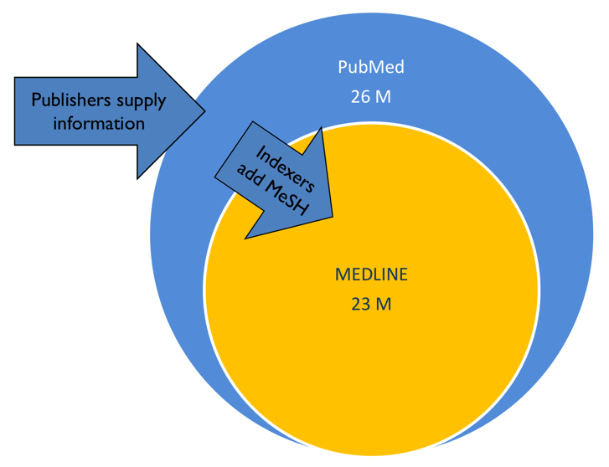
“Indexed” means each article is read and additional information (“metadata”) is added to the database of articles making it easier for searchers to find what they want.10-15 “tags” are applied to each article. These describe what the article is about. Of those 10-15 MeSH, 2 or 3 are identified as the most important (MAJOR).
The tags are selected from a standardized set of ~25,000 Medical Subject Headings (MeSH) by indexers at NLM. Think of MeSH as the index to the book that is MEDLINE/PubMed.
The details of learning how to take advantage of the structure of PubMed to search more effectively is more than we have time for today. There is a lot to learn about PubMed, and there are classes and consultations available at UCSF for those who are interested in more depth. Contact me for information.
Today we are going to use a fairly simple method to search in PubMed. This works OK because PubMed attempts to translate the words of your search into MeSH. This translation process is called Automatic Term Mapping (ATM). By including the exact wording of MeSH as part of your search, PubMed looks for all the synonyms of the term and also searches the term as a keyword. Search sensitivity is greatly increased as a result.
PubMed search modifiers – “”, [ti], *
fever in children -- each word needs to be somewhere in the entry (any order, together or not)
“fever in children” – searches for exactly what is between quotes anywhere in a PubMed entry
“fever in children”[ti] searches for the word or words in the title
child* - the asterisk is a “truncation symbol” means PM will search for child, children, childhood, etc.

Type in PubMed search box | # Results
diagnostic reasoning
“diagnostic reasoning”
“diagnostic reasoning”[ti]
A little finesse with Keywords
(=basically anything that is not a MeSH term).

Two Useful PubMed Tools Clinical Queries and Single Citation Matcher
Try Clinical Queries. CQ is a useful tool for rapidly finding a few high quality clinical articles. See evidence pyramids in the Appendix (p. 16) for related information.
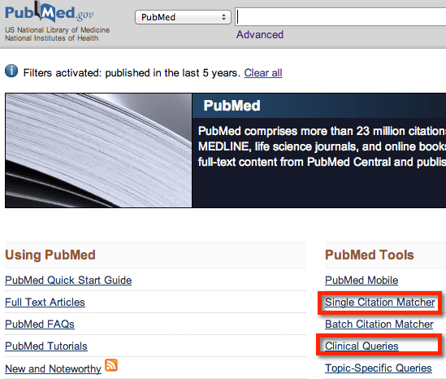
To search for “which drug is better for fever in children, Tylenol or Motrin” type Tylenol Motrin fever children into the search box look at results. Notes: 1. CQ and PM assume AND between words.
2. Therapy, narrow = RCTs.

Single Citation Matcher is a useful tool to find a particular article when you have incomplete information. Ex. Find BMJ article from 2003 by Smith. It is from the BMJ yearly joke edition.

Intelligent Search – 1. Carefully define your question 2. Find the best keywordsUse MeSH as a dictionary, use Google, GoogleScholar, use “pearl growing”. Include MeSH wording in your PubMed search (adds the power of the MEDLINE synonym search), add the keywords used by authors in the field, combine synonyms with OR, combine concepts with AND (see page 4). 3. Improve search iteratively with Search details.
“Pearl growing” uses a good known article to find others. Search article title in PubMed, find the article, notice MeSH and related articles….
Enter a search into the PubMed search box and search.
Do you remember about Boolean operators
and using parentheses?
See diagram on page 4. Ask if you have questions.
Look at the first 20-40 results to see if you are getting what you want. If not, time to revise…
Very Important! Find the Search details box (located on right lower area on search page), and click see more for details of what PubMed did with your search. This is especially useful when PubMed misinterprets what you typed. You can edit in the search box to add, change, or remove words or phrases from your search.
Saving your work
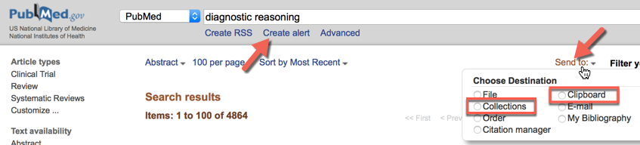
You have created a good search; save it so you can get back to it with Create alert.
You can temporarily save articles to Clipboard as you work and then permanently save articles to MyNCBI Collections.
Try it!

1. Check boxes of 3 articles. Send to: Clipboard.
2. Send the articles now in Clipboard to Collections.
Look just to the right of Send to: Clipboard: 3 items, click 3 items… Then Send to: Collections, the last steps are pretty self-explanatory
3. Click Create alert, rename the search something you can remember and Save.
a. If you want to receive new articles from your saved search, leave “Yes, please” checked, choose frequency and amount settings and Save.
5. Go to MyNCBI to find your Collections and Saved Searches
6. You can share a collection with others by clicking on the gear symbol next to your search and making your collection public. Share resulting URL with any collaborators.
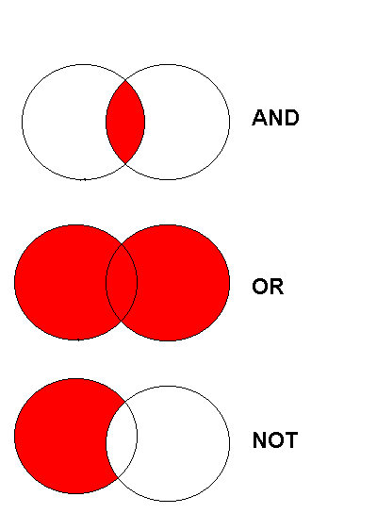
Boolean operators
and Venn Diagrams 1
Boolean Operators (AND, OR, NOT)
Combine concepts with AND
Combine synonyms with OR
Use NOT rarely.

Receive tables of contents from favorite journals:
From Single Citation Matcher (see p. 3), type in journal name and Search. Click Create alert (see figure p.3), name it something useful, leave “Yes, please” checked. Then set parameters as daily, abstract, 100. Now you will receive any new output from this journal
Too many results? Too few? Results not on topic?
Formulate the Search: To use a database effectively, think before you type!

1. After some background reading your original question may need to be reformulated; it may begin to look like several questions or you may answer it with background information. What might be a problem with not looking at foreground sources?
2. Create a simple, searchable question. This is the single most important (and difficult) step!
What does “simple searchable” mean? Avoid unnecessary detail. Carefully choose your words. Be willing to change words if they do not seem to work when you do your search. 4 construction methods to try…
a. Make a simple sentence of your question. Use the subject and object as search terms, avoid the verb as search engines are usually no good with those.
b. Write down a list of all the concepts within your topic. Select two or three as your search terms.
c. Most time consuming, organized and effective method: Create a table of concepts. Select two or three. Think of synonyms for each. String all that together and use that as your search.
d. Use the PICO model. This approach is derived from Evidence-Based Medicine (EBM), or more properly EBP (EB Practice)
See page 6 for examples.

Too many? | Too few | Not on topic?
For a keyword search: “” (phrase), [ti], [tiab] search  Add concepts with AND.  Use filters (will lose articles that are not indexed). | For a keyword search: Remove terms. Remove “” (phrase), [ti], [tiab].  Add synonyms with OR. | Consider going back to background sources. Learn more and try again…
For a MeSH search:  Move down one level in MeSH “tree” to more specific term. Add filters, subheadings, MeSH terms. Change MeSH to Majr in disease or condition. | For a MeSH search:  Move up one level in “tree” to more general term. Remove filters, subheadings, fewer MeSH terms, substitute MeSH for Majr. | “Pearl grow” find one good article about the topic from a text, Google search, quick PubMed search, etc. In PM, look at MeSH terms, and look at related articles. In Google look for cited articles, related articles.
Consider moving outside of PubMed Web of Science
Education related? ERIC
Sociology? Sociological Abstracts
Psychology? PsycINFO
Nursing/Allied Health? CINAHL
PLAN YOUR SEARCH!
a. One searchable sentence:

b. Concept List: circle the most important two or three concepts:
1.
2.
3.
4.
5.
c. Concept/synonym table:
OR
OR
OR
 | Synonym A | Synonym B | Synonym C | Synonym D
Concept 1
Concept 2
Concept 3
Concept 4

AND

AND

AND

d. PICO:

P | Population or Problem or Patient
I (or E) | Intervention (or Exposure)
C | Comparison Group (if any)
O | Outcome
Examples of search formulation:
You are asked by a parent which medicine is best to give their 3-year-old boy for a temperature of 102º F, Tylenol or Advil?
What is the one sentence clinical question you might ask based on this vignette?
Probably something like “Which is better for treating fever in children, acetaminophen or ibuprofen?”
Concept list: * = most important concepts for search
parental anxiety
medication side-effect
medication effectiveness
*3 year old (age group)
boy (sex)
*temperature (fever)
102º F
*Tylenol
*Advil
Concept/synonym table:
 | Synonym A | Synonym B | Synonym C | Synonym D
Concept 1 | Tylenol | acetaminophen | Panadol
Concept 2 | Motrin | ibuprofen | Advil
Concept 3 | fever | hyperpyrexia | pyrexia
Concept 4 | children | infants | toddlers | pediatric

PICO or PECO:
P | Population or Problem | Children with fever
I (or E) | Intervention (or Exposure) | Ibuprofen
C | Comparison (if any) | Acetaminophen
O | Outcome | How low, how long T ⬇?

Final search: (Tylenol OR acetaminophen OR Panadol) AND (Motrin OR ibuprofen OR Advil) AND (fever OR hyperpyrexia OR pyrexia) AND (children OR infants OR toddlers OR pediatrics) into the search box.
Why AND between concepts rather than OR? Why OR between synonyms?

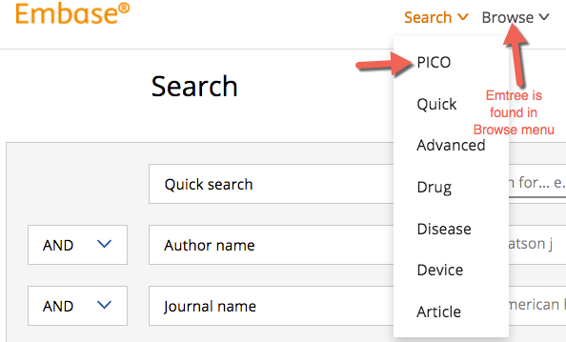
Other Databases.
We usually recommend checking three sources before making important decisions.

Embase Biomedical database that extends the reach of PubMed by 8-9 M articles. Use is similar to PubMed. Has a MeSH equivalent called Emtree. Find on library home page just below PubMed
Suggested methods of use:
Quick search: Type in words combined with AND or OR in search box.

PICO search: Use this EBM question format to create your search
More comprehensive search:
- Search for terms for your first concept in Emtree (see image)
- Click on your chosen term
- Add it to Query builder
- Then repeat for other concepts
- Make sure ANDs and ORs are correct then Take to Advanced Search
- Make sure Search as broadly as possible is selected, then Search
- From here you can export to reference managers, save your search, etc.

Web of Science (WoS), commercial article database with broad range of content. Find by search on library home page or from Databases link in Popular
Large database with ~10K journals, 35M articles indexed. More social sciences content than PubMed.
The good:
If you find an article you like you can look for related articles, PM, WoS, and GoogleScholar have a similar feature but this one seems to work better than PM or GS.
Three generations of information in one place!
From within WoS you may look at the references of an article; you can link to those.
From within WoS you may look at newer articles which have cited the article an article; you can link to those. “three generations of information on one page”
The bad: A “black box”, you gain simplicity but lose control of your search.
See figure below.
Search for web of science from the library home page search box. Find it in databases
Create a search in this database. In web of science you can copy and paste your PubMed search.
Pick an article you like from your search.
Notice the left column. It provides an almost overwhelming number of ways to Refine Results. In Document Types choose Review (includes systematic reviews)
How many articles were cited in the article you chose? _______________.
How many times has this article been cited by other articles? __________________
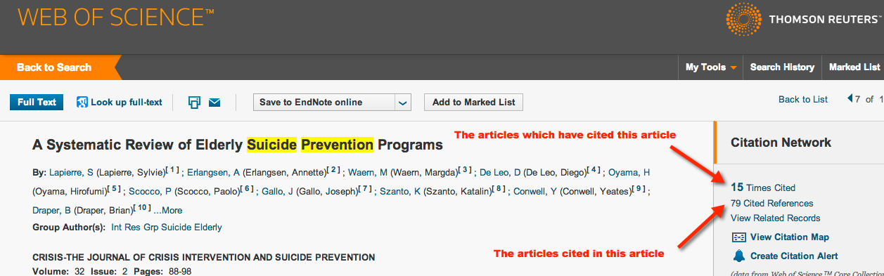
GoogleScholar
scholar.google.com
Searches for scholarly output, case law, and patents.
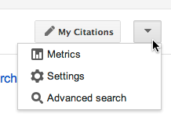
Sadly, Google has stopped supporting many sophisticated search features over time. GS remains very useful. Use it near the beginning of a search to get an idea what is out there and what words might be useful in a search.
Use it near the end of a search session to see if it finds
anything you did not find elsewhere.
TIP: Only look through the first 20-40 hits
To make GS most useful: Change 3 settings
Library links UCSF
Display 20 per page
Reference managerSelect what works for you.
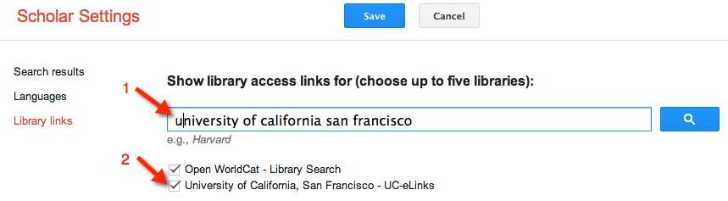

What it is good for?
- When other sources fail. Sometimes you can find one or a few good articles. These articles can be used as “keys” to open up other databases.
- When you are starting to learn about a topic and don’t know the vocabulary yet.
- When your topic has a very unique name that makes for precise searching.
- At the end of your search process, sometimes you will find something not found elsewhere.
Scholar notes:
GS had a synonym search that is no longer supported. Opinions vary about whether the proximity search function works anymore.

Boolean operators: AND is assumed between words. OR seems to cause problems with searches. Although is worth a try.
What makes it hard to use the usual Google issues…too many results; harder to figure out whether the material is coming from a trusted source.

Try our same search: use Advanced Search:
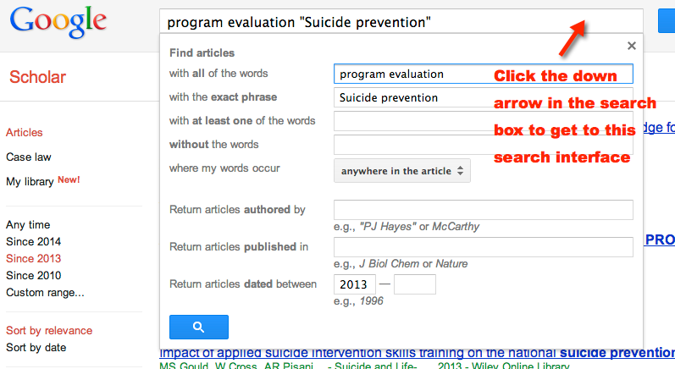

Notice that there are UC-eLinks ( full-text), Related articles and Cited by … in the GoogleScholar display.

How many times does GoogleScholar say the article shown in the Web of Science portion (see screen shot on page 8 for title) was cited? __________________

One last word about
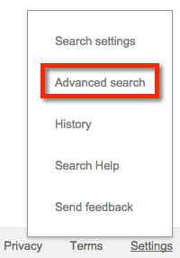
Advanced search is well hidden in Settings.
Limit to domain of search to “aim” better and get better quality results.

PsycINFO and Sociological Abstracts Subject area is obvious from title. Both use a Thesaurus (equivalent to MeSH for MEDLINE) = a good place to find good words to search with. Yellow folder icon hides suggested terms. Construct search just like Web of Science.

Anthropology Plus You can guess the emphasis of this database. Once again it has a MeSH equivalent (“controlled vocabulary”). See image on top of next page.

Reference Manager – Why would you want one? Store and organize the information you find. Use it to format Word documents. Use it to share your work with others. They are major time and energy savers!

I am fond of RefWorks and Zotero see: https://goo.gl/A3qQgT for online tutorials and/or handout https://ucsf.box.com/s/i996dlr0frfzkduxwk7ixa48yaa9zbe4 for setup and use. There are many others…

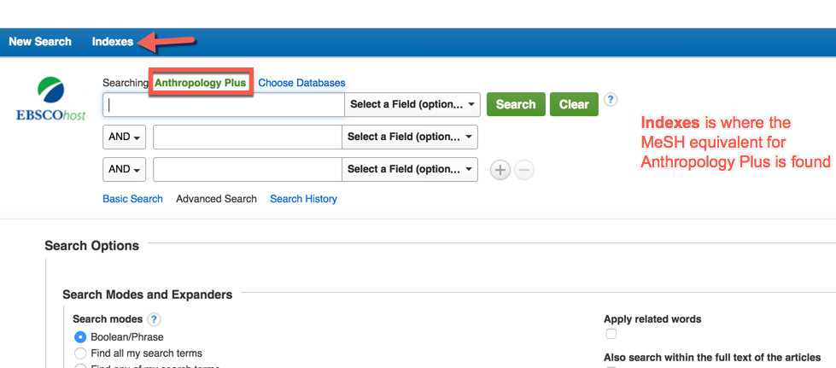
RefWorks

Refworks is an easy to learn and use reference manager. Recently purchased by ProQuest who has at last gotten around to modernizing and improving it! It is truly a worthy contender with EndNote and others. Reference managers do three things, they store and organize information you use for your work. They automate adding citations and references to documents.

Sign up:
Go to https://refworks.proquest.com/ Create an account using your UCSF email.
Set up:
Once you are on the RefWorks All Documents page notice 3 vertical dots (red arrow), click on that icon (see next page for details)

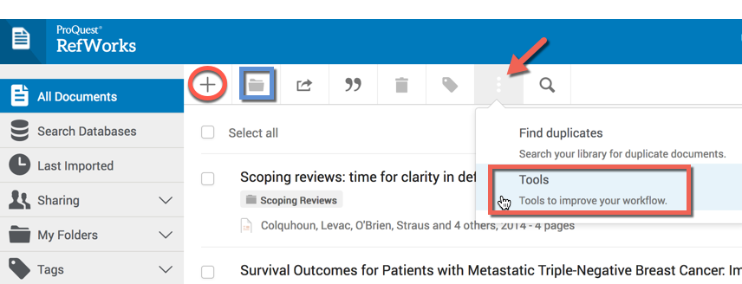
See left.
Red arrow. Access tools you need to set up RW. Identify and remove duplicates from RefWorks.

Red circle Add files, documents (PDFs), or create a new reference manually

Blue square. Select articles, then click square to add them to a folder. You may create a new folder here.

From tools menu. On top half of page:
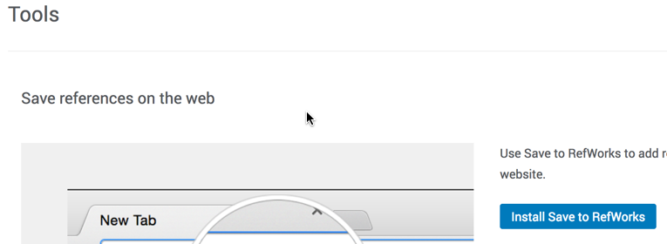
Click Install Save to RefWorks.
On next page “click and drag” gray Save to RefWorks to bookmarks toolbar.

Close page using pale X in top right corner.

On bottom half of page:

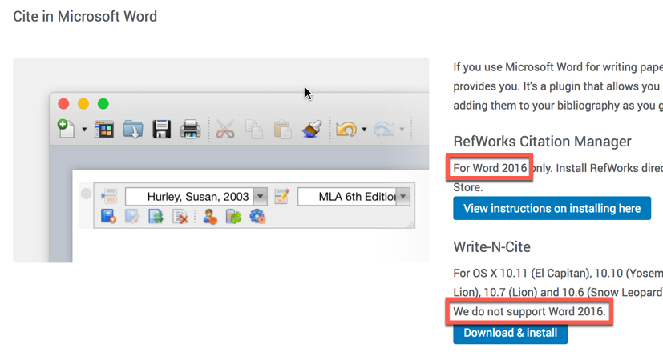
Locate the proper version of the Word plugin. If you have Word 2016 be sure to pick the right one! Follow the instructions that follow.

Now open Word and be sure you see evidence of RefWorks plugin.

If you have Word 2016 you will find RefWorks by clicking on the Insert tab, finding Add-ins, then finding MyAdd-Ins. There you should see RefWorks. Highlight RefWorks and click insert.
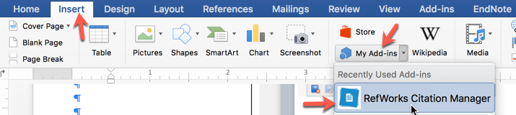

Your Word page will now look like (see next page):
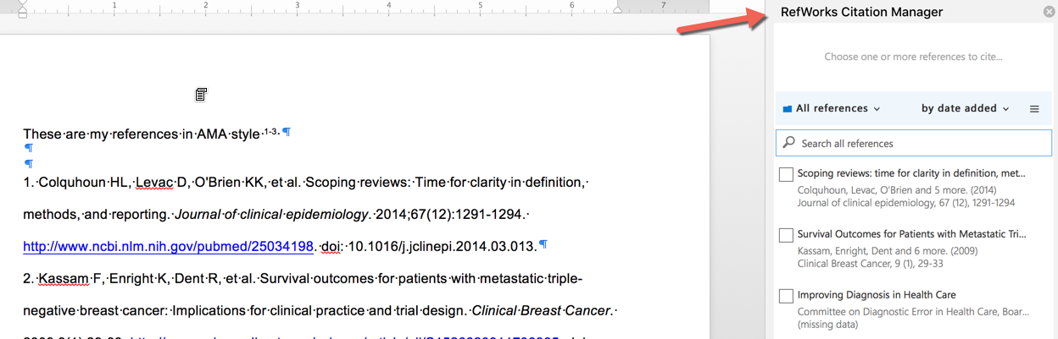

If you have Word for Mac 2011 you will see an inconspicuous toolbar in the far upper left. Each icon will identify itself if you hover over it, here you will want to login and sync. You can drag the tool bar to a better spot on the page by clicking and dragging on the far left of the tool bar (but not in the red circle!)

If you have Word for Windows 2013 you will see a RefWorks or ProQuest tab in Word. Log in and sync as mentioned above

Adding things to RefWorks:
PubMed and most article databases other than Embase, use the Send to Refworks bookmarklet

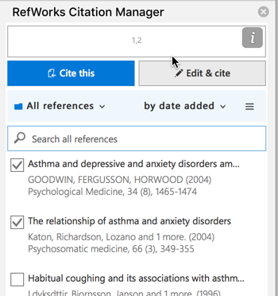
Embase is harder. Select the articles you want to move to RefWorks, export them as an RIS file and then import to RefWorks. What?! More detail follows.

Most websites: use the Send to RefWorks bookmarklet. Websites vary a lot about how well they import into reference managers. My advice? Check the information each time you import a website and edit as necessary. Though annoying it will save time later.

Formatting a Word document
With the RefWorks Citation Manager selected (see image above), pick the article or articles you want to cite. If you will cite more than one article check the boxes and then Cite this (see image to right).

Not everything, but enough to get you started!

There is much more to know but this is a good start. If you have problems or questions or need help please contact me. Thanks. Whit

