Spaces in Field Names: REDCap will not allow spaces in field names, but Access will. Even so, they can cause headaches later on, so do not use spaces in field names. For example, use “FirstName”, “First_Name”, or “first_name”, but not “First Name” or “first name”.

Capital Letters in Field Names: REDCap will not allow capital letters in field names, but Access will. We love using IntraCaps/CamelCase (e.g., “FirstName”) to distinguish words and make field names more readable. This is our preference for field names in Access. However, in REDCap, you will have to use underscores to distinguish words, e.g., “first_name”.

Indicator Fields: Always code Yes/No fields with “1” for Yes and “0” for No. The mean value is the proportion in the sample with the characteristic. Try to name the field with the “Yes” response and add “ ind” or “IND” at the end of the variable names. For example, in Lab 1, the field that indicates whether the subject had neonatal hyperbilirubinemia is named “hyperbili_ind” and coded 1 for yes and 0 for no. The field type for an indicator field should be “Integer” or “Byte”, not “Boolean” or “Yes/No”. A true Boolean variable does not differentiate between “False” and blank/not valued. See “Boolean field type and checkbox controls” below.

Coding a Field for Subject’s Sex: “F” or “M” is a fine system for coding a field for the subject’s sex. Sometimes, it is preferable to use a numeric code. In that case, always use 0 for Female and 1 for Male, or to be consistent with what we said above about indicator variables, name the field “sex_male_ind”. The average value of this field is the proportion of males in the sample.

Multiple Response Questions
Use check boxes (squares) to identify response options in “all-that-apply” questions (which we discourage).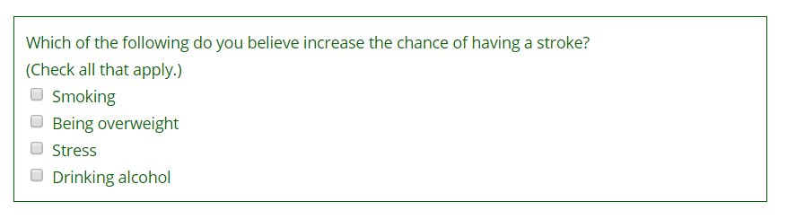However, checking “all that apply” does not force the respondent to consider each possible item; an unchecked box may mean the item does not apply or was simply overlooked. It is better to ask respondents to mark each possible answer as either “yes” or “no”.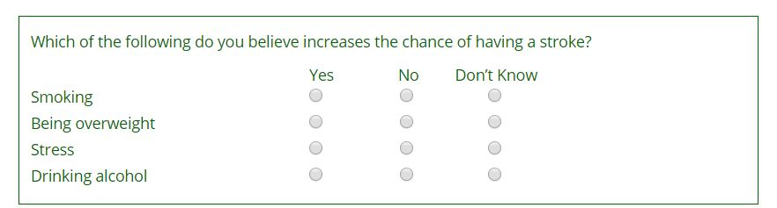
As demonstrated above, an “all-that-apply” question with 4 possible responses is really 4 single-response questions.
Use radio buttons (circles) to identify response options to single-response questions. The set of possible responses should be mutually exclusive (i.e., the categories should not overlap). When indicated, make the set of response options collectively exhaustive by including an “other (specify)” response.
Radio buttons are for mutually exclusive response options.

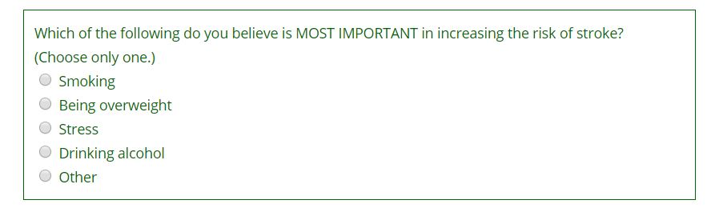

Boolean field type and checkbox controls

We recommend against creating Boolean (aka Yes/No) fields and using checkbox controls because they do not allow you to differentiate “No” from blank or not valued.

Checkbox controls are really only useful for a true checklist of things that must be completed before moving on. Here is an example:

NOTE: ALL the boxes below must be reviewed and checked before you proceed.

Informed Consent Form has been signed by participant and person obtaining consent
Completion of “Demographic Characteristics”
Completion of “KS Disease & Overall Health Characteristics”
Completion of “Lymphedema Assessment”
Completion of “Leg Edema Quality of Life”
Completion of “Overall Health Quality of Life”
This participant has Stage 1B or Stage 2 lymphedema. If both legs are affected, this participant has Stage 1B or Stage 2 lymphedema in the less severe leg.

NOTE: ALL the boxes above must be reviewed and checked before you proceed.

Race coding: In this class, we will use “Race” coding similar to (but not the same as) that used by the CDC. Here is how the CDC codes Race:

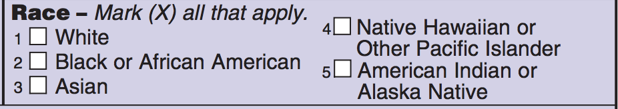

We will not use “all that apply” because it allows 32 distinct combinations. Instead, we will create a set of 7 mutually exclusive and collectively exhaustive options:

1, White
2, Black or African American
3, Asian
4, Native Hawaiian or Other Pacific Islander
5, American Indian or Alaska Native
8, Other (includes more than one race)
9, Unknown/Not Reported

Here’s how the Race field should look in REDCap.

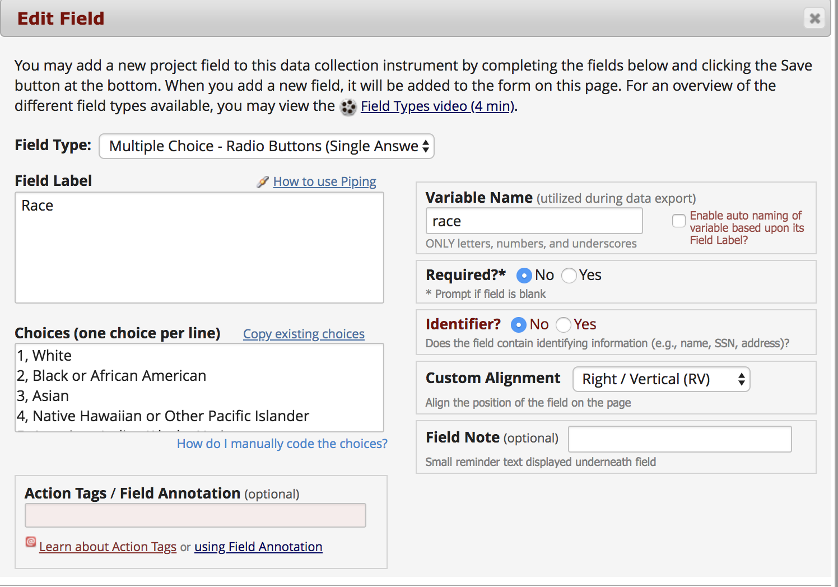

Ethnicity: Again, we will follow (sort of) the CDC, OMB, and US Census. The ethnicity field should be coded as follows:

1, Hispanic or Latino
0, NOT Hispanic or Latino
9, Unknown/Not reported

If we were to adhere strictly to the indicator variable naming convention, this field would be named “ethnicity_latino_ind”, but that isn’t necessary.

Here is what the field should look like in REDCap:
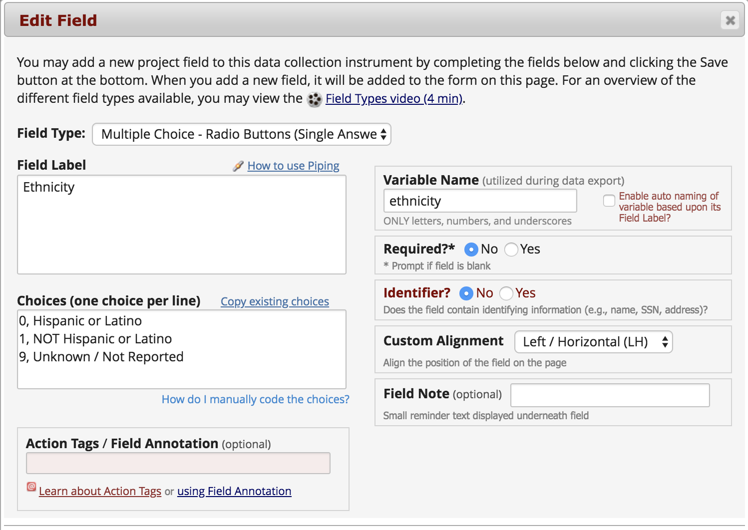

Multiple Choice Numeric Codes for Unknown and Other: REDCap, Stata, and other programs require you to code your multiple-choice options with integers. Try to use only the digit 9 when the option is “Unknown”, “Does Not Apply”, “Not Answered”, etc. In our Race field above, we used 9 for “Unknown/Not Reported”. It is fine, perhaps even preferable, to use 99 or even 999. Similarly, we used 8 for “Other (includes more than one race)”. More commonly, the option is “Other (Specify)”, and if you choose this option, a text field opens up. Try to use the only the digit 8 when the option is “Other”, “Other (Specify)”, etc. Again, it is fine, perhaps even preferable, to use 88 or even 888.

Additional Form Design Tips
Limit hard stops to record identifiers.
Allow saving of incomplete records.
Include a “Mark as Complete” option that triggers edit checks.
Collect raw data fields, not calculated fields.

