2 Dichotomous tests

Introduction
For a test to be useful it must be informative; that is, it must (at least some of the time) give different answers depending on what is going on. In Chapter 1 we said we would simplify (at least initially) what is going on into just two homogeneous alternatives, D+ and D−. In this chapter, we consider the simplest type of tests, dichotomous tests, which have only two possible results (T+ and T−).
While some tests are naturally dichotomous (e.g., a home pregnancy test), others are often made dichotomous by assigning a cutoff to a continuous test result, as in considering a white blood cell count > 15,000 as "abnormal" in a patient with suspected appendicitis.
With this simplification, we can quantify the informativeness of a test by its accuracy: how often it gives the right answer. Of course, this requires that we have a “gold standard” (also known as “reference standard”) against which to compare our test. Assuming such a standard is available, there are 4 possible combinations of test result and disease state: two in which the test is right (true positive and true negative) and two in which it is wrong (false positive and false negative; Box 2.1). Similarly, there are 4 sub-groups of patients in whom we can quantify the likelihood that the test will give the right answer: those who do (D+) and do not (D−) have the disease and those who test positive (T+) and negative (T−). These lead to our four commonly used metrics for evaluating diagnostic test accuracy: sensitivity, specificity, positive predictive value and negative predictive value.
Box 2.1: Dichotomous tests: definitions
 | Disease+ | Disease- | Total
 | a | b | a + b
Test + | True Positives | False Positives | Total Positives
 | c | d | c + d
Test− | False Negatives | True Negatives | Total Negatives
 | a+c | b + d | a + b + c + d
Total | Total With Disease | Total Without Disease | Total N
Sensitivity: the probability that the test will be positive in someone with the disease:
Mnemonics: PID = Positive In Disease; SnNOUT = Sensitive tests, when Negative, rule OUT the disease
Specificity: the probability that the test will be negative in someone who does not have the disease:
Mnemonics: NIH = Negative In Health; SpPIN = Specific tests, when Positive, rule IN a disease
The following four parameters can be calculated from a 2 × 2 table only if there was cross-sectional sampling:
Positive Predictive Value: the probability that a person with a positive test has the disease: .
Negative Predictive Value: the probability that a person with a negative test does NOT have the disease: .
Prevalence: the probability of disease in the entire population: .
Accuracy: the proportion of those tested in which the test gives the correct answer: .

Definitions

Sensitivity, specificity, positive and negative predictive value
We will review these definitions using as an example the evaluation of a rapid bedside test for influenza virus reported by Poehling et al. [1]. Simplifying somewhat, the study compared results of a rapid bedside test for influenza called QuickVue with the true influenza status in children hospitalized with fever or respiratory symptoms. The authors used as a gold standard for diagnosing influenza either a positive viral culture or two positive polymerase chain reaction tests. We present the data using just the polymerase chain reaction test results as the gold standard. The results were as shown in Table 2.1.
Sensitivity is the probability that the test will give the right answer in D+ subjects, i.e., the probability that a patient with the disease will have a positive test. In this case, there were eighteen patients with influenza, of whom fourteen had a positive test, so the sensitivity was 14/18 = 78%. A mnemonic for sensitivity is PID, which stands for Positive In Disease. (This is easy to remember because the other PID, Pelvic Inflammatory Disease, is a problem that requires clinician sensitivity.) A perfectly sensitive test (sensitivity = 100%) will never give a false negative (never be negative in disease), so a “perfectly Sensitive test, when Negative, rules OUT disease” (mnemonic, SnNOUT). An example would be the highly sensitive urine pregnancy test in a young woman with abdominal pain, where the disease in question is ectopic pregnancy. A negative urine pregnancy test rules out ectopic pregnancy. Sensitivity can also be written as P(T+|D+), which is read “Probability of T+ given D+”. (Box 2.2)
TABLE 2.1. Results of “QuickVue” influenza test in a 2 × 2 table
 | Flu + | Flu − | Total
Test + | 14 | 5 | 19
Test − | 4 | 210 | 214
Total | 18 | 215 | 233

Box 2.2: Brief digression: the “|” symbol
The “|” symbol is used to represent a conditional probability. It is read “given.” The expression P(A|B) is read “the probability of A given B” and means the probability of A being true (or occurring) if B is known to be true (or to occur). Here are some examples:

P(Headache|Brain tumor) = Probability of headache given that the patient has a brain tumor ~ 0.7.
P(Brain tumor|Headache) = Probability of a brain tumor given that the patient has a headache ~ 0.001.
Note, as illustrated above, P(A|B) will generally be quite different from P(B|A).
Using the “|” symbol,
Sensitivity = P(T+|D+) = Probability of a positive test given disease.
Specificity = P(T−|D−) = Probability of a negative test given no disease.
Positive Predictive Value = P(D+|T+) = Probability of disease given a positive test.
Negative Predictive Value = P(D−|T−) = Probability of no disease given a negative test.
Specificity is the probability that the test will give the right answer in D− subjects, i.e., the probability that a patient without the disease will have a negative test. In our example above, there were 215 patients without the disease, of whom 210 had a negative test, so the specificity was 210/215 = 98%. A mnemonic for specificity is NIH for Negative In Health. (Remember this by recalling that the other NIH, the National Institutes of Health, are very specific in their requirements on grant applications.) A perfectly specific test (specificity = 100%) will never give a false positive (never be positive in health), so a “perfectly Specific test, when Positive, rules IN disease (SpPIN). An example of this would be pathognomonic findings, such as visualization of head lice for that infestation or gram-negative diplococci on gram stain of the cerebrospinal fluid for meningococcal meningitis. These findings are highly specific; they never or almost never occur in patients without the disease, so their presence rules in the disease. Note that, although NIH is a helpful way to remember specificity, we want the test not just to be negative in health, we want it to be negative in everything that is not the disease being tested for, including other diseases that may mimic it. Specificity = P(T−|D−).
Positive Predictive Value is the probability that the test will give the right answer in T+ subjects, i.e., the probability that a patient with a positive test has the disease. In Table 2.1, there are nineteen patients with a positive test, of whom fourteen had the disease, so the positive predictive value was 14/19 = 74%. This means that, in a population like this one (hospitalized children with fever or respiratory symptoms), about three out of four patients with a positive bedside test will have the flu. Positive Predictive Value = P(D+|T+).
Negative Predictive Value is the probability that the test will give the right answer in T− subjects, i.e., the probability that a patient with a negative test does not have the disease. In Table 2.1, there were 214 patients with a negative test, of whom 210 did not have the flu, so the negative predictive value was 210/214 = 98%. This means that, in a population such as this one, the probability that a patient with a negative bedside test does not have the flu is about 98%. Negative Predictive Value = P(D−|T-). Another way to say this is: the probability that a patient with a negative test does have the flu is about 100% − 98% = 2%.

Prevalence, pre-test probability, post-test probability and accuracy
We need to define four additional terms.
Prevalence is the proportion of patients in the at-risk population who have the disease at one point in time. It should not be confused with incidence, which is the proportion who get the disease over a period of time. In Table 2.1, there were 233 children hospitalized for fever or respiratory symptoms, of whom 18 had the flu. In this population, the prevalence of flu was 18/233 or 7.7%.
Prior probability (also called "pre-test probability") is the probability of having the disease before the test result is known. It is closely related to prevalence; in fact, in our flu example, they are the same. The main difference is that prevalence tends to be used when referring to broader, sometimes nonclinical populations, who may or may not receive any further tests, whereas prior probability is used in the context of testing individuals, and may differ from prevalence based on results of the history, physical examination or other laboratory tests done before the test being studied.
Posterior probability (also called "post-test probability") is the probability of having the disease after the test result is known. In the case of a positive dichotomous test result, it is the same as positive predictive value. In the case of a negative test result, posterior probability is still the probability that the patient has the disease. Hence, it is 1− negative predictive value. (The negative predictive value is the probability that the patient with a negative test result does not have the disease.)
Accuracy has both general and more precise definitions. We have been using the term “accuracy” in a general way to refer to how closely the test result agrees with the true disease state as determined by the gold standard. The term accuracy also refers to a specific numerical quantity: the percent of all results that are correct. In other words, accuracy is the sum of true positives and true negatives, divided by the total number tested. Table 2.1 shows 14 true positives and 210 true negatives out of 233 tested. The accuracy is therefore (14 + 210)/233 = 96.1%.
Accuracy can be understood as a prevalence (or prior probability)-weighted average of sensitivity and specificity:
Accuracy = Prevalence × Sensitivity + (1 − Prevalence) × Specificity.
Although completeness requires that we provide this numerical definition of accuracy, it is not a particularly useful quantity. Because of the weighting by prevalence, for all but very common diseases, accuracy is mostly determined by specificity. Thus, a test for a rare disease can have extremely high accuracy just by always coming out negative.

False-Positive Rate and False-Negative Rate can be confusing terms. The numerators for these “rates” (which are actually proportions) are clear, but the denominators are not. (Box 2.3). The most common meaning of False-Positive Rate is 1 – Specificity or P(T+|D–) and the most common meaning of False-Negative Rate is 1 – Sensitivity or P(T–|D+).
Box 2.3: Avoiding False Positive and False Negative Confusion
A common source of confusion arises from the inconsistent use of terms like False-Positive Rate and False-Negative Rate. The numerators of these terms are clear – in 2 × 2 tables like the one in Box 2.1, they correspond to the numbers of people with false-positive and false-negative results in cells b and c, respectively. The trouble is that the denominator is not used consistently. For example, the False-Negative Rate is generally defined as (1 − Sensitivity), i.e., the denominator is (a + c). But sometimes the term is used when the denominator is (c + d) or even (a + b + c + d).
Here is an example of how this error can get us into trouble. We have often heard the following rationale for requiring a urine culture to rule out a urinary tract infection (UTI), even when the urinalysis (UA) is negative:
1. The sensitivity of the UA for a UTI is about 80%.
2. Therefore, the false-negative rate is 20%.
3. Therefore, after a negative UA, there is a 20% chance that it’s a false negative and that a UTI will be missed.
4. The 20% chance of missing a UTI is too high; therefore, always culture, even if the UA is negative.
Do you see what has happened here? The decision to culture should be based on the posterior probability of UTI after the UA. We do want to know the chance that a negative UA represents a false negative, so it seems like the false-negative rate should be relevant. But the false-negative rate we want is (1 − Negative Predictive Value), not (1 − Sensitivity). In the example above, in Statement 2, we began with a false-negative rate that was (1 − Sensitivity), and then in Statement 3, we switched to (1 − Negative Predictive Value). But we can’t know negative predictive value just from the sensitivity; it will depend on the prior probability of UTI (and the specificity of the test) as well.
This is illustrated below for two different prior probabilities of UTI in a 2-month-old boy. In the high-risk scenario, the baby is an uncircumcised boy, has a high (39.3◦C) fever, and a UTI risk of about 40%. In the low-risk scenario, he is circumcised, has a lower (38.3◦C) fever, and a UTI risk of only ~2% [2]. The sensitivity of the UA is assumed to be 80% and the specificity 85%.
High-Risk Boy: Prior = 40% |  |  |  |  |  | Low Risk-Boy: Prior = 2%
 | UTI | No UTI | Total |  | UTI | No UTI | Total
UA+ | 320 | 90 | 410 | UA+ | 16 | 147 | 163
UA− | 80 | 510 | 590 | UA− | 4 | 833 | 837
Total | 400 | 600 | 1000 | Total | 20 | 980 | 1000
Posterior probability after negative |  |  |  |  | Posterior probability after negative
UA = 80/590 = 13.5%  13.5% |  |  |  |  | UA = 4/837 = 0.4%
For the high-risk boy, the posterior probability after a negative UA is still 13.5%, perhaps justifying a urine culture. In the low-risk boy, however, the posterior probability is down to 0.4%, meaning that 250 urine cultures would need to be done on such infants for each 1 expected to be positive.
There are many similar examples of this confusion (perhaps in the problems at the end of this chapter!), where Test A is not felt to be sufficiently sensitive to rule out the disease, so if it is negative, we are taught that Test B needs to be done. This only makes sense if Test A is never done when the prior probability is low.

Importance of the sampling scheme
It is not always possible to calculate prevalence and positive and negative predictive values from a 2 × 2 table as we did above. Calculating prevalence, positive predictive value, and negative predictive value from a 2 × 2 table generally requires sampling the D+ and D− patients from a whole population, rather than sampling separately by disease status. This is sometimes called cross-sectional (as opposed to case-control) sampling. A good way to obtain such a sample is by consecutively enrolling eligible subjects at risk for the disease before knowing whether or not they have it.
However, such cross-sectional or consecutive sampling may be inefficient. Sampling diseased and nondiseased separately may increase efficiency, especially when the prevalence of disease is low, the test is expensive, and the gold standard is done on everyone. What if this study had sampled children with and without flu separately (a case-control sampling scheme) with two non-flu controls for each of the 18 patients with the flu, as in Table 2.2?
Table 2.2. Sample 2 × 2 table for the flu test when subjects with and without flu are sampled separately, leading to meaningless “prevalence” of 33%
 | Flu + | Flu − | Total
Test + | 14 | 1 | 15
Test − | 4 | 35 | 39
Total | 18 | 36 | 54
We could still calculate the sensitivity as 14/18 = 78% and would estimate specificity as 35/36 = 97%, but calculating the prevalence as 18/54 = 33% is meaningless. The 33% proportion that looks like prevalence in the 2 × 2 table was determined by the investigators when they decided to have two non-flu controls for each flu patient; it does not represent the proportion of the at-risk population with the disease. When patients are sampled in this case-control fashion, we cannot generally estimate prevalence or positive or negative predictive value, both of which depend on prevalence.
The exception to the rule above is that even if diseased and nondiseased subjects are sampled separately, if they are sampled from a population with known prevalence of the disease, that prevalence can be used to recreate a 2 × 2 table with the population prevalence of disease, as shown in the next section.
It is also possible to sample separately on index test result. Patients with a positive test result could be sampled separately from patients with a negative test result. Instead of case-control sampling, this is test result-based sampling. Such a study would allow calculation of positive and negative predictive values but not sensitivity, specificity, or prevalence. We will return to this issue in Chapter 4, when we discuss partial verification bias.

Combining information from the test with information about the patient
We can express a main idea of this book as:
What you thought before + New information = What you think now
This applies generally, but with regard to diagnostic testing, “what you thought before” is also the prior (or pre-test) probability of disease. “What you think now” is the posterior (or post-test) probability of disease. We will spend a fair amount of time in this and the next chapter discussing how to use the result of a diagnostic test to update the prior probability and obtain the posterior probability of disease. The first method that we will discuss is the 2 × 2 Table Method; the second uses likelihood ratios.

2 × 2 table method for updating prior probability
This method uses the prior probability, sensitivity and specificity of a test to fill in the 2 × 2 table that would result if the test were applied to an entire population with a given prior probability of disease. Thus, we assume either that the entire population is studied or that a random or consecutive sample is taken, so that the proportions in the “Disease” and “No Disease” columns are determined by the prior probability, P(D+). As mentioned above, this is sometimes referred to as cross-sectional sampling, because subjects are sampled according to their frequency in the population, not separately based on either disease status or test result.
The formula for posterior probability after a positive test is:
To understand what is going on, it helps to fill the numbers into a 2 × 2 table, as shown in a step-by-step “cookbook” fashion in Example 2.1.
Example 2.1 2 × 2 Table Method Instructions for Screening Mammography Example
One of the clinical scenarios in Chapter 1 involved a 45-year-old woman who asks about screening mammography. If this woman gets a mammogram and it is positive, what is the probability that she actually has breast cancer? Among 40 to 49 year-old women the prevalence of invasive breast cancer in previously unscreened women is about 2.8/1000, that is, 0.28% [3, 4] The sensitivity and specificity of mammography in this age group are about 75% and 93%, respectively. [3, 5] Here are the steps to get her posterior probability of breast cancer:
1. Make a 2 × 2 table, with “Disease” and “No Disease” on top and “Test+” and “Test −” on the left, like the one below.
2 × 2 Table to Use for Calculating Posterior Probability
 | Disease | No Disease | Total
Test + | a | b | a+b
Test − | c | d | c+d
Total | a+c | b+d | a+b+c+d
2. Put a large, round number below and to the right of the table for your total N (a+b+c+d). We will use 10,000.
3. Multiply that number by the prior probability (prevalence) of disease to get the left column total, the number with disease or (a + c). In this case, it is 2.8/1000 × 10,000 = 28.
4. Subtract the left column total from the total N to get the total number without disease (b + d). In this case, it is 10,000 − 28 = 9972.
5. Multiply the “total with disease” (a + c) by the sensitivity, a/(a + c) to get the number of true positives (a); this goes in the upper left corner. In this case, it is 28 × 0.75 = 21.
6. Subtract this number (a) from the “total with disease” (a + c) to get the false negatives (c). In this case, it is 28 − 21 = 7.
7. Multiply the “number without disease” (b + d) by the specificity, d/(b + d), to get the number of true negatives (d). Here, it is 9972 × 0.93 = 9274.
8. Subtract this number from the “total without disease” (b + d) to get the false positives (b). In this case, 9972 − 9274 = 698.
9. Calculate the row totals. For the top row, (a+b)=21 + 698 = 719. For the bottom row, (c+d) = 7 + 9274 = 9281.
The completed table is shown below.
Completed 2 × 2 Table to Use for Calculating Posterior Probability
 | Breast (Cancer) | No Breast Cancer | Total
Mammogram (+) | 21 | 698 | 719
Mammogram (−) | 7 | 9274 | 9281
Total | 28 | 9972 | 10,000
10. Now you can get posterior probability from the table by reading across in the appropriate row and dividing the number with disease by the total number in the row with that result. So the posterior probability if the mammogram is positive (positive predictive value) = 21/719 = 2.9%, and our 45-year-old woman with a positive mammogram has only about a 2.9% chance of breast cancer!
If her mammogram is negative, the posterior probability (1 – Negative Predictive Value) is 7/9281 = 0.075%, and the negative predictive value is 1 − 0.075% = 99.925%. This negative predictive value is very high. However, this is due more to the very low prior probability than to the sensitivity of the test, which was only 75%. In fact, if the sensitivity of mammography were 0% (equivalent to simply calling all mammograms negative without looking at them), the negative predictive value would still be (1-prior probability) = (1-0.28%) = 99.72%!

Likelihood ratios for dichotomous tests
One way to think of the likelihood ratio is as a way of quantifying how much a given test result changes the your estimate of the likelihood of disease. More exactly, it is the factor by which the odds of disease either increase or decrease because of your test result. (Note the distinction between odds and probability below). There are two big advantages to using likelihood ratios to calculate posterior probability. First, as discussed in the next chapter, unlike sensitivity and specificity, likelihood ratios work for tests with more than two possible results. Second, they simplify the process of estimating posterior probability.
You have seen that it is possible to get posterior probability from sensitivity, specificity, prior probability, and the test result by filling in a 2 × 2 table. You have also seen that it is kind of a pain. We would really love to just multiply the prior probability by some constant derived from a test result to get the posterior probability. For instance, wouldn’t it be nice to be able to say that a positive mammogram increases the probability of breast cancer about tenfold, or that a white blood cell count of more than 15,000/μL triples the probability of appendicitis?
But there is a problem with this: probabilities cannot exceed 1. So if the prior probability of breast cancer is greater than 10%, there is no way you can multiply it by ten. If the prior probability of appendicitis is more than one-third, there is no way you can triple it. To get around this problem, we switch from probability to odds. Then we will be able to say:
Prior Odds × Likelihood Ratio = Posterior odds

Necessary digression: a crash course in odds and probability
This topic trips up a lot of people, but it really is not that hard. “Odds” are just a probability (P) expressed as a ratio to (1 − P); in other words, the probability that something will happen (or already exists) divided by the probability that it won’t happen (or does not already exist). For our current purposes, we are mostly interested in the odds for diagnosing diseases, so we are interested in:
If your only previous experience with odds comes from gambling, do not get confused – in gambling they use betting odds, which are based on the odds of not winning. That is, if the tote board shows a horse at 2:1, the odds of the horse winning are 1:2 (or a little less to allow a profit for the track).
We find it helpful always to express odds with a colon, like a:b. However, mathematically, odds are ratios, so 4:1 is the same as 4/1 or 4, and 1:5 is 1/5 or 0.2.
Here are the formulas for converting from probability to odds and vice versa:
If probability is P, the corresponding odds are P/(1 − P).
• If the probability is 0.5, the odds are 0.5:0.5 = 1:1 = 1.
• If the probability is 0.75, the odds are 0.75:0.25 = 3:1 =3.
If odds are a:b, the corresponding probability is a/(a + b).
- If the odds are 1:9, the probability is 1/(1 + 9) = 1/10.
- If the odds are 4:3, the probability is 4/(4 + 3) = 4/7.
If the odds are already expressed as a single number (e.g., 0.5 or 2), then the formula simplifies to: Probability = Odds/(Odds + 1) because the “b” value of the a:b way of writing odds is implicitly equal to 1. In class, we like to illustrate the difference between probability and odds using pizzas (Box 2.4).
Box 2.4: Understanding odds and probability using pizzas

It might help to visualize a delicious but insufficient pizza to be completely divided between you and a hungry friend when you are on-call together. If your portion is half as big as hers, it follows that your portion is one-third of the pizza. Expressing the ratio of the size of your portion to the size of hers is like odds; expressing your portion as a fraction of the total is like probability. If you get confused about probability and odds, just draw a pizza!
Call night #1: Your portion is half as big as hers. What percent of the pizza do you eat?
Answer: 1/3 of the pizza (if odds = 1:2, probability = 1/3).
Call night #2: You eat 10% of the pizza. What is the ratio of the size of your portion to the size of your friend’s portion?
Answer: Ratio of the size of your portion to the size of hers portion, 1:9 (if probability = 10%, odds = 1:9).

The only way to learn this is just to do it. Box 2.5 has some problems to practice on your own right now.
Box 2.5: Practice with odds and probabilities
Convert the following probabilities to odds:
a) 0.01
b) 0.25
c) 3/8
d) 7/11
e) 0.99
Convert the following odds to probabilities:
a) 0.01
b) 1:4
c) 0.5
d) 4:3
e) 10
Check your answers with Appendix 2.3. Then take a pizza break!
One thing you probably noticed in these examples (and could also infer from the formulas) is that, when probabilities are small, they are almost the same as odds. Another thing you notice is that odds are always higher than probabilities (except when both are zero). Knowing this may help you catch errors. Finally, probabilities cannot exceed one, whereas odds can range from zero to infinity.
The last thing you will need to know about odds is that, because they are just ratios, when you want to multiply odds by something, you multiply only the numerator (on the left side of the colon). So if you multiply odds of 3:1 by 2, you get 6:1. If you multiply odds of 1:8 by 0.4, you get odds of (0.4 × 1):8 = 0.4/8 = 0.05.
Table 2.3. 2 × 2 table for likelihood ratio derivation
 | Disease+ | Disease− | Total
Test+ | a | b | a + b
 | True Positives | False Positives | Total Positives
Test− | c | d | c + d
 | False Negatives | True Negatives | Total Negatives
Total | a +c | b+d | a +b+c+d
 | Total With Disease | Total Without Disease | Total N

Deriving likelihood ratios (“lite” version)
Suppose we want to find something by which we can multiply the prior odds of disease in order to get the posterior odds. What would that something have to be?
Recall the basic 2 × 2 table and assume we study an entire population or use cross-sectional sampling, so that the prior probability of disease is (a + c)/N (Table 2.3).
What, in terms of a, b, c, and d, are the prior odds of disease? The prior odds are just the probability of having disease divided by the probability of not having disease, based on knowledge we have before we do the test. So
Now, if the test is positive, what are the posterior odds of disease? We want to calculate the odds of disease as above, except now use information we have derived from the test. Because the test is positive, we can focus on just the upper (positive test) row of the 2 × 2 table. The probability of having disease is now the same as the positive predictive value: True Positives/All Positives or a/(a + b). The probability of not having disease if the test is positive is: False Positives/All Positives or b/(a + b). So the posterior odds of disease if the test is positive are:
So now the question is: by what could we multiply the prior odds (a + c)/(b + d) in order to get the posterior odds (a/b)?
The answer is:
So,
This must be the likelihood ratio (LR) we have been searching for!
But look more closely at the formula for the LR that we just derived – some of it should look familiar. Remember what a/(a + c) is? That’s right, sensitivity! And b/(b + d) is (1 − Specificity). So the LR for a positive dichotomous test is just Sensitivity/(1 − Specificity).
You do not need to derive this every time you want to know what an LR is, although you could. Instead, just remember this one formula:
$$Likelihood ratio\left(Result\right)= \frac{P(Result|Disease)}{P(Result|No Disease)}$$
Stated in words, this says that the likelihood ratio for a test result is the probability of obtaining this test result in those with the disease divided by the probability of obtaining this result in those without the disease. This formula is a good one to memorize, because, as we will see in Chapter 3, it works for all tests, not just dichotomous ones. The numerator refers to patients with the disease, and the denominator refers to patients without the disease. One way to remember it is WOWO, which is short for “With Over WithOut.” Each possible test result has an LR. For dichotomous tests, there are two possible results and therefore two LRs: LR(+), the LR of a positive result, and LR(−), the LR of a negative result.
To derive the formula for the LR for a negative result, you might first find it helpful to go back to the 2 × 2 table and retrace the steps we took to get the LR for a positive result, but instead use the cell values for the negative test, which appear in the lower row of the 2 × 2 table. If you do this, at the end, you should have derived for the “?” factor the formula . If you think about what other ways we have to express this, you should come up with or the likelihood of a negative result in patients with the disease divided by the likelihood of a negative result in patients without the disease, the same as the WOWO formula above.
Example 2.2 Using LRs to Calculate Posterior Probability
Let us return to Example 2.1, where the prevalence (prior probability) of breast cancer was 2.8/1000, the sensitivity of the mammogram was 75%, and the specificity was 93%. The LR for a positive mammogram would then be [Sensitivity/(1 − Specificity)] = 0.75/0.07 = 10.7. Since odds and probabilities are almost the same when probabilities are low, let us first try a short cut: simply multiply the prior probability by the LR:
0.0028 × 10.7 = 0.030 = 3%
This is close to the 2.9% we calculated with the 2 × 2 table method used before. However, if the prior probability and/or the LR are higher, this shortcut will not work. For example, consider a 65-year-old woman (prior probability ≈ 1.5%) with a mammogram “suspicious for malignancy” (LR ≈ 100). If we simply multiplied the prior probability by the LR(+), without conversion to odds, we would get [0.015 × 100] = 1.5, which doesn’t make any sense as a posterior probability, because it is greater than one. In general, if the either the prior probability or posterior odds are more than about 10%, we have to convert to odds and back again. For the example above, the steps are:
1. Convert prior probability (P) to prior odds [P/(1 − P)] = 0.015/(1 − 0.015) = 0.0152.
2. Find the LR for the patient’s test result (r): .
3. Multiply prior odds by the LR of the test result: 0.0152 × 100 = 1.52.
4. Convert posterior odds back to probability :
P = 1.52/(1 + 1.52) = 1.52/2.52 = 0.60.
So if the prior probability of breast cancer were 1.5%, a mammogram “suspicious for malignancy” would raise the posterior probability to about 60%.

Using the LR slide rule
Although LRs make calculation of posterior probability a little easier than the 2 × 2 table method, it still is rather burdensome, especially if the probabilities are too high to skip the conversion from probability to odds and back. An alternative is to use an online calculator or a LR slide rule (Figure 2.1), which uses a probability scale that is spread out so that distances on it are proportional to the logarithm of the prior odds. On online calculator with an animated slide rule is available at www.EBD-2.net.

To use the slide rule to calculate posterior probability from prior probability and LR:
1. Line up the 1 on the LR portion (sliding insert) with the prior probability on the probability (lower) portion.2. Find the LR of the test result on the LR (top) half and read off the posterior probability just below.
We will see how the LR slide rule can help us understand testing thresholds.
This example shows the position if the prior probability is 0.015 and the likelihood ratio is 100. The posterior probability is about 0.6.
1. Line up the 1 on the LR (top) half with the prior probability on the bottom half.
2. Find the LR of the test result on the LR (top) half and read off the posterior probability just below:
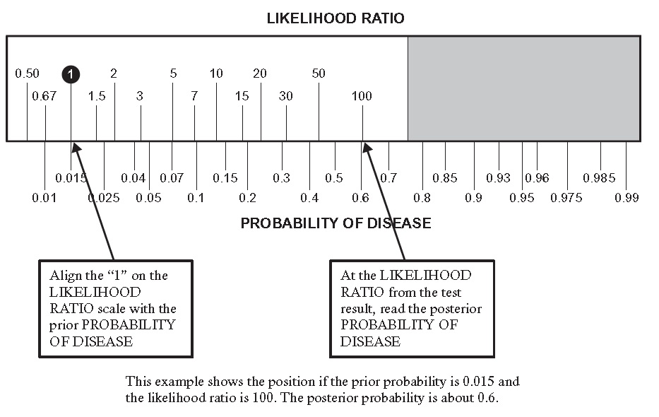
Figure 2.1 Likelihood Ratio Slide Rule. See also www.ebd-2.net
We like the slide rule, because we think it helps visualize how the LR moves the prior probability to the posterior probability. However, for readers who may think slide rules just too quaint there are also smartphone apps that will calculate the posterior probability from the prior probability and likelihood ratio.

Treatment and testing thresholds
Recall that in Chapter 1 we said that a good reason to do a diagnostic test is to help you make a decision about administering or withholding treatment. There are two main factors that limit the usefulness of tests:
1. They sometimes give wrong answers.
2. They have a “cost,” which includes the financial cost as well as the risks, discomfort, and complications that arise from testing.
Even a costless test has limited usefulness if it is not very accurate, and even a 100% accurate test has limited usefulness if it is very costly. In the following sections, we will show how test inaccuracy and costs narrow the range of prior probabilities for which the expected benefits justify performing the test. Readers interested in a more in-depth discussion should read about decision analysis. [6, 7]
As an example, we will consider the question of whether to use a rapid bedside test, such as the QuickVue test discussed earlier in this chapter, to guide antiviral treatment for the flu. An antiviral medication, such as oseltamivir (Tamiflu®), reduces the duration of flu symptoms by about 1 day.

Quantifying costs and benefits
In order to calculate the range of prior probabilities for which the expected benefits justify testing, we need to quantify three things:
1. How bad is it to treat someone who does not have the disease? This quantity is generally denoted “C” (for cost) [8, 9]. C is the cost of (unnecessarily) treating someone without the disease. In the flu example, we will take the cost of this unnecessary treatment as just the monetary cost of the antiviral medication, about $60.
2. How bad is it to fail to treat someone who has the disease? This quantity is generally denoted “B”) [8, 9]. You can think of B as the cost of failing to achieve the Benefit of treatment. For example, if the value we assign to patients with the flu feeling better 1 day sooner is $160, but the medication costs $60, the net benefit of treatment is $160 − $60 = $100, so we can think of that missed opportunity to get the $100 benefit of treatment as the net cost of not treating someone with the flu.
3. What is the cost of the test? This cost includes the cost of the time, reagents, etc. to do the test, as well as the cost of complications or discomfort from doing the test itself (including assigning a dollar value to any pain and suffering involved). We will denote this test cost as “T.”
A note about the term “cost”: Some of our colleagues have objected to using the term “cost,” because readers might construe it to refer only to monetary costs. Our various “costs” include all harm, pain, suffering, time, and money associated with 1) treating someone unnecessarily, 2) failing to treat someone who needs treatment, and 3) performing the diagnostic test. These costs must be measured in the same units. We chose dollars, but the units could be QALYs (Quality Adjusted Life Years) or “utils” (an arbitrary utility unit).
Finally, what we refer to as “cost” might more strictly be termed “regret,” the difference in outcome between the action we took and the best action we could, in retrospect, have taken. (See Hilden and Glasziou 1996 [9] .) The regret associated with treating a patient who turns out to have the disease is zero, since it was the best action we could have taken. Similarly, the regret associated with not treating an individual who turns out not to have the disease is also zero. For this reason, the graphs you are about to see are called regret graphs.

The treatment threshold probability (P_{TT})
First introduced by Pauker and Kassirer[10], the treatment threshold probability (P_{TT}) is the probability of disease at which the expected costs of the two types of mistakes we can make (treating people without the disease and not treating people with the disease) are balanced. By expected costs, we mean the cost of these mistakes (C and B) multiplied by their probability of occurring. For example, the expected cost of not treating is P (the probability of disease) × B. This is because the probability that not treating is the wrong decision is the probability that the person has the disease, or P, and the cost of that wrong decision is B. This makes sense: if P = 0, then not treating will not be a mistake, and the cost will be zero. On the other hand, if P = 1, the person has the disease, and the expected cost of not treating is 1 × B = B. If P = 0.5, then half the time the cost will be zero, and half the time the cost will be B, so the expected cost is 0.5 × B. We can graph this expected cost of not treating as a function of the probability of disease: P × B is the equation for a straight line with slope B and intercept 0, as shown in Figure 2.2.
Similarly, the expected cost of treating is (1 − P) × C. The probability that treating is the wrong decision is the probability that the person does not have the disease (1 − P), and the cost of treating someone who does not have the disease is C. Because (1 − P) × C = C − C × P, the expected cost of treating is a straight line, with intercept C and slope −C. The place where these two lines cross is the treatment threshold probability of disease, P_{TT}, at which the expected costs of not treating and treating are equal (Fig. 2.2). Put mathematically, P_{TT} is the probability of disease at which:
P_{TT} × B = (1 − P_{TT}) × C
And therefore, the treatment threshold odds are given by:
and the treatment threshold probability is
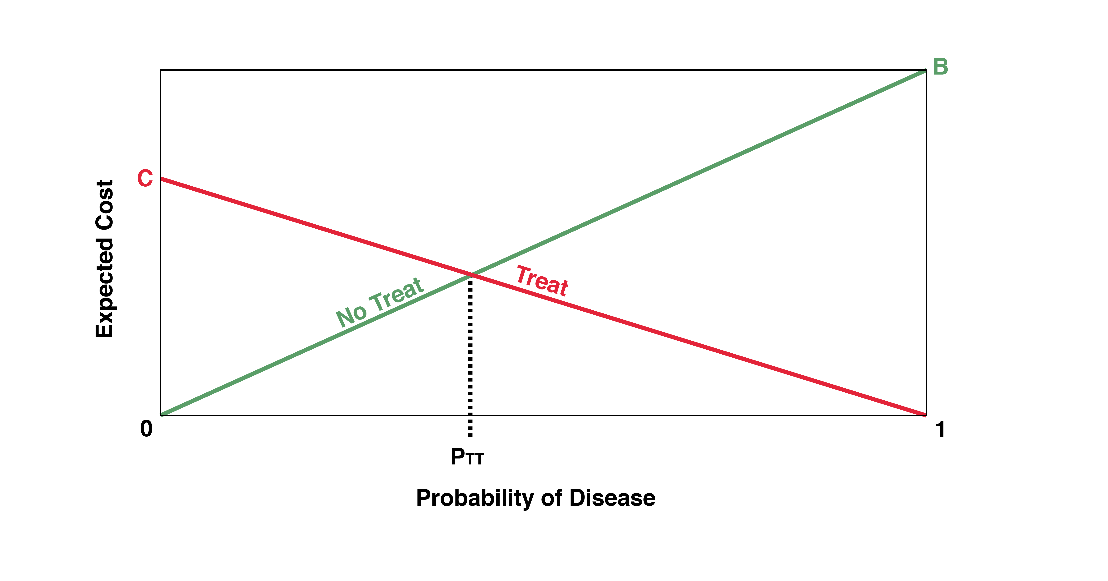Figure 2.2 Expected costs of not treating and treating by probability of disease. For probabilities from 0 to P_{TT}, “No Treat” has the lower expected cost. For probabilities from P_{TT} to 1, “Treat” has the lower expected cost.
Stop here to convince yourself that this formula makes sense. If treating someone who does not have the disease is half as bad as failing to treat someone who does have the disease, we should be willing to treat two people without disease to avoid failing to treat one person who has it, and the threshold probability P_{TT} should be 1/3. Using the formula above, if B = 2 × C, then we get P_{TT} = C/(C + 2C) = C/3C = 1/3. Similarly, if the two types of mistakes are equally bad, C = B, and P_{TT} should be 0.5.
Finally, look at the regret graph in Figure 2.2 and visualize what happens as C gets closer to zero. Can you see how the treatment threshold, P_{TT}, slides down the “No Treat” line, approaching zero? This makes sense: if the cost of treating people without disease is low relative to the benefit of treating someone who has it, you will want to treat even when the probability of disease is low. Similarly, imagine what happens when C goes up in relation to B. The treatment threshold, P_{TT,} will move to the right.
As did Pauker and Kassirer[11], we now extend the threshold calculation to the case where a dichotomous diagnostic test is available. There are now two threshold probabilities: the No Treat–Test threshold and the Test–Treat threshold (Figure 2.3)

Testing thresholds for an imperfect but costless test
We will first assume that the test itself has absolutely no monetary cost or risks to the patient. Even if a test is very inexpensive or free, if it isn’t perfect, there are some situations in which testing is not indicated because it should not change the treatment decision. If a dichotomous test has less than perfect specificity (i.e., false positives are possible) and the treatment has some risks (i.e., C > 0), there will be some low prior probability below which you would not want to treat even if the test were positive. This is because the low prior probability keeps the posterior probability low, so that the false positives would overwhelm the true positives and there would be too many people treated unnecessarily. That defines a lower testing threshold, the No Treat–Test threshold, below which there is no point performing the test. For a dichotomous test, this lower threshold is related to the LR for a positive result.
At the other end of the scale, if the test has less than perfect sensitivity (i.e., false negatives are possible) and the treatment has some benefits (i.e., B > 0), there will be some high prior probability above which you would want to treat even if the test were negative. This is because the high prior probability keeps the posterior probability high, so that false negatives would overwhelm the true negatives and testing would lead to too many failures to treat patients with the disease. That defines a higher testing threshold, the Test–Treat threshold, above which one should just treat, rather than do the test. This higher threshold is related to the LR of a negative result for a dichotomous test.
Between these two testing thresholds, there is a zone in which the results of the test have the potential to affect your decision to treat (Fig. 2.3).
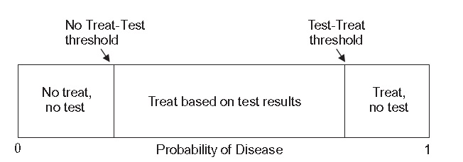
Figure 2.3 The No Treat–Test and Test–Treat probability thresholds, between which the test can affect treatment decisions.
Example 2.3 In patients with the flu, we quantified the net benefit of antiviral treatment at $100 and the cost of unnecessary treatment at $60. Then, our treatment threshold should be C/(C + B) = 60/160 = 37.5%. That is, after we do our rapid bedside test, if the probability of influenza is greater than 37.5%, we will treat the patient. We will assume that the sensitivity of the rapid antigen test is 75% and specificity is 95%. (These are close to, but slightly worse than, the estimates from Table 2.1.) What are our testing thresholds in this case – that is, for what range of prior probabilities of influenza should the results of the bedside test affect the decision to treat? (For now, we are assuming that the test is free and harmless to the patient.) Here are the steps to follow:
1. Calculate LRs for positive and negative test results:
LR(+) = Sensitivity/(1 − Specificity) = 0.75/(1 − 0.95) = 0.75/0.05 = 15
LR(−) = (1 − Sensitivity)/Specificity = (1 − 0.75)/0.95 = 0.25/0.95 = 0.26
2. Convert the treatment threshold of 0.375 to odds:
odds = P/(1 − P) = 0.375/(1 − .375) = 0.6
3. Divide LR(+) and LR(−) into treatment threshold to get the prior odds for the testing thresholds:
(since posterior odds = prior odds × LR, then posterior odds/LR = prior odds)
Posterior odds/LR(+) = (0. 6/15) = 0.04(for positive test)
Posterior odds/LR(−) = 2.28(for negative test)
4. Convert each of these prior odds (for testing thresholds) back to a prior probability P = odds/(1 + odds):
P = 0.04/1.04 = 0.04 (for positive test)
P = 2.28/3.28 = 0.70 (for negative test)
5. Interpret the result:
• If the prior probability of influenza is <4% (the no treat–test threshold), then even if the rapid antigen test is positive, the post-test probability will still be below 37.5% (the treatment threshold), and you would not treat the patient.
• If the prior probability is >70% (the test–treat threshold), then even if the antigen test is negative, the post-test probability will be above 37.5%, and you would treat the patient in spite of the negative test result.
• If the prior probability is between 4% and 70%, the test may be indicated, because it at least has the potential to affect management.
So far, we have not considered costs or risks of the test (as opposed to those of the treatment). When these are factored in as well, the testing range will be narrower.

Visualizing testing thresholds
The LR slide rule’s log(odds) scale provides a nice way of visualizing testing thresholds when the accuracy of a test (rather than its costs or risks) is the main thing that limits its usefulness. In the flu example (Example 2.3), the positive and negative LRs of the bedside antigen test can be visualized as arrows. If they are placed with their points on the treatment threshold, their origins will define the testing thresholds as in Figure 2.4.
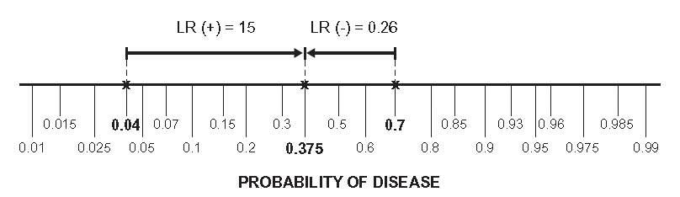
Figure 2.4 LR slide rule arrows demonstrate the concept of test and treatment thresholds.
Looking at the slide rule, we can see that the origin on the LR+ arrow is at about 0.04, indicating that if the prior probability of influenza is less than about 0.04, even if the test is positive, the posterior probability will remain below 0.375, and we should not treat. Similarly, the origin of the LR− arrow is at about 0.7, indicating that if the prior probability is more than 0.7, even if the test is negative, the posterior probability will remain high enough to treat. These are the same numbers we got algebraically in Example 2.3.
You can also visualize the testing threshold using a regret graph like Figure 2.2. In this case, we draw a line for the expected cost of testing and treating according to the result of the test. When the probability of disease is zero, the expected cost is C × (1 − Specificity). This is the cost of unnecessary treatment (C) times the probability that the test will be falsely positive in patients without the disease. Similarly, when the probability of disease is 1, the expected cost is B × (1 − Sensitivity). This is the cost (B) of failing to treat times the probability that the test will be falsely negative. If we connect these two points with a straight line, we can see that, at very low and very high probabilities of disease, “No Treat” and “Treat” have lower expected costs than “Test,” because testing too often leads to wrong answers (Figure 2.5).

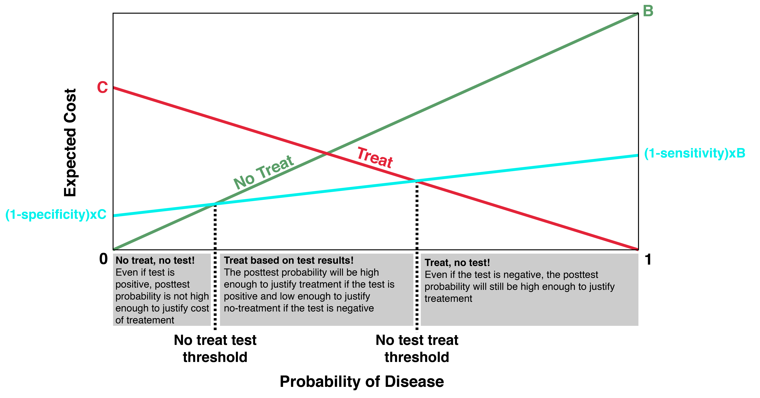
Figure 2.5 Imperfect but costless test. The expected cost of the “Test” option is higher than the cost of “No Treat” below the No Treat–Test threshold, and higher than the cost of “Treat” above the Test–Treat threshold.

Testing thresholds for a perfect but risky or expensive test
In the preceding discussion, we showed that, when tests are imperfect, there are some prior probabilities for which the test is not worth doing because the results do not have the potential to affect management. But some tests, with close to 100% sensitivity or specificity, do have the potential to change management, even when the prior probability of disease is very close to zero or one. However, because there are risks and costs to tests themselves, even a nearly perfect test may not be worth doing in some patients. Although it has the potential to change management in some clinical situations, the probability of it doing so is too small to justify the cost of the test.
To explore this issue, we now assume that the test is perfect (Sensitivity = Specificity = 100%), but that it has some “cost.” Keep in mind that “cost” could represent monetary cost, which is easy to quantify, or risks to the patient (such as pain and loss of privacy), which are harder to quantify. In this situation, there are still two threshold probabilities: 1) the No Treat–Test threshold, where the expected benefits of identifying and treating D+ individuals first justify the testing costs; and 2) the Test–Treat threshold, where the expected savings from identifying and not treating D− individuals no longer justify the testing costs.
If the bedside test for influenza were perfect and the prior probability of influenza were 5%, we would have to test twenty patients to identify one case of the flu. If the prior probability were 10%, we would have to test ten patients to identify one case. For a perfectly sensitive test, the number needed to test to identify one D+ individual is simply 1/P(D+), where P(D+) is the prior probability of disease.
To find the No Treat–Test threshold probability, we need to ask how many individuals we are willing to test to identify one D+ individual.
We have already utilized B, the cost of not treating a D+ individual, which we can also think of as the net benefit of treating someone with the disease, and C, the cost of unnecessarily treating a D− individual; now we utilize T, the cost of the test. For a perfect test, the No Treat–Test threshold probability is T/B.
Assume that the perfect bedside flu testing kits cost $10 each (T = $10). If B = $100 after subtracting the cost of the drug, then T/B = $10/$100 = 10%. This makes sense: for every ten patients we test, on average one will have the flu and be treated, which is worth $100, but the cost of testing those ten people is also 10 × $10 = $100. The costs of testing and benefits of treating are equal, and we break even. If the prior probability of flu is less than 10%, on average we will have to test more than ten people (and hence spend more than $100) for each one who tests positive and gets the treatment; hence the average costs of testing would exceed the benefits.
To understand the test–treat threshold probability, we reverse the logic. We again assume that C, the cost of treating someone without the flu, is just the $60 cost of the medication. Start by assuming that the probability of influenza is 100%. There is no point in testing to identify D− individuals because there aren’t any, so we would just treat without testing. As the probability of flu decreases from 100%, it eventually reaches a point where the $60 treatment cost we save by identifying a D− individual justifies the cost of testing to identify that individual. This occurs when the probability of not having the disease is T/C, corresponding to a probability of having the disease of (1 − T/C), the Test–Treat threshold.
This makes sense, too. When the probability of nondisease is 1/6, the number needed to test to identify one patient without the disease is six. We test six patients at a testing cost of $10 each in order to save $60 on the one without disease, and hence we come out even. We have to convert this 1/6 probability of nondisease to a probability of disease by subtracting from 100%, so the test–treat threshold probability of disease is 1 − 1/6 = 5/6 = 83.3%.
You can easily visualize testing thresholds for a perfect but costly test by drawing a horizontal line at expected cost = T for the testing option (Figure. 2.6).

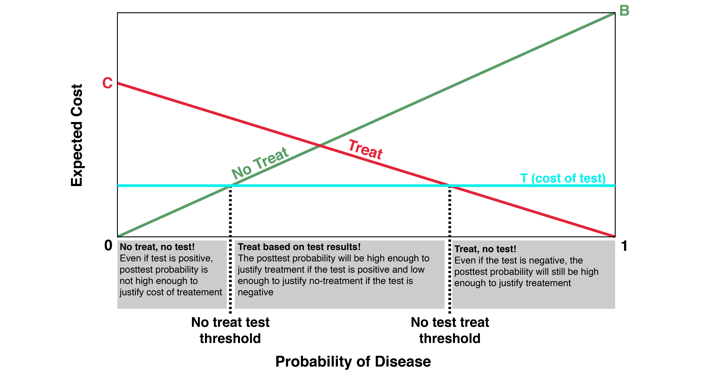
Figure 2.6 “No Treat–Test” and “Test–Treat” thresholds for a perfect but costly test.

Testing thresholds for an imperfect and costly test
Using the same parameters, C = $60, B = $100, T = $10 (or $0), Sensitivity = 0.75 (or 1.0), and Specificity = 0.95 (or 1.0), Table 2.4 gives the testing thresholds assuming the test is 1) imperfect and costless, 2) perfect and costly, and 3) imperfect and costly. For interested readers, the formulas for the testing thresholds of an imperfect and costly test are given in Appendix 2.4. The graph showing expected costs would be the same as Figure 2.5, except that the testing line would be displaced upward by an amount equal to the testing cost (T).
As mentioned above, in order to do these calculations, we have to express misclassification costs (B and C) and testing costs (T) in common units. It is usually difficult to reduce the costs and risks of testing, as well as failing to treat someone with disease or treating someone without the disease, to units such as dollars. We present the algebra and formulas here, not because we want you to use them clinically, but because we want you to understand them and want to show that the theory here is actually quite simple.

Table 2.4. Thresholds for a flu test, taking into account accuracy, cost, and both
Test characteristics | No treat–test threshold | Test–treat threshold
Imperfectª but costless | 0.04 | 0.70
Perfect but costly^{b} | 0.10 | 0.83
Imperfect and costly | 0.17 | 0.57
ª Sensitivity = 0.75; Specificity = 0.95; C/B = 60/100.
^{b} T = $10.
Testing thresholds exist both because the test is imperfect (and might lead to too many misclassifications) and because the test has costs and risks (that might outweigh the benefits of the additional information). Sometimes, especially when the test is expensive and risky but accurate, the testing costs so outweigh the misclassification risks that you can ignore the misclassification risks. Would you do the test if it were perfect? If the answer is “no,” then the risks and costs of the test, not the misclassification risks, are driving your decision. We don’t do lumbar punctures on well-looking febrile infants. This is not just because we are worried about false positives but because the low probability of a positive does not justify the discomfort, risk, and expense of the test.
Would you do the test if it were free of discomfort, risks, and costs? If the answer is “no,” then the misclassification risks, not the costs and risks of the test itself, are driving your decision. This is one reason we don’t perform screening mammography on 30-year-old women. The false positives would vastly overwhelm the true positives and cause an enormous burden of stress and ultimately unnecessary follow-up testing.

Summary of key points
1. The accuracy of dichotomous tests can be summarized by the proportion in whom the test gives the right answer in five groups of patients:
• those with disease (sensitivity),
• those without the disease (specificity),
• those who test positive (positive predictive value),
• those who test negative (negative predictive value), and
• the entire population tested (accuracy).
2. Although sensitivity and specificity are more useful for evaluating tests, clinicians evaluating patients will more often want to know the posterior probability of disease given a particular test result.
3. Posterior probability can be calculated by using the sensitivity and specificity of the test and the prior probability of disease. This can be done by using the 2 × 2 table method or by converting probabilities to odds and using the LR of the test result, defined as P(Result|Disease)/P(Result|No disease).
4. The treatment threshold (P_{TT}) is the probability of disease at which the expected cost of treating those without disease equals the expected cost of not treating those with the disease: P_{TT} = C/(C + B).
5. If a test is less than perfectly specific or has costs or risks, it does not make sense to use it on patients with very low prior probabilities of disease – probabilities below the “No Treat–Test” threshold.
6. Similarly, if a test is less than perfectly sensitive or has costs or risks, it does not make sense to use it on patients with very high prior probabilities of disease – probabilities above the “Test–Treat” threshold.
7. Both the “No Treat–Test” and “Test–Treat” thresholds can be visualized graphically or calculated algebraically if the cost of treating someone without the disease (C), the cost of failing to treat someone with the disease (B), and the cost of the test (T) can all be estimated on the same scale.

Appendix 2.1: General summary of definitions and formulas for dichotomous tests
 | Disease | No Disease | Totals
Test+ | a | b | a+b
Test− | c | d | c+d
Totals | a + c | b + d | N = a + b + c + d
If sampling is cross-sectional (i.e., diseased and nondiseased are not sampled separately), then:
Prevalence = prior probability = (a + c)/N
Positive Predictive Value (PPV) = Posterior probability if test + = a/(a + b)
Negative Predictive Value (NPV) = 1 − Posterior probability if test − = d/(c + d)
For tests with dichotomous results:
LR(+) = P(+|D+)/P(+|D−) = sensitivity/(1 − specificity)
LR(−) = P(−| D+)/P(−|D−) = (1 − sensitivity)/specificity
Probability = P = odds/(1 + odds);
Odds = P/(1 − P) or
If odds = a/b, probability = a/(a + b)
Prior odds × LR = posterior odds (ALWAYS TRUE!)

Appendix 2.2: Rigorous derivation of likelihood ratios
Here is a real derivation – it is not that hard!
First, you need to accept some basic axioms of probability:
1. P(A and B) = P (B and A)
2. P (A and B) = P(A|B)P(B). This just says the probability of both A and B is the probability of B times the probability of A given B.
From 1 and 2 (which both seem self-evident), it is easy to prove Bayes’s theorem:
3. P(A|B)P(B) = P(A and B) = P(B and A) = P(B|A)P(A). Therefore, P(A|B) = P(B|A)P(A)/P(B), which is how Bayes’s theorem is generally written. Now by Bayes’s theorem (where r = a specific test result):
4. Posterior probability = P(D+|r) = P(r|D+)P(D+)/P(r)
5. 1 − Posterior probability = P(D−|r) = P(r|D−)P(D−)/P(r) Dividing 4 by 5 gives:
6.
Note that this derivation applies regardless of the form the result takes (dichotomous, continuous, etc.) and requires no assumptions other than the probability axioms we started with.

Appendix 2.3: Answers to odds/probability conversions in Box 2.5
If probability is P, Odds are P/(1 − P)
 | Probability | Odds
a. | .01 | 1/99
b. | .25 | 1/3
c. | 3/8 | 3/5
d | 7/11 | 7/4
e. | .99 | 99
If odds are a/b, probability is a/(a + b).
 | Odds | Probability
a. | .01 | 1/101
b. | 1:4 | 1/5
c. | .5 | .5/1.5 = 1/3
d. | 4:3 | 4/7
e. | 10 | 10/11

Appendix 2.4: Formulas for testing thresholds for dichotomous tests
B = Net Benefit of Treating a D+ individual
C = Cost of Unnecessarily Treating a D−individual
C/B = Treatment Threshold Odds
T = Cost of Test
2.3a: For an imperfect but costless test:
Example: Imperfect but costless test for influenza
B = Net Benefit of Antiviral Treatment = $100
C = Net Cost of Antiviral Treatment = $60
Sensitivity = P(+|D+) = 0.75; 1 − Sensitivity = P(−|D+) = 0.25
Specificity = P(−|D−) = 0.95; 1 − Specificity = P(+|D−) = 0.05
2.3b: For a perfect but costly test:
No Treat-Test Threshold Probability = T/B
Test-Treat Threshold Probability = 1 − T/C
Example: Perfect but costly test for influenza
B = Net Benefit of Antiviral Treatment = $100
C = Antiviral Treatment Cost = $60
T = Cost of the Perfect Bedside Test = $10
No Treat-Test Threshold Probability = T/B = $10/$100 = 0.10
Test-Treat Threshold Probability = 1 − T/C = 100% − $10/$60 = 0.833
2.3c: For an imperfect and costly test:
Example: Imperfect and costly test for influenza
B = Net Benefit of Antiviral Treatment = $100
C = Antiviral Treatment Cost = $60
T = Cost of Test = $10
Sensitivity = P(+|D+) = 0.75; 1 − Sensitivity = P(−|D+) = 0.25
Specificity = P(−|D−) = 0.95; 1 − Specificity = P(+|D−) = 0.05

Appendix 2.5: Derivation of No Treat-Test and Test-Treat Probability Thresholds
We’ll do these derivations two ways: with geometry (2.5a and 2.5c) and with algebra (2.5b and 2.5d).

B = cost of failing to treat a D+ individual
C = cost of treating a D– individual unnecessarily
T = cost of test
P = probability of D+

p[–|D+] = probability of negative test given D+ = 1– sensitivity
p[+|D–] = probability of positive test given D– = 1– specificity Expected Cost of No Treat strategy: (P)B
Expected Cost of Treat Strategy: (1–P)C

Expected Cost of Test Strategy:
P (p[–|D+]) B + (1–P) (p[+|D– ]) C + T

Reminder about odds and probability:
Convert odds to probability by adding the numerator to the denominator. If threshold odds are C/B, then threshold probability is C/(B+C).

No Treat-Test Threshold
2.5.a Geometry

B
1 – P

C
Cost
Denominator
No Treat
p[–|D+] B + T
Test

p[+|D–] C + T
Numerator

T T

P P = No Treat-Test Threshold

Probability of Disease

Convince yourself that the ratio of the line labeled “Numerator” to the line labeled “Denominator” is equal to the threshold odds P / (1–P)

P / (1−P) = (p[+|D–])C + T
B – (p[–|D+])B – T

= (p[+|D–] C + T B (1– p[–|D+]) – T

Substitute p[+|D+] for 1– p[–|D+]

= (p[+|D–]) C + T
(p[+|D+]) B – T

= No Treat-Test Threshold Odds
(add numerator to denominator for probability)

= (p[+|D–]) C + T (p[+|D–]) B + (p[+|D–]) C
= No Treat-Test Threshold Probability

No Treat-Test Threshold

2.5.b Algebra

No Treat-Test threshold is where the expected cost of the “No Treat” strategy equals the expected cost of the “Test” strategy.

(P)(B) = P (p[–|D+]) B + (1–P) (p[+|D–]) C + T

Substitute (P)(T) + (1–P)T for T

(P)(B) = P (p[–|D+]) B + (P)(T) + (1–P) (p[+|D–]) C + (1–P) T

(P)(B) = P (p[–|D+] B + T) + (1–P) (p[+|D–] C + T)
Subtract this

(P)(B) – P (p[–|D+] B + T) = (1–P) (p[+|D–] C + T)

(P)[(B) (1– p[–|D+] ) – T] = (1–P) (p[+|D–] C + T)

Substitute p[+|D+] for 1–p[–|D+]
(P) [p[+|D+](B) – T] = (1–P) (p[+|D–] C + T) P p[+|D–] C + T
=
(1–P) p[+|D+] B – T

This is threshold odds. To get threshold probability add the numerator to the denominator.

(p[+|D–]) C + T
P =
(p[+|D+]) B + (p[+|D–]) C

= No Treat-Test Threshold Probability

Test-Treat Threshold
2.5.c Geometry

B
P

C
Numerator
Cost
p[–|D+] B + T
Test

p[+|D–] C + T
Treat
Denominator

T T

1 – P

Convince yourself that

P / (1–P) = C – (p[+|D–]) C + T
(p[–|D+]) B + T

= C (1 – p[+|D–] – T p[–|D+] B + T

Substitute p[–|D–] for 1– p[+|D–]

= C (p[–|D–]) – T
(p[– | D+]) B + T

= Test-Treat Threshold Odds
(add numerator to denominator for probability)

(p[–|D–]) C – T
P =
(p[–|D+]) B + (p[–|D–]) C

= Test-Treat Threshold Probability

Test-Treat Threshold

2.5.d. Algebra

The Test-Treat strategy is where the expected cost of the “Test” strategy equals the expected cost of the “Treat” strategy.

P (p[–|D+]) B + (1–P) (p[+|D–]) C + T = (1–P) C

Substitute (P)(T) + (1–P)T for T

P (p[–|D+]) B + (P)(T) + (1–P) (p[+|D–]) C + (1–P) T = (1–P) C P (p[–|D+] B + T) + (1–P) (p[+|D–] C + T) = (1–P) C
Subtract this
P (p[–|D+] B + T) = (1–P) C – (1–P) (p[+|D–] C + T)

Rearrange

P (p[–|D+] B + T) = (1–P) (1 – p[+|D–]) – (1 – P) T

Substitute p [–|D–] for 1 – p [+|D–]

P (p[–|D+] B + T) = (1–P) (p[–|D–] C – T)

P =
p[–|D–] C – T

(1–P) p[–|D+] B + T

This is threshold odds. To get threshold probability add the numerator to the denominator.
p[–|D–] C – T

P =
p[–|D+] B + p[–|D–] C

= Test-Treat Threshold Probability

References
1. Poehling KA, Griffin MR, Dittus RS, Tang YW, Holland K, Li H, et al. Bedside diagnosis of influenzavirus infections in hospitalized children. Pediatrics. 2002;110(1 Pt 1):83-8.
2. Newman TB, Bernzweig JA, Takayama JI, Finch SA, Wasserman RC, Pantell RH. Urine testing and urinary tract infections in febrile infants seen in office settings: the Pediatric Research in Office Settings' Febrile Infant Study. Arch Pediatr Adolesc Med. 2002;156(1):44-54.
3. Kerlikowske K, Grady D, Barclay J, Sickles EA, Ernster V. Likelihood ratios for modern screening mammography. Risk of breast cancer based on age and mammographic interpretation. JAMA. 1996;276(1):39-43.
4. Kerlikowske K, Grady D, Barclay J, Sickles EA, Ernster V. Effect of age, breast density, and family history on the sensitivity of first screening mammography. JAMA. 1996;276(1):33-8.
5. Losina E, Walensky RP, Geller A, Beddingfield FC, 3rd, Wolf LL, Gilchrest BA, et al. Visual screening for malignant melanoma: a cost-effectiveness analysis. Arch Dermatol. 2007;143(1):21-8.
6. Hunink MGM. Decision making in health and medicine : integrating evidence and values. Second edition. ed. Cambridge, United Kingdom: Cambridge University Press; 2014.
7. Sox HC, Higgins MC, Owens DK. Medical decision making. 2nd ed. Chichester, West Sussex, UK: John Wiley & Sons; 2013.
8. Sox HC, Blatt MA, Higgins MC, Marton KI. Medical decision making. Boston: Butterworths; 1988. 406 p.
9. Hilden J, Glasziou P. Regret graphs, diagnostic uncertainty and Youden's Index. Stat Med. 1996;15(10):969-86.
10. Pauker SG, Kassirer JP. Therapeutic decision making: a cost-benefit analysis. N Engl J Med. 1975;293(5):229-34.
11. Pauker SG, Kassirer JP. The threshold approach to clinical decision making. N Engl J Med. 1980;302(20):1109-17.

We will show in Chapter 3 that making continuous and multi-level tests dichotomous is often a bad idea.
It is just a coincidence that the negative predictive value 210/215 and the specificity 210/214 both round to 98%. As we shall see, the probability that a patient without the disease will have a negative test (specificity) is not the same as the probability that a patient with a negative test does not have the disease (negative predictive value).
Students who have taken epidemiologic methods may cringe at this use of the term “rate,” since these are proportions rather than rates, but that is not the confusion we are addressing here.
The term "cross-sectional" is potentially confusing because it is used two ways in epidemiology. The meaning here relates to sampling and implies that D+, D−, T+ and T− subjects are all included in numbers proportional to their occurrence in the population of interest. The other use of the term relates to the time frame of the study, when it means predictor and outcome variables are measured at about the same time, in contrast to longitudinal studies, in which measurements are made at more than one point in time.
“Accuracy” also depends on prevalence, but as mentioned above, it is not a useful quantity.
Another way to say and do this is that if the sampling fractions (proportions of diseased and non diseased included) are known, the effect of the sampling can be undone by weighting each cell by the inverse of the sampling weight. So, for example, if you only took 10% of the nondiseased, you could just multiply the numbers in the nondiseased column 1/ 0.1 = 10 to undo the effect of the undersampling of nondiseased.
Again, if the proportion testing positive in the population is known, we can recreate a 2 × 2 table that will allow us to estimate sensitivity and specificity by starting with row rather than column totals. We then proceed as described in the next section or by using inverse sampling weights as described above. See Problem 2.7 for an example.
We simplify here by treating mammography as a dichotomous test, by grouping together the 3 reported positive results: "additional evaluation needed" (92.9%), "suspicious for malignancy" (5.5%) and "malignant" (1.6%).3. Kerlikowske K, Grady D, Barclay J, Sickles EA, Ernster V. Likelihood ratios for modern screening mammography. Risk of breast cancer based on age and mammographic interpretation. JAMA. 1996;276(1):39-43.
In case you are wondering why we call this the “lite” derivation, it is because the formula for the LR works even when sensitivity and specificity come from a study that does not have cross-sectional sampling, but this derivation would not work in such a study. See Appendix 2.2 for a rigorous derivation.
Thanks to Dr. Warren Browner for this mnemonic.
Try searching your App Store for “evidence-based medicine” to find them.
This was the lowest price (with a coupon) at www.GoodRx.com 6/27/17

