Epi 204 -- Problem Set #2
Chapter 2 Problems (Dichotomous tests)
Upload to CLE by
10/4/2018 1 pm

Do problems #1 – #5 below. The “Ch02.XX” numbering is for our problem database; please ignore.
You may use whatever tools you like, including Excel, an online calculator, and Stata. But please respond clearly and directly to the questions.
1. 02.01 Grunderschnauzer disease
You are informed by your doctor that you have tested positive for Grunderschnauzer disease. You may ask one question to help you figure out whether you really have it. What do you want to know (choices are sensitivity, specificity, prevalence, predictive value, etc.)? [2]

2. Ch02.06. Testing Thresholds for Strep Throat
Let's return to Clinical Scenario #1 from Chapter 1, in which we had a graduate student with sore throat, fever, pus on the tonsils and tender lymph nodes.
Assume:
i. The drug cost of a course of penicillin V (500 mg 3 times a day) to treat acute Group A streptococcal throat infection (“strep throat”) is about $12 (www.GoodRx.com, with a coupon), and the expected cost in patient inconvenience, risk of adverse or allergic reactions, and contribution to antibiotic resistance is another $48. So, the total expected treatment cost is $60.
ii. Treating someone who really has strep throat (and not some other pharyngitis) decreases symptom severity, length of illness, transmission to others and the (already minute) risk of rheumatic fever. The value of this averages about $150, but since the cost of treatment is $60, the net benefit of treating someone with strep throat is $90. This can also be viewed as the net cost of failing to treat someone with strep throat. Penicillin will not help the patient if the sore throat is caused by something other than Group A strep.
- Draw a graph like figure 2.2 based on the assumptions above, labeling the axes, lines and intercepts. Although you can check your answer at www.ebd-2.net, draw the graph by hand. You can use pencil and paper and paste a low-resolution photo into your HW. [2]

- At what probability of strep throat should you treat with penicillin? Show the point on the graph and the equation to derive it; you can check your answer at ebd-2.net. [2]
- According to UpToDate (7/11/18) the sensitivity of a rapid strep test is 77-92% and specificity is 88-99%. If a rapid strep test were 85% sensitive and 95% specific, for what range of prior probabilities would it have the potential to affect management? (Ignore the cost of the test.) Do this calculation using likelihood ratios (show your work), then draw a line for “free rapid strep testing” on the graph. [4]

- Now assume that a perfect rapid strep test for Group A streptococcal throat infection has been developed. The test causes negligible discomfort and results are available nearly instantaneously, but the test costs $40. When does it make sense to use this test? Draw a line for testing on the graph and explain. [3]
- UpToDate recommends using the Centor criteria to estimate the pretest probability ofstrep throat to assist in the decision to do a rapid strep test in patients with a sore throat. The criteria are: 1) tonsillar exudates (pus on the tonsils); 2) tender anterior cervical (front of the neck) lymph nodes; 3) Fever and 4) absence of cough. The authors recommend forgoing testing for patients with ≤ 2 criteria (probability of strep ≤ 21%) and testing for 3 criteria (probability of strep 38%) or 4 criteria (probability of strep 57%). Use the regret graph calculator at www.ebd-2.net or the spreadsheet on the CLE site (“Cost-Benefit X Graph and calcs for Chapter 3 MAK.xls”) to find a cost T for the rapid strep test that would be consistent with the UpToDate recommendation. [4]
3. Ch02.07. Are negative and positive test results always equally informative?
Give a REAL example of a test for which a positive result is generally very informative but a negative test is not. It need not be medical – in fact, we encourage you to think outside the medical box! What are the characteristics of a test for which positive results are generally more informative? [4]

4. Ch02.10. Rapid Influenza Diagnostic Testing
The U.S. Centers for Disease Control (CDC) has a web page intended to provide guidance to clinical laboratory directors about rapid influenza diagnostic tests (RIDT). (http://www.cdc.gov/flu/professionals/diagnosis/rapidlab.htm, accessed on 7/13/18) It includes a table with calculations of positive predictive value as a function of specificity and pretest probability. A portion of the table is reprinted below.
.Positive Predictive Value (PPV) of a Rapid Antigen Test for Influenza
If Influenza Prevalence is… | And Specificity is… | Then PPV is… | False Pos. rate is…
VERY LOW (2.5%) | HIGH (98%) | LOW (39-56%) | HIGH (44-61%)
MODERATE (20%) | HIGH (98%) | HIGH (86-93%) | LOW (7-14%)

(We deleted calculations assuming a “moderate” specificity of 80%, because specificity is generally much higher than that. Although the table uses the term “prevalence,” the web page says, “The interpretation of positive results should take into account the clinical characteristics of the case.” So by “prevalence” they actually mean pre-test probability.)
- What definition of False Positive Rate did the CDC use in this table? [2]

- In the first row of the table, the pre-test probability is 2.5% and the PPV ranges from 39% to 56%. What sensitivity for the RIDT did they use for the 39% PPV estimate? [3]

- The “GOOD” specificity of 98% may be too low. The Quidel (QuickVue) rapid antigen test has a specificity of at least 99%.[1] How would using 99% instead of 98% specificity, change the LR(+)? [2]

- Repeat the calculation of the PPV in the first row of the table using 99% instead of 98% specificity. [2]

The CDC website says that when the pre-test probability of influenza is relatively low and the RIDT is positive,

"If an important clinical decision is affected by the test result, the RIDT result should be confirmed by a molecular assay, such as reverse transcription polymerase chain reaction (RT-PCR)."

- Assume that the “important clinical decision” is whether or not to treat with oseltamivir (Tamiflu®) and the patient is a pregnant woman at high-risk for complications. Further assume that the RT-PCR will not further identify the strain or sensitivities of the flu virus, and it will take 3 days to get the results back. Do you agree with the CDC about confirming a positive result? Why or why not? [4]

5. 02.51Q Breast/Ovarian Cancer Test With Oversampling of Positives
(with thanks to Yi-Hsuan Wu, MAS 2017)
Mutations in BRCA1 and BRCA2 (BRCA1/2) genes increase the risk of breast and ovarian cancer, but the genetic test for them is costly. There are models to assess the probability of carrying a BRCA1/2 mutation, but they are complicated and time-consuming, requiring a very detailed family history ("pedigree"). Bellcross et al.[2] evaluated the accuracy of a referral screening tool (RST) designed for use in primary care practice to help clinicians select patients for BRCA testing (Figure).
Figure: BRCA testing referral tool. Reprinted by permission from Springer Nature Customer Service Centre GmbH: Springer Nature Genetics in Medicine. Evaluation of a breast/ovarian cancer genetics referral screening tool in a mammography population. Cecelia A Bellcross, Amy A Lemke, Laura S Pape, Angela L Tess, Lorraine T Meisner, Copyright 2009.

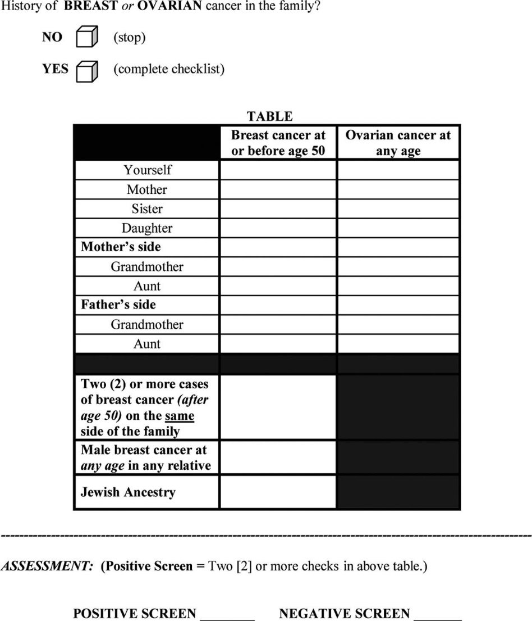

From the abstract (reprinted with permission; see above):

Methods: The RST was administered to 2464 unselected women undergoing screening mammography. Detailed four-generation cancer pedigrees were collected by telephone interview on a random subset of 296 women. The pedigrees were analyzed using four established hereditary risk models…with a ≥10% BRCA1/2 mutation probability using any [established] model as the definition of “high risk.”
Results: The RST identified 6.2% of subjects as screen “positive” (high risk). … In comparison with the pedigree analyses [i.e., the four established hereditary risk models], the RST demonstrated an overall sensitivity of 81.2%, specificity of 91.9%, [PPV of 80%, NPV of 92%], and discriminatory accuracy of 0.87.
For the pedigree analysis of 296 women, the authors chose to oversample (randomly) from the RST-positive group, which only represented 6.2% of the screening mammography population, "to provide a sufficient number of potentially high-risk pedigrees to adequately address sensitivity."
- Is the sampling of the 296 women in this study cross-sectional, case-control, or test result-based (index positive-negative)? [3]
The following table shows results in the pedigree analysis sample consistent with what the authors reported:
 |  | Risk based on pedigree analysis and risk models
 |  | High risk | Low risk | Total
RST result | Positive | 69 | 17 | 86 | PPV= 80%
RST result | Negative | 16 | 194 | 210 | NPV= 92%
RST result | Total | 85 | 211 | 296
 |  | Sensitivity= 81.2% | Specificity= 91.9%
Now you want to know the sensitivity and specificity of RST in the underlying mammography population (n= 2464).
b) Given that 6.2% of the subjects in the entire mammography population were identified as RST positive and the predictive values observed, complete the following 2 × 2 table and calculate the sensitivity and specificity of RST in the entire mammography population. [Hint: First figure out how many in the entire population tested positive, to fill in the cell labeled "A".] [5]

Sample |  | Risk based on pedigree analysis and risk models
 |  | High risk | Low risk | Total
RST | Positive |  |  |  | PPV=
RST | Negative |  |  |  | NPV=
RST | Total |  |  | 2464
 |  | Sensitivity= | Specificity=

c) Compare the sensitivity and specificity of the RST in the mammography population you obtained from (b) with what was reported in the abstract. Why are they different? Which do you think is correct? [4]

In the Results section the authors wrote:
“It should be noted that these predictive values are not representative of those that would be obtained in a general mammography population, as … high-risk subjects were intentionally oversampled. Using the prevalence of 6.2% RST screen-positive individuals in this study, and the overall sensitivity and specificity obtained, the PPV and NPV values expected in a general mammography population would be 0.39 and 0.78, respectively.”
d) Do you agree with the authors that the PPV and NPV, not the sensitivity and specificity, are the measures that needed to be adjusted to be representative of the ones in the mammography population? Explain. [5]

Reference

1. Faix, D.J., S.S. Sherman, and S.H. Waterman, Rapid-test sensitivity for novel swine-origin influenza A (H1N1) virus in humans. N Engl J Med, 2009. 361(7): p. 728-9.
2. Bellcross, C.A., et al., Evaluation of a breast/ovarian cancer genetics referral screening tool in a mammography population. Genet Med, 2009. 11(11): p. 783-9.

At this writing, the CDC’s assay for the novel swine-origin influenza A (H1N1) virus (S-OIV) known as swine flu is not widely available. RT-PCR is the gold standard for identifying an influenza A virus infection but cannot further identify the strain or subtype. This can only be done at special labs, primarily county health departments and the CDC.
To simplify this problem we have combined "moderate" and "high-risk" groups into a single "positive" category.

