10 Screening tests

Introduction
While screening tests share some features with diagnostic tests, they deserve a chapter of their own because of important differences. Whereas we generally do diagnostic tests on sick people to determine the cause of their symptoms, we generally do screening tests on healthy people with a low prior probability of disease. The problems of false positives and harms of treatment loom larger. In Chapter 4 on evaluating studies of diagnostic test accuracy, we assumed that accurate diagnosis would lead to better outcomes. The benefits and harms of screening tests are so closely tied to the associated treatments that it is hard to evaluate diagnosis and treatment separately. We postponed our discussion of screening until after our discussion of randomized trials because randomized trials are a key element in the evaluation of screening tests. Finally, because decisions about screening are often made at the population level, political and other nonmedical factors are more influential. Thus, in this chapter we focus explicitly on the question of whether doing a screening test improves health, not just on how it alters disease probabilities, and we pay particular attention to biases and nonmedical factors that can lead to excessive screening.

Definition and types of screening
Our favorite definition of screening is one suggested by Eddy:[1] “the application of a test to detect a potential disease or condition in people with no known signs or symptoms of that disease or condition.” The “test” being applied may be a laboratory test or x-ray, or it may be nothing more than a standard series of questions, as long as the goal is to detect a disease or condition of which the patient has no known symptoms.

Table 10.1. Types of screening
 | Unrecognized Symptomatic disease | Presymptomatic disease | Risk factor
Examples | • Refractive errors in children  • Depression  • Iron deficiency  • Hearing loss in the elderly | • Syphilis  • Neonatal  hypothyroidism  • Cervical cancer  • Glaucoma  • Abdominal Aortic Aneurysm | • High blood pressure  • High blood cholesterol
Number Labeled | Few | Few | Many
Number Treated | Few | Few | Many
Duration of Treatment | Varies, may be short | Varies, may be short or long | Usually long
Number Needed to Treat | Few | Few | Many
Ease of Showing Benefit | Often easy | More difficult | Usually very difficult
Potential for Harm | False positives | • False positives  • Pseudodisease  • Labeling | • Risks from treatment, including delayed adverse effects  • Labeling
This definition has two advantages over the definitions you will see elsewhere, which specify that screening involves “testing for asymptomatic disease.” First, “no known symptoms” is not quite the same as asymptomatic, because some people may have symptoms they do not recognize as such. Second, the Eddy definition includes testing not just for diseases, but for “conditions.” The goal of many screening tests is not to detect disease, but to detect risk factors – that is, to detect the condition of being at increased risk for one or more diseases.
Based on this definition, we can divide screening into three types:
• Screening for unrecognized symptomatic disease,
• Screening for presymptomatic disease, and
• Screening for risk factors.
The goals of these types of screening differ, thus the study designs, numbers of subjects, and amount of time needed to study them differ as well (Table 10.1). There is, however, some overlap between these categories. For example, glaucoma may be asymptomatic or cause unrecognized visual field loss, and an abdominal aortic aneurysm might be considered a disease or just a risk factor for rupture.
Screening for unrecognized symptomatic disease is generally the most easily evaluated type of screening, because both the accuracy of the test and the benefits of early detection can be assessed in short-term studies, often with modest sample sizes. Vision screening in children is a good example: children who have trouble with the eye chart are referred for further evaluation. If they are confirmed to have refractive errors, glasses are prescribed. No randomized trials are needed to tell that glasses will help the child see better, because the effect is immediate. Other examples of this type of screening are screening for hearing loss or iron deficiency anemia. When patients are already symptomatic, demonstrating a benefit from identifying and treating them does not require a long trial with many subjects.
Screening for presymptomatic disease is harder to assess. As is the case with unrecognized symptomatic disease, because the disease is already present at the time of screening, the accuracy of the screening test can be measured in the present, without a long follow-up period. But because the disease is initially asymptomatic, demonstrating benefits of treatment generally will require a follow-up study (often a randomized trial), to show that early diagnosis and treatment of disease reduces the frequency or severity of symptoms later. Examples include screening for cystic fibrosis, abdominal aortic aneurysms (AAAs), and breast cancer. On the other hand, if the natural history and pathophysiology of the disease are clear and the effects of treatment are dramatic (e.g., as with screening for syphilis or neonatal hypothyroidism), randomized trials of treatment may not be needed.
It is most difficult to evaluate screening for risk factors for disease, because both the ability of the test to predict disease and the ability of treatment to prevent it generally must be assessed by using longitudinal studies, often with very large sample sizes. The first step is quantifying how well the measurement of the risk factor (e.g., a blood cholesterol level) predicts the risk of disease (heart attacks or strokes). The second step involves determining whether and by how much treatment lowers that risk and at what cost. Because deaths or other serious events occur in only a small proportion of subjects (even for relatively common diseases like heart disease), this second step may require following many thousands of subjects for years. An intermediate step, determining how well treatment lowers the level of the risk factor, is generally insufficient, because (as we will discuss in the next section) lowering the level of a risk factor may not lead to the expected lowering of the risk of disease. A dramatic example of this was the Cardiac Arrhythmia Suppression Trial, in which patients were screened for premature ventricular contractions (PVCs), a risk factor for sudden death after a heart attack. The PVCs were diminished by treatment with antiarrhythmic drugs, but unfortunately, this did not translate into fewer sudden deaths. In fact, the death rate was nearly 3 times higher in those treated, leading to an estimated 50,000 excess deaths in the U.S. [2].

Importance of a critical approach to screening tests

Possible harms from screening
Although screening tests and resulting treatments, when properly selected and done, may have substantial benefits, there are also significant possible harms from screening. The potential to do harm is particularly great for risk factor-screening tests, because the number treated and duration of treatment may be much greater than for other screening tests. Some of the possible harms of screening apply to all persons screened, some only to those with specific test results, and others extend beyond those screened. These possible harms from screening, although perhaps generally underappreciated, are not conceptually difficult, so we will just list them with examples in Table 10.2, rather than discussing them at length.

Reasons for excessive screening
The possible costs and risks of screening are more than sufficient to justify a cautious approach. But there is another reason as well: awareness of the strong forces likely to lead to excessive screening. The main force may be the desire to help people live longer and healthier lives. But other forces tending to increase screening are worth considering as well (Table 10.3). Unlike the potential market for tests and treatments for symptomatic diseases, which is limited by the prevalence of those diseases and their symptoms, the potential market for screening tests and resulting treatments has no such limits. The number of people at risk for each disease times the number of years for which they are at risk creates a vast potential market for screening tests, including the machines and personnel required to do them.
The “patients” identified by screening become a similarly vast market for the drugs or other interventions intended to reduce their risk. In the case of disease screening, the market for treatments is limited by the number of people found to have the disease. The market for treatments for risk factors, in contrast, has no such limits, as there may be a measurable (or imagined) health benefit to treatment even at levels of the risk factor that are highly prevalent in the population. Thus, we should not be surprised that companies selling products related to screening tests or to treating the diseases they are intended to diagnose or hospitals that have invested in these technologies should be very interested in moving the public toward more screening.
Pressure for increased screening does not arise solely from for-profit companies. For academic researchers like us, the greater the number of people who have, get, or worry about our disease of interest, the greater the importance of the research and the researcher, and the greater the opportunities for funding, collaborators, publications, and prestige. Similarly, nonprofit organizations (like the American Liver Foundation
Table 10.2. Possible harms from screening
Group at risk or affected and type of harm | Examples
A. Everyone tested
• Time, cost of test | • CT scan for early lung cancer
 | • Genetic testing for predisposition to breast and ovarian cancer
• Pain, discomfort, anxiety, or embarrassment from the screening test or anticipation thereof | • Venipuncture
 | • Digital rectal examination
 | • Sigmoidoscopy
 | • Mammography
• Late adverse effects | • Cancer from radiation for mammography[3]
B. People with a negative test result
• Inappropriate reassurance leading to delay in diagnosis of target disease (false negative) or to unhealthy decisions with regard to other risk factors (false or true negative) | • Delay in evaluation of hearing loss in baby with falsely normal newborn hearing screen
 | • Patients with normal cholesterol levels deciding they do not need to exercise or stop smoking
C. People with a positive test result
• Time, cost, pain, discomfort, anxiety, and complications of follow-up testing – generally much worse than costs and risks of initial tests | • Breast or prostate biopsies
 | • Perforation from colonoscopy following fecal occult blood testing
• Costs and risks of treatment for those testing positive; may exceed benefits, even in “true positives” | • Increased fractures when osteoporosis is treated with sodium fluoride[4]
 | • Increased mortality from use of clofibrate for high blood cholesterol[5]
 | • Increased mortality in patients with asymptomatic PVCs after myocardial infarction when treated with antiarrhythmic drugs[6]
• Overdiagnosis | • Prostatectomies, mastectomies, or lung resections for biopsy-proven cancer that would not have caused problems anyway
• Loss of privacy or insurability | • Testing for hepatitis C, HIV, or syphilis
• Labeling or other psychological distress; failure to be reassured after normal follow-up testing | • Increased absenteeism in steelworkers found to have hypertension[7]
 | • Self-restriction of activities following low bone density measurements in elderly women[8]
 | • Altered parent-infant relationship following false-positive newborn hypothyroidism screening[9]
 | • Continued anxiety following false-positive mammograms[10]
D. People not tested
• Injuries to testing personnel | • Radiation, needle sticks, etc.
• Harms to contacts, partners, family members | • False-positive or false-negative tests for sexually transmitted diseases
 | • Finding of infant blood group inconsistent with supposed paternity
• Time cost of patients and physicians informing themselves about tests the patient chooses not to have done | • Expensive screening tests being marketed directly to consumers[11]
• Removal of resources from where they would do more good (Eddy 1997) | • Mammography for the wealthy in poor countries[12]
or the American Cancer Society) tend to favor screening tests for their disease or organ system. Aside from any medical benefits from screening, it has the potential to identify large groups of people likely to be interested in the work of the organization and to make donations. As discussed below, some of those most in favor of screening may believe that their lives were saved by screening tests.
Finally, the general public tends to be supportive of screening programs. Part of this is wishful thinking. We would like to believe that bad things happen for a reason, and that there are things we can do to prevent them.[13] We also tend to be much more swayed by stories of individual patients (either those whose disease was detected early or those in whom it was found “too late”) than by boring statistics about risks, costs, and benefits.[14, 15] Because, at least in the U.S., there is no clear connection between money spent on screening tests and money not being available to spend on other things, the public tends not to be swayed by arguments about cost efficacy [16-18]. In fact, in the general public’s view of screening, even wrong answers are not necessarily a bad thing.
Schwartz et al. [19] did a national telephone survey of attitudes about cancer screening in the U.S. They found that 38% of respondents had experienced at least one false-positive screening test. Although more than 40% of these subjects referred to that experience as “very scary” or the “scariest time of my life,” 98% were glad they had the screening test! As our gynecologist colleague George Sawaya (who studies Pap smears) puts it, “the patients are so grateful when we come to the rescue and put out the fire that they forget that we were the ones who set it in the first place.”
Table 10.3. Powerful non-medical forces that could lead to increased enthusiasm for screening
Stakeholder | Reasons to favor screeninga | Example
Companies selling tests or testing equipment | Sell more tests or testing machines | • Osteoporosis testing machines  • Office cholesterol machines  • Private companies marketing genetic tests or body scans
Companies selling products to treat the condition | Sell more product | • Schering-Plough has funded public awareness campaigns to encourage PSA and hepatitis C screening [they make Eulexin (flutamide) used to treat prostate cancer and Intron (inteferon) used to treat hepatitis C]
Clinicians or hospitals who diagnose or treat the condition | More patients, procedures, income, importance | • Gynecologists tend to recommend more Pap smears and urologists more PSA testing than generalists  • Thoracic surgeons or radiologists may favor more CT screening for lung cancer
Politicians | • Appear sympathetic to those who have or are at risk of the condition  • Be responsive to special interests or contributors | • U.S. Senate vote 98-0 overturning National Cancer Institute panel’s recommendations that mammography decisions for 40- to 49-year-old women be individualized [20]
Nonprofit disease research and advocacy groups | • Increased importance of disease and hence of organization’s work  • More people with the disease or risk factor who become interested are active constituents and potential donors  • Increase attractiveness for donations from industry | • American Liver Foundation Hepatitis C Screening promotion (paid for by Schering-Plough)  • American Cancer Society recommendations for cancer screening often more aggressive than those of the U.S. Preventive Health Services Task Force
Academics who study the condition | • Increased importance, recognition, and funding for research for the condition  • Accessible funding from industry | • Hypercholesterolemia, osteoporosis, and virtually everything else
Patients/the public | • Wishful thinking - wanting to believe bad things happen for a reason and that there are things we can do to prevent them  • Individualistic perspective - lack of concern about costs if someone else is paying them | • Belief in and demand for PSA testing and mammography disproportionate to evidence of benefit  • View that those (even elderly) not wishing to be screened are “irresponsible”(Schwartz et al. 2004)
We know of no similar survey that addresses how patients feel about false-negative results, but some may still be happy they had the test. Patients whose cancer is diagnosed at a late stage who did not get screened are likely to wonder if they could have been saved if they had been screened. Those who were screened and were (presumably falsely) negative will at least have the comfort of knowing it was not their fault and of not being blamed by their doctors, family, and friends.[13] Another disturbing result of the survey by Schwartz et al. was that, even though the U.S. Preventive Health Services Task Force felt that evidence was insufficient to recommend prostate cancer screening, more than 60% of respondents said that a 55-year-old man who did not have a routine prostate specific antigen (PSA) test was “irresponsible,” and more than a third said this for an 80-year old man! Thus, regardless of the efficacy of screening tests, they have become an obligation if one does not wish to be blamed for being diagnosed with late-stage disease.

Reasons for underscreening
We have emphasized many reasons to worry about excessive screening, but insufficient screening can occur as well. The potential problems that screening can cause (Table 10.2) are all reasons why it might not be done even when a net benefit could be projected: it costs money, takes time, may cause discomfort or loss of privacy, etc. If screening leads to improved health but increases in costs, managed care organizations could deliberately make it difficult to do the tests. Some hospitals may lack the confidence, competence, and capacity to deal with positive results. To make screening work, the systems for dealing with positive results and providing services to identified patients need to be in place.

Critical appraisal of studies of screening tests

The big picture
The general idea of a lot of screening (and diagnostic tests) is that if you do the test it will help you diagnose the disease, and if you diagnose the disease, it will improve your outcome. If we want to know whether to do a test, we would really like to know whether people who get the test have a better outcome than comparable people who do not (Figure 10.1). Unfortunately, most studies do not address that question directly. Instead, studies either 1) correlate testing or test results with diagnosis or stage (e.g., studies that estimate diagnostic yield, sensitivity, specificity, Receiver Operating Characteristic curves, likelihood ratios, etc.) or 2) correlate diagnosis or stage with ultimate outcome. The latter studies are those susceptible to lead- or length-time biases, which we will discuss below.
For simplicity, assume that we are screening for presymptomatic disease, and in a subset of patients, the disease is fatal a predictable time after symptoms develop. The disease is detectable by screening after its biological onset but before symptoms develop. The rationale for screening is that intervention during this latent phase forestalls or prevents symptom onset and improves outcome.
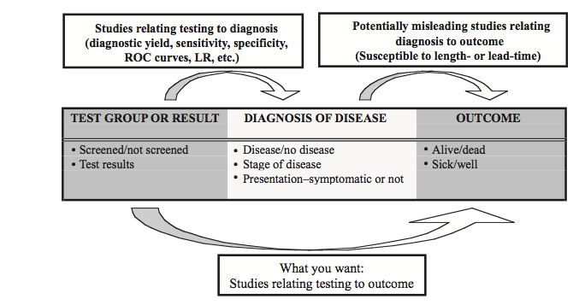
Figure 10.1 Predictor and outcome variables in studies of screening. The best studies bridge the gap and compare outcomes in those screened and not screened.
Not all screening tests are intended to prolong life, but for now let’s focus on those that are. The best way to assess such tests is to randomly assign some people to receive the screening test and others not to and compare mortality in the two groups. As you learned in Chapter 8, randomization prevents systematic differences between the two groups with respect to disease risk, health habits, and other factors that can affect the outcome of interest (e.g., life expectancy). Both the screened and unscreened groups will include mostly individuals who do not have the disease in question. If screening affects the life expectancy of these nondiseased individuals at all, it is likely to have a negative effect.
Both groups will also include individuals with the disease. In the screened group, more of the cases of disease will be diagnosed from screening, while in the group assigned to no screening, more of the cases of disease will be diagnosed from symptoms. If screening genuinely allows interventions that forestall or prevent symptoms and prolong life, and if this benefit exceeds the negative effect of screening on nondiseased individuals, the overall death rate should be lower and life expectancy longer in the screened group. So, the ideal study would be a randomized trial of screening versus no screening that compares the overall mortality (or some other global outcome that would capture harms as well as benefits) between the two randomization groups. Although such a study may not be practical, keeping this ideal study design in mind can help you understand biases common in observational studies, to be discussed below.

Box 10.1 Mortality vs Survival
It might seem like survival is simply the complement of mortality, since everyone who does not die must survive. But when used in studies of screening (particularly cancer screening) survival generally refers to how long people live (or the proportion that survive for at least a specified interval) after diagnosis, and hence is measured only in those diagnosed with disease. In contrast mortality often includes people not diagnosed with the disease in the denominator, as it does in population-wide statistics, such as the US mortality rate from lung cancer of 42 per 100,000 per year.
This distinction is important because for many reasons discussed below, screening tests can easily increase survival among those diagnosed, for example by starting counting earlier and/or adding a lot of patients with a good prognosis to the diseased group. On the other hand, if the entire population at risk is kept in the denominator, diagnosing more people with the disease will not affect mortality. A useful shortcut when critically appraising studies of screening is to be immediately suspicious of any study in which the benefit is expressed as survival rather than comparing mortality in entire populations at risk (not just those diagnosed).

Observational studies of screening tests
Observational studies of screening deviate in various ways from the ideal randomized trial of screening versus no screening. Some compare the outcome (such as death from prostate cancer) among persons who have been screened with those who have not been screened, but the assignment to the screened and unscreened groups is not random, and there are systematic differences between them. Others limit the comparison to those with the disease. The screened patients with the disease (even if it was missed on screening and diagnosed by symptoms) may be compared with the unscreened patients with the disease (all of whom were diagnosed by symptoms). Finally, those diagnosed by screening may be compared with those diagnosed by symptoms (whether or not they were ever screened). Observational studies are subject to several important biases that can make screening tests appear to be more beneficial than they are.

Volunteer effect (confounding)
When assignment to the screening group is not random, comparisons between people who are and are not screened may be invalid because people who volunteer for screening are generally different from people who do not (Figure 10.2). The screened group may be at higher risk of poor outcome, if, for example, they volunteered for screening because of a symptom they did not disclose (people with symptoms are generally excluded from studies of screening tests). More typically, they may be at lower risk of poor outcome, because of healthier habits or better access to health care.
This volunteer effect is a specific example of the more general phenomenon of confounding discussed in Chapter 9. It is addressed the same way as other types of confounding. Investigators may measure and attempt to control for factors that might be associated with both receiving the screening test and outcome (e.g., family history, education level, number of health maintenance visits, etc.). Alternatively, they might look for a natural experiment or instrumental variable or measure alternative predictors or outcomes (Chapter 9). However, the only way to eliminate the possibility of volunteer bias is to randomize the study subjects either to receive or not to receive the screening test.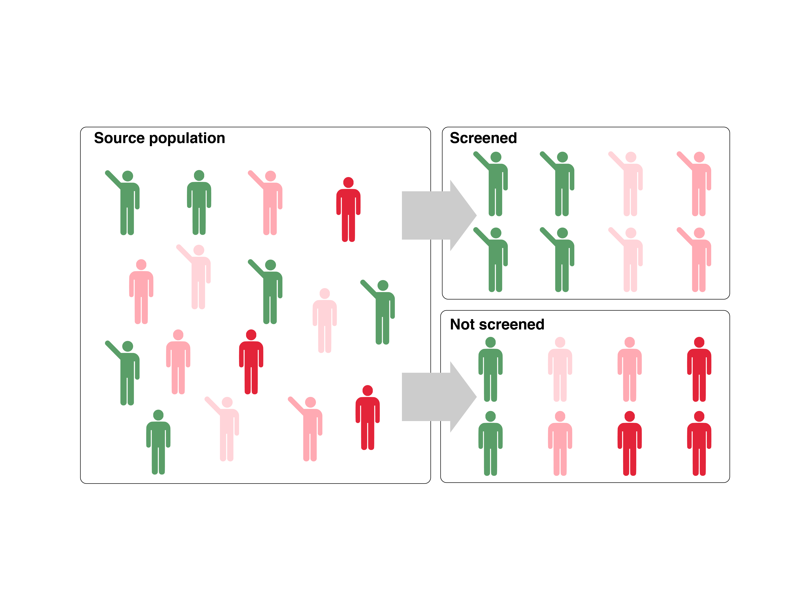
Figure 10.2. Volunteer effect: people who volunteer for screening may differ in other important ways from people who do not.

Lead-time bias
Lead time is the apparent increase in survival obtained when a disease is detected before it would have become symptomatic and been detected clinically (Fig. 10.3). Lead-time bias affects the subset of the population destined to die of the disease whether or not they are screened. The trouble is, even if screening and/or treatment are completely ineffective, if you start counting years of survival from the date of diagnosis, moving the date of diagnosis earlier will make survival seem longer (Fig. 10.3). Lead-time bias is thus a problem when post diagnosis survival is compared between persons whose disease was detected by screening and those whose disease was detected by development of symptoms. Lead-time bias cannot occur in a properly analyzed randomized trial of screening or a cohort study that compares an entire screened group with an entire unscreened group. These studies compare mortality in all subjects rather than survival in those diagnosed with disease (Box 10.1).
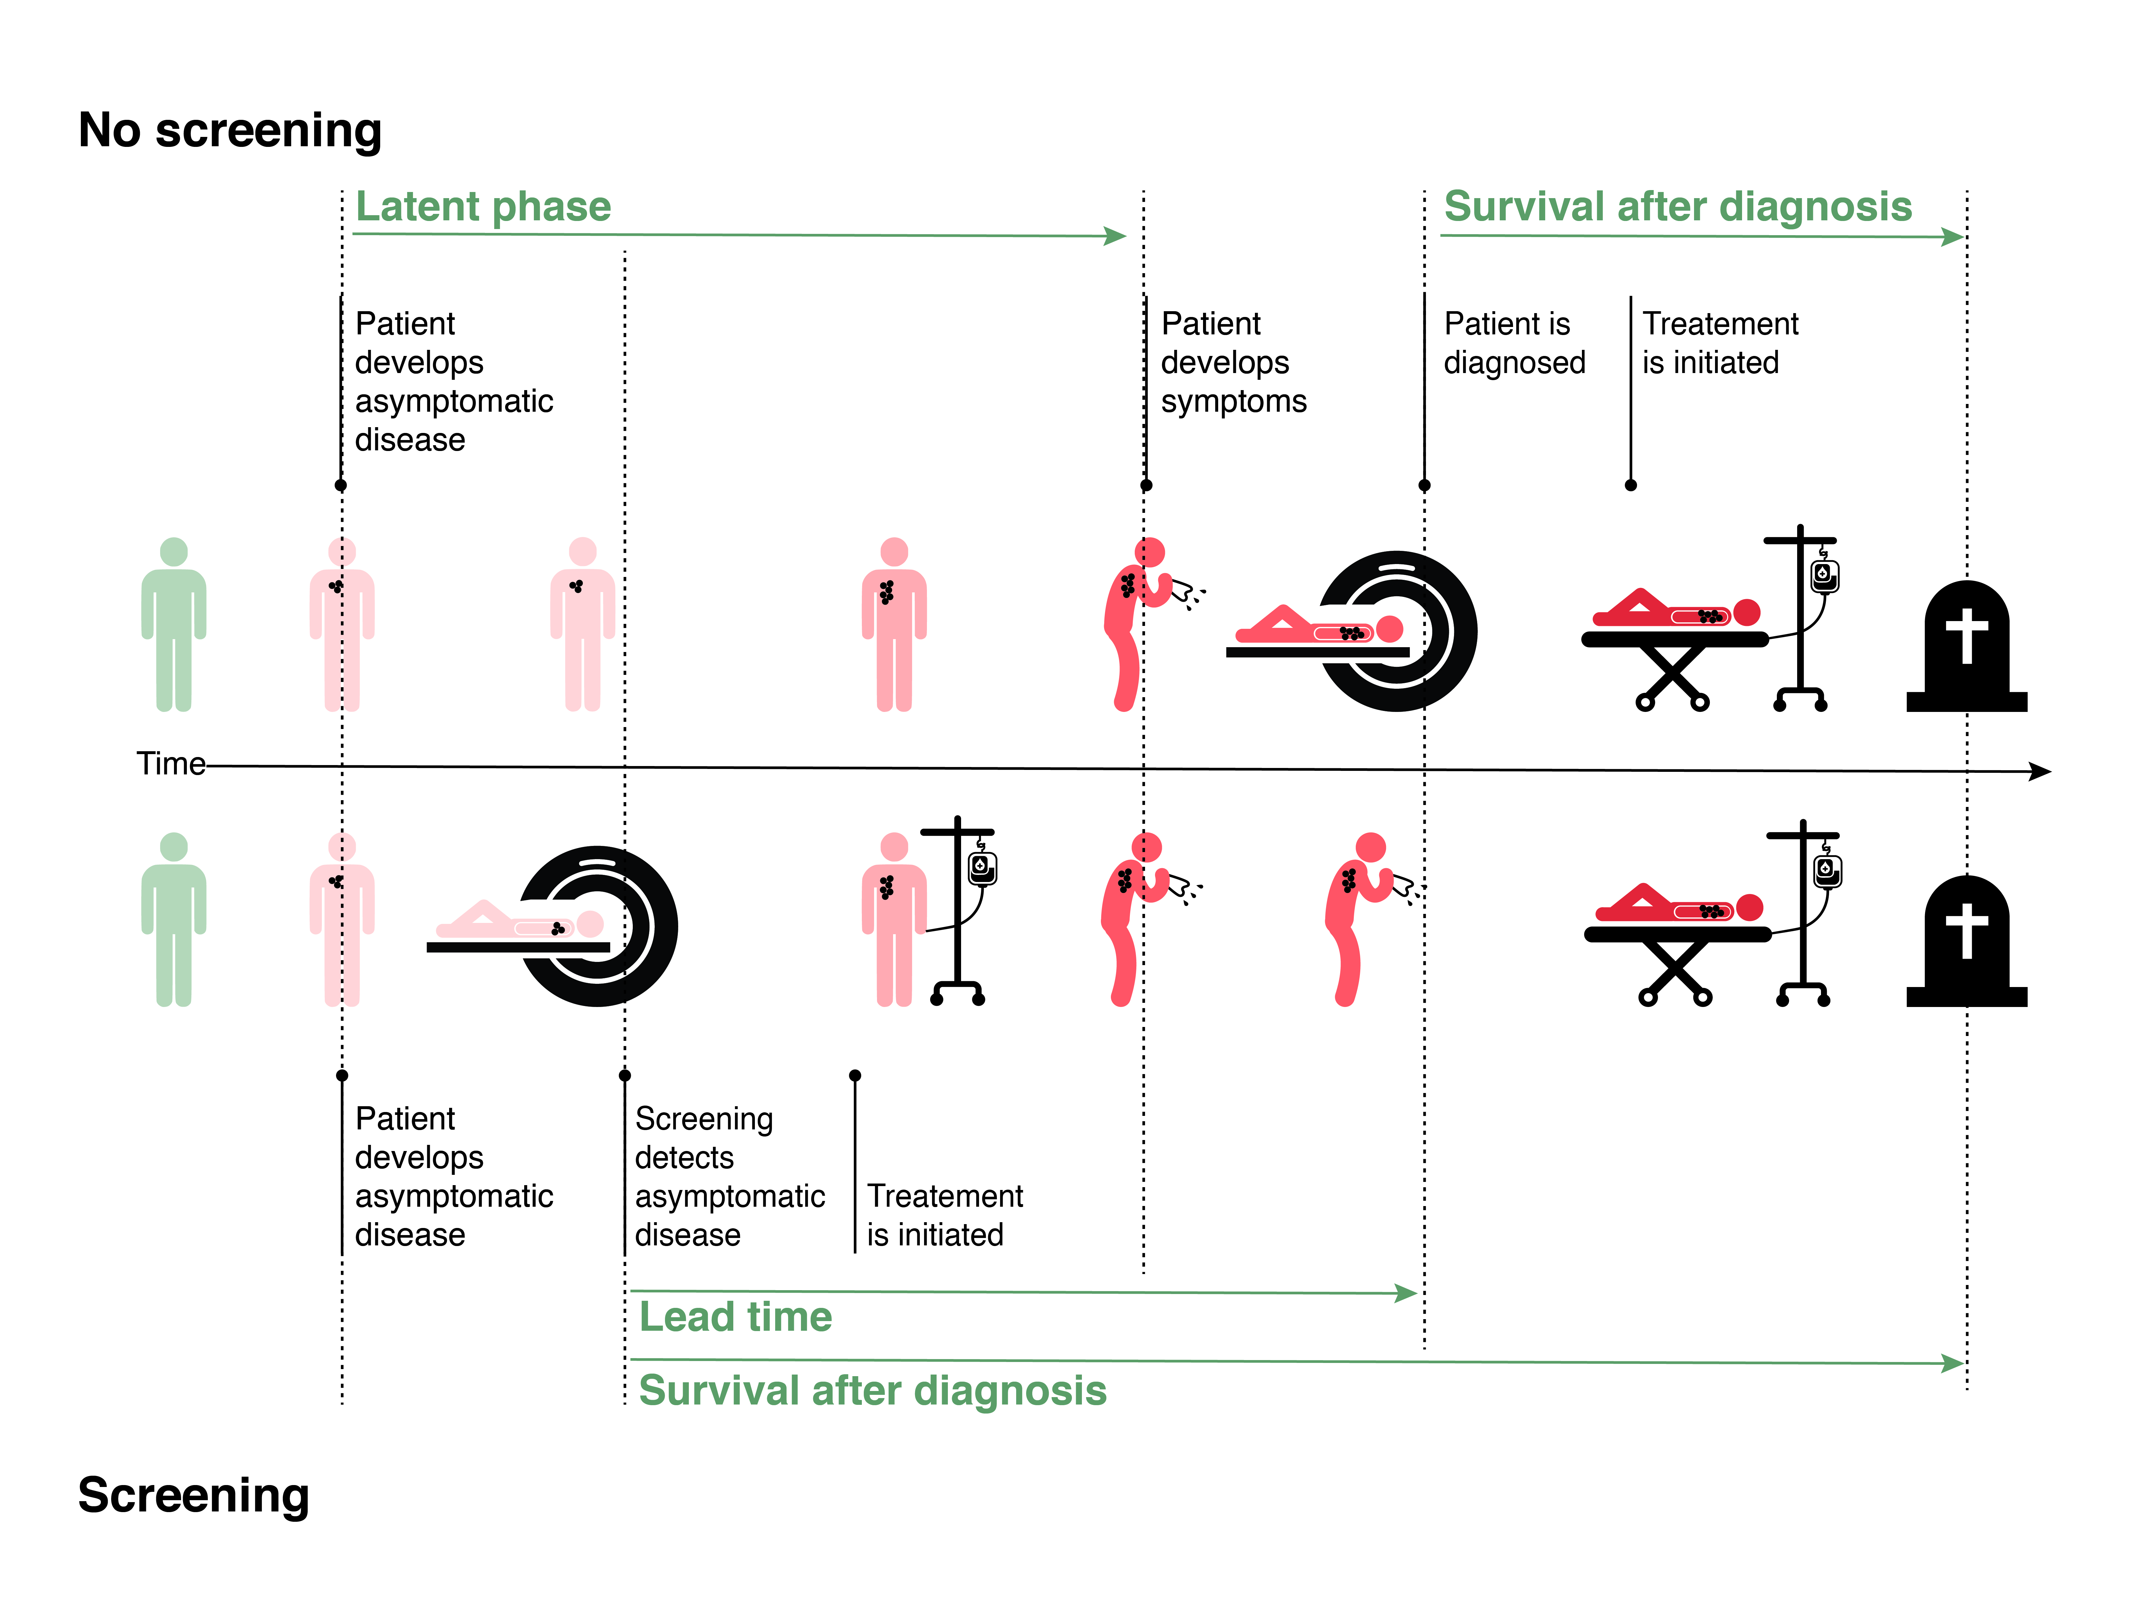
Figure 10.3 Lead Time Bias: Upper Panel: Natural history of disease in people affected by lead-time bias. The disease is not detected until symptoms trigger a test, at which point the disease is diagnosed and survival time starts. Lower Panel: Lead-time bias: detection during the latent period increases the survival time by moving forward the date of diagnosis without affecting the date of death.

Length-time bias
This bias gets its name from the fact that heterogeneity in the natural history of a disease can lead to subjects spending a variable length of time in the presymptomatic phase. A clearer name for it could be “different natural history bias.” Length-time bias can occur in studies of one-time screening or screening at regular intervals, if they compare survival time from diagnosis between those diagnosed by screening and those diagnosed by symptoms.
When thinking about length-time bias, assume that we are screening the entire population for disease; there is no unscreened group. If the disease we are screening for is heterogeneous (e.g., some tumors are indolent, whereas others rapidly metastasize and kill), our screening will preferentially diagnose the cases that are more slowly progressive (and have a longer latent phase). Compared with individuals diagnosed from symptoms, those with disease diagnosed by screening have more indolent disease, and hence have longer expected survival (Figure 10.4).
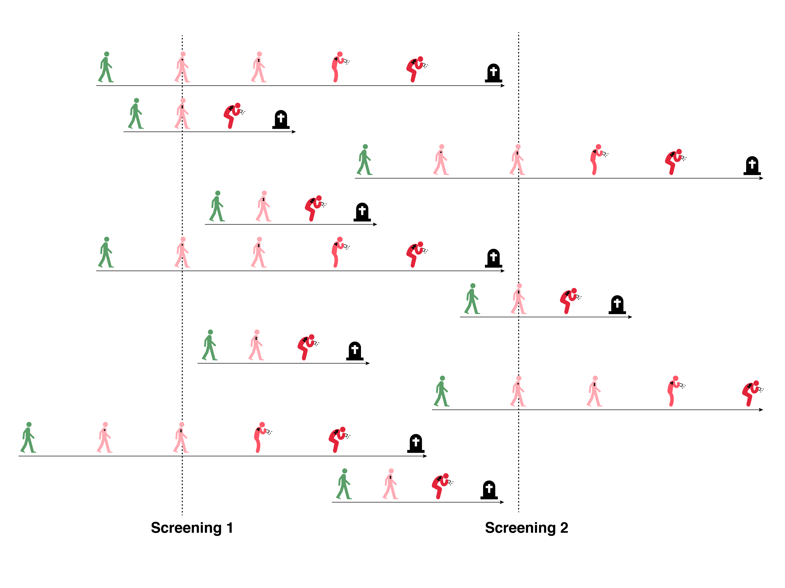
Figure 10.4: Length-time bias: More slowly progressive cases of disease (the 5 of 10 with longer time lines in the figure) spend more time in the latent period. This makes them more likely to be identified by screening (5 of 7 of the cases diagnosed by screening). The 3 cases diagnosed between screening intervals (from symptoms) were all rapidly progressive.
Because screening tests done at any point in time can only get the head start on detection if they catch the disease in its latent phase (Fig. 10.3), patients whose diseases spend a short time in that state are less likely to be identified by screening and more likely to present with symptoms. These patients will have a poorer prognosis due to the rapidly progressive nature of their disease. Thus, the basic problem is that although detection by the screening test will be associated with a better prognosis, the causal inference is incorrect: both early detection and the improved prognosis are due to the better expected natural history of the disease (Fig. 10.5).
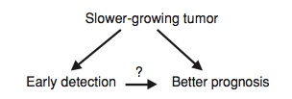
Figure 10.5 A noncausal relationship between early detection and a better prognosis is the cause of length-time bias.
Length-time bias is only operative when disease is heterogeneous and survival from diagnosis is compared between persons whose disease was detected by screening and those whose disease was detected in other ways. Length-time bias will generally be accompanied by at least some lead-time bias. However, the reverse is not always true: lead-time bias will occur even if the natural history of the disease is entirely homogeneous and there is no length-time bias.
Finally, as long as a study (randomized trial or cohort study) compares the entire screened group with the entire unscreened group (between-groups comparison), lead-time and length-time bias cannot occur.

Stage migration bias
Newer, more sensitive diagnostic tests can lead to the diagnosis of disease at an earlier or milder stage, and also to patients being classified as being in a higher stage of disease than would have been known previously (Fig. 10.6). For example, a more sensitive bone scan might lead to some patients being classified as having stage IV prostate cancer, when previously they would have been thought to be in a less advanced stage. These patients likely have a longer life expectancy than those with the more significant bone metastases detectable by a less sensitive scan. The result is that stage-specific survival (e.g., survival of patients with stage IV disease) will appear to improve with the more sensitive test, even if no one lives longer. The survival of those at lower stages is improved by having the patients with a worse-than-average stage-specific prognosis leave their stage and be classified in a higher stage. Survival at higher stages is increased because of the entry of subjects from lower stages with better-than-average, stage-specific prognosis for their new stage.
If a change in the distribution to more advanced stages is the cause of the improvement in stage-specific survival, overall survival will be the same.[21] If a study reports stage-specific improvement in survival with a new screening test, comparing overall survival between screened and unscreened groups is a good way to check for stage migration bias.
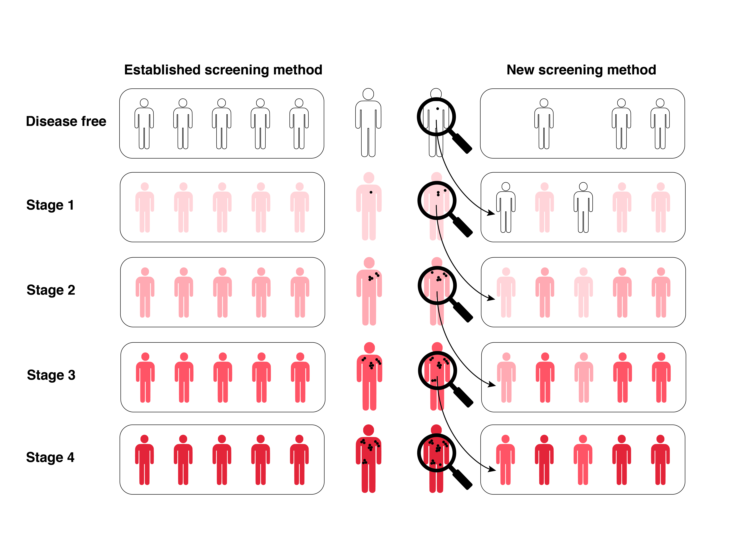
Figure 10.6 Stage migration bias. Newer, more sensitive tests lead to less severe disease and a better prognosis at each stage. (Note: the bottom right box should have 2 more dark red people in it.)
Stage migration bias can also occur in the absence of changes in diagnostic testing, simply because of changes in the diagnostic criteria for different stages over time. This was demonstrated for breast cancer, when changes in classification of lymph node involvement between the 5th and 6th editions of the American Joint Committee on Cancer staging system dramatically altered stage-specific survival[22, 23].

Overdiagnosis (pseudodisease)
In Chapter 4 on biases in studies of test accuracy, we described differential verification bias, in which some patients could be designated as D+ on surgical pathology but as D− on clinical follow-up if they had either transient or dormant disease. We showed how for patients like this, if a positive index test leads to biopsy but a negative index test leads to clinical follow-up, the index text will always appear to give the right answer. Here, we are not worried about overestimating the accuracy of an index text, but rather about overestimating the effectiveness of a screening program. In this context, the problem is overdiagnosis: the possibility of detecting pseudodisease that never would have affected the patient had it not been diagnosed (Figure 10.7).

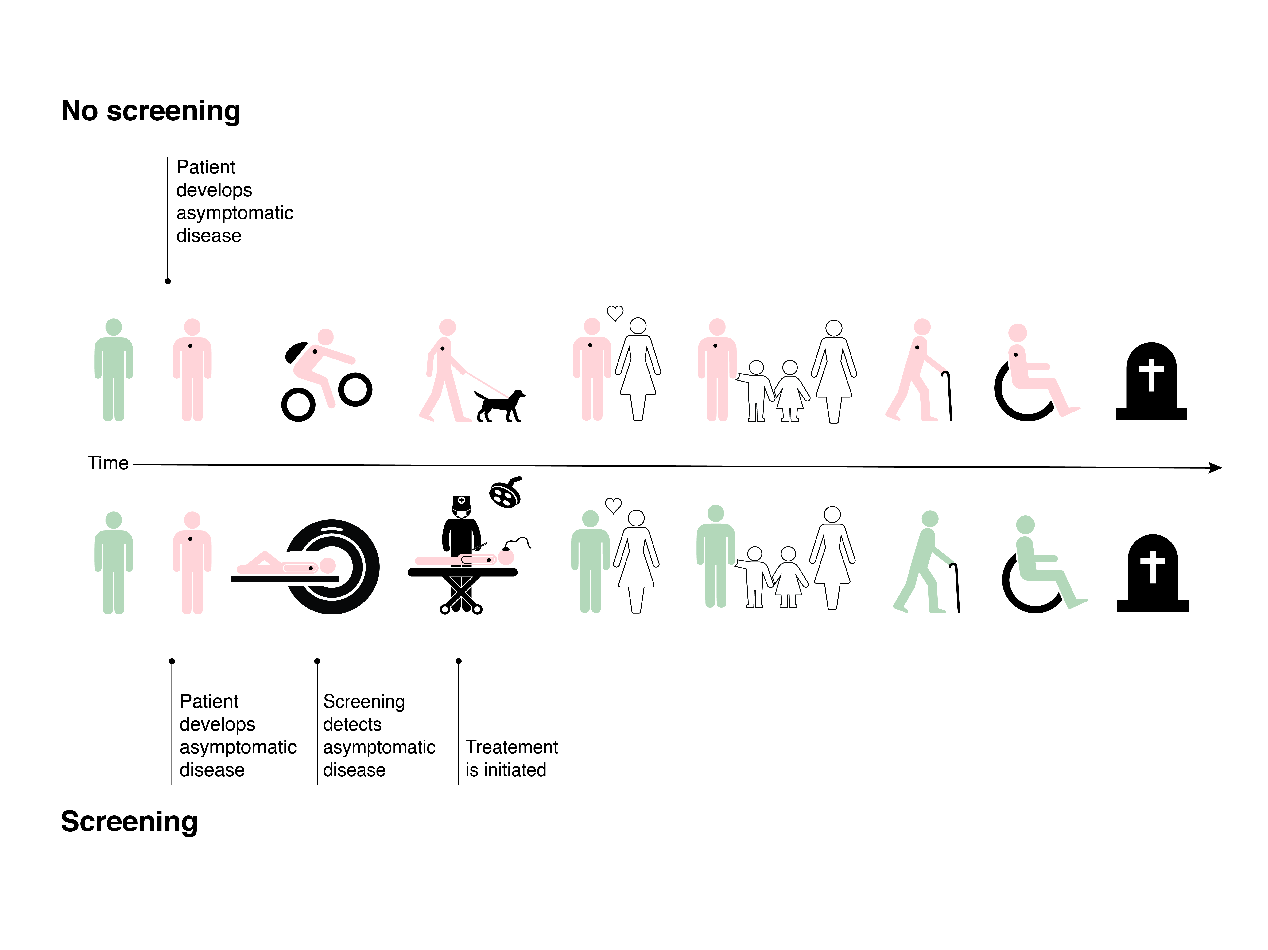
Figure 10.7: Overdiagnosis is like length bias with a latent phase equal to the patient's life expectancy. The patients believe they have been cured, but the treatment was entirely unnecessary.
It is difficult to identify pseudodisease in an individual patient, because it requires completely ignoring the diagnosis. (If you treat pseudodisease, the treatment will always appear to be curative, and you won’t realize the patient had pseudodisease rather than real disease!) In some ways, overdiagnosis is like stage migration bias, moving from stage 0 (undiagnosed) to one of the other stages. Although the incidence of the disease goes up, the prognosis of those diagnosed with it apparently improves.
We would like to believe that pathologists can look at a biopsy and reliably distinguish benign from malignant tissue. However, we saw in Box 4.1 that pathologists operating under normal time constraints make errors, and there is abundant evidence that some tumors that microscopically are diagnosed as breast, prostate, thyroid and even lung cancers do not behave as cancerous. [24, 25] Because the word "cancer" is so frightening and overdiagnosis so common, a National Cancer Institute panel suggested referring to these lesions with low malignant potential as indolent lesions of epithelial origin ("IDLEs").[26]
Lack of understanding of overdiagnosis, including the lack of people who know it happened to them, is a real problem, because most of us understand the world through stories.[14] Patients whose pseudodisease has been “cured” become strong proponents of screening and treatment and can tell a powerful and easily understood story about their experience. On the other hand, there aren’t people who can tell a compelling story of overdiagnosis – men who can say, “I had a completely unnecessary prostatectomy,” or women who say, “I had a completely unnecessary mastectomy,” even though we know statistically that many such people exist. Clinicians who understand the problem need to supply competing narratives to counter what otherwise threatens to be an epidemic of overdiagnosis.[27]
Several lines of evidence can suggest overdiagnosis. The most definitive is a randomized trial with long term follow-up, in which significantly more cases of the disease are diagnosed in the screened group without a reduction (and often with an increase) in morbidity or mortality. For example in the Mayo Lung Study, a randomized trial of chest x-rays and sputum cytology to screen for lung cancer among 9,211 male cigarette smokers,[28] after a median follow-up of 20.5 years, there was a highly significant 29% increase in the cumulative incidence of lung cancer in the screened group. There was an excess of tumors at an early, resectable stage, but no decrement in late-stage tumors. The screened group therefore had more lung “cancer” resections, but no overall decrease in lung cancer deaths. In fact, there was a trend (P = 0.09) toward an increase in deaths attributed to lung cancer in the screened group [28]. Similarly, randomized trials of screening for ovarian cancer[29, 30] and prostate cancer[31-33] have found that screening leads to a sustained increase in the number of people diagnosed with the disease, with little or no effect on mortality from the disease.
This same pattern of increased detection of early cases but no decrease in late stage cases and no effect on mortality can also be observed in observational studies that compare places or time periods with different levels of screening[34] (Figure 10.8). While it is possible that a true increase in the incidence of a disorder was exactly matched by an improvement in treatment, a much more likely explanation for this pattern is overdiagnosis.
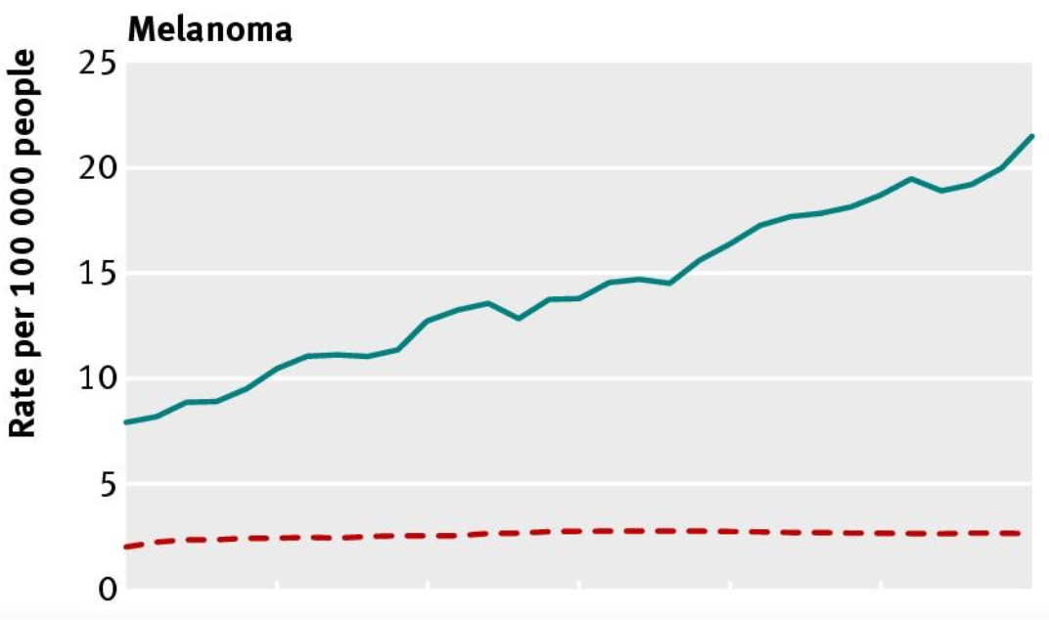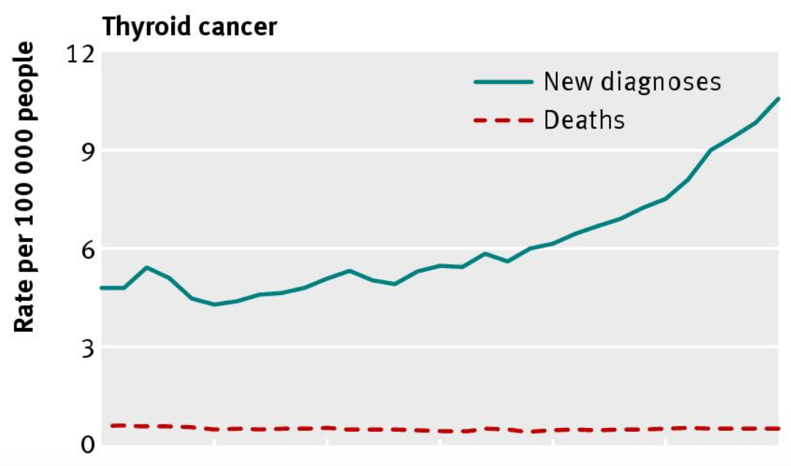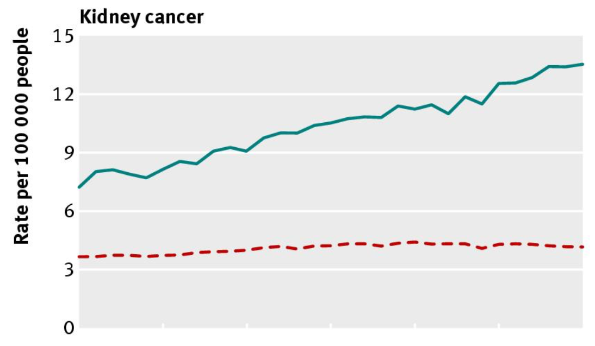
Figure 10.8: Dramatic increases in incidence with little effect on total mortality suggests overdiagnosis. Reproduced from: Preventing overdiagnosis: how to stop harming the healthy. Moynihan R, Doust J, Henry D, BMJ. 2012;344:e3502, copyright 2012, with permission from BMJ Publishing Group Ltd.

Finally, a concern about overdiagnosis can be supported by autopsy studies, in which evidence of disease is sought among patients who died without ever being diagnosed with the target disorder. The poster child for this is prostate cancer. A meta-analysis of 29 studies found that the mean prevalence of incidental prostate cancer at autopsy ranged from about 5% (95% CI 3 to 8%) in men who died at < 30 years to 59% (95% CI 48-71%) among those 80 years or older.[35] This sort of prevalence is sobering when one considers that it is in the same range as the reported positive predictive value of a screening PSA test![36]

Randomized trials of screening tests
We have said that the best way to determine whether a test is of benefit is to perform a randomized trial in which subjects are randomized to be tested or not. A drawback to randomized trials is that they may need to be very large and of long duration. Aside from the fact that the target diseases may be quite uncommon, the sample size has to be increased even further to make up for the bias toward the null (finding no effect) that occurs as a result of crossover between groups: some subjects randomized to screening will decline it, and some randomized to usual care will get screened anyway.

Total mortality versus cause-specific mortality
There are good arguments for saying that to know that a screening test saves lives, we need to see a decrease in total mortality in a group randomized to screening as opposed to just a decrease in cause-specific mortality. Whereas mortality is easy to ascertain objectively, cause-specific mortality is subject to judgment and might be influenced by the screening test. It also may be difficult or impossible to know whether some deaths occurred as late effects of the treatment or of the screening test itself. This is a particular problem with large studies where death certificates are used to determine cause of death. Although blinding those assigning cause of death to treatment group assignment will reduce that problem, it will not eliminate it, because screening produces information and events that become part of the patient’s medical history.
Black et al.[37] describe two major biases that result from using cause-specific rather than overall mortality as the outcome in studies of screening tests. Sticky diagnosis bias refers to the likelihood that, once a disease (particularly cancer) is diagnosed, deaths are more likely to be attributed to it (Figure 10.9, top). For example, sometimes patients die of unclear causes. If they previously had a cancer diagnosed by screening, their death would be more likely to be attributed to that cancer. The diagnosis of cancer “sticks” to the patient. This is a bias that will make a comparison of cause-specific mortality look worse for screening. Those in the screened group will tend to have higher cause-specific mortality attributed to the cancer they were screened for, even if they die of other conditions.
On the other hand, another possibility, which leads to underestimation of the harm from screening is what Black et al. call slippery linkage bias (Figure 10.9, bottom). This occurs when the linkage between deaths due to screening, follow-up, or treatment “slips,” so that deaths that may have occurred as a result of screening are not counted in the cause-specific mortality for the disease. This can occur from late complications from the screening test itself or from complications of treatment. For example, if a patient in a randomized trial of fecal occult blood testing to screen for colon cancer eventually dies after a series of complications that began with a colonic perforation during colonoscopy for a false-positive fecal occult blood test, the death would not be counted as a colon cancer death, although it was caused by screening for colon cancer. Similarly, there is good evidence from randomized trials that radiation therapy for breast cancer is associated with a late increase in coronary heart disease death rates.[38] These deaths may occur with greater frequency in screened women, who are more likely to receive radiation, but will be difficult or impossible to link them to screening.

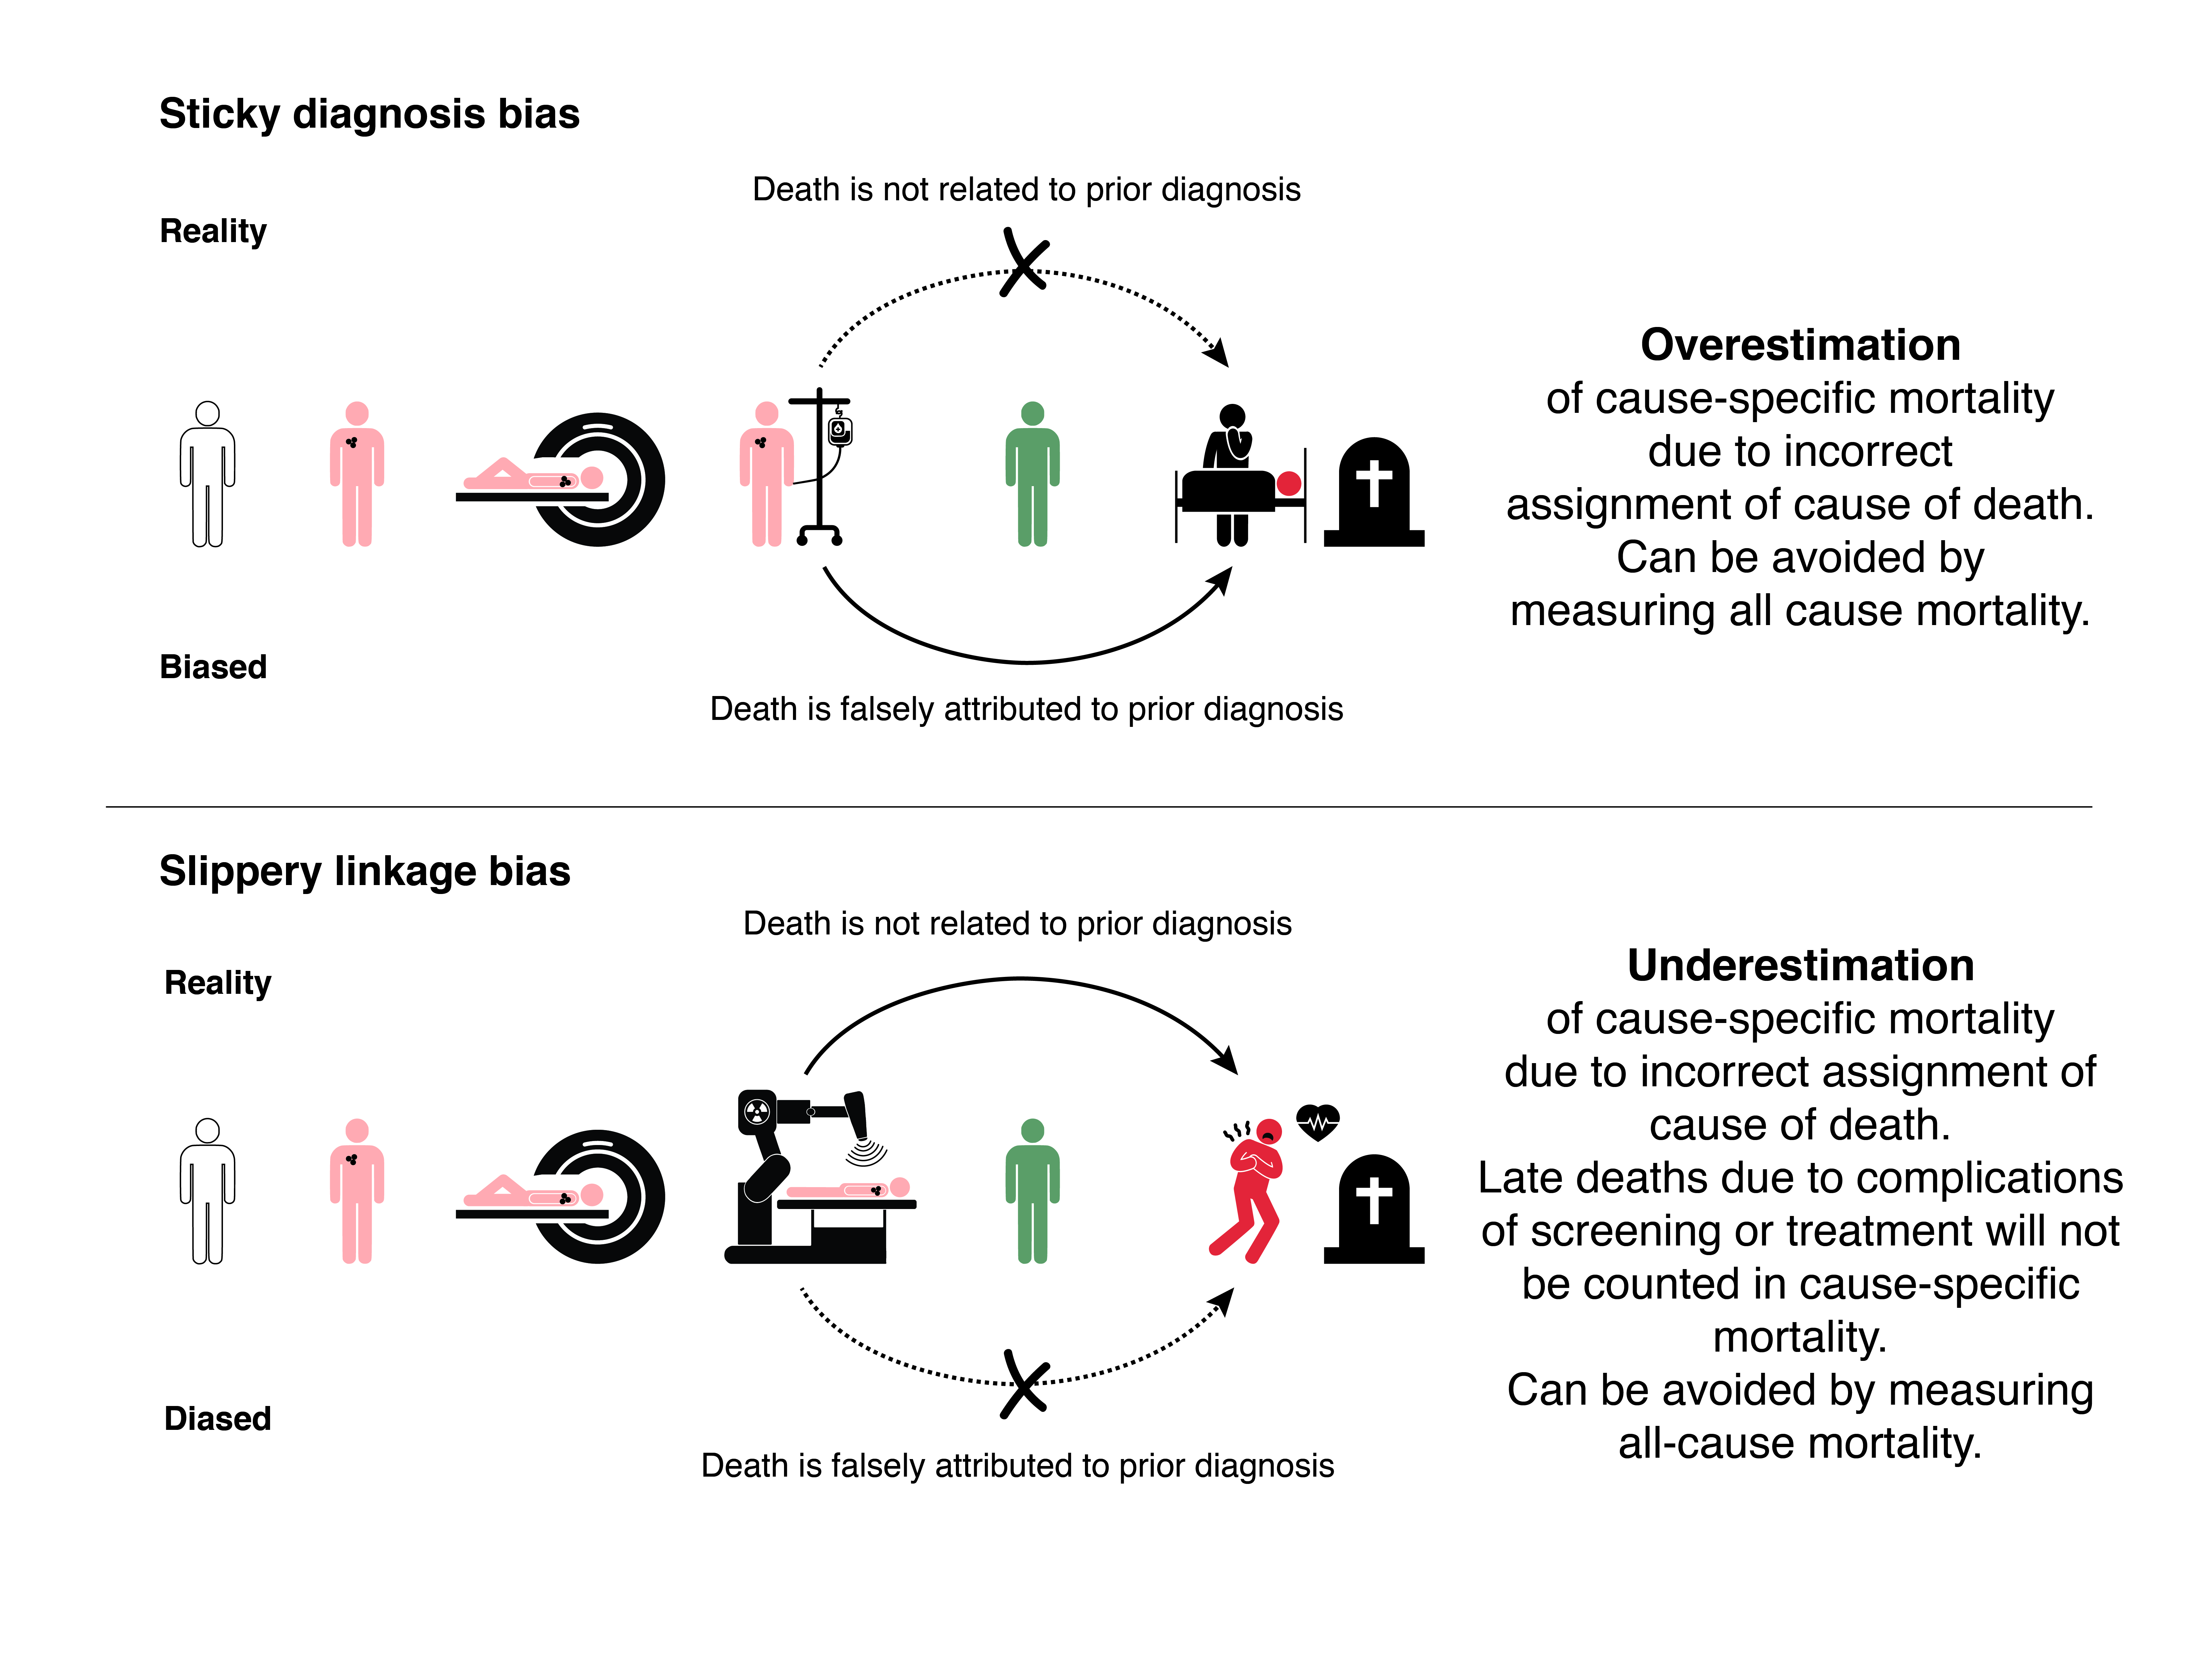
Figure 10.9. Sticky diagnosis and slipper linkage biases lead to over- or under- estimation of benefits of screening when cause-specific mortality is used as an outcome in randomized trials of screening. (Bottom panel should say, "Death is related to prior diagnosis" above the green man and "Death is not attributed to prior diagnosis" below the green man.)
There really is only one problem with using total mortality as an endpoint in screening trials, but it is a big one: deaths from causes unrelated to screening or the target condition will generally swamp deaths affected by screening, making it virtually impossible to identify beneficial (or harmful) effects. This is illustrated graphically in Figure 10.6. When only a few percent of deaths are likely to be due to the target condition, it is difficult to detect any effect on total mortality. But without such data, proponents of screening should not promise that it “saves lives.”[39]

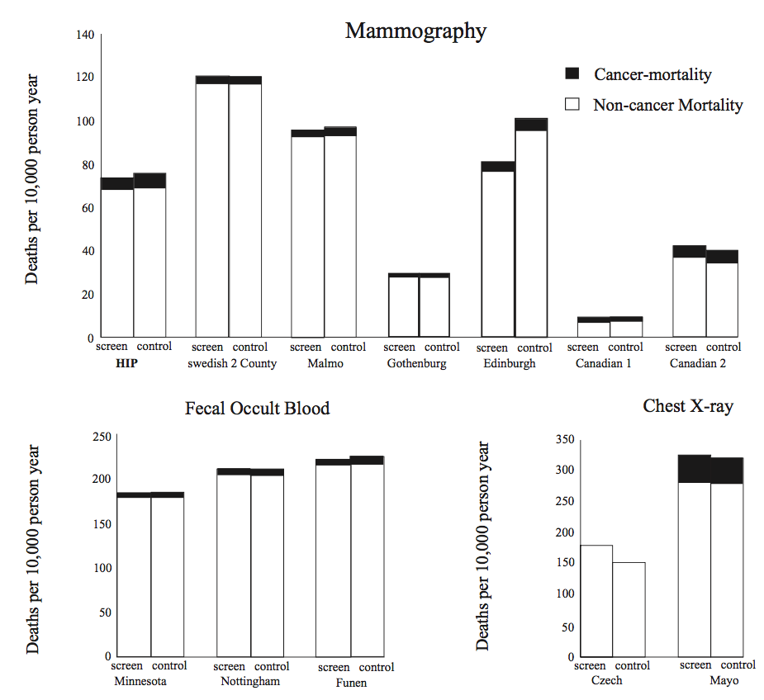
Figure 10.10. Cancer and noncancer mortality in randomized trials of cancer screening. From Black et al. (2002), used with permission.

Biases that make screening tests look worse
We have focused on biases that tend to make tests look better than they really are. This is because, at least historically, people doing studies of tests have often been advocates of the tests, so these were the biases to be most concerned about. But as more people (like us) who are skeptical about tests write articles about them, we should consider biases that can make tests look worse in a study than they might be in practice:
- Inadequate power: It is easy to fail to find any benefit of a test if your sample size is too small or duration of follow-up too short. For uncommon and slow growing cancers a very large sample size and a long follow-up period and may be needed.
- Contamination or crossover: Since randomized trials of screening often randomize subjects to be encouraged to get a test rather than actually getting it, any study where the proportion of subjects allocated to screening who are actually screened is well under 100% or where the proportion in the control group who have already been screened (contamination) or who get screened during the trial (crossover)[40] is well over 0% will underestimate the effects (good and bad) of screening. For example in the PLCO randomized trial of PSA screening, the mean number of screening PSA tests was 2.7 in the control group, compared with 5.0 in the intervention group, likely contributing to the overall results not being statistically significant in that trial.[41]
3. Lack of follow-up of abnormal test results. Randomized trials of screening tests are really randomized trials not just of the test (or of encouragement to get the test) but of the whole screening program, which includes all of the follow-up tests and interventions done as a result. For example, if one wanted to show that fecal occult blood testing was worthless, one could study it in a setting where many patients were not followed up or where those who were followed up were not well treated.

Back to the big picture
So what should we do to avoid recommending screening tests that might do harm, while not taking a completely nihilistic stance? First, every effort must be made to perform studies that answer the main question of whether screening leads to better outcomes. Because the ideal study design (randomized trial with total mortality as the outcome) is rarely feasible, keep several criteria in mind when considering the alternatives. First, studies should attempt to capture morbidity and mortality due to the screening test itself. Second, we should recognize that the need to examine total mortality varies with the screening test and the intervention. For fecal occult blood screening, for example, where the test involves no exposure to radiation and the treatment is primarily surgical, we have fewer concerns about late adverse effects than with mammography. In addition to the radiation from the test itself, treatment resulting from mammography may involve radiation and/or systemic treatment with hormone analogs or chemotherapeutic agents that may have significant effects on causes of death other than breast cancer that may not be apparent for years.[38] Finally, large, relatively simple, randomized trials (Chapter 8) and, when possible, much lower cost observational alternatives like natural experiments (Chapter 9), are desirable to address specific concerns about increases in mortality from causes other than the disease being screened for.

Summary of key points
1. The purpose of screening tests is to identify unrecognized symptomatic disease, presymptomatic disease, or risk factors for disease.
2. A critical approach to screening tests is important because screening tests can cause harm and because there are many forces and biases that tend to favor screening.
3. The most definitive way to assess screening tests is with randomized trials that have total mortality as the outcome, but these are seldom feasible, necessitating care when interpreting observational studies and trials focused on cause-specific mortality.

REFERENCES

1. Eddy D. Common screening tests. Philadelphia, PA: American College of Physicians; 1991.
2. Moore TJ. Deadly medicine : why tens of thousands of heart patients died in America's worst drug disaster. New York: Simon & Schuster; 1995. 349 p. p.
3. Law J, Faulkner K. Cancers detected and induced, and associated risk and benefit, in a breast screening programme. Br J Radiol. 2001;74(888):1121-7.
4. Riggs BL, Hodgson SF, O'Fallon WM, Chao EY, Wahner HW, Muhs JM, et al. Effect of fluoride treatment on the fracture rate in postmenopausal women with osteoporosis. N Engl J Med. 1990;322(12):802-9.
5. WHO. W.H.O. cooperative trial on primary prevention of ischaemic heart disease using clofibrate to lower serum cholesterol: mortality follow-up. Report of the Committee of Principal Investigators. Lancet. 1980;2(8191):379-85.
6. Epstein AE, Hallstrom AP, Rogers WJ, Liebson PR, Seals AA, Anderson JL, et al. Mortality following ventricular arrhythmia suppression by encainide, flecainide, and moricizine after myocardial infarction. The original design concept of the Cardiac Arrhythmia Suppression Trial (CAST). Jama. 1993;270(20):2451-5.
7. Haynes RB, Sackett DL, Taylor DW, Gibson ES, Johnson AL. Increased absenteeism from work after detection and labeling of hypertensive patients. N Engl J Med. 1978;299(14):741-4.
8. Rubin SM, Cummings SR. Results of bone densitometry affect women's decisions about taking measures to prevent fractures. Ann Intern Med. 1992;116(12 Pt 1):990-5.
9. Fyro K, Bodegard G. Four-year follow-up of psychological reactions to false positive screening tests for congenital hypothyroidism. Acta Paediatr Scand. 1987;76(1):107-14.
10. Barton M, Morley D, Moore S, Allen J, Kleinman K, Emmons K, et al. Decreasing women's anxieties after abnormal mammograms: a controlled trial. JNCI. 2004;96:529-38.
11. Lee T, Brennan T. Direct-to-consumer marketing of high-technology screening tests. New Engl J Med. 2002;346(7):529-31.
12. Braveman P, Tarimo E. Screening in primary health care: setting priorities with limited resources. Geneva: World Health Organization; 1994.
13. Marantz PR. Blaming the victim: the negative consequence of preventive medicine. Am J Public Health. 1990;80(10):1186-7.
14. Newman TB. The power of stories over statistics. BMJ. 2003;327(7429):1424-7.
15. Bishai D. Hearts and minds and child restraints in airplanes. Arch Pediatr Adolesc Med. 2003;157(10):953-4.
16. Daniels N. Why saying no to patients in the United States is so hard. Cost containment, justice, and provider autonomy. N Engl J Med. 1986;314(21):1380-3.
17. Mariner WK. Rationing health care and the need for credible scarcity: why Americans can't say no. Am J Public Health. 1995;85(10):1439-45.
18. Eddy DM. Breast cancer screening in women younger than 50 years of age: what's next? Ann Intern Med. 1997;127(11):1035-6.
19. Schwartz LM, Woloshin S, Fowler FJ, Jr., Welch HG. Enthusiasm for cancer screening in the United States. JAMA. 2004;291(1):71-8.
20. Ernster VL. Mammography screening for women aged 40 through 49--a guidelines saga and a clarion call for informed decision making. Am J Public Health. 1997;87(7):1103-6.
21. Feinstein AR, Sosin DA, Wells CK. The Will Rogers phenomenon: improved technologic diagnosis and stage migration as a source of nontherapeutic improvement in cancer prognosis. Trans Assoc Am Physicians. 1984;97:19-24.
22. Olivotto IA, Truong PT, Speers CH. Staging reclassification affects breast cancer survival. J Clin Oncol. 2003;21(23):4467-8.
23. Woodward WA, Strom EA, Tucker SL, McNeese MD, Perkins GH, Schechter NR, et al. Changes in the 2003 American Joint Committee on Cancer staging for breast cancer dramatically affect stage-specific survival. J Clin Oncol. 2003;21(17):3244-8.
24. Welch HG. Should I be tested for cancer? Maybe not, and here's why. Berkeley,CA: University of California Press; 2004.
25. Esserman LJ, Thompson IM, Jr., Reid B. Overdiagnosis and overtreatment in cancer: an opportunity for improvement. JAMA. 2013;310(8):797-8.
26. Esserman LJ, Thompson IM, Reid B, Nelson P, Ransohoff DF, Welch HG, et al. Addressing overdiagnosis and overtreatment in cancer: a prescription for change. Lancet Oncol. 2014;15(6):e234-42.
27. Hofmann B, Welch HG. New diagnostic tests: more harm than good. BMJ. 2017;358:j3314.
28. Marcus PM, Bergstralh EJ, Fagerstrom RM, Williams DE, Fontana R, Taylor WF, et al. Lung cancer mortality in the Mayo Lung Project: impact of extended follow-up. J Natl Cancer Inst. 2000;92(16):1308-16.
29. Buys SS, Partridge E, Black A, Johnson CC, Lamerato L, Isaacs C, et al. Effect of screening on ovarian cancer mortality: the Prostate, Lung, Colorectal and Ovarian (PLCO) Cancer Screening Randomized Controlled Trial. JAMA. 2011;305(22):2295-303.
30. Pinsky PF, Yu K, Kramer BS, Black A, Buys SS, Partridge E, et al. Extended mortality results for ovarian cancer screening in the PLCO trial with median 15years follow-up. Gynecol Oncol. 2016;143(2):270-5.
31. Andriole GL, Grubb RL, 3rd, Buys SS, Chia D, Church TR, Fouad MN, et al. Mortality results from a randomized prostate-cancer screening trial. N Engl J Med. 2009;360(13):1310-9.
32. Ilic D, Djulbegovic M, Jung JH, Hwang EC, Zhou Q, Cleves A, et al. Prostate cancer screening with prostate-specific antigen (PSA) test: a systematic review and meta-analysis. BMJ. 2018;362:k3519.
33. Bibbins-Domingo K, Grossman DC, Curry SJ. The US Preventive Services Task Force 2017 Draft Recommendation Statement on Screening for Prostate Cancer: An Invitation to Review and Comment. JAMA. 2017;317(19):1949-50.
34. Moynihan R, Doust J, Henry D. Preventing overdiagnosis: how to stop harming the healthy. BMJ. 2012;344:e3502.
35. Bell KJ, Del Mar C, Wright G, Dickinson J, Glasziou P. Prevalence of incidental prostate cancer: A systematic review of autopsy studies. Int J Cancer. 2015;137(7):1749-57.
36. Mistry K, Cable G. Meta-analysis of prostate-specific antigen and digital rectal examination as screening tests for prostate carcinoma. J Am Board Fam Pract. 2003;16(2):95-101.
37. Black WC, Haggstrom DA, Welch HG. All-cause mortality in randomized trials of cancer screening. J Natl Cancer Inst. 2002;94(3):167-73.
38. Early Breast Cancer Trialists' Collaborative Group. Favourable and unfavourable effects on long-term survival of radiotherapy for early breast cancer: an overview of the randomised trials. Lancet. 2000;355(9217):1757-70.
39. Welch HG. Less medicine, more health : 7 assumptions that drive too much medical care. Boston: Beacon Press; 2015. xxii, 218 pages p.
40. Pron G. Prostate-Specific Antigen (PSA)-Based Population Screening for Prostate Cancer: An Evidence-Based Analysis. Ont Health Technol Assess Ser. 2015;15(10):1-64.
41. Pinsky PF, Blacka A, Kramer BS, Miller A, Prorok PC, Berg C. Assessing contamination and compliance in the prostate component of the Prostate, Lung, Colorectal, and Ovarian (PLCO) Cancer Screening Trial. Clin Trials. 2010;7(4):303-11.

We do not wish to come across as complete screening nihilists. In fact, both of us have loved ones whose lives we believe may have been prolonged by screening. However, this is an area where we are concerned that enthusiasm has sometimes exceeded evidence, where there is a potential for harm, and where we see a growth industry that could consume ever greater resources with diminishing return. Hence our emphasis here is on taking a critical approach to screening tests, and on not overestimating their value.
The requirement for longitudinal studies is one shared with studies of prognostic tests, discussed in Chapter 6. But one difference is that studies of risk factor screening often must be much larger and longer than studies of prognostic tests because bad outcomes happen less frequently among people who are well than among people who have a disease.
a Aside from the desire to help people, which is assumed to be a reason for all.
This is almost always the case, but a possible exception is the Multicenter Aneurysm Screening Study described in Problem 10.1.
We called this Volunteer Bias in the first edition; but that term is more often used when subjects enrolled in a clinical trial differ from the population to which trial results are to be generalized. In this case it’s volunteering for the screening test rather than for a research study that is the cause for concern. (The Volunteer Effect leads to a problem with internal validity, not just external validity.)
Of course one can compare survival among those diagnosed with the disease between screening and control groups in a randomized trial, but such a comparison should not be used to evaluate the test because it would violate the Intention to Treat (once randomized, always analyzed) principle by ignoring all those in both groups not diagnosed with disease.
This discussion is focused on screenings whose goal is to prolong life.
Except Sticky Diagnosis Bias, which makes the screening test look worse in terms of cause specific mortality.

