9 Alternatives to randomized trials for estimating treatment effects

Introduction
We said in Chapter 8 that randomized blinded trials are the best way to estimate treatment effects because they minimize the potential for confounding, co-interventions, and bias, thus maximizing the strength of causal inference. However, sometimes observational studies can be attractive alternatives to randomized trials because they may be more feasible, ethical, or elegant. Of course, the issue of inferring causality from observational studies is a major topic in classical risk factor epidemiology. In this chapter, we focus on observational studies of treatments rather than risk factors, describing methods of reducing or assessing confounding that are particularly applicable to such studies.

Confounding by indication
We discussed in Chapter 8 that confounding refers to the distortion of the effect of variable A on the outcome C by a third variable B, which is a cause of (or shares a common cause with) both A and C. We focus on treatments that are supposed to be beneficial, that is, to have an RR < 1 for a bad outcome. One type of confounding makes treatments appear better than they really are – for example, finding a beneficial treatment effect when, in truth, the treatment either has no effect or causes harm. In this situation, a confounder associated with receiving the treatment reduces the risk of a bad outcome.
An example is use of vitamin E to prevent cardiovascular disease. Multiple observational studies suggested a protective effect [1], but randomized trials have found no benefit [2] suggesting that favorable health habits of people who took Vitamin E (e.g., better diet, exercise, or health awareness) were the true cause of their lower risk of cardiovascular disease (Figure 9.1).
Alternatively, when a confounder associated with receiving the treatment increases the risk of a bad outcome, it can mask or reduce the apparent benefit of the treatment. For example, if only the sickest people get the treatment in question, the treatment may look harmful even when it actually helps. This effect is called confounding by indication because those in whom the treatment is most indicated are those at highest risk of the bad outcome that the treatment is designed to prevent.
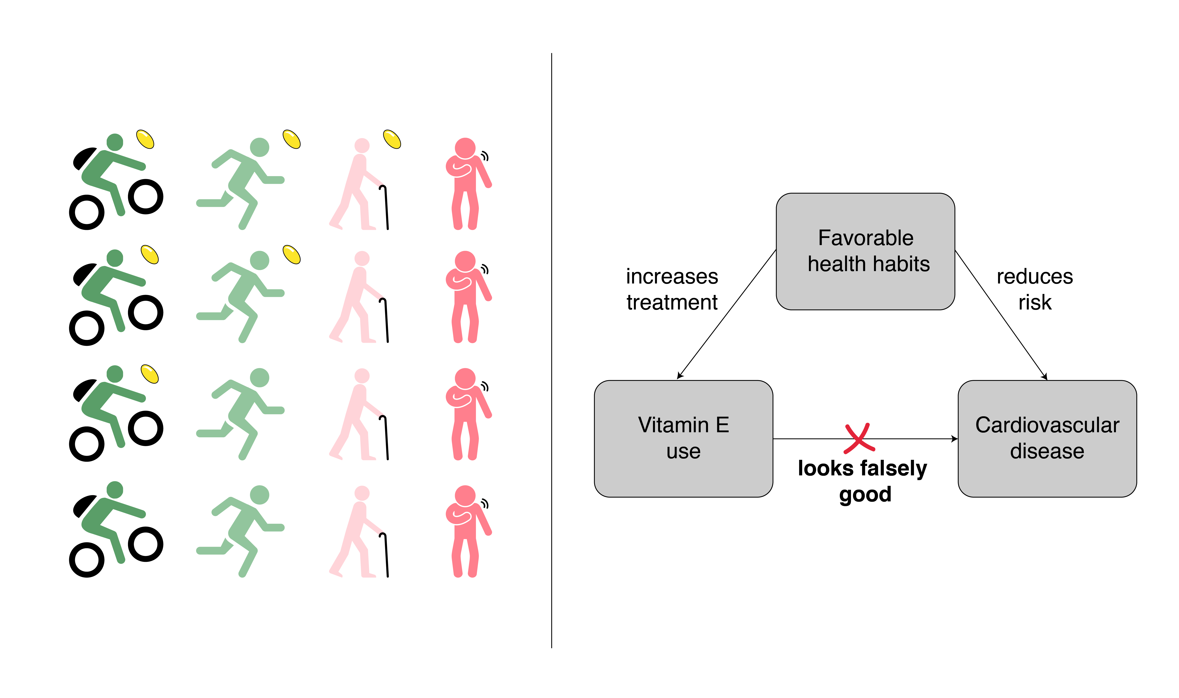Figure 9.1 Confounding: Vitamin E seemed to reduce the risk of cardiovascular disease when presumably it is only associated with favorable health habits that reduce risk.
An example of confounding by indication is diuretic treatment of hypertension in diabetics. A cohort study[3] found that diuretics appeared to increase the risk of cardiovascular mortality in hypertensive diabetics compared with leaving the hypertension untreated. However, subsequent randomized trials demonstrated that treating hypertensive diabetics with diuretics reduces their risk of cardiovascular mortality.[4] The confounder was the severity of cardiovascular disease. The patients with more severe disease were more likely to be treated with diuretics, and they were also more likely to die of their cardiovascular disease (Figure 9.2).
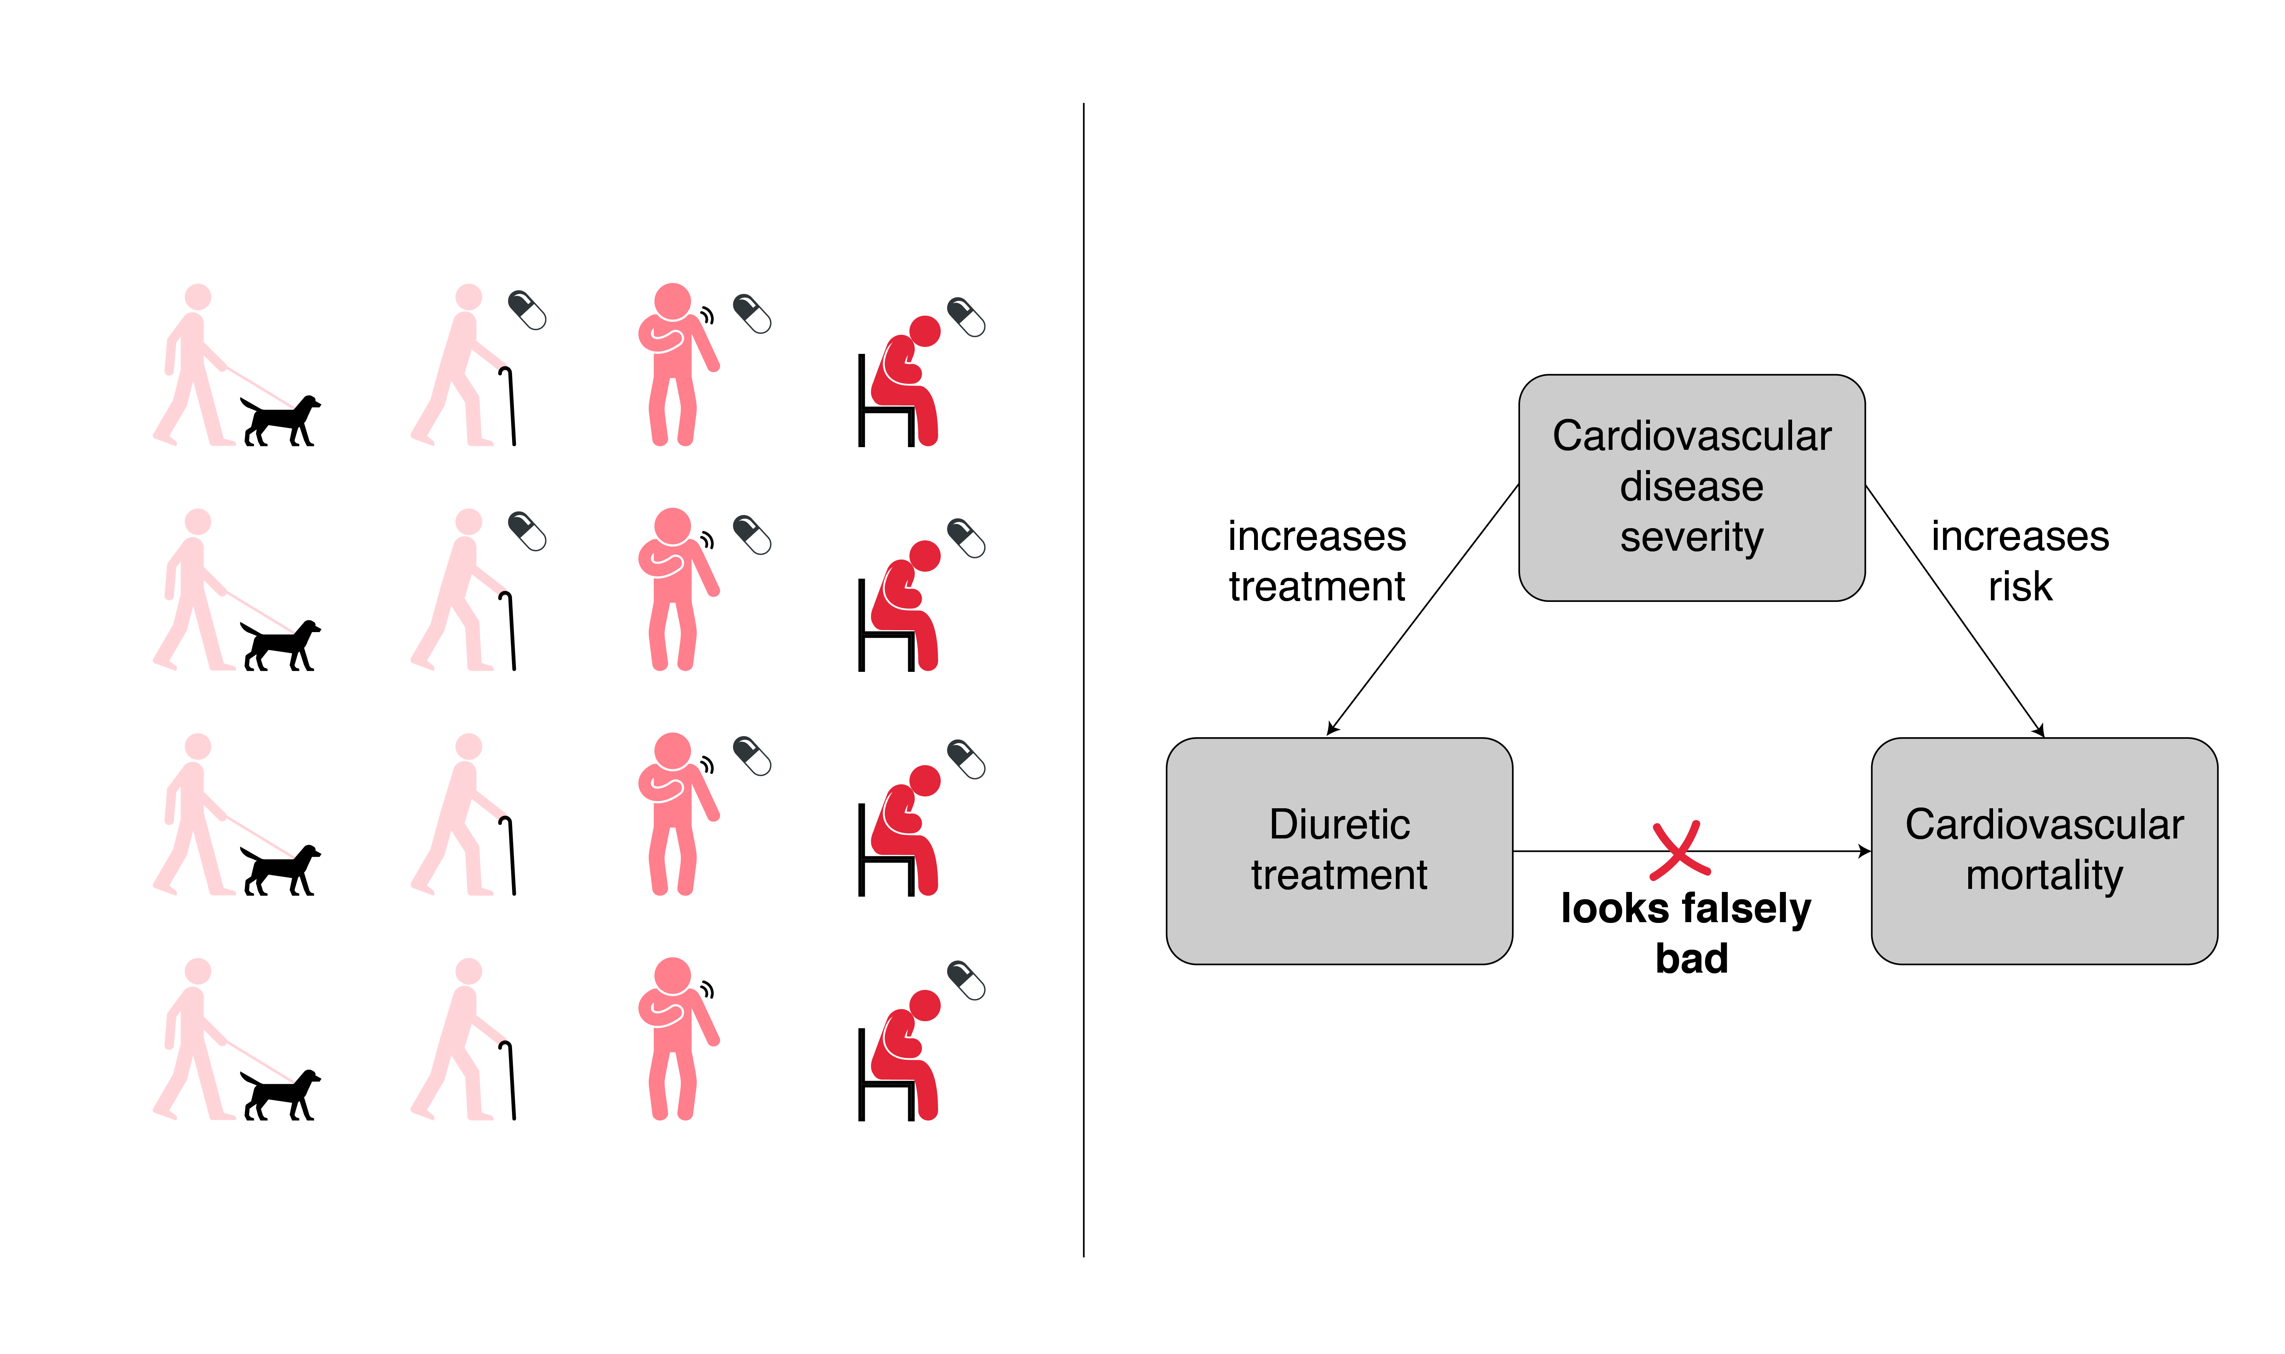
Figure 9.2 Confounding by indication. Diuretic treatment among hypertensive diabetics was associated with cardiovascular mortality because the treated subjects had more severe cardiovascular disease.
If all the important confounders can be measured, a multivariable analysis may reduce or adequately adjust for confounding, allowing us to estimate treatment effects with an observational study. In the remainder of this chapter we will review some other approaches.

Instrumental variables
Although studies of instrumental variables are generally observational, the concepts are most readily appreciated for randomized trials, so we will begin with those. When we discussed the “Intention to Treat” principle in Chapter 8, we acknowledged that in randomized controlled trials, there might be an imperfect relationship between the predictor variable of interest (e.g., actually taking the medication) and the predictor variable analyzed (group assignment). We stressed that to maintain the strength of causal inference provided by randomization it is important to analyze by group assignment. For example, we should compare people assigned to take the active medication with people assigned to placebo, rather than comparing people who actually took the medication with those who took placebo. However, if this intention-to-treat analysis results in significant misclassification of exposure (e.g., because some people assigned to the drug do not take it and/or some assigned to placebo obtain the active drug), the estimate of effect size will be biased toward the null.
One of the best applications of an instrumental variable analysis is to mathematically reverse the bias toward the null that results from nonadherence or treatment crossover in a randomized trial (or other situations when the likelihood of treatment is randomly assigned, as discussed below). If the investigators can assume that all of the observed difference between groups is due to the greater likelihood of receiving the treatment under study among those randomized to it, they can calculate what the effect of actually receiving the treatment would need to be to produce the observed (attenuated) difference between treatment groups.
A good example of this comes from a randomized trial that compared two different types of smoking cessation interventions with usual care among CVS Caremark employees. [5] In reward-based interventions, employees were given $200 for biochemically confirmed tobacco abstinence at each of 4 time periods, for a total bonus of up to $800 for abstinence at 6 months. In deposit-based interventions, the employees had to deposit $150 of their own money, which would be refunded only if they quit smoking.
In the intention-to-treat analysis, quit rates were higher in the reward group (15.7% vs 10.2%,) because many more people randomized to that program accepted their treatment assignment (90.0% vs 13.7% in the deposit group). But the instrumental variable analysis addressed a different question: how effective were interventions if they were accepted. This question cannot be answered with a “per protocol” analysis, comparing quit rates among people who accepted their treatment assignment, because people who accepted the deposit program almost certainly were more motivated to quit at the outset than those who accepted the reward program. But the instrumental variable analysis showed that, among those who would accept either program, the deposit program was more effective; the absolute increase in quit rates compared with the reward program was 13.2%.
Box 9.1 Estimating the Complier Average Causal Effect
There's a very simple equation for something often called the Complier Average Causal Effect (CACE) that we can't resist including here. The CACE is the effect of an intervention among those who get it as a result of the instrument, in this case being randomly assigned to it. The algebra in the smoking cessation study gets a bit hairy because of the 3 different groups, but for a 2-armed trial it is simple. Let's just look at the comparison between the deposit-based intervention and usual care as a risk difference. To obtain the CACE, the intention-to-treat risk difference is simply divided by the difference in proportions actually getting the active treatment in each group:
CACE = Effect of treatment received on outcome, as a risk difference
Effect of treatment assignment on outcome = ITT effect, as a risk difference
=
Effect of treatment assignment on treatment received, as a risk difference
=

The equation above makes sense: if everyone assigned the treatment and no one not assigned the treatment received it, then the denominator would be 100% − 0% =1 and the effect of receiving treatment would just be the ITT effect.
In the smoking cessation study, quit rates were 10.2% in the group randomized to be offered the deposit intervention and 6.0% in the group randomized to usual care, an ITT difference of 4.2%. The proportions that actually received the deposit-based intervention in the two groups were 13.7% and 0%, a 13.7% difference. So, the effect of the deposit intervention on quit rates among those who actually accepted it (the CACE) was about a 4.2%/13.7% = 30.7% absolute increase in quit rates.
10.2% − 6.0%
30.7%
13.7% − 0%
=

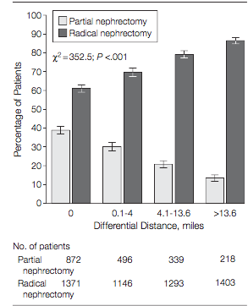
Of course, instruments that are randomly assigned are limited, so in most cases the investigator needs to seek out other variables that are associated with the treatment of interest and thought not to be (independently) associated with the outcome. The outcome is then determined in relation to this “instrumental variable,” rather than the actual treatment or exposure of interest. As with a randomized study, the expected bias toward the null that then occurs from misclassification of exposure is overcome with a combination of a large sample size and calculations to reverse the effect of the imperfect relationship between the instrumental variable and the predictor of interest.
For example, Tan et al[6] wished to compare partial nephrectomy (removing just the kidney tumor) with radical nephrectomy (removing the whole kidney and surrounding lymph nodes) among older patients with early-stage kidney cancer. Radical nephrectomy has been the traditional treatment, and at the time of their study, many surgeons did not yet do partial nephrectomies in these patients. The authors used Medicare data to create a “differential distance” instrument for each of the 7,138 patients in the study, equal to the distance (in miles) between the closest surgeon who had performed at least one partial nephrectomy in the previous year and the closest kidney surgeon of any kind. (Thus, this distance would be 0 if the closest kidney surgeon had performed at least one partial nephrectomy in the previous year.) They showed that as this differential distance increased, patients were less likely to be treated with partial nephrectomy, as expected (Figure 9.3). The authors found that the instrument, shorter differential distance, was a statistically significant predictor of decreased mortality. Assuming that the only reason for this is the increased likelihood of partial vs. total nephrectomy, the authors calculated that hazard ratio associated with partial vs. total nephrectomy was 0.54 (95% CI 0.34, 0.85), corresponding to an absolute increase in 8-year survival of 15.5%.
Figure 9.3 Surgical treatment by differential distance. Reproduced with permission from JAMA. 2012. 307(15):1629-35. Copyright© 2012 American Medical Association. All rights reserved.

This type of geographic proximity instrument has also been used for many other treatments, including heart attack interventions[7] and hip fracture anesthesia.[8] Its main limitation is the assumption that there are not other important differences between patients who live near different hospitals besides those measured and controlled for in analyses.[9] For example, are patients who live near medical centers that offer newer procedures likely to have different health habits or get better medical care in other ways? The causal inference can be strengthened if the authors search for and fail to find evidence that underlying assumptions might be violated (for example, by looking for differences in outcomes thought not to be related to the treatment of interest). This is the topic of the next section.

Falsification tests for confounding or bias
Clinical trials, natural experiments, and studies using instrumental variables all share the goal of minimizing or controlling confounding. A complementary approach is not to control confounding but to propose falsification tests, i.e., comparisons designed to make your hypothesis look less credible. These should be specified in advance, to avoid the temptation of running multiple falsification tests and reporting only those that look good.[10]
There are three strategies for these falsification tests. The first is to measure another outcome that would be affected by the unmeasured confounder of concern but not by the treatment. If the treatment seems to affect this second outcome, confounding is likely to be a problem. The second is to measure another predictor variable in addition to the treatment of interest that is not felt to have a causal effect on the outcome but which should be associated with the unmeasured confounder. If confounding has an important effect on the relationship between the treatment and the outcome, it should also affect the relationship between the second predictor and the outcome. Finally, the association can be studied in different patient populations predicted to be more or less susceptible to the exposure or treatment being studied; the effect should be smaller (or absent) in the less (or not) susceptible population.
Concrete examples of these methods should help clarify this abstract discussion.

Measuring another outcome
A classic example of measuring a second outcome, subject to the same potential confounders as the outcome of interest is a study of sigmoidoscopy by Selby et al. [11] In their case–control study of screening sigmoidoscopy to prevent colon cancer mortality, they divided the colon cancer deaths into those caused by cancers that likely were and were not within reach of the sigmoidoscope. The cancers not within reach of the sigmoidoscope were the second outcome; they were presumably associated with the same confounders as those within reach of the scope, but not preventable with the sigmoidoscopy treatment. Although the authors used logistic regression to adjust for relevant covariables, the particularly elegant aspect of the study is their demonstration that sigmoidoscopy conferred protection against deaths from colon cancers that were within reach of the sigmoidoscope (adjusted OR = 0.41; 95% CI 0.25 to 0.69), but not from those that were beyond the reach of the sigmoidoscope (OR = 0.96; 95% CI 0.61 to 1.50). If unmeasured confounders like better health habits were responsible for the apparent protective effect of sigmoidoscopy, it seems likely that they would have led to apparent protection from cancers both within and beyond the reach of the sigmoidoscope.

Measuring another predictor
The second approach, measuring other predictors in addition to the treatment of interest, is illustrated by a study of whether the oral hypoglycemic drug pioglitazone causes bladder cancer. A retrospective cohort study of 145,806 new users of antidiabetic drugs in the United Kingdom Clinical Practice Research database found an increased risk of bladder cancer with pioglitazone (adjusted hazard ratio 1.63, 95% CI 1.22, 2.19) but not with the closely related oral hypoglycemic drug rosiglitazone (adjusted hazard ratio 1.1, 95% CI 0.83, 1.47). [12] The risk with pioglitazone increased with cumulative dose and duration, whereas there was no such effect with rosiglitazone. This result was consistent with a meta-analysis of both randomized trials and observational studies,[13] but would have been even more convincing if the authors' Table 1 would have compared pioglitazone users with rosiglitazone users (rather than with pioglitazone nonusers) and if the authors had shown no difference in other (non-bladder cancer) outcomes between users of the two drugs.
A humbling example of the limitations of measuring another predictor as a falsification test for confounding comes from studies of the effect of Vitamin E vs other vitamins on the risk of heart disease. In both the Health Professionals study [14] and the Nurses’ Health Study,[15] taking at least 400 International Units of Vitamin E daily was associated with a reduced risk of coronary heart disease, even after adjusting for all known confounders. Of course, as noted at the beginning of this chapter, people who take Vitamin E are different from people who do not – for example, they might be more health conscious. But if that were the case, one might expect a favorable outcome in people taking a multivitamin pill or vitamin C as well, behaviors that are also associated with being health conscious. However, this was not observed. The lack of an association of the outcome with an alternative predictor variable that one would expect to suffer from the same confounding as the treatment of interest suggested causality strongly enough that Tom briefly took supplemental vitamin E. Unfortunately, as mentioned above, subsequent evidence from randomized trials suggests vitamin E is of no benefit[2] and may even be harmful.[16] Fortunately, he survived to tell the story.

Studying another patient population
A provocative study (coauthored by the authors of the review of falsification endpoints cited above)[17] used all three techniques (and prespecified them!). The authors examined mortality and treatment patterns among patients hospitalized for acute heart conditions during the dates of national cardiology meetings, when many attending academic cardiologists would be away from their home teaching hospitals. They found that both percutaneous coronary intervention rates and mortality among heart failure and cardiac arrest patients were lower during meeting dates than on the same days of the week during the 3 weeks before and 3 weeks after the meetings.
They found no effects of admission during cardiology meetings on mortality from gastrointestinal hemorrhage or hip fracture (alternative outcomes). Similarly, they found no effect (on heart patients) of being admitted during national oncology, gastroenterology, or orthopedic meeting days, compared with the days before and after (alternative predictors). Finally, the investigators used acute heart patients admitted to nonteaching hospitals as an alternative patient population. The patients in nonteaching hospitals would be predicted to be less susceptible to the exposure of being admitted during national cardiology meetings, because the meetings are less often attended by cardiologists at nonteaching hospitals. The authors found no effect of being admitted during national cardiology meetings on patients cared for in nonteaching hospitals. A possible explanation for these findings offered by the authors is that “the intensity of care provided during meeting dates is lower and that for high-risk patients with cardiovascular disease, the harms of this care may unexpectedly outweigh the benefits.”

Propensity scores
Another approach to controlling confounding in observational studies of treatment efficacy is the use of propensity scores. In order for a variable to be a confounder, it has to be associated with both treatment and outcome. (For this discussion, assume that the binary outcome is occurrence of something bad like death and that fewer subjects have the outcome than don’t have it.) The usual approach to multivariable analysis to control for confounding is to create a model for the outcome that includes the treatment variable and other predictors of outcome (the potential confounders). If the model fits, the coefficient for the treatment will reflect its independent contribution to the outcome.
For example, the equation for the logistic regression model (Chapter 7) can be written as:
ln
where
“P(Y)” is the probability of the outcome Y,
“ln ” is the log-odds of the outcome,
“a” is a constant (the intercept, related to the overall probability of the outcome),
“X_{i}” are the different predictor variables associated with outcome, including the predictor variable of interest as well as the potential confounders. For example, the variable of interest to you might be X₁ (the treatment you are studying) and the rest would be confounders.
“b_{i}” are coefficients equal to the change in the log odds per unit change in the predictor (equal to the logarithm of the odds ratio if “X_{i}” is dichotomous)
“k” is the number of predictor variables.
One limitation of this approach is that, if there are many potential confounders, there may not be enough outcomes in the dataset to be able to estimate their coefficients with much precision. There’s a rule of thumb: you would like to see at least 10 outcomes for each predictor variable. Imagine there are 1,000 patients, of whom 300 received the treatment of interest, but only 30 died. With only 30 outcomes, it will be difficult to control for confounding by more than 2 other variables aside from the treatment variable – the dataset just does not have enough outcomes to do this well.
Enter propensity scores. The idea of propensity scores is that, instead of controlling for all possible predictors of outcome, investigators instead control for predictors of the treatment. They do this by creating a model to estimate the predicted probability of treatment (or propensity to be treated). Then they either match or stratify on this propensity score and compare outcomes in those who were actually treated to those who weren’t. Continuing with the notation above, if X₁ is the treatment of interest, the model for the propensity score would look like this:
ln[P(X₁)/(1−P(X₁)] = a + b₁X₁ + b₂X₂ + b₃X₃ + … + b_{j}X_{j}
Note that now the probability we are trying to predict is not the probability of the outcome, P(Y), it is probability of treatment, P(X₁). Only variables whose values are known at the time of the treatment decision should be included in the propensity score. (Including variables measured later runs the risk that they may have been affected by the treatment, and adjusting for them could adjust away treatment effects.) The number of predictors of treatment may be different from the number of predictors of outcome, so we end up with j instead of k − 1 variables.
Because the number of treated subjects often far exceeds the number of subjects with outcomes, it may be possible to control for many more potential confounders in a propensity score model than in a model for outcome.
Now the investigator can stratify or match on this P(X₁) variable and compare the risk of outcome in those who actually were and were not treated but had approximately the same propensity to be treated.
Alternatively, the investigator can use inverse probability weighting to create exposed and unexposed populations with similar distributions of propensities to be treated. This is done by weighting the treated group by 1/P(X₁) and the untreated group by 1/(1-P(X₁)). This inverse probability of treatment weighting works because subjects with a low propensity to be treated will be under-represented in the treatment group. To undo this under-representation, we count the treated subjects with low propensity more by multiplying by a weight of 1/P(X₁), which will be a higher number the lower P(X₁) is. Similarly, untreated subjects with high propensity scores will be under-represented, so we give them extra weight by multiplying by 1/(1-P(X₁)), which will be higher if P(X₁) is higher.
For example, Gum et al.[18] prospectively studied total mortality of 6,174 consecutive adults undergoing stress echocardiography, 2,310 of whom (37%) were taking aspirin. In unadjusted analyses, mortality did not differ between users and nonusers of aspirin: it was 4.5% in each group. Multivariable analysis, however, suggested a mortality benefit was hidden by confounding by indication. This was confirmed by matching subjects by propensity scores and then comparing survival in the two groups (Figure 9.4).
Figure 9.4 Survival of aspirin users and nonusers following stress echocardiography, matched by propensity score for aspirin use. (From Gum et al. 2001; used with permission.)
Note that the figure is based on only 1,351 subjects in each group. This is because only 1,351 of the 2310 subjects who received aspirin had a “match,” – that is, had someone with the same propensity to receive aspirin but did not receive it – in the non-aspirin users group. This is not unexpected in observational studies such as this one. When the treatment is not randomized, the average propensity to receive aspirin will be higher in the group that received it than in the group that did not, which may make it difficult to match all treated subjects to untreated subjects. This loss of subjects affects both power (which was still more than adequate in this study) and generalizability.
For example, the results of this study are only generalizable to patients whose propensity to receive aspirin was in a range where there was overlap between those who did and did not receive it. But this makes sense. If there are some people who absolutely should get aspirin and some who should not, their propensities will be close to 1 and 0, respectively. Such patients will not have a match and hence will not be included in the matched results.
Think of this exclusion of subjects with propensity scores near 0 or 1 as analogous to exclusion criteria in a clinical trial. If there are some persons for whom either drug or placebo is known to be contraindicated, then you neither can nor should study the difference between drug and placebo in those patients. In fact, this is another advantage of a propensity analysis: if there is little overlap between the propensity scores of those who were and were not treated, it means that those treated appear to be very different from those not treated, in terms of their indication for the treatment, and that trying to adjust for this with multivariable analysis may require questionable extrapolations beyond the data.
Figure 9.5 (A) Propensity scores do not overlap; treated and untreated groups are not comparable. A propensity analysis cannot be done and any comparison between groups is hazardous. (B) Propensity distributions are nearly identical. A propensity analysis is not necessary as groups are already matched or treatment was randomly assigned. (C) Good overlap in propensity scores; the subjects in the overlapping parts of the distribution can be studied. (Figure courtesy of Thomas Love; Case Western Reserve University Center for Health Research and Policy.)
A propensity score analysis requires that scores overlap between a substantial portion of the treated and untreated groups. (Figure 9.5C) If the model predicts treatment too well, only a few subjects in the treated and untreated groups will have the same propensity score (Figure 9.5A). For this reason, one should avoid including in a propensity score factors that are associated with receiving treatment but unlikely to cause the outcome, such as day of week or geographical location. (Note that these same factors might make good instrumental variables!) On the other hand, if the propensity score distributions in the treated and untreated groups are nearly identical, there is no need to do a propensity score analysis (Figure 9.5B).
Propensity score analysis in an observational study of a treatment helps to separate out the effects of the treatment itself from other factors associated both with receiving the treatment and with the outcome. However, propensity score analysis is not helpful if the goal is to identify or to quantify the effects of these other confounding factors.

The importance of timing
To this point of the chapter we have largely focused on ways to reduce or eliminate the possibility of confounding in observational studies of treatment efficacy (or harm). We pointed out that a goal of randomized trials is to assemble comparable groups, in order to use outcomes in the untreated subjects to estimate what would have happened to the treated subjects if they had not been treated. Randomization helps, by making the two groups comparable at baseline, and blinding helps keep the groups comparable. But another thing that randomization does is that it establishes the starting point for follow-up, the time period during which we are watching for and counting events.

Sometimes in observational studies, the starting points for follow-up may not be so clear. For those who were treated, we can start follow-up when treatment starts. But what about those who are not treated – when do we start counting the time at risk for them? And how do we handle those who are not initially treated but start treatment later in the study, or those who start treatment but then stop it soon thereafter, resembling cross-overs in a clinical trial?

For example, consider a retrospective cohort study of the association between pioglitazone and bladder cancer,[19] included in the meta-analysis cited above.[13] The authors divided the cohort of 207,714 subjects aged ≥ 40 years with type 2 diabetes taking an oral antidiabetic drug between January, 2001 and December, 2010 into those exposed (≥ 1 prescription for pioglitazone) and those unexposed (no prescriptions for pioglitazone during the study period).

In considering follow-up time in observational studies (most commonly retrospective cohort studies) it is helpful to imagine that what we are trying to do is to simulate a randomized trial. This should immediately raise a red flag about the study above, because the unexposed group is defined as never receiving pioglitazone during the follow-up period. But in a randomized trial, people are randomized to get the treatment or not at the outset, and should not be excluded from the group they were assigned to based on what might happen years later.

To see the problem here, imagine that Sally starts pioglitazone on February 1, 2001, and that a very similar patient named Jennie does not. Over the next 8 years, they both have the opportunity to get bladder cancer, and neither of them does. But then in 2009, Jennie starts taking pioglitazone. She now will be analyzed with the pioglitazone group, and the 8 years of person time she had when she did not take pioglitazone and did not get bladder cancer does not count towards person-time denominator in the unexposed group. But if she had gotten bladder cancer in that time, it would have counted as an unexposed group cancer. Thus, the person-time denominator for the risk of cancer in the unexposed group in this study is too small, so the unexposed group's incidence of bladder cancer will be overestimated, diminishing the apparent adverse effect of pioglitazone (Figure 9.6).

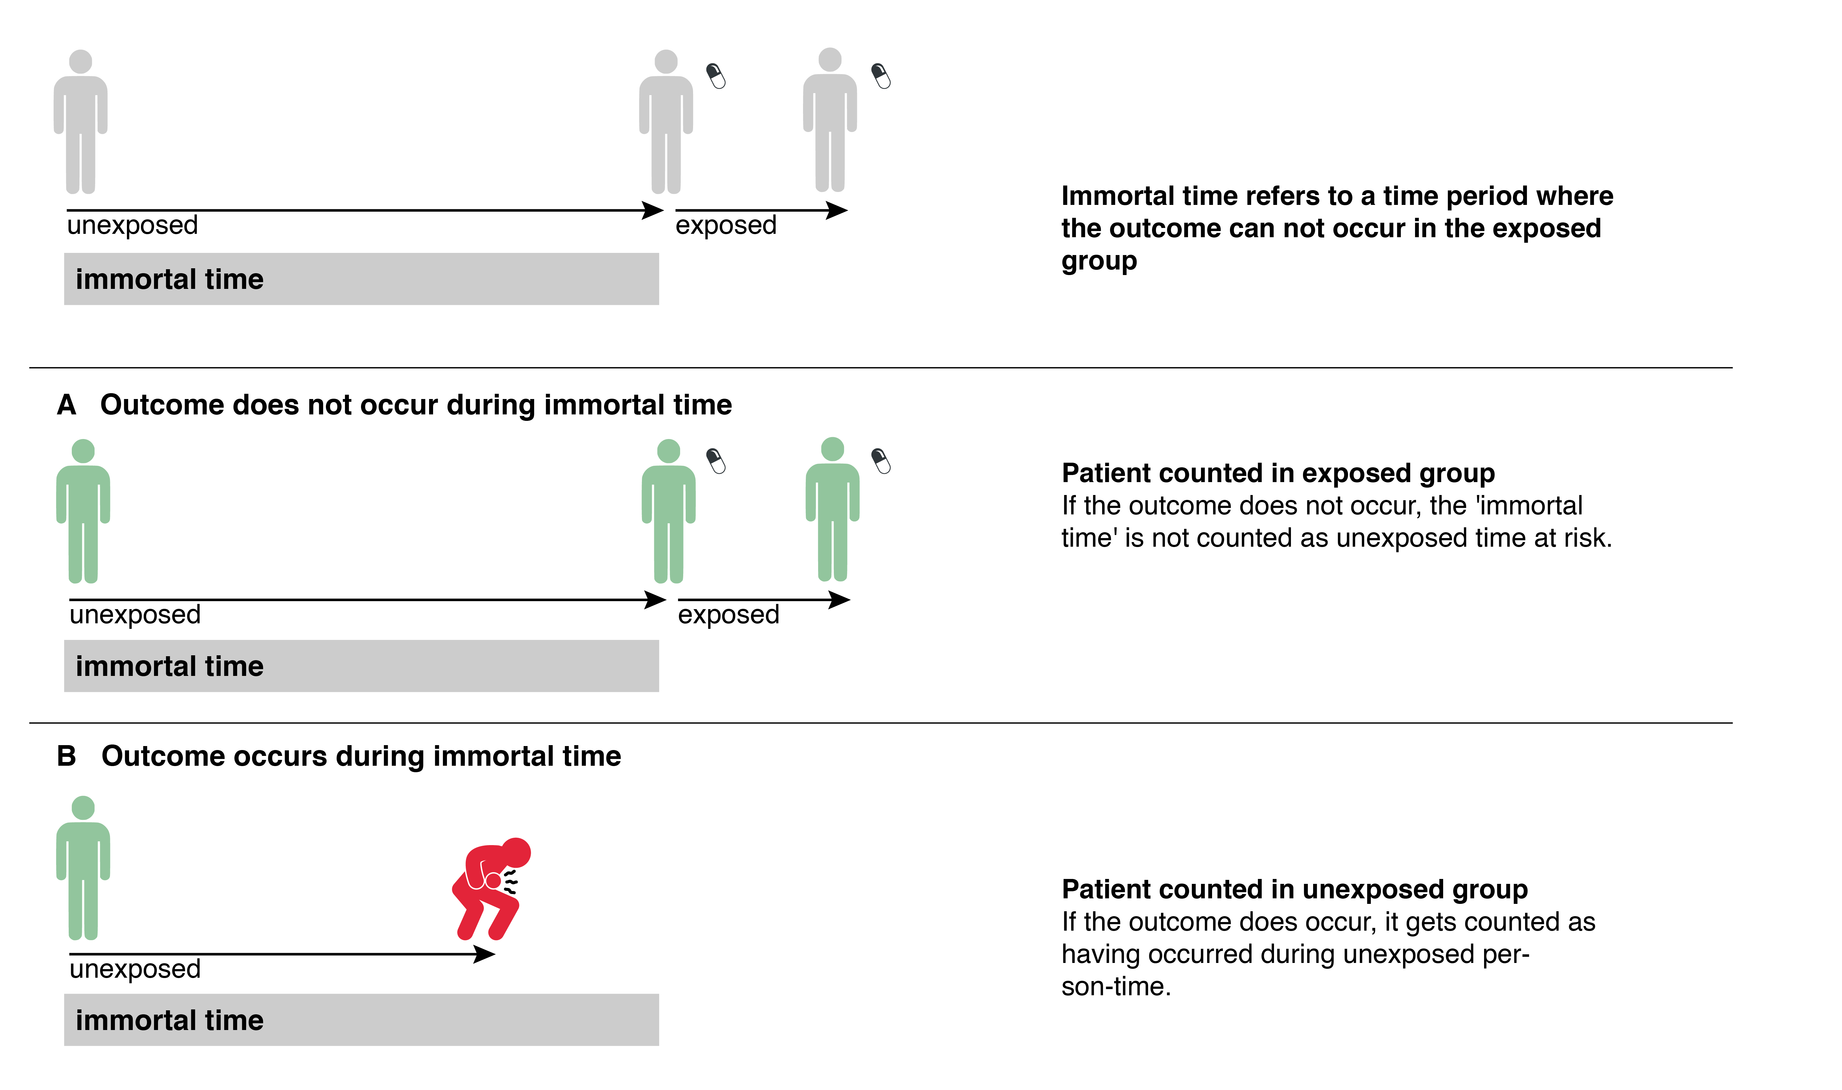
Figure 9.6: Immortal time bias. When incidence is compared between ever exposed and never exposed people, the person time before exposure in the ever-exposed is "immortal" − events occurring during that time would be counted as occurring to the unexposed group.

This is an example of immortal time bias,[20] so named based on studies where the outcome was mortality and there were "immortal" time periods when patients could not die, analogous to Jennie's unexposed time before starting pioglitazone in the example above. It can be avoided by a new user design[21] and proper analysis, which is most straightforward when subjects started on one drug are compared with those starting on another for the same indication. It is often subtle, which is why it is also prevalent, even in articles published in good journals. But it can be suspected any time you try to envision the randomized trial that the cohort study is trying to emulate, and see what would be the equivalent of people switching groups or disappearing from the study after the point at which they would have been randomized.

Summary
1. Although randomized blinded trials are the best way to establish causal relationships between treatments and outcomes, it is sometimes possible, by thinking creatively, to design observational studies that provide strong evidence of causality.
2. One approach is to identify an instrumental variable that is associated with treatment but not independently related to the outcome. Comparing outcomes between groups based on values of the instrumental variable is then similar to an intention-to-treat analysis of a randomized trial with substantial crossover between the treatment and control groups. The bias toward the null induced by this misclassification can then be corrected using an appropriate instrumental variable analysis.
3. Another approach is (pre-specified) falsification tests: measuring effects on alternative outcomes, effects of alternative predictors, or effects in patient populations with different susceptibility to the exposure under study.
4. A final approach is to model the propensity to receive treatment and compare outcomes of subjects with similar treatment propensities.
5. Observational studies of treatment effects can be tricky because of confusion about when to start counting the follow-up time in treated and untreated subjects, leading to immortal time bias. Describing a randomized trial that the observational study is trying to emulate can help.

REFERENCES

1. Ye Z, Song H. Antioxidant vitamins intake and the risk of coronary heart disease: meta-analysis of cohort studies. Eur J Cardiovasc Prev Rehabil. 2008;15(1):26-34.
2. Curtis AJ, Bullen M, Piccenna L, McNeil JJ. Vitamin E supplementation and mortality in healthy people: a meta-analysis of randomised controlled trials. Cardiovasc Drugs Ther. 2014;28(6):563-73.
3. Warram JH, Laffel LM, Valsania P, Christlieb AR, Krolewski AS. Excess mortality associated with diuretic therapy in diabetes mellitus. Arch Intern Med. 1991;151(7):1350-6.
4. Turnbull F, Neal B, Algert C, Chalmers J, Chapman N, Cutler J, et al. Effects of different blood pressure-lowering regimens on major cardiovascular events in individuals with and without diabetes mellitus: results of prospectively designed overviews of randomized trials. Arch Intern Med. 2005;165(12):1410-9.
5. Halpern SD, French B, Small DS, Saulsgiver K, Harhay MO, Audrain-McGovern J, et al. Randomized trial of four financial-incentive programs for smoking cessation. N Engl J Med. 2015;372(22):2108-17.
6. Tan HJ, Norton EC, Ye Z, Hafez KS, Gore JL, Miller DC. Long-term survival following partial vs radical nephrectomy among older patients with early-stage kidney cancer. JAMA. 2012;307(15):1629-35.
7. McClellan M, McNeil BJ, Newhouse JP. Does more intensive treatment of acute myocardial infarction in the elderly reduce mortality? Analysis using instrumental variables. JAMA. 1994;272(11):859-66.
8. Neuman MD, Rosenbaum PR, Ludwig JM, Zubizarreta JR, Silber JH. Anesthesia technique, mortality, and length of stay after hip fracture surgery. JAMA. 2014;311(24):2508-17.
9. Garabedian LF, Chu P, Toh S, Zaslavsky AM, Soumerai SB. Potential bias of instrumental variable analyses for observational comparative effectiveness research. Ann Intern Med. 2014;161(2):131-8.
10. Prasad V, Jena AB. Prespecified falsification end points: can they validate true observational associations? JAMA. 2013;309(3):241-2.
11. Selby JV, Friedman GD, Quesenberry CP, Jr., Weiss NS. A case-control study of screening sigmoidoscopy and mortality from colorectal cancer. N Engl J Med. 1992;326(10):653-7.
12. Tuccori M, Filion KB, Yin H, Yu OH, Platt RW, Azoulay L. Pioglitazone use and risk of bladder cancer: population based cohort study. BMJ. 2016;352:i1541.
13. Turner RM, Kwok CS, Chen-Turner C, Maduakor CA, Singh S, Loke YK. Thiazolidinediones and associated risk of bladder cancer: a systematic review and meta-analysis. Br J Clin Pharmacol. 2014;78(2):258-73.
14. Rimm EB, Stampfer MJ, Ascherio A, Giovannucci E, Colditz GA, Willett WC. Vitamin E consumption and the risk of coronary heart disease in men. N Engl J Med. 1993;328(20):1450-6.
15. Stampfer MJ, Hennekens CH, Manson JE, Colditz GA, Rosner B, Willett WC. Vitamin E consumption and the risk of coronary disease in women. N Engl J Med. 1993;328(20):1444-9.
16. Bjelakovic G, Nikolova D, Gluud LL, Simonetti RG, Gluud C. Antioxidant supplements for prevention of mortality in healthy participants and patients with various diseases. Cochrane Database Syst Rev. 2012(3):CD007176.
17. Jena AB, Prasad V, Goldman DP, Romley J. Mortality and treatment patterns among patients hospitalized with acute cardiovascular conditions during dates of national cardiology meetings. JAMA Intern Med. 2015;175(2):237-44.
18. Gum PA, Thamilarasan M, Watanabe J, Blackstone EH, Lauer MS. Aspirin use and all-cause mortality among patients being evaluated for known or suspected coronary artery disease: A propensity analysis. JAMA. 2001;286(10):1187-94.
19. Wei L, MacDonald TM, Mackenzie IS. Pioglitazone and bladdercancer: a propensity scorematched cohort study. Br J Clin Pharmacol. 2012;75(1):254-59.
20. Suissa S. Immortal time bias in pharmaco-epidemiology. Am J Epidemiol. 2008;167(4):492-9.
21. Ray WA. Evaluating medication effects outside of clinical trials: new-user designs. Am J Epidemiol. 2003;158(9):915-20.

This discussion and Figure 9.1 simplify a little. It’s not actually the other favorable health habits themselves that increase Vitamin E intake, it’s the interest in staying healthy that is the common cause of both the Vitamin E intake and the favorable health habits, but we're trying to keep it simple.
This type of confounding is sometimes referred to as suppression and the confounder is referred to as a suppressor because it suppresses the beneficial effect of treatment (or other predictor of interest)
The effect of differential distance looks more impressive with the inclusion of both light and dark colored bars, doesn’t it? But in fact, the dark colored bars provide no information in this figure: the light and dark bars at each distance always sum to 100%.
The assumption, of course, is that the only difference between these cancers is that some are within reach of the sigmoidoscope and some are not. But this is becoming controversial because of evidence that right and left sided colon cancers may differ biologically and that mortality benefits of screening sigmoidoscopy and colonoscopy are similar. See e.g., Schmidt C. Colonoscopy vs sigmoidoscopy: new studies fuel ongoing debate. J Nat Cancer Inst 2012;104:1350-1.
Why Vitamin E intake and not other vitamins would be associated with decreased coronary heart disease risk is unclear. But it is curious that in the Health Professionals study the investigators noted that there was no association between coronary disease and Vitamin C (without specific mention of multiple vitamins) and in the Nurses Health Study they noted there was no association between coronary disease and multiple vitamins (without specific mention of Vitamin C), possibly reinforcing the need for prespecified falsification tests.
Personal communication from Anupam Jena, 10/25/17.

